    Joint Collaborative Team on Video Coding (JCT-VC)  of ITU-T SG16 WP3 and ISO/IEC JTC1/SC29/WG11  2nd Meeting: Geneva, Switzerland, 21-28 July, 2010 | Document: JCTVC-B303

Title: | Tool Experiment 3: Inter Prediction in HEVC
Status: | Output Document to JCT-VC
Purpose: | TE description
Authors: | Andreas Krutz¹,  Thomas Sikora ¹,  Alexander Glantz ¹,  Seugwook Park²,  Jaehyun Lim²,  Edouard Francois³,  Peisong Chen⁴  Xiaozhen Zheng⁵,  Haoping Yu⁵  Stavros Paschalakis ⁶  Nikola Sprljan⁶  Shangwen Li ⁷  Ali Tabatabai ⁸  Teruhikos Suzuki ⁸  Takeshi Chujoh ⁹  Wen-Hsiao Peng ¹⁰  Shohei Matsuo ¹¹ | krutz@nue.tu-berlin.de  sikora@nue.tu-berlin.de  glantz@nue.tu-berlin.de  seungwook.park@lge.com  jaehyun.lim@lge.com  edouard.francois@technicolor.com  peisongc@qualcomm.com xiaozhenzheng@huawei.com  haopingyu@huawei.com  s.paschalakis@uk.merce.mee.com  n.sprljan@uk.merce.mee.com  dylanwen@zju.edu.cn  ali.tabatabai@am.sony.com  teruhikos@jp.sony.com  takeshi.chujoh@toshiba.co.jp  pawn@mail.si2lab.org  matsuo.shohei@lab.ntt.co.jp
Source: | TU Berlin¹, LG², Technicolor³, Qualcomm⁴, Huawei Technologies⁵, Mitsubishi Electric⁶, Zhejiang University⁷, Sony⁸, Toshiba⁹, NCTU/ITRI¹⁰, NTT ¹¹
_____________________________

1 Introduction 2
2 Participants 2
3 Experimental Conditions 3
3.1 Software 3
3.2 Test Sequences, Bit Rates and Coding Conditions 3
3.3 Evaluation of TE Results 3
3.4 Evaluation of Complexity 3
4 Description of Tool Experiment 4
4.1 Subtest 1: Warped Motion Compensated and Second Order Prediction 4
4.1.1 Adaptive Warped Reference (LG, [3]) 4
4.1.2 Adaptive Global Motion Temporal Prediction (GMTP) (TUB, [4]) 4
4.1.3 Second Order Prediction (SOP) (Zhejiang University, [5]) 5
4.1.4 Participants 6
4.2 Subtest 2: Flexible Motion Partitioning 7
4.2.1 Motion compensation with adaptable block shapes (Huawei & HiSilicon, [6]) 7
4.2.2 Geometry Motion Partitioning (Qualcomm, [7]) 9
4.2.3 Simplified Geometric Block Partitioning (Technicolor, [8]) 9
4.2.4 Participants 10
4.3 Subtest 3: Multi-hypothesis inter prediction 10
4.3.1 Efficient motion-hypothesis inter prediction (LG, [11]) 10
4.3.2 Local Intensity Compensation (Mitsubishi Elect., [12]) 11
4.3.3 Joint Template and Block Prediction (NCTU/ITRI, [14]) 12
4.3.4 Multi-Parameter Motion (MPM) (Sony, [15]) 13
4.3.5 Participants 14
4.4 Subtest 4: Improved Inter Prediction with enhanced MC filter 14
4.4.1 Bi/Single filter switching in FIF (Sony, [16]) 14
4.4.2 High Accuracy Interpolation Filter (Toshiba [17]) 17
4.4.3 Region-Based Adaptive Interpolation Filter (NTT [20]) 17
4.4.4 Participants 18
5 Timline 18
6 References 18

Introduction

The goal of this Tool Experiment (TE) is to further investigate temporal prediction and geometric block partitioning in the HEVC. It is an ongoing work of TE3 – Inter prediction defined in [1]. Results of the TE in [1] are summarized in [2]. Concerning the temporal prediction, techniques are evaluated that apply to translational as well as global and warped motion.

The inter prediction methods are organized in subtest 1 and participants in this activity are LG Electronics, TU Berlin, and Zeijang University. In subtest 2, flexible motion partitioning is examined. Several techniques will be tested that define non-rectangular partitioning for inter prediction. Participants in this subtest are Technicolor, Qualcomm, and Huawei. Subtest 3 is about multi-hypothesis prediction, where LG Electronics, Mitsubishi Electric, NCTU/ITRI, and Sony test their tools. In subset 4, improved inter prediction with enhanced MC filters will be tested. Participants in this subset are Toshiba, Sony and NTT.

Finally, a complexity evaluation is conducted for each subtest.

Participants

Nr. | Name | Company | Email
1  2  3  4  5  6  7  8  9  10  11  12  13  14  15´  16  17  18  19  20  21  22  23  24  25  26  27  28  29  30  31  32  33  34  35  36  37  38  39  40  41  42 | Andreas Krutz (coordinator)  Thomas Sikora (coordinator)  Alexander Glantz  Byeong Moon Jeon  Seungwook Park  Jaehyun Lim  Edouard Francois  Peng Yin  Peisong Chen  Xiaozhen Zheng  Haoping Yu  Shangwen Li  Lu Yu  Binbin Yu  Yeping Su  Stavros Paschalakis  Nikola Sprljan  Shigeru Fukushima  Hiroya Nakamura  Kenneth Vermeirsch  Jan de Cock  Wen-Hsiao Peng  Yi-Wen Chen  Hui Yong Kim  Seyoon Jeong  Sung-Chang Lim  Hae-Chul Choi  Xun Guo  Jianliang Lin  Shawmin Lei  YW Huang  Krit Panusopone  Yi-Jen Chiu  Ali Tabatabai  Teruhikos Suzuki  Takeshi Chujoh  Akiyuki Tanizawa  Lazar Bivolarski  Yoshinori Suzuki  Akira Fujibayashi  Damian Karwowski  Shohei Matsuo | TU Berlin  TU Berlin  TU Berlin  LG Electronics  LG Electronics  LG Electronics  Technicolor  Technicolor  Qualcomm  HiSilicon  Huawei  Zhejiang University  Zhejiang University  Zhejiang University  Sharp Labs  Mitsubishi Electric  Mitsubishi Electric  JVC Kenwood  JVC Kenwood  Ghent University  Ghent University  NCTU/ITRI  NCTU/ITRI  ETRI  ETRI  ETRI  Hanbat University  MediaTek  MediaTek  MediaTek  MediaTek  Motorola  Intel  Sony  Sony  Toshiba  Toshiba  Skype  NTT DOCOMO  NTT DOCOMO  PUT  NTT | krutz@nue.tu-berlin.de  sikora@nue.tu-berlin.de  glantz@nue.tu-berlin.de  bm.jeon@lge.com  seungwook.park@lge.com  jaehyun.lim@lge.com  edouard.francois@technicolor.com  peng.yin@technicolor.com  peisongc@qualcomm.com  xiaozhenzheng@huawei.com  haopingyu@huawei.com  dylanwen@zju.edu.cn  yul@zju.edu.cn  zjuybb@zju.edu.cn  ysu@sharplabs.com  s.paschalakis@uk.merce.mee.com  n.sprljan@uk.merce.mee.com  fukushima.shigeru@jk-holdings.com  nakamura.hiroya@jk-holdings.com  kenneth.vermeirsch@ugent.be  jan.decock@ugent.be  pawn@mail.si2lab.org  ewchen@csie.nctu.edu.tw  hykim5@etri.re.kr  jsy@etri.re.kr  sclim@etri.re.kr  choihc@hanbat.ac.kr  xun.guo@mediatek.com  jl.lin@mediatek.com  shawmin.lei@mediatek.com  yuwen.huang@mediatek.com  krit@motorola.com  yi-jen.chiu@intel.com  ali.tabatabai@am.sony.com  teruhikos@jp.sony.com  takeshi.chujoh@toshiba.co.jp  akiyuki.tanizawa@toshiba.co.jp  lazar.bivolarsky@skype.net  suzukiyos@rd.nttdocomo.co.jp  fujibayashi@nttdocomo.com  dkarwow@multimedia.edu.pl  jctvc-te@lab.ntt.co.jp

Experimental Conditions

Software

All subtests of this TE will be implemented into the TMuC software that is recommended by the TMuC software group at the end of this meeting in Geneva.

Test Sequences, Bit Rates and Coding Conditions

In this TE, only the recommended test conditions for high complexity (except the intra-only configuration), test sequences as defined in the CfP document [9] and provided config files by the TMuC software group as described in [18] are used for all subtests.

Evaluation of TE Results

Results of the TE will be evaluated on the Basis of BD-measures as defined in the CfP document [9].

Evaluation of Complexity

For the complexity measurement, the reference software and the reference software with the tool implemented will be executed on the same machine and the computational time will be measured for each software. Then, a time factor is calculated which the reference software including the subtest tool needs in comparison to the reference software without the tool as well as the anchor.

Description of Tool Experiment

Subtest 1: Warped Motion Compensated and Second Order Prediction

Adaptive Warped Reference (LG, [3])
Adaptive warped reference technique is the new motion compensation method with additional reference picture(s) reflecting complex motion between the current and reference picture. In order to reflecting the complex motion like zooming, rotation, affine and perspective motion, several warping matrixes are derived and the best one is chosen in the encoder side. By using this matrix, the best warped reference picture is generated and inserted to the reference picture list, temporally for ME/MC process (refer to Figure 1).

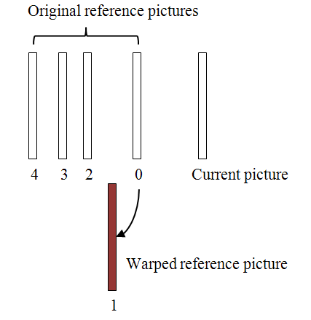
Figure 1 - Reference picture reordering with warped reference picture

Warping information is represented by four motion vectors of picture corner positions and transmitted in the slice header (refer to Figure 2).
Fig 2. Four motion vectors for warping parameters

Adaptive Global Motion Temporal Prediction (GMTP) (TUB, [4])

The core of the method presented herein is a refined motion prediction based on short-term and long-term global motion estimation. Multiple previously decoded reference pictures from the past and/or future can be used in combination in order to arrive at a precise prediction signal. Figure 3 shows a coding environment that is based on the proposed Adaptive Global Motion Temporal Prediction.

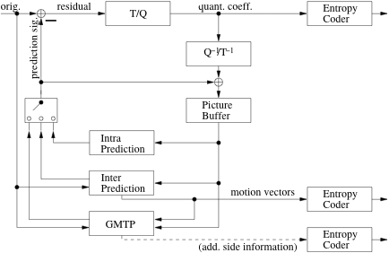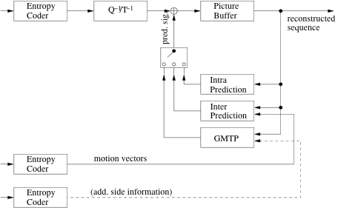
Figure 3 - Encoder and decoder based on Adaptive Global Motion Temporal Prediction

For prediction signal generation, global motion parameters are estimated between the current picture and a number N of previously decoded pictures at the encoder, resulting in a set of short-term global motion parameters, e.g. based on an 8-parameter perspective motion model, which can then be combined to long-term parameters. These long-term parameters can then be used to compensate the global motion between those N pictures and the current picture, which is illustrated in Figure 4.

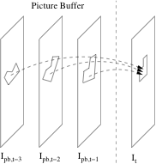
Figure 4 - Generation of a prediction signal for the current picture. The pictures inside the decoded picture buffer can be past and/or future pictures in display order.

For each pixel in a block of the current picture, the N related pixels in the N decoded pictures are blended together, e.g. using a median filter, to generate a predicted value with reduced coding noise. The encoder can adaptively choose an optimal number of pictures N by means of error minimization between prediction signal and original.
Once available, the encoder chooses the macroblock types by means of rate-distortion optimization. If it chooses to encode a block using GMTP, only the type identifier is sent inside the macroblock header. No further information, e.g. coded block pattern, quantization parameters or coefficients, is included in the bitstream for that block. This corresponds to the SKIP mode. However, the prediction quality is generally better. The encoder sends additional side information to the receiver, i.e. global motion parameters and number N of pictures used for filtering on a slice/picture level.

Second Order Prediction (SOP) (Zhejiang University, [5])
Second Order Prediction (SOP) applies intra prediction to motion compensated residue to eliminate the remaining spatial correlation. Its main architecture is illustrated in Figure 5.
Figure 5 – Architecture of Second Order Prediction

Second Order Prediction process mainly consists of 3 steps. Firstly, reference residue of the second prediction is derived by subtracting the black shaded area from the blue shaded area in Figure 3. Secondly, first order residue prediction value is generated with one of 4x4 or 8x8 intra prediction modes in H.264/AVC. Last, reconstructed values are obtained by adding three components: motion compensated prediction values, first order residue prediction values and second order residue.
To achieve SOP, three syntax elements are added in the macroblock layer for SOP: sop_flag, pred_sp_mode_flag and rem_sp_mode. The first one is used to indicate the usage of SOP at macroblock level. The latter two are used to signify the second prediction mode. Furthermore, when a macroblock is indicated as a SOP macroblock, transform_size_8x8_flag is always presented in the bitstream. In the SOP macroblock, transform_size_8x8_flag not only indicates transform size but also the second prediction block size.

Participants

Participant | Contact
LG | seungwook.park@lge.com
TU Berlin | glantz@nue.tu-berlin.de  krutz@nue.tu-berlin.de
Zhejiang University | dylanwen@zju.edu.cn  yul@zju.edu.cn

Subtest 2: Flexible Motion Partitioning

In this subtest, Asymmetric Motion Partitioning (AMP), which is in the upcoming TMuC software, will not be evaluated. This will be done in TE12 [19]. Here, the following experiments will be conducted:

- Proposed tool + TMuC with AMP off;
- TMuC with AMP tuned off;

Participants in this subtest are Huawei, Qualcomm, and Technicolor.

Motion compensation with adaptable block shapes (Huawei & HiSilicon, [6])

Representation method
The general idea of this representation is to use two parameters to indicate the position of points of intersection between the boundary of two segments and the boundary of the block. As illustrated in Figure 6, moving the position of point A and B can change the partitioning of the block. At the decoder side, after parsing the value of two position parameters, the block partitioning information can be obtained.
Figure 6 Motion partitioning representation

Meanwhile, quad-tree design is used to signal the block partitioning. A position parameter pos is used to indicate the position of the boundary between two block segments. Another parameter scale_factor is used to signal the triangle shape in the case of non-rectangle partition. The representation of flexible motion partitioning is illustrated in Figure 7 (a) ~ (e).

Figure 7(a) Horizontal partitioning Figure 7(b) Vertical partitioning

Figure 7(c) 45 degree partitioning Figure 7(d) 22.5 degree partitioning

Figure 7(e) 66.5 degree partitioning

Predictive coding based on block partitioning
Considering the connectivity property of image texture, same or similar block partitioning may be used by the adjacent macroblocks at some specific areas in an image. Therefore, information of neighboring blocks can be used to predict the current block's position parameters and motion vectors. To form the prediction of the current block’s position parameters, the left block and up block’s partitioning mode and position parameters are used.

Under the consideration of image texture connectivity, the accuracy of motion vector prediction can be improved by using neighboring blocks’ partitioning mode and motion vector. The prediction mechanism is illustrated in Figure 8.

Figure 8(a) Horizontal prediction Figure 8(b) Vertical prediction
Figure 8(c) Left-down to right-up prediction Figure 8(d) Left-up to right-down prediction

Geometry Motion Partitioning (Qualcomm, [7])

In geometry motion partition, a square block is divided into 2 regions. One motion vector is sent for each region. The boundary separating the 2 regions is defined by a straight line. Assuming the origin is at the center of the block, each geometry partition is defined by a line passing through the origin that is perpendicular to the line defining the partition boundary. This is shown in Figure 9. The geometry partition is defined by the angle subtended by the perpendicular line with the X axis $θ$ and the distance of the partition line from the origin$ρ$. The equation of the line defining the partition boundary can be specified as
$$y=\frac{−1}{\text{tan}θ}x+\frac{ρ}{\text{sin}θ}=\text{mx}+c$$
We use two lookup tables, one to store the slope, , and the other to store the Y-intercept, . The region to which each pixel belongs is calculated on the fly.
Geometry motion partition is applied to 3 different block sizes: 64×64, 32×32 and 16×16. At each block size, 32 different values of $θ$are permitted (from 0 to ${\text{360}}^{0}$ in steps of $\text{11}\text{.}{\text{25}}^{0}$). The number of values $ρ$ can take depends on the block size. For block size of 16×16,$ρ$can take 8 possible values (from 0 to 7 in steps of 1). For block sizes of 32×32 and 64×64, $ρ$ can take 16 and 32 possible values, respectively. Thus for block sizes of 16×16, 32×32, and 64×64, there are 256, 512, and 1024 possible geometry partitions respectively.

Simplified Geometric Block Partitioning (Technicolor, [8])

The proposed method, described in JCTVC-B085 [9], aims at providing a simplification of Geometry Block Partitioning (GEO) scheme. Specifically, Most Valuable Partitions are proposed to achieve the best tradeoff between the complexity and coding efficiency. Most Valuable Partitions are derived from a statistical analysis of the actual used GEO partitions.

In JCTVC-A121, at each block size, 32 different values of θ are permitted (from 0 to 360° in steps of 11.25°, i.e., Δθ = 11.25°). The number of values ρ depends on the block size. For block size of 16×16, ρ can take 8 possible values (from 0 to 7 in steps of 1, i.e., Δρ = 1). For block sizes of 32×32 and 64×64, ρ can take 16 and 32 possible values, respectively. Thus for block sizes of 16×16, 32×32, and 64×64, there are 256, 512, and 1024 possible geometry partitions, respectively. The number of supported partitions is relatively big.

In this proposal, GEO mode simplifications are proposed. The solution consists in identifying the Most Valuable Partitions (MVP) to reduce the number of supported partitions so the best tradeoff between the complexity and coding efficiency can be achieved.

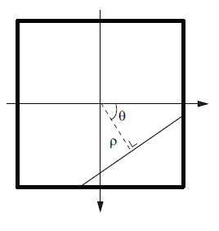
Figure 9 - Parameters defining a geometry motion partition.

A statistical analysis of the distribution of GEO partitions in 16x16 blocks depending on the distance ρ to the block center and on the angle θ of the oriented splitting line brings to the following observations:
- For ρ, balanced partitions (small ρ) are mostly chosen
- For θ,
  - Diagonal partitions are more important for small ρ values, while Vertical and Horizontal partitions compete with 8x16 /16x8 rectangular partitions;
  - For medium ρ values, Vertical and Horizontal partitions are dominant, which give more balanced partitions;
  - For large ρ values, only Diagonal partitions are mostly observed.

It is therefore proposed to apply the following restrictions to the GEO partitioning:
- For Non-uniform sampling of distance parameter (ρ), dense sampling is used when distance is small and sparse sampling is used when distance is large;
- For Sampling of angle parameter (θ), only Horizontal, Vertical and Diagonal partitions are considered.

This firstly enables encoder complexity reduction. GEO syntax is also simplified corresponding to the reduced partitions to improve the coding performance.

Participants

Participant | Contact
Huawei &  HiSilicon | haopingyu@huawei.com xiaozhenzheng@huawei.com
Qualcomm | peisongc@qualcomm.com
Technicolor | edouard.francois@technicolor.com  peng.yin@technicolor.com

Subtest 3: Multi-hypothesis inter prediction

Efficient motion-hypothesis inter prediction (LG, [11])

In the merging process of TMuC, the current motion partition is motion-compensated by using one of motion parameters of left and above motion partitions. It is known that the accuracy of motion compensated prediction can be increased with multi-hypothesis prediction [10]. Accordingly, the proposed method, described in JCTVC-B023 [11], aims at extending the merging scheme of TMuC by using multi-hypothesis prediction in order to achieve high coding efficiency. In this TE, the original scheme is more extended to be used not only for B slice but also N slice which is introduced in JCTVC-B108. And furthermore it will be applied extensively to the skip/direct mode as well as to the merging mode.

The basic concept of this scheme is described in Fig. 10. The extended merging scheme is selected at the encoder based on RD optimization process and signaled using 1bit flag in PU level.

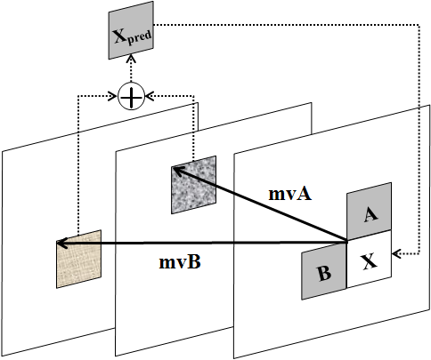

Figure 10 – Extended merging scheme using multi-hypothesis prediction

Local Intensity Compensation (Mitsubishi Elect., [12])

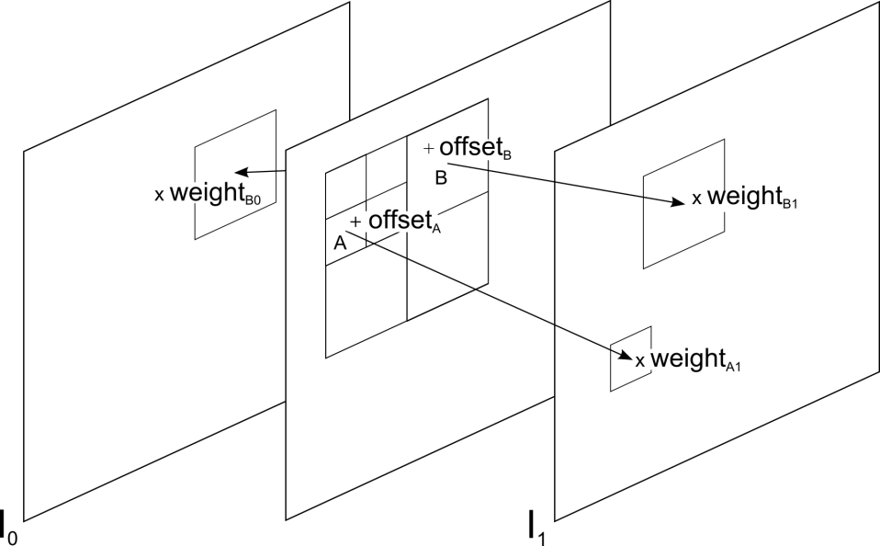

Figure 11 - Example of local intensity compensation

The operation of our weighted prediction method for local intensity compensation is defined at the PU (prediction unit) level, where for each block unit in a partition a different set of parameters is derived and transmitted. An offset combined with weighted reference signals is used as this can model more complex pixel intensity changes than a uniform illumination change. A weight is associated with each reference block, and when these blocks are summed an offset is also added (Figure 11). The default case of zero offset and default weighting (for bidirectional case it is averaging of two blocks) is signalled with a zero flag and encoded along the motion data. For the non-default case this flag is set and a differential signal of parameters is transmitted.
In more detail, the operation of local intensity compensation can be represented with:
,
where Bc_{n} is n-th reference block, o is offset and w_{n} is the weight associated with block Bc_{n}. N relates to the number of reference blocks, such that for unidirectional prediction N=0, and for bidirectional N=1. The result of this operation, Bp, is used to predict the current block. The parameters are quantised and predicted from the already processed data, and sent alongside with the motion vector for the current block.

The search algorithm is briefly explained here. A list of visited motion vectors is maintained during the ME stage of the encoding, and for the best M motion vectors their optimal intensity compensation parameters are computed. When choosing the best M motion vectors, they are sorted by their rate constrained cost as used in the ME. Alternatively, any other cost based on appropriate distortion metric can be used. In the initial step of the search for local intensity compensation parameters, the parameters are found that minimize only the distortion part of the cost. Next, that parameter set is used as a seed for the search for the minimal rate constrained cost $J\left(o,w_{0},w_{1},\text{mv}\right)$. Out of M motion vectors, only R are preserved for which the intensity compensation parameters are non-default, i.e. for which the offset is non-zero or weights non-unit. Here R can be equal to M, but in practice for a large number of motion vectors no weighting parameters can be found that lead to cost smaller than .

Joint Template and Block Prediction (NCTU/ITRI, [14])
This technique, proposed in JCTVC-B072 [12], aims to improve the prediction efficiency of PUs by a joint application of template and block motion compensations. Figure 12 shows its main concept of operations. As illustrated, the motion vector (MV) v_{t} found by minimizing template matching error is viewed as an additional free MV, which can contribute to estimating pixel intensities in a PU. The predictors derived from the template and block MVs are linearly combined based on a distance-weighting criterion, as in POBMC [13]. In particular, given that the template MV tends to minimize the prediction error in the upper left quarter of a PU, the block MV search criterion is changed so that the resulting MV v_{b} can contribute more to minimizing the error in the remaining part. Optimizing the block MV search criterion in order to use both MVs to their best advantage is the main subject of this sub-experiment. Extending the notion to PUs of arbitrary shape with single- or multi-hypothesis compensation is another direction that will be pursued further in this study. In addition, the framework will be generalized to accommodate MVs inferred by various template matching techniques or other means.

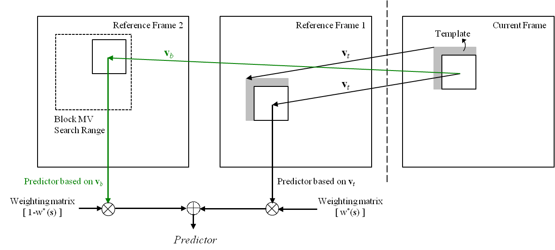
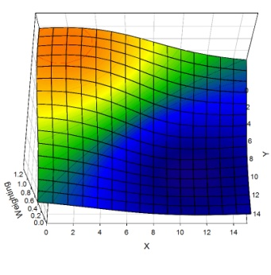 | 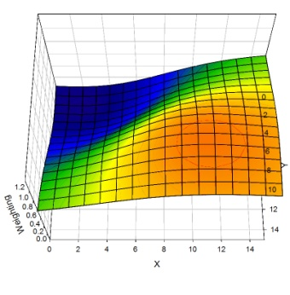
Weighting Matrix for Template MV, w*(s) | Weighting Matrix for Block MV, 1-w*(s)
Block MV Search Criterion

Figure 12 – Joint application of template and block motion compensated prediction.

Multi-Parameter Motion (MPM) (Sony, [15])
For a block or Prediction Unit (PU), we allow up to motion vectors per list. is a pre-define fixed number which is hard-wired into the decoder. The prediction signal is constructed by a linear combination of the MCP from each motion vector. To simplify the encoder motion search and allow a better prediction of the motion vectors, we restrict all motion vectors of the same list to be from one reference frame. The proposed syntax changes and motion vector prediction the case of one-list prediction (prediction in P-Slices) is described below. In the case of B-pictures where two lists (forward and backward) are generally present, each list uses the described syntax separately.

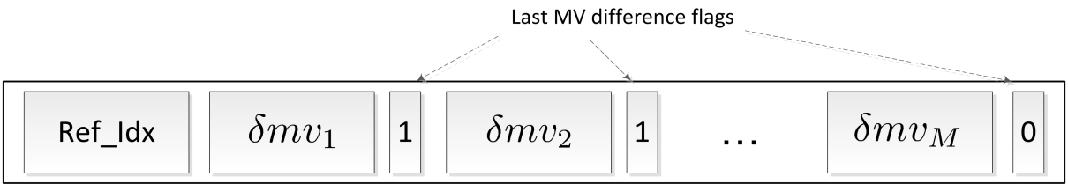
Figure 23. Syntax changes to signal multiple motion vectors (single list case).

Let be the current motion vector predictor, i.e., the spatial or temporal motion vector predictor for the block to be coded. Furthermore, let , , be the set of all motion vectors selected for the current block (for a non-skip block). In addition, let to be the position of the motion vector when written to the bit stream. In other words, is a permutation of the set which determines the order in which motion vectors of the current block are written into the bit stream. Then, the motion vector differences are calculated according to
where and .

Once motion vector differences are computed, then they are encoded into the bit stream in the following way: first the index of the reference frame that these motion vectors point to is coded in the bit stream. This is followed by the first motion vector difference . Then, a one bit flag is added to signal to the decoder whether this motion vector difference is the last one or more motion vector differences will follow. In the latter case a is transmitted to signal the existence of next motion vector difference. The second motion vector difference is then binarized and coded into the bit stream. This process continues until is coded. If , a is transmitted to indicate the termination of the motion vector parsing process to the decoder. Otherwise, no extra bits are transmitted and the decoder terminates the parsing process due to prior knowledge of the maximum number of motion vectors. Error: Reference source not found demonstrates this process for the case of . Note that since the motion vectors are sequentially predicted, the number of bits to transmit the entire set depends on the permutation as well as the spatial/temporal predictor .

The coding of the last MV difference flags (see Fig. 13) employs several new contexts in CABAC. The first flag which appears after the first MV difference employs three contexts based on the same flag in the spatial neighbors (top and left blocks) of the current block. The rest of the flags share one context.

Participants

Participant | Contact
LG | jaehyun.lim@lge.com
Mitsubishi Elect. | s.paschalakis@uk.merce.mee.com  n.sprljan@uk.merce.mee.com
NCTU/ITRI | pawn@mail.si2lab.org  ewchen@csie.nctu.edu.tw
Sony | ehsan.maani@am.sony.com  ali.tabatabai@am.sony.com

Subtest 4: Improved Inter Prediction with enhanced MC filter

In subset 4, improved inter prediction with enhanced MC filters, which are the enhancements tested in TE12, will be tested. Proponents in this subset are Toshiba and Sony. The proponents also participate to TE12 [] and compare with the deafult TMuC settings and the related results of TE12.

Bi/Single filter switching in FIF (Sony, [16])

Separable fixed interpolation filter (SFIF)
In AVC, 2 tap interpolation filter is used for MC interpolation filter at 1/2 pel position and 6 tap filter is used at 1/4 pel position. In our 6 tap separable interpolation filter is used for MC interpolation at all pixel positions. The definition of the sub pel position is the same as 14. Figure 14 indicates the sub pel position for MC interpolation. The light blue squares are the reference pixels stored in coded picture buffer. E, F, G, H, I, J are integer pixels. h[sub pel][z] is the z-th filter coefficient at the sub pel position.

Figure 14: Sub pel position

The interpolation filter is defined as Error: Reference source not found and Error: Reference source not found. In case of AVC, to calculate quarter pel, rounding and clipping is done to obtain half pel (b-position). It reduces the accuracy of the prediction, because of the accumulation of error. In our proposal, both quarter pel and half pel value are derived directly by separable interpolation filter as specified in Error: Reference source not found and Error: Reference source not found.

Step 1:
Horizontal interpolation is applied to derive pixels a, b and c using Error: Reference source not found.

$\begin{aligned}a=h[a][0]×E+h[a][1]×F+h[a][2]×G+h[a][3]×H+h[a][4]×I+h[a][5]×J \\ b=h[b][0]×E+h[b][1]×F+h[b][2]×G+h[b][2]×H+h[b][1]×I+h[b][0]×J \\ c=h[c][0]×E+h[c][1]×F+h[c][2]×G+h[c][3]×H+h[c][4]×I+h[c][5]×J\end{aligned}$
Equation 1: Horizontal interpolation filter
The pixels a1-a5, b1-b5, c1-c5 are derived in the same way as specified in Error: Reference source not found. The following filter coefficients are used. Here, we know that Bi/Single filter has 3 sets of filter coefficient as introduced in Error: Reference source not found. The Bi/Single filter switch those filter set whether bi-pred or single-pred and slice type is used.

For single-pred in P slice
- h[a][0] = h[c][5] = 3 /128
- h[a][1] = h[c][4] = -14 /128
- h[a][2] = h[c][3] = 111 /128
- h[a][3] = h[c][2] = 36, /128
- h[a][4] = h[c][1] = -9 /128
- h[a][5] = h[c][0] = 1 /128
- h[b][0] = h[b][5] = 3 /128
- h[b][1] = h[b][4] = -15 /128
- h[b][2] = h[b][3] = 76 /128
For single-pred in B slice
- h[a][0] = h[c][5] = 0 /128
- h[a][1] = h[c][4] = -5 /128
- h[a][2] = h[c][3] = 97 /128
- h[a][3] = h[c][2] = 47 /128
- h[a][4] = h[c][1] = -15 /128
- h[a][5] = h[c][0] = 3 /128
- h[b][0] = h[b][5] = 3 /128
- h[b][1] = h[b][4] = -15 /128
- h[b][2] = h[b][3] = 76 /128
For bi-pred
- h[a][0] = h[c][5] = 8 /128
- h[a][1] = h[c][4] = -28 /128
- h[a][2] = h[c][3] = 129 /128
- h[a][3] = h[c][2] = 26 /128
- h[a][4] = h[c][1] = -7 /128
- h[a][5] = h[c][0] = 0 /128
- h[b][0] = h[b][5] = 6 /128
- h[b][1] = h[b][4] = -23 /128
- h[b][2] = h[b][3] = 81 /128

In order to obtain e, f, g, i, j, k, m, n, o positions, the values of a1-a5, b1-b5, c1-c5 positions are necessary and those values are stored at memory.

Step 2:
Vertical interpolation is applied to derive pixels d-o using

$$\begin{aligned}d=h[d][0]×G1+h[d][1]×G2+h[d][2]×G+h[d][3]×G3+h[d][4]×G4+h[d][5]×G5 \\ h=h[h][0]×G1+h[h][1]×G2+h[h][2]×G+h[h][2]×G3+h[h][1]×G4+h[h][0]×G5 \\ l=h[d][5]×G1+h[d][4]×G2+h[d][3]×G+h[d][2]×G3+h[d][1]×G4+h[d][0]×G5\end{aligned}$$
$$\begin{aligned}e=h[e][0]×a1+h[e][1]×a2+h[e][2]×a+h[e][3]×a3+h[e][4]×a4+h[e][5]×a5 \\ h=h[i][0]×a1+h[i][1]×a2+h[i][2]×a+h[i][2]×a3+h[i][1]×a4+h[i][0]×a5 \\ m=h[e][5]×a1+h[e][4]×a2+h[e][3]×a+h[e][2]×a3+h[e][1]×a4+h[e][0]×a5\end{aligned}$$
$$\begin{aligned}f=h[f][0]×b1+h[f][1]×b2+h[f][2]×b+h[f][3]×b3+h[f][4]×b4+h[f][5]×b5 \\ j=h[j][0]×b1+h[j][1]×b2+h[i][2]×b+h[j][2]×b3+h[j][1]×b4+h[j][0]×b5 \\ n=h[f][5]×b1+h[f][4]×b2+h[f][3]×b+h[f][2]×b3+h[f][1]×b4+h[f][0]×b5\end{aligned}$$
$$\begin{aligned}g=h[g][0]×c1+h[g][1]×c2+h[g][2]×c+h[g][3]×c3+h[g][4]×c4+h[g][5]×c5 \\ k=h[k][0]×c1+h[k][1]×c2+h[k][2]×c+h[k][2]×c3+h[k][1]×c4+h[k][0]×c5 \\ o=h[g][5]×c1+h[g][4]×c2+h[g][3]×c+h[g][2]×c3+h[g][1]×c4+h[g][0]×c5\end{aligned}$$
Equation 2: Vertical interpolation filter
The following filter coefficients are used.

For single-pred in P slice
- h[d][0] = h[e][0] = h[f][0] = h[g][0] = h[l][5] = h[m][5] = h[n][5] = h[o][5] = 3 /128
- h[d][1] = h[e][1] = h[f][1] = h[g][1] = h[l][4] = h[m][4] = h[n][4] = h[o][4] = -14 /128
- h[d][2] = h[e][2] = h[f][2] = h[g][2] = h[l][3] = h[m][3] = h[n][3] = h[o][3] = 111 /128
- h[d][3] = h[e][3] = h[f][3] = h[g][3] = h[l][2] = h[m][2] = h[n][2] = h[o][2] = 36 /128
- h[d][4] = h[e][4] = h[f][4] = h[g][4] = h[l][1] = h[m][1] = h[n][1] = h[o][1] = -9 /128
- h[d][5] = h[e][5] = h[f][5] = h[g][5] = h[l][0] = h[m][0] = h[n][0] = h[o][0] = 1 /128
- h[h][0] = h[i][0] = h[j][0] = h[k][0] = h[h][5] = h[i][5] = h[j][5] = h[k][5] = 3 /128
- h[h][1] = h[i][1] = h[j][1] = h[k][1] = h[h][4] = h[i][4] = h[j][4] = h[k][4] = -15 /128
- h[h][2] = h[i][2] = h[j][2] = h[k][2] = h[h][3] = h[i][3] = h[j][3] = h[k][3] = 76 /128
For single-pred in B slice
- h[d][0] = h[e][0] = h[f][0] = h[g][0] = h[l][5] = h[m][5] = h[n][5] = h[o][5] = 0 /128
- h[d][1] = h[e][1] = h[f][1] = h[g][1] = h[l][4] = h[m][4] = h[n][4] = h[o][4] = -5 /128
- h[d][2] = h[e][2] = h[f][2] = h[g][2] = h[l][3] = h[m][3] = h[n][3] = h[o][3] = 97 /128
- h[d][3] = h[e][3] = h[f][3] = h[g][3] = h[l][2] = h[m][2] = h[n][2] = h[o][2] = 47 /128
- h[d][4] = h[e][4] = h[f][4] = h[g][4] = h[l][1] = h[m][1] = h[n][1] = h[o][1] = -15 /128
- h[d][5] = h[e][5] = h[f][5] = h[g][5] = h[l][0] = h[m][0] = h[n][0] = h[o][0] = 4 /128
- h[h][0] = h[i][0] = h[j][0] = h[k][0] = h[h][5] = h[i][5] = h[j][5] = h[k][5] = 1 /128
- h[h][1] = h[i][1] = h[j][1] = h[k][1] = h[h][4] = h[i][4] = h[j][4] = h[k][4] = -10 /128
- h[h][2] = h[i][2] = h[j][2] = h[k][2] = h[h][3] = h[i][3] = h[j][3] = h[k][3] = 73 /128
For Bi-pred
- h[d][0] = h[e][0] = h[f][0] = h[g][0] = h[l][5] = h[m][5] = h[n][5] = h[o][5] = 8 /128
- h[d][1] = h[e][1] = h[f][1] = h[g][1] = h[l][4] = h[m][4] = h[n][4] = h[o][4] = -28 /128
- h[d][2] = h[e][2] = h[f][2] = h[g][2] = h[l][3] = h[m][3] = h[n][3] = h[o][3] = 129 /128
- h[d][3] = h[e][3] = h[f][3] = h[g][3] = h[l][2] = h[m][2] = h[n][2] = h[o][2] = 26 /128
- h[d][4] = h[e][4] = h[f][4] = h[g][4] = h[l][1] = h[m][1] = h[n][1] = h[o][1] = -7 /128
- h[d][5] = h[e][5] = h[f][5] = h[g][5] = h[l][0] = h[m][0] = h[n][0] = h[o][0] = 0 /128
- h[h][0] = h[i][0] = h[j][0] = h[k][0] = h[h][5] = h[i][5] = h[j][5] = h[k][5] = 6 /128
- h[h][1] = h[i][1] = h[j][1] = h[k][1] = h[h][4] = h[i][4] = h[j][4] = h[k][4] = -23 /128
- h[h][2] = h[i][2] = h[j][2] = h[k][2] = h[h][3] = h[i][3] = h[j][3] = h[k][3] = 81 /128

Therefore, the number of filter coefficients in Error: Reference source not found and Error: Reference source not found is 18. The filter coefficient is fixed for entire sequence for SFIF.

High Accuracy Interpolation Filter (Toshiba [17])
HAIF (High-Accuracy Interpolation Filter) is a motion compensation scheme to interpolate fractional pixels according to fractional pixel motion vector with quarter-pel resolution. The interpolation filter is defined as a 1-dimentional FIR filter. If the motion vector points out fractional pixel position both horizontally and vertically, the 1-dimentional FIR filter is performed horizontally and vertically.
In H.264/AVC, the purposes of the interpolation filter are (1) to reduce coding noise of decoded picture and (2) adjust the pixel position to fractional pixel position. Since TMuC software adopts several image in-loop restoration filters to reduce coding noise, the purpose of the interpolation filter is concentrated to (2). Therefore, each fractional pixel potion is derived directly from pixels at integer pixel positions to minimize low pass filter characteristics.
For example, if the number of filter coefficients is eight, filter coefficients are as follows:
1/4 pixel position: {-3, 12, -37, 229, 71, -21, 6,-1} // 256
1/2 pixel position: {-3, 12, -39, 158, 158, -39, 12, -3} // 256
3/4 pixel position: {-1, 6, -21, 71, 229, -37, 12, -3} // 256.
This experiment is conducted to improve MC interpolation filters by considering the relationship between interpolation filter and in-loop filter.

Region-Based Adaptive Interpolation Filter (NTT [20])
Conventional Adaptive Interpolation Filter (AIF) optimizes the filter coefficients on a frame-by-frame basis. When an original image has uniform texture or movement, conventional AIF scheme is adequate. However, when the original image has multiple movements or each region of the image has different texture, the coding efficiency could be improved by using region-by-region interpolation filters.
In the proposal, Region-Based Adaptive Interpolation Filter (RBAIF) described in JCTVC-B051 [20], the input frame is divided into multiple regions according to coding information such as motion vectors and spatial coordinates and so on. The optimal filter coefficients are derived on a region-by-region basis as shown in Fig. 15. Several region-dividing modes are predefined, and the RD cost of each mode is calculated. Finally, the best region-dividing mode is chosen and sent to the decoder.

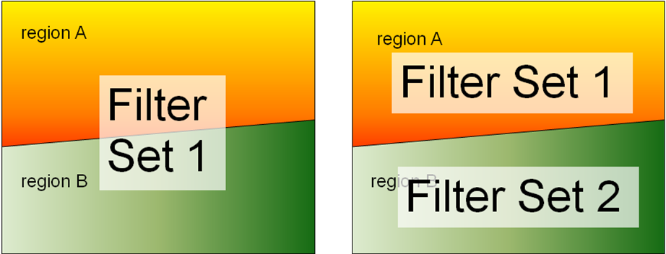

Figure 15: Conventional frame-based interpolation (left) and proposed region-based interpolation (right)

Participants

Participant | Contact
Sony Corp. | teruhikos@jp.sony.com
Toshiba | takeshi.chujoh@toshiba.co.jp  akiyuki.tanizawa@toshiba.co.jp
NTT | jctvc-te@lab.ntt.co.jp

Timline

Aug. 9, 2010: Upload of the final TE-document
Sept.23, 2010: Start doing cross-checks
Oct. 1, 2010: Upload all input documents

References

[1] | A. Krutz, A. Glantz, T. Sikora, J. Park, S. Park, E. Francois, P. Yin, X. Zheng, H. Yu, W.-J. Han, and W.-H. Peng, “Tool Experiment 3: Inter Prediction in HEVC,” Doc. JCTVC-A303, Joint Collaborative Team on Video Coding (JCT-VC) of ITU-T VCEG and ISO/IEC MPEG, Dresden, Germany, Apr 2010
[2] | A. Krutz, T. Sikora, “Summary report for TE3 on inter prediction in HEVC,” Doc. JCTVC-B053, Joint Collaborative Team on Video Coding (JCT-VC) of ITU-T VCEG and ISO/IEC MPEG, Geneva, Switzerland, Jul 2010
[3] | S. Park, J. Sung, J. Young Park, B.-M. Jeon, “TE 3: Motion compensation with adaptive warped reference,” Doc. JCTVC-B022, Joint Collaborative Team on Video Coding (JCT-VC) of ITU-T VCEG and ISO/IEC MPEG, Geneva, Switzerland, Jul 2010
[4] | A. Krutz, A. Glantz, T. Sikora, “TE 3: Adaptive Global Motion Temporal Prediction,” Doc. JCTVC-B052, Joint Collaborative Team on Video Coding (JCT-VC) of ITU-T VCEG and ISO/IEC MPEG, Geneva, Switzerland, Jul 2010
[5] | S. Li, L. Yu “Second Order Prediction” Doc. JCTVC-B079, Joint Collaborative Team on Video Coding (JCT-VC) of ITU-T VCEG and ISO/IEC MPEG, Geneva, Switzerland, Jul 2010
[6] | X. Zheng (HiSilicon), H. Yu (Huawei) , “TE3: Huawei & Hisilicon report on flexible motion partitioning coding,” Doc. JCTVC-B041, Joint Collaborative Team on Video Coding (JCT-VC) of ITU-T VCEG and ISO/IEC MPEG, Geneva, Switzerland, Jul 2010
[7] | P. Chen, W. Chien, R. Panchal, M. Karczewicz, “Geometry Motion Partition,” Doc. JCTVC-B049, Joint Collaborative Team on Video Coding (JCT-VC) of ITU-T VCEG and ISO/IEC MPEG, Geneva, Switzerland, Jul 2010
[8] | Liwei Guo, Peng Yin, Edouard Francois, “TE3: Simplified Geometry Block Partitioning,” Doc. JCTVC-B085, Joint Collaborative Team on Video Coding (JCT-VC) of ITU-T VCEG and ISO/IEC MPEG, Geneva, Switzerland, Jul 2010
[9] | ISO/IEC JTC1/SC29/WG11, “Joint Call for Proposals on Video Compression Technology,” MPEG Document N11113, Jan 2010
[10] | Bernd Girod, “Efficiency Analysis of Multihypothesis Motion-Compensated Prediction for Video Coding,” IEEE transactions on Image Processing, VOL.9, NO.2, Feb 2000
[11] | J. Lim, S. Park, B.-M. Jeon, “Extended merging scheme using motion-hypothesis inter prediction,” Doc. JCTVC-B023, Joint Collaborative Team on Video Coding (JCT-VC) of ITU-T VCEG and ISO/IEC MPEG, Geneva, Switzerland, Jul 2010
[12] | N. Sprljan, S. Paschalakis, P. Wu, “Local intensity compensation for inter prediction in HEVC,” Doc. JCTVC-B096, Joint Collaborative Team on Video Coding (JCT-VC) of ITU-T VCEG and ISO/IEC MPEG, Geneva, Switzerland, Jul 2010
[13] | Y.-W. Chen, T.-W. Wang, C.-H. Chan, C.-L. Lee, C.-H. Wu, Y.-C. Tseng, W.-H. Peng, C.-J. Tsai, H.-M. Hang, “Description of video coding technology proposal by NCTU,” Doc. JCTVC-A123, Joint Collaborative Team on Video Coding (JCT-VC) of ITU-T VCEG and ISO/IEC MPEG, Dresden, Germany, Apr 2010.
[14] | Y.-W. Chen, C.-H. Wu, C.-L. Lee, T.-W. Wang and W.-H. Peng , “MB Mode with Joint Application of Template and Block Motion Compensations,” Doc. JCTVC-B072, Joint Collaborative Team on Video Coding (JCT-VC) of ITU-T VCEG and ISO/IEC MPEG, Geneva, Switzerland, Jul 2010
[15] | E. Maani, W. Liu, A. Tabatabai, M. Gharavi “Multiparameter Motion Model (MPM)” Doc. JCTVC-B108, Geneva, Switzerland, July 2010
[16] | K.Kondo, T.Suzuki “Study of MC filter for bi-prediction” Doc. JCTVC-B083, Joint Collaborative Team on Video Coding (JCT-VC) of ITU-T VCEG and ISO/IEC MPEG, Geneva, Switzerland, Jul 2010
[17] | A. Tanizawa, T. Chujoh, T. Yamakage, “Synergistic Effect of High Accuracy Interpolation Filter (HAIF) and Quad-tree based Adaptive Loop Filter (QALF),” Doc. JCTVC-B043, Joint Collaborative Team on Video Coding (JCT-VC) of ITU-T VCEG and ISO/IEC MPEG, Geneva, Switzerland, Jul 2010
[18] | F. Bossen, “Common test conditions and software reference configurations,” Doc. JCTVC-B300, Joint Collaborative Team on Video Coding (JCT-VC) of ITU-T VCEG and ISO/IEC MPEG, Geneva, Switzerland, Jul 2010
[19] | Ken McCann, “Tool Experiment 12: Evaluation of TMuC Tools,” Doc. JCTVC-B312, Joint Collaborative Team on Video Coding (JCT-VC) of ITU-T VCEG and ISO/IEC MPEG, Geneva, Switzerland, Jul 2010
[20] | S. Matsuo, Y. Bandoh, S. Takamura, H. Jozawa, “Region-Based Adaptive Interpolation Filter,” Doc. JCTVC-B051, Joint Collaborative Team on Video Coding (JCT-VC) of ITU-T VCEG and ISO/IEC MPEG, Geneva, Switzerland, Jul 2010

