    Joint Collaborative Team on Video Coding (JCT-VC)  of ITU-T SG16 WP3 and ISO/IEC JTC1/SC29/WG11  2nd Meeting: Geneva, CH, 21-28 July, 2010 | Document: JCTVC-B110

Title: | Separable Adaptive Loop Filter
Status: | Input Document to JCT-VC
Purpose: | Proposal
Author(s) or  Contact(s): | Cheung Auyeung  1730 N. First Street  San Jose, CA, USA  Ali Tabatabai  1730 N. First Street  San Jose, CA, USA | Tel:  Email:  Tel:  Email: | +1-408-352-4725  cheung.auyeung@am.sony.com  +1-408-352-4715  ali.tabatabai@am.sony.com
Source: | Sony Corp.
_____________________________

Abstract
In this proposal, the separable and non-separable loop filters are compared. To provide better trade-off of complexity and subjective quality, this document proposes to allow the encoder and decoder to switch between non-separable filters and separable filters. In particular for CS1 applications, non-separable filters are applied to filter the I pictures and the separable filters are applied to filter the P and B pictures.
This document proposes a tool-experiment to compare the performance of non-separable and separable loop filters.

Introduction
In AVC, a deblocking loop filter is applied in the decoding loop to the reconstructed picture to improve picture quality. In this proposal, an adaptive loop filter (ALF) is added to the decoding loop after the deblocking filter to further improve the decoded picture quality. To provide trade-off of improving picture quality and reducing computation, this contribution proposes to allow the encoder and decoder to switch between non-separable filters and separable filters. For example, for CS1 applications, this contribution proposes to apply non-separable filter to filter the I pictures and to apply separable filters to filter the P and B pictures.

Non-Separable and Separable ALF
This proposal is based on QALF [1] which divides a picture into quadtree blocks and each quadtree block is partite into quadtree structure. Figure 1shows an example on how a quadatree block is partitioned into sub-blocks, As shown in Figure 1, the quadtree sub-blocks indicated by “ON” are filtered by a FIR loop filter and the quadtree sub-blocks indicated by “OFF” are not filtered. The loop filter is a least squares filter, and it is optimized by a conventional bottom-up rate-distortion optimization of quadtree data structure [2].
Figure 1: Quadtree partition and data structure
The filter in the QALF can be implemented as a non-separable filter or a separable filter. In this proposal for CS1, non-separable zero-phase FIR filters are used in the filtering of the I pictures to maximize picture quality, and separable non-zero phase filters are used in the filtering of the P and B pictures to minimize computation.

Design of least squares filter
The non-separable and separable adaptive filters are least squares filter and they are determined in the following manor:
Let be the original pixels inside the “ON” regions of all quadtree structures, . Let be the decoded image. The goal of the least squares filtering is to find a 2 dimensional FIR filter with support and a DC bias term so that
is the best approximation of in the least-square sense.
More specifically, let and denote the support of and , respectively, and let has coefficients. Then the filtered image is computed for each pel position by
We can express the above convolution and DC bias in the following form as

The optimal least square filter is obtained by minimizing the following error function:
For both non-separable and separable filter, is either a 5x5, 7x7, or 9x9 filter. The filter size for the loop filter is selected by a rate-distortion criterion.

Design of separable least squares filter
The separable loop filters for the P and B picture are determined by finding the best non-separable filter which minimizes . To find the best separable loop filter, the best non-separable filter is first determined and then it is used to derive the best separable loop filter by means of iteratively method as described in the followings.
In general a filter can be represents as a matrix
To reduce computation in the decoder and to maintain picture quality, this proposal constrains the filter for P and B pictures to be separable filters. In other words, and can be written in the form
where and are dimensional vectors and and are scalars.
The optimal separable filter is obtained by iteratively minimizing the sum of squares error under the constraint of separability. To reduce redundancy, the filter is normalized so that and so that they do not need to be encoded in the bitstream.

Quantization of separable loop filter coefficients
The non-separable and separable QALF filter coefficients are quantized in the same way as in QALF. In particular, each filter coefficient is scaled by 256 and clipped to the integer range of. The DC bias is scaled by 256 and clipped to the integer range of.

Entropy coding of loop filter coefficients and quadtree data structure
The quantized separable and non-separable QALF coefficients are differentially encoded, and the differences are encoded in the slice header by UVLC. The quadtree data structure is also encoded in the slice header by UVLC where each of the block partition flag and filter on/off_flag are encoded by one bit.
In non-separable QALF , each loop filter has zero phase and it has independent coefficients and a DC bias. Each non-separable QALF loop filter has a total of coefficients encoded in the slice header by UVLC.
In contrast, SQALF has two one-dimensional filters and a DC bias. The vertical filter has independent coefficients. Since by construction, the horizontal filter has independent coefficients. Consequently, the SQALF loop filter has a total of coefficients encoded in the slice header by UVLC.

Complexity characteristics of encoder in-loop filtering type selection
Complexity and memory analysis

Memory
Since the memory for storing the auto-correlation and the cross-correlation of the quad-tree blocks dominated the memory needed for SQALF, it is used as an estimate of the memory required by SQALF.

In the encoder, the number of quadtree blocks is limited to blocks, and the maximum size of the filter is . Since, the auto-correlation matrix is symmetric, an upper-bound for the memory required to store the auto-correlation and the cross-correlation is bytes.

Computation
Since the R-D optimization of the quadtree structure for the luminance dominates the SQALF computation, it is used as an estimate of the SQALF computation.

The R-D optimization is performed with an upper-bound of passes. In each pass,
- a FIR filter with could be used to filter the picture, and
- the correlations of the child blocks could be added together to form the correlations of the parent block in the quadtree block structure .

The dominated computation per frame for the P and B picture are the followings:
- In the initial pass, the correlation of the picture is computed with multiplications and additions per pixel in the picture.
- In the 90 passes, the correlation of the smaller child blocks could be added to form the correlation of the larger parent blocks. The 90 passes take approximately additions per pixel to add the correlations.
- In each pass, the picture could be filtered by separable filters. The 91 passes take approximately multiplications and additions per pixel to filter the picture.

The dominated computation per frame for I picture are the followings:
- In the initial pass, the correlation of the picture is computed with multiplications and additions per pixel in the picture.
- In the 90 passes, the correlation of smaller child blocks are merged to form the correlation of the larger parent blocks. The 90 passes take approximately additions per pixel to add the correlations.
- In each pass, the picture could be filtered by symmetric non-separable filters. For the 91 passes, it takes approximately multiplications and additions per pixel.

Complexity characteristics of decoder in-loop filtering operation
Complexity and memory analysis

Memory
Since the memory required by the SQALF is dominated by the memory for one extra frame buffer to store the filtered pixels, the amount of memory allocated for the frame buffer is used as an estimate of the memory required by SQALF.

Let be the size of the picture. Assuming 2 bytes per luminance or chrominance pixel, an estimate of the frame memory required is bytes as in the followings:
- For Class A, 11.8 Mb.
- For Class B, 6.01 Mb
- For Class C, 1.18 Mb
- For Class D, 310 Kb
- For Class E, 2.69Mb

Computation
Since the computation of the 2D filtering dominated the computation of the SQALF in the decoder, it is used as an estimate of the computation of SQALF.

The computation of the SQALF is estimated in the followings:

- The P and B pictures are filtered by separable filter. For luminance, the largest is . For chrominance, . Consequently, the computation for P and B picture is approximately multiplications and additions per pixel.
- The I picture is filtered by symmetric non-separable filter. For luminance, the largest is . For chrominance, . Consequently, the computation for I picture is approximately multiplications and additions per pixel.

Experiments

Software and Coding Conditions
The proposed algorithm was implemented in the KTA2.6r1 software. Two seconds of each video were encoded with the QP and configuration recommended by the In-LoopFilter Ad hoc Group as anchors:

MVCompetition = 1 # Competition for motion vector prediction
UseIntraMDDT = 1 # Use Mode Dependent Directional Transform
UseHPFilter = 4 # Use High Precision filter
UseAdaptiveLoopFilter = 1 # Quadtree-based adaptive loop filtering
UseExtMB = 2 # Use extended block size
InputBitDepth = 8 # InputBitDepth for IBDI
BitDepthLuma = 12 # Bit Depth for Luminance
BitDepthChroma = 12 # Bit Depth for Chrominance
AdaptiveRounding = 0 # Disabled Adaptive Rounding

The encoded QP values are QPI=26, 30, 34, 38; QPP=QPI+1; and QPB=QPI+3 with the following setting for B slice:

HierarchyLevelQPEnable = 1 # Adjust QP based on Pyramid Level (in increments of 1).

Class | Sequence | StartFrame | FramesToBeEncoded |  | IntraPeriod for CS1
Class | Sequence | StartFrame | CS1 | CS 2 | IntraPeriod for CS1
A | Traffic | 0 | 9 | 65 | 4
A | People on Street | 0 | 9 | 65 | 4
B1 | Kimono | 116 | 7 | 49 | 3
B1 | ParkScene | 0 | 7 | 49 | 3
B2 | Cactus | 0 | 13 | 97 | 6
B2 | BasketballDrive | 0 | 13 | 97 | 6
B2 | BQTerrace | 0 | 17 | 129 | 8
C | BasketballDrill | 0 | 13 | 97 | 6
C | BQMall | 0 | 17 | 129 | 8
C | PartyScene | 0 | 13 | 97 | 6
C | RaceHorses | 0 | 9 | 65 | 4
D | BasketballPass | 0 | 13 | 97 | 6
D | BQSquare | 0 | 17 | 129 | 8
D | BlowingBubbles | 0 | 13 | 97 | 6
D | RaceHorses | 0 | 9 | 65 | 4
E | Vidyo1 | 0 | N/A | 129 | N/A
E | Vidyo3 | 0 | N/A | 129 | N/A
E | Vidyo4 | 0 | N/A | 129 | N/A
Table 1: Test sequences and coding frame numbers.

Results
Figure 2 to Figure 3 shows comparison of the percentage BD-R and BD-PSNR for the CS1, CS2 test conditions respectively among the following three cases with non-separable filter as anchor:
- (NS – NS) Non-separable filters are applied to I pictures and non-separable filters are also applied to P and B pictures. This is used as anchor for BD comparison.
- (NS – S) Non-separable filters are applied to I pictures and separable filters are applied to P and B pictures.
- (S – S) Separable filters are applied to I pictures and separable filters are applied to P and B pictures.
For CS1 test conditions, the difference of (NS – S) filter relative to (S – S) filter is -0.37% BD-R and 0.013 dB BD-PSNR. But for the worst case, the ClassC BasketBallDrill sequence resulted in the difference of -2.29% BD-R and 0.091 dB BD-PSNR.
For CS2 test conditions, the difference of (NS – S) filter relative to (S – S) filter is -0.21% BD-R and 0.007 dB BD-PSNR. But for the worst case, the ClassC BasketBallDrill sequence resulted in the difference of -1.77% BD-R and 0.061 dB BD-PSNR. However, both resulted in 5 to 8 % increase in BD-Rate when compared with the (NS – NS) filters.
In CS1, both (NS – S) and (S – S) filters performed almost the same as (NS – NS) filters (less than 0.6% increase in BD-R). But In CS2, both (NS – S) and (S – S) filters resulted in 1.21% to 1.42% BDR increases with respect to (NS – NS) filters.

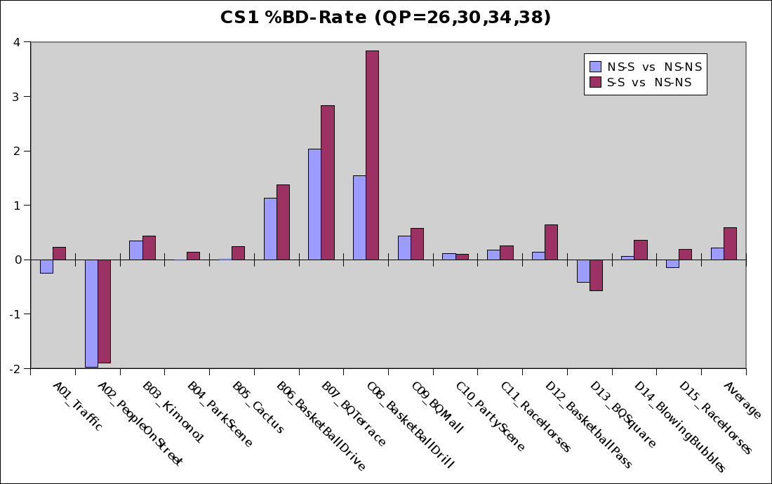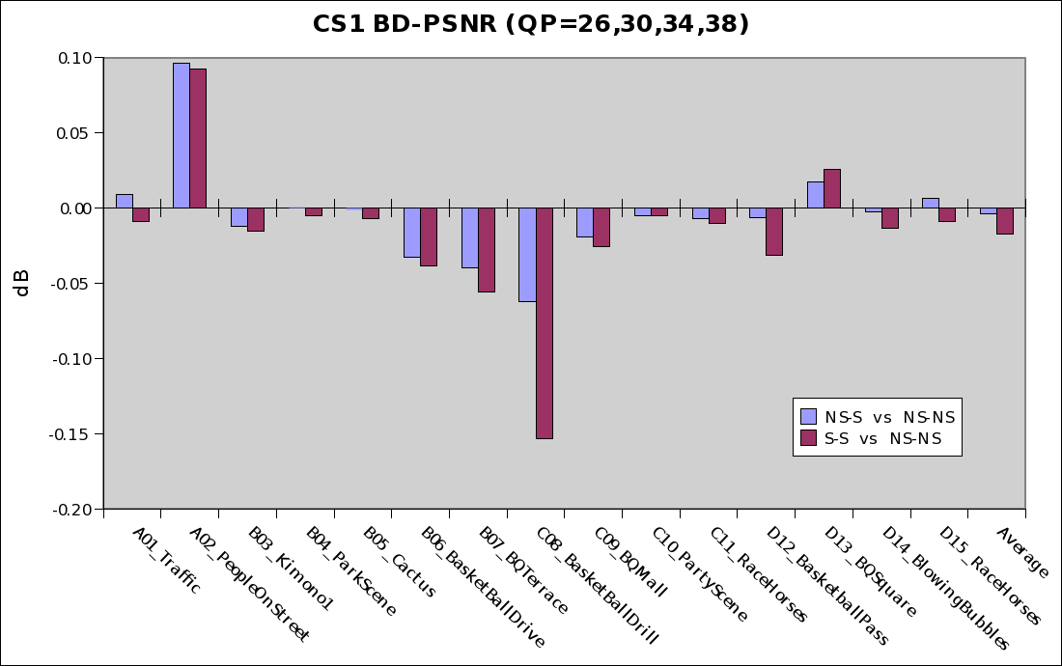
Figure 2: Percentage BD-R and BD-PSNR for CS1 test conditions.
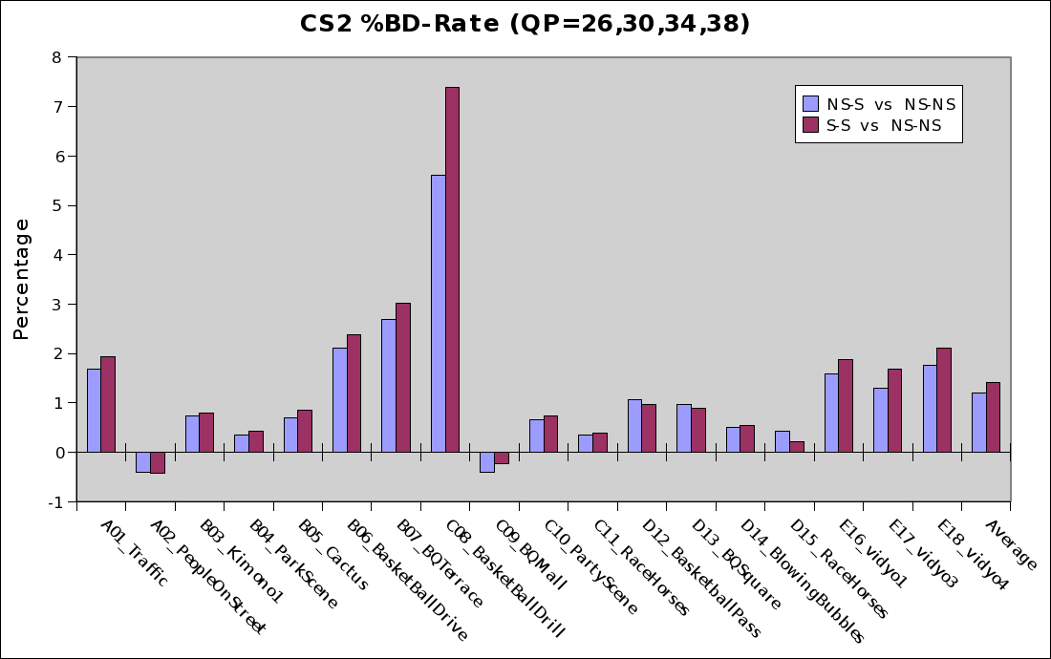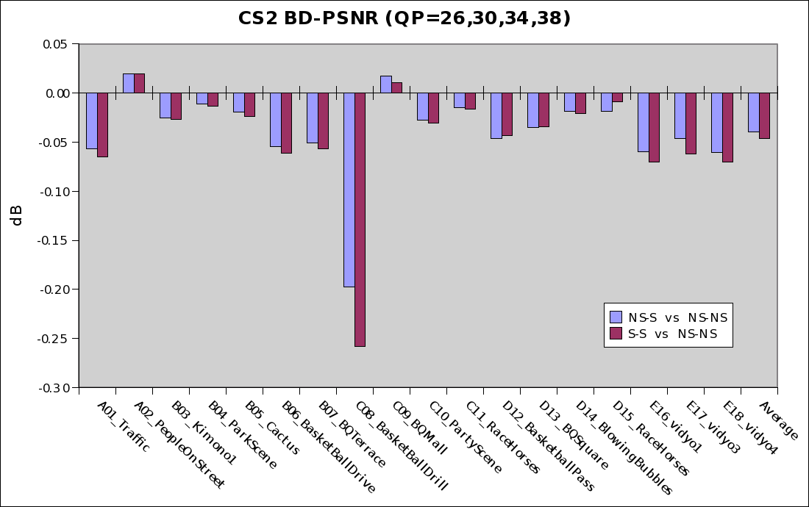
Figure 3: Percentage BD-R and BD-PSNR for CS2 test conditions.

Conclusion
Applying separable adaptive loop filter can result in reduction computation in the decoder with some loss in picture quality when compared with using non-separable filters. For CS1, the subjective quality appears to be better for (NS – S) than (S – S).
We proposed to perform a Tool Experiment to verify the performance and subjective quality of various combinations of non-separable and separable loop filters.

Reference
- T. Chujoh, N. Wada, G. Yasuda, “Quadtree-based adaptive loop filter,” ITU-T Q6/SG16, C181, January 2009.
- T Chujoh, N. Wada, T. Watanabe, G. Yasuda, T. Yamakage, “Specification and experimental results of Quadtree-based Adaptive Loop Filter,” ITU-T Q6/SG16 Doc VCEG-AK22, April 2009.

Patent rights declaration(s)
Sony Corporation may have IPR relating to the technology described in this contribution and, conditioned on reciprocity, is prepared to grant licenses under reasonable and non-discriminatory terms as necessary for implementation of the resulting ITU-T Recommendation | ISO/IEC International Standard (per box 2 of the ITU-T/ITU-R/ISO/IEC patent statement and licensing declaration form).

