    Joint Collaborative Team on Video Coding (JCT-VC)  of ITU-T SG16 WP3 and ISO/IEC JTC1/SC29/WG11  2nd Meeting: Geneva, Switzerland, 21-30 July, 2010 | Document: JCTVC-B096

Title: | Local intensity compensation for inter prediction in HEVC
Status: | Input Document to JCT-VC
Purpose: | Proposal
Authors: | Nikola Sprljan, Stavros Paschalakis, Ping Wu
Contact: | Nikola Sprljan  20 Frederick Sanger Road The Surrey Research Park Guildford Surrey GU2 7YD United Kingdom | Tel:  Email: | +44-1483885538  n.sprljan@uk.merce.mee.com
Source: | Mitsubishi Electric Research Centre Europe (MERCE)
_____________________________

Abstract
This contribution presents new results for the Macroblock Weighted Prediction (MBWP) method for improved video coding efficiency. The basic concept of the presented method is to derive weighted prediction parameters adaptively at the macroblock and the sub-macroblock partitions levels, as opposed to the H.264 video coding standard where the weighted prediction are derived and transmitted at the picture level. The test platform has been described in JCTVC-A107. In this contribution we also present a comparison with other similar tools presented during the 92nd MPEG meeting in response to the CfP for HEVC.

Overview
The responses to the CfP [4] for HEVC presented during the 92nd MPEG meeting featured the following tools that can be classified under “local intensity compensation” category:

- MBWP (Macroblock Weighted Prediction), JCTVC-A107 [3]
- IC (Intensity Compensation), JCTVC-A114 [5]
- Template-based IC (Illumination Compensation), JCTVC-A110 [6]
- Inter-frame DC offset (IDCO), JCTVC-A111 [7]

Methods from A110 and A111 use offset component (or DC difference) based on the template that contains already decoded pixels. This mainly addresses uniform illumination changes. This is extended in A107 and A114, where the weight component (or scale) is added. Offset combined with one or more weights, for one or multiple reference blocks, can model more complex pixel intensity changes, as in the example provided in Figure 1.

The first implementation of MBWP was presented in the 90th MPEG meeting [1], in which the performance evaluation had been carried out on the JM platform. In this contribution, we further improve the MBWP algorithm with extension to B pictures and test it within a more advanced video coding platform [3]. The codec [3] has participated in Call for Evidences and Call for Proposals activities in MPEG. Within the test platform we have maintained high performance by using tools adopted in most high-performing CfP submissions, e.g., large block size related processing, adaptive Wiener loop filtering (enhanced BALF), RDOQ, etc. The evidence from the 92nd MPEG meeting suggests that the video codecs employing these tools offer a significant gain compared to the current standard anchor streams [8].
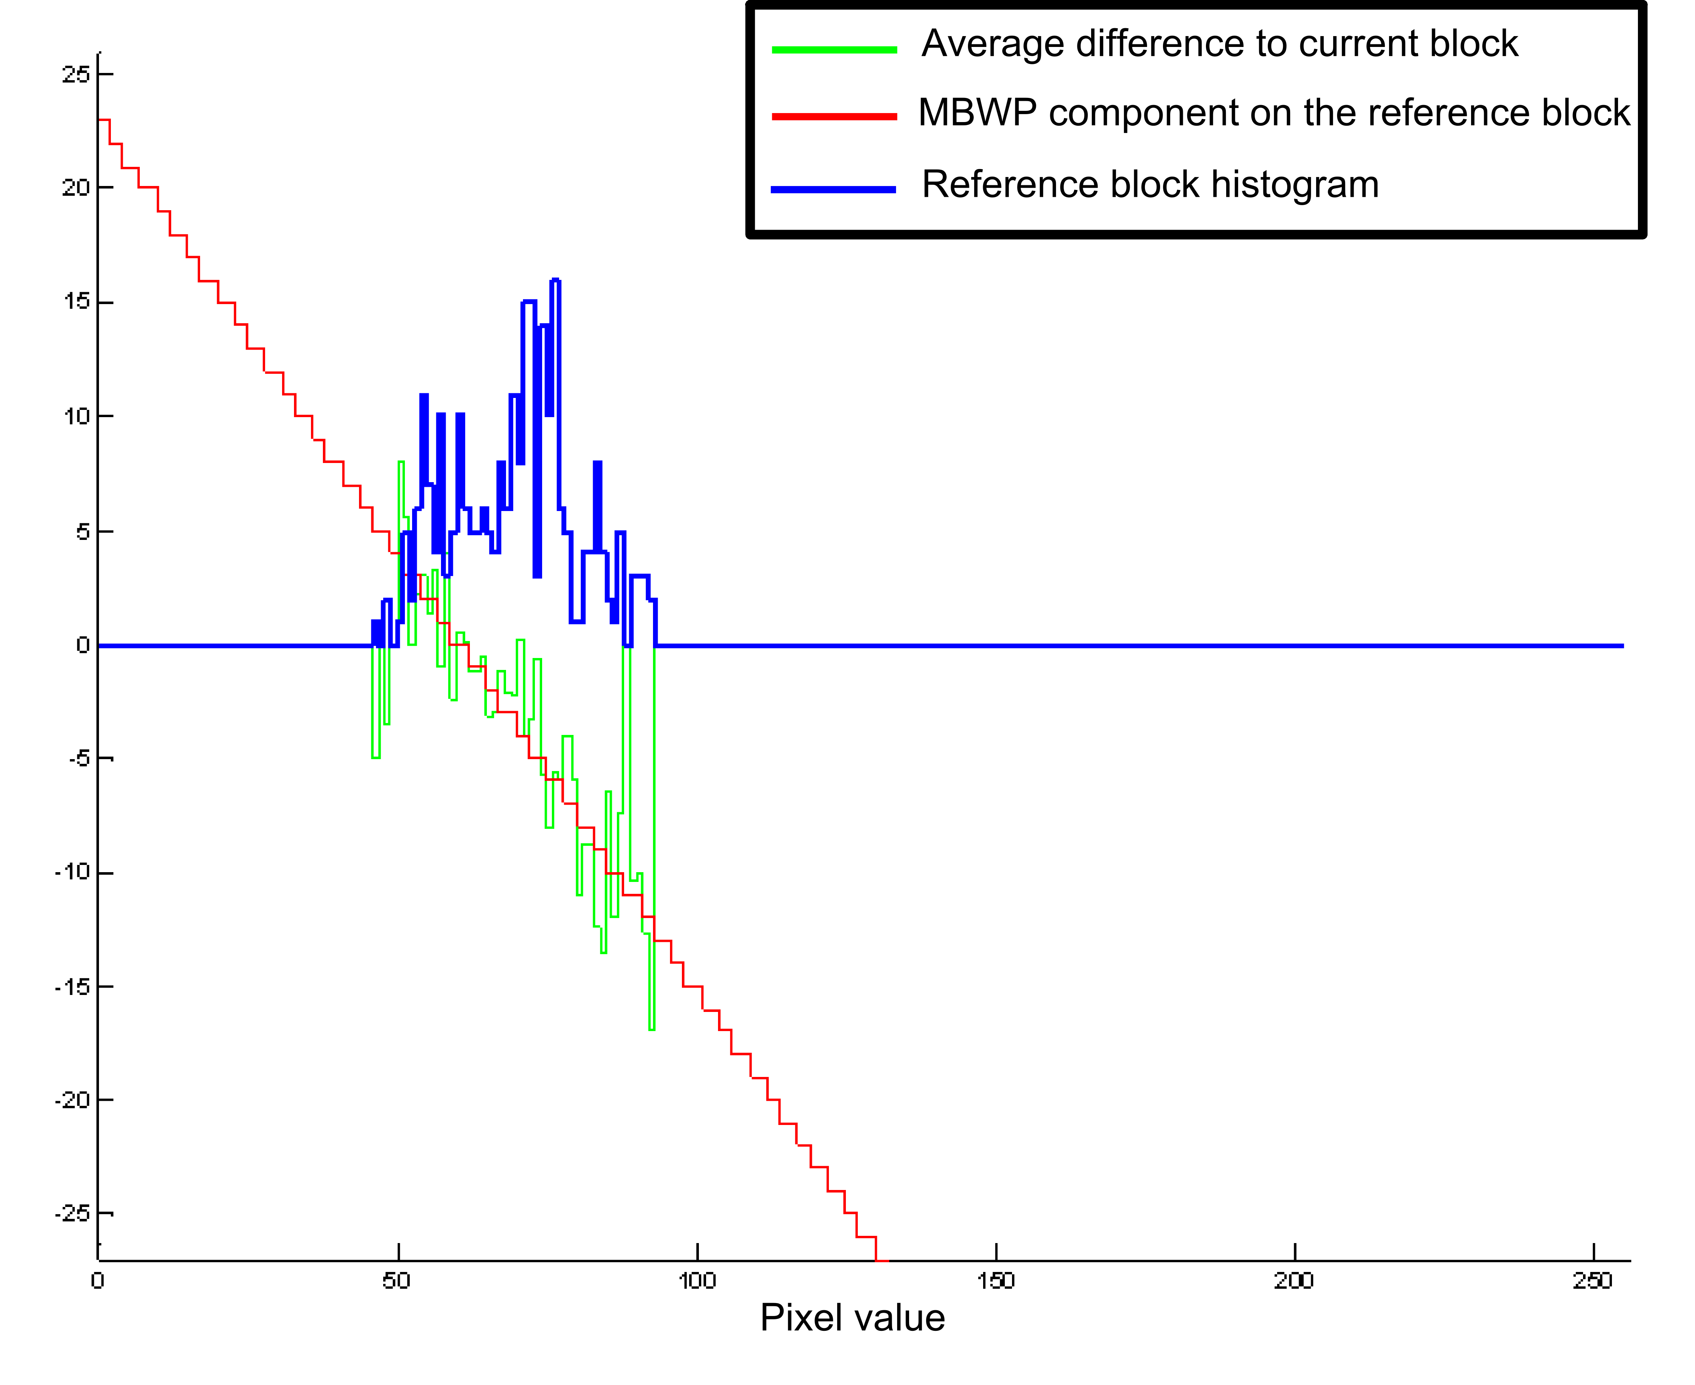
Figure 1: Example of pixel intensity change

MBWP

Only a brief summary is given here; more details on the method can be found in [1]. The basic concept of MBWP is that the operation of weighted prediction is defined at the local level, where for each block a different set of weighting parameters can be defined. The operation of weighted prediction (WP) can be represented with:

, (1)

where Bc_{n} is n-th reference block, o is offset and w_{n} is the weight associated with block Bc_{n}. The result of this operation, Bp, is used to predict the current block. The parameters are quantised and predicted from the already processed data, and sent alongside with the motion vector for the current block.

The search algorithm is briefly explained here. A list of visited motion vectors is maintained during the ME stage of the encoding, and for the best N motion vectors their optimal WP parameters are computed. When choosing the best N motion vectors, they are sorted by their rate constrained cost as used in the ME. Alternatively, any other cost based on appropriate distortion metric can be used. In the initial step of the search for WP parameters a set is found that minimises only the distortion part of the cost. Next, that parameter set is used as a seed for the search for the minimal rate constrained cost (here bidirectional representation is used):
(22)

Out of N motion vectors, only M are preserved for which the WP parameters are non-default, i.e. for which the offset is non-zero or weights non-unit. Here M can be equal to N, but in practice for a large number of motion vectors no weighting parameters can be found that lead to cost smaller than . Out of those M, only for the first P the real cost (based on real distortion and rate) is computed and compared with other modes in the mode selection stage of the encoder. Settings for N and P that we have used in the experiments are N=128 and P=4. Based on our experiments, these settings lead to approximately 30% of additional complexity at the encoder.

IC in A114

In terms of the weighting operation IC is similar to MBWP. On the other hand, the derivation of the parameters is quite different. In IC, values of both offset and weights are defined to be in a certain range and an exhaustive search is performed within the limits around the current candidate. In contrast, in MBWP the parameters are independently found for each MV and are constrained only by the rate cost and numerical properties of the processed signal. Note that what is referred to as “offset” and “weight” in MBWP, is referred to as “DC” and “scale” in the A114 software,. Another difference is the quantisation of weights, which is coarser in IC than in MBWP (1/64 as opposed to 1/128). In the initial stage of the algorithm, the offset is estimated between the matched blocks and then some combinations of weights are used to calculate the distortion. All these are kept as candidates for the later stages of the motion estimation, e.g. trellis stage. This implementation leads to approximately 50% of additional complexity at the encoder, as measured in our experiments. The main deficiencies of the approach seem to be the constrained range and lower precision, which lead to less flexibility in approximating the matched block. It is unclear whether the approach in A114 is reliant on the later trellis stage of the search for parameters, or a single initial pass would be sufficient for obtaining gain.

Test conditions
We have used 6 Class B (1920×1080) HEVC test sequences. The test is based on the constraint set 1 settings (hierarchical B structure with reference B and non reference B pictures). Table 1 lists the tested sequences and the total number of frames used in coding, where encoding starts from the first frame.

Table 1: Sequences and encoding parameters
Sequence | Total number of frames | QP1 | QP2 | QP3 | QP4
BasketballDrive | 96 | 37 | 34 | 31 | 28
BQTerrace | 128 | 34 | 32 | 30 | 28
Cactus | 96 | 36 | 33 | 30 | 27
Kimono (1st scene) | 48 | 34 | 31 | 27 | 24
Kimono (2nd scene) | 48 | 34 | 31 | 27 | 24
ParkScene | 48 | 36 | 33 | 30 | 27
Train | 128 | 34 | 31 | 27 | 24

Based on the some initial experiments, the quantization parameters for A114 have been derived from the above quantisation parameters by using the relation QP_{A114}=2.4*QP_{A107}. Other options were as in the configuration file encoder_improved_CS1.cfg from the A114 software.

Results

The results of MBWP and IC performance are given in Table 2. Although it is difficult to draw conclusions on the performance of different tools when comparing implementations in different codecs, some observations still can be made. Although the average gain is modest, there exist some variation in performance between different sequences, and for some there is clearly some benefit in applying local intensity compensation.

Table 2: Compression results, BD-rate
Sequence | MBWP (A107) | IC  (A114)
BasketballDrive | -0.53 % | -2.00 %
BQTerrace | -1.99 % | -1.70 %
Cactus | -0.45 % | -2.21 %
Kimono (1st scene) | -0.006 % | +1.01 %
Kimono (2nd scene) | -0.006 % | +0.21 %
ParkScene | +0.03 % | +0.24 %
Train | -1.45 % | -1.97 %
Average | -0.63 % | -0.92 %

For an easier interpretation of the results, the delta rate / rate plots for some typical results are used below in Figure 2. These plots have been created using the PSNR curve extrapolation macros from [9].

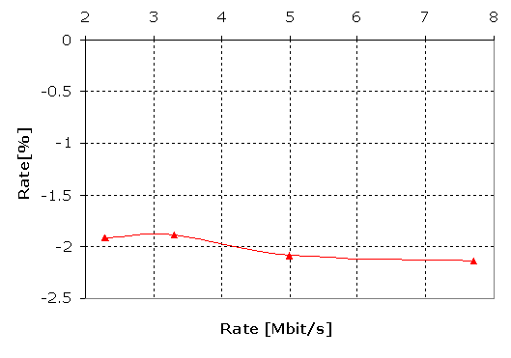 | 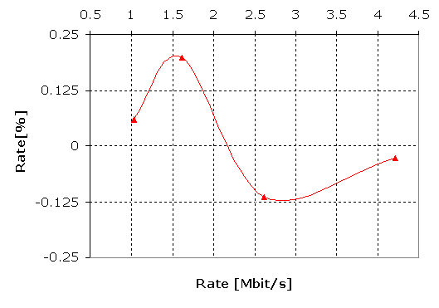
MBWP, BQTerrace | MBWP, ParkScene
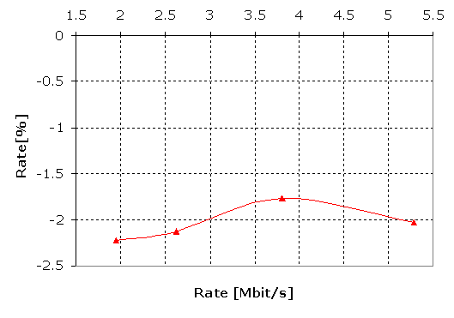 | 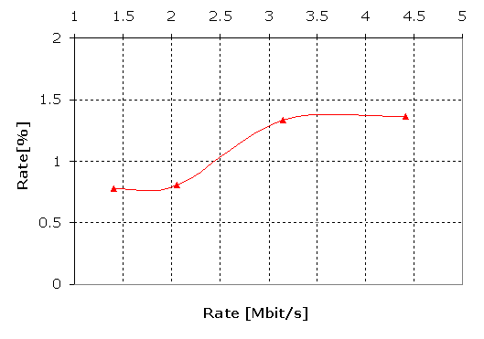
IC, BasketballDrive | IC, Kimono
Figure 2: Delta rate / rate plots for some sequences

Conclusion

From the presented results it can be observed that there is benefit in applying intensity compensation on particular sequences. Further investigation will reveal whether it offers gain in other software platforms, or sequences with specific local intensity change characteristics. Both the MBWP and the IC methods offer performance gains. Due to its reliance on a more conventional ME stage design of the encoder, MBWP may be a good option when considering integration into future HEVC Test Model software.

References

- N. Sprljan, L. Cieplinski, “Macroblock-level Weighted Prediction” (MPEG M16969), 26-30, October, 2009, Xian, P R of China.
- H.264/MPEG-4 part-10 AVC: ITU-T H.264 and ISO/IEC 14496-10
- Kazuo Sugimoto, Yusuke Itani, Yoshimi Isu, Norimichi Hiwasa, Shun-ichi Sekiguchi, Robert A. Cohen, Ping Wu, and Nikola Sprljan, JCTVC-A107, “Description of video coding technology proposal by Mitsubishi Electric”.
- ISO/IEC JTC1/SC29/WG11 and ITU-T Q6/16, "Joint Call For Proposals on Video Compression Technology", WG11 document N11113 and Q6/16 document VCEG-AM91, Kyoto, January 2010.
- I. Amonou, N. Cammas, G. Clare, J. Jung, L. Noblet, S. Pateux, S. Matsuo, S. Takamura, C.S. Boon, F. Bossen, A. Fujibayashi, S. Kanumuri, Y. Suzuki, J. Takiue, T.K. Tan, V. Drugeon, C.S. Lim, M. Narroschke, T. Nishi, H. Sasai, Y. Shibahara, K. Uchibayashi, T. Wedi, S. Wittmann, P. Bordes, C. Gomila, P. Guillotel, L. Guo, E. François, X. Lu, J. Sole, J. Vieron, Q. Xu, P. Yin, Y. Zheng, JCTVC-A114, " Description of video coding technology proposal by France Telecom, NTT, NTT DOCOMO, Panasonic and Technicolor ".
- ByeongMoon Jeon, SeungWook Park, JungSun Kim, and JoonYoung Park JCTVC-A110, “Description of video coding technology proposal by LG Electronics”.
- Haitao Yang, Jiali Fu, Sixin Lin, Jin Song, Dong Wang, Mingyuan Yang, Jiantong Zhou, Haoping Yu, Changcai Lai, Yongbin Lin, Lingzhi Liu, Jianhua Zheng, and Xiaozhen Zheng, JCTVC-A111, “Description of video coding technology proposal by Huawei Technologies & Hisilicon Technologies”.
- Vittorio Baroncini , Jens-Rainer Ohm, and Gary Sullivan, JCTVC-A204, “Report of Subjective Test Results of Responses to the Joint Call for Proposals (CfP) on Video Coding Technology for High Efficiency Video Coding (HEVC)”.
- Stéphane Pateux, Joel Jung, VCEG-AE07, “An excel add-in for computing Bjontegaard metric and its evolution”

Patent rights declaration(s)
Mitsubishi Electric Research Centre Europe (MERCE) may have IPR relating to the technology described in this contribution and, conditioned on reciprocity, is prepared to grant licenses under reasonable and non-discriminatory terms as necessary for implementation of the resulting ITU-T Recommendation | ISO/IEC International Standard (per box 2 of the ITU-T/ITU-R/ISO/IEC patent statement and licensing declaration form).

