    Joint Collaborative Team on Video Coding (JCT-VC)  of ITU-T SG16 WP3 and ISO/IEC JTC1/SC29/WG11  2nd Meeting: Geneva, CH, 21-28 July, 2010 | Document: JCTVC-B085

Title: | TE 3: Simplified Geometry Block Partitioning
Status: | Input
Purpose: | Information
Author(s) or  Contact(s): | Liwei Guo, Peng Yin, Edouard Francois  1, Av. Belle Fontaine - CS 17616  35576 Cesson-Sévigné Cedex, France | Tel:  Email: | edouard.francois@technicolor.com
Source: | Technicolor
_____________________________

Abstract
This contribution provides a simplification of Geometry Block Partitioning (GEO) scheme as described in JCTVC-A121. Specifically, Most Valuable Partitions are proposed to achieve the best tradeoff between the complexity and coding efficiency. Most Valuable Partitions are derived from a statistical analysis of the actual used GEO partitions. For defined test conditions in TE3, for IPPP coding case, simplified GEO mode gives an average 3.12% bitrate saving, up to 6.65%, which is very close to the performance of the initial reference GEO mode version, with a reduced complexity.

Introduction
The general concept of Geometry block partitioning (GEO mode) was proposed to VCEG as document VCEG-AF10 [1]. In addition to the classical horizontal and vertical motion partitions, GEO mode consists of another kind of motion partition. This motion partition divides the block into 2 regions. The boundary separating the 2 regions is defined by a straight line. One motion vector is sent for each region. The sequel describes how the various geometry partitions are created. The origin is assumed to be at the center of the block. Then, each geometry partition is defined by a line passing through the origin that is perpendicular to the line defining the partition boundary. This is shown in Figure 1. The geometry partition is defined by the angle subtended by the perpendicular line with the X axis (θ) and the distance of the partition line from the origin (ρ).
Figure 1: Parameters defining a geometry motion partition

In JCTVC-A121 [2], at each block size, 32 different values of θ are permitted (from 0 to 360° in steps of 11.25°, i.e., Δθ = 11.25°). The number of values ρ depends on the block size. For block size of 16×16, ρ can take 8 possible values (from 0 to 7 in steps of 1, i.e., Δρ = 1). For block sizes of 32×32 and 64×64, ρ can take 16 and 32 possible values, respectively. Thus for block sizes of 16×16, 32×32, and 64×64, there are 256, 512, and 1024 possible geometry partitions, respectively. The number of supported partitions is relatively big.
In this contribution, GEO mode simplifications are proposed. The proposed solution consists on identifying the Most Valuable Partitions (MVP) to reduce the number of supported partitions so the best tradeoff between the complexity and coding efficiency can be achieved.

Proposal
MVP is identified based on statistical analysis. Statistics show that different partitions have different contribution to the coding efficiency. It is assumed that the more frequently a partition is selected and statistically the more important it is to the coding efficiency. For distance, balanced partitions (small ρ) are more important. For angles, the horizontal, vertical and diagonal partitions only are considered.
- For GEO16, Δρ=2, ρ_{max}=6, Δθ=45, so in total, there are 26 modes.
- For GEO32, Δρ=4, ρ_{max}=12, Δθ=45, so in total, there are 26 modes.
- For GEO64, it was found out in general the contribution for 64x64 macroblock to coding efficiency is not high. So only AMP (Asymmetric Partitions proposed in JCTVC-A124 [3]) are enabled for GEO64, which are 64x16, 64x48, 16x64 and 48x64 partitions.
The advantage of this proposal is that the number of supported partitions is highly reduced. In addition, since only horizontal, vertical and diagonal partitions are supported, the masks are very simple. A big memory is not needed to store all masks.

Simulation Results
The test conditions defined in TE3 [4] are followed. The simulation is done using JCTVC-A121 software (r1 version). Tests were done on the mandatory case for IPPP only. For the encoder, fast mode decision was used as done in [2]. The only change is that for GEO32, the same fast mode decision as GEO16 is used. For GEO64, AMP modes are simply tested.
The following tools are turned on in JCTVC-A121 software (including large block size):
- $MDDT=1;
- $MVC=1;
- $HPF=4; (SIFO case)
- $QALF=1;
- $MVResolution=1;
QP of 22, 27, 32, and 37 are tested. All the other settings are set the same as the configuration file provided in JCTVC-A121.
Table 1 and Figure 2 show the simulation results with the proposed ‘simplified GEO’ scheme compared to without GEO case.

Table 1 Average Bitrate saving for IPPP coding relative to Qualcomm’s software (r1 version) without GEO

 |  | Bitrate Saving
B | S03-Kimono | 0.74%
B | S04-ParkScene | 3.06%
B | S05-Cactus | 3.12%
B | S06-BasketballDrive | 1.72%
B | S07-BQTerrace | 2.66%
C | S08-BasketballDrill | 3.46%
C | S09-BQMall | 4.20%
C | S10-PartyScene | 2.17%
C | S11-RaceHorses | 2.98%
D | S12-BasketballPass | 2.99%
D | S13-BQSquare | 2.60%
D | S14-BlowingBubbles | 3.65%
D | S15-RaceHorses | 3.51%
E | S16-Vidyo1 | 3.34%
E | S17-Vidyo3 | 6.65%
E | S18-Vidyo4 | 3.01%
AVERAGE | AVERAGE | 3.12%

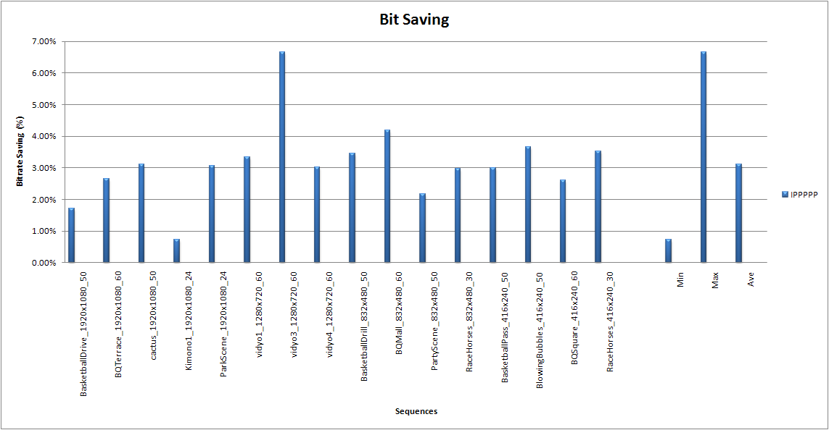
Figure 2 Average Bitrate Saving for IPPP coding relative to JCTVC-A121 software (r1 version) without GEO

For the reference, Table 2 and Figure 3 show the simulation results with JCTVC-A121 GEO scheme compared to without GEO case. It should be noted in the software the fast mode decision is used for GEO. If full GEO modes are tested, the gain should be much higher.

Table 2 Average Bitrate saving for JCTVC-A121 software (r1), GEO on vs off, IPPP coding

 |  | Bitrate Saving
B | S03-Kimono | 0.84%
B | S04-ParkScene | 2.95%
B | S05-Cactus | 2.76%
B | S06-BasketballDrive | 1.36%
B | S07-BQTerrace | 1.48%
C | S08-BasketballDrill | 4.32%
C | S09-BQMall | 5.02%
C | S10-PartyScene | 2.21%
C | S11-RaceHorses | 3.92%
D | S12-BasketballPass | 3.24%
D | S13-BQSquare | 1.68%
D | S14-BlowingBubbles | 3.65%
D | S15-RaceHorses | 4.83%
E | S16-Vidyo1 | 3.41%
E | S17-Vidyo3 | 6.59%
E | S18-Vidyo4 | 3.33%
AVERAGE | AVERAGE | 3.22%

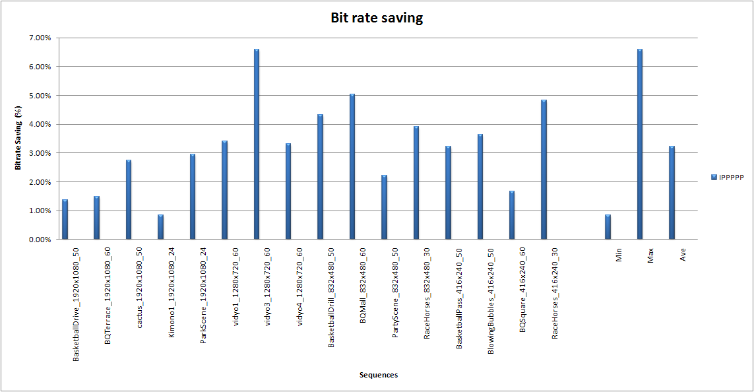
Figure 3 Average bitrate saving for Qualcomm’s software (r1), GEO on vs off, IPPP coding

Complexity wise, the speed of the encoder is in the same range of JCTVC-A121 software. For decoder, there is almost no difference.

Conclusion
GEO shows promising gain even with a big reduction of the partitions, average 3.12% bitrate saving in IPPP coding case. The simplifications proposed in this contribution bring very similar performance as the reference version considered for TE3 of the JCTVC. It is therefore proposed to continue the core experiment using the Test Model software.

Reference
- O. Divorra, P. Yin and C. Gomila, “Geometry-Adaptive Block Partitioning”, ITU-TQ.6/SG16 VCEG, VCEG-AF10, April 2007.
- M.Karczewicz, P.Chen, R.Joshi, X.Wang, W-J.Chien, R.Panchal, “Video coding technology proposal by Qualcomm Inc”, JCTVC-A121, Dresden, Germany, April 2010.
- Ken McCann, Woo-Jin Han and Il-Koo Kim, “Samsung’s Response to the Call for Proposals on Video Compression Technology,” JCTVC-A124, Dresden, Germany, April 2010.
- JCTVC-A303, “Tool Experiment 3: Inter Prediction in HEVC”, Dresden, DE, April, 2010

Patent rights declaration(s)
(NOTE – Activities in the JCT-VC and contributions to the JCT-VC are subject to the common patent policy for ITU-T/ITU-R/ISO/IEC. A statement of that policy can be found at
http://www.itu.int/ITU-T/dbase/patent/patent-policy.html, with further information available at http://www.itu.int/ITU-T/ipr/index.html and in the ISO/IEC Directives. The form to be used for the formal reporting of patent rights to ITU-T/ITU-R/ISO/IEC can be found at http://www.itu.int/ITU-T/ipr/index.html. Contributions to the JCT-VC proposing normative technical content shall contain a non-binding informal notice of whether the submitter may have patent rights that would be necessary for implementation of the resulting standard. The provided informal notice shall indicate the category of anticipated licensing terms according to the ITU-T/ITU-R/ISO/IEC patent statement and licensing declaration form. This obligation to provide an informal notice is supplemental to, and does not replace, any existing obligations of parties with technology included in a final or draft standard to submit formal IPR declarations to ITU-T/ITU-R/ISO/IEC. An example of an informal IPR notification statement for a contribution is provided below.)

Technicolor may have IPR relating to the technology described in this contribution and, conditioned on reciprocity, is prepared to grant licenses under reasonable and non-discriminatory terms as necessary for implementation of the resulting ITU-T Recommendation | ISO/IEC International Standard (per box 2 of the ITU-T/ITU-R/ISO/IEC patent statement and licensing declaration form).

