    Joint Collaborative Team on Video Coding (JCT-VC)  of ITU-T SG16 WP3 and ISO/IEC JTC1/SC29/WG11  2nd Meeting: Geneva, CH, 21-28 July, 2010 | Document: JCTVC-B082

Title: | Proposal of Non-Square Coding Unit Structure
Status: | Input Document to JCT-VC
Purpose: | Proposal
Author(s) or  Contact(s): | Peng Wang and Kazushi Sato  W12F 1-11-1Osaki  Shinagawa, Tokyo  141-0032, Japan | Tel:  Email: | +81 3 5435 3308  Kazushi.Sato@jp.sony.com
Source: | Sony Corp.
_____________________________

Abstract

AVC standard employs the concept of macroblock that consists of 16x16 luma pixels and 8x8 chroma poxels, and most proposals of the response to CfP employs extended macroblock size like 64x64 or 32x32, which is one of the key tools of coding efficiency improvement.
However increasing of macroblock size has two problems in terms of implementation. First, it causes increase in buffer to store pixels in the neighboring macroblocks for intra prediction or deblocking filter. Second, order of processing for each of 16x16 blocks differs with HEVC from MPEG-2 or AVC if larger CTB than 16x16 is employed. This would become a bottleneck in developing multi-codec LSI.
Therefore we propose Non-square CTB scheme like 32x16 or 64x32, which provides a trade-off solution between coding efficiency and complexity or interoperability with existing codec.
Our simulation result shows that compared with average gain obtained with 32x32, the average gain obtained with 32x16 is 91.4% for IPPP with lower QPs, 79.1% for IPPP with higher QPs, 83.1% for HierB with lower QPs, and 64.5% for HierB with higher QPs.
Non-Square LMB provides a good trade-off between coding efficiency and implementation cost or interoperability. We propose this topic be included in the discussion of AhG on Large block structures.

Introduction

AVC standard employs the concept of macroblock that consists of 16x16 luma pixels and 8x8 chroma pixels.
In the document [1] and [2], the concept of extended macroblock size has been proposed both for intra and inter coding. The later one can greatly reduce motion information at stationary areas or at areas with uniform motion, and contributes to the coding efficiency improvement especially with larger images. It is implemented in KTA [3] and one of the key technologies for most responses to HEVC CfP employs this scheme.
TMuC [4] employs the concept of CTB (Coding Tree Block), which is similar to the concept of macroblock already specified in the current video coding standard like MPEG-2 or AVC but the size is not restricted to 16x16.
Enlarging macroblock has two problems for implementation: first, it causes increase in buffer to store pixels in the neighboring macroblock for intra prediction or deblocking filter. Second, scan order of processing for each of 16x16 blocks differs with HEVC if larger CTB than 16x16 is employed. This would be a bottleneck in developing multi-codec LSI, which can encode or decode HEVC as well as other codecs like MPEG-2 or AVC.

Coding Unit Structure in TMuC

In TMuC [4] Coding Unit (Coding Tree Block; CTB) is defined as shown in Fig 2.1.
CTB is a basic unit which has a square shape. Although it has a similar role to the macroblock and sub-macroblock in AVC, the main difference lies in the fact that CTB can have various sizes. Two special terms are defined: the largest coding unit (LCTB) and the smallest coding unit (SCTB). For convenient implementation, LCTB size and SCTB size are limited to values which are a power of 2 and which are greater than or equal to 8.
A picture consists of non-overlapped LCTBs. Since the CTB is restricted to be a square shape, the CTB structure within a LCTB can be expressed in a recursive tree representation adapted to the picture. That is, CTB is characterized by LCTB size and the hierarchical depth in the LCTB that the CTB belongs to.

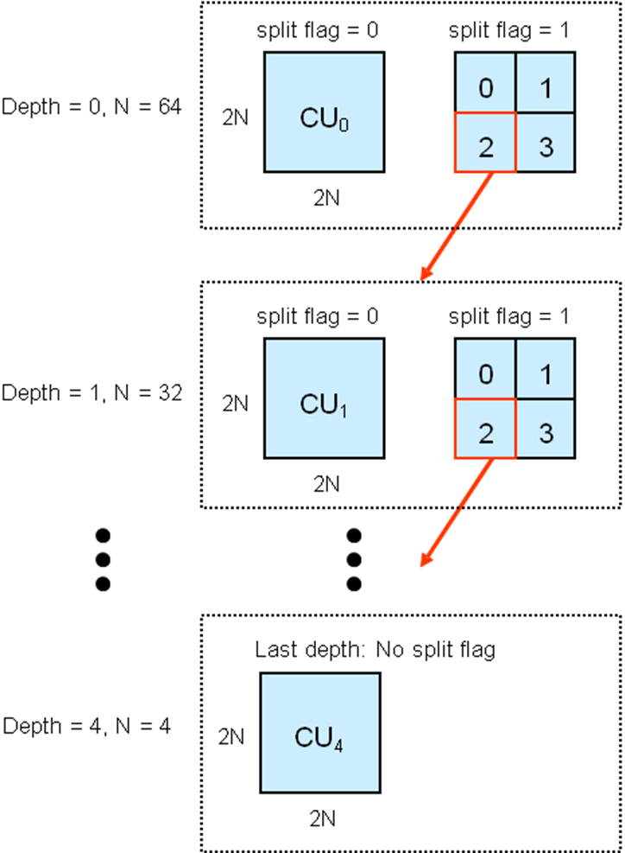

Fig 2.1

Considering implementation, enlarging the size of the macroblock has two problems as follows:

- For intra prediction or deblocking filter, buffer is necessary to store decoded pixels of the neighboring CTB, and larger CTB requires larger buffer.

- With larger CTB than 16x16, scan order of each 16x16 differs from the existing codec like MPEG-2 or AVC. With existing codec like MPEG-2 or AVC, scan order of each 16x16 block is shown in Fig 2.2(a). If CTB with 32x32 is employed, it becomes as shown in Fig 2.2(b). This would be bottleneck for implementing multi-codec LSI.

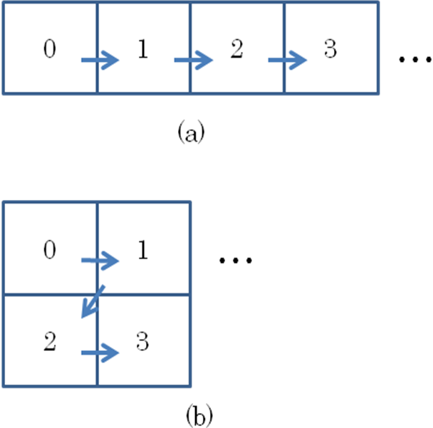

Fig 2.2

Proposed Method

We propose 2 scenarios to introduce Non-Square CTB into TMuC structure. Syntax modification is rather simple with each of the scenario. For each scenario, information called “non_square_ctb_flag” will be added in the sequence parameter set RBSP syntax, which indicates if Non-Square CTB is applied for the current sequence.
If the value of non_square_ctb_flag is 1, one additional information will be inserted with each of the scenario as follows. It is possible that the solution can be mixture of scenario -1 and -2.
Both of the scenarios can be applied for intra- and inter-coding.

Scenario -1

This is the case that only the top layer is non-square.
In the sequence parameter set RBSP syntax one additional information “highest_layer_aspect_ratio” will be contained as follows.

Table 3.1
…
log2_min_coding_unit_size_minus3 | 0 | ue(v)
max_coding_unit_hierarchy_depth | 0 | ue(v)
non_square_ctb_flag | 0 | ue(v)
if(non_square_ctb_flag)
highest_layer_aspect_ratio | 0 | ue(v)
…

Semantics of the highest_layer_aspect_ratio is as follows:

Table 3.2

value | Aspect ratio
0 | 2:1
1 | 4:1
…

The following is the example of scenario -1.
In this example highest_layer_aspect_ratio = 1 (4:1) .

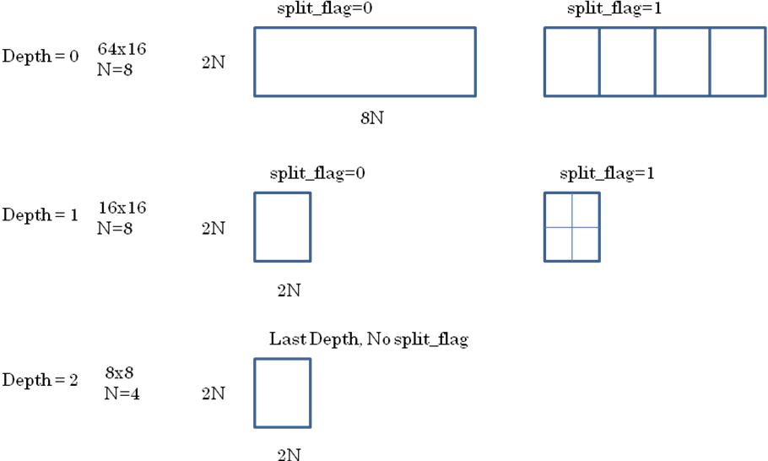

Fig 3.1

Scenario -2

This is the case that the ratio of non-square CTB is fixed to 2:1 but the boundary between non-square and square CTB is flexible.
In the sequence parameter set RBSP syntax one additional information “lowest_non_square_layer_depth” will be contained as follows.

Table 3.3
…
log2_min_coding_unit_size_minus3 | 0 | ue(v)
max_coding_unit_hierarchy_depth | 0 | ue(v)
non_square_ctb_flag | 0 | ue(v)
if(non_square_ctb_flag)
lowest_non_square_layer_depth | 0 | ue(v)
…

In the following example, the value of “lowest_non_square_layer_depth” is set as 1.

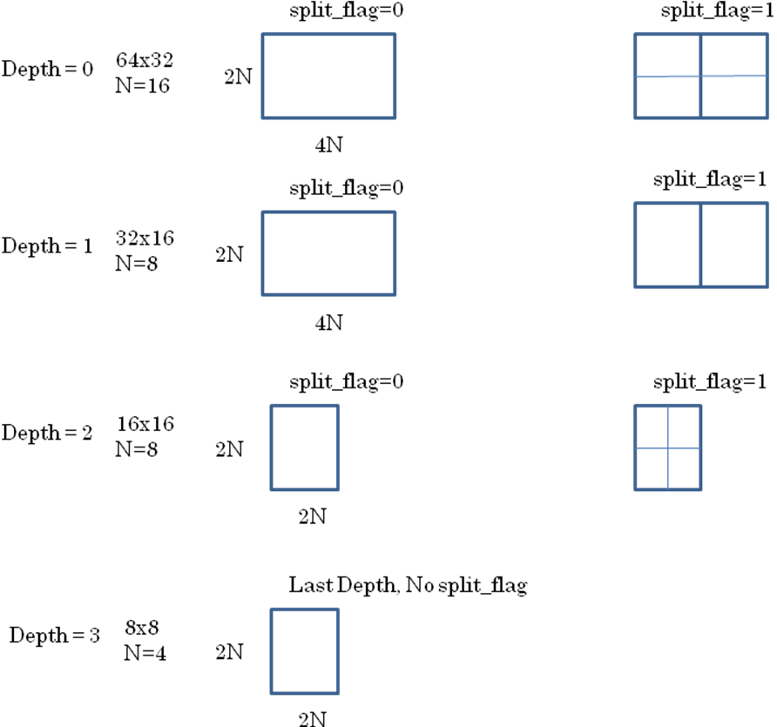

Fig 3.2

Simulation

Simulation Condition

In Table 4.1.1 simulation condition is shown. Basic setting complies with inter prediction TE condition and additionally ClassE sequences have been tested.

Table 4.1.1
Codec | KTA2.6r1 + NSLMB implementation  - LMB 16x16  - LMB 32x16 [proposed method]  - LMB 32x32  JM17.1 [anchor]
Sequences | ClassB:  BQTerrace, BasketballDrive, Cactus, Kimono, ParkScene  ClassC:  BQMall, BasketballDrill, ParkScene, RaceHorses  ClassD:  BQSquare, BasketballPass, BlowingBubbles, PartyScene  ClassE:  Vidyo_1, Vidyo_3, Vidyo_4
FramesToBeEncoded | 100
GOP | - IPPP  - HierB
QP | QPI=22,27,32,37,42,47  QPP=QPI+1  QPB=QPI+2
AdaptiveRounding | 0
UseAdaptiveFilter | 0
MVCompetition | 0
UseIntraMDDT | 1
UseHPFilter | 0
UseAdaptiveLoopFilter | 1
UseRDO_Q | 0

As of the PU (Prediction Unit) in the Non-Square layer the following modes are used in the simulation.

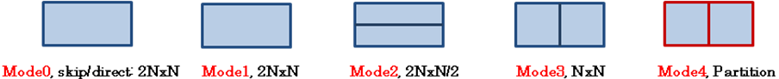
[N=16]
Fig 4.1.1

In Table 4.1.2 the possible transform sizes for each PU are shown. It is similar to the one with 32x32 LMB in KTA2.6r1.

Table 4.1.2
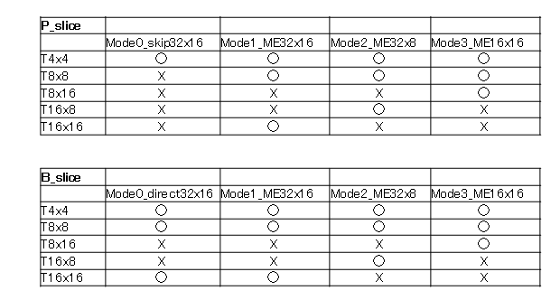

Simulation Result

In Table 4.2.1, Fig 4.2.1, Table 4.2.2, Fig 4.2.2, Table 4.2.3, Fig 4.2.3, Table 4.2.4, and Fig 4.2.4, simulation results with each test condition are shown.
Compared with average gain obtained with 32x32, the average gain obtained with 32x16 is 91.4% for IPPP with lower QPs, 79.1% for IPPP with higher QPs, 83.1% for HierB with lower QPs, and 64.5% for HierB with higher QPs.It is interesting that although the size of 32x16 is half of 32x32, gain obtained with 32x16 is closer to 32x32 rather than 16x16.
Gain also depends on what kinds of PUs are implemented. It is possible to employ asymmetric motion partition as proposed in [6] or geometry motion partition proposed in [7].

Table 4.2.1: IPPP; QP=22 to 37

BDRATE | LMB16x16 | NSLMB32x16 | LMB32x32
bqterrace | -19.811 | -24.629 | -26.620
cactus | -8.004 | -13.845 | -15.244
parkscene | -7.625 | -12.397 | -14.363
basketballB | -13.809 | -23.379 | -25.598
kimono1 | -14.477 | -29.526 | -32.828
bqmall | -8.709 | -11.622 | -12.478
basketballC | -15.257 | -20.665 | -21.493
partyscene | -6.369 | -8.604 | -9.366
racehorses | -3.964 | -6.798 | -7.293
bqsquare | -9.590 | -10.308 | -11.233
basketballD | -7.839 | -11.047 | -11.482
bubbles | -5.199 | -7.640 | -7.961
racehorses | -2.934 | -4.795 | -5.060
vidyo1 | -21.855 | -27.480 | -31.299
vidyo3 | -18.258 | -19.299 | -21.151
vidyo4 | -16.440 | -23.916 | -26.700
AVE | -11.259 | -15.997 | -17.511

Gain (32x16) / Gain(32x32) = 0.914

Table 4.2.2: IPPP; QP=32 to 37

BDRATE | LMB16x16 | NSLMB32x16 | LMB32x32
bqterrace | -33.325 | -48.643 | -54.484
cactus | -8.932 | -16.953 | -22.014
parkscene | -9.105 | -22.178 | -29.847
basketballB | -11.572 | -23.936 | -30.564
kimono1 | -10.295 | -26.932 | -35.885
bqmall | -10.432 | -13.843 | -17.793
basketballC | -13.816 | -19.925 | -22.785
partyscene | -9.812 | -15.856 | -19.162
racehorses | -4.938 | -11.173 | -14.419
bqsquare | -13.450 | -19.272 | -23.889
basketballD | -6.587 | -11.044 | -13.694
bubbles | -6.728 | -13.072 | -16.937
racehorses | -3.944 | -8.712 | -11.077
vidyo1 | -11.623 | -22.756 | -32.277
vidyo3 | -15.893 | -19.820 | -25.820
vidyo4 | -9.436 | -23.423 | -30.910
AVE | -11.243 | -19.846 | -25.097

Gain (32x16) / Gain(32x32) = 0.791

Table 4.2.3: HierB: QP=22 to 37

BDRATE | LMB16x16 | NSLMB32x16 | LMB32x32
bqterrace | -16.270 | -23.372 | -26.304
cactus | -6.342 | -12.175 | -15.050
parkscene | -6.242 | -11.410 | -15.030
basketballB | -10.025 | -18.769 | -24.127
kimono1 | -11.307 | -20.726 | -27.177
bqmall | -8.605 | -11.070 | -13.293
basketballC | -10.857 | -16.008 | -18.397
partyscene | -11.745 | -14.006 | -14.952
racehorses | -5.944 | -8.509 | -10.375
bqsquare | -19.164 | -20.850 | -21.535
basketballD | -7.107 | -9.214 | -10.854
bubbles | -6.061 | -9.270 | -10.815
racehorses | -5.906 | -7.073 | -8.473
vidyo1 | -11.323 | -16.532 | -20.618
vidyo3 | -11.389 | -15.900 | -19.901
vidyo4 | -7.699 | -16.596 | -21.798
AVE | -9.749 | -14.467 | -17.419

Gain (32x16) / Gain(32x32) = 0.831

Table 4.2.4 HierB: QP=32 to 47

BDRATE | LMB16x16 | NSLMB32x16 | LMB32x32
bqterrace | -8.689 | -23.230 | -31.585
cactus | -1.814 | -10.890 | -17.899
parkscene | -4.742 | -13.882 | -22.504
basketballB | -2.591 | -16.846 | -28.060
kimono1 | -6.323 | -19.980 | -33.155
bqmall | -2.946 | -8.540 | -15.571
basketballC | -0.375 | -9.551 | -15.541
partyscene | -4.294 | -10.122 | -13.214
racehorses | -2.876 | -10.850 | -18.905
bqsquare | -7.432 | -11.411 | -13.987
basketballD | -2.117 | -6.597 | -11.478
bubbles | -0.583 | -7.399 | -10.890
racehorses | -1.504 | -7.142 | -12.867
vidyo1 | -5.273 | -12.428 | -19.055
vidyo3 | -8.405 | -13.819 | -20.488
vidyo4 | -5.296 | -16.925 | -24.363
AVE | -4.079 | -12.476 | -19.348

Gain (32x16) / Gain(32x32) = 0.645

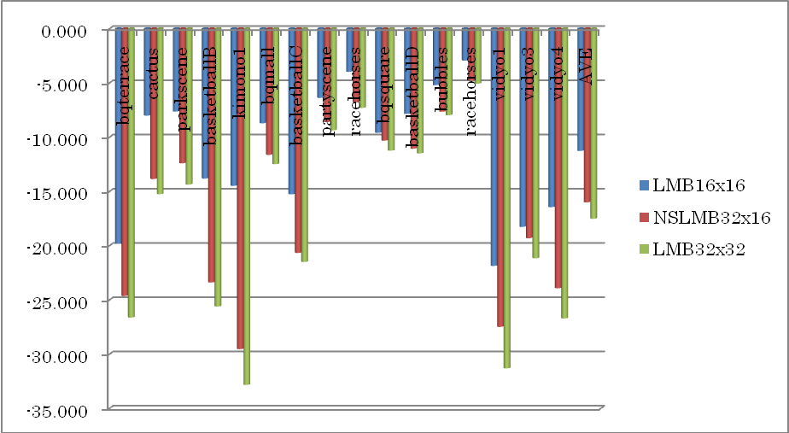

Fig 4.2.1 IPPP; QP=22 to 37

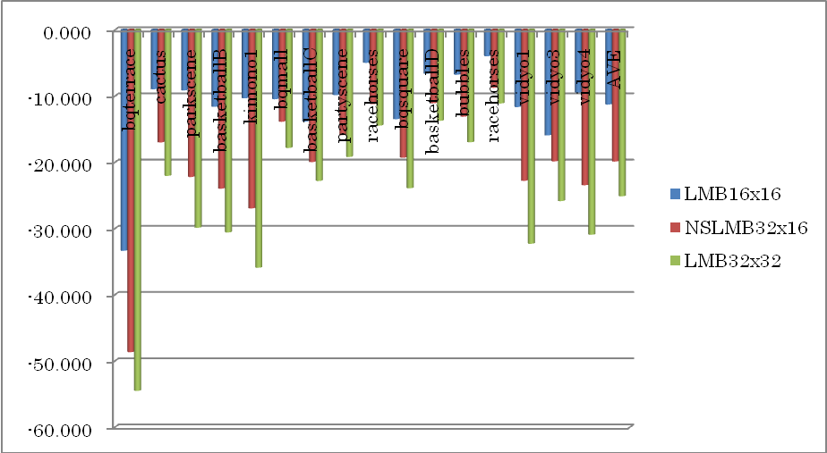

Fig 4.2.2 IPPP; QP=32 to 47

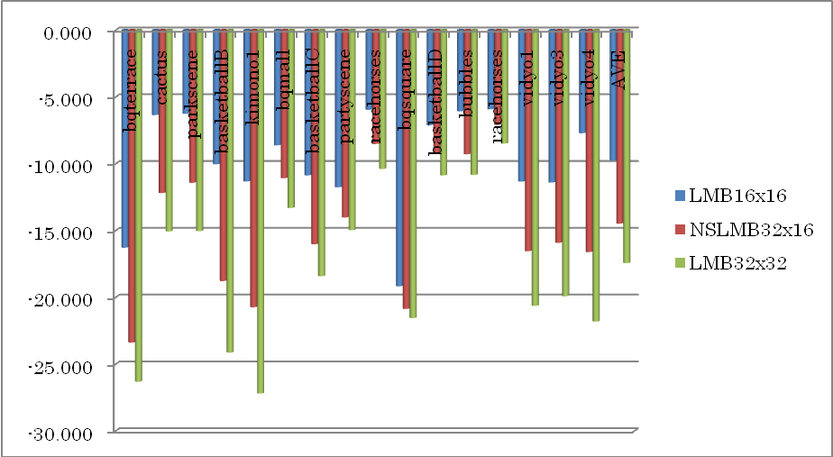

Fig 4.2.3 HierB; QP=22 to 37

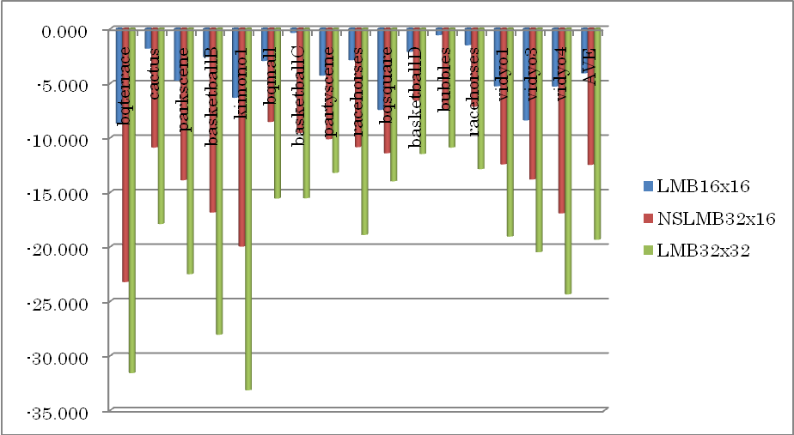

Fig 4.2.3 IPPP; QP=32 to 47

Conclusion

In this document we propose the concept of Non-Square CTB, which provides a trade-off solution between coding efficiency and implementation cost or interoperability with existing codec like MPEG-2 or AVC.
Our simulation result shows that compared with average gain obtained with 32x32, the average gain obtained with 32x16 is 91.4% for IPPP with lower QPs, 79.1% for IPPP with higher QPs, 83.1% for HierB with lower QPs, and 64.5% for HierB with higher QPs.
Non-Square LMB provides a good trade-off between coding efficiency and implementation cost or interoperability. We propose this topic be included in the discussion of AhG on Large block structures.

References
[1] “Intra coding using extend macroblock”, VCEG-AL28, Jul 2009
[2] “Video Coding Using Extended Macroblock”, Study Group 16 – Contribution 123, Jan 2009
[3] “Key Technology Area Software”, http://iphome.hhi.de/suehring/tml/
[4] “Test Model under Consideration (TMuC)”, JCTVC-A205, Apr, 2010
[5] “Joint call for proposals on video compression technology,” ISO/IEC MPEG 91st meeting, N11113, Apr. 2010
[6]”Samsung and BBC response to Call for Proposals on Video Compression Technology”, JCTVC-A124, Apr 2010
[7] “Video coding technology proposal by Qualcomm Inc.”, JCTVC-A121, Apr 2010

Patent rights declaration(s)

Sony Corporation may have IPR relating to the technology described in this contribution and, conditioned on reciprocity, is prepared to grant licenses under reasonable and non-discriminatory terms as necessary for implementation of the resulting ITU-T Recommendation | ISO/IEC International Standard (per box 2 of the ITU-T/ITU-R/ISO/IEC patent statement and licensing declaration form).

