    Joint Collaborative Team on Video Coding (JCT-VC)  of ITU-T SG16 WP3 and ISO/IEC JTC1/SC29/WG11  2nd Meeting: Geneva, CH, 21-28 July, 2010 | Document: JCTVC-B081

Title: | On Motion Vector Coding
Status: | Input Document to JCT-VC
Purpose: | Proposal
Author(s) or  Contact(s): | Kazushi Sato  W12F 1-11-1Osaki  Shinagawa, Tokyo  141-0032, Japan | Tel:  Email: | +81 3 5435 3308  Kazushi.Sato@jp.sony.com
Source: | Sony Corp.
_____________________________

Abstract

Motion vector coding is one of the key issues for improvement in visual quality as well as coding efficiency.
Motion vector competition scheme was proposed at VCEG [1] and has been implemented into the KTA software. Most responses to the HEVC CfP employ this scheme.
For further improvement we propose dynamic code number assignment for motion vector predictors. The proposed method also improves subjective quality between the moving object and still background in camera-fixed-type sequences.
This proposal is part of Sony’s response to HEVC CfP [8].

Introduction

Motion vector coding is one of the key issues for improvement in visual quality as well as coding efficiency.
Other than the temporal direct mode, AVC employs median prediction. For further improvement of coding efficiency motion vector competition scheme was proposed in [1] and has been implemented in KTA [2]. Most proposals on responses to HEVC CfP in April applied this motion vector competition scheme.

Background

Median Prediction in AVC

AVC employs median prediction as follows.
In Fig 2.1.1, “E” is a current motion partition and “A”, “B”, “C”, and “D” are surrounding partitions of “E”.
Motion vector data of “E” mvd_{E} in the bitstream is calculated as

mvd_{E} = mv_{E} – pmv_{E}

where mv_{E} and pmv_{E} are the motion vector and motion vectore predictor of “E”. pmv_{E} is calculated as

pmv_{E} = median (mv_{A}, mv_{B}, mv_{C})

where mv_{A}, mv_{B}, and mv_{C} are the motion vector of “A”, “B” and “C” respectively. If “C” is not available, motion vector of D mv_{D} is used instead.

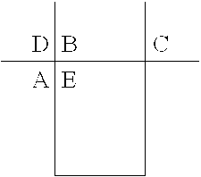

Fig2.1.1

Motion Vector Competition

In [1] the “Motion Vector Competition” scheme has been proposed as follows:
Unlike AVC, this scheme allows a set of multiple motion vector predictors P.
P can consist of motion vectors of surrounding partitions mv_{a}, mv_{b}, mv_{c} and mv_{d} as well as mv_{H.264}, that is a median of the motion vectors of surrounding partitions as described in 2.1, and the motion vector of the co-located block mvcol, as shown in Fig 2.2.1.
In addition, the following temporal predictors mv_{tm5} and mv_{tm9}, and the spatio-temporal predictor mv_{spt} can be candidate.

Temporal predictors:
$${\text{mv}}_{\text{tm}5}=\text{median}\left\{{\text{mv}}_{\text{col}},{\text{mv}}_{t0},\text{.}\text{.}\text{.},{\text{mv}}_{t3}\right\}$$
$${\text{mv}}_{\text{tm}9}=\text{median}\left\{{\text{mv}}_{\text{col}},{\text{mv}}_{t0},\text{.}\text{.}\text{.},{\text{mv}}_{t8}\right\}$$

Spatio-temporal predictor:
$${\text{mv}}_{\text{spt}}=\text{median}\left\{{\text{mv}}_{\text{col}},{\text{mv}}_{\text{col}},{\text{mv}}_{a},{\text{mv}}_{b},{\text{mv}}_{c}\right\}$$

At the encoder which predictor to be used is determined based on RD-based mode decision. A flag is transmitted to indicate the predictor for each of the motion partition.
This scheme is also applied for skip macroblocks.

Fig 2.2.1

Motion Vector Coding in Responses to HEVC CfP

Most responses to CfP employs motion vector coding scheme similar to the one as described in [1].
Additionally, in the responses like [3] or [4] advanced motion vector coding schemes are proposed as follows:

Proposal in Document [3]

The best predictor is selected from a given set, where the set is composed of three spatial motion vectors, a median motion vector and a temporal motion vector.
In the predictor set, the three spatial motion vectors are chosen from among those above, to the left and from each applicable corner. In each direction, the first available motion vector is inspected among neighboring blocks and it is chosen as a spatial motion predictor once it is found. The corner blocks include the right top, the left top as well as the left below neighboring block depending on the current block position.
The temporal motion predictor is given by the nearest reference frame and is scaled according to temporal distance. For B pictures, the direction to get the reference frame is indicated for each slice, to provide the better temporal motion predictor among forward and backward reference frames.
The ordering of candidates in the set is important, to reduce the overhead of signaling the position of the best motion predictor in the predictor set. The ordering of the set is adapted depending on the current prediction mode to place the most probable motion predictor in the first position, since minimum overhead occurs if the first candidate is chosen as the best predictor.

Proposal in Document [4]

In a first step, the vertical motion vector component is predicted using conventional median prediction and the difference between the actual vertical component and its prediction is coded. Then, only the motion vectors of the neighborhood for which the absolute difference between their vertical component and the coded vertical component for the current motion vector is minimized are used for the prediction of the horizontal component.

Proposed Method

We employ spatial predictor or temporal predictor for motion vector coding for each of the motion compensated block based on motion vector competition scheme.
Furthermore we propose that a user can define code number assignment of motion vector predictor at slice-level. That is, a one-bit flag mv_prediction_definition_flag is contained in every slice header. mv_prediction_definition_flag=0 means that code number 0 is assigned for the spatial predictor and code number 1 is assigned for the temporal predictor. mv_prediction_definition_flag=1 means that code number 0 is assigned for the temporal predictor and code number 1 is assigned for the spatial predictor.
Both the spatial and the temporal predictor has pros & cons: for some sequences the former works better and for other sequences the latter works better. Especially with the sequences where camera is fixed and still background is contained in the scene, the temporal predictor generally works better than the spatial predictor. Fig 3.1 is the explanation that the temporal predictor works better with the boundary between a moving object and still background in such sequences.
However if RD-optimized mode decision is employed the predictor with smaller code number is more likely to be selected especially at lower bitrate regardless of the characteristics of the scene, because a flag with smaller code number requires less bit. Therefore for the sequences that temporal predictor works better, smaller code number should be assigned for the temporal predictor.

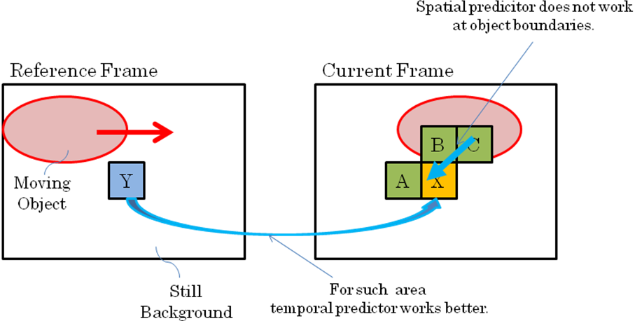

Fig 3.1

Document [3] says that “the ordering of candidates in the set is important”. We support this idea, and we would also like such dynamic code_number assignment at slice-level, as which predictor of spatial or temporal works better is different slice by slice.
Document [4] employs median prediction scheme for vertical component. We would like scheme as motion vector competition here, and additionally we would like dynamic code number assignment.

Simulation

Simulation Condition

In Table 4.1.1, simulation condition is shown.
Basically it complies with Inter Prediction TE test condition. We have tested with JCTVC-A121_software rather than KTA, as it contains some of the coding tools like scaled motion vector prediction and we believe that the performance should be closer to TMuC than KTA. However, in JCTVC-A121 software, motion vector competition has not been implemented with direct mode right now, so any kind of modification with regard to motion vector competition does have very little impact on the coding efficiency with CS1 test condition. For this reason only results with CS2 test condition are shown in this document.
Class E sequences have additionally been tested to show that the proposed scheme performs well with camera-fixed-type sequences for TV conference applications.

Table 4.1.1

Codec | JCTVC-A121-software_r1  - Anchor – MVCompOff  - MVCompOn with Default Method  - MVCompOn with Proposed Method [*]
Sequences | ClassB:  BQTerrace, BasketballDrive, Cactus, Kimono, ParkScene  ClassC:  BQMall, BasketballDrill, ParkScene, RaceHorses  ClassD:  BQSquare, BasketballPass, BlowingBubbles, PartyScene  ClassE:  Vidyo_1, Vidyo_3, Vidyo_4
FramesToBeEncoded | 100
GOP | IPPP
QP | QPI=22,27,32,37,42,47  QPP=QPI+1
Transform8x8Mode | 1
MotionVectorResolution | 1/8
IntraMDDT | 1
RDO_Q | 1
HP_Filter | 4
AdaptiveLoopFilter | 1
Geometry Motion Partition | 0

[*] The value of mv_prediction_definition_flag for each slice is determined with 2-pass algorithm.

Simulation Result

In Table 4.2.1 and 4.2.2, the results of BD-PSNR/Bitrate of lower and higher QP range are shown respectively. As can be seen, the proposed method works better if higher QP and camera-fixed-type sequences like “B_Cactus” ,“C_BasketballDrive” or Class E sequences.
We believe that this kind of spatial-temporal scheme would help improvement in efficiency with direct modes.

Table 4.2.1 BD-Bitrate/PSNR QP22-37

Sequence | MVCmpDefault |  | MVCmpProposed
 | BDPSNR | BDBitrate | BDPSNR | BDBitrate
B_BQTerrace
B_BasketballDrive
B_Cactus
B_Kimono1
B_ParkScene
C_BQMall | 0.072993 | -1.70716 | 0.094134 | -2.22244
C_BasketballDrill | 0.039199 | -1.02597 | 0.043955 | -1.16617
C_PartyScene | 0.050892 | -1.04207 | 0.057569 | -1.20765
C_RaceHorses | 0.024694 | -0.5229 | 0.02476 | -0.52435
D_BQSquare | 0.065249 | -1.65379 | 0.077624 | -1.92367
D_BasketballPass | 0.046091 | -0.88383 | 0.057389 | -1.12722
D_BlowingBubbles | 0.051159 | -1.24777 | 0.070561 | -1.72165
D_RaceHorses | 0.056976 | -1.09352 | 0.062273 | -1.23186
E_vidyo1 | 0.065123 | -2.073692 | 0.144446 | -4.593431
E_vidyo3 | 0.021954 | -0.579685 | 0.038321 | -1.051308
E_vidyo4 | 0.042256 | -1.747852 | 0.065156 | -2.474406

Table 4.2.2 BD-Bitrate/PSNR QP32-47

Sequence | MVCmpDefault |  | MVCmpProposed
 | BDPSNR | BDBitrate | BDPSNR | BDBitrate
B_BQTerrace
B_BasketballDrive
B_Cactus
B_Kimono1
B_ParkScene
C_BQMall | 0.095886 | -2.34214 | 0.204627 | -4.96394
C_BasketballDrill | 0.113081 | -2.82188 | 0.192715 | -4.91969
C_PartyScene | 0.056617 | -1.77936 | 0.083382 | -2.66991
C_RaceHorses | 0.038926 | -1.14117 | 0.053915 | -1.58388
D_BQSquare | 0.125447 | -3.2624 | 0.195068 | -5.04281
D_BasketballPass | 0.079668 | -2.01553 | 0.146002 | -3.52592
D_BlowingBubbles | 0.049284 | -1.52927 | 0.104703 | -3.17959
D_RaceHorses | 0.070557 | -1.82823 | 0.117818 | -3.06795
E_vidyo1 | 0.160731 | -3.401641 | 0.419014 | -8.696540
E_vidyo3 | 0.068172 | -1.459269 | 0.195704 | -4.149243
E_vidyo4 | 0.145301 | -3.436369 | 0.308636 | -7.339924

In addition to coding efficiency, subjective quality improvement is observed with camera-fixed-type sequences like B_Cactus, C_BasketballDrive and E_vidyo3.
With the areas between moving object and still background as shown with red circles in Fig 4.2.1, 4.2.2 or 4.2.3, temporal predictor works better. However, if smaller code_number is assigned for the spatial predictor, it is more likely to be selected based on RD-based selection especially at lower bitrate then motion vector predictor of the moving object propagates to the still background and causes severe image degradation. Such degradation can be avoided if smaller code_number is assigned for the temporal predictor.

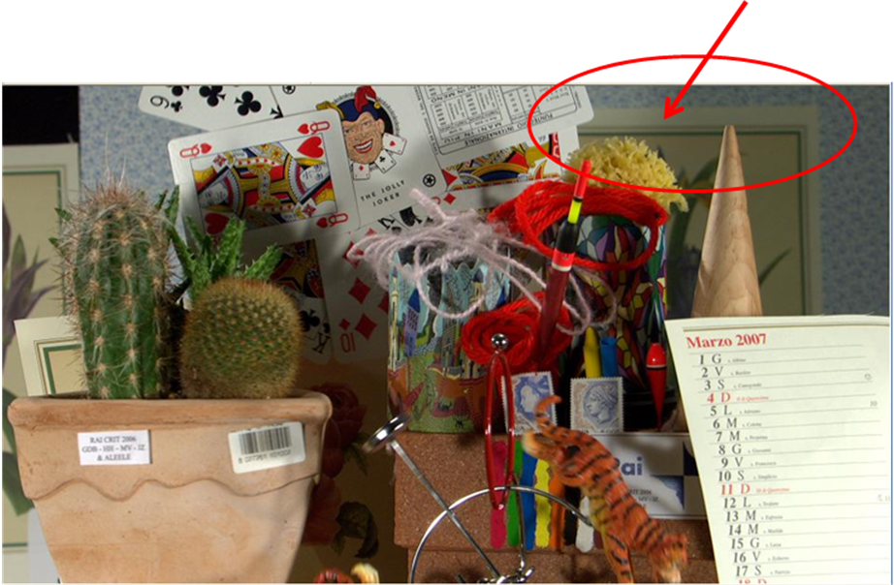

Fig 4.2.1

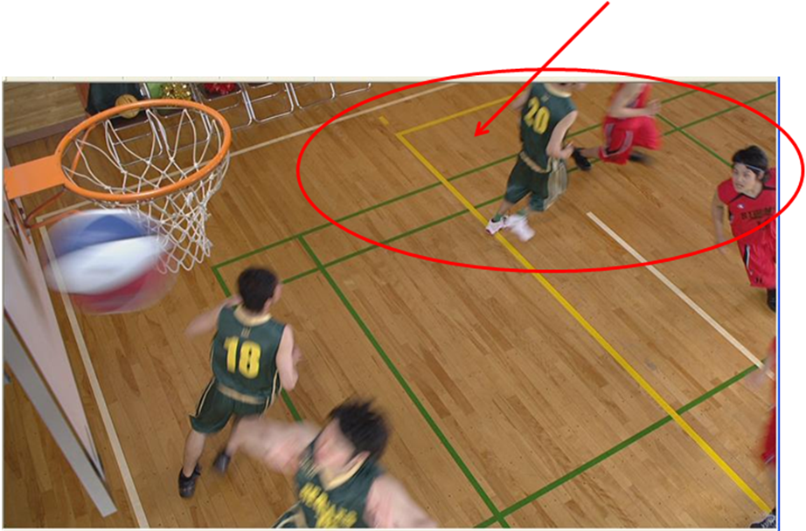

Fig 4.2.2

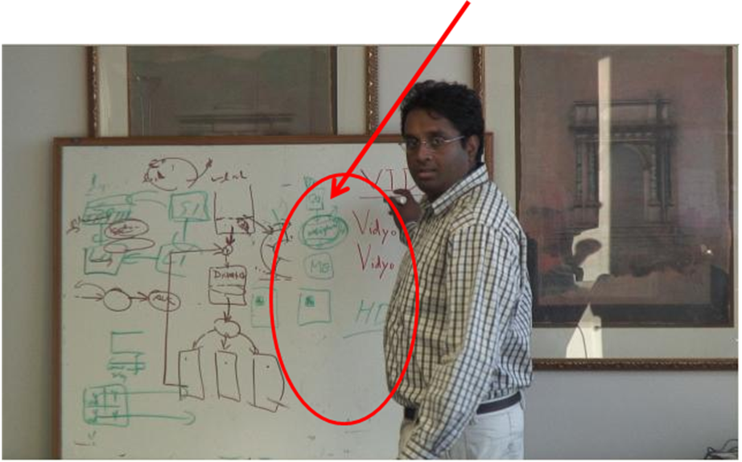

Fig 4.2.3

Conclusion

We support the motion vector coding scheme similar to motion vector competition for HEVC standard. The predictor set should at least contain a spatial predictor and a temporal predictor. We would also like dynamic code number assignment for motion vector predictors at slice level. In addition to the improvement in coding efficiency, it will improve visual quality between the moving area and still background in the camera-fixed-type sequences where spatial predictors do not perform well.

References

[1] “Competition-Based Scheme for Motion Vector Selection and Coding”, VCEG-AC06, Jul 2006
[2] “Key Technology Area Software”, http://iphome.hhi.de/suehring/tml/
[3]”Description of video coding technology proposal by Fraunhofer HHI”, JCTVC-A116, Apr 2010
[4]”Samsung and BBC response to Call for Proposals on Video Compression Technology”, JCTVC-A124, Apr 2010
[5] “Test Model under Consideration (TMuC)”, JCTVC-A205, Apr 2010
[6] “Video coding technology proposal by Qualcomm Inc.”, JCTVC-A121, Apr 2010
[7] “Joint call for proposals on video compression technology,” ISO/IEC MPEG 91st meeting, N11113, Kyoto, Japan, Apr. 2010.
[8] “Video Coding Technology Proposed by Sony”, JCTVC-A103, Apr 2010

Patent rights declaration(s)

Sony Corporation may have IPR relating to the technology described in this contribution and, conditioned on reciprocity, is prepared to grant licenses under reasonable and non-discriminatory terms as necessary for implementation of the resulting ITU-T Recommendation | ISO/IEC International Standard (per box 2 of the ITU-T/ITU-R/ISO/IEC patent statement and licensing declaration form).

