    Joint Collaborative Team on Video Coding (JCT-VC)  of ITU-T SG16 WP3 and ISO/IEC JTC1/SC29/WG11  2nd Meeting: Geneva, CH, 21-28 July, 2010 | Document: JCTVC-B073

Title: | Fast Mode Dependent Directional Transform via Butterfly-Style Transform and Integer Lifting Steps
Status: | Input Document to JCT-VC
Purpose: | Proposal
Author(s) or  Contact(s): | Wenpeng Ding  Beijing University of Technology, China  Yunhui Shi, China  Beijing University of Technology, China  Baocai Yin  Beijing University of Technology, China | Tel:  Email:  Tel:  Email:  Tel:  Email: | 86-01067396568-2116  wpding@gmail.com  86-01067396568-2116  syhzm@bjut.edu.cn  86-01067396568-2116  ybc@bjut.edu.cn
Source: | Beijing University of Technology
_____________________________

Abstract
Mode Dependent Directional Transform (MDDT) can improve the coding efficiency of H.264/AVC but it also brings high computation complexity. In this contribution, a new design for implementing fast MDDT transform through integer lifting steps is presented. First, MDDT is approximated by a proper transform matrix that can be implemented with butterfly-style operation. Then the butterfly-style transform is factored into a series of integer lifting steps to eliminate the need of multiplications. Experimental results show that the proposed fast MDDT can significantly reduce the computation complexity while introducing negligible loss in the coding efficiency. Due to the merit of integer lifting steps, the proposed fast MDDT is reversible and can be implemented on hardware very easily.

Proposed Solution
To simplify MDDT [1], the transform matrices are approximated using eq (1).

$S_{N}=P_{N}\left[\begin{matrix}U & 0 \\ 0 & V\end{matrix}\right]\left[\begin{matrix}I & J \\ J & −I\end{matrix}\right]$. (1)
where U and V can be any orthogonal matrices and $P_{N}$ is a known reordering matrix defined as
$P_{N}(m,n)=\left\{\begin{matrix}1, m=2n,\text{ n}<\frac{N}{2} \\ \text{1, }m=(n−\frac{N}{2})∗2+1,n≥\frac{N}{2} \\ 0, \text{otherwise}\end{matrix}\right.$.
For N=8, the reordering matrix $P_{8}$ is
$P_{8}=\left[\begin{matrix}1 & 0 & 0 & 0 & 0 & 0 & 0 & 0 \\ 0 & 0 & 0 & 0 & 1 & 0 & 0 & 0 \\ 0 & 1 & 0 & 0 & 0 & 0 & 0 & 0 \\ 0 & 0 & 0 & 0 & 0 & 1 & 0 & 0 \\ 0 & 0 & 1 & 0 & 0 & 0 & 0 & 0 \\ 0 & 0 & 0 & 0 & 0 & 0 & 1 & 0 \\ 0 & 0 & 0 & 1 & 0 & 0 & 0 & 0 \\ 0 & 0 & 0 & 0 & 0 & 0 & 0 & 1\end{matrix}\right]$.
The implementation of $S_{N}$ is illustrated in Fig.1 for N=8. The whole transform is the concatenation of a simple butterfly transform, two separate transform U and V of halved data size, and a data reordering P.
Fig. 1. The butterfly implementation structure for S₈.
It is known that any $M×M$orthogonal matrix can be decomposed into $M×(M−1)/2$ plane rotations. The transform kernels U and V in the butterfly-style matrix can be expressed as the product of several plane rotations. A plane rotation is defined as follows. The transform kernels of the butterfly-style matrices can be decomposed to a series of plane rotations. For example, a 4x4 orthogonal matrix can be factorized into six plane rotations as

(2)
Where $\hat{R}(α_{i})$ denotes a 4x4 plane rotation matrix and S is a matrix which flips the sign of the last input signal when necessary. Fig. 2 illustrates the plane rotation operations for a 4x4 orthogonal matrix.
Fig. 2. The plane rotation operations for a 4X4 orthogonal matrix.
We further factorize the plane rotation operation into simple integer lifting steps. Lifting step is a biorthogonal transform and its inverse is also a simple lifting operation, i.e.
${\left[\begin{matrix}1 & x \\ 0 & 1\end{matrix}\right]}^{−1}=\left[\begin{matrix}1 & 0 \\ −x & 1\end{matrix}\right]$, ${\left[\begin{matrix}1 & 0 \\ x & 1\end{matrix}\right]}^{−1}=\left[\begin{matrix}1 & −x \\ 0 & 1\end{matrix}\right]$ (3)
A plane rotation operation can be decomposed into a series of lifting steps as follows
$\left[\begin{matrix}\text{cos}(α) & −\text{sin}(α) \\ \text{sin}(α) & \text{cos}(α)\end{matrix}\right]=\left[\begin{matrix}1 & p \\ 0 & 1\end{matrix}\right]\left[\begin{matrix}1 & 0 \\ u & 1\end{matrix}\right]\left[\begin{matrix}1 & p \\ 0 & 1\end{matrix}\right]$ (4)
The transform kernels U and V, which consist of several plane operations, can be expressed as the product of a series of lifting steps. Fig. 3 shows the lifting structure of a 4x4 transform kernel.
To accelerate the computation of the transform U and V, the lifting steps in (17) can be implemented with constrained precision for the scaling factors p and u. By setting the precision of p and u to 1/2^{m}, all the computation in a lifting step in (4) can be implemented by simple integer operations. In the experiments, the precision of the lifting steps is set to 1/32.
Fig. 3. Lifting structure for a 4X4 transform kernel.

Complexity Analysis
Table I tabulates the number of multiplications and addition needed in MDDT and the proposed butterfly-style transform matrices. The multiplications needed in the structured matrices have been significantly reduced.

TABLE I
Improvement in Number of Multiplications
 | 4x4 |  | 8x8
 | Mul. | Add. | Mul. | Add.
MDDT | 16 | 12 | 64 | 56
BSTM | 8 | 8 | 32 | 32

Employing integer lifting steps, the multiplications in the proposed BSTM scheme are eliminated by replacing them with shifts and additions. The number of shifts and additions needed varies with the transform matrices and the precision of lifting steps. In the experiments, the precision of the lifting steps is set to 1/32. Thus one multiply operation can be replaced with 3 shifts and 4 additions in the worst case. The values of each lifting steps is listed in the Appendix A.

Simulation Results
The proposed scheme has been implemented into the reference software JM11.0/KTA2.4 [2]. In this experiment, the lifting based butterfly-style transform matrices are adopted to replace the 4x4 and 8x8 MDDT matrices. Note that the row matrix for mode 1 and column matrix for mode 0 are not replaced with the proposed matrices. The coding parameters are set according to the H.264/AVC High Profile. All the KTA features are disabled except for MDDT. All the test sequences used in JCT-VC are used in our experiments. All the frames are coded as I-frames. Table II shows the details of the experimental conditions. BDPSNR results are used to measure the performance of the proposed scheme when both anchor and test have similar bitrates but different PSNR values [3]. BDRate results are also included as reference [3].
Table III compares the coding efficiency of the proposed butterfly-style transform matrices with that of MDDT matrices. Overall, the proposed scheme achieves almost the same coding performance with MDDT. The average PSNR loss at the same bit rate is less than 0.1dB for sequences in class B, C, D and E. Even for the worst cases, the average PSNR loss at the same bit rate is about 0.12dB. Fig.4 shows the PSNR-rate curves with different transform matrices. As we can observe, the proposed scheme achieves comparable coding efficiency with MDDT at all bit rates.

TABLE II
Test Sequences and Experimental Conditions
Class | Sequences | Resolution | Experimental Conditions
A | PeopleOnStreet  Traffic | 2560x1600 | JM11.0/KTA2.4, High Profile, I Frame only,  QP = 22, 27,32,28,42,  CABAC, RDO, MDDT
B | BasketballDrive  BQTerrace  Cactus  Kimono1  ParkScene | 1920x1080
C | vidyo1  vidyo3  vidyo4 | 1280x720
D | BasketballDrill  BQMall  PartyScene  RaceHorses | 832x480
E | BasketballPass  BlowingBubble  BQSquare  RaceHorses | 416x240

TABLE III
Test Results for Proposed Scheme
Class | Sequence | BDRate(%) | BDPSNR(dB)
E | BasketballPass | 0.41 | -0.03
E | BlowingBubbles | 0.93 | -0.06
E | BQSquare | 0.08 | -0.01
E | RaceHorses | 1.31 | -0.09
E | Average | 0.68 | -0.05
D | BasketballDrill | 1.46 | -0.07
D | BQMall | 0.85 | -0.05
D | PartyScene | 0.50 | -0.04
D | RaceHorses | 1.06 | -0.07
D | Average | 0.97 | -0.06
C | vidyo10 | 2.40 | -0.12
C | vidyo3 | 1.44 | -0.08
C | vidyo4 | 1.54 | -0.07
C | Average | 1.79 | -0.09
B | BasketballDrive | 1.03 | -0.03
B | BQTerrace | 0.79 | -0.05
B | Cactus | 1.34 | -0.05
B | Kimono1 | 1.85 | -0.06
B | ParkScene | 1.19 | -0.05
B | Average | 1.24 | -0.05
A | PeopleOnStreet | 2.35 | -0.13
A | Traffic | 2.17 | -0.10
A | Average | 2.26 | -0.12

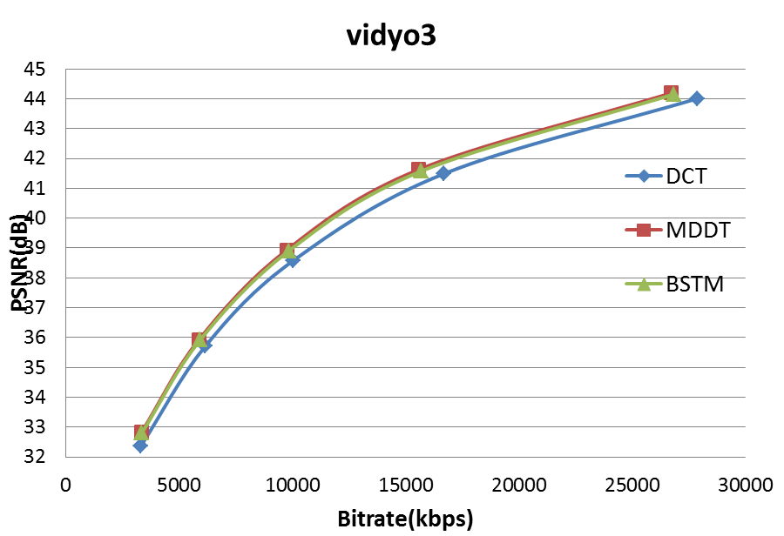
Fig. 4. The performance of DCT, MDDT and BSTM.

Patent rights declaration(s)
Beijing University of Technology may have IPR relating to the technology described in this contribution and, conditioned on reciprocity, is prepared to grant licenses under reasonable and non-discriminatory terms as necessary for implementation of the resulting ITU-T Recommendation | ISO/IEC International Standard (per box 2 of the ITU-T/ITU-R/ISO/IEC patent statement and licensing declaration form).

- Y. Ye and M. Karczewicz, “Improved Intra Coding,” ITU-T Q.6/SG16 VCEG, VCEG-AG11, Shenzhen, Oct. 2007
- KTA software, http://iphome.hhi.de/suehring/tml/.
- G. Bjontegaard, “Calculation of average PSNR differences between RD-curves,” in Document VCEG-M33, VCEG 13th Meeting, Austin,Texas, USA, Apr. 2001.

Appendix A: BSTM lifting steps

4x4 lifting steps :
static int pu_col_4x4[9][2][2] =
{
{{-34, 12},{-26, 14},},//u0 p0 for U matrix and u0 p0 for V matrix
{{-32, 13},{-28, 14},},
{{-35, 12},{-26, 14},},
{{-31, 13},{-27, 14},},
{{-30, 13},{-28, 14},},
{{-31, 13},{-27, 14},},
{{-31, 13},{-28, 14},},
{{-32, 13},{-27, 14},},
{{-36, 12},{-26, 14},},

};
static int pu_row_4x4[9][2][2] =
{
{{-34, 12},{-26, 14},},
{{-34, 12},{-26, 14},},
{{-35, 12},{-26, 14},},
{{-34, 12},{-27, 14},},
{{-31, 13},{-28, 14},},
{{-32, 13},{-28, 14},},
{{-32, 13},{-27, 14},},
{{-34, 12},{-27, 14},},
{{-33, 13},{-26, 14},},
};

8x8 lifting steps :
static int taps_row_8x8_u[9][6][2] = // lifting steps for U matrix of row transform
{
{{-60, 27},{ 11, -20},{ 5, -9},{-25, 31},{-12, 21},{ 50, -29},},// u0 p0 u1 p1 … u5 p5
{{-60, 27},{-11, 20},{ -6, 11},{ 24, -31},{ 13, -23},{-21, 30},},
{{-59, 27},{ 10, -19},{ 6, -11},{-23, 30},{-14, 23},{ 47, -30},},
{{-59, 27},{ 10, -19},{ 5, -10},{-24, 31},{-13, 22},{ 48, -30},},
{{-53, 28},{-12, 21},{ -6, 12},{ 24, -31},{ 14, -23},{-21, 30},},
{{-55, 28},{ 12, -21},{ 6, -12},{-25, 31},{-13, 22},{ 48, -29},},
{{-52, 29},{-11, 20},{ -6, 11},{ 24, -31},{ 13, -22},{-22, 30},},
{{-59, 27},{ 11, -19},{ 5, -10},{-24, 31},{-13, 22},{ 48, -29},},
{{-55, 28},{-11, 20},{ -6, 12},{ 24, -31},{ 14, -23},{-22, 30},},
};
static int taps_row_8x8_v[9][6][2] =// lifting steps for V matrix of row transform
{
{{-46, 30},{ 15, -25},{ 13, -22},{-23, 30},{-16, 26},{ 48, -29},},
{{-45, 30},{-15, 24},{-13, 22},{ 23, -30},{ 16, -26},{-21, 30},},
{{-45, 30},{-14, 24},{-13, 22},{ 23, -30},{ 17, -26},{-22, 30},},
{{-47, 30},{-16, 25},{-13, 22},{ 24, -31},{ 16, -26},{-21, 30},},
{{-50, 29},{-15, 25},{-13, 22},{ 23, -30},{ 15, -25},{-20, 29},},
{{-50, 29},{ 15, -25},{ 13, -22},{-22, 30},{-16, 25},{ 50, -29},},
{{-48, 29},{-15, 25},{-13, 22},{ 23, -30},{ 16, -26},{-21, 29},},
{{-47, 30},{-15, 25},{-13, 22},{ 23, -31},{ 16, -26},{-22, 30},},
{{-48, 30},{-15, 25},{-13, 22},{ 22, -30},{ 16, -26},{-22, 30},},

};
static int taps_col_8x8_u[9][6][2] =// lifting steps for U matrix of column transform
{
{{-62, 26},{-12, 20},{ -5, 10},{ 25, -31},{ 13, -22},{-21, 29},},
{{-78, 22},{ 15, -25},{ 5, -10},{-31, 32},{-13, 22},{ 50, -29},},
{{-64, 26},{ 12, -21},{ 6, -11},{-26, 31},{-13, 22},{ 49, -29},},
{{-56, 28},{-13, 22},{ -6, 12},{ 25, -31},{ 13, -23},{-21, 30},},
{{-51, 29},{ 13, -22},{ 6, -11},{-25, 31},{-13, 22},{ 48, -30},},
{{-53, 28},{-12, 21},{ -6, 11},{ 25, -31},{ 13, -22},{-21, 29},},
{{-56, 28},{ 12, -22},{ 6, -12},{-25, 31},{-13, 23},{ 48, -30},},
{{-56, 28},{-12, 21},{ -6, 11},{ 25, -31},{ 13, -22},{-21, 30},},
{{-62, 26},{ 10, -19},{ 5, -10},{-24, 31},{-13, 22},{ 48, -29},},
};

static int taps_col_8x8_v[9][6][2] = // lifting steps for V matrix of column transform
{
{{-47, 30},{-16, 25},{-12, 21},{ 24, -31},{ 16, -25},{-22, 30},},
{{-39, 31},{ 15, -25},{ 12, -21},{-24, 31},{-16, 25},{ 50, -29},},
{{-47, 30},{-16, 25},{-12, 21},{ 24, -31},{ 16, -25},{-21, 29},},
{{-52, 29},{-15, 24},{-13, 22},{ 23, -30},{ 16, -26},{-21, 29},},
{{-53, 28},{-15, 24},{-13, 22},{ 22, -30},{ 16, -26},{-21, 29},},
{{-49, 29},{-15, 25},{-12, 22},{ 22, -30},{ 16, -26},{-22, 30},},
{{-51, 29},{ 15, -24},{ 13, -22},{-22, 30},{-16, 26},{ 50, -29},},
{{-49, 29},{-15, 25},{-12, 22},{ 23, -30},{ 16, -26},{-21, 30},},
{{-47, 30},{-16, 26},{-13, 22},{ 24, -31},{ 16, -26},{-22, 30},},
};

