    Joint Collaborative Team on Video Coding (JCT-VC)  of ITU-T SG16 WP3 and ISO/IEC JTC1/SC29/WG11  2nd Meeting: Geneva, CH, 21-28 July, 2010 | Document: JCTVC-B072

Title: | MB Mode with Joint Application of Template and Block Motion  Compensations
Status: | Input Document to JCT-VC
Purpose: | Proposal
Author(s) or  Contact(s): | Yi-Wen Chen, Chung-Hao Wu, Chung-Lin Lee, Tse-Wei Wang and Wen-Hsiao Peng  1001 Ta-Hsueh Rd., HsinChu 30010, Taiwan | Tel:  Email: | +886-955-028-902  pawn@mail.si2lab.org
Source: | National Chiao Tung University (NCTU) /ITRI International
_____________________________

Abstract
This contribution introduces a MB mode, termed the P+ mode, to improve the prediction efficiency of P-MBs by a joint application of template and block motion compensations. The motion vector (MV) found by minimizing template matching error is viewed as an additional free MV, which can contribute to estimating pixel intensities in a P-MB. As in POBMC [1], the predictors derived from the template and block MVs are linearly combined based on a distance weighting criterion. In particular, given that the template MV tends to minimize the prediction error in the upper left quarter of a MB, the block MV search criterion is changed so that the resulting MV can contribute more to minimizing the error in the remaining part. When applied to 16x16 P-MBs, the proposed scheme is observed to have an average BD-Rate saving of 2.42% and a corresponding BD-PSNR gain of 0.08dB. It achieves the highest rate saving (4.21%) in S03 (Kimono, Class B) and the lowest (0.4%) in S10 (PartyScene, Class C).

Introduction
POBMC was introduced in JCTVC-A123 [1] to extend the notion of OBMC in H.263 to accommodate variable block-size motion partitions in AVC. It solves for the optimal weights associated with different MVs as functions of the distances between the predicted pixel and its nearby block centers where these MVs are located. This far-reaching generalization provides a generic reconstruction framework, allowing MVs associated with multiple motion partitions of arbitrary shape to be optimally combined for motion compensation. Some examples are given in Fig. 1, where the block MVs are approximated as the motion of the block centroids.

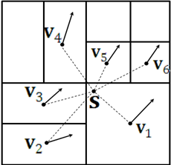 | 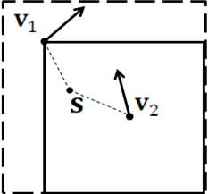 | 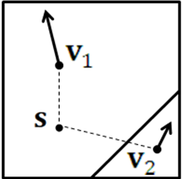 | 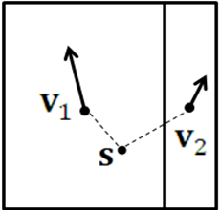
- Quad-tree | - TMP-like | - Geometry | - Asymmetric
Figure 1. POBMC combined with various motion partitions
Among the various applications of POBMC in Fig. 1, the combination of template matching prediction (TMP) and block motion-compensated prediction is of particular interest. Similar to bi-prediction, it carries out (pixel-adaptive) weighted prediction for the target block based on two MVs: one obtained from template matching and the other from block motion estimation. Because the TMP MV is computed on the decoder side, this bi-prediction scheme need only transmit one block MV, making it particularly attractive. Unlike the conventional use of TMP, where it is intended for decoder side motion inference, the present invention aims to utilize TMP as a tool for improving prediction efficiency. Since we have less control over the selection of the TMP MV, a question that naturally arises is, how can we optimize the search of the block MV so that both MVs can be used to their best advantage for minimizing prediction error?
To gain some insights into the answer, Fig. 2 plots the mean squared prediction error surface with the single use of TMP MV for motion compensation of the target block. It is seen that this MV tends to minimize the prediction error in the upper left quarter, a result that is intuitively agreeable since it approximates the true motion associated with the template centroid. This observation implies that the block MV should be managed to contribute more to minimizing the error in the remaining part, especially in the bottom right region. We thus propose in this contribution a new search criterion for the block MV to achieve this objective.
In the interest of time, this new prediction mode is applied to 16x16 P-MBs only as an enhancement and is thus termed the P+ mode. Its notion however can readily be extended to any MB or sub-MB partition with single- or multi-hypothesis prediction. Moreover, our framework allows the TMP MV to be replaced with a MV inferred by other means.
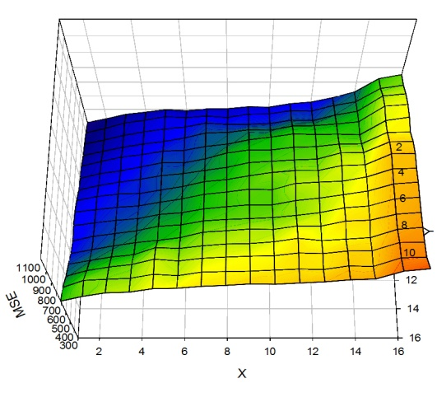
Figure 2. Mean squared prediction error surface of TMP using the sequence “Football”.

P+ Prediction Mode

Theoretical Analysis
The usual search criterion of a block MV is to minimize squared prediction error over the pixels in the prediction block. However, with the new prediction mode, we wish to arrive at a block MV that when applied together with the TMP MV for POBMC, results in minimum prediction error. To proceed analytically, we approximate the TMP MV as the motion of the template centroid and assume the block MV to be found corresponds to the true motion of some unknown pixel . The problem to find the block MV can now be cast as the search for that unknown pixel location that minimizes the sum of mean squared prediction error (SMSE) over the entire block :
(1)
where 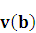 represents the true motion of pixel , and the weighting factor 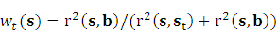 is computed by POBMC with 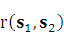 denoting the L₂ distance (measured in unit of pixel) between and .

Proceeding in much the same way as in [1], we obtain
(2)
As an illustration of the relationship between the SMSE and the location of pixel , consider the example in Fig. 3(a), where the target block is a 16x16 P-MB and the template size is 4. Fig. 3(b) plots the SMSE as a function of the location of pixel according to (2). From the figure, the minimum SMSE is achieved when pixel is located at around (10, 10), which is obviously not the block center . As expected, the optimal block MV, approximated by the true motion of pixel , has a higher correlation with the true motion of pixels in the bottom right quarter. This result also agrees with our previous conjecture.
Given the optimal location of pixel , Fig. 3(c) and Fig. 3(d) further show the window functions 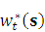,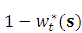 of the template and block MVs, respectively. Interestingly, their distributions resemble a special case of geometry partition, where the two MVs are located on the diagonal.
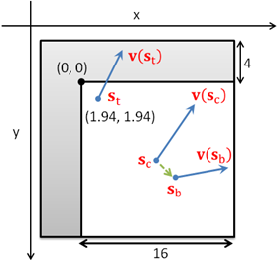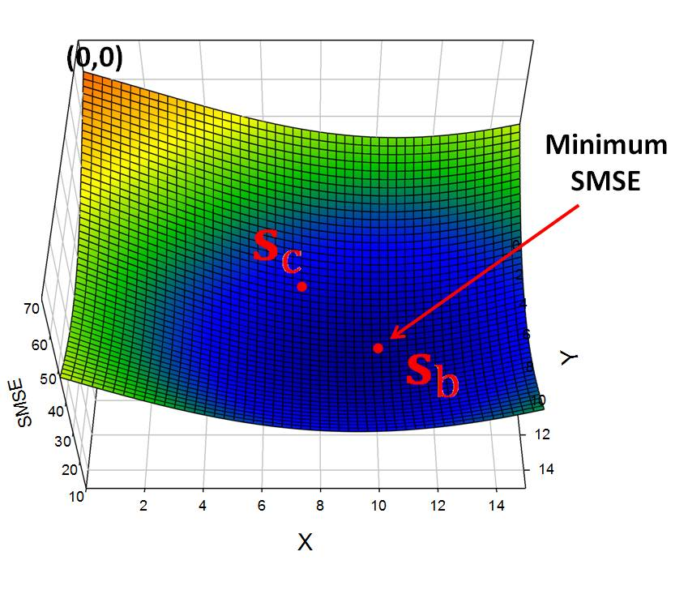
- (b)
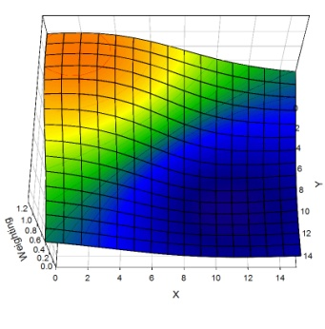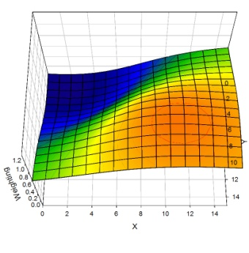
(c) (d)
Figure 3. 16x16 P+ mode: (a) geometry relationship between template centroid (1.94, 1.94), block center and the optimal location of pixel , (b) SMSE as a function of the location of pixel , (c) the optimal window function of the TMP MV, and (d) the optimal window function of the block MV.

Motion Search Criterion
The preceding result can readily be applied to design a block MV search criterion specifically optimized for the new prediction mode. We circumvent the difficulties of having to find the true motion of pixel by noting the one-to-one relationship between 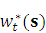 and the location of . If we substitute 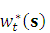for 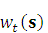in (1), the SMSE will be minimum only when 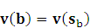. As a result, a block MV is likely to be 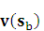if it minimizes the sum of squared predication error over block :
(3)
We thus propose using (3) as the new block MV search criterion.

Experimental Results
The P+ mode has been integrated into KTA2.4r1 reference software [2] without enabling RDOQ and KTA tools. A flag is transmitted for each non-skipped P-MB to adaptively switch on/off P+ mode. The results are obtained based on the encoding of 100 frames of all CfP sequences [4], except for those in Class D. Some other encoder settings are detailed in Table 1. The anchor is KTA2.4r1 reference software with RDOQ and KTA tools turned off.
Table 2 summarizes the BD-Rate savings and the BD-PSNR gains [3]. As can be seen, the maximum BD-Rate saving is 4.21% (Kimono, Class B) while the minimum is 0.4% (PartyScene, Class C). On average, the BD-Rate saving is 2.42% and the BD-PSNR gain is 0.08dB. For a deeper analysis, Fig. 4 shows the mode distributions under different QP settings. It is observed that one third of the 16x16 P-MBs are coded in P+ mode. Inspection of Fig. 5 further indicates that the inclusion of P+ mode increases the overall percentage of 16x16 P-MBs. Interestingly, quite a few P-MBs originally coded in 16x8/8x16 mode are now turned into P+ mode. This is attributed to the additional use of TMP MV, which makes P+ mode become comparable or superior to 16x8/8x16 mode in terms of prediction efficiency. This is also corroborated by the higher percentage of P+ mode relative to that of 16x8 or 8x16 (See Fig. 4).

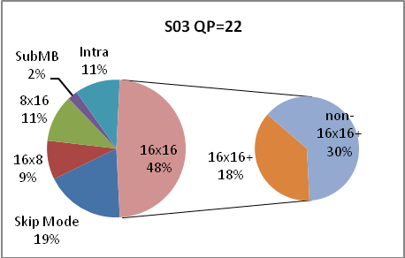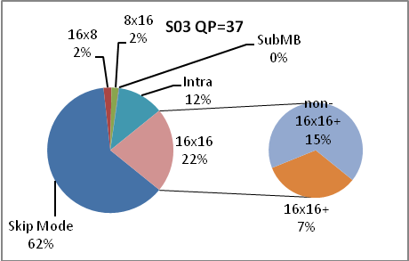
- (b)
Figure 4. Mode distributions of S03: (a) QP=22 and (b) QP=37.

↑4.8%
↑9.8%
Figure 5. Mode distributions with (proposed) and without (Anchor) P+ mode of S03:
(a) QP=22, (b) QP=37.

Table 1. Encoding Configurations
Reference Frame | 4
CABAC | On
8x8 Transform | On
Deblocking | On
RDO | On
MV Search Range | 128
Motion Search | EPZS
Sub-pel MC | On
Quantization Parameter (I/P) | 22/23, 27/28, 32/33, 37/38
Adaptive Rounding | off
Prediction Structure | IPPP…
Block Partitioning | 16x16 to 4x4

Table 2. Comparison of coding efficiency for CfP sequences
 | Sequences | BD-PSNR  Gain | BD-Rate  Saving
Class A | S01 | 0.082 | -2.24%
 | S02 | 0.070 | -1.51%
 | Average | 0.076 | -1.88%
Class B | S03 | 0.158 | -4.21%
 | S04 | 0.033 | -0.91%
 | S05 | 0.047 | -1.89%
 | S06 | 0.083 | -3.12%
 | S07 | 0.094 | -3.49%
 | Average | 0.083 | -2.72%
Class C | S08 | 0.102 | -2.64%
 | S09 | 0.097 | -2.20%
 | S10 | 0.018 | -0.40%
 | S11 | 0.046 | -1.04%
 | Average | 0.066 | -1.57%
Class E | S16 | 0.140 | -3.76%
 | S17 | 0.074 | -1.87%
 | S18 | 0.059 | -2.01%
 | Average | 0.091 | -2.55%
Overall Average |  | 0.079 | -2.42%

Conclusions
In this contribution, a new prediction mode with joint application of TMP and BMC is proposed. In the interest of time, the proposed scheme was integrated into 16x16 P-MBs only, but even so, we already observed an average BD-Rate saving of 2.42% and a BD-PSNR gain of 0.08dB. In some test sequences, the BD-Rate saving can be as high as 3-4%. This work is still in its early stage. We believe there is still plenty of room for further improvement.

References
- Y. W. Chen, T. W. Wang, C. H. Chan, C. L. Lee, C. H. Wu, Y. C. Tseng, W. H. Peng, C. J. Tsai, and H. M. Hang, “Description of video coding technology proposal by NCTU,” JCTVC-A123, Dresden, Germany, April 2010.
- KTA Reference Software, http://iphome.hhi.de/suehring/tml/kta/.
- G. Bjøntegaard, “Improvements of the BD-PSNR Model,” ITU-T SG16 Q.6 Document, VCEG-AI11, Berlin, July 2008.
- ITU-T Q6/16 and ISO/IEC JTC1/SC29/WG11, “Joint Call for Proposals on Video Compression Technology,” ISO/IEC MPEG 91st meeting, N11113, Kyoto, Japan, Jan. 2010

Patent rights declaration(s)
(NOTE – Activities in the JCT-VC and contributions to the JCT-VC are subject to the common patent policy for ITU-T/ITU-R/ISO/IEC. A statement of that policy can be found at
http://www.itu.int/ITU-T/dbase/patent/patent-policy.html, with further information available at http://www.itu.int/ITU-T/ipr/index.html and in the ISO/IEC Directives. The form to be used for the formal reporting of patent rights to ITU-T/ITU-R/ISO/IEC can be found at http://www.itu.int/ITU-T/ipr/index.html. Contributions to the JCT-VC proposing normative technical content shall contain a non-binding informal notice of whether the submitter may have patent rights that would be necessary for implementation of the resulting standard. The provided informal notice shall indicate the category of anticipated licensing terms according to the ITU-T/ITU-R/ISO/IEC patent statement and licensing declaration form. This obligation to provide an informal notice is supplemental to, and does not replace, any existing obligations of parties with technology included in a final or draft standard to submit formal IPR declarations to ITU-T/ITU-R/ISO/IEC. An example of an informal IPR notification statement for a contribution is provided below.)

NCTU may have IPR relating to the technology described in this contribution and, conditioned on reciprocity, is prepared to grant licenses under reasonable and non-discriminatory terms as necessary for implementation of the resulting ITU-T Recommendation | ISO/IEC International Standard (per box 2 of the ITU-T/ITU-R/ISO/IEC patent statement and licensing declaration form).

