    Joint Collaborative Team on Video Coding (JCT-VC)  of ITU-T SG16 WP3 and ISO/IEC JTC1/SC29/WG11  2nd Meeting: Geneva, CH, 21-28 July, 2010 | Document: JCTVC-B068

Title: | Performance evaluation on implicit direct vector derivation
Status: | Input Document to JCT-VC
Purpose: | Proposal
Author(s) or  Contact(s): | Shun-ichi Sekiguchi  Yusuke Itani  Information Technology R&D Center  Mitsubishi Electric Corporation  5-1-1, Ofuna, | Tel:  Email: | +81-467-41-2463  Sekiguchi.Shunichi@eb.MitsubishiElectric.co.jp
Source: | Mitsubishi Electric Corporation
_____________________________

Abstract
This contribution is to report coding performance of spatio-temporal adaptive direct vector derivation for B-skip/B-direct modes without explicit signaling that was proposed in our CfP submission at the last Dresden meeting. With this design, B-skip and B-direct modes do not need to send any side information for locally adaptive direct MV derivation relying on a simple decoder-side decision. A performance evaluation using A124 software, which has been chosen as the code base for TMuC software, was conducted and the result shows coding gain up to around 5% BD rate reduction. It is proposed to establish tool experiment for this category to identify relevant direct mode design to be included into test model.

Introduction
One of key technical points to be improved in HEVC standard is to seek advanced direct mode design relative to conventional standards, which significantly contributes to coding efficiency of B-pictures. With this motivation, various proposals were made in the CfP submissions at the Dresden meeting and most of them claimed the advantage of introducing spatio-temporal locally adaptive direct MV derivation, some of which employed extension of MVC (Motion Vector Competition) concept. The basic idea of MVC is sending signaling bit for the selection of MV candidates for use in direct MV derivation, which requires side information even for Skip mode. In the case of B-picture, the side information for selecting one from several MV candidates can completely be eliminated by exploiting temporally previous and future reference pictures those can be shared by both encoder and decoder. This concept was first utilized in an idea to derive B-Skip MV using decoder-side motion search [1], and we applied it to spatio-temporal adaptive direct MV derivation in our CfP submission [2].
In this contribution, we report simulation results on our implicit adaptive direct vector derivation scheme using A124 software, which is used as the code base for upcoming TMuC software. It has been observed that the proposed direct mode design can achieve certain level of BD rate reduction around 2.3% in average and up to 4.9% relative to spatial only direct mode configuration. Given this observation, we propose to establish tool experiment to identify the relevant direct mode design to be included in the test model.

Proposed design
As described in our CfP submission [2], adaptive selection of direct vector candidate is performed using “knowledge” that can be shared between encoder and decoder without sending explicit signaling bit, as illustrated in Figure 1. Similarity of prediction block candidates is used as decision criteria for selection. In figure 1, and represent prediction blocks with list0 and list1 obtained by one of the direct vector candidate derived from temporal co-located vector, and and are prediction blocks with list0 and list1 obtained by the other direct vector candidate derived from spatial neighboring vector. Given this notation, similarity criteria are defined by:
＝ (1)
＝ (2)
The bigger SAD means that the difference between list0 and list1 prediction samples is more significant and their correlation is lower. Thus, the direct motion vector is simply determined as the one that can produce a smaller SAD value.

Figure 1 Adaptive direct vector derivation

In the proposed design, the following temporal and spatial PMVs are used as direct vector candidates.
(3)
(4)
is derived by referring to motion vector of co-located motion partition in a list1 reference picture. If the reference direction of the motion vector of a co-located motion partition is different from the current motion vector, then is obtained by motion vector scaling assuming a linear motion field.
(a) (b)
Figure 2 Candidates for direct vector derivation

Simulation results
The proposed direct mode has been implemented into A124 software [3] that was made available to the group. Table 1 and 2 show test sequences and coding conditions used for our experiment, respectively. Note that new SHV sources provided by NHK [4] have been included in our test set. Anchor coding condition does employ spatial only direct vector derivation, and its performance was compared to the encoding result with the proposed implicit direct vector derivation.

Table 1 Test Sequences
Test Sequence ID | Test Set | Original Sequence Name | Starting Frame Number | Number of  Frames
S01 | Class A | Traffic | 0 | 65
S02 | Class A | PeopleOnStreet | 0 | 65
S03 | Class B | Kimono (first scene) | 0 | 49
S04 | Class B | ParkScene | 0 | 49
S05 | Class B | Cactus | 0 | 97
S06 | Class B | BasketballDrive | 0 | 97
S07 | Class B | BQTerrace | 140 | 129
S08 | Class C | BasketballDrill | 0 | 97
S09 | Class C | BQMall | 400 | 129
S10 | Class C | PartyScene | 403 | 97
S11 | Class C | RaceHorses | 0 | 65
S19 | Class B | Kimono (second scene) | 140 | 49
S20 | SHV | Steam locomotive train | 0 | 129
S21 | SHV | Nebuta Festival | 0 | 129

Table 2 Test Condition
GOP structure | Hierarchical B structure with I/P picture interval equals to 8 (consistent with CfP CS1 condition)
Motion Search Range | 128x128 (int pel unit)
Largest Coding Unit size | 64x64
Largest Transform size | 64x64
CU partitioning depth | 4
QP | 4QP points determined per each sequence
Common tool configurations | Intra Coding:  ADI and adaptive reference smoothing for prediction, adaptive block size 2-D transform for residual coding  Inter Coding:  Square motion partition shapes only, non-adaptive 1/4-pel MV representation, and default MC interpolation filter for prediction, adaptive block size 2-D transform for residual coding  Loop-filtering:  De-blocking + adaptive Wiener

The BD rate reduction obtained by the proposed direct mode is listed in Table 3. It is observed that the proposed direct mode can achieve consistent coding gain especially for the sequences where spatially detailed texture and stable background scene co-exist, such as PeopleOnStreet or Steam locomotive train. In such cases, spatially adjacent motion vector may not work as sufficient estimator for direct vector, but temporal candidate could contribute to improvement of direct vector accuracy.
Figure 3 presents an example of visual impact of the proposed direct mode (3rd decoded frame of People on Street sequence, QP=41). With the proposed direct vector derivation, prediction accuracy can be improved around edge region of moving object in B-picture.

Table 3 Performance in BD rate measurement
Sequence | BD-rate(Y) [%] | BD-rate(U) [%] | BD-rate(V) [%]
S01 | -2.14252 | -0.98009 | -1.50071
S02 | -4.94732 | -4.36401 | -4.19395
S03 | -0.76209 | -1.02544 | -0.82559
S04 | -2.4273 | -2.23223 | -1.86526
S05 | -2.81615 | -2.54437 | -3.00284
S06 | -0.78087 | -0.81932 | -0.92438
S07 | -1.48954 | -2.37299 | -1.78456
S08 | -1.36656 | -2.60614 | -2.54794
S09 | -4.09376 | -4.38662 | -3.4995
S10 | -4.25602 | -4.49746 | -4.18194
S11 | -1.13795 | -2.42574 | -3.73547
S19 | -3.1355 | -3.0538 | -2.21146
S20 | -4.03194 | -2.91496 | -3.52496
S21 | -0.34421 | -3.99019 | -5.05375
average | -2.40941 | -2.72952 | -2.77516

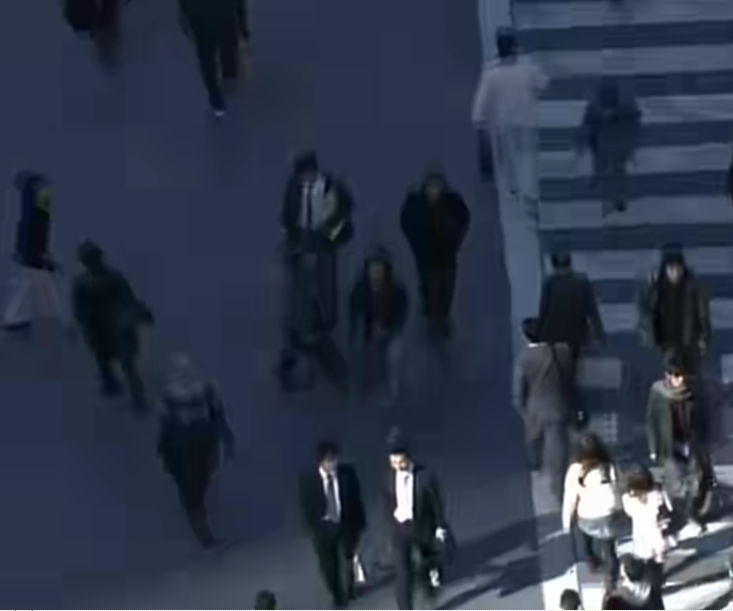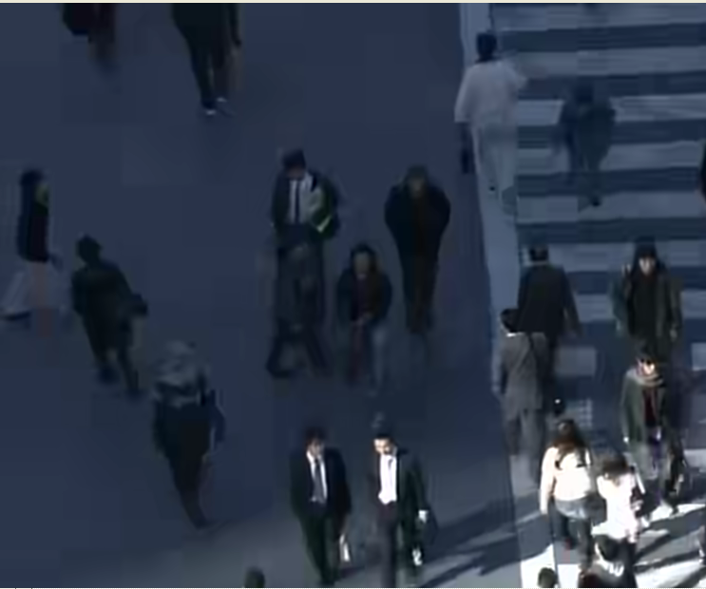
Figure 3 Example of improvement with the proposed direct mode

Conclusion
Coding performance of an implicit adaptive vector derivation for direct mode, which was proposed in our CfP submission [2], has been evaluated using A124 software [3] that supports fundamental coding tools included in TMuC. Our experimental results showed consistent coding gain to various high-resolution contents including new SHV sources those should be important for HEVC applications. We propose to establish formal tool experiment on this category to identify the relevant direct mode design to be included in the test model.

References:
- T. Murakami and S. Saito, “Advanced B Skip Mode with Decoder-side Motion Estimation”, VCEG-AK12, April 2009.
- K. Sugimoto, et.al., “Description of video coding technology proposal by Mitsubishi Electric,” JCTVC-A107, April 2010.
- K.McCann, et.al., “Samsung’s Response to the Call for Proposals on Video Compression Technology”, JCTVC-A124, April 2010.
- S. Sakaida, et. al., “7680 × 4320 format test sequences for JCT-VC”, JCTVC-A023, April 2010.

Patent rights declaration(s)

Mitsubishi Electric Corporation may have IPR relating to the technology described in this contribution and, conditioned on reciprocity, is prepared to grant licenses under reasonable and non-discriminatory terms as necessary for implementation of the resulting ITU-T Recommendation | ISO/IEC International Standard (per box 2 of the ITU-T/ITU-R/ISO/IEC patent statement and licensing declaration form).

