    Joint Collaborative Team on Video Coding (JCT-VC)  of ITU-T SG16 WP3 and ISO/IEC JTC1/SC29/WG11  2nd Meeting: Geneva, CH, 21-28 July, 2010 | Document: JCTVC-B067

Title: | DCT-based noise filtering for intra prediction samples
Status: | Input Document to JCT-VC
Purpose: | Proposal
Author(s) or  Contact(s): | Shun-ichi Sekiguchi  Akira Minezawa  Information Technology R&D Center  Mitsubishi Electric Corporation  5-1-1, Ofuna, Kamakura, JAPAN  Kazuhisa Iguchi  Yoshiaki Shishikui  NHK  Science & Technology Research Laboratories  1-10-11, Kinuta, Setagaya-ku, Tokyo, JAPAN | Tel:  Email: | +81-467-41-2463  Sekiguchi.Shunichi@eb.MitsubishiElectric.co.jp
Source: | Mitsubishi Electric Corporation and NHK(Japan Broadcasting Corporation)
_____________________________

Abstract
This contribution reports experimental results on a noise filtering method to intra prediction samples, based on the iterative adjustment intra prediction (IAIP) mode proposed in JCTVC-A122. The IAIP mode tries to get better intra prediction samples especially for texture with moderate gradation by involving continuity between target prediction samples and neighboring reference samples. It applies DCT to an image region covering the block to be predicted and its neighboring decoded samples, then inversely transforms the coefficients after cutting off of some high frequency components. By repeating this process, characteristics of neighboring samples can effectively be incorporated into the prediction samples. In this contribution, we applied this idea for noise filtering on intra prediction sample generated by angular multi-dimensional intra prediction (ADI) modes, which has been included into TMuC. The proposed filtering just applies DCT once to an image region consisting of intra prediction samples derived from ADI process and its spatially neighboring blocks, then inversely transforms after cutting high frequency coefficients. The experimental result shows that the proposed approach could improve intra coding performance of ADI modes even without use of adaptive reference sample smoothing scheme.

Introduction
After evaluation of all CfP submissions in the Dresden meeting, JCT-VC produced TMuC document [1] as a starting point of further evaluation of tools to be adopted in a formal test model. Intra coding of TMuC basically consists of intra prediction with adaptive reference sample smoothing and multi-angular spatial prediction (ADI), and residual coding with various transform strategies. In this document, we focus on intra prediction part and report experimental results on an idea of noise filtering to be applied to the result of multi-angular prediction. Through the evaluations in Dresden, it is believed certain that use of large prediction/transform blocks can be one of the most effective tools. Considering the intra prediction process with large prediction unit, resulting prediction samples are getting unreliable for ADI modes due to a need of linear interpolation using reference samples located far each other. Thus, prediction signal obtained by ADI modes should contain some noisy pattern that is not contained in corresponding source signal.
As an approach to reduce such noise component, we tried a DCT-based overlapped filtering to the result of ADI process, which is utilizing the iterative adjustment intra prediction (IAIP) mode proposed in JCTVC-A122 [2]. The IAIP mode tries to get better intra prediction samples especially for texture with moderate gradation by involving continuity between target prediction samples and neighboring reference samples. It applies DCT to an image region covering the block to be predicted and its neighboring decoded samples by filling DC prediction samples into the block to be predicted as initial values, then inversely transforms the coefficients after cutting off some high frequency components. By repeating this process, characteristics of neighboring samples can effectively be incorporated into the prediction samples, which results in better intra prediction where global spatial correlation exists. In this contribution, the proposed filtering just applies DCT once to an image region consisting of intra prediction samples derived from ADI process and its spatially neighboring decoded blocks, then inversely transforms the coefficients after cutting high frequency components. The proposed filtering may also contain similar effect to adaptive reference smoothing scheme. Our experimental result shows that the advantage of the proposed approach such that it could improve intra coding performance of ADI modes even without use of adaptive reference sample smoothing (ARSS) scheme.

Proposed scheme
Figure 1 illustrates the IAIP mode that was proposed in JCTVC-A122 [2]. “Current block” represents block to be predicted by intra prediction, and its size L was fixed to 16 in [2]. In our experiment here, L can be 4, 8, 16 and 32, and the size of “Reconstructed neighboring samples” plus “Current block” is set to 2L. And instead of using DC prediction samples as “initial value” for the “Current block” as in [2], we set ADI output samples to its position. This configuration of IAIP mode works as noise filtering to intra prediction samples obtained by ADI process. In contrast to the original IAIP mode, DCT and IDCT were applied only once to keep complexity lower. The use of this filtering can be locally adaptive, which means 1-bit ON/OFF flag is sent per each prediction unit.
Figure 1 Process flow of the IAIP mode

Simulation results
The proposed filtering has been implemented into A124 software [3] that was made available to JCT-VC. Table 1 shows test condition for our simulations. In this experiment, DCT is implemented as a simple floating-point matrix multiplication, but we used only the same set of DCT block sizes as those can be used for residual coding process in TMuC. This means that the largest DCT is limited to 64x64, and maximum value for L can be 32. Thus, this filtering was not applied to 64x64 prediction unit. With this configuration, the encoder could completely re-use transforms used for residual coding for the purpose of this filtering, and the decoder only needs DCT process in addition to the base method.
Table 1 Test Condition
Test sequence | SHV sources [4], Class A, B sequences [5]
GOP structure | Intra-only Coding
Number of encoded frames | SHV: first 10 frames @ 8Kx4K resolution  Class A,B: First 2 sec
Largest Coding Unit | 64x64
CU partitioning depth | 4 levels
QP | 17, 22, 27, 32, 37
Base coding tools | ALF, ADI, IBDI
Coding performance in BD-rate reduction is shown in Table 2. In this table, it can be found that the use of the proposed filter (“ADI + proposed filter”) outperforms combined use with ARSS (“ADI + ARSS”), which is TMuC configuration in many sequences. Especially, more gain can be observed for higher resolution contents, where ARSS does not work well. In Figure 2, performance with various additional configurations is shown in the form of R-D curves. The proposed filter added to ADI exhibits higher gain around high bitrate range. And further addition of ARSS (“ADI + ARSS + proposed filter”) does not show additive gain, which can be interpreted that pre-filtering to reference samples would not be necessary if the proposed filter is employed. A subjective advantage of the proposed filter can also be found in Figure 3, which is a part of intra prediction image for the first picture of “PeopleOnStreet” sequence encoded with Qp=17. ARSS can obtain some sort of coding gain for this sequence as can be seen in Table 2, however, prediction result cannot capture original image structure sufficiently due to loss of prediction accuracy around human being objects etc. The proposed filter can increase the number of directional prediction modes those can represent image structure better than DC or planar prediction modes, by reducing unreliable noise component from ADI outputs.
Table 2 Luma BD-rate for ADI only
Sequence | BD-rate (4 low-rate point) |  | BD-rate (4 high-rate point)
Sequence | ADI + proposed filter | ADI + ARSS | ADI + proposed filter | ADI + ARSS
Kimono | -0.441 | -0.664 | -0.691 | -0.664
ParkScene | -2.107 | -1.832 | -2.183 | -1.699
Cactus | -2.239 | -2.019 | -1.926 | -1.551
BasketballDrive | -1.838 | -1.435 | -2.752 | -2.338
BQTerrace | -1.812 | -1.226 | -2.117 | -1.514
Traffic | -2.437 | -1.932 | -2.834 | -1.886
PeopleOnStreet | -3.525 | -3.074 | -4.078 | -2.906
Steam locomotive train | -1.704 | -0.862 | -1.523 | -0.637
Nebuta festival | -4.407 | -1.844 | -3.570 | -1.204
Avarage | -2.279 | -1.654 | -2.408 | -1.600
(a) PeopleOnStreet
(b) Nebuta festival
Figure 2 RD-graph
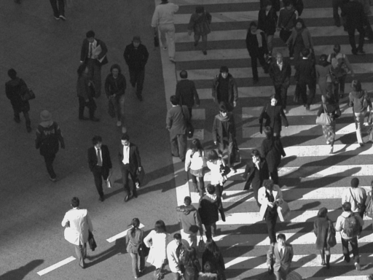
(a) original image
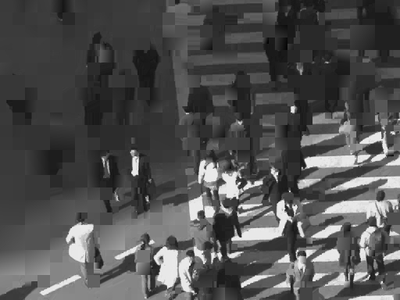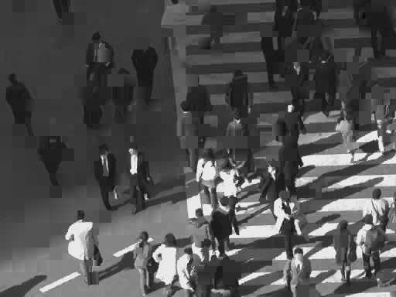
(b) ADI + ARSS (c) ADI + proposed noise filtering
Figure 3 Comparison of prediction images (PeopleOnStreet, Y component, QP=17, First frame)

Conclusion
This contribution reported an evaluation of DCT-based noise filtering for intra prediction samples. Our experimental results showed that performance of intra coding based on ADI prediction can be improved by adding the proposed post processing to a normal angular intra prediction. We propose to establish tool experiment on this category for further evaluation of the proposed approach on common TMuC software, in order to study better test condition and to understand usefulness of its inclusion into formal test model.

Patent rights declaration(s)
Mitsubishi Electric Corporation may have IPR relating to the technology described in this contribution and, conditioned on reciprocity, is prepared to grant licenses under reasonable and non-discriminatory terms as necessary for implementation of the resulting ITU-T Recommendation | ISO/IEC International Standard (per box 2 of the ITU-T/ITU-R/ISO/IEC patent statement and licensing declaration form).
NHK may have IPR relating to the technology described in this contribution and, conditioned on reciprocity, is prepared to grant licenses under reasonable and non-discriminatory terms as necessary for implementation of the resulting ITU-T Recommendation | ISO/IEC International Standard (per box 2 of the ITU-T/ITU-R/ISO/IEC patent statement and licensing declaration form).

References:
- “Test Model under Consideration”, JCTVC-A205, April 2010.
- A. Ichigaya, et.al., “Description of video coding technology proposal by NHK and Mitsubishi,” JCTVC-A122, April 2010.
- K.McCann, et.al., “Samsung’s Response to the Call for Proposals on Video Compression Technology”, JCTVC-A124, April 2010.
- S. Sakaida, et. al., “7680 × 4320 format test sequences for JCT-VC”, JCTVC-A023, April 2010.
- ITU-T Q6/16 Visual Coding and ISO/IEC JTC1/SC29/WG11 Coding of Moving Pictures and Audio, “Joint Call for Proposals on Video Compression Technology”, ISO/IEC JTC1/SC29/WG11 N11113, January 2010.

