    Joint Collaborative Team on Video Coding (JCT-VC)  of ITU-T SG16 WP3 and ISO/IEC JTC1/SC29/WG11  2nd Meeting: Geneva, CH, 21-28 July, 2010 | Document: JCTVC-B063

Title: | Flexible Representation of Intra Prediction Modes
Status: | Input Document
Purpose: | Proposal
Author(s) or  Contact(s): | Tomoyuki Yamamoto, Yukinobu Yasugi  1-9-2 Nakase, Mihama-ku, Chiba-shi,  Chiba 261-8520 JAPAN | Tel:  Email: | +81-43-299-8475  yamamoto.tomoyuki@sharp.co.jp
Source: | SHARP Corporation
_____________________________

Abstract
In this contribution, FDMR (Flexible Directional Mode Representation) is introduced as a novel intra prediction mode representation. The functionalities achieved by introducing FDMR are (1) simple probable mode derivation process, (2) use of the rank order of the intra prediction modes in the probable mode derivation process, and (3) use of more than one probable mode. Those functionalities provide flexibility and extensibility as well as the increase of coding efficiency.

Introduction
In the last JCT-VC meeting, Test Model under Consideration (TMuC) [1] was created after reviewing number of responses to HEVC CfP. Intra Prediction is one of the most active research areas since TMuC includes several related tools and AHG [2] was set up to study many related tools included in the CfP responses.

After the last meeting, we have studied on “directional intra prediction,” which we think important and basic area among various intra coding technologies. Specifically, we have investigated the representation of directional intra prediction modes that can accommodate the following features;
(i) Increase of the number of directional modes,
(ii) Different set of directional modes depending on the size of the prediction unit.

The remaining of this contribution is organized as follows; In section 2, intra prediction mode representation by ADI is reviewed. In section 3, the proposed intra prediction mode representation which gives more flexibility is introduced. Section 4 and 5 discusses techniques for improving coding efficiency in combination with the proposed flexible representation. In section 6, several experimental results of the proposed representation are shown. Finally, section 7 provides the conclusion.

Analysis of intra prediction mode representation in ADI
Among several intra coding tools included in TMuC, ADI (Adaptive Directinal Intra Prediction) proposed by Samsung/BBC [3] might be something worth investigating at this stage, in consideration of the frequency of its usage in intra slice and of the implementation maturity in the ‘current’ TMuC software.

ADI introduced up to 33 intra prediction modes, which are Horizontal, Vertical, DC, Plane, Bipred, and 28 directional modes whose direction is represented by vector (dx, dy). The prediction set, which is the collection of applicable intra prediction modes for certain PU (prediction unit), varies depending on the size of PU. Specifically, the prediction set in [3] consists of 5 modes for 64x64 PU, 33 modes for 32x32/16x16 PUs, and 9 modes for 8x8/4x4 PUs.

With regard to the encoding/decoding of the intra prediction modes, AVC/H.264 approach is extended and applied. That is, the concept of Most Probable Mode (MPM) is used. The difference is that the intra prediction mode of neighboring PU is once mapped into an intermediate mode (which is an element of the intermediate prediction set of 9 modes) in order to handle with the fact that neighboring PUs may use different prediction sets. The encoding process of intra prediction mode in ADI is depicted in Fig. 1.

Although the intra prediction mode representation in ADI works fine in the current TMuC software, we believe that the following aspects of the design can be improved.
(a) Derivation of MPM is done using the intermediate prediction set which consists of only nine intra prediction modes. Intra prediction mode other than the nine modes cannot be selected as the MPM. That means such mode always needs to be represented using 6 bins when prediction set with 33 modes is used.
(b) Probability of each intra prediction mode is not included in the encoding pass explicitly. Probability is accounted in MPM derivation process by selecting the mode with smaller index as MPM. In that sense, it is implicit and only intermediate prediction mode probability is accounted.
(c) Always uses only one probable mode (i.e. MPM). In the case of the prediction sets with 33 modes, one out of 33 candidates is represented using 1 bin, and others are represented using 6 bins.

Proposed intra prediction mode representation
In order to improve the aspects mentioned in the last section, we have designed a new representation of the intra prediction mode, which is called FDMR (Flexible Directional Mode Representation). The encoding process of intra prediction mode in FDMR is depicted in Fig. 2. There are three important components in the proposed representation: Probable Mode (PM) derivation process, PM mapping process, and Generalized Flag & Rem encoding process.

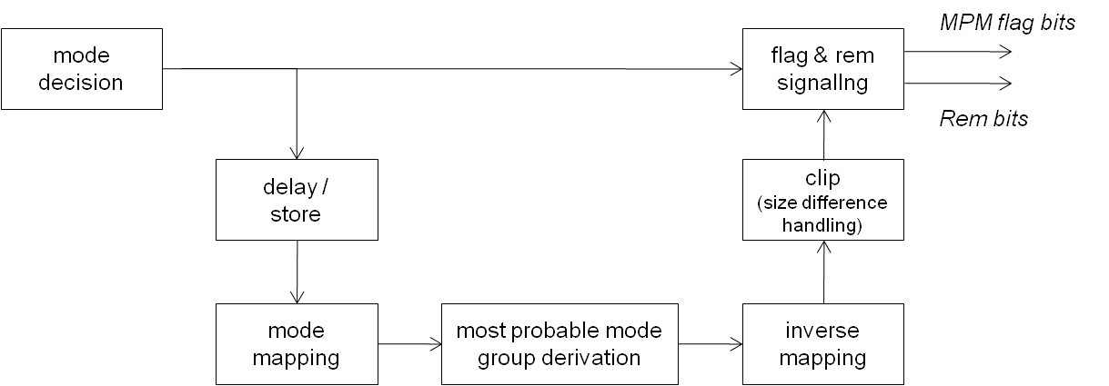
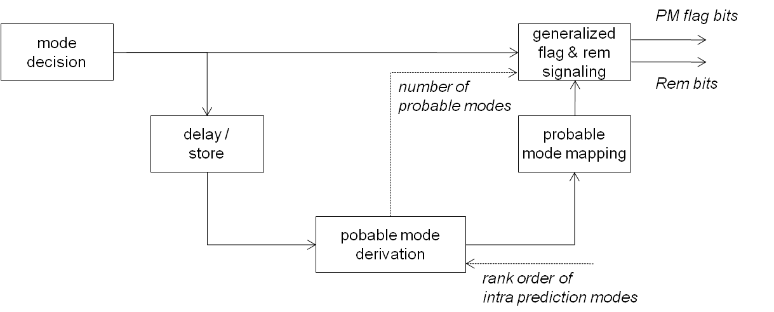
PM derivation is something like MPM derivation in AVC/H.264 but PM may contain more than one intra prediction modes. It should also be noted that the identifier of the intra prediction mode is directly used while the mapped identifier is used in ADI.
Figure 1. Encoding of intra prediction mode in ADI
Figure 2. Encoding of intra prediction mode in FDMR

PM mapping process handles the case when the derived intra prediction modes in PM are not included in the prediction set for the target PU. Each intra prediction mode in PM is converted into the one included in the prediction set and having similar property. The basic strategies for the mapping are; (1) For directional mode, map it into the one associated with the similar direction, (2) For DC, Plane, or Bipred mode, map it into DC mode.

In Generalized Flag & Rem signaling process, intra prediction mode information is encoded, which consists of ‘PM Flag bit’ and ‘Rem bits’. PM Flag bit indicates whether the intra prediction mode to be encoded or decoded is included in PM. Since PM is not necessary consists of one mode, Rem bits may be needed even when PM Flag bit is true.

Although the flexibility of the proposed system provides the extensibilities discussed in the following sections, let us start with introducing the simplest adaptation of the proposed system. Here, only one PM (i.e. MPM) is used. Firstly, the PM derivation is carried out by referring to the identifier of the neighboring (top and left) PUs. The identifier is the same as those defined in TMuC document. The intra prediction mode of the neighboring PU that has smaller identifier is selected as MPM. Then, the mapping from the derived MPM to the MPM used for the signaling is done using a table, which is indexed by a derived MPM and prediction set used for the target PU. The mapping is done by adopting the strategies mentioned above. Finally, PM Flag bit and Rem bits are derived by comparing the mapped MPM with the target intra prediction mode, and then encoded. As known, the number of Rem bits can be derived based on the number of intra prediction modes included in the prediction set.

The above example is simple, but with it, the aspect (a) mentioned in section 2 can be improved. That is, any intra prediction mode in any prediction set has a chance to be chosen as MPM, thus it could be encoded with a bin or two. Another benefit of the above example is that it requires fewer tables for the mapping among different intra prediction mode expressions. Since PM derivation is carried out referring directly to the identifier of the intra prediction modes, the table used in ADI in order to convert the stored mode into the “intermediate mode” is not needed anymore.

PM decision based on the rank order
The functionality to utilize the rank order of the probability of each intra prediction mode can be easily incorporated into the proposed system. The rank order is accounted in the PM derivation process. The following equation is used when the specific rank order is used.
$$\text{MPM} = \underset{p_{x} ∈ \left\{p_{T},p_{L}\right\}}{\text{argmin}}$$
Where, p_{T} and p_{L} are the identifier of the intra prediction mode of top and left neighboring block, respectively. And rankorder(p_{x}) returns the rank order of the given intra prediction mode p_{x}. Note that the above equation is a simple extension of the MPM derivation in AVC/H.264, where the identifier of the intra prediction mode is corresponds to rank order.

The three types of rank orders can be used: default rank order, sequence dependent rank order, and local rank order. As the default rank order, the identifier of the intra prediction mode described in TMuC is used. Sequence dependent rank order is useful to accommodate statistical differences of the intra prediction modes distribution among sequences. It is signaled in SPS. Since we observed that the probabilities vary depending on the size of PU, the different rank order for different PU can be signaled. Local rank order is derived by updating default or sequence dependent rank order based on the intra prediction modes of the neighboring regions.

By introducing three types of rank order, the proposed system can utilize the probabilities of intra prediction mode at various levels, thus aspect (b) in section 2 is improved.

Changing the number of probable mode
The proposed system can also be extended by adding functionality to use more than one PM (Probable Mode). We use two PMs for the PU where the associated prediction set consists of 33 modes, and use one PM for the other PUs. The motivation is that the MPM selected from 33 candidates seems to be less reliable compared to the MPM selected from 9 candidates.

The candidates of the PM are the intra prediction modes of the top, left, and top-left neighboring PUs. Each candidate is scored, and then one or two intra prediction modes with relatively higher score are selected as PM(s). In the scoring process, the direction associated with the intra prediction mode is taken into account. For example, if the top neighboring PU has intra prediction mode associated with horizontal direction, it is less evaluated compared to the case when top PU has the mode associated with vertical direction. In addition, the relative size of the neighboring PU is also evaluated. The score is lowered if the neighboring PU has different size with the target PU.

Experimental results
In order to examine the impact on coding efficiency that the proposed system introduces, three experiments have been conducted (see Table 1).

Table 1. Description of experiments
Short  name | Purpose | Section in the document | num. of PMs | rank order
Exp1 | Evaluate impact by introducing basic FDMR framework | 3 | one (MPM) | default
Exp2 | Evaluate impact by using sequence dependent rank order. | 4 | one (MPM) | sequence dependent
Exp3 | Evaluate impact by using more than one Probable Mode | 5 | two | default

The proposed system has been integrated on top of the software provided by Samsung/BBC (A124_stripped version). The same A124 software is used as the reference of the experiments. Other test conditions are summarized in Table 2. The conditions not appeared in the table should follow the conditions in Joint CfP [4].

Table 2. Test conditions
sequence | Class B, C, and D sequences of CfP
QP | 26, 30, 34, 38
number of frames | same as defined in IPred AHG report [5]
GOP structure | I only (-g 1 -ip 1 -r 0)
CU size | from 4x4 to 64x64

Exp1: impact by introducing basic FDMR framework
Table 3 shows the result of Exp1. Although the result tells the proposed system is comparable to the reference in terms of coding efficiency, we assert that the proposed system is better than the reference because it requires fewer mapping tables.

Table 3. bdrate / bdsnr (impact by introducing basic FDMR framework)
Resolution | Sequence | bdsnr (gain) [dB] | bdrate (reduction) [%]
1080p | BQTerrace | 0.000 | 0.00
1080p | Basketball Drive | 0.002 | 0.06
1080p | Cactus | 0.002 | 0.05
1080p | Kimono1 | 0.000 | -0.01
1080p | ParkScene | 0.000 | -0.01
WVGA  (832x480) | BQMall | 0.002 | 0.04
WVGA  (832x480) | Basketball Drill | 0.004 | 0.08
WVGA  (832x480) | Party Scene | 0.000 | 0.00
WVGA  (832x480) | Race Horses | 0.002 | 0.03
WQVGA  (416x240) | BQSquare | 0.002 | 0.02
WQVGA  (416x240) | Basketball Pass | -0.003 | -0.07
WQVGA  (416x240) | Blowing Bubbles | 0.000 | 0.01
WQVGA  (416x240) | Race Hosrses | 0.001 | -0.01
Average |  | 0.001 | 0.02

Exp2: impact by using sequence dependent rank order
Table 4 shows the result of Exp2. The sequence dependent rank orders defined in Table 5 are used in this experiment. Those rank orders are derived based on the distribution of the intra prediction modes for each sequence. Note that we signaled only intra prediction modes in top 5 ranks in SPS, and other ranks were derived based on the default rank order. The result shows that the proposed modification is effective.

Table 4. bdrate / bdsnr (impact by using rank order in PM decision)
Resolution | Sequence | bdsnr (gain) [dB] | bdrate (reduction) [%]
1080p | BQTerrace | -0.008 | -0.15
1080p | Basketball Drive | 0.013 | 0.45
1080p | Cactus | 0.004 | 0.09
1080p | Kimono1 | 0.004 | 0.09
1080p | ParkScene | 0.001 | 0.03
WVGA  (832x480) | BQMall | 0.004 | 0.07
WVGA  (832x480) | Basketball Drill | 0.043 | 1.00
WVGA  (832x480) | Party Scene | 0.006 | 0.09
WVGA  (832x480) | Race Horses | 0.002 | 0.04
WQVGA  (416x240) | BQSquare | -0.004 | -0.05
WQVGA  (416x240) | Basketball Pass | 0.008 | 0.15
WQVGA  (416x240) | Blowing Bubbles | -0.002 | -0.03
WQVGA  (416x240) | Race Hosrses | 0.008 | 0.13
Average |  | 0.005 | 0.154

Table 5. Sequence dependent rank order signaled by SPS
(the identifiers of the intra prediction modes in the range of 1st to 5th rank is shown)
BasketballDrive | 1,0,2,7,9 |  | BasketballDrill | 5,6,9,2,7 |  | BasketballPass | 0,1,6,2,9
BQTerrace | 0,9,1,2,7 |  | BQMall | 0,1,6,2,8 |  | BQSquare | 0,9,1,2,7
Cactus | 0,1,6,2,9 |  | PartyScene | 1,0,6,2,5 |  | BlowingBubbles | 0,8,1,6,2
Kimono1 | 2,0,3,1,6 |  | RaceHorses | 6,0,2,8,5 |  | RaceHorses_wqvga | 0,6,5,8,2
ParkScene | 1,2,0,9,5

Exp3: impact by using more than one Probable Mode
Table 6 shows the result of Exp3. Note that two Probable Modes are used only for the block where 33 modes can be used, while MPM approach is used for other cases. Table 7 shows the result of the additional experiments in order to compare ‘two Probable Modes only for blocks with 33 modes’ and ‘two Probable Modes for all blocks.’ The result shows that the former is better than the latter.

Table 6. bdrate / bdsnr (impact by using more than one PM)
Resolution | Sequence | bdsnr (gain) [dB] | bdrate (reduction) [%]
4Kx2K  (cropped) | Traffic | 0.011 | 0.22
4Kx2K  (cropped) | PeopleOnStreet | 0.029 | 0.53
1080p | BQTerrace | -0.008 | -0.15
1080p | Basketball Drive | 0.023 | 0.80
1080p | Cactus | 0.004 | 0.10
1080p | Kimono1 | 0.001 | 0.03
1080p | ParkScene | 0.004 | 0.11
WVGA  (832x480) | BQMall | -0.004 | -0.06
WVGA  (832x480) | Basketball Drill | 0.045 | 1.14
WVGA  (832x480) | Party Scene | 0.002 | 0.00
WVGA  (832x480) | Race Horses | 0.002 | 0.05
WQVGA  (416x240) | BQSquare | -0.003 | -0.08
WQVGA  (416x240) | Basketball Pass | 0.000 | 0.02
WQVGA  (416x240) | Blowing Bubbles | 0.003 | 0.03
WQVGA  (416x240) | Race Hosrses | 0.000 | 0.00
720p | vidyo1 | 0.030 | 0.58
720p | vidyo3 | 0.002 | 0.04
720p | vidyo4 | 0.019 | 0.42
Average |  | 0.014 | 0.30

Table 7. bdrate / bdsnr (impact of using 2PM only for blocks with 33 predictors)
(Note: this evaluation is done with fewer (15) frames )
 |  | 2 PM for all PU |  | 2PM for PU with 33 modes  1PM for other PUs
Resolution | Sequence | bdsnr  (gain) [dB] | bdrate  (reduction) [%] | bdsnr  (gain) [dB] | bdrate  (reduction) [%]
1080p | BQTerrace | 0.005 | 0.10 | 0.012 | 0.24
1080p | Basketball Drive | 0.015 | 0.54 | 0.025 | 0.89
1080p | Cactus | 0.004 | 0.11 | 0.019 | 0.49
1080p | Kimono1 | 0.007 | 0.17 | 0.008 | 0.20
1080p | ParkScene | 0.006 | 0.18 | 0.012 | 0.33
WVGA  (832x480) | BQMall | -0.024 | -0.41 | -0.015 | -0.26
WVGA  (832x480) | Basketball Drill | 0.039 | 0.98 | 0.057 | 1.43
WVGA  (832x480) | Party Scene | -0.003 | -0.07 | 0.001 | 0.05
WVGA  (832x480) | Race Horses | 0.015 | 0.27 | 0.024 | 0.48
WQVGA  (416x240) | BQSquare | -0.004 | -0.07 | 0.014 | 0.17
WQVGA  (416x240) | Basketball Pass | -0.001 | -0.09 | 0.010 | 0.13
WQVGA  (416x240) | Blowing Bubbles | 0.001 | 0.04 | 0.010 | 0.24
WQVGA  (416x240) | Race Hosrses | 0.004 | 0.09 | 0.031 | 0.57
Average |  | 0.005 | 0.14 | 0.016 | 0.38

Conclusion
In this contribution, FDMR (Flexible Directional Mode Representation) is introduced as the novel intra prediction mode representation. With FDMR, intra prediction mode is directly used in the probable mode derivation process instead of using ‘intermediate mode mode’ approach. FDMR also provides functionality to utilize the rank order of the intra prediction modes in the probable mode derivation process. In addition, FDMR is designed to use more than one probable mode. FDMR provides the flexible framework for intra prediction mode coding with the comparable coding efficiency compare to the one included in TMuC. In addition, coding efficiency improvement can also be obtained when adding some complexity in encoding or decoding process as exemplified in section 4 and 5. We request to create Tool Experiment on this proposal to further validate its flexibility, extensibility, and impact on coding efficiency and complexity.

Reference
- JCT-VC, “Draft Test Model under Consideration”, JCTVC-A205, 1. JCT-VC Meeting, Dresden, April 2010.
- G. J. Sullivan (Microsoft), J.-R. Ohm, “Meeting report of the first meeting of the Joint Collaborative Team on Video Coding (JCT-VC)”, JCTVC-A200, JCT-VC Meeting, Dresden, April 2010.
- K. McCann, W.-J. Han, I.-K. Kim, J.-H. Min, E. Alshina, A. Alshin,T. Lee, J. Chen, V. Seregin, S. Lee, Y.-M. Hong, M.-S. Cheon, N. Shlyakhov, “Samsung’s Response to the Call for Proposals on Video Compression Technology,” JCTVC Contribution JCTVC-A124, Dresden, Germany, April 2010.
- ITU-T Q6/16 and ISO/IEC JTC1/SC29/WG11, Joint call for proposals on video compression technology, MPEG Document N11113, Kyoto, Japan, January 2010.
- C. Auyeung, S. Lei, K. Sugimoto, and H. Yu, “JCTVC-B004: AHG report: Intra prediction,” JCT-VC Meeting, Geneva, July 2010

Patent rights declaration(s)
SHARP Corporation may have IPR relating to the technology described in this contribution and, conditioned on reciprocity, is prepared to grant licenses under reasonable and non-discriminatory terms as necessary for implementation of the resulting ITU-T Recommendation | ISO/IEC International Standard (per box 2 of the ITU-T/ITU-R/ISO/IEC patent statement and licensing declaration form).

