    Joint Collaborative Team on Video Coding (JCT-VC)  of ITU-T SG16 WP3 and ISO/IEC JTC1/SC29/WG11  2nd Meeting: Geneva, CH, 21-28 July, 2010 | Document: JCTVC-B037

Title: | TE1: Huawei report on DMVD improvements
Status: | Input Document to JCT-VC
Purpose: | Proposal
Author(s) or  Contact(s): | Sixin Lin, Mingyuan Yang, Jiantong Zhou, Jin Song, Dong Wang, Haitao Yang, Jiali Fu, Haoping Yu  Huawei Technologies Co., Ltd.  Section B1, Huawei Industrial Base,  Bantian Longgang Shenzhen, China  Yue Wang, Li Zhang, Siwei Ma, Wen Gao  Institute of Digital Media, Peking University  Address: Room 2641, No. 2 Science Building, No. 5 Yiheyuan Road, Haidian District, Beijing, China 100871 | Tel:  Email: | +86 755 28567191  linsx@huawei.com  myyang@huawei.com  haopingyu@huawei.com  wangyue@jdl.ac.cn  zhanglili@jdl.ac.cn  swma.la@gmail.com
Source: | Huawei Technologies Co., Ltd. & Peking University
_____________________________

Abstract
Motion estimation/compensation is one of the most important techniques in video compression. In H.264/AVC video coding standard, motion information takes a considerable portion of compressed bitstream. In some low bit rate applications, more than 50% of bitstream is motion information. In the last few years, researchers introduced several techniques where motion vector information could be derived at decoder side (DMVD). When encoder and decoder use the same algorithm to derive motion vector, it will be unnecessary to transmit the motion vector to the decoder. Therefore, significant amount of bits can be saved. Recently, Huawei Technologies has developed two DMVD related techniques and both of them have been implemented and tested following the TE1 requirements (JCTVC-A301). One of them is Simplified DMVD technique for complexity reduction, and the other is Spatial and Temporal Direct Mode which exploits both spatial and temporal information. This document describes these two techniques in details, which includes descriptions of coding algorithms and their implementations, coding performance, and complexity evaluation and analysis. According to the test results, a combined performance gain of 5.32% over the TE1 anchor bistreams is observed.

Simplified DMVD

Algorithm description
Simplified DMVD (SDMVD) adopts the similar encoding and decoding structure as that of RWTH Aachen University’s DMVD. However, there’re some differences in our approach.
As for SDMVD, the flowchart is as follow (Fig. 3). Here the decoding process is depicted.
1. Firstly template of the current encoding block is created. Usually, the template is created by the reconstructed pixels nearby the current block as shown in Fig. 1, where an L-shaped symmetric region around the upper-left corner of the target block is selected as the template. However, when DMVD is used in a motion partition, in order to make parsing and decoding process separated, the prediction instead of the unavailable reconstruction from the other motion partitions is used to construct the current template as illustrated in Fig. 2.
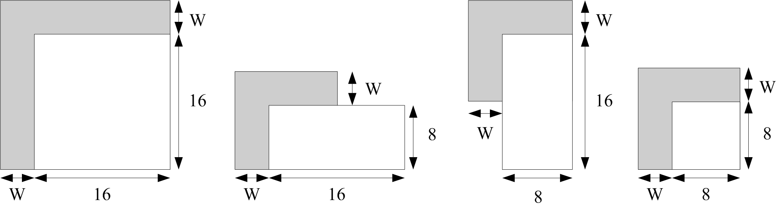
Fig. 1 Template composition for block partitions with different size
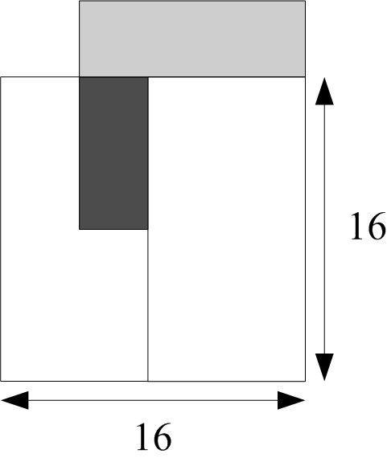
Fig. 2 Template composition when a part of the template is not available
2. The motion information candidates from the left block and upright block are achieved from the neighbor blocks. In order to refine the motion estimation, the neighborhood of those in sub-pixel range could also be used as shown in Fig. 4.
3. Simple upsample reference block is applied during the motion estimation. After a candidate is obtained, a simple filter, namely bilinear filter [1,1] is used to interpolate the reference region pointed by the candidate. Then the upsampled reference region sim_refblk is achieved, and an upsampled reference template ref_TM is obtained.
The process is illustrated in Fig. 4, where a rectangle means the integer pixel position. A circle means the half pixel position. And a triangle means 1/4 pixel position. E.g. the interpolation process is shown as below,
h = (A + C + 1) / 2;
m = (B + D +1) / 2;
b = (A + B + 1) / 2;
s = (C + D + 1) / 2;
j = (b + s + 1) / 2;
a = (A + b +1 ) /2;
… (1)
Then the upsampled reference template ref_TM can be constructed.
4. Template matching is used. After the upsampled reference template ref_TM is obtained from the sim_refblk pointed by the candidates or the refinement motion vectors nearby the candidates, the distortion cost between cur_TM and ref_TM could be calculated by the following expression (2).
(2)
Where curr_TM(x,y) stands for the pixel value on the position (x,y). u and v mean the horizontal and vertical components of the motion vector.
5. Get the MVs. The process in 3 and 4 are applied looply according to the number of the candidates. N(=2) motion vectors with the minimum distortion cost are used to predict the current block.
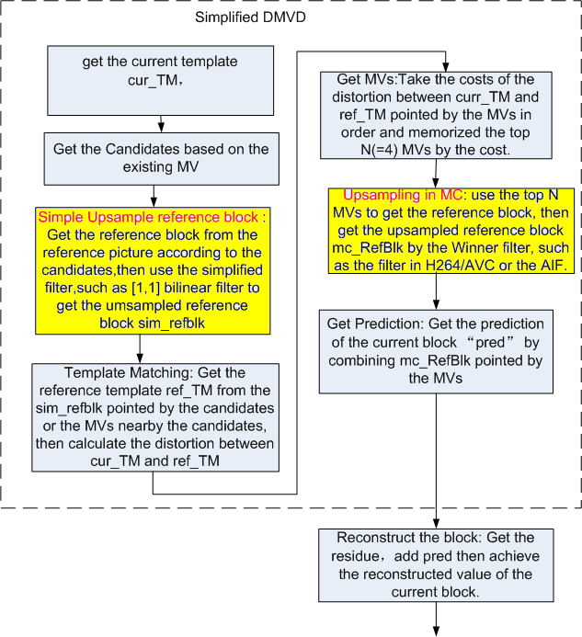
Fig. 3 flowchart of SDMVD
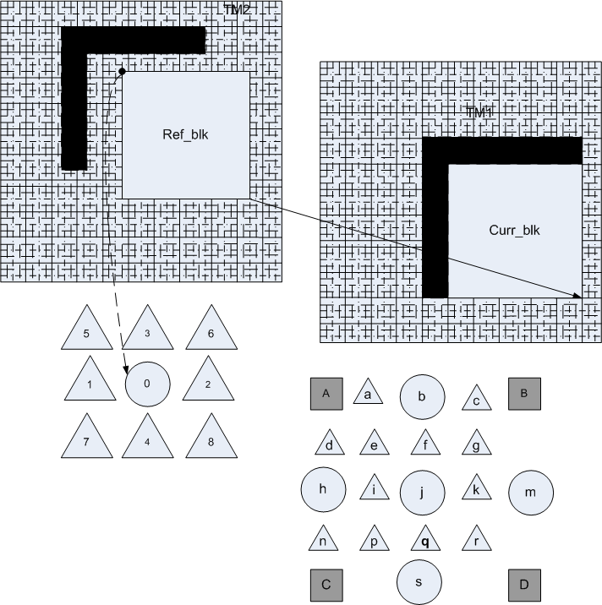
Fig. 4 simple upsample process in ME of SDMVD
6. Upsample the reference block in Motion Compensation(MC). In MC winner filter such as the filter in H.264/AVC or the AIF is used to interpolate the reference block (mc_RefBlk). The process is illustrated in Fig. 5. Here, the gray rectangle means integer pixel position, and the white rectangle means half and 1/4 pixel position. E.g. the half pixel is interpolated by the Winner filter [1,-5, 20, 20,-5, 1] firstly, then, the 1/4 pixel is interpolated by the integer and half pixel with bilinear filter, as illustrated as follow,
;
;
a = (G + b + 1) / 2;
… (3)
7. Get the prediction. mc_RefBlks pointed by N motion vector (abtained in step 5) are used to predict current block. The equation is as below,
(4)
Where mc_RefBlk(x+u_{i},y+v_{i}) is the upsampled reference block, (u_{i},v_{i}) is the motion vector.
After the prediction is achieved, we can encode or decode the current block as usual.
Fig. 5 upsample in motion compensation of SDMVD

Syntax and Semantic Change
For SDMVD, the simplified technique is implemented into the motion vector derivation process so no extra syntax is added into the bitstream.

Spatial Temporal Direct Mode (STDM)

Algorithm description
A novel DIRECT mode called STDM is proposed here which could exploit both spatial and temporal information and improve coding efficiency. Here the decoding process is depicted and the flowing chart is as below.
Fig.6 Flowing Chart of STDM
1． Specify the reference frames
Two reference frames should be specified for the current encoding block. In B slice, the two reference frames are the nearest forward and backward reference frames in List0 and List1. In P slice the two reference frames are the nearest and the second nearest forward references in List0. The corresponding position of the two reference frames is illustrated in Fig. 7. In the following chapters the nearest forward reference frame is called the forward reference frame, and the nearest backward reference frame in B slice and the second nearest forward reference frame in P slice is called the corresponding reference frame.
Fig. 7 The positions of the two reference frames
2． Set up a motion vector candidate set
A motion vector candidate set is set up which consists of spatial-temporal neighboring motion vectors. Currently the candidate set only includes forward motion vectors. As illustrated in Fig. 8, four spatial motion vector candidates are obtained from four adjacent, the left (A), top (B), topright (C), topleft (D), blocks of the current MB. Another spatial candidate motion vector is the median motion vector of these neighboring motion vectors. The derivation procedure of this median motion vector is the same as the derivation procedure of motion vector predictor in H.264. The temporal candidate is obtained from the collocated motion vector in the forward reference frame. If the candidate block is intra-coded, then we will use zero motion instead. All these motion vectors are scaled based on their reference index or POC number.
Fig.8 Spatial Neighboring Motion Vectors
3 Derivation of motion vector pairs
Each forward candidate motion vector will have a corresponding motion vector in the corresponding reference frame. Assuming that the motion of objects is simple translation, the corresponding motion vector is obtained by the following formula:
(5)
represents the distance between the current encoding frame and the forward reference frame and represent the distance between the current encoding frame and the corresponding reference frame. If the direction between the current frame and the forward reference frame is assumed to be positive, then in P slice is positive and in B slice is negative.
4． Find the best motion vector pair
After the candidate set is set up, each of motion vectors in the set will be checked. The one that minimize the following spatial-temporal cost function is selected as the final motion vector of current macroblock.
Cost = SAD(MBforward, MBcorresponding)+lambda*SAD(Templateforward, Templatecurrent) +lambda*SAD(Templatecorresponding, Templatecunrent) (6)
This cost function consists of 3 parts: sum of absolute differences (SAD) between the forward and the corresponding reference MB, template matching cost between the forward reference MB and the current MB, and template matching cost between the corresponding reference MB and the current MB. Each template is an L-shape template with a width of 4 beside current MB (illustrated in Fig.9), and the matching cost is SAD between pixels of the template region in the current frame and the corresponding displaced template-shaped region in the reference frames. Lamda is simply set as 1.
The above process is applied to P SKIP and B SKIP/DIRECT MB. For B_DIRECT_8x8 block, we firstly derive the motion vectors of the MB which the direct block belongs to, then these motion vectors are used for the B_DIRECT_8x8 block directly.
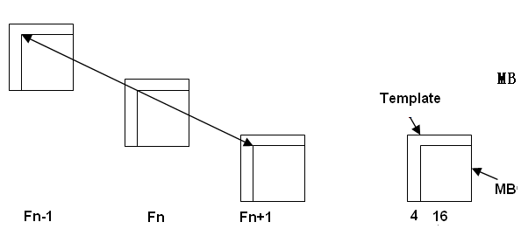
Fig. 9 Illustration for the Cost Function
After these steps, the reference block is subtracted by the current block to get the residual and the residual is encoding into the bitstream. P SKIP and B SKIP do not need to code residual.
The simplified technique described in chapter 1 can also be used in STDM which could further decrease the complexity of motion vector derivation. In the follow chapter we called it as SSTDM (Simplified STDM). The process of SSTDM is similar with Fig. 3 to simplify the reference interpolation in Motion Estimation and the cost is only calculated with equation (7).
(7)

Software Implementation
For P slice in RWTH Aachen University’s DMVD, conventional PSKIP mode is replaced by DMVD PSKIP mode in macroblock 16x16 level. In proposed STDM, conventional PSKIP mode is replaced by STDM PSKIP in macroblock 32x32 level and STDM PSKIP is compete with DMVD PSKIP mode in macroblock 16x16 level. Since RWTH Aachen University’s DMVD already supports this kind of competition between DMVD PSKIP and conventional PSKIP, so compared with RWTH’s implementation no extra flag is needed. For B Slice, STDM BSKIP/BDIRECT is competing with conventional BSKIP/BDIRECT in macroblock 16x16 and 32x32 levels. One flag for B SKIP/DIRECT mode is needed to indicate which specific method is chosen in B SKIP/DIRECE mode.

Syntax and Semantic Change
New syntax elements “use_stdm_flag” and “stdm_flag” are added as follows. (The green part is modification of proposed new syntax elements and the yellow part is modification of syntax elements in RWTH Aachen University’s DMVD.)
Slice header syntax modification：
Slice_type |  | ue(v) | ae(v)
if (Slice_type != I_Slice){
use_stdm_flag | 2 | ue(v) | ae(v)
…
}
Table 1
Macroblock layer syntax modification:
macroblock_layer32( ) { | C | Descriptor
mb_type | 2 | ue(v) | ae(v)
If(Slice_type == B_Slice && USE_STDM_FLAG ==1 && (mb_type ==B_Direct_32x32 || mb_type == B_Skip_32x32) )
stdm_flag | 2 | ae(v)
if( dmvdAllowedInMB ) {
if( mb_type = = P_L0_16x16 | |
mb_type = = B_X_16x16 | |
mb_type = = P_L0_32x32 | |
mb_type = = B_X_32x32 ) {
dmvd_flag[ 0 ] | 2 | ae(v)
} else if( mb_type = = P_L0_L0_16x8 | |
mb_type = = P_L0_L0_8x16 | |
mb_type = = B_X_X_16x8 | |
mb_type = = B_X_X_8x16 ) {
dmvd_flag[ 0 ] | 2 | ae(v)
dmvd_flag[ 1 ] | 2 | ae(v)
}
}
if( mb_type = = I_PCM ) {
…

macroblock_layer( ) { | C | Descriptor
mb_type | 2 | ue(v) | ae(v)
If(Slice_type == B_Slice && USE_STDM_FLAG ==1 && (mb_type ==B_Direct_16x16 || mb_type == B_Skip_16x16) )
stmd_flag | 2 | ae(v)
If(Slice_type == P_Slice && USE_STDM_FLAG ==1 && mb_type ==P_SKIP )
stmd_flag | 2 | ae(v)
if( dmvdAllowedInMB ) {
if( mb_type = = P_L0_16x16 | |
mb_type = = B_X_16x16 | |
mb_type = = P_L0_32x32 | |
mb_type = = B_X_32x32 ) {
dmvd_flag[ 0 ] | 2 | ae(v)
} else if( mb_type = = P_L0_L0_16x8 | |
mb_type = = P_L0_L0_8x16 | |
mb_type = = B_X_X_16x8 | |
mb_type = = B_X_X_8x16 ) {
dmvd_flag[ 0 ] | 2 | ae(v)
dmvd_flag[ 1 ] | 2 | ae(v)
}
}
if( mb_type = = I_PCM ) {
…

sub_mb_pred( mb_type ) { | C | Descriptor
for( mbPartIdx = 0; mbPartIdx < 4; mbPartIdx++ )
sub_mb_type[ mbPartIdx ] | 2 | ue(v) | ae(v)
if(Slice_type == B_Slice && USE_STDM_FLAG ==1 && mb_type == B_8X8 && (sub_mb_type[0] == B_Direct_8x8 || sub_mb_type[1] == B_Direct_8x8 || sub_mb_type[2] == B_Direct_8x8 || sub_mb_type[3] == B_Direct_8x8))
stmd_flag | 2 | ae(v)
if( dmvdAllowedInMB &&
mb_type = = P_8x8 ) {
for( mbPartIdx = 0; mbPartIdx < 4; mbPartIdx++ )
if( sub_mb_type[ mbPartIdx ] = = P_L0_8x8 )
dmvd_flag[ mbPartIdx ] | 2 | ae(v)
for( mbPartIdx = 0; mbPartIdx < 4; mbPartIdx++ )
if( ( num_ref_idx_l0_active_minus1 > 0 | |
mb_field_decoding_flag != field_pic_flag ) &&
mb_type != P_8x8ref0 &&
sub_mb_type[ mbPartIdx ] != B_Direct_8x8 &&
SubMbPredMode( sub_mb_type[ mbPartIdx ] ) != Pred_L1 &&
dmvd_flag[ mbPartIdx ] = = 0 )
ref_idx_l0[ mbPartIdx ] | 2 | te(v) | ae(v)
for( mbPartIdx = 0; mbPartIdx < 4; mbPartIdx++ )
if( ( num_ref_idx_l1_active_minus1 > 0 | |
mb_field_decoding_flag != field_pic_flag ) &&
sub_mb_type[ mbPartIdx ] != B_Direct_8x8 &&
SubMbPredMode( sub_mb_type[ mbPartIdx ] ) != Pred_L0 &&
dmvd_flag[ mbPartIdx ] = = 0 )
ref_idx_l1[ mbPartIdx ] | 2 | te(v) | ae(v)
for( mbPartIdx = 0; mbPartIdx < 4; mbPartIdx++ )
if( sub_mb_type[ mbPartIdx ] != B_Direct_8x8 &&
SubMbPredMode( sub_mb_type[ mbPartIdx ] ) != Pred_L1 &&
dmvd_flag[ mbPartIdx ] = = 0 )
for( subMbPartIdx = 0;
subMbPartIdx < NumSubMbPart( sub_mb_type[ mbPartIdx ] );
subMbPartIdx++)
for( compIdx = 0; compIdx < 2; compIdx++ )
mvd_l0[ mbPartIdx ][ subMbPartIdx ][ compIdx ] | 2 | se(v) | ae(v)
for( mbPartIdx = 0; mbPartIdx < 4; mbPartIdx++ )
if( sub_mb_type[ mbPartIdx ] != B_Direct_8x8 &&
SubMbPredMode( sub_mb_type[ mbPartIdx ] ) != Pred_L0 &&
dmvd_flag[ mbPartIdx ] = = 0 )
for( subMbPartIdx = 0;
subMbPartIdx < NumSubMbPart( sub_mb_type[ mbPartIdx ] );
subMbPartIdx++)
for( compIdx = 0; compIdx < 2; compIdx++ )
mvd_l1[ mbPartIdx ][ subMbPartIdx ][ compIdx ] | 2 | se(v) | ae(v)
}
use_stdm_flag indicates STDM is used or not in a slice.
- If USE_STDM_FLAG is equal to 1, the motion vectors of P_SKIP, B_SKIP, B_DIRECT_16X16 and B_DIRECT_8X8 in a slice could be derived by STDM.
- Otherwise STDM is not used for the motion vector derivation of P_SKIP, B_SKIP, B_DIRECT_16X16 and B_DIRECT_8X8.
stdm_flag specifies which motion vector derivation method is used for current B_SKIP, B_DIRECT_16X16 or B_DIRECT_8X8 mode in B slice.
- If stdm_flag is equal to 1, STDM motion vector derivation method is used.
- Otherwise conventional motion vector derivation method is used.

Compression performance discussion
Since some of our technique is developed based on RWTH Aachen University’s DMVD, not only the proposed techniques but also RWTH Aachen University’s DMVD are simulated.
The test conditions in the simulation comply with the TE1 test conditions agreed with all TE1 participants. Detailed test conditions are available in attached configure files.
Detailed test results are available in attached Excel files.

Test results for Constraint set 1 configuration relative to TE1 anchor
In the table 1 below, average BDPSNR as well as average BDRATE is used. rwthDMVD represents RWTH Aachen University’s DMVD. SDMVD represents proposed Simplified DMVD. SDMVD_STDM represents proposed Simplified DMVD plus proposed STDM. SDMVD_SSTDM represents Simplified DMVD plus Simplified STDM.
Video Sequences |  | rwthDMVD |  | SDMVD |  | SDMVD_STDM |  | SDMVD_SSTDM
 |  | BDPSNR  [dB] | BDRATE  [%] | BDPSNR  [dB] | BDRATE  [%] | BDPSNR  [dB] | BDRATE  [%] | BDPSNR  [dB] | BDRATE  [%]
Class A | PeopleOnStreet | 0.15 | -3.12 | 0.15 | -3.09 | 0.25 | -5.34 | 0.25 | -5.34
Class A | Traffic | 0.17 | -4.15 | 0.15 | -3.71 | 0.24 | -6.01 | 0.24 | -6.09
Class B | Kimono1 | 0.23 | -6.85 | 0.21 | -6.35 | 0.33 | -9.98 | 0.33 | -9.97
Class B | ParkSene | 0.17 | -4.89 | 0.16 | -4.68 | 0.23 | -6.63 | 0.23 | -6.61
Class B | BasketballDrive | 0.16 | -5.63 | 0.16 | -5.38 | 0.21 | -7.14 | 0.20 | -6.93
Class B | BQTerrace | 0.11 | -5.01 | 0.11 | -4.96 | 0.16 | -7.02 | 0.16 | -6.91
Class B | Cactus | 0.11 | -3.53 | 0.10 | -3.38 | 0.21 | -6.88 | 0.21 | -6.86
Class C | RaceHorses | 0.09 | -2.36 | 0.09 | -2.41 | 0.11 | -2.93 | 0.12 | -3.04
Class C | PartyScene | 0.10 | -2.33 | 0.10 | -2.31 | 0.16 | -3.91 | 0.16 | -3.83
Class C | BQMall | 0.16 | -3.67 | 0.15 | -3.47 | 0.23 | -5.22 | 0.23 | -5.21
Class C | BasketballDrill | 0.13 | -3.34 | 0.14 | -3.54 | 0.16 | -4.12 | 0.16 | -4.20
Average |  | 0.14 | -4.08 | 0.14 | -3.94 | 0.21 | -5.93 | 0.21 | -5.91
Table 1. RD Performance in CS1 Condition
From Table 1 both SDMVD and SSTDM have equivalent RD performance as DMVD and STDM, respectively. And compared with RWTH Aachen University’s DMVD, SSTDM achieves about 2% bitrate saving and about 0.07 dB PSNR increasing. Compared with TE1 anchor, the total gain for proposed techniques is about 6% bitrate saving and 0.2 dB PSNR increasing.

Test results for Constraint set 2 configuration relative to TE1 anchor
Video Sequences |  | rwthDMVD |  | SDMVD |  | SDMVD_STDM |  | SDMVD_SSTDM
 |  | BDPSNR  [dB] | BDRATE  [%] | BDPSNR  [dB] | BDRATE  [%] | BDPSNR  [dB] | BDRATE  [%] | BDPSNR  [dB] | BDRATE  [%]
Class B | Kimono1 | 0.07 | -2.19 | 0.05 | -1.79 | 0.12 | -4.07 | 0.11 | -3.80
Class B | ParkSene | 0.07 | -2.14 | 0.07 | -2.02 | 0.09 | -2.84 | 0.09 | -2.83
Class B | BasketballDrive | 0.09 | -3.38 | 0.09 | -3.28 | 0.12 | -4.21 | 0.12 | -4.23
Class B | BQTerrace | 0.28 | -12.59 | 0.27 | -12.02 | 0.28 | -12.44 | 0.28 | -12.38
Class B | Cactus | 0.07 | -2.47 | 0.08 | -2.61 | 0.14 | -4.66 | 0.14 | -4.74
Class C | RaceHorses | 0.12 | -2.94 | 0.13 | -3.06 | 0.14 | -3.45 | 0.15 | -3.55
Class C | PartyScene | 0.15 | -3.66 | 0.14 | -3.50 | 0.15 | -3.62 | 0.14 | -3.51
Class C | BQMall | 0.11 | -2.44 | 0.10 | -2.20 | 0.15 | -3.50 | 0.15 | -3.54
Class C | BasketballDrill | 0.12 | -3.38 | 0.14 | -3.69 | 0.15 | -3.99 | 0.15 | -4.07
Average |  | 0.12 | -3.91 | 0.12 | -3.80 | 0.15 | -4.75 | 0.15 | -4.74
Table 2. RD Performance in Beta Condition
From Table 2 both SDMVD and SSTDM have equivalent RD performance as DMVD and STDM, respectively. And compared with RWTH Aachen University’s DMVD, SSTDM achieves about 1% bitrate saving and about 0.03 dB PSNR increasing. Compared with TE1 anchor, the total gain for proposed techniques is about 4.7% bitrate saving and 0.15 dB PSNR increasing.

Complexity Analysis

Complexity characteristics of SDMVD and SSTDM

SDMVD
As for the upsampling process in the motion estimation, because it is only used to find the appropriate motion vectors to get the prediction, there’s no straightforward relationship between it and the prediction. So a relative simple filter such as a bilinear filter is used to upsample the reference block in the motion estimation. In theory, corresponding to adopting H.264/AVC filter, the operators can reduce to 1/3, and to consider hardware design, the memory bandwith can be reduced. Meanwhile the encoding performance is also maintained.

SSTDM
For each macroblock, six pairs of motion vectors need to be checked. So 12 template information (one for current macroblock and one for the forward motion vector) and 12 reference macroblock information are required. All these information need to be moved from the memory to the cache. In order to find the best motion vector STDM need 6 SAD calculations for macroblock size and 6 SAD calculation for template size. In addition because one of six positions is the collocated motion vector, all motion vector information in the forward reference frame need to be saved which add extra memory. However since some of these six motion vector pairs might be the same and only the different motion vectors are needed for cost calculation, the complexity could be further reduced.
And the following experiment result also shows that although the complexity can be decreased significantly, the performance can be maintained.

Decoding time and measurement methodology
In the tables below, the data means the decoding time (seconds) of the decoder. The data in the tables are the average decoding time for each sequence at all rate points.
All of the data are measured on the same computer. The computer’s configuration is as below:
MS windows Server 2003R2, Enterprise x64 Edition, SP2. Inter® Xeon® CPU E5520 @2.27GHz, 2.27GHz, 16 GB of RAM. And the soucecode is implemented only in C language, without any optimization by assemble language, such as MMX or SSE2 instruction, etc. Constraint set 1 configuration relative to TE1 anchor

Constraint set 1 configuration relative to TE1 anchor
Video Sequences |  | Anchor | rwthDMVD | SDMVD | SDMVD_STDM | SDMVD_SSTDM
Class A | PeopleOnStreet | 126.38 | 704.85 | 338.62 | 338.77 | 291.88
Class A | Traffic | 121.75 | 524.86 | 252.92 | 240.66 | 222.95
Class B | Kimono1 | 60.68 | 237.00 | 122.22 | 119.45 | 102.19
Class B | ParkSene | 67.63 | 283.52 | 144.91 | 142.57 | 125.97
Class B | BasketballDrive | 65.76 | 277.29 | 144.71 | 151.17 | 134.08
Class B | BQTerrace | 65.19 | 241.20 | 129.11 | 129.59 | 123.69
Class B | Cactus | 49.09 | 220.35 | 110.51 | 111.48 | 93.56
Class C | RaceHorses | 12.86 | 64.25 | 31.68 | 33.91 | 29.53
Class C | PartyScene | 12.25 | 52.11 | 26.73 | 27.72 | 24.44
Class C | BQMall | 9.97 | 49.94 | 24.09 | 23.26 | 21.21
Class C | BasketballDrill | 9.77 | 47.73 | 23.00 | 22.70 | 21.75
Average |  | 54.67 | 245.74 | 122.59 | 121.93 | 108.30
Table 3. Complexity Analysis in CS1 Condition
From Table 3 rwthDMVD is about 4.5 times slower than TE1 anchor. After using SDMVD, the decoding time reduces to 2.1 times slower than TE1 anchor. When using SDMVD_SSTDM, the decoding time further reduces to 1.99 times slower than TE1 anchor. So SDMVD_SSTDM can significantly reduce the DMVD decoding complexity.

Constraint set 2 configuration relative to TE1 anchor
Video Sequences |  | Anchor | rwthDMVD | SDMVD | SDMVD_STDM | SDMVD_SSTDM
Class B | Kimono1 | 58.09 | 309.10 | 143.17 | 175.40 | 160.39
Class B | ParkSene | 64.09 | 398.93 | 182.66 | 216.12 | 199.76
Class B | BasketballDrive | 64.76 | 450.05 | 203.43 | 228.03 | 212.75
Class B | BQTerrace | 59.87 | 680.35 | 261.09 | 282.20 | 272.07
Class B | Cactus | 46.29 | 267.51 | 124.17 | 129.36 | 120.43
Class C | RaceHorses | 13.66 | 116.47 | 50.95 | 53.54 | 50.72
Class C | PartyScene | 11.98 | 137.71 | 52.29 | 53.61 | 52.41
Class C | BQMall | 9.84 | 78.89 | 33.41 | 33.42 | 31.20
Class C | BasketballDrill | 9.81 | 77.91 | 33.12 | 34.93 | 33.62
Average |  | 37.60 | 279.66 | 120.48 | 134.07 | 125.93
Table 4. Complexity Analysis in CS2 Condition
From Table 3 rwthDMVD is about 7.5 times slower than TE1 anchor. After using SDMVD, the decoding time reduces to 3.2 times slower than TE1 anchor. When using SDMVD_SSTDM, the decoding time further reduces to 3.35 times slower than TE1 anchor. So SDMVD_SSTDM can significantly reduce the DMVD decoding complexity.

Conclusion
In this proposal we present the detailed description of our SDMVD and STDM together with the analysis of coding performance and complexity. From the simulation results, we can see that the coding performance of TE1 anchor can be significantly improved by the proposed techniques. We really hope decoder side motion vector derivation techniques could be integrated into the TMuC test model for further investigation.

Patent rights declaration(s)
(NOTE – Activities in the JCT-VC and contributions to the JCT-VC are subject to the common patent policy for ITU-T/ITU-R/ISO/IEC. A statement of that policy can be found at
http://www.itu.int/ITU-T/dbase/patent/patent-policy.html, with further information available at http://www.itu.int/ITU-T/ipr/index.html and in the ISO/IEC Directives. The form to be used for the formal reporting of patent rights to ITU-T/ITU-R/ISO/IEC can be found at http://www.itu.int/ITU-T/ipr/index.html. Contributions to the JCT-VC proposing normative technical content shall contain a non-binding informal notice of whether the submitter may have patent rights that would be necessary for implementation of the resulting standard. The provided informal notice shall indicate the category of anticipated licensing terms according to the ITU-T/ITU-R/ISO/IEC patent statement and licensing declaration form. This obligation to provide an informal notice is supplemental to, and does not replace, any existing obligations of parties with technology included in a final or draft standard to submit formal IPR declarations to ITU-T/ITU-R/ISO/IEC. An example of an informal IPR notification statement for a contribution is provided below.)

Huawei Technology and Peking University may have IPR relating to the technology described in this contribution and, conditioned on reciprocity, is prepared to grant licenses under reasonable and non-discriminatory terms as necessary for implementation of the resulting ITU-T Recommendation | ISO/IEC International Standard (per box 2 of the ITU-T/ITU-R/ISO/IEC patent statement and licensing declaration form).

