    Joint Collaborative Team on Video Coding (JCT-VC)  of ITU-T SG16 WP3 and ISO/IEC JTC1/SC29/WG11  2nd Meeting: Geneva, CH, 21-28 July, 2010 | Document: JCTVC-B030

Title: | TE1: RWTH partner report on DMVD
Status: | Input Document to JCT-VC
Purpose: | Proposal
Author(s) or  Contact(s): | Mathias Wien, Steffen Kamp  Institut für Nachrichtentechnik  RWTH Aachen University  D-52056 Aachen, Germany | Tel:  Email: | +49 241 80-27671  {wien,kamp}@ient.rwth-aachen.de
Source: | RWTH Aachen University
_____________________________

Abstract
In this contribution, the RWTH tool description and simulation results for the contribution to the Tool Experiment TE1 on Decoder Side Motion Vector Derivation (DMVD) are provided. The technical description of the proposed tools in this document closely relates to the tool description provided as in the response to the Call for Proposals for HEVC.
Simulation results are provided relative to the defined TE1 simulation conditions. The accompanying spreadsheets provide rate-distortion measurements, BD-delta rate and SNR values, and complexity assessment data.

Introduction
The partners in TE1 agreed to select the RWTH implementation of DMVD as the common platform for this tool experiment [1]. The technical description of the proposed tools in this document closely relates to the tool description provided as in the response to the Call for Proposals for HEVC [2]. The software was made available via a SVN repository with personal login for the TE participants shortly after the meeting. The software is based on the KTA software version 2.6r1. Unless otherwise noted, the algorithm details of the proposal are identical to the tools found in the original KTA software.

Algorithm description

Motion representation
The motion representation is based on the H.264/AVC motion representation found in the KTA software with the addition of 32x32 macroblocks introduced using the UseExtMB=1 encoder parameter setting. Inter-frame pictures may either be P or B pictures (i.e. allowing unidirectional prediction only or bidirectional prediction) and are coded in 32x32 macroblocks processed in line scan order. Each macroblock may be coded using either one 32x32 partition, two 32x16 partitions, two 16x32 partitions, or four 16x16 partitions coded in zig-zag scan order. In the latter case, all H.264/AVC macroblock subdivisions down to 4x4 blocks are possible for each of the four 16x16 partitions.
Motion vectors may either be coded explicitly or implicitly. Boolean flags in the bitstream signal whether explicit or implicit coding is used. One such flag is present for each 32x32, 16x16, 16x8, 8x16, or 8x8 partition. Other partitions (32x16, 16x32, 8x4, 4x8, 4x4) always use explicit coding. The explicit coding is done according to the original KTA software when UseExtMB=1 and MVCompetition=1 (i.e. quarter pel accuracy, differential coding relative to a motion vector predictor, coding of reference picture indices). When using implicit motion vector coding (further denoted as Decoder-side Motion Vector Derivation, DMVD), the motion vector differences, MV Competition flags, and reference picture index(es) are not present in the bitstream for that particular partition.

Decoder-side Motion Vector Derivation (DMVD)
Implicit motion vector coding with DMVD may introduce additional motion granularity. Therefore we introduce the concept of a prediction “target” which is defined as a rectangular set of pixels in the decoded picture for which a set of motion parameters is valid. For the case of explicit motion coding, the target is always equal to a full partition. With DMVD, motion parameters for multiple targets within one partition may be derived. While the subdivision of partitions into targets is conceptually configurable for our proposal, the setting listed in Table 1 was used for all simulations.

Table 1 DMVD target counts and target sizes for different prediction partition sizes.

Partition size | 32x32 | 16x16 | 16x8 | 8x16 | 8x8
Number of targets | 4 | 1 | 2 | 2 | 4
Target size | 16x16 | 16x16 | 8x8 | 8x8 | 4x4

The basic principle for DMVD is a template matching algorithm on a set of motion candidates. A motion candidate is composed of a 2D motion vector and the associated reference picture index. The template matching cost of a candidate is obtained by calculating the sum of absolute differences (SAD) between the template region in the current picture and the identically shaped template region referenced by the motion candidate. The template region in the current picture is defined as the four pixel wide, rotated L-shaped region adjacent to the prediction target (see Figure 1). The template region in the reference picture is of identical shape, its position is offset by the displacement given by the 2D motion vector of the candidate. If the template region referenced by a motion candidate is located at a sub-pixel position, the spatial interpolation method associated with the respective reference picture is used to obtain the signal for cost calculation. For our proposal the template matching cost is calculated on the luma signal component only.

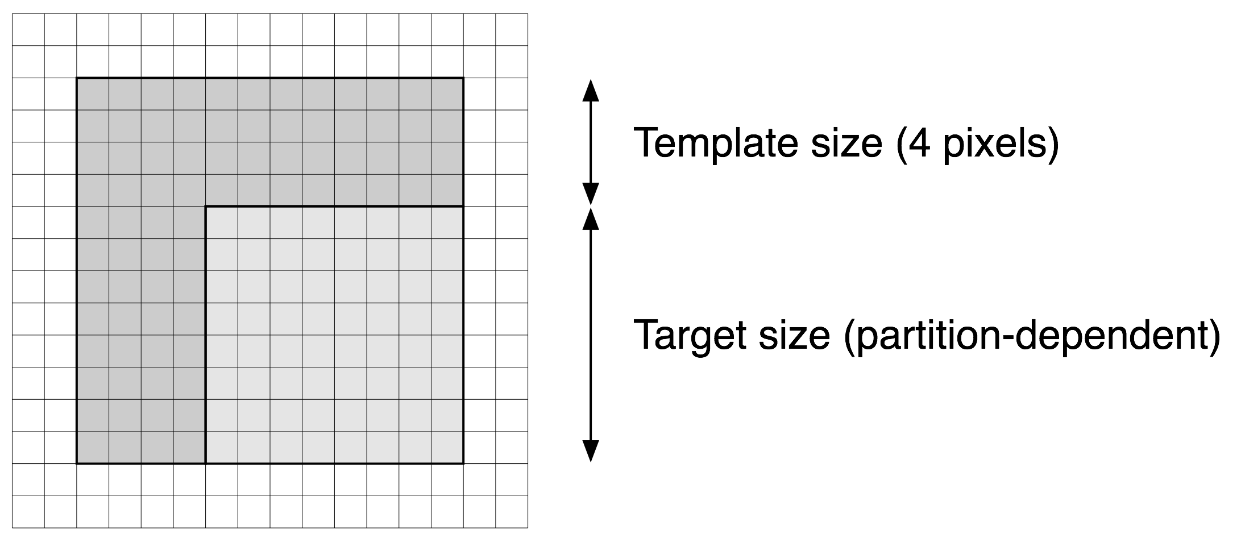

Figure 1 DMVD prediction target and template region on a pixel grid. While the template size is dependent on the block partition size, the template region always extends four pixels to the top and left edges of the target.

For each partition using DMVD (i.e. dmvd_flag[ mbPartIdx ] is equal to 1), the DMVD prediction process as described in Section 2.1.3 is performed successively for all targets inside the partition in zig-zag scan order.

Usage of the derived motion parameters
During the decoding process, the motion parameters derived using DMVD (motion vector and reference picture index) are utilized for regular motion vector prediction (MVP) calculation. For this purpose, if the MVP derivation process references a DMVD partition it accesses the parameters of the motion candidate with lowest cost as determined in the DMVD prediction process.
During the bitstream parsing process, the motion vector differences and reference picture indices of DMVD blocks are assumed to be equal to zero for purposes of CABAC context derivation. As the DMVD prediction process may yield different motion parameters in the case of transmission errors (e.g. if a reference picture used for the DMVD search is unavailable to the decoder) this ensures that the correct context is selected in any event.
Note: When using motion vector competition the presence of motion vector competition syntax elements in the bitstream depends on decoded motion vectors. I.e. if all candidate vectors competing to be the motion vector predictor are equal, the motion vector competition syntax element is not present in the bitstream. If DMVD yields a different decoded motion vector due to transmission errors, the decoder may erroneously assume the presence or non-presence of the motion vector competition syntax element, which would prevent further parsing of the bitstream. Further study would be required for resolving issues due to the combination of the two tools.

Handling of template regions within the currently decoded macroblock
The template matching calculation of DMVD relies on the availability of a template signal within the currently decoded picture. Consequently, template matching is performed prior to any deblocking operations in the current KTA implementation. Another issue arises if some part of the template region lies within the currently decoded macroblock: While at the decoder the residual signal (after inverse quantization and transform) for the currently decoded block could be obtained and used for template matching, this is not always easily possible at the encoder. In order to perform rate-distortion optimized mode decision, the encoder needs to obtain the prediction signal covering the full support of the spatial transform. Therefore, if the DMVD target region and parts of the template region lie within the support of the spatial transform, the prediction signal (without residual) for the affected template region should be used in the template matching calculation.
For the purpose of this proposal, the following rules apply:
DMVD in 32x32 partitions: As the DMVD target size is 16x16 and the maximum spatial transform support is also 16x16 the residual can be obtained for the target directly after DMVD prediction. Therefore, the template matching calculation in 32x32 blocks always uses the fully reconstructed signal (prediction plus residual), even if the template region lies partially within the current 32x32 partition.
DMVD in 16x16 partitions: For blocks coded in 16x16 mode a DMVD target size of 16x16 is used. Consequently, the template region always lies outside of the current block in fully reconstructed blocks.
DMVD in 16x8, 8x16, or 8x8 partitions: At least for some targets the template region will lie within the currently decoded block. In these cases, the prediction signal (without residual) obtained for this area – either using regular motion compensation or DMVD prediction – is used for template matching calculation.

DMVD syntax and semantics
The following syntax tables detail the changes required for DMVD relative to H.264/MPEG-4 Part 10 (AVC). For better clarity, the tables do not include the full changes required for other KTA tools that have been used for this proposal. Only in the specification of macroblock_layer( ) the larger macroblock partition sizes are included.

macroblock_layer( ) { | C | Descriptor
mb_type | 2 | ue(v) | ae(v)
if( dmvdAllowedInMB ) {
if( mb_type = = P_L0_16x16 | |
mb_type = = B_X_16x16 | |
mb_type = = P_L0_32x32 | |
mb_type = = B_X_32x32 ) {
dmvd_flag[ 0 ] | 2 | ae(v)
} else if( mb_type = = P_L0_L0_16x8 | |
mb_type = = P_L0_L0_8x16 | |
mb_type = = B_X_X_16x8 | |
mb_type = = B_X_X_8x16 ) {
dmvd_flag[ 0 ] | 2 | ae(v)
dmvd_flag[ 1 ] | 2 | ae(v)
}
}
if( mb_type = = I_PCM ) {
…

mb_pred( mb_type ) { | C | Descriptor
if( MbPartPredMode( mb_type, 0 ) = = Intra_4x4 | |
MbPartPredMode( mb_type, 0 ) = = Intra_8x8 | |
MbPartPredMode( mb_type, 0 ) = = Intra_16x16 ) {
if( MbPartPredMode( mb_type, 0 ) = = Intra_4x4 )
for( luma4x4BlkIdx=0; luma4x4BlkIdx<16; luma4x4BlkIdx++ ) {
prev_intra4x4_pred_mode_flag[ luma4x4BlkIdx ] | 2 | u(1) | ae(v)
if( !prev_intra4x4_pred_mode_flag[ luma4x4BlkIdx ] )
rem_intra4x4_pred_mode[ luma4x4BlkIdx ] | 2 | u(3) | ae(v)
}
if( MbPartPredMode( mb_type, 0 ) = = Intra_8x8 )
for( luma8x8BlkIdx=0; luma8x8BlkIdx<4; luma8x8BlkIdx++ ) {
prev_intra8x8_pred_mode_flag[ luma8x8BlkIdx ] | 2 | u(1) | ae(v)
if( !prev_intra8x8_pred_mode_flag[ luma8x8BlkIdx ] )
rem_intra8x8_pred_mode[ luma8x8BlkIdx ] | 2 | u(3) | ae(v)
}
if( ChromaArrayType = = 1 | | ChromaArrayType = = 2 )
intra_chroma_pred_mode | 2 | ue(v) | ae(v)
} else if( MbPartPredMode( mb_type, 0 ) != Direct ) {
for( mbPartIdx = 0; mbPartIdx < NumMbPart( mb_type ); mbPartIdx++)
if( ( num_ref_idx_l0_active_minus1 > 0 | |
mb_field_decoding_flag != field_pic_flag ) &&
MbPartPredMode( mb_type, mbPartIdx ) != Pred_L1 &&
dmvd_flag[ mbPartIdx ] = = 0 )
ref_idx_l0[ mbPartIdx ] | 2 | te(v) | ae(v)
for( mbPartIdx = 0; mbPartIdx < NumMbPart( mb_type ); mbPartIdx++)
if( ( num_ref_idx_l1_active_minus1 > 0 | |
mb_field_decoding_flag != field_pic_flag ) &&
MbPartPredMode( mb_type, mbPartIdx ) != Pred_L0 &&
dmvd_flag[ mbPartIdx ] = = 0 )
ref_idx_l1[ mbPartIdx ] | 2 | te(v) | ae(v)
for( mbPartIdx = 0; mbPartIdx < NumMbPart( mb_type ); mbPartIdx++)
if( MbPartPredMode ( mb_type, mbPartIdx ) != Pred_L1 &&
dmvd_flag[ mbPartIdx ] = = 0 )
for( compIdx = 0; compIdx < 2; compIdx++ )
mvd_l0[ mbPartIdx ][ 0 ][ compIdx ] | 2 | se(v) | ae(v)
for( mbPartIdx = 0; mbPartIdx < NumMbPart( mb_type ); mbPartIdx++)
if( MbPartPredMode( mb_type, mbPartIdx ) != Pred_L0 &&
dmvd_flag[ mbPartIdx ] = = 0 )
for( compIdx = 0; compIdx < 2; compIdx++ )
mvd_l1[ mbPartIdx ][ 0 ][ compIdx ] | 2 | se(v) | ae(v)
}
}

sub_mb_pred( mb_type ) { | C | Descriptor
for( mbPartIdx = 0; mbPartIdx < 4; mbPartIdx++ )
sub_mb_type[ mbPartIdx ] | 2 | ue(v) | ae(v)
if( dmvdAllowedInMB &&
mb_type = = P_8x8 ) {
for( mbPartIdx = 0; mbPartIdx < 4; mbPartIdx++ )
if( sub_mb_type[ mbPartIdx ] = = P_L0_8x8 )
dmvd_flag[ mbPartIdx ] | 2 | ae(v)
for( mbPartIdx = 0; mbPartIdx < 4; mbPartIdx++ )
if( ( num_ref_idx_l0_active_minus1 > 0 | |
mb_field_decoding_flag != field_pic_flag ) &&
mb_type != P_8x8ref0 &&
sub_mb_type[ mbPartIdx ] != B_Direct_8x8 &&
SubMbPredMode( sub_mb_type[ mbPartIdx ] ) != Pred_L1 &&
dmvd_flag[ mbPartIdx ] = = 0 )
ref_idx_l0[ mbPartIdx ] | 2 | te(v) | ae(v)
for( mbPartIdx = 0; mbPartIdx < 4; mbPartIdx++ )
if( ( num_ref_idx_l1_active_minus1 > 0 | |
mb_field_decoding_flag != field_pic_flag ) &&
sub_mb_type[ mbPartIdx ] != B_Direct_8x8 &&
SubMbPredMode( sub_mb_type[ mbPartIdx ] ) != Pred_L0 &&
dmvd_flag[ mbPartIdx ] = = 0 )
ref_idx_l1[ mbPartIdx ] | 2 | te(v) | ae(v)
for( mbPartIdx = 0; mbPartIdx < 4; mbPartIdx++ )
if( sub_mb_type[ mbPartIdx ] != B_Direct_8x8 &&
SubMbPredMode( sub_mb_type[ mbPartIdx ] ) != Pred_L1 &&
dmvd_flag[ mbPartIdx ] = = 0 )
for( subMbPartIdx = 0;
subMbPartIdx < NumSubMbPart( sub_mb_type[ mbPartIdx ] );
subMbPartIdx++)
for( compIdx = 0; compIdx < 2; compIdx++ )
mvd_l0[ mbPartIdx ][ subMbPartIdx ][ compIdx ] | 2 | se(v) | ae(v)
for( mbPartIdx = 0; mbPartIdx < 4; mbPartIdx++ )
if( sub_mb_type[ mbPartIdx ] != B_Direct_8x8 &&
SubMbPredMode( sub_mb_type[ mbPartIdx ] ) != Pred_L0 &&
dmvd_flag[ mbPartIdx ] = = 0 )
for( subMbPartIdx = 0;
subMbPartIdx < NumSubMbPart( sub_mb_type[ mbPartIdx ] );
subMbPartIdx++)
for( compIdx = 0; compIdx < 2; compIdx++ )
mvd_l1[ mbPartIdx ][ subMbPartIdx ][ compIdx ] | 2 | se(v) | ae(v)
}
The variable dmvdAllowedInMB is derived to be equal to 0 if the current macroblock shares an edge with either the left or top edge of the current slice and equal to 1 otherwise. This ensures that the template region (see below) is not outside of the currently decoded slice.
When dmvd_flag[ mbPartIdx ] is equal to 1 the DMVD prediction process (see Section 2.1.3) is invoked for obtaining the prediction signal of the corresponding partition. When dmvd_flag[ mbPartIdx ] is not present it shall be inferred to be equal to 0.

DMVD Processes
DMVD Prediction Process
Inputs: The currently decoded picture and the location and size of the current prediction target region. The prediction direction for the current prediction target region. The current reference pictures list(s).
Output: The prediction signal for the current prediction target region.
The following reference pictures are used in the DMVD process:
For P pictures: All pictures from the List_0 reference picture list.
For B pictures: A modified reference picture list is derived, such that a reference picture can only occur in one of the two lists. If a reference picture is contained in both reference picture lists, it is removed from the list where the reference picture index is higher. If the reference picture index is the same into both lists, the picture is removed from List_1. The reason for having a reference picture appear in only one of the two lists is that the template cost does not depend on the reference picture index. If e.g. both lists contained the same set of reference pictures in a different order, the DMVD process would yield the same prediction signal independent of whether List_0 or List_1 prediction was used and the coding of the prediction direction would be redundant. Hence, using two lists with disjoint sets of reference pictures gives the encoder more choices for a suitable mode.
For each reference picture from the (modified) lists relevant for the prediction direction (coded using the macroblock type, either as List_0, List_1, or bidirectional prediction) a motion candidate set and the DMVD cost associated with each candidate in the set is obtained by invoking the DMVD Search Process (see below) for the reference picture. The union set of these motion candidate sets is used for the further steps.
The prediction signal for the target is obtained depending of the prediction direction:
- For unidirectional prediction:
  - Luma: The two motion candidates of the union set with lowest cost are used to obtain two prediction signals (with spatial interpolation and weighted prediction applied). These signals are pixel wise added and divided by two.
  - Chroma: The motion candidate of the union set with lowest cost is used to obtain one prediction signal (with spatial interpolation and weighted prediction applied).
- For bidirectional prediction: The motion candidate of the union set with lowest cost from List_0 and the motion candidate of the union set with lowest cost from List_1 are used to obtain two prediction signals (with spatial interpolation and weighted prediction applied). These signals are pixel wise added and divided by two. (This applies to luma and chroma.)
In other words: For all partitions using DMVD the luma prediction signal for each target is obtained as an average of two prediction signals (hypotheses), even if unidirectional prediction is used. As the motion parameters are derived, the coding cost is generally independent of the number of motion hypotheses used for generating the prediction signal.

DMVD Search Process
Inputs: The currently decoded picture and the location and size of the current prediction target region. Decoded motion parameters of the adjacent left, top-right and top-left block partitions or targets. A reference picture.
Output: A set containing one or two motion candidates
An initial motion candidate set is constructed from the motion parameters taken from neighboring blocks to the left and top-right of the current target. If motion is unavailable for the top-right block (it is either outside of the picture region or has not yet been decoded due to the block coding order) the top-left block is used instead (see Figure 2). Depending on whether the neighboring block is coded as intra, inter with unidirectional prediction, or inter with bidirectional prediction, zero, one, or two motion vectors with corresponding reference picture index are associated with it. Accordingly, the motion parameters from the two neighboring blocks form a candidate set of up to two candidates in P pictures and up to four candidates in B pictures. Should the candidate set be empty (i.e. the neighboring blocks are unavailable or coded as intra), a zero-motion vector is added so the initial set contains at least one candidate.

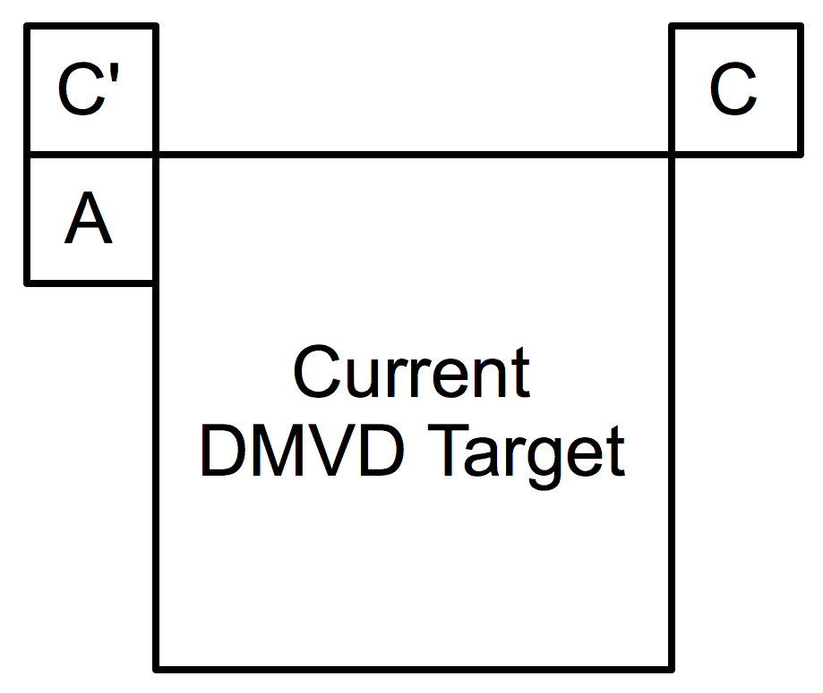

Figure 2 Motion parameters from blocks A and C adjacent to the current DMVD target are used as motion candidates. If motion for block C is unavailable, block C' is used instead.

In order to adjust the candidates to the current reference picture, each candidate motion vector is linearly scaled by multiplying its spatial components with the quotient of the temporal distances between a) current picture and current reference picture (the input to the DMVD search process) and b) current picture and candidate reference picture (the reference picture associated with the motion candidate). The picture order count (POC) values are used for determining temporal distances. Finally each candidate’s reference picture index is set to the current reference picture index and the template matching cost is calculated for the candidate by invoking the DMVD Cost Derivation Process (see below). See Figure 3 for an illustration of the candidate adjustment.

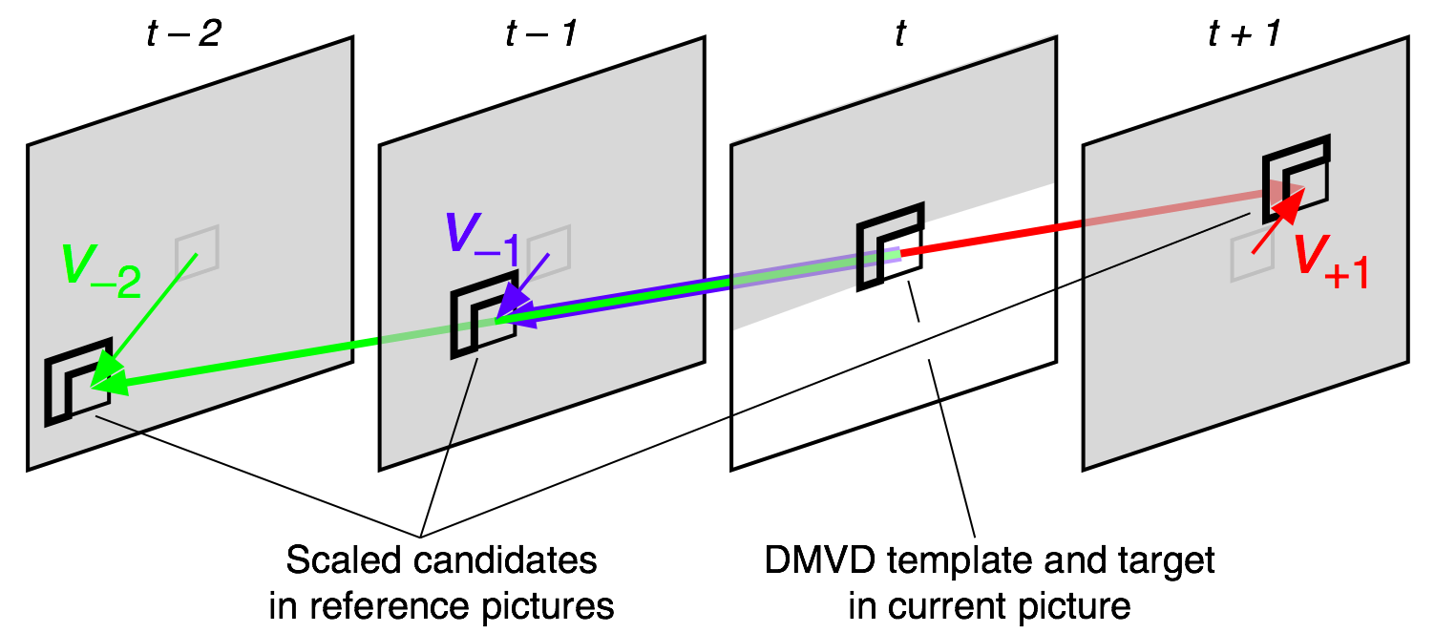

Figure 3 Adjusting candidates to reference pictures. Grey areas are decoded picture regions, the white area has not yet been decoded. Given that the original candidate was one of $v_{−2}$, $v_{−1}$, $v_{+1}$, the other two would result as the scaled candidates for the respective reference picture.

In the layout of this proposal, for each reference picture the final motion candidate set contains two candidates at most. It is constructed from refined motion candidates obtained by invoking the DMVD Candidate Refinement Process (see below) one by one on the initial candidates in order of ascending template cost. The repeated invocation of the candidate refinement process is performed until the final set contains two refined candidates or all initial candidates have been refined. (As it is possible that the refinement of the different candidates yields the same vector for all candidates it may happen that the final set contains only one candidate, even if the initial set contains more than one candidate.)

DMVD Candidate Refinement Process
Inputs: The currently decoded picture and the location and size of the current prediction target region. A motion candidate and its corresponding reference picture.
Output: The refined motion candidate.
Note: The candidate refinement process is similar to a motion vector sub-pel refinement often performed as part of the motion estimation at the encoder. However, the original candidate may already reference a sub-pixel position. Half-pel or quarter-pel offsets as discussed in the next paragraph are always relative to this original candidate.
In a first step the template matching costs for the motion candidate and all eight horizontal and/or vertical half-pixel offsets relative to the input motion candidate are obtained by invoking the DMVD Cost Derivation Process. From these nine positions (eight offsets plus the original candidate), the one with lowest template matching cost is selected and in a second step the costs for the eight surrounding horizontal and/or vertical quarter-pixel offsets are calculated. The position with absolute lowest cost among all tested positions is used as motion vector of the final refined motion candidate.

DMVD Cost Derivation Process
Inputs: The currently decoded picture and the location and size of the current prediction target region. A motion candidate and its associated reference picture.
Output: The template matching cost.
The template matching cost is obtained by calculating the sum of absolute differences between the luma signal defined by a rotated, L-shaped, four pixel wide region adjacent to the top-left of the current prediction target and the luma signal (with weighted prediction applied) of the identically shaped region, offset by the spatial displacement given by the motion candidate in the reference picture. If the candidate references a sub-pixel position, the spatial interpolation filter associated with the reference picture is used to obtain the signal of the referenced region.

Simulation Results
The simulations carried out in this contribution were performed using the common TE1 configuration files for the constraint sets CS1 and CS2 as specified in the TE1 document [1]. The respective configuration files as well as the applied encoder call are provided with this document.
The simulation data was generated with the (KTA) TE software as provided in the TE1 SVN repository. For the DMVD results, the DMVD-configuration file was passed to the TE software in addition to the basic configuration file. All simulations were performed using the same encoder and decoder binaries. The encoder calls for all simulations are provided with this document in JCTVC-B030_enc.zip.
In addition to the TE1 anchor conditions, the following settings have been analyzed. For each, anchor and DMVD results were generated:
- UseExtMB=0, setting the macroblock size to 16x16 as in H.264/AVC.
- MVCompetition=1, using motion vector competition (MVC), which was not used in the TE anchors
- UseExtMB=0 + MVCompetition=1, the combination of the settings listed above.
In subsection 3.1, the rate-distortion results are summarized. In subsection 3.2, memory consumption and simulation time measurements are reported. Detailed data on the rate-distortion measurements and the memory and simulation time assessment are provided in the accompanying spreadsheets JCTVC-B030_bdsnr.xls (BD-delta measurements), JCTVC-B030_cmplx_anal.xls (memory and simulation time deltas), and JCTVC-B030_rd_cmplx_data.xls (the raw data).

Rate Distortion Results
In JCTVC-B030_bdsnr.xls, the detailed data is provided. Here, only the average numbers are reported. Rate-distortion plots for all sequences as well as BD-rate plots are provided for all test cases in JCTVC-B030_plots.

Constraint Set 1
Default configuration:
 | BD Rate [%] | BD PSNR [dB]
Average Class A | -3,71 | 0,16
Average Class B | -4,34 | 0,14
Average Class C | -2,93 | 0,12
Average total | -4,11 | 0,14

ExtMB=0
 | BD Rate [%] | BD PSNR [dB]
Average Class A | -6,29 | 0,29
Average Class B | -7,69 | 0,27
Average Class C | -5,05 | 0,21
Average total | -7,24 | 0,23

With Motion vector competition
 | BD Rate [%] | BD PSNR [dB]
Average Class A | -3,05 | 0,13
Average Class B | -3,69 | 0,12
Average Class C | -2,78 | 0,11
Average total | -3,49 | 0,12

With ExtMB=0 and Motion vector competition
 | BD Rate [%] | BD PSNR [dB]
Average Class A | -4,58 | 0,21
Average Class B | -6,03 | 0,21
Average Class C | -4,56 | 0,19
Average total | -5,69 | 0,21

Constraint Set 2
Default configuration
 | BD Rate [%] | BD PSNR [dB]
Average Class B | -4,87 | 0,13
Average Class C | -3,25 | 0,13
Average total | -4,15 | 0,13

ExtMB=0
 | BD Rate [%] | BD PSNR [dB]
Average Class B | -7,39 | 0,22
Average Class C | -3,76 | 0,15
Average total | -5,78 | 0,19

With Motion vector competition
 | BD Rate [%] | BD PSNR [dB]
Average Class B | -4,27 | 0,11
Average Class C | -3,17 | 0,13
Average total | -3,78 | 0,12

With ExtMB=0 and Motion vector competition
 | BD Rate [%] | BD PSNR [dB]
Average Class B | -4,53 | 0,12
Average Class C | -3,36 | 0,14
Average total | -4,01 | 0,13

Complexity Assessment
In JCTVC-B030_cmplx_anal.xls, the detailed data is provided. Here, only the average numbers are reported.

Constraint Set 1
Default CS1
 | Relative memory usage |  | User time
Average | total | decoder | total | decoder
Class A | 0,00% | 0,01% | 107,81% | 238,43%
Class B | -0,05% | -0,48% | 90,03% | 192,65%
Class C | -0,07% | -1,29% | 102,79% | 242,20%
CS1 ExtMB=0
 | Relative memory usage |  | User time
Average | total | decoder | total | decoder
Class A | 0,00% | -0,18% | 106,78% | 357,99%
Class B | -0,05% | -0,24% | 105,25% | 270,62%
Class C | -0,10% | -0,89% | 85,70% | 255,20%
CS1 MVC=1
 | Relative memory usage |  | User time
Average | total | decoder | total | decoder
Class A | 0,00% | -0,06% | 127,25% | 213,65%
Class B | -0,03% | 0,54% | 114,33% | 179,21%
Class C | 0,11% | -1,22% | 110,45% | 229,59%
CS1 ExtMB=0 MVC=1
 | Relative memory usage |  | User time
Average | total | decoder | total | decoder
Class A | 0,00% | 0,06% | 108,67% | 305,91%
Class B | 0,00% | -0,40% | 99,19% | 251,87%
Class C | -0,27% | -1,33% | 91,37% | 247,54%

Constraint Set 2
Default CS2
 | Relative memory usage |  | User time
Average | total | decoder | total | decoder
Class B | 0,00% | -0,17% | 56,44% | 399,58%
Class C | 0,00% | -1,63% | 49,87% | 475,91%
CS2 ExtMB=0
 | Relative memory usage |  | User time
Average | total | decoder | total | decoder
Class B | 0,00% | -0,28% | 35,89% | 485,02%
Class C | 0,02% | -2,05% | 39,29% | 495,16%
CS2 MVC=1
 | Relative memory usage |  | User time
Average | total | decoder | total | decoder
Class B | 0,00% | 0,14% | 42,59% | 310,86%
Class C | 0,00% | -1,22% | 48,18% | 448,31%
CS2 ExtMB=0 MVC=1
 | Relative memory usage |  | User time
Average | total | decoder | total | decoder
Class B | 0,00% | -0,17% | 26,80% | 270,74%
Class C | 0,01% | -1,73% | 34,17% | 430,38%

Discussion
The simulation results show an average of about 4% rate savings in the default configuration. For both, CS1 and CS2. The usage of Motion Vector Competition results in a drop of approximately 0.5% points in both cases. At the H.264/AVC macroblock size of 16x16, average savings are around 7% for CS1 and around 5.8% for CS2. Here, the combination with motion vector competition reduces the gains of DMVD by around 1.3%.
In CS2, while most of the sequences provided consistent gains, remarkable gains are observed for the test sequence BQTerrace. BD rate savings of about 11-16% are observed.
The complexity data reveals a significant timing impact in the current implementation. The decoding time may be significantly increased. It should be noted that this might have strong relation to the KTA software and the implementation therein. The implementation in a clean new HEVC Test Model may reveal a clearer picture on the performance impact of DMVD.

Conclusions
Based on the observed results, it is suggested to continue the activity of the TE. The performance of DMVD has to be investigated within the HEVC test model (TM) software to be defined. Work may begin in the Test Model under Consideration (TMuC). The interaction of DMVD with other tools needs further study, e.g. the combination of DMVD with larger block sizes.
The authors suggest the formation of an AhG on decoder-side parameter derivation in which the TE on DMVD and other activities are coordinated.

References
- M. Wien, and Y. Chiu, “Tool Experiment 1: Decoder-Side Motion Vector Derivation”, Doc. JCTVC-A301, Joint Collaborative Team on Video Coding (JCT-VC) of ITU-T SG16 WP3 and ISO/IEC JTC1/SC29/WG11, Dresden, Germany, Apr. 2010.
- S. Kamp, and M. Wien, “Description of video coding technology proposal by RWTH Aachen University”, Doc. JCTVC-A112, Joint Collaborative Team on Video Coding (JCT-VC) of ITU-T SG16 WP3 and ISO/IEC JTC1/SC29/WG11, Dresden, Germany, Apr. 2010.
- S. Kamp, M. Evertz, and M. Wien, “Decoder side motion vector derivation,” Doc. MPEG2007/M14917, ISO/IEC JTC1/SC29/WG11, Shenzen, China, Oct. 2007.
- S. Kamp, M. Evertz, and M. Wien, “Decoder side motion vector derivation,” Doc. VCEG-AG16, ITU-T SG16/Q6 VCEG, 33rd Meeting, Shenzhen, China, Oct. 2007.
- S. Kamp, M. Evertz, and M. Wien, “Decoder side motion vector derivation with multiple reference pictures,” Doc. VCEG-AH15, ITU-T SG16/Q6 VCEG, 34rd Meeting, Antalya, Turkey, Jan. 2008.
- S. Kamp and M. Wien, “Multi-hypothesis prediction with decoder side motion vector derivation,” Doc. JVT-AA040, Joint Video Team (JVT) of ISO/IEC MPEG & ITU-T VCEG, 27th Meeting, Geneva, Switzerland, Apr. 2008.
- S. Kamp and M. Wien, “Improving AVC compression performance by template matching with decoder-side motion vector derivation,” Doc. MPEG2008/M15375, ISO/IEC JTC1/SC29/WG11, Archamps, France, Apr. 2008.
- S. Kamp, B. Bross, and M. Wien, “Fast decoder side motion vector derivation,” Doc. VCEG-AJ18, ITU-T SG16/Q6 VCEG, 36th Meeting, San Diego, California, USA, Oct. 2008.
- S. Kamp, M. Evertz, and M. Wien, “Decoder side motion vector derivation for inter frame video coding,” in Proc. of IEEE International Conference on Image Processing ICIP ’08, (San Diego, CA, USA), pp. 1120–1123, Oct. 2008.
- S. Kamp and M. Wien, “Fast decoder side motion vector derivation with candidate scaling,” Doc. JVT-AD018, Joint Video Team (JVT) of ISO/IEC MPEG & ITU-T VCEG, 30th Meeting, Geneva, Switzerland, Jan. 2009.
- S. Kamp, J. Ballé, and M. Wien, “Multihypothesis prediction using decoder side motion vector derivation in inter frame video coding,” in Proc. of SPIE Visual Communications and Image Processing VCIP ’09, (San José, CA, USA), Jan. 2009.
- S. Kamp and M. Wien, “Fast decoder side motion vector derivation with candidate scaling for improving AVC compression performance,” Doc. MPEG2009/M16069, ISO/IEC JTC1/SC29/WG11, Lausanne, Switzerland, Feb. 2009.
- S. Kamp, B. Bross, and M. Wien, “Fast decoder side motion vector derivation for inter frame video coding,” in Proc. of International Picture Coding Symposium PCS ’09, (Chicago, IL, USA), May 2009.
- S. Kamp, J. Ballé, and M. Wien, “Response to Call for Evidence in HVC: Hybrid video coding with ETP and DMVD,” Doc. MPEG2009/M16661, ISO/IEC JTC1/SC29/WG11, London, UK, July 2009.

Patent rights declaration(s)
RWTH Aachen university may have IPR relating to the technology described in this contribution and, conditioned on reciprocity, is prepared to grant licenses under reasonable and non-discriminatory terms as necessary for implementation of the resulting ITU-T Recommendation | ISO/IEC International Standard (per box 2 of the ITU-T/ITU-R/ISO/IEC patent statement and licensing declaration form).

