    Joint Collaborative Team on Video Coding (JCT-VC)  of ITU-T SG16 WP3 and ISO/IEC JTC1/SC29/WG11  2nd Meeting: Geneva, CH, 21-28 July, 2010 | Document: JCTVC-B029

Title: | Summary Report for TE1 on DMVD
Status: | Input Document to JCT-VC
Purpose: | Tool Experiment Report
Author(s) or  Contact(s): | Mathias Wien  RWTH Aachen University  Yi-Jen Chiu  Intel Corp. | Tel:  Email: | +49-241-8027672  wien@ient.rwth-aachen.de  yi-jen.chiu@intel.com
Source: | TE coordinators (RWTH Aachen University, Intel Corp.)
_____________________________

Introduction
This document summarizes the activities in the Tool Experiment TE1 on Decoder-side Motion Vector Derivation (DMVD).
A group of 15 companies has registered for participation in TE1. Between the meetings, a lively email discussion took place among the about 30 individuals representing the participating companies.

Document List

TE Documents
(Status: list scanned until doc B116)
Participant | Document | Title | Type
Huawei | JCTVC-B037 | TE1: Huawei report on DMVD improvements (joint document with Peking University) | Proposal, verified by Intel (JCTVC-B048)
Intel | JCTVC-B047  JCTVC-B048 | TE1: Fast techniques to improve self derivation of motion estimation  TE1: Cross-checking of DMVD result from Huawei | Proposal, verified by Mitsubishi (JCTVC-B069)  Verification
JVC | JCTVC-B032 | TE1: Refinement Motion Compensation using Decoder-side Motion Estimation | Proposal, verified by TUB (JCTVC-B105)
Leibniz Univ. Hannover (LUH) | JCTVC-B119 | Verification of DMVD implementation (JCTVC-B0769) | Verification
LGE
MediaTek | JCTVC-B076 | TE1: Decoder-side motion vector derivation with switchable template matching | Proposal, verified by LUH (JCTVC-B119)
Mitsubishi Electric Corp. | JCTVC-B069 | Report of TE1: Decoder-side motion vector derivation | Verification
Peking University | JCTVC-B037 | TE1: Huawei report on DMVD improvements (joint document with Huawei)
Qualcomm | JCTVC-B097 | TE1: Decoder-side motion vector derivation report from Qualcomm | Proposal
RWTH Aachen University | JCTVC-B030 | TE1: RWTH partner report on DMVD | Proposal, verified by Samsung (JCTVC-B099)
Samsung | JCTVC-B099 | TE1: Verification results of RWTH DMVD approach | Verification
Skype
Sungkyunkwan University
Technische Univ. Berlin (TUB) | JCTVC-B105 | Cross-check result of JCTVC-B032 Refinement motion compensation using decoder-side motion estimation | Verification
Yonsei University

Related Documents
Participant | Document | Title
Leibniz Univ. Hannover | JCTVC-B026 | Decoder-side motion estimation with modified reference list

Summary of proposals

JCTVC-B037 (Huawei)
Huawei Technologies has developed two DMVD related techniques and both of them have been implemented and tested following the TE1 requirements (JCTVC-A301). One of them is Simplified DMVD technique (SDMVD) for complexity reduction, and the other is Spatial and Temporal Direct Mode (STDM) which exploits both spatial and temporal information. SDMVD adopts the similar structure of DMVD, however it applies different interpolation filter in motion estimation and motion compensation of DMVD. A fix simple bilinear filter is applied to interpolate the reference block for refinement motion estimation, while the relative complex filter such as the Winner filter in H264/AVC is used to get the upsampled reference block for motion compensation. Simple translational model is adopted by STDM. Through minimizing the spatial-temporal cost function, STDM can adaptively choose the spatial or temporal motion information. According to the test results, a combined performance gain of 5.91% (CS1) and 4.74 (CS2) over the TE1 anchor bistreams is observed. Compared with TE1 anchor, the complexity of our decoder is 1.99 times for CS1 and 3.35 times for CS2.

RD results
Test results for CS1 and CS2 configuration relative to TE1 anchor
Video Sequences |  | SDMVD_SSTDM
 |  | BDPSNR  [dB] | BDRATE  [%]
Class A | PeopleOnStreet | 0.25 | -5.34
Class A | Traffic | 0.24 | -6.09
Class B | Kimono1 | 0.33 | -9.97
Class B | ParkSene | 0.23 | -6.61
Class B | BasketballDrive | 0.20 | -6.93
Class B | BQTerrace | 0.16 | -6.91
Class B | Cactus | 0.21 | -6.86
Class C | RaceHorses | 0.12 | -3.04
Class C | PartyScene | 0.16 | -3.83
Class C | BQMall | 0.23 | -5.21
Class C | BasketballDrill | 0.16 | -4.20
Average |  | 0.21 | -5.91

Video Sequences |  | SDMVD_SSTDM
 |  | BDPSNR  [dB] | BDRATE  [%]
Class B | Kimono1 | 0.11 | -3.80
Class B | ParkSene | 0.09 | -2.83
Class B | BasketballDrive | 0.12 | -4.23
Class B | BQTerrace | 0.28 | -12.38
Class B | Cactus | 0.14 | -4.74
Class C | RaceHorses | 0.15 | -3.55
Class C | PartyScene | 0.14 | -3.51
Class C | BQMall | 0.15 | -3.54
Class C | BasketballDrill | 0.15 | -4.07
Average |  | 0.15 | -4.74

JCTVC-B047 (Intel)
This contribution presents the techniques to improve the derivation of motion vector at decoder (DMVD) side with the aim to increase coding efficiency of B pictures as well as to realize parallel friendly implementation of a video decoder. With the motion vector (MV) information self derived at video decoder side, the transmission of these MVs from video encoder side to video decoder side is skipped and thus better coding efficiency can be achieved. The proposed self derivation of motion estimation (SDME) techniques are friendly to the parallel implementation by utilizing on the temporal correlation among the available pixels in the previously-decoded reference pictures, instead of operating on the previously reconstructed pixels of the neighboring area of the current picture, which poses an inherent decoding ordering causal relationship among decoding blocks of current picture. Experiments have demonstrated that the BD bitrate improvement on top of ITU-T/VCEG Key Technology Area (KTA) Reference Software platform with an overall about 7.56% improvement on the hierarchical IbBbBbBbP coding structure under the test conditions with the block size 16x16 from the Tool Experiment group at JCT-VC. A fast version of the candidate based scheme has demonstrated an overall saving of the SDME computation time by about 93.9% with an overall 7.52% BD bitrate improvement. In addition, a parallel-friendly version to further remove the MV prediction neighbor dependency has shown an overall 6.78% improvement in BD bitrate reduction.

RD results
Table 2 Full search based SDME performance compared with TE1 anchors
 | Sequence | UseExtMB = 1 |  | UseExtMB = 0
 | Sequence | BD_PSNR (dB) | BD_Bitrate (%) | BD_PSNR (dB) | BD_Bitrate (%)
Average of Class A |  | 0.217 | -5.120 | 0.376 | -8.580
Average of Class B |  | 0.151 | -4.832 | 0.345 | -10.217
Average of Class C |  | 0.070 | -1.684 | 0.156 | -3.715
Overall Average |  | 0.133 | -3.740 | 0.282 | -7.555
Table 3 Candidates based fast SDME performance compared with TE1 anchors
 | Sequence | UseExtMB = 1 |  | UseExtMB = 0
 | Sequence | BD_PSNR (dB) | BD_Bitrate (%) | BD_PSNR (dB) | BD_Bitrate (%)
Average of Class A |  | 0.179 | -4.193 | 0.335 | -7.668
Average of Class B |  | 0.158 | -5.048 | 0.359 | -10.618
Average of Class C |  | 0.056 | -1.330 | 0.151 | -3.577
Overall Average |  | 0.125 | -3.540 | 0.279 | -7.521
Table 4 Candidates based fast SDME performance compared with TE1 anchors (No MV prediction dependency on self derived MVs)
 | Sequence | UseExtMB = 1 |  | UseExtMB = 0
 | Sequence | BD_PSNR (dB) | BD_Bitrate (%) | BD_PSNR (dB) | BD_Bitrate (%)
Average of Class A |  | 0.147 | -3.496 | 0.309 | -7.230
Average of Class B |  | 0.131 | -4.139 | 0.335 | -9.870
Average of Class C |  | 0.030 | -0.679 | 0.113 | -2.684
Overall Average |  | 0.097 | -2.764 | 0.249 | -6.777

JCTVC-B032 (JVC)
RMC (Refinement Motion Compensation using Decoder-side Motion Estimation) aims to improve the quality of a reference block in a motion compensation process using a decoder-side motion estimation process between reference pictures.

In RMC, a general motion compensation process with the transmitted motion vector and a decoder side motion estimation process are applied.

At first, the transmitted motion vector for reference picture 1 is rounded to integer accuracy.
Then, reference picture 1 is indicated by ref_idx transmitted in the bitstream.
Next, inter-reference motion estimation between reference picture 1 and reference picture 2 is performed using a template block obtained by the motion vector rounded to integer.
The motion vector rounded to integer for reference picture 1 is scaled based on relative distance between reference picture 1 from current picture and reference picture 2 from current picture like temporal direct mode in AVC.
Centered on the scaled motion vector, block based full search motion estimation is executed on reference picture 2 by full-pixel and sub-pixel accuracy hierarchically.
The inter reference motion vector is obtained by the result of the inter reference motion estimation.
A first MC block is obtained from reference picture 1 by executing motion compensation using the transmitted motion vector as the conventional motion compensation method.
On the other hand, a second MC block is obtained from reference picture 2 by executing motion compensation using the motion vector calculated by adding inter-reference motion vector to the transmitted motion vector.
Finally, a combined MC block is generated by the synthesis of the first MC block and the second MC block.

As a result, RMC can smooth the distortion of the reference picture and supplement the partially missing texture component to the reference picture like bi-predictive prediction. RMC needs only one motion vector for transmitting, therefore RMC can reduce additional information compared with bi-predictive prediction.

RMC is applicable to not only B slice but also P Slice. In the case of B Slice, reference MC block can lead other past and future reference pictures. In the case of P Slice, past reference MC block leads other past reference pictures.

Uni-predictive mode is replaced by RMC mode per prediction block adaptive. The information of the RMC applicable mode is sent in Slice Header. The flag of enabling RMC is sent per prediction block.

In Decode-side Motion Vector Derivation approach, the feature of RMC is as follows.

- Send one motion vector, and DMVD gets other motion vector for using bi-directional prediction.
- Use full-pixel accuracy reference block as template of DMVD.

The RMC tool has been implemented to KTA2.6r1 based TE1’s base software.
The prediction mode that can use RMC in this software is as follows.

RD results
The results of experiment for the implemented RMC tool are as follows. The anchor settings are the common anchor conditions under the TE1 activity. (The maximum MB size is 32x32)

JCTVC-B076 (MediaTek)
This contribution describes MediaTek’s work on decoder-side motion vector derivation (DMVD). In prior arts, template matching (TM) is always used to obtain motion information. In this proposal, it is suggested to adopt a switchable TM, and therefore two DMVD modes, DMVD_DIRECT and DMVD_TM, are provided. For DMVD_DIRECT, TM is disabled. A corresponding decoder utilizes only reference picture indices and motion vectors (MVs) of neighboring coding units (CUs) to derive motion information of a current CU with help from a corresponding encoder telling which spatial-temporal neighbors should be used. For DMVD_TM, TM is enabled. The TM search algorithm begins with an initial stage followed by a refinement stage. Moreover, adaptive template shape and boundary weighting are newly developed to improve the coding efficiency with low complexity overhead. Simulation results of two operating points are shown. The less complex operating point allows DMVD_DIRECT only. It achieves 5.35% and 5.63% average bit rate reductions for the TE1-DMVD Alpha and Gamma common test conditions, respectively, while the average decoding times are increased by 23% and 30% in comparison with the anchor that disables DMVD. For the more complex operating point, DMVD_DIRECT and DMVD_TM are both allowed. Average bitrate reductions become 7.24% and 7.66% for Alpha and Gamma, respectively, while the average decoding times are increased by 87% and 99%.

RD results
Table 2 BD-rates under TE1-DMVD test conditions
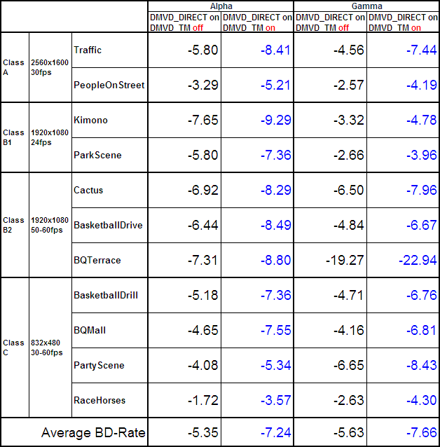
Table 3 BD-rates under MediaTek test conditions
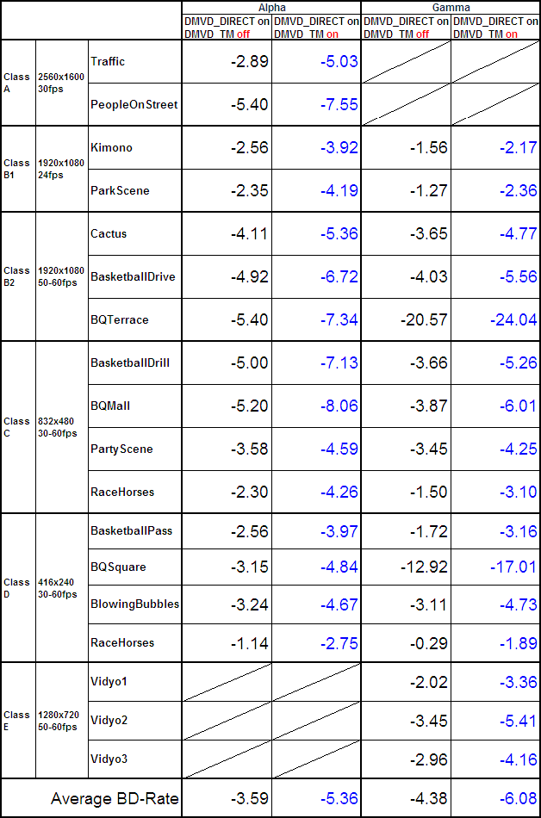

JCTVC-B097 (Qualcomm)
This is a decoder-side motion vector derivation (DMVD) scheme based on template matching prediction with a multihypothesis control. The template matching prediction method is used to create a better motion predictor without increasing the amount of side information. The DMVD mode is added to all the modes except P_4x4, P_8x4, and P_8x8. The template region is set to 4.
Additionally, a multihypothesis control flag is introduced to signal the selection of the number of hypotheses used in template matching motion prediction. The decoder may consider 2 or 8 hypotheses. This choice is signaled to the decoder for each partition. If 2 (8) hypotheses are used, the first 2 (8) best matched hypotheses are used in the motion prediction.

RD results
For IPPP configuration, a coding gain of 5.49% is achieved for the low bit-rate case and a coding gain of 6.18% is achieved for the high bit-rate case. For hierarchical B configuration, a coding gain of 2.99% is achieved for the low bit-rate case and a coding gain of 3.30% is achieved for the high bit-rate case.
Table 1: Simulation results of the proposed coding scheme
IPPP | High Bit-rate | Low Bit-rate
WVGA30_RaceHorses | -5.69 | -4.88
WVGA50_Basketball | -2.04 | -2.03
WVGA50_PartyScene | -4.37 | -2.87
WVGA60_BQSquare | -4.58 | -3.89
WVGA AVE | -4.17 | -3.42
1080p24_ParkScene | -4.39 | -4.36
1080p24_Kimono | -5.38 | -6.91
1080p50_Basketball | -5.97 | -5.69
1080p50_Cactus | -5.90 | -4.58
1080p60_BQSquare | -18.98 | -16.06
1080p AVE | -8.12 | -7.52
2560x1600_30_PeopleOnStreet | -4.24 | -3.99
2560x1600_30_Traffic | -6.42 | -5.16
2K AVE | -5.33 | -4.58
Average | -6.18 | -5.49

Hierarchical B | High Bit-rate | Low Bit-rate
WVGA30_RaceHorses | -2.39 | -2.40
WVGA50_Basketball | -0.79 | -0.45
WVGA50_PartyScene | -1.55 | -1.61
WVGA60_BQSquare | -2.43 | -2.35
WVGA AVE | -1.79 | -1.70
1080p24_ParkScene | -3.60 | -4.39
1080p24_Kimono | -4.83 | -5.30
1080p50_Basketball | -3.45 | -3.23
1080p50_Cactus | -3.43 | -2.63
1080p60_BQSquare | -8.03 | -5.32
1080p AVE | -4.67 | -4.17
2560x1600_30_PeopleOnStreet | -1.60 | -1.48
2560x1600_30_Traffic | -4.22 | -3.71
2K AVE | -2.91 | -2.60
Average | -3.30 | -2.99

JCTVC-B030 (RWTH)
In this contribution, the RWTH tool description and simulation results for the contribution to the Tool Experiment TE1 on Decoder Side Motion Vector Derivation (DMVD) are provided. The technical description of the proposed tools in this document closely relates to the tool description provided as in the response to the Call for Proposals for HEVC.
Simulation results are provided relative to the defined TE1 simulation conditions. The accompanying spreadsheets provide rate-distortion measurements, BD-delta rate and SNR values, and complexity assessment data.
The partners in TE1 agreed to select the RWTH implementation of DMVD as the common platform for this tool experiment [1]. The technical description of the proposed tools in this document closely relates to the tool description provided as in the response to the Call for Proposals for HEVC [2]. The software was made available via a SVN repository with personal login for the TE participants shortly after the meeting. The software is based on the KTA software version 2.6r1.

RD results
CS1
default |  |  |  |  | ExtMB=0
 | BD Rate [%] | BD PSNR [dB] |  |  |  |  | BD Rate [%] |  | BD PSNR [dB]
Average Class A | -3,71 | 0,16 |  |  | Average Class A |  | -6,29 |  | 0,29
Average Class B | -4,34 | 0,14 |  |  | Average Class B |  | -7,69 |  | 0,27
Average Class C | -2,93 | 0,12 |  |  | Average Class C |  | -5,05 |  | 0,21
Average total | -4,11 | 0,14 |  |  | Average total |  | -7,24 |  | 0,23
MVC=1 |  |  |  | ExtMB=0 MVC=1
 | BD Rate [%] | BD PSNR [dB] |  |  |  | BD Rate [%] |  | BD PSNR [dB]
Average Class A | -3,05 | 0,13 |  | Average Class A |  | -4,58 |  | 0,21
Average Class B | -3,69 | 0,12 |  | Average Class B |  | -6,03 |  | 0,21
Average Class C | -2,78 | 0,11 |  | Average Class C |  | -4,56 |  | 0,19
Average total | -3,49 | 0,12 |  | Average total |  | -5,69 |  | 0,21

CS2
default |  |  |  |  | ExtMB=0
 | BD Rate [%] | BD PSNR [dB] |  |  |  |  | BD Rate [%] |  | BD PSNR [dB]
Average Class B | -4,87 | 0,13 |  |  | Average Class B |  | -7,39 |  | 0,22
Average Class C | -3,25 | 0,13 |  |  | Average Class C |  | -3,76 |  | 0,15
Average total | -4,15 | 0,13 |  |  | Average total |  | -5,78 |  | 0,19
MVC=1 |  |  |  | ExtMB=0 MVC=1
 | BD Rate [%] | BD PSNR [dB] |  |  |  | BD Rate [%] |  | BD PSNR [dB]
Average Class B | -4,27 | 0,11 |  | Average Class B |  | -4,53 |  | 0,12
Average Class C | -3,17 | 0,13 |  | Average Class C |  | -3,36 |  | 0,14
Average total | -3,78 | 0,12 |  | Average total |  | -4,01 |  | 0,13

Conclusions
Based on the observed results, it is suggested to continue the activity of the TE. The performance of DMVD has to be investigated within the HEVC test model (TM) software to be defined. Work may begin in the Test Model under Consideration (TMuC).
The TE partners suggest the formation of an AhG on decoder-side parameter derivation in which the TE on DMVD and other activities are coordinated.

References
- M. Wien, and Y. Chiu, “Tool Experiment 1: Decoder-Side Motion Vector Derivation”, Doc. JCTVC-A301, Joint Collaborative Team on Video Coding (JCT-VC) of ITU-T SG16 WP3 and ISO/IEC JTC1/SC29/WG11, Dresden, Germany, Apr. 2010.

