    Joint Collaborative Team on Video Coding (JCT-VC)  of ITU-T SG16 WP3 and ISO/IEC JTC1/SC29/WG11  2nd Meeting: Geneva, CH, 21-28 July, 2010 | Document: JCTVC-B025

Title: | Intra-prediction with Adaptive Sub-sampling
Status: | Input Document to JCT-VC
Purpose: | Proposal
Author(s) or  Contact(s): | Yih Han Tan  Chuohao Yeo  Zhengguo Li  Susanto Rahardja  1 Fusionopolis Way  #21-01 Connexis (South Tower)  Singapore 138632 | Tel: +65 6408 2000  Email: chyeo@i2r.a-star.edu.sg
Source: | Institute for Infocomm Research
_____________________________

Abstract

Intra-prediction improves coding performance by reducing inter-pixel redundancy. However, to accommodate the use of block transforms, not all pixels can be predicted from reconstructed pixels that are located close to themselves. This causes prediction performance to suffer as pixel values further apart are less correlated. This proposal presents additional intra-prediction modes designed with the goal of improving prediction performance. Experimental results show an average gain of about 2% when the new modes are incorporated in the current 8x8 prediction modes. Since the new coding modes (8x8) are designed with transform size smaller than coding block size, the modes can also be useful when the prediction unit is larger than the maximum transform size.

Introduction

During intra-coding in H.264/AVC, spatial redundancies are removed by predicting the pixels in the current block with the reconstructed pixels of neighboring blocks. Due to the use of block transforms, not all pixels in the current block are well predicted by using the reconstructed pixels. The prediction performance is affected as pixels further apart are less correlated. A possible way to alleviate this problem is setting the transform size to be smaller than the prediction unit, trading off better energy compaction with the possibility of partially reconstructing the prediction unit. In this way, the reconstructed pixels can be used as predictors for coding the remaining pixels within the prediction unit.

There are existing works that improve intra prediction by selectively coding a subset of the source image before using its reconstruction as predictors for the rest of the image. The work in [1] sub-samples pixels within a 16x16 block in both horizontal and vertical direction. Multiple levels of sub-sampling can be used to partition the pixels, while reconstructed values of the sub-sampled pixels are used to predict and code the rest of the pixels within the block. Piao et al. [2] propose the use of frame-level sub-sampling decision (horizontal, vertical or not sub-sampling). The sub-sampled part of the picture is coded as an intra-frame while the rest of the picture is coded as a P-frame using the intra-coded part as its reference picture.

In this proposal, we introduce 3 new prediction modes that can be used in conjunction with existing intra-prediction techniques. Each of these modes uses transform sizes that are smaller than the prediction unit and partitions the prediction unit into sub-blocks. Sub-blocks that are coded are reconstructed and used for prediction of subsequent sub-blocks.

In our experiments, the proposed prediction modes are implemented as new 8x8 intra-prediction modes. When used in conjunction with all currently available intra-prediction modes in KTA, the new modes result in an average gain of about 2%. More gains are expected when the proposed scheme is used for larger prediction units. The new modes are also expected to be useful in situations where the prediction unit is larger than the maximum transform size.

Proposed intra-prediction scheme

In the proposed prediction modes, we perform block-based intra encoding for a 2Nx2N block of pixels, assuming that an NxN transform is available. For example, if a 4x4 integer DCT transform is used, then the method is applicable for encoding a 8x8 block of pixels. While the proposed method is generally applicable for any N that is a power of 2, for illustrative purposes, we will assume that N=4.

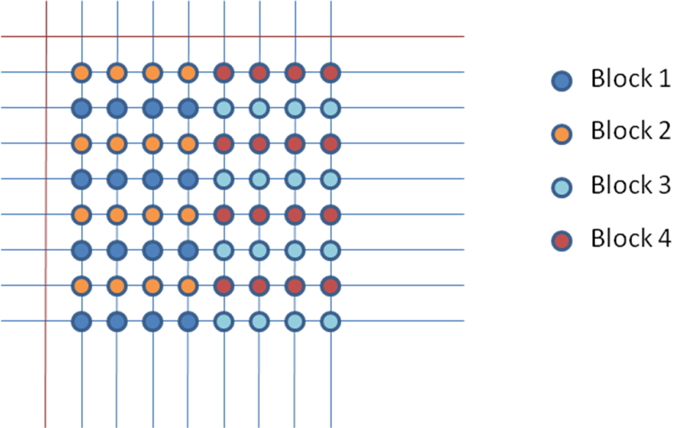 | 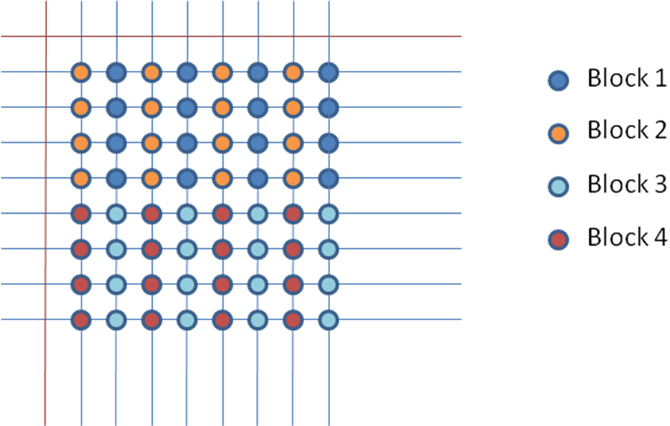 | 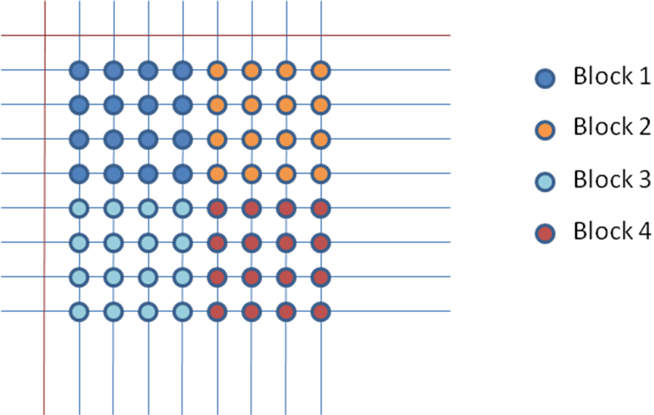
Fig. 1a: sub-sample mode 1  (vertical sub-sampling) | Fig. 1b: sub-sample mode 2 (horizontal sub-sampling) | Fig. 1c: sub-sample mode 3

Fig. 1 above shows the three possible ways pixels within an 8x8 prediction unit can be grouped into 4 sub-blocks. Fig. 1a illustrates the case of vertical sub-sampling while Figure 1b illustrates the case of horizontal sub-sampling. Fig. 1c illustrates a third mode in which the 8x8 block is coded as 4 4x4 intra blocks. This mode is different from the existing 4x4 intra-prediction modes since only 1 prediction mode is coded (all 4 sub-blocks use the same prediction mode). It is different from the existing 8x8 intra-prediction mode as it uses a 4x4 transform and each sub-block is reconstructed after encoding and used as predictors for subsequent sub-blocks.

In these cases, sub-blocks 1-4 each refers to a subset of 4x4 pixels operated on during the encoding process. Encoding proceeds in the same way, and differs only in the subset of pixels used.

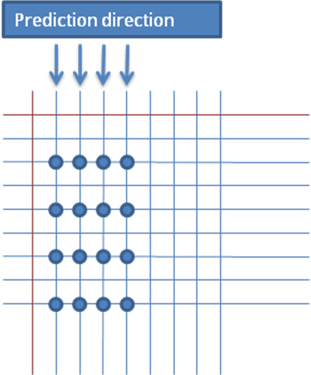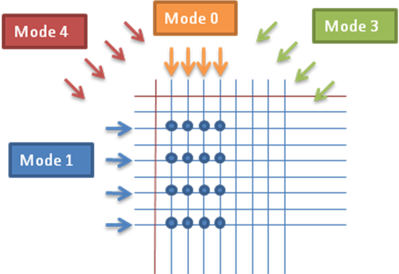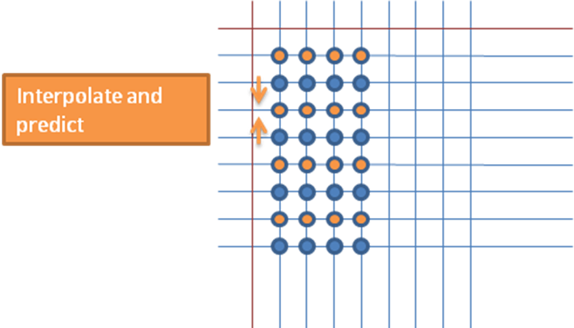
Fig. 2a Fig. 2b Fig. 2c

The encoding process is illustrated for the case of sub-sample mode 1 (vertical sub-sampling). Sub-block 1 is first intra encoded using one of the nine prediction modes defined in H.264/AVC (Figs.2a-b). The reconstructed pixels of sub-block 1 can then be used to predict the pixels in sub-block 2. A bi-linear interpolation on the pixels of sub-block 1 and the neighboring pixels of the entire block is used to obtain a prediction of sub-block 2 (Fig. 2c). The residual between the source pixels and prediction pixels for sub-block 2 is then transform coded.

Next, sub-block 3 is intra-coded like sub-block 1. In addition to using the neighboring pixels of the entire block, sub-block 3 can also use the reconstructed pixels from sub-blocks 1 and 2 for its prediction. Finally, sub-block 4 is coded like sub-block 2.

For each 8x8 block, a sub_sample_mode flag signals to the decoder which of the 4 possible modes (sub-sample mode 1-3 and the existing 8x8 prediction mode) is used, while the Intra8x8PredMode flag is derived as in H.264/AVC and signals which of the 9 intra-prediction modes is used. In addition, a MB-level sub_sample_flag signals whether any of the 4 8x8 blocks in the MB is coded with one of the proposed sub-sample modes.

Implementation and Simulation Results

We have implemented the proposed technique on the JM-KTA software platform (JM11.0KTA2.6r1). The proposed prediction scheme is included to provide 3 additional 8x8 prediction modes while all previous intra-prediction modes remain available to the encoder.

We use the following KTA tools in the all-intra configurations: adaptive loop filter (UseAdaptiveLoopFilter=1), extended block sizes (UseExtMB=2) and RDOQ (UseRDO_Q=1).

Table 1 shows the BD-Rate and BD-PSNR [4] results of the proposed method compared to KTA, where frames are sampled at approximately 1s interval and coded as intra, for all the test sequences used in the HVC CfP [3]. An average bit-rate reduction of about 2% can be observed.

Table 1. RD results for all intra configuration.
 | BD-Rate (%) | BD-PSNR (dB)
PeopleOnStreet | -2.92 | 0.17
Traffic | -2.27 | 0.12
Average for Class A | -2.60 | 0.14
BasketballDrive | -2.09 | 0.07
BQTerrace | -1.59 | 0.10
Cactus | -2.03 | 0.09
Kimono1 | -0.66 | 0.03
ParkScene | -2.13 | 0.10
Average for Class B | -1.70 | 0.08
BasketballDrill | -2.93 | 0.15
BQMall | -2.45 | 0.14
PartyScene | -1.36 | 0.11
RaceHorses | -1.61 | 0.10
Average for Class C | -2.09 | 0.13
BasketballPass | -2.15 | 0.13
BlowingBubbles | -1.55 | 0.12
BQSquare | -1.31 | 0.11
RaceHorses | -1.61 | 0.10
Average for Class D | -1.66 | 0.12
vidyo1 | -2.39 | 0.13
vidyo3 | -1.86 | 0.11
vidyo4 | -2.03 | 0.10
Average for Class E | -2.09 | 0.11

Conclusion

This proposal presents an intra-prediction technique that is beneficial to the performance of intra-coding when included with existing tools in the KTA. Experimental results show an average bit-rate reduction of about 2%. We recommend further study of the proposed technique in Core Experiments.

References

[1] Changcai Lai, Yongbing Lin, “New intra prediction using the correlation between pixels and lines,” JTC1/SC29/WG11, JCTVC-A025, Dresden, Apr 2010.

[2] Yinji Piao, HyunWook Park, “An Adaptive Divide-and-Predict Coding for Intra-frame of H.264/AVC,” Proc. International Conference on Image Processing, Nov 2009, pg 3421 – 3424.

[3] “Joint Call for Proposals on Video Compression Technology,” ISO/IEC JTC1/SC29/WG11/N11113, Kyoto, Japan, Jan 2010.

[4] Gisle Bjontegaard, “Calculation of Average PSNR Differences between RD curves,” ITU-T SC16/Q6, VCEG-M33, Austin, USA, Apr 2001.

Patent rights declaration(s)

Institute for Infocomm Research may have IPR relating to the technology described in this contribution and, conditioned on reciprocity, is prepared to grant licenses under reasonable and non-discriminatory terms as necessary for implementation of the resulting ITU-T Recommendation | ISO/IEC International Standard (per box 2 of the ITU-T/ITU-R/ISO/IEC patent statement and licensing declaration form).

