    Joint Collaborative Team on Video Coding (JCT-VC)  of ITU-T SG16 WP3 and ISO/IEC JTC1/SC29/WG11  1st Meeting: Dresden, DE, 15-23 April, 2010 | Document: JCTVC-A303

Title: | Tool Experiment 3: Inter Prediction in HEVC
Status: | Output Document to JCT-VC
Purpose: | TE description
Authors: | Andreas Krutz¹,  Alexander Glantz¹,  Thomas Sikora¹,  Joonyoung Park²,  Seugwook Park²,  Edouard Francois³,  Peng Yin³,  Peisong Chen⁴  Xiaozhen Zheng⁵,  Haoping Yu⁵  Woo-Jin Han⁶  Wen-Hsiao Peng⁷ | krutz@nue.tu-berlin.de  glantz@nue.tu-berlin.de  sikora@nue.tu-berlin.de  jy.park@lge.com  seungwook.park@lge.com  edouard.francois@technicolor.com  peng.yin@technicolor.com  peisongc@qualcomm.com xiaozhenzheng@huawei.com  haopingyu@huawei.com  wjhan.han@samsung.com  pawn@mail.si2lab.org
Source: | TU Berlin¹, LG², Technicolor³, Qualcomm⁴, Huawei Technologies⁵, Samsung⁶, NCTU⁷
_____________________________

1 Introduction 2
2 Participants 2
3 Experimental Conditions 3
3.1 Software 3
3.2 Test Sequences, Bit Rates and Coding Conditions 3
3.3 Evaluation of TE Results 3
3.4 Evaluation of Complexity 3
4 Description of Tool Experiment 3
4.1 Subtest 1: Parametric Motion Compensation 3
4.1.1 Adaptive Warped Reference (AWR [2]) 3
4.1.2 Parametric Overlapped Block Motion Compensation (POBMC) 4
4.1.3 Adaptive Global Motion Temporal Prediction (Adaptive GMTP) 5
4.1.3.2 Motion model and motion parameter estimation 6
4.1.3.3 Concatenation of short-term global motion parameters 6
4.1.3.4 Prediction signal generation 7
4.1.3.5 Bitstream organization 7
4.1.4 Participants 7
4.2 Subtest 2: Flexible Motion Partitioning 8
4.2.1 Geometry Block Partitioning 8
4.2.2 Motion compensation with adaptable block shapes 9
4.2.3 Asymmetric motion partition 10
4.2.4 Proposed works/tools 10
4.2.5 Participants 11
5 References 11

Introduction

The goal of this Tool Experiment (TE) is to improve temporal prediction and geometric block partitioning in the HEVC test model. Concerning the temporal prediction, techniques are evaluated that apply to translational as well as global and warped motion. The first evaluated method is called AWR (Adaptive Warped Reference [1]) where additional reference frames for inter prediction of the current frame are generated. Second, an improved technique to AWR, called adaptive GMTP (adaptive global motion temporal prediction), is tested. Both methods are organized in subtest 1 and participants in this activity are LG Electronics, TU Berlin, and NCTU. In subtest 2, flexible motion partitioning is examined. Several techniques will be tested that define non-rectangular partitioning for inter prediction. Participants in this subtest are Technicolor, Qualcomm, Huawei, and Samsung.
The software bases for this TE is the JM 17.0 for the subtest 1 and the Qualcomm model proposed in [5] for subtest 2. For the test sequences, a subset (class B, C, and D) of the sequences defined in [1] is used for all subtests. However, only the first 100 frames of each test sequence are taken into account. A preliminary defined coding condition set for constraint set 1 and 2 is used in all subtests. Finally, a complexity evaluation is conducted for each subtest.

Participants

Nr. | Name | Company | Email
1  2  3  4  5  6  7  8  9  10  11  12  13  14  15  16  17  18  19  20  21  22  23  24  25  26  27  28  29  30  31  32 | Andreas Krutz (coordinator)  Thomas Sikora (coordinator)  Alexander Glantz  Seungwook Park  Byeong Moon Jeon  Joonyoung Park  Yi-Jen Chiu  Edouard Francois  Peng Yin  Yung-Lyul Lee  Martin Winken  Peisong Chen  Xiaozhen Zheng  Haoping Yu  Jan de Cock  Krit Panusopone  Shawmin Lei  YW Huang  Lazar Bivolarsky  Xing Wen  Feng Zou  Shangwen Li  Lu Yu  Wen-Hsiao Peng  Yi-Wen Chen  Shigeru Fukushima  Hiroya Nakamura  Woo-Jin Han  Yeping Su  Hui Yong Kim  Seyoon Jeong  Sung-Chang Lim | TU Berlin  TU Berlin  TU Berlin  LG Electronics  LG Electronics  LG Electronics  Intel  Technicolor  Technicolor  Sejong University/SKT  Fraunhofer HHI  Qualcomm  Huawei  Huawei  Universiteit Gent  Motorola  MediaTek  MediaTek  Skype  HKUST  HKUST  Zhejiang University  Zhejiang University  NCTU  NCTU  JVC  JVC  Samsung  Sharp Labs  ETRI  ETRI  ETRI | krutz@nue.tu-berlin.de  sikora@nue.tu-berlin.de  glantz@nue.tu-berlin.de  seungwook.park@lge.com  bm.jeon@lge.com  jy.park@lge.com  yi-jen.chiu@intel.com  edouard.francois@technicolor.com  peng.yin@technicolor.com  yllee@sejong.ac.kr  Martin.Winken@hhi.fraunhofer.de  peisongc@qualcomm.com  xiaozhenzheng@huawei.com  haopingyu@huawei.com  jan.decock@ugent.be  krit@motorola.com  shawmin.lei@mediatek.com  yuwen.huang@mediatek.com  lazar.bivolarsky@skype.net  wxxab@ust.hk  fengzou@ust.hk  dylanwen@zju.edu.cn  yul@zju.edu.cn  pawn@mail.si2lab.org  ewchen@csie.nctu.edu.tw  fukushima.shigeru@jk-holdings.com  nakamura.hiroya@jk-holdings.com  wjhan.han@samsung.com  ysu@sharplabs.com  hykim5@etri.re.kr  jsy@etri.re.kr  sclim@etri.re.kr

Experimental Conditions

Software

Since there is currently no common Test Software available, subtest 1 of this TE will be implemented into the JM 17.0 software and subtest 2 will be implemented into the Qualcomm software (see contribution [5]).

Test Sequences, Bit Rates and Coding Conditions

The TE algorithms will be tested on class B, C, and D test sequences and for constraint set 1 and 2 as defined in the CfP document [1]. The following additional test conditions will be used:
- Number of frames: first 100 frames
- QP values: for subtest 1, the QP values 22, 27, 32, 37, 42, and 47 are used and for subtest 2, the QP values as used in [5] will be used
Considering the coding conditions, for each subtest a config-file will be used for each constraint set.

Evaluation of TE Results

Results of the TE will be evaluated on the Basis of BD-measures as defined in the CfP document [1]. This also means that the results will be compared against the anchor as defined in the CfP. In addition subjective viewing will be done optional during MPEG July 2010 Geneva meeting.

Evaluation of Complexity

For the complexity measurement, the anchor, the reference software and the reference software with the tool implemented will be executed on the same machine and the computational time will be measured for each software. Then, a time factor is calculated which the reference software including the subtest tool needs in comparison to the reference software without the tool as well as the anchor.

Description of Tool Experiment

Subtest 1: Parametric Motion Compensation

Adaptive Warped Reference (AWR [2])

General Concept

AWR algorithm generates warped reference pictures that compensate complex motions between a reference image and a current image to encode, where the complex motions are modeled as a parametric image transformation function.
The warped reference pictures are inserted to the reference picture list to be used in the motion estimation and motion compensation processes. To increase the selection ratio of warped reference pictures, we reorder the reference pictures as follows. If n warped reference pictures are generated from i’th reference picture, then the n warped reference pictures are inserted right after the i’th reference picture. Figure 1 shows an example of reordered reference picture list when the first (0th) reference picture is used to generate one warped reference picture.

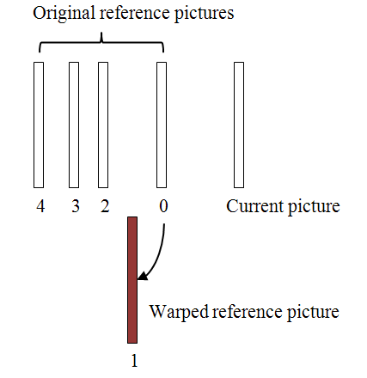
Figure 1 - Reordering of the reference picture list

The more detailed technical description is described in [2].

Bitstream organization

Besides the common bitstream, the following side information is send to the decoder:

Location | Description
Frame Header | A flag that indicates whether AWR is applied or not
Frame Header | 4 motion vectors of the 4 corner points instead of the 8 homography parameters

Parametric Overlapped Block Motion Compensation (POBMC)

General Concept

POBMC was introduced in JCTVC-A123 [12] to extend the notion of OBMC in H.263 to accommodate the variable block-size motion estimates. It views motion-compensated prediction process as consisting of sparse motion sampling followed by the reconstruction of a temporal predictor. In this context, block-based motion estimation acts as a motion sampler taking samples at block centers, and the various motion partitions are assimilated to different sampling structures. To make full use of motion vectors sampled on a possibly irregular grid for motion-compensated prediction, POBMC extends the notion of OBMC and solves for the optimal weights associated with different motion vectors as a function of the distances between the predicted pixel and the block centers where they are sampled. This far-reaching generalization provides a generic reconstruction framework, allowing motion vectors associated with multiple arbitrarily shaped motion partitions to be optimally combined for temporal prediction. Figure 2 shows an example of POBMC combined with various motion partitions. The detailed description of POBMC can be found in [12].

 | 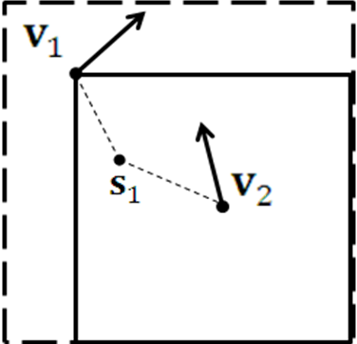 | 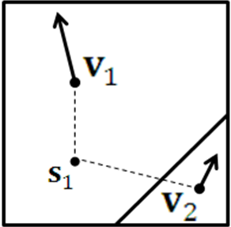 | 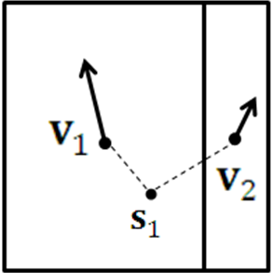
Quad-tree | TMP-like | Geometry | Asymmetric

Figure 2 – POBMC combined with various motion partitions

Adaptive Global Motion Temporal Prediction (Adaptive GMTP)

General Concept

The core of the TE is a refined motion prediction based on short-term and long-term global motion estimation. Multiple previously decoded reference frames from the past and future can be used in combination in order to arrive at a precise prediction signal. Figure 1 shows a decoder that is based on the proposed adaptive global motion temporal prediction.

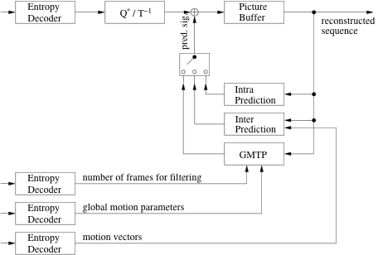

Figure 1 - Decoder based on Adaptive Global Motion Temporal Prediction

For prediction signal generation, global motion parameters are estimated between the current frame and a number N of previously decoded frames at the encoder, resulting in a set of short-term global motion parameters, e.g. based on an 8-parameter perspective motion model, which can then be combined to long-term parameters. These long-term parameters can then be used to compensate the global motion between those N frames and the current frame, which is illustrated in Figure 2.
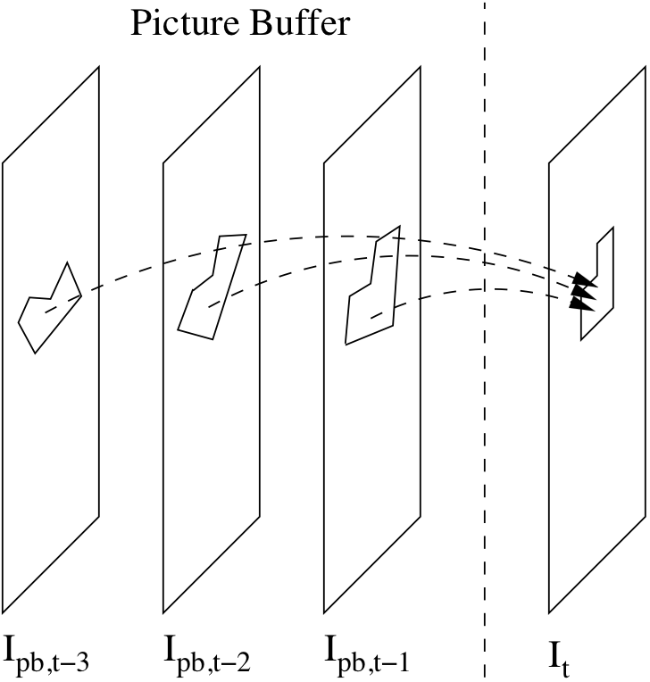

Figure 2 - Generation of a prediction signal I_{t,pred} for the current picture I_{t}. The pictures inside the picture buffer can be past and/or future pictures in display order.

For each pixel in a block of the current frame the N related pixels in the N decoded frames are averaged to generate a predicted value with reduced coding noise. Figure 3 illustrates the averaging concept.

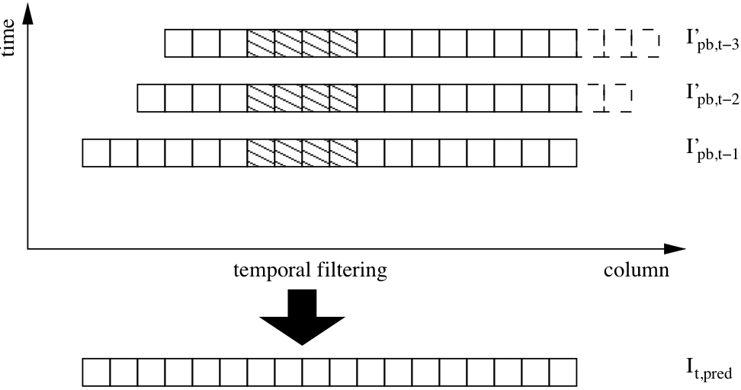

Figure 3 - Temporal prediction process to form a prediction signal I_{t,pred} for the current picture I_{t}, depicted is one line y_{k} from a set of aligned pictures

4.1.3.2 Motion model and motion parameter estimation
Since many video sequences have been recorded with a moving and zooming camera, resulting in complex motion in sequences to be coded. Higher-order motion models can efficiently account for the motion a camera. In the TE an 8-parametric higher-order motion model (the well-known perspective motion model) is used.

$$\begin{aligned}x_{q}=\frac{m_{0}x_{p}+m_{1}y_{p}+m_{2}}{m_{6}x_{p}+m_{7}y_{p}+1} \\ y_{q}=\frac{m_{3}x_{p}+m_{4}y_{p}+m_{5}}{m_{6}x_{p}+m_{7}y_{p}+1}\end{aligned}$$

In the above equation, (x_{p},y_{p})^{T} is the location of a pixel in picture I_{p} and (x_{q},y_{q})^{T} is its corresponding position in picture I_{q}. The parameters m₀ to m₇ describe the motion by means of translation, scaling, rotation, and perspective transformation. The matrix below describes these parameters between frame p and q.

$W_{p,q}=\left[\begin{matrix}m_{0,p,q} & m_{1,p,q} & m_{2,p,q} \\ m_{3,p,q} & m_{4,p,q} & m_{5,p,q} \\ m_{6,p,q} & m_{7,p,q} & 1\end{matrix}\right]$.

In order to keep memory requirements and complexity during motion estimation low, global motion estimation is only performed between two consecutive frames in display order.

Powerful low complex motion estimation algorithms appeared recently that allow global estimation to be performed on transmitted motion vectors [3][4]. For the purpose of the TE the global motion parameters for each frame of each sequence will be provided.

4.1.3.3 Concatenation of short-term global motion parameters
Long-term motion parameters are then derived by accumulating previously estimated/decoded short-term motion parameters of several frames

$$T=\left\{W_{0,1},W_{1,2},K,W_{N−2,N−1}\right\}$$

as is exemplary shown in . The accumulation is done by simple matrix multiplication. In that way, the motion between any arbitrary pair of pictures from the set is obtained.

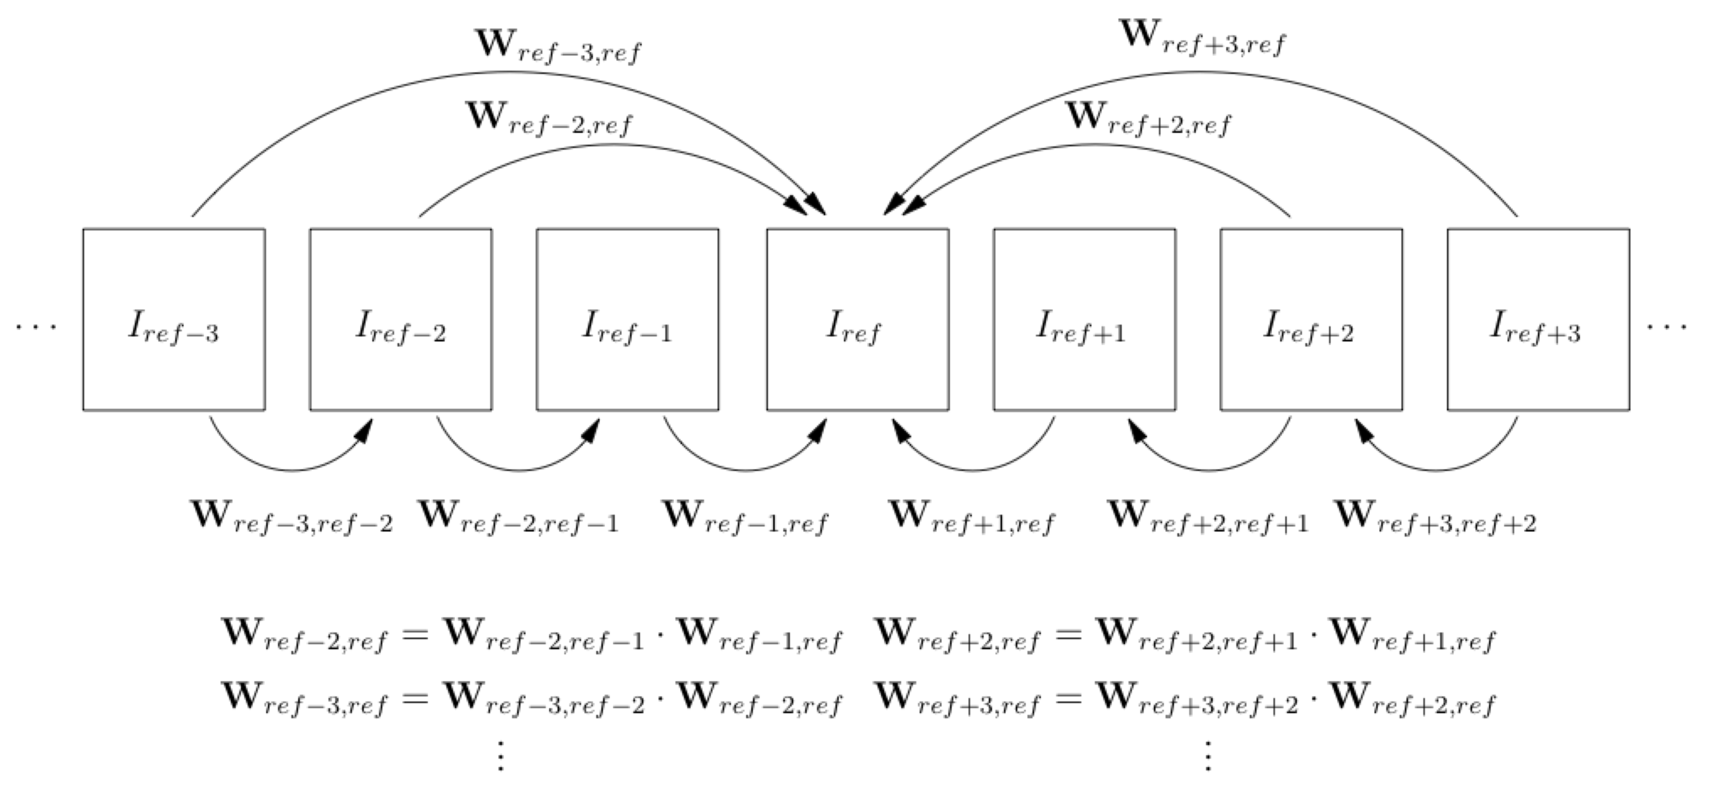

Figure 4 - Generation of long-term global motion parameters

4.1.3.4 Prediction signal generation
At the encoder, the final prediction signal is generated on a 16x16 macroblock basis. First, for each possible N, one preliminary prediction signal picture is computed. For that, each macroblock MSE, measured between prediction and original, is minimized. If the MSE of GMTP is less or equal than the MSE of the other modes, the GMTP block is taken for the preliminary prediction signal picture. When all preliminary prediction signals have been generated, the picture with minimum MSE, measure on picture-basis, is taken as the final prediction signal.

4.1.3.5 Bitstream organization
Besides the common bitstream, the following side information is send to the decoder:

Location | Description
Frame Header | 24 byte global motion parameter set (3 byte floating point precision per parameter, 8 parameters in perspective motion model)
Frame Header | 4 bit number N of pictures used for filtering GMTP blocks in current picture (FLC based on the assumption of maximum decoded picture buffer size of 16=2⁴)
Macroblock Header | List of possible mb_type is extended to GMTP16x16 (size depends on entropy coding method)

Participants

Participant | Contact
LG | jy.park@lge.com  seungwook.park@lge.com
TU Berlin | glantz@nue.tu-berlin.de  krutz@nue.tu-berlin.de
NCTU | pawn@mail.si2lab.org  ewchen@csie.nctu.edu.tw

The goal is to evaluate the performance of each individual tool listed in this subtest and to explore further coding efficiency improvements as well as combinations of the listed tool, which is optional.

Subtest 2: Flexible Motion Partitioning

Geometry Block Partitioning

General Concept
The general concept of Geometric block partitioning (GEO mode) was proposed to VCEG as document VCEG-AF10. In addition to the classical horizontal and vertical motion partitions, GEO mode consists in another kind of motion partition. This motion partition divides the block into 2 regions. The boundary separating the 2 regions is defined by a straight line. One motion vector is sent for each region. Now we will describe how the various geometry partitions are created. The origin is assumed to be at the center of the block. Then, each geometry partition is defined by a line passing through the origin that is perpendicular to the line defining the partition boundary. This is shown in Fig. 5. The geometry partition is defined by the angle subtended by the perpendicular line with the X axis (q) and the distance of the partition line from the origin (r).
Figure 5: Parameters defining a geometry motion partition

Overlapped motion compensation
For a block that is predicted in a manner described above, overlapped block motion compensation (OBMC) is applied. Let the two regions created by a geometry partition be denoted by region 1 and region 2. Let the corresponding motion vectors be denoted by and , respectively. A pixel from region 1 (2) is defined to be a boundary pixel if any of its four connected neighbors (left, top, right, and bottom) belongs to region 2 (1). Fig. 6 shows an example where light blue pixels belong to the boundary of region 1 and white pixels belong to the boundary of region2. If a pixel is not a boundary pixel, normal motion compensation is performed using the appropriate motion vector. If a pixel is a boundary pixel, the motion compensation is performed using a weighted sum of the motion predictions from the two motion vectors, and . The weights are for the region containing the boundary pixel and for the other region.

Figure 6: Overlapped motion compensation for geometry partitions

Motion vector prediction for geometric block partitions
The process of forming motion vector prediction for a geometric block partition is shown Figure 7. Motion vectors of neighboring blocks are used to form the motion vector prediction. Depending on the partition, a subset of blocks from is used to form motion vector prediction. The choice of block for motion vector prediction depends upon whether they lie on the same side or opposite side of the geometry partition boundary.

Figure 7: Motion vector prediction for a block having geometry partition

A more detailed description of the tool and of its implementation can be found in [5 to 8].

Motion compensation with adaptable block shapes

General Concept
The general idea of this approach has been discussed in A111 [9] and A029 [10]. As illustrated at Figure 8a to Figure 8d, the boundary between two blocks can be controlled by the point A and B. The partition mode can be parsed after getting point A and B’s position. Since point A and B locate at one of the of macroblock’s boundaries, only one position parameter need to be coded for point A and B. The block partition mode can be described by the two position parameters. Use the values of xpos and ypos, and the symbol of xpos and ypos, the macroblock’s partitioning can be identified. To be compatible with the quad-tree structure used in MPEG4-AVC/H.264, the proposed approach reuse the quad-tree structure used in MPEG4-AVC/H.264 to identify the partition modes

Figure 8a Figure 8b
Figure 8c Figure 8d

Motion vector prediction
To accommodate the adaptable block shape, motion vector prediction mechanism is also modified. As illustrated at Figure 9, blockE is the current macroblock; blockA, blockB and blockC are the neighboring blocks of blockE. If one of blockA, blockB and blockC has same block partition mode as blockE’s mode, the block’s motion vector is used for blockE’s motion vector coding.

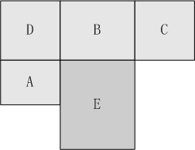
Figure 9 Current macroblock and its neighboring blocks

Asymmetric motion partition
Asymmetric motion partition was introduced in A124 [11] to extend conventional symmetric horizontal and vertical motion partitions. Figure 10 shows an example of the asymmetric motion partition where a 64x64 block is asymmetrically partitioned into 64x16, 64x48, 16x64, or 48x16 blocks, instead of two 64x32 or 32x64 blocks. This kind of motion partition improves the coding efficiency for the irregular image patterns, which otherwise would be constrained to being represented by a symmetric partition, can now be more efficiently represented without requiring further splitting. One of the main advantages of this technique lies in the simplicity in the decoder side, since motion compensation can be carried by the conventional rectangular block based motion compensation while allowing more flexibility. In addition, motion vector prediction scheme is straightforward.

Figure 10 Example of asymmetric motion partitions for 64x64 block

Proposed works/tools
Technicolor has made several works related to GEO mode, in particular [6 to 8].
Qualcomm’s submission to the Call for Proposal with software implementation [5] provides a good reference point.

The performance of each method listed in this subtest will be evaluated individually with other new CfP tools turned on to evaluate the synergy of flexible motion partitioning with these new tools. A second round of experiments can optionally be performed with other new CfP tools turned off, except the large MB mode.

For the mandatory case, the following tools are turned on in Qualcomm’s software (including large block size):

$MDDT=1;
$MVC=1;
$HPF=4; (SIFO case)
$QALF=1;
$MVResolution=1;

Participants

Participant | Contact
Technicolor | peng.yin@technicolor.com
Qualcomm | peisongc@qualcomm.com
Huawei | haopingyu@huawei.com xiaozhenzheng@huawei.com
Samsung Electronics | wjhan.han@samsung.com

References

[1] ISO/IEC JTC1/SC29/WG11, “Joint Call for Proposals on Video Compression Technology”, MPEG
Document N11113, January 2010

[2] Joonyoung Park, Seungwook Park, and Byeongmoon Jeon, “Coding tools using parametric
representations to improve coding efficiency”, JCTVC-A021

[3] Michael Tok, Alexander Glantz, Marina Georgia Arvanitidou, Andreas Krutz, Thomas
Sikora, “Compressed Domain Global Motion Estimation using the Helmholtz Tradeoff Estimator”,
submitted to ICIP 2010

[4] Martin Haller, Andreas Krutz, Thomas Sikora, “Robust Global Motion Estimation using Motion Vectors
of variables Block Sizes and automatic Motion Model Selection”, submitted to ICIP 2010

[5] Marta Karczewicz, Peisong Chen, Rajan Joshi, Xianglin Wang, Wei-Jung Chien, Rahul Panchal,
“Video coding technology proposal by Qualcomm Inc” JCTVC Contribution JCTVC-A121, Dresden,
Germany, April 2010.

[6] O. Divorra, P. Yin and C. Gomila, “Geometry-Adaptive Block Partitioning”, ITU-TQ.6/SG16 VCEG,
VCEG-AF10, April 2007.

[7] O. Divorra, P. Yin and C. Gomila, “Geometry-Adaptive Block Partitioning On B-Frames”, ITU-
TQ.6/SG16 VCEG, VCEG-AG13, October 2007.

[8] O. Divorra Escoda, P. Yin and C. Gomila, Geometry-adaptive Block Partitioning; ITU-TQ.6/SG16
VCEG-AH16 January 2008.

[9] H. Yang, J. Fu, S. Lin, J. Song, D. Wang, M. Yang, J. Zhou, H. Yu, C. Lai, Y. Lin, L. Liu, J. Zheng,
X. Zheng, “Description of video coding technology proposal by Huawei Technologies & Hisilicon
Technologies” JCTVC Contribution JCTVC-A111, Dresden, Germany, April 2010.

[10] X. Zheng, H. Yu, “Flexible macroblock partition for inter-frame coding”, JCTVC Contribution JCTVC-
A029, Dresden, Germany, April 2010.

[11] Ken McCann, Woo-Jin Han and Il-Koo Kim, “Samsung’s Response to the Call for Proposals on Video
Compression Technology,” JCTVC Contribution JCTVC-A124, Dresden, Germany, April 2010.

[12] Y.-W. Chen, T.-W. Wang, C.-H. Chan, C.-L. Lee, C.-H. Wu, Y.C. Tseng, W.-H. Peng, C.-J. Tsai, and
H.-M. Hang, “Description of video coding technology proposal by NCTU,” JCTVC-A123, Dresden,
Germany, April 2010.

