    Joint Collaborative Team on Video Coding (JCT-VC)  of ITU-T SG16 WP3 and ISO/IEC JTC1/SC29/WG11  1st Meeting: Dresden, DE, 15-23 April, 2010 | Document: JCTVC-A204

Title: | Report of Subjective Test Results of Responses to the Joint Call for Proposals (CfP) on Video Coding Technology for High Efficiency Video Coding (HEVC)
Status: | Output Document Approved by JCT-VC
Purpose: | Report
Author(s) or  Contact(s): | Vittorio Baroncini  Fondazione Ugo Bordoni  Via Baldassarre Castiglione, n° 59  00142 Rome (RM), Italy  Jens-Rainer Ohm  Institute of Communications Engineering  RWTH Aachen University  Melatener Straße 23  D-52074 Aachen, Germany  Gary Sullivan  Microsoft Corp.  1 Microsoft Way  Redmond, WA 98052 USA | Tel:  Email:  Tel:  Email:  Tel:  Email: | +39-06-54802134  vittorio@fub.it  +49 241 80 27671  ohm@ient.rwth-aachen.de  +1 425 703 5308  garysull@microsoft.com
Source: | JCT-VC
_____________________________

Introduction
This document provides results and a description of the subjective testing for the Joint Call For Proposals (CfP) on Video Coding Technology [1] for the High Efficiency Video Coding (HEVC) standardization initiative. This Call was issued jointly in final form in January 2010 by ISO/IEC JTC1/SC29/WG11 (MPEG) and ITU-T Q6/16 (VCEG), and the subsequent standardization work will be conducted by the ITU-T/ISO/IEC Joint Collaborative Team on Video Coding (JCT-VC) that has been established by both organizations for the HEVC project [2].

Testing sites
The tests were conducted during March 2010 at three testing laboratories:
- FUB (Rome, Italy) – Test Coordinator: Dr. Vittorio Baroncini
- EPFL (Lausanne, Switzerland)
- EBU (Geneva, Switzerland).

Test design

Source sequences, formats and frame rates
The source video sequences that were used for the CfP were in five classes of video resolution, as listed in Table 1. All source video test material was progressively scanned and used 4:2:0 YCbCr color sampling with 8 bits per sample. The video sequence encodings that were used in the subjective testing each had a duration of 10 seconds. (The Class A video sequence encodings, which were not used in the subjective testing, each had a duration of 5 seconds.) Proponents were required to submit complete results for all test cases.
Table 1 – Source video classes and test sequences for the CfP submissions
Class A | S01 | Traffic (*) | 2560x1600p | 30 fps
 | S02 | PeopleOnStreet (*) | 2560x1600p | 30 fps
Class B | S03 | Kimono | 1920x1080p | 24 fps
 | S04 | ParkScene | 1920x1080p | 24 fps
 | S05 | Cactus | 1920x1080p | 50 fps
 | S06 | BasketballDrive | 1920x1080p | 50 fps
 | S07 | BQTerrace | 1920x1080p | 60 fps
Class C | S08 | BasketballDrill | 832x480p | 50 fps
 | S09 | BQMall | 832x480p | 60 fps
 | S10 | PartyScene | 832x480p | 50 fps
 | S11 | RaceHorses | 832x480p | 30 fps
Class D | S12 | BasketballPass | 416x240p | 50 fps
 | S13 | BQSquare | 416x240p | 60 fps
 | S14 | BlowingBubbles | 416x240p | 50 fps
 | S15 | RaceHorses | 416x240p | 30 fps
Class E | S16 | Vidyo1 | 1280x720p | 60 fps
 | S17 | Vidyo2 | 1280x720p | 60 fps
 | S18 | Vidyo3 | 1280x720p | 60 fps
(*) Cropped areas of size 2560x1600 were taken from the first 5 sec. of higher resolution video for "Traffic" (4096x2048p 30 fps) and "PeopleOnStreet" (3840x2160p 30 fps).

Coding Conditions of Submissions
Two Constraint set cases were defined as follows:
- Constraint set 1 ("Random Access" encoding): Structural delay of processing units not larger than 8-picture "groups of pictures" (GOPs) (e.g., dyadic hierarchical B usage with four levels), and random access intervals of 1.1 seconds or less.
- Constraint set 2 ("Low Delay" encoding): No picture reordering between decoder processing and output, with bit rate fluctuation characteristics and any frame-level multi-pass encoding techniques to be described with the proposal. A metric to measure bit rate fluctuation was implemented in an Excel file submitted for each proposal.
Proposal submissions were required to include encodings for all sequences in all classes, and each decoding was required to produce the full specified number of pictures for the sequence (no missing pictures).
Submissions were required to be made for the test cases (combinations of classes and constraint sets) listed in Table 2.
Table 2 – Combinations of classes and constraint sets
 | Class A | Class B | Class C | Class D | Class E
Constraint set 1 | X | X | X | X | --
Constraint set 2 | -- | X | X | X | X

- Submissions for Class A were evaluated based on Bjøntegaard-delta (BD) PSNR and bit rate [3][4] criteria (without formal subjective assessment).
- Submissions for Classes B, C, D and E were evaluated by means of a formal subjective assessment and BD PSNR and bit rate criteria.
Submissions in response to the CfP were obliged, for each of the test cases defined above, to provide results for each of the target bit rate points (which were not to be exceeded) listed in Table 3.
Table 3 – Target bit rate points not to be exceeded (*)
Class | Bit Rate 1 | Bit Rate 2 | Bit Rate 3 | Bit Rate 4 | Bit Rate 5
A: 2560x1600p30 | 2.5 Mbit/s | 3.5 Mbit/s | 5 Mbit/s | 8 Mbit/s | 14 Mbit/s
B1: 1080p24 | 1 Mbit/s | 1.6 Mbit/s | 2.5 Mbit/s | 4 Mbit/s | 6 Mbit/s
B2: 1080p50-60 | 2 Mbit/s | 3 Mbit/s | 4.5 Mbit/s | 7 Mbit/s | 10 Mbit/s
C: WVGAp30-60 | 384 kbit/s | 512 kbit/s | 768 kbit/s | 1.2 Mbit/s | 2 Mbit/s
D: WQVGAp30-60 | 256 kbit/s | 384 kbit/s | 512 kbit/s | 850 kbit/s | 1.5 Mbit/s
E: 720p60 | 256 kbit/s | 384 kbit/s | 512 kbit/s | 850 kbit/s | 1.5 Mbit/s
(*) 1 kbit/s means 10³ bits per second, and 1 Mbit/s means 10⁶ bits per second.
Proponent submissions to the CfP were required to obey the following additional constraints:
- No use of pre-processing.
- Only use post-processing if it is part of the decoding process, i.e. processing that is applied to a picture prior to its use as a reference for inter prediction of other pictures. Such processing could also be applied to non-reference pictures.
- Quantization settings should be kept static. When change of quantization is used it shall be described.
- Proponents were discouraged from optimizing encoding parameters using non-automatic means.
- The video coding test set was not to be used as the training set for training large entropy coding tables, VQ codebooks, etc.

Anchors
Two anchor encodings were generated and were included in the formal subjective tests in the same way if they were two Proponents' submissions, by encoding the above source sequences using an AVC encoder (JM16.2 with modifications as necessary for support of encoding structures described below). The purpose of the anchors was to facilitate the analysis of the testing effort results, providing two reference points to demonstrate the behaviour of well-understood configurations of current technology obeying the same constraints as imposed on the proposals. The anchors were included among the encodings used in the testing process.
For the Random Access coding cases (Constraint set 1), the first of the two Anchors (A01) was the Alpha (α) anchor encoding described below and the second (A02) was simply another copy of the same Alpha (α) anchor encoding.
For the Low Delay coding cases (Constraint set 2), the first of the two Anchors (A01) was the Beta (β) anchor encoding described below and the second (A02) was the Gamma (γ) anchor encoding described below.
This means that the measured quality of the two anchors should be equivalent in the Random Access testing cases and should be somewhat different in the Low Delay testing cases.
The above expectations were confirmed by the subjective test results, confirming the validity of the formal visual testing process.
The α, β and γ anchor encoding configurations are described below in terms of terminology used in the AVC standard and the JM reference software. The anchors and the associated encoding configuration files were made available to the proponents in advance.
Alpha (α) anchor (satisfying Constraint set 1)
- Conformance with AVC High Profile
- Hierarchical B pictures IbBbBbBbP (8) coding structure – each picture using at most 4 reference pictures in each list for inter prediction
  - Open GOP structuring with an Intra picture every 24, 32, 48 and 64 pictures for 24 fps, 30 fps, 50 and 60 fps sequences, respectively
  - num_reorder_frames = 3 ("GOP length 8")
  - max_num_ref_frames = 4
  - QP scaling: QP (I picture), QP+1 (P picture), QP+2 (first B layer), QP+3 (second B layer), QP+4 (third B layer)
- CABAC, 8x8 transforms enabled
- Flat quantization weighting matrices
- RD Optimization enabled
- RDOQ enabled (fast mode, NUM=1)
- Adaptive rounding disabled
- Weighted prediction enabled
- Fast motion estimation (range 128x128)
Beta (β) anchor (satisfying Constraint set 2)
- Conformance with AVC High Profile
- No random access refresh requirement (a single I frame as the first picture)
- Hierarchical P pictures IpPp (GOP size of 4, with 3 temporal P picture layers, and no backward reference for inter prediction, nested_prediction_flag=on) coding structure – each picture uses at most 4 reference pictures for inter prediction
  - QP scaling: QP (I picture), QP+1 (first P layer), QP+4 (second P layer), QP+5 (third P layer)
  - num_reorder_frames = 0
  - max_num_ref_frames = 4
- CABAC, 8x8 transforms enabled
- Flat quantization weighting matrices
- RD Optimization enabled
- RDOQ enabled (fast mode, NUM=1)
- Adaptive rounding disabled
- Weighted prediction enabled
- Fast motion estimation. (range 128x128)
Gamma (γ) anchor (satisfying Constraint set 2)
- Conformance with AVC Constrained Baseline Profile
- IPPPP coding structure (num_reorder_frames = 0)
- 2 reference pictures (max_num_ref_frames = 2)
- RD Optimization enabled
- Fast motion estimation (range 128x128)
- RDOQ enabled (fast mode, NUM=1)
- Adaptive rounding disabled
- Frame-level multipass optimizations disabled

Test design

Introduction
The design and conduction of a test regime of such a large magnitude was the biggest problem to be overcome in this testing effort. To convey an idea of the complexity of the test dimensions, it should be observed that a typical comparison test in MPEG has involved about 10 test sessions.
Looking into the scientific literature, we have not identified any prior report with such a large test, nor any information about how to design a formal subjective assessment trial of such dimensions in terms of the number of participants and the amount of video material that needed to be evaluated.
In regard to the prior history in the MPEG and VCEG working groups, the largest previous test ever done was the 1995 MPEG-4 proposal test. At that time that test effort was considered very large, in which 45 participants came to Los Angeles (Hughes Aircraft premises) to participate as viewing subjects, while 15 experts in video quality assessment acted as “test administrators” under the coordination of Ing. Laura Contin (CESLT). A total of 32 submissions had been received. For that evaluation, partial submissions had also been accepted. Somewhat more than 150 test combinations (Proponents vs. bit/rates vs. test sequences) were evaluated, running a total of 32 test sessions for a total of more than 13 hours of actual testing time.
In contrast, for the current CfP testing effort for HEVC, the total number of conducted test sessions was 134, with a total of more than 50 hours of actual testing time.
Thus, this test was about four times the magnitude of the largest prior test of its kind.
The issues involved in designing such a test were basically of four kinds:
- Activity scheduling and organization; i.e. the distribution of work among the testing sites,
- Test material preparation and distribution; i.e. from the hard drives received from the Proponents to the hard drives sent to the testing laboratories,
- Test design,
- Results monitoring and presentation.

Activity scheduling and organization
In more detail, the overall coordination activity for this testing effort involved the following tasks:
- Collection of the more than 23 000 files from the 27 Proponents,
- Verification of the correctness of the received material,
- Arrangements with the Proponents to fix delivery errors or missing files,
- Distribution of the test material to the testing sites,
- Verification of the test site preparations and organization of the work,
- Assignment of the task to the testing sites,
- Collection of the results,
- Statistical analysis of the data,
- Presentation of the results.
The Joint CfP issued by the MPEG and VCEG working groups [1] provided a general schedule related primarily to the obligations for the proponents to follow in order to submit acceptable proposals.
To accomplish the above tasks, a more detailed schedule was agreed between the Test Coordinator and the testing laboratories, as provided in Table 4 below.
Table 4 – Detailed schedule for test coordination
 | 2010
 | M | T | W | T | F | S | S | Overall CfP schedule |  | Detailed Test Schedule
January |  |  |  |  | 1 | 2 | 3
January | 4 | 5 | 6 | 7 | 8 | 9 | 10 | Deadline for Pre-registration
January | 11 | 12 | 13 | 14 | 15 | 16 | 17 | 39th VCEG & 91st MPEG meetings
January | 18 | 19 | 20 | 21 | 22 | 23 | 24 | Final Call for Proposals
January | 25 | 26 | 27 | 28 | 29 | 30 | 31 |  |  | Test pre-design
February | 1 | 2 | 3 | 4 | 5 | 6 | 7 |  |  | and dry run
February | 8 | 9 | 10 | 11 | 12 | 13 | 14 |  |  | Labs calibration-measurement
February | 15 | 16 | 17 | 18 | 19 | 20 | 21 | Formal registration & fees |  | Final test design / HDD collection
February | 22 | 23 | 24 | 25 | 26 | 27 | 28 | Coded test material available |  | Proponents’ files verification and
March | 1 | 2 | 3 | 4 | 5 | 6 | 7 |  |  | AVI files delivery to test Labs
March | 8 | 9 | 10 | 11 | 12 | 13 | 14 |  |  | Test site final set-up
March | 15 | 16 | 17 | 18 | 19 | 20 | 21 | Subjective assessment starts
March | 22 | 23 | 24 | 25 | 26 | 27 | 28 |  |  | Formal subjective tests
March | 29 | 30 | 31 | 1 | 2 | 3 | 4
April | 5 | 6 | 7 | 8 | 9 | 10 | 11 | Proposals description |  | Data analysis / test (back-up)
April | 12 | 13 | 14 | 15 | 16 | 17 | 18 | 1st JCT-VC meeting |  | Data analysis / results presentation
April | 19 | 20 | 21 | 22 | 23 | 24 | 25 | 40th VCEG & 92nd MPEG meetings
April | 26 | 27 | 28 | 29 | 30

Test material preparation and distribution
The CfP document prescribed the delivery of a full proposal from each Proponent, and this implied that each company (or group of companies) submitting a proposal needed to send a hard disk to the Test Coordinator (Dr. Vittorio Baroncini – FUB) containing four kinds of files for each combination bit rate and test sequence in each video Class:
- Bitstream file,
- YUV decoded file,
- AVI decoded file,
- Checksum files for all of the above.
This led to a total of (145 * 3) * 2 = 870 files.
All the above were to be delivered to the Test Coordinator site on a hard drive by 22 February 2010.
When the video materials began reaching the Test Coordinator site, the verification of the delivered AVI files began. This activity implied an accurate visual check of around 4500 video clips of 10 seconds length each.
The week following 22 February was dedicated to logistical efforts with the Proponents to fix the cases where the hard drives had been damaged by transportation or some files had been discovered to be missing or badly formatted (e.g. including a frame with a copyright declaration statement).
The complete sets of files for the submissions coming from the 27 confirmed Proponents were available at the Test Coordinator site on 26 February, and the verification of the AVI files was completed by Tuesday 2 March.
By that date, two sets of hard disks were prepared to be delivered to the other two test sites (EBU and EPFL); the disks contained the AVI files for Classes B, C, D and E.
The two disk sets were personally carried by the Test Coordinator to the other test sites on 3 March 2010 during a technical visit to those test sites (both located in Switzerland).
On this date, a final refinement of the test design and conduction plan was made, and the test schedule was finalized. The site visit was also useful to define some important aspects relating to the test conduction, such as the instructions to provide to the naïve viewers, the design of the scoring sheets, etc.
Since the very beginning, a decision had been taken to collect scores from the testing subjects on paper sheets. This decision, together with the necessity of providing assistance to such a large number of testing subjects (more than 850), led to the hiring of a set of eight support assistants (“staff”) for each testing laboratory.
The testing staff members were selected among the graduate and PhD students associated with the local test laboratories.
All of them actively contributed to the recruiting, selection and training of the testing subjects.
The staff members also had the task of transcribing the test data from the scoring sheets (those filled out by the testing subjects) into an electronic form.
The staff members acted under the direct supervision of the Test Managers, who were as follows
- Ing. Francesca De Simone at EPFL,
- Dr. Adi Kouadio at EBU,
- Dr. Cristina Delogu at FUB.
To speed up the process and to prevent transcription errors, one of the staff members at FUB developed an automatic scanning system for the scoring sheets; in this way each scoring sheet was converted into an Excel spreadsheet by passing it over a scanner.

Testing fee collection
In the meantime, the difficult and large task of collecting the test fees from the Proponents was done by EPFL under the direct supervision of Prof. Touradj Ebrahimi and by the kind organization of Mrs. Cristine Gabriel. Great patience, diligence, and flexibility was necessary to accomplish this task. The various difficulties encountered in that process resulted in the collection of the fees (originally foreseen to be completed by 22 February) being completed on 9 April.

Test design and conduction

Test design considerations
The test design effort was quite difficult, due to the large number of proposals and the large number of coding conditions.
To properly accommodate so many test cases, the design of the test took into account the following aspects:
- Number of submitted proposals
- Number of test sequences,
- Coding bit rates,
- Coding constraints,
- Overall visual quality of the video material.
A first consideration was the number of correctly-received formal submissions to the CfP.
The test coordinator received, by the due date, a total of 27 submissions (recorded on SATA Hard Drives and organized according to the video Classes as specified in the CfP).
For purposes of the testing process, two Anchor cases were tested subjectively for each test case (as described above in section 3.3), in the same manner as if the anchors were a proposal submission.
The above led to a total number of 29 complete submissions (as also referred to below as "Proponents") to be tested.
The test session design was customized for each Class of video material, taking into account the number of coding conditions (i.e. the combinations of test material, bit rates, frame rates, Proponents and coding constraints) and the general level of perceived quality in the video material.
Below in Table 5 is provided the details of the test cases for the tested video Classes.
Table 5 – Video test cases for subjective testing
Class | Proponents | test sequences | bit rates | frame rates | coding constraints | test conditions
B | 29 | 5 | 5 | 3 | 2 | 1450
C | 29 | 4 | 5 | 3 | 2 | 1160
D | 29 | 4 | 5 | 3 | 2 | 1160
E | 29 | 3 | 5 | 1 | 1 | 435
 |  |  |  |  |  | 4205
Starting from the data reported in the above table, the test sessions were designed, taking into account some key aspects essential for a good outcome in such a formal subjective assessment:
- Selection of the test method,
- Test sessions design,
- Training of the test subjects

Selection of the test methodology
The selection of the test method was performed taking into account the quality of the video across the various Classes.
The test methods applied in individual test sessions were the Double Stimulus Continuous Quality Scale (DSCQS) and Double Stimulus Impairment Scale (DSIS) methodologies. For DSIS, a particular variation using a quality scale from 0 to 10 was applied (instead of the classical “impairment” quality scale).
For Classes C, D and E, the DSIS method was chosen; this decision was taken considering the wide spread of quality expected in the video clips under assessment.
Special attention was paid to the selection of the test method for the Class B video material.
A visual inspection of the video clips of this Class showed that, for some coding conditions, the measured visual quality was expected to be very high. In this case, a method with higher accuracy in visual quality assessment under such conditions was selected: i.e. the DSCQS.
For this reason Class B was tested using either the DSCQS or DSIS test methods, with the method selected for each case according to the expected level of quality of the individual coding conditions (see Table 6). The combinations of bit rates and test material shown with grey background in Table 6 were tested using DSCQS; while other combinations (those with no background shading) were tested using DSIS.
Table 6 – Test case usage of DSCQS and DSIS test methodologies
 |  |  |  |  | 1 Mbit/s | 1.6 Mbit/s | 2.5 Mbit/s | 4 Mbit/s | 6 Mbit/s
 | S03 | Kimono | 1920x1080p | 24 fps | S03R1C1 | S03R2C1 | S03R3C1 | S03R4C1 | S03R5C1
Random | S04 | ParkScene | 1920x1080p | 24 fps | S04R1C1 | S04R2C1 | S04R3C1 | S04R4C1 | S04R5C1
 |  |  |  |  | 2 Mbit/s | 3 Mbit/s | 4.5 Mbit/s | 7 Mbit/s | 10 Mbit/s
 | S05 | Cactus | 1920x1080p | 50 fps | S05R1C1 | S05R2C1 | S05R3C1 | S05R4C1 | S05R5C1
Access | S06 | BasketballDrive | 1920x1080p | 50 fps | S06R1C1 | S06R2C1 | S06R3C1 | S06R4C1 | S06R5C1
 | S07 | BQTerrace | 1920x1080p | 60 fps | S07R1C1 | S07R2C1 | S07R3C1 | S07R4C1 | S07R5C1
 |  |  |  |  | 1 Mbit/s | 1.6 Mbit/s | 2.5 Mbit/s | 4 Mbit/s | 6 Mbit/s
 | S03 | Kimono | 1920x1080p | 24 fps | S03R1C2 | S03R2C2 | S03R3C2 | S03R4C2 | S03R5C2
Low | S04 | ParkScene | 1920x1080p | 24 fps | S04R1C2 | S04R2C2 | S04R3C2 | S04R4C2 | S04R5C2
 |  |  |  |  | 2 Mbit/s | 3 Mbit/s | 4.5 Mbit/s | 7 Mbit/s | 10 Mbit/s
 | S05 | Cactus | 1920x1080p | 50 fps | S05R1C2 | S05R2C2 | S05R3C2 | S05R4C2 | S05R5C2
Delay | S06 | BasketballDrive | 1920x1080p | 50 fps | S06R1C2 | S06R2C2 | S06R3C2 | S06R4C2 | S06R5C2
 | S07 | BQTerrace | 1920x1080p | 60 fps | S07R1C2 | S07R2C2 | S07R3C2 | S07R4C2 | S07R5C2

Guide: | DSCQS |  |  | DSIS

Test sessions design
To avoid any influence of fatigue on the naïve testing subjects, the Test Managers agreed with the Test Coordinator to reduce the length of the test sessions significantly below what is prescribed in the current normative literature – using a total length of less than 20 minutes for each test session (which is 2/3 of the 30 minute length that most technical literature suggests)
In the design of each test session, a first consideration was the selection of the test material to include in it; in this regard each session included a video clip from each Proponent; and this led to 29 Basic Test Cells (BTC). A BTC is the portion of a test session used to completely evaluate a test case.
The best practices in subjective assessment, as well as in the more relevant normative literature, suggest to insert a “stabilization phase” at the beginning of a test session. The stabilization phase is commonly composed of 5 BTC of a test session, selecting them to cover the whole range of visual quality in the sessions; i.e. the lowest quality, the highest quality and three mid-quality viewings.
In this test design, time was an important constraint, and therefore it was decided to use a shorter 3 BTC stabilization phase. Additionally one “original vs. original” BTC was inserted to enable monitoring of the behaviour of the testing subjects.
Table 7 shows the details of the design of the test sessions for each Class.
Table 7 – Video test case test session designs for subjective testing
Class | Test method | Proponents | Coding conditions | Test conditions | Test sessions | BTC
B | DSCQS | 29 | 18 | 522 | 29 | 22
B | DSIS | 29 | 32 | 928 | 32 | 36
C | DSIS | 29 | 40 | 1160 | 29 | 44
D | DSIS | 29 | 40 | 1160 | 29 | 44
E | DSIS | 29 | 15 | 435 | 15 | 19
 |  |  | TOTALS | 4205 | 134

Results monitoring and presentation
An important aspect in the conduct of a test is the monitoring of the results during its execution. This was especially important in this testing effort, considering that. To minimise the time necessary to complete the test, the testing effort was to be equally distributed among the three testing laboratories. To allow proper monitoring of the results, it was decided that 3 sessions were to be run by each of the testing laboratories. In this way it was possible to verify the stability of the results among the laboratories.
The validity of the test design strategy was confirmed by reviewing the results that were obtained. The main confirmation of this was evident from the good homogeneity of performance of the Proponents over all the video material Classes (B, C, D and E) in this test.
Another important aspect was to determine how to present such a large amount of data. A total of 4205 Mean Opinion Score (MOS) values and the associated Confidence Interval (CI) values had to be represented on tables and graphs in a way such that the performance of the Proponents could be understood reasonably easily – particularly in relation to the performance of the Anchors.
The result is a set of graphs (Figures 1 through 39 below) in which the vertical axis represents the MOS values on a quality scale ranging from the worst reported quality, placed at “0” on the vertical axis, to the best reported quality, placed at “10” on the vertical axis.
The horizontal axis of each of the graphs corresponds to the Proponents that were measured in the MOS measurements. The figures in this document do not identify the individual Proponents, other than identifying the Anchors (by placing red and blue circles on the corresponding plot points). In this way it is possible (with a relatively limited number of graphs) to provide an overall picture of the performance of the various submitted proposals.
In the MOS graphs for each particular source video test sequence and Constraint set (Figures 1 through 29), data are plotted in five groups according to the bit rate under consideration, with an MOS measurement and CI shown for each Proponent.
In this way it is possible to observe the range of bit rates for which the new technology proposals are providing more significant improvements, and also to see when a Proposal was providing the same visual quality at a lower bit rate than the corresponding anchors. The CI values are illustrated, centred on the MOS values of each point in the graphs. This graphical representation of the CI values is useful to obtain a “reasonable” indication of when there is a “significant statistical difference” between two MOS values in the graphs; this assumption can be made when the MOS values are different and the associated CI plotted lines do not overlap.

Results
The results in this report are shown using three sets of graphs as follows:
- A first set of graphs (Figures 1 through 29) shows, for each subjectively-tested Class of video material (B, C, D and E), two graphs depicting the results of each test sequence as follows:
  - For the Random Access (Constraint set 1) coding constraint conditions (in the odd-numbered figures), and
  - For the Low Delay (Constraint set 2) coding constraint conditions (in the even-numbered figures).
- A second set of graphs (Figures 30 through 32) provides the same results averaged over all of the test sequences; in which
  - The first graph (Figure 30) shows the general average results across all of the test cases,
  - The next graph (Figure 31) shows the average results for the Random Access constraint conditions, and
  - The third graph (Figure 32) shows the average results for the Low Delay constraint conditions.
- A third set of graphs details the results for each tested video Class, as follows:
  - For the Random Access (Constraint set 1) coding constraint conditions (Figures 33 through 35), and
  - For the Low Delay (Constraint set 1) coding constraint conditions (Figures 36 through 39).
The results are based on an 11 grade scale, where 0 stands for the worst and 10 stands for the best quality. All mean opinion score (MOS) data points in the figures below show a 95% confidence interval (CI) in addition to the mean MOS value.
Bitstream decoding capability (for at least some of the bitstreams) and the conformance of all encoded bit rates to the specified limits were checked for each proposal, and no significant problems were identified in this cross-checking process. Individual proposals are not specifically identified in the following graphs.
The series of “Overview” graphs in Figures 1 through 29 was produced to show the relationship between the AVC anchors and various proposals for each sequence over the five bit rate points and the two coding constraint conditions. Proposals are ordered for each case, ranked by their respective MOS performance (i.e. it is not necessarily the same proposal that appears in the same column for different bit rates). From these graphs, it is possible to observe the approximate bit rate savings for similar quality between proposals and anchors. For this purpose, the confidence interval of the best-performing proposal at the lowest bit rate is indicated by red horizontal bars. Anchor measurements for the three lowest bit rates are highlighted by circles. For Constraint set 1 (Random Access) the “Alpha” anchor was tested twice and the better of the two results is indicated by red circles. For Constraint set 2 (Low Delay), the “Beta” anchor has a red circle and the “Gamma” anchor has a blue circle. It can be observed that in many cases, and particularly in various cases for the higher resolution Classes B, C and E, the confidence intervals of the anchors at all three lowest bit rates are below or within the confidence intervals of the best proposals at the lowest bit rate, which indicates a bit rate savings at the same subjective quality of roughly a factor of two to three. It must however be observed that different individual proposals were the “best performing” in the various cases shown below.
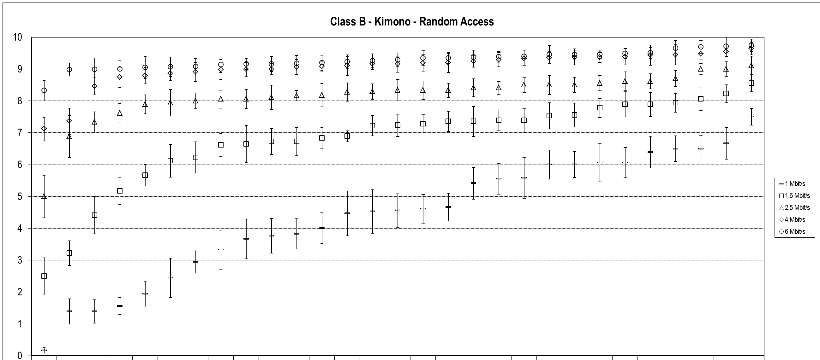
Figure 1 – Summary results for "Kimono" Class B sequence
with Random Access (constraint set 1) coding conditions

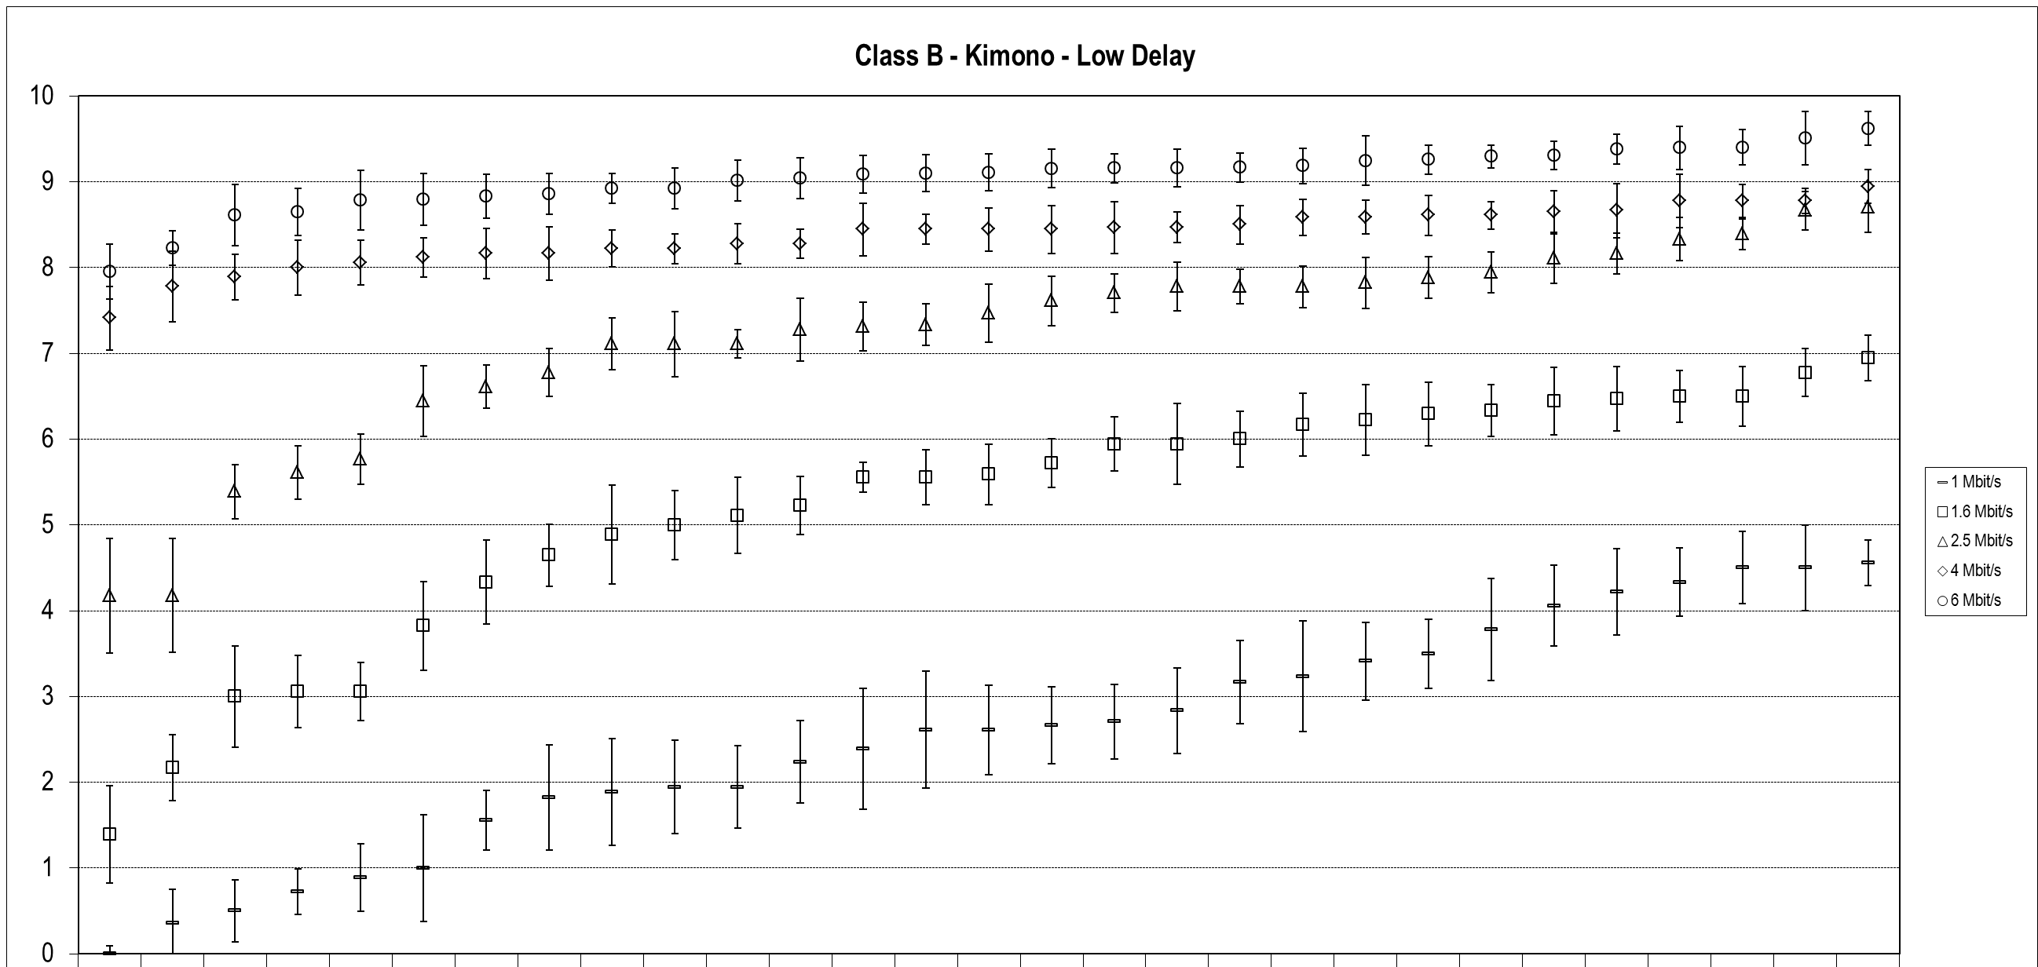
Figure 2 – Summary results for "Kimono" Class B sequence
with Low Delay (constraint set 2) coding conditions

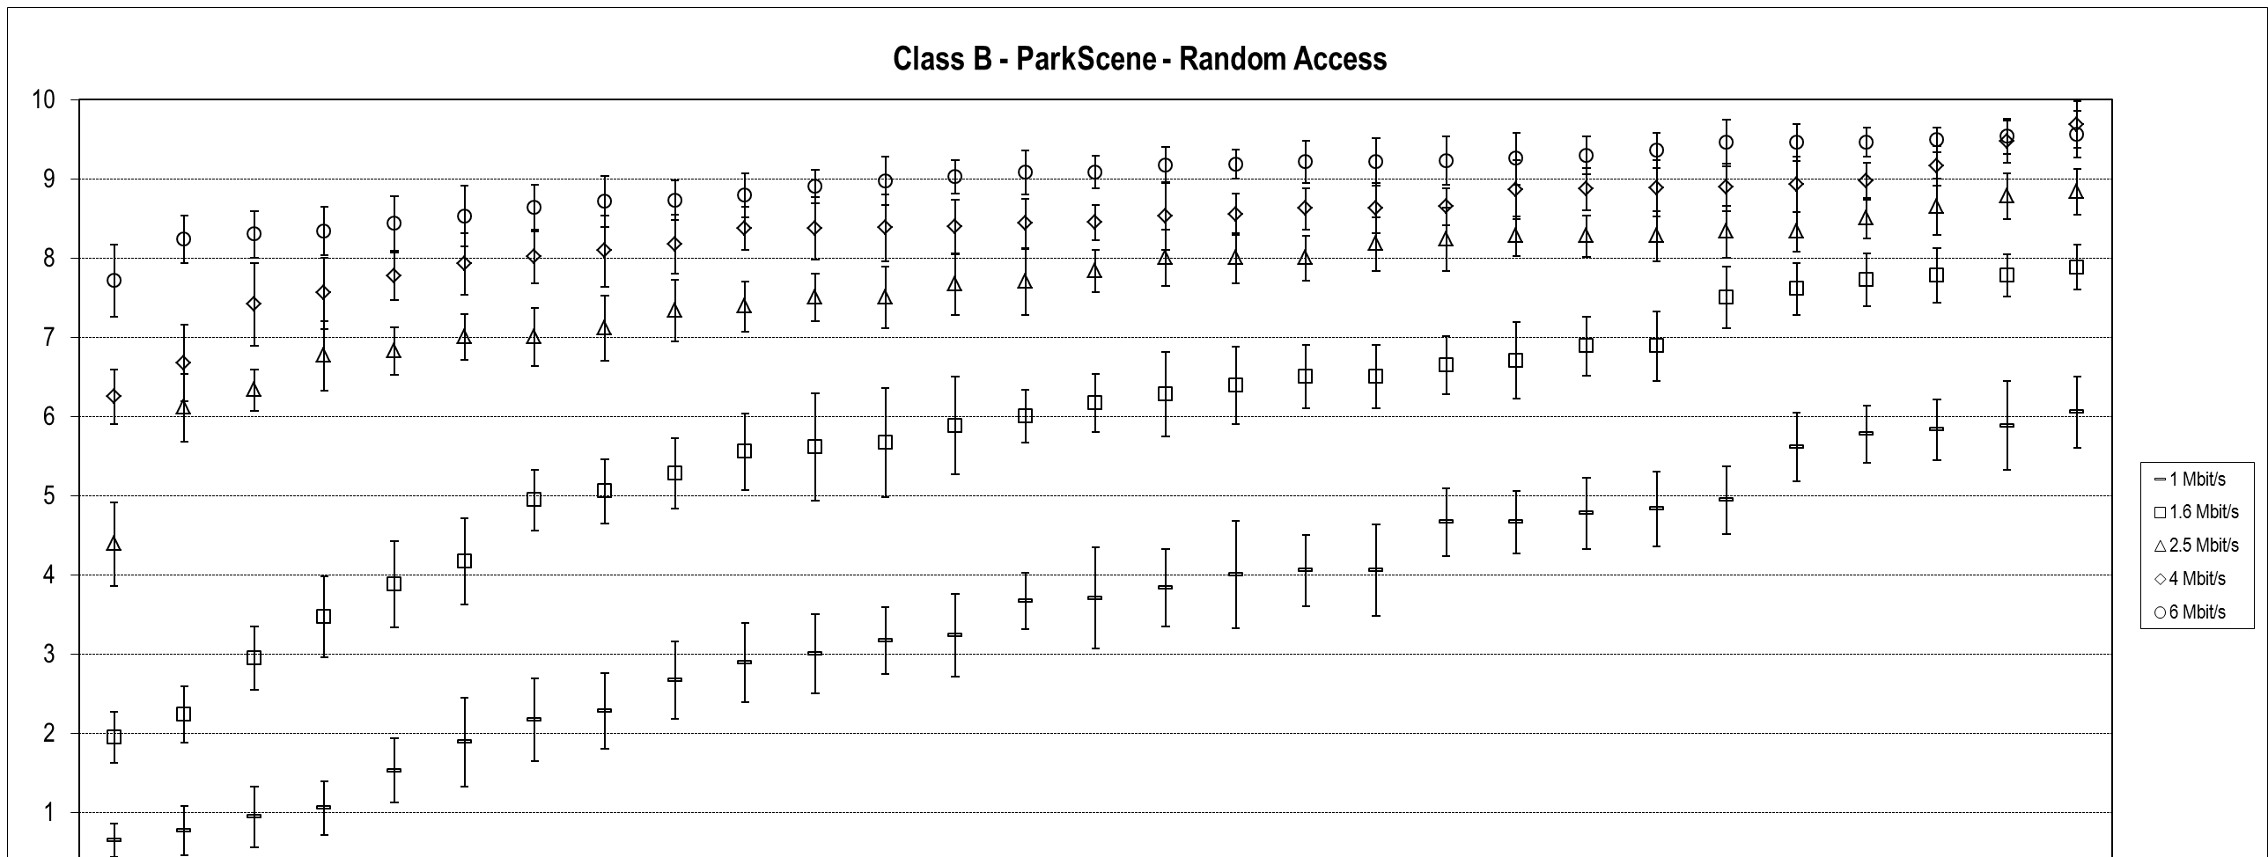
Figure 3 – Summary results for "ParkScene" Class B sequence
with Random Access (constraint set 1) coding conditions

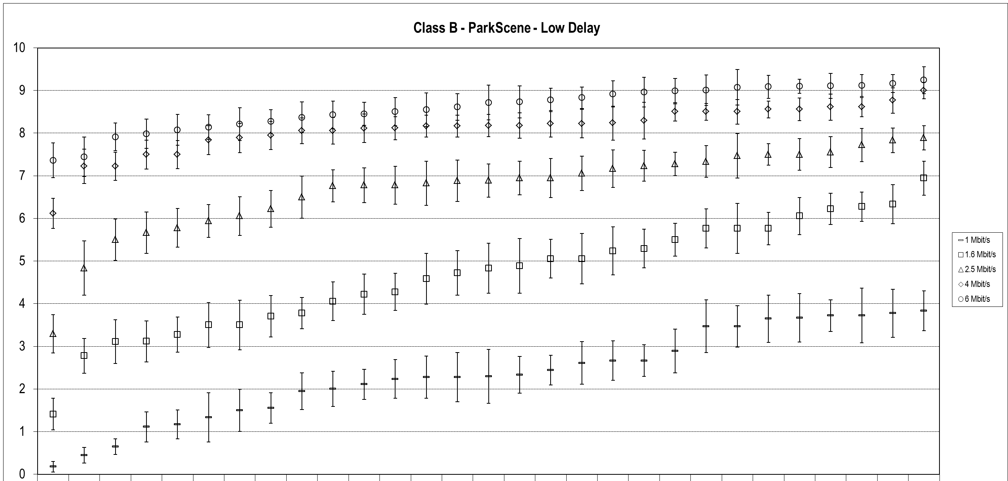
Figure 4 – Summary results for "ParkScene" Class B sequence
with Low Delay (constraint set 2) coding conditions

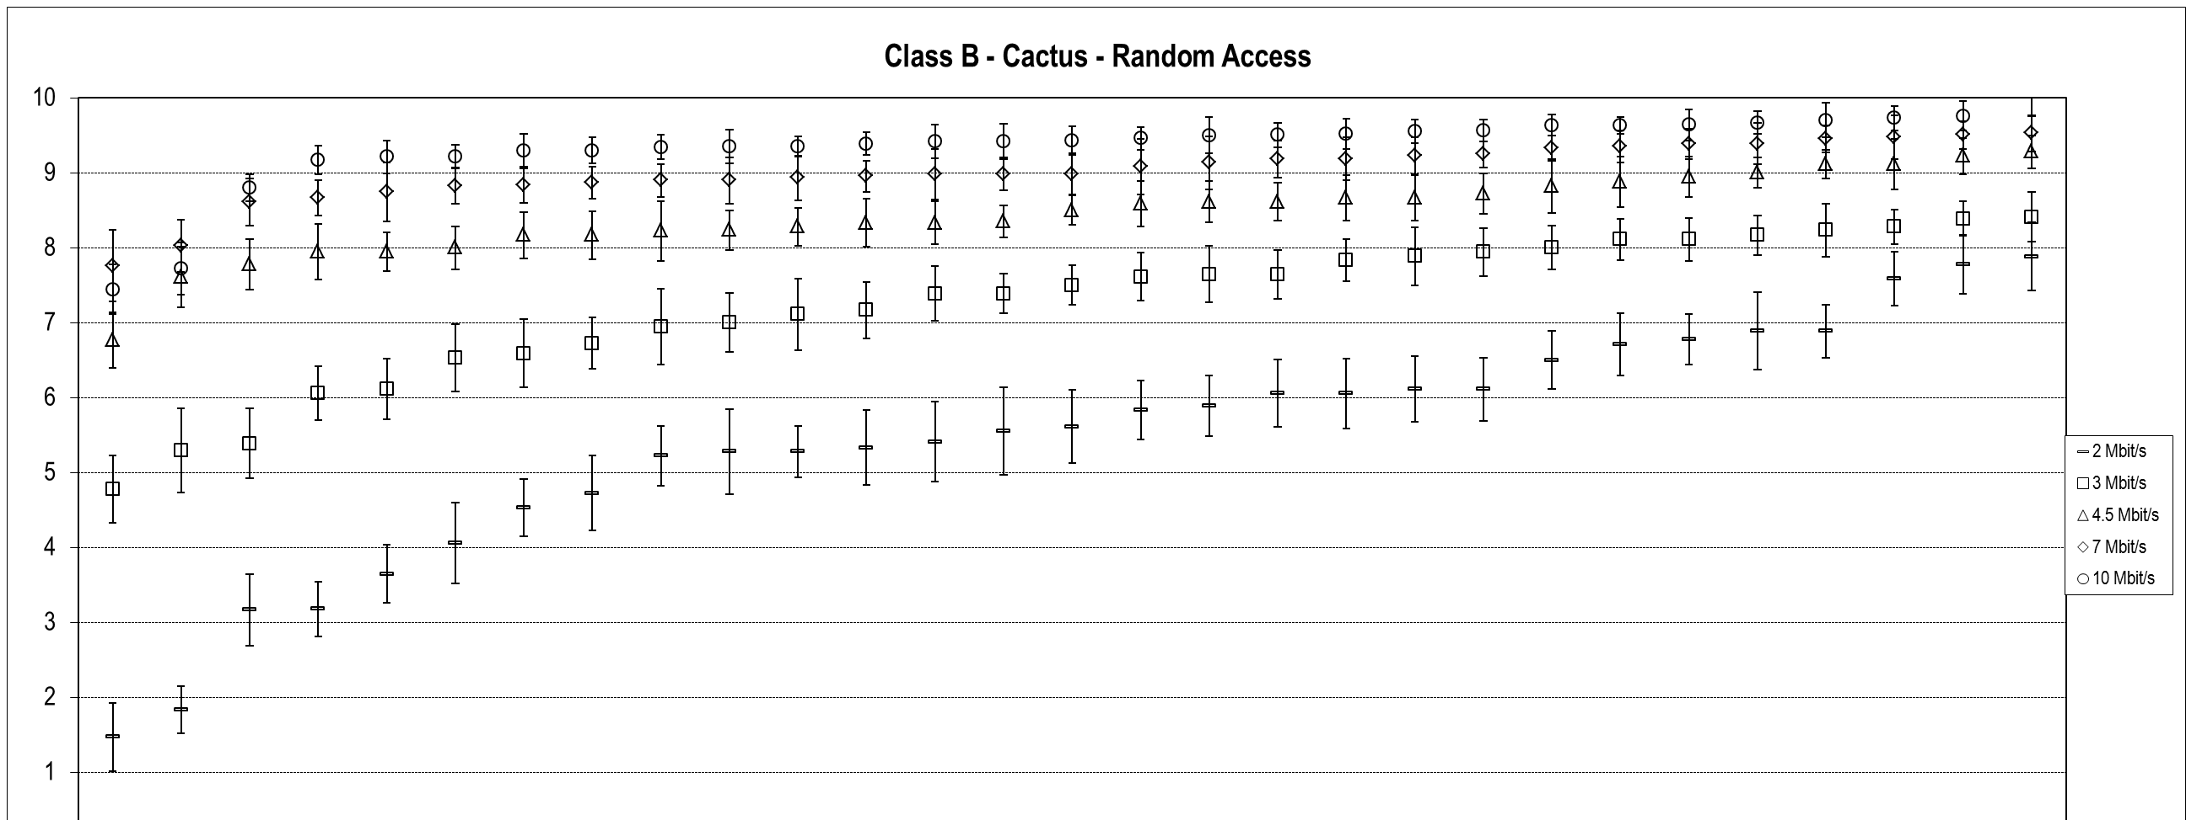
Figure 5 – Summary results for "Cactus" Class B sequence
with Random Access (constraint set 1) coding conditions

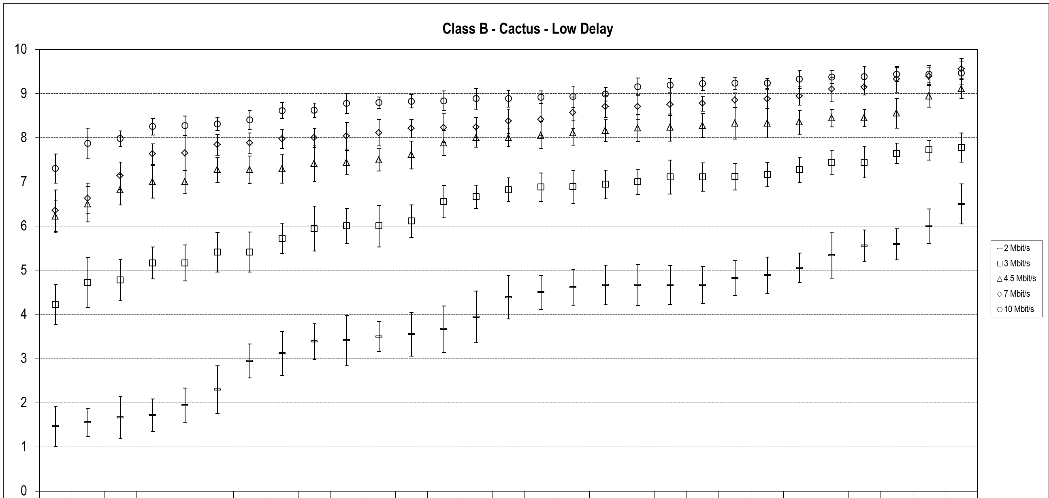
Figure 6 – Summary results for "Cactus" Class B sequence
with Low Delay (constraint set 2) coding conditions

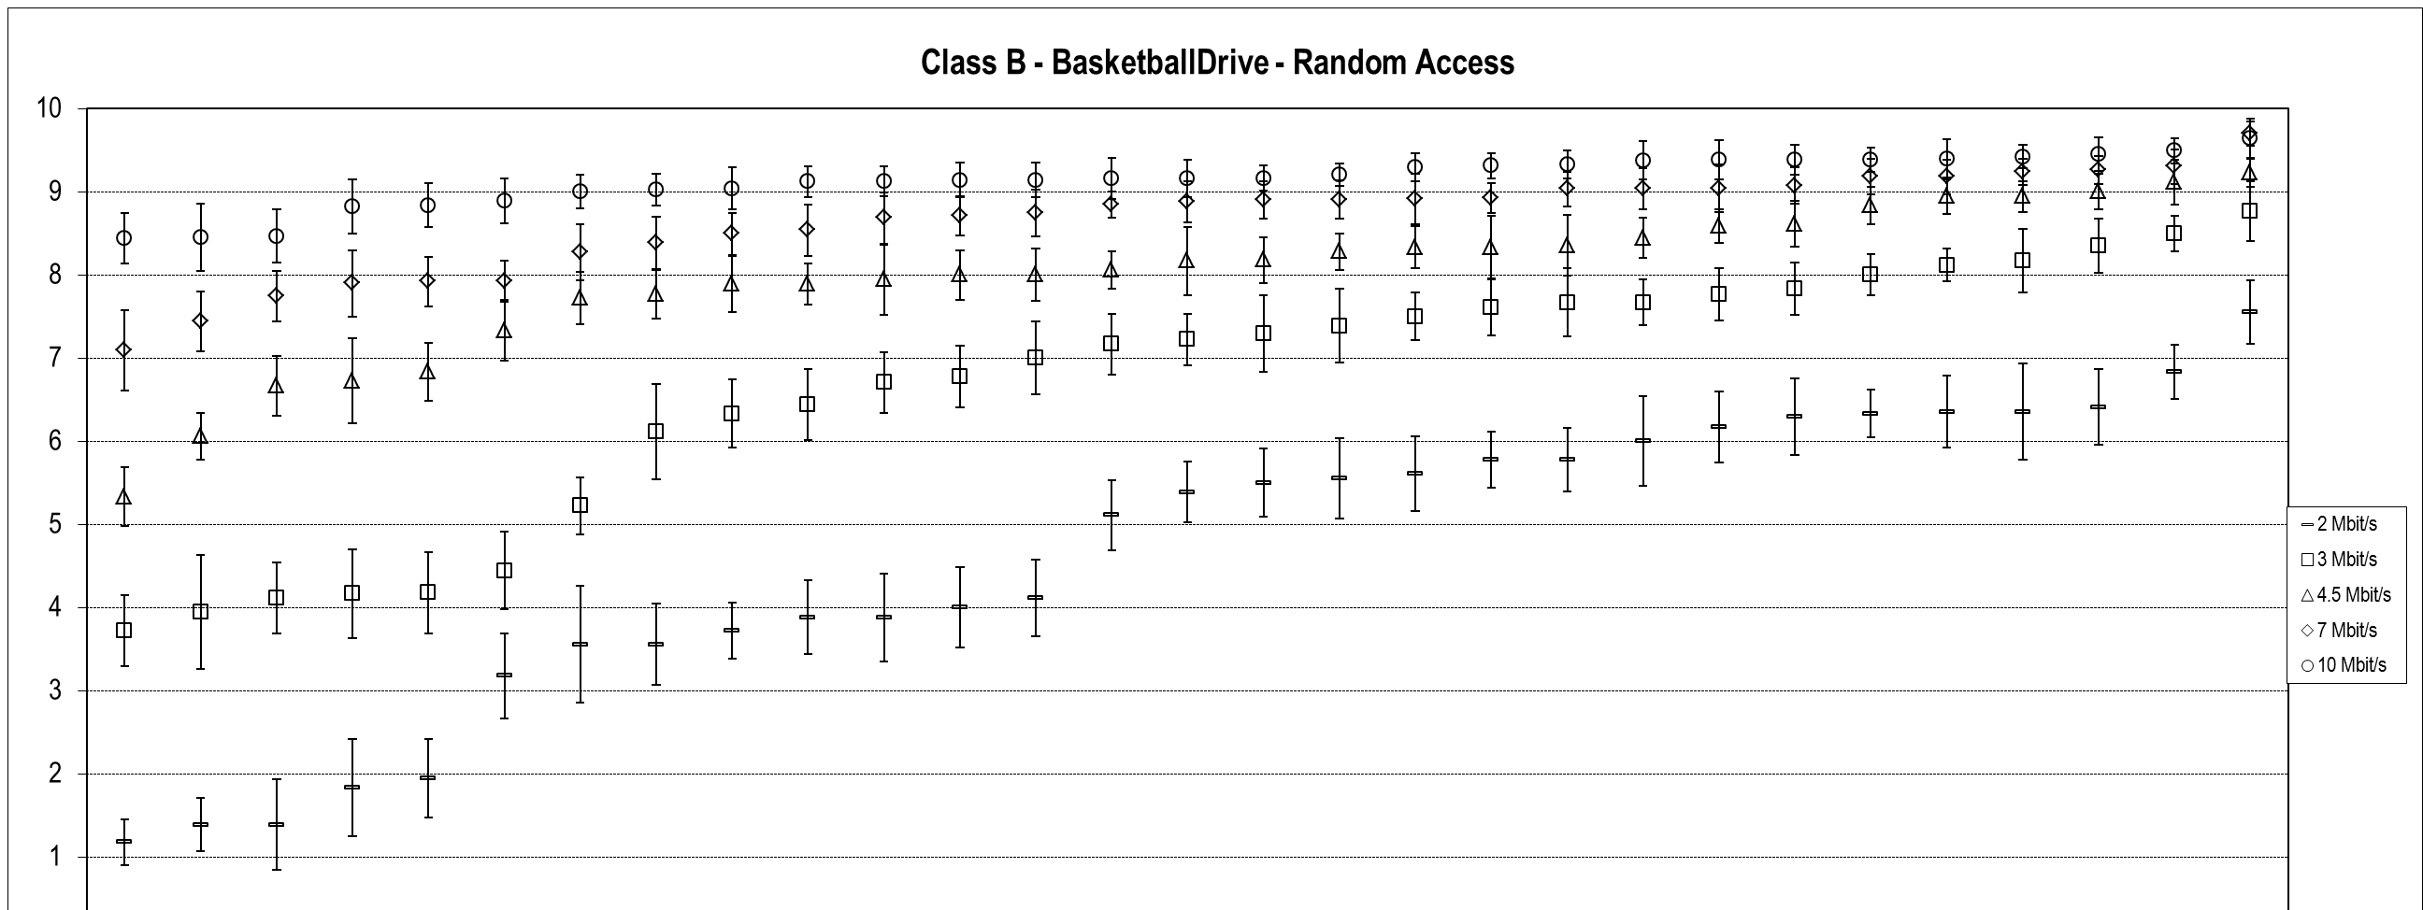
Figure 7 – Summary results for "BasketballDrive" Class B sequence
with Random Access (constraint set 1) coding conditions

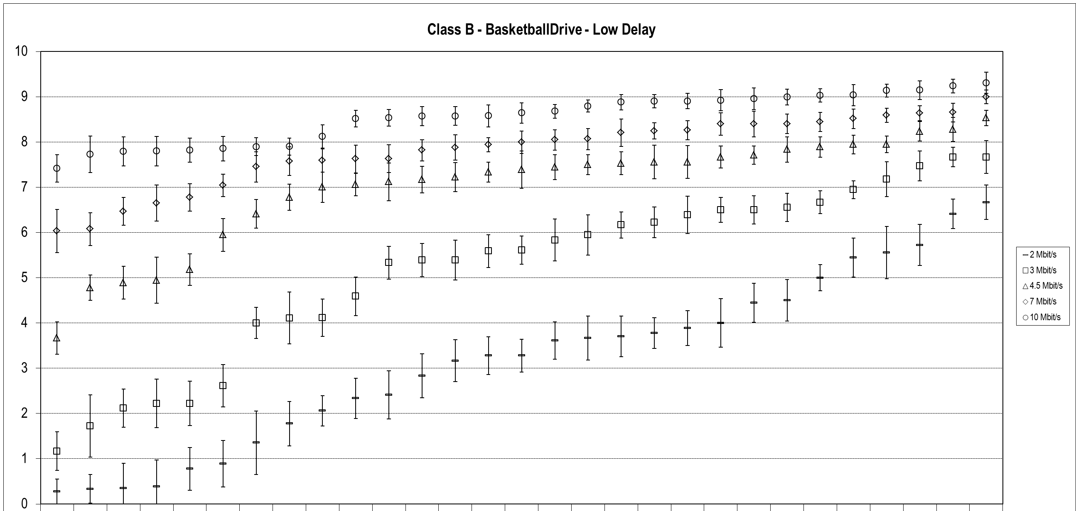
Figure 8 – Summary results for "BasketballDrive" Class B sequence
with Low Delay (constraint set 2) coding conditions

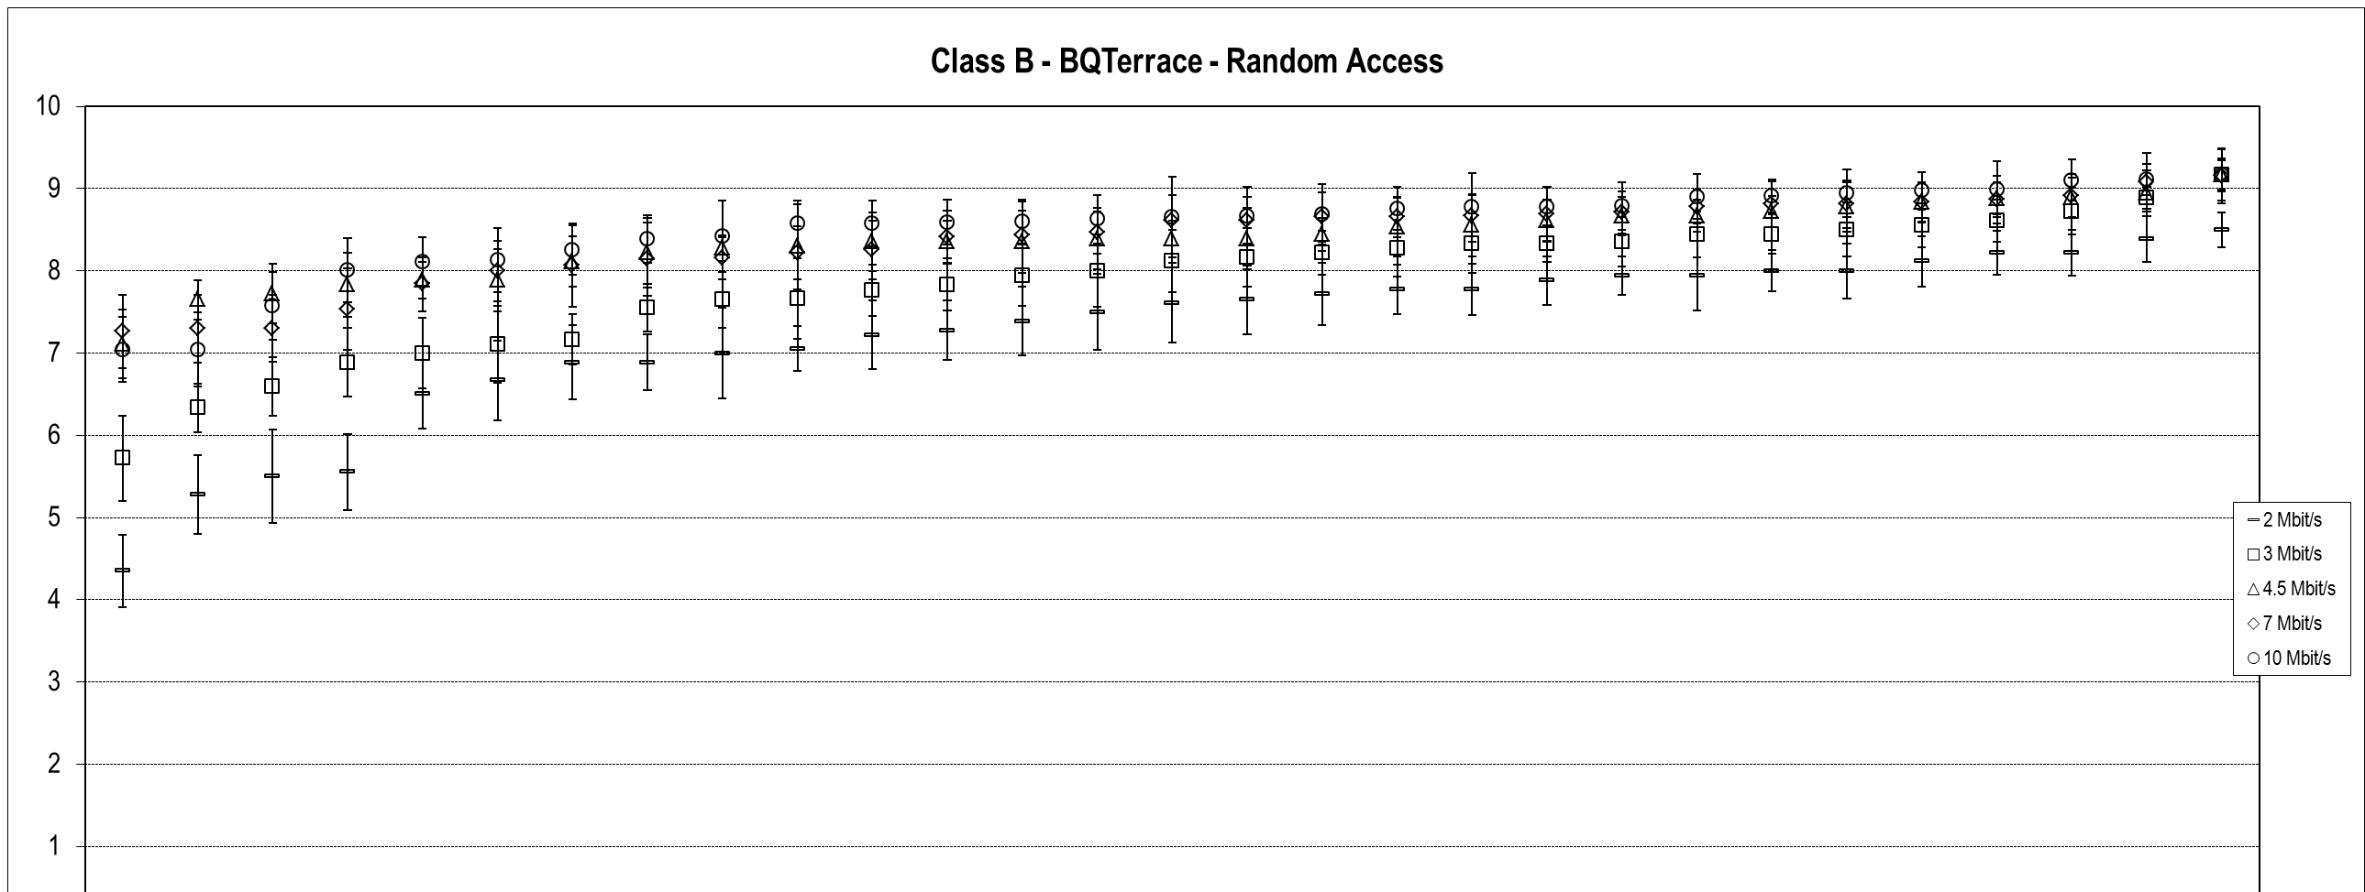
Figure 9 – Summary results for "BQTerrace" Class B sequence
with Random Access (constraint set 1) coding conditions

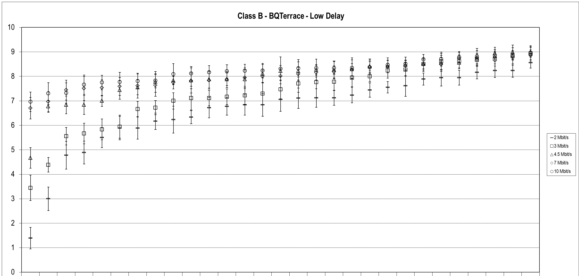
Figure 10 – Summary results for "BQTerrace" Class B sequence
with Low Delay (constraint set 2) coding conditions

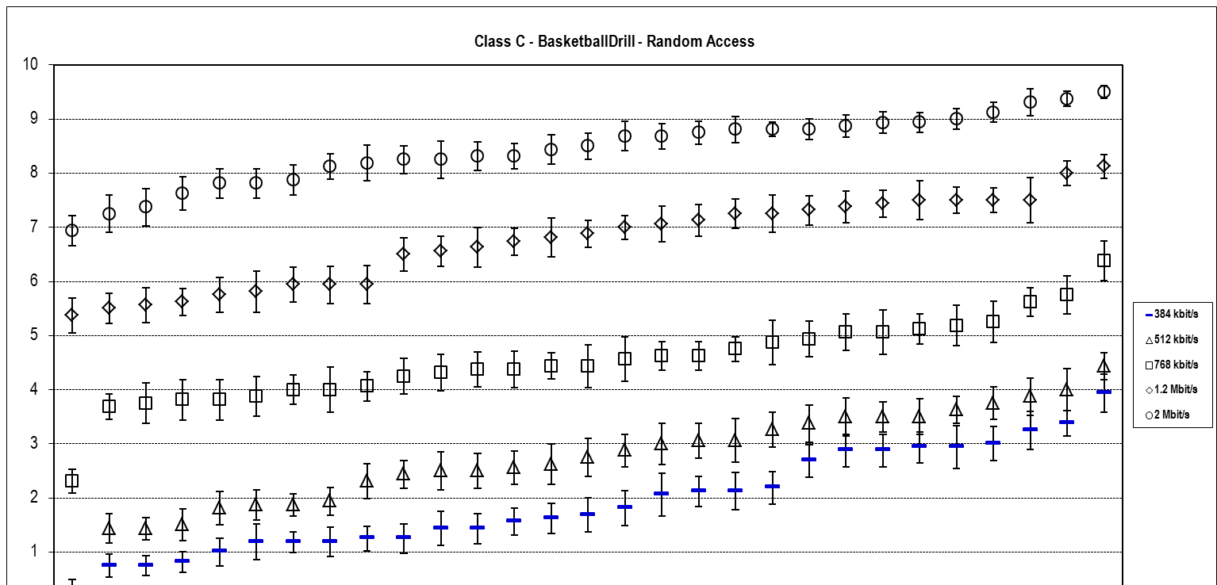
Figure 11 – Summary results for "BasketballDrill" Class C sequence
with Random Access (constraint set 1) coding conditions

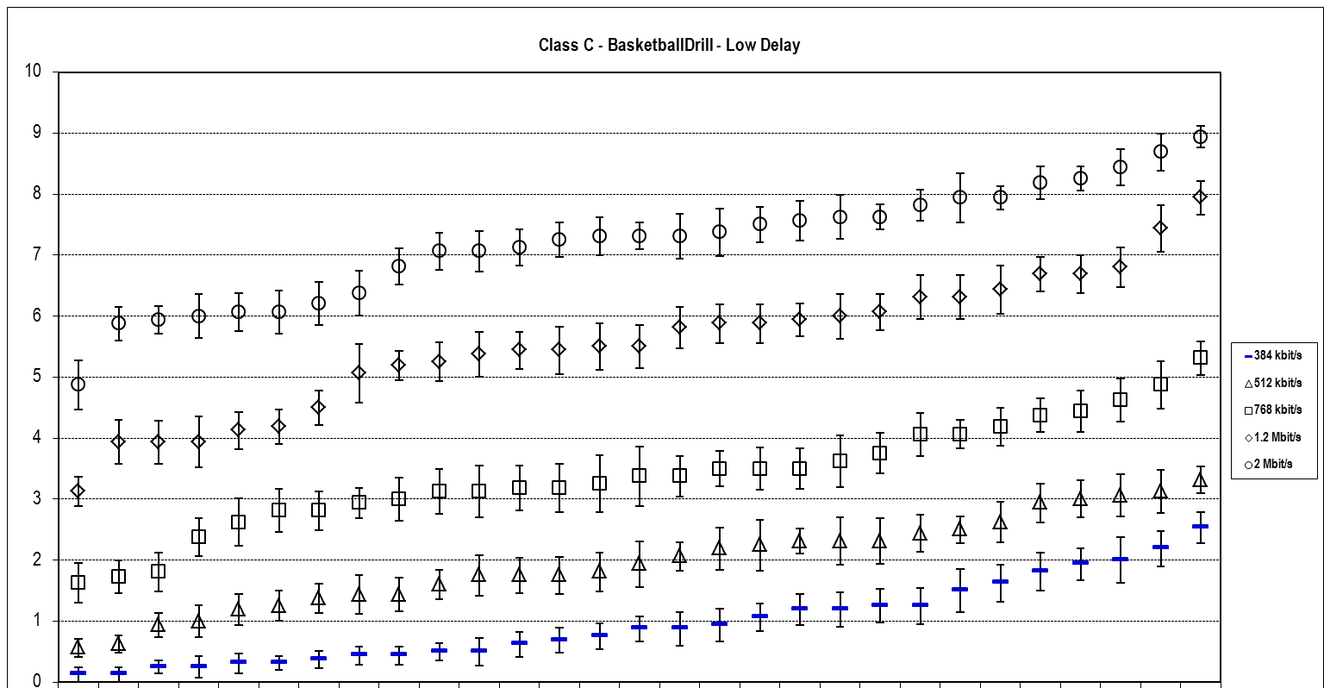
Figure 12 – Summary results for "BasketballDrill" Class C sequence
with Low Delay (constraint set 2) coding conditions

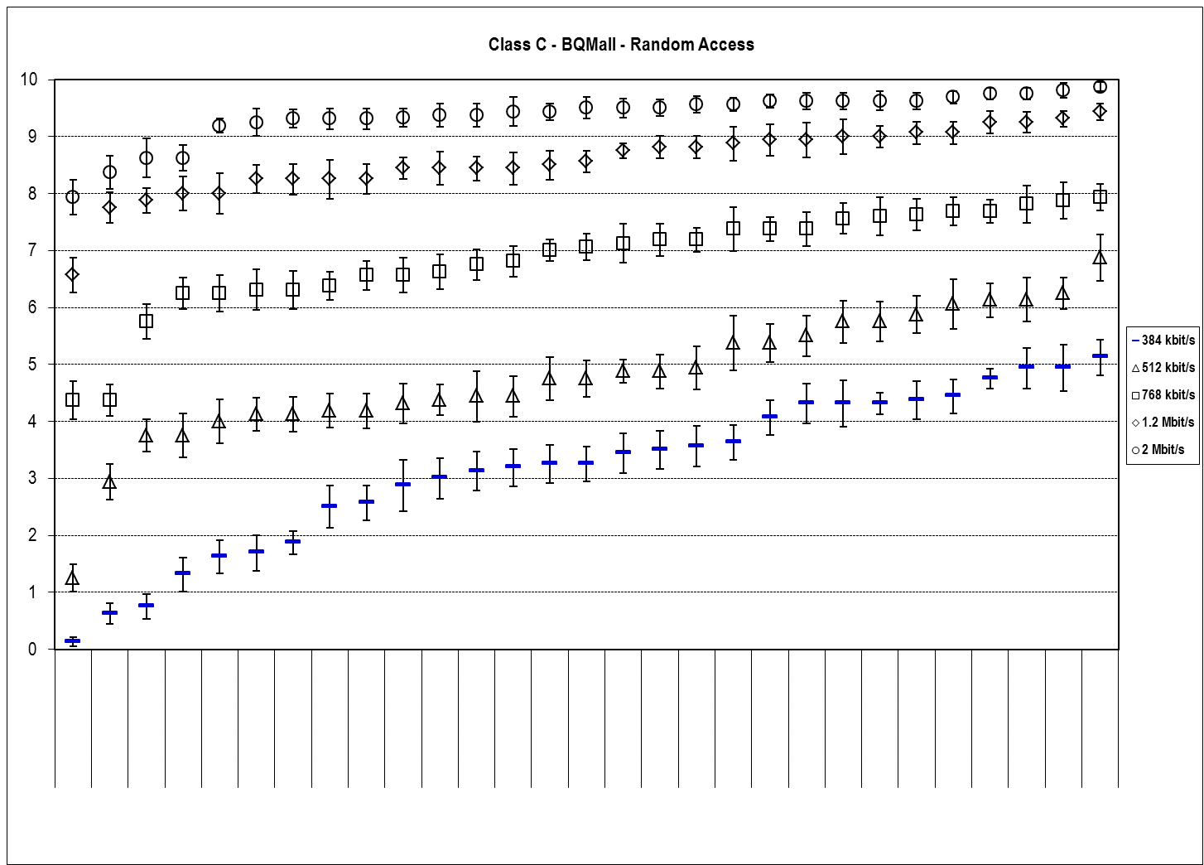
Figure 13 – Summary results for "BQMall" Class C sequence
with Random Access (constraint set 1) coding conditions

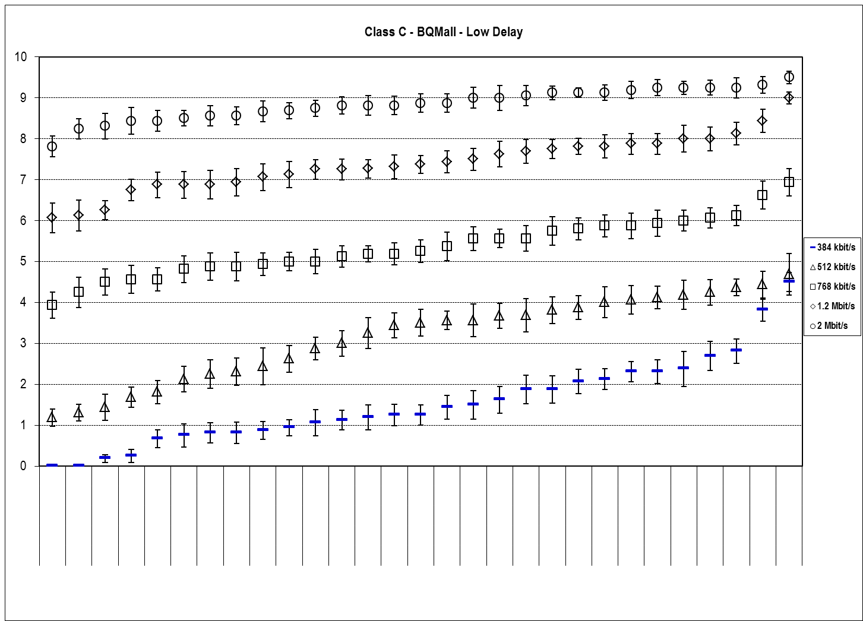
Figure 14 – Summary results for "BQMall" Class C sequence
with Low Delay (constraint set 2) coding conditions

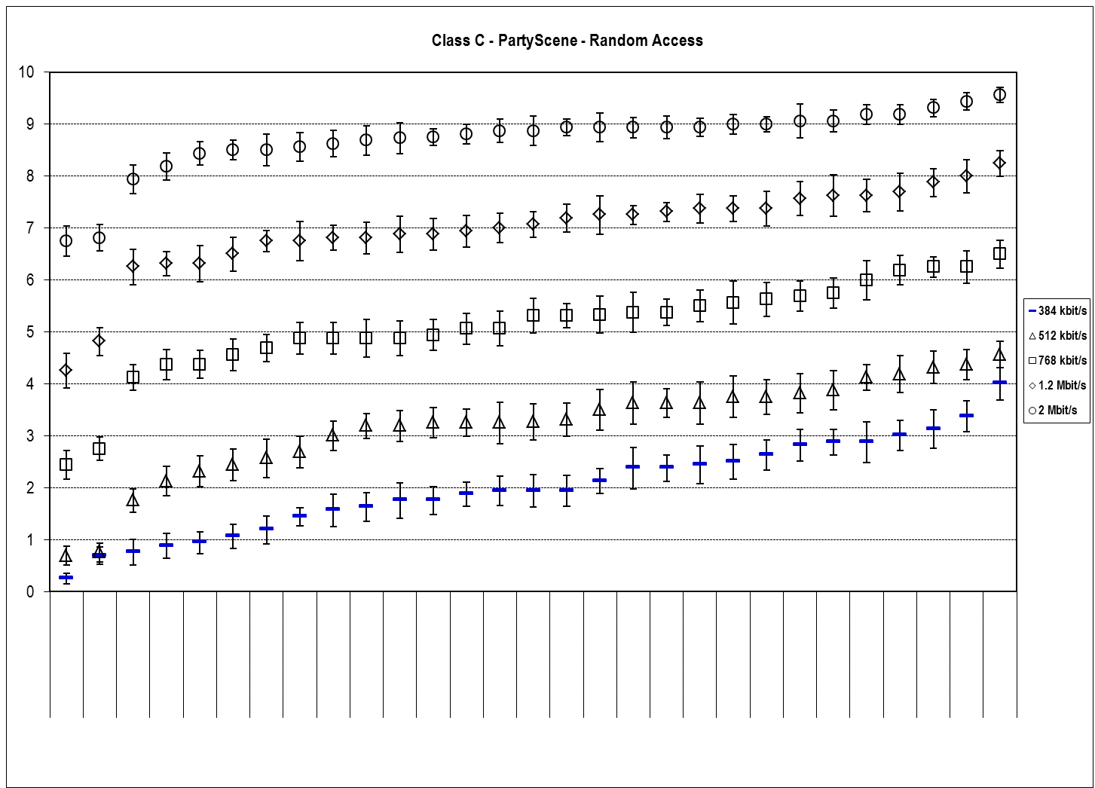
Figure 15 – Summary results for "PartyScene" Class C sequence
with Random Access (constraint set 1) coding conditions

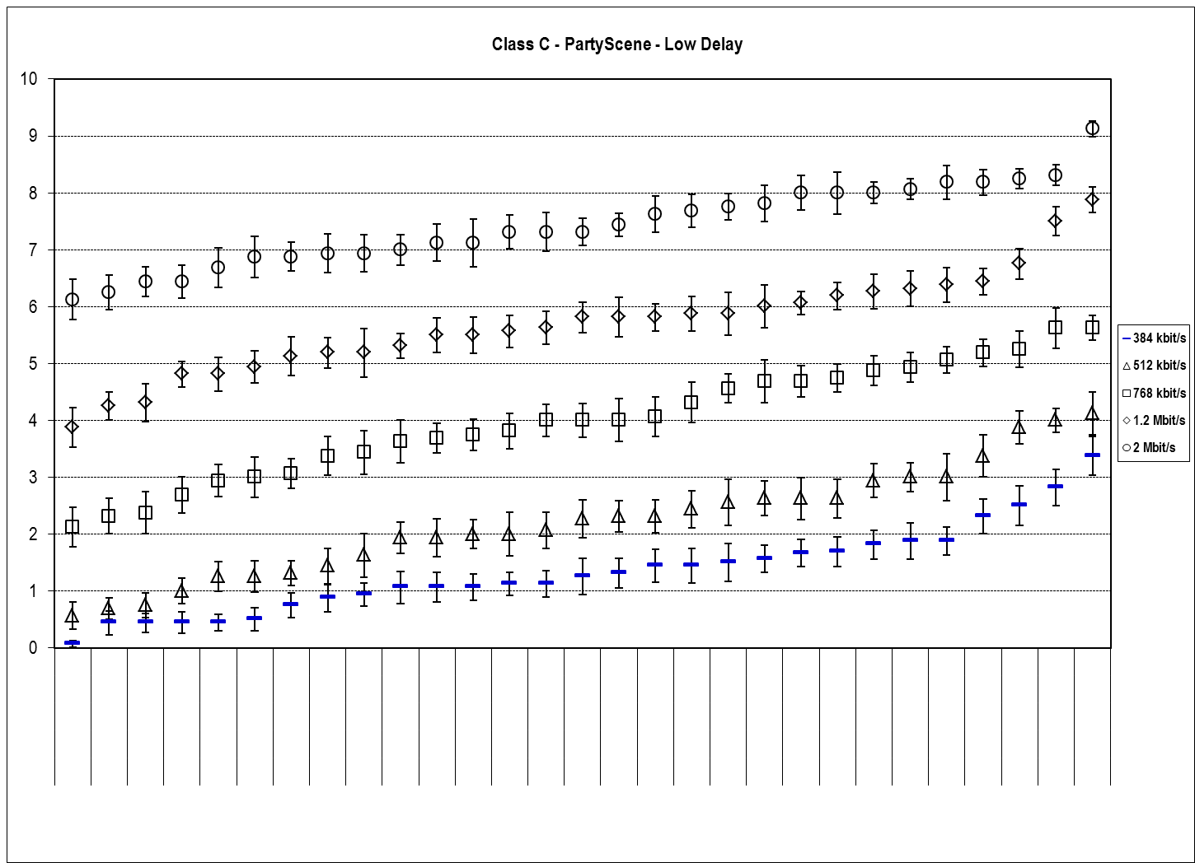
Figure 16 – Summary results for "PartyScene" Class C sequence
with Low Delay (constraint set 2) coding conditions

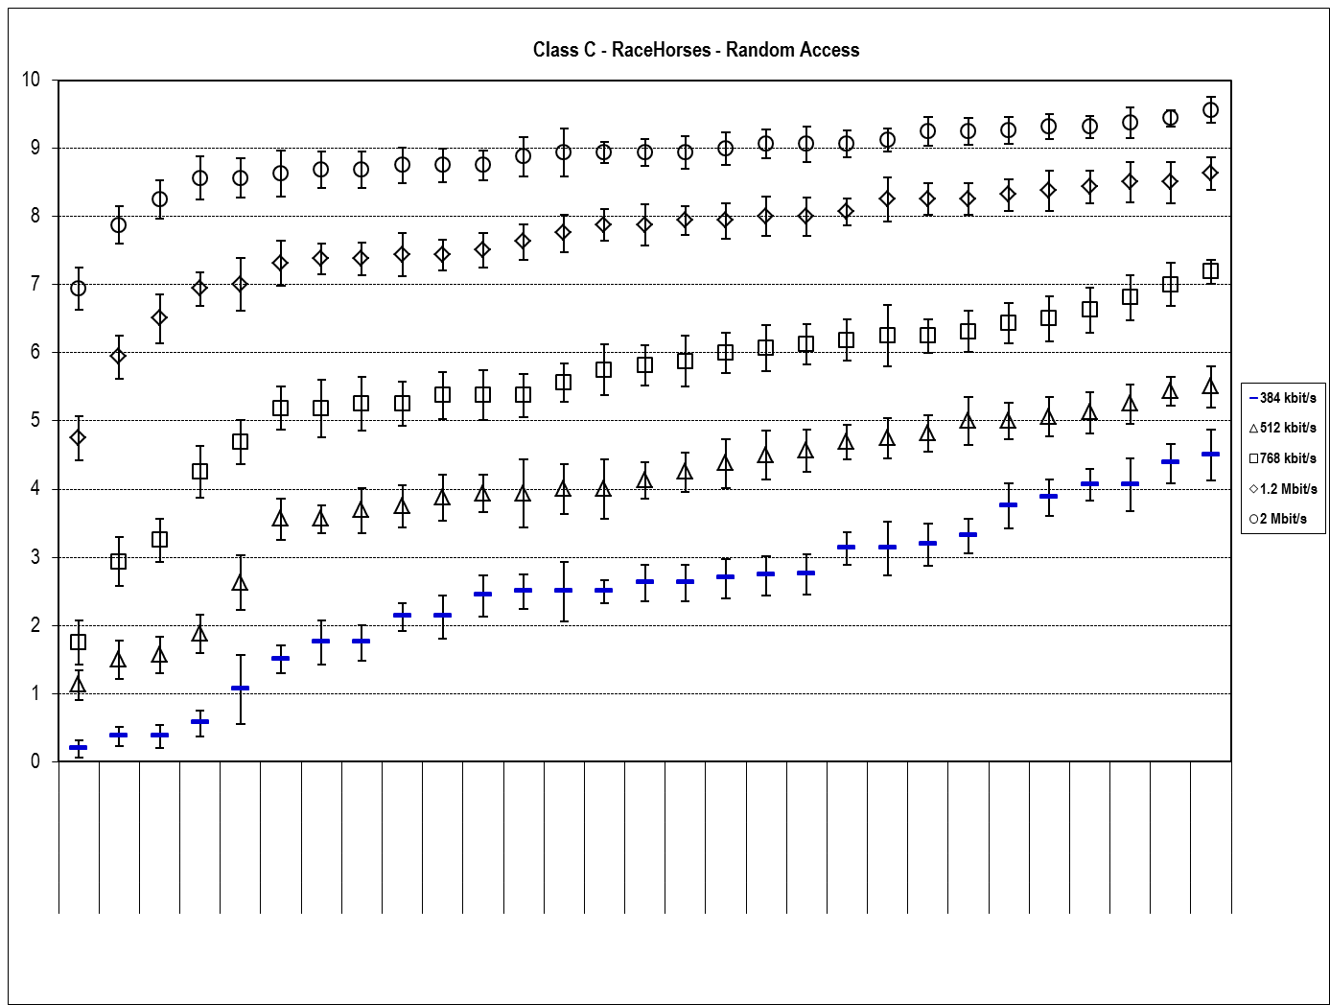
Figure 17 – Summary results for "RaceHorses" Class C sequence
with Random Access (constraint set 1) coding conditions

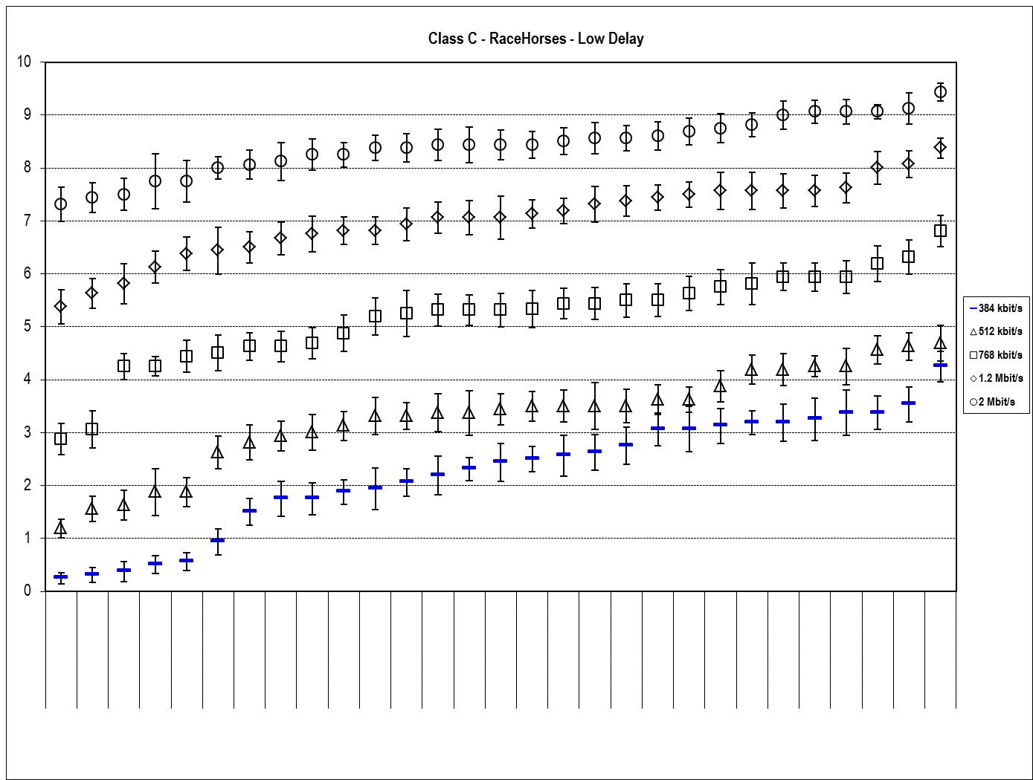
Figure 18 – Summary results for "RaceHorses" Class C sequence
with Low Delay (constraint set 2) coding conditions

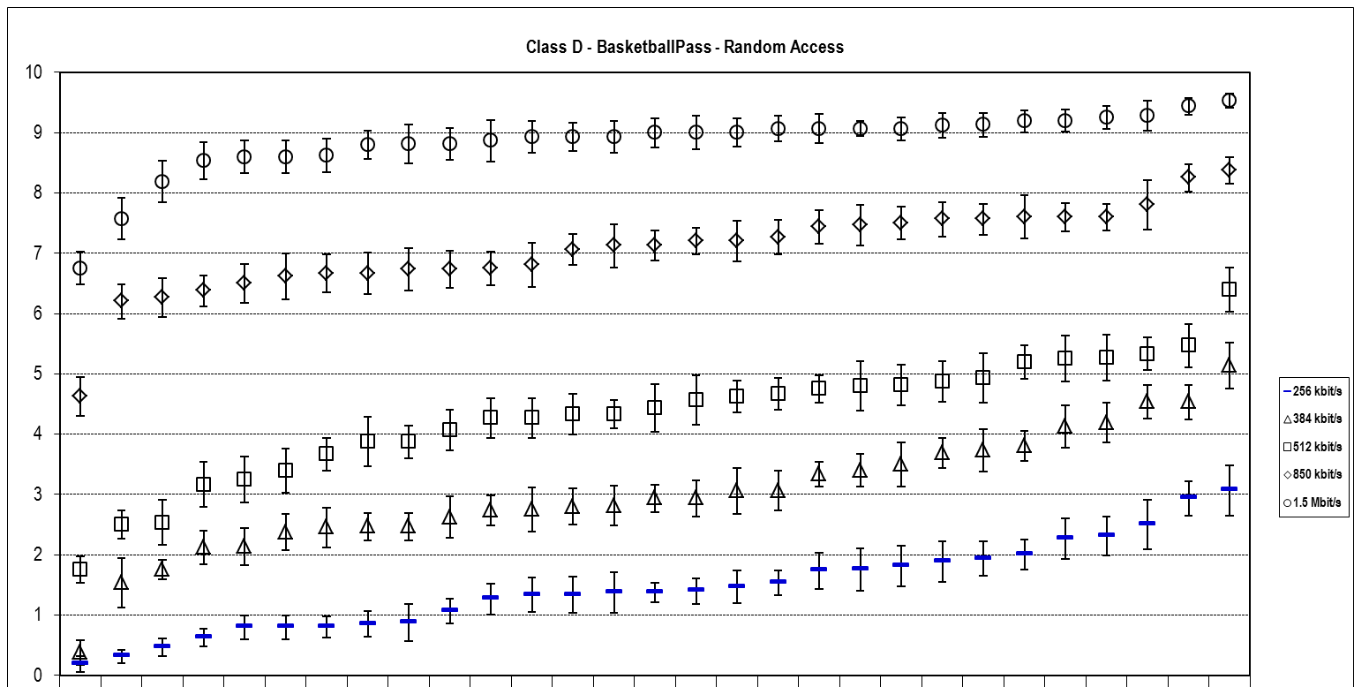
Figure 19 – Summary results for "BasketballPass" Class D sequence
with Random Access (constraint set 1) coding conditions

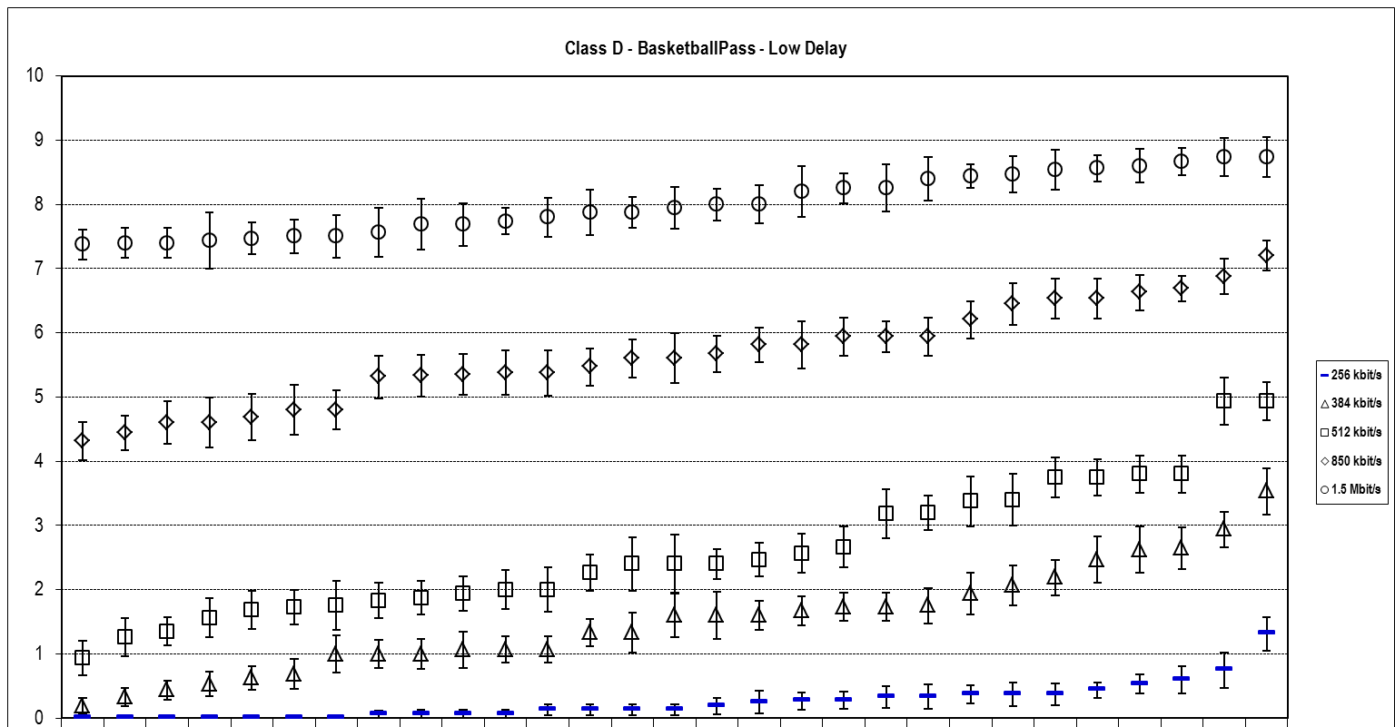
Figure 20 – Summary results for "BasketballPass" Class D sequence
with Low Delay (constraint set 2) coding conditions

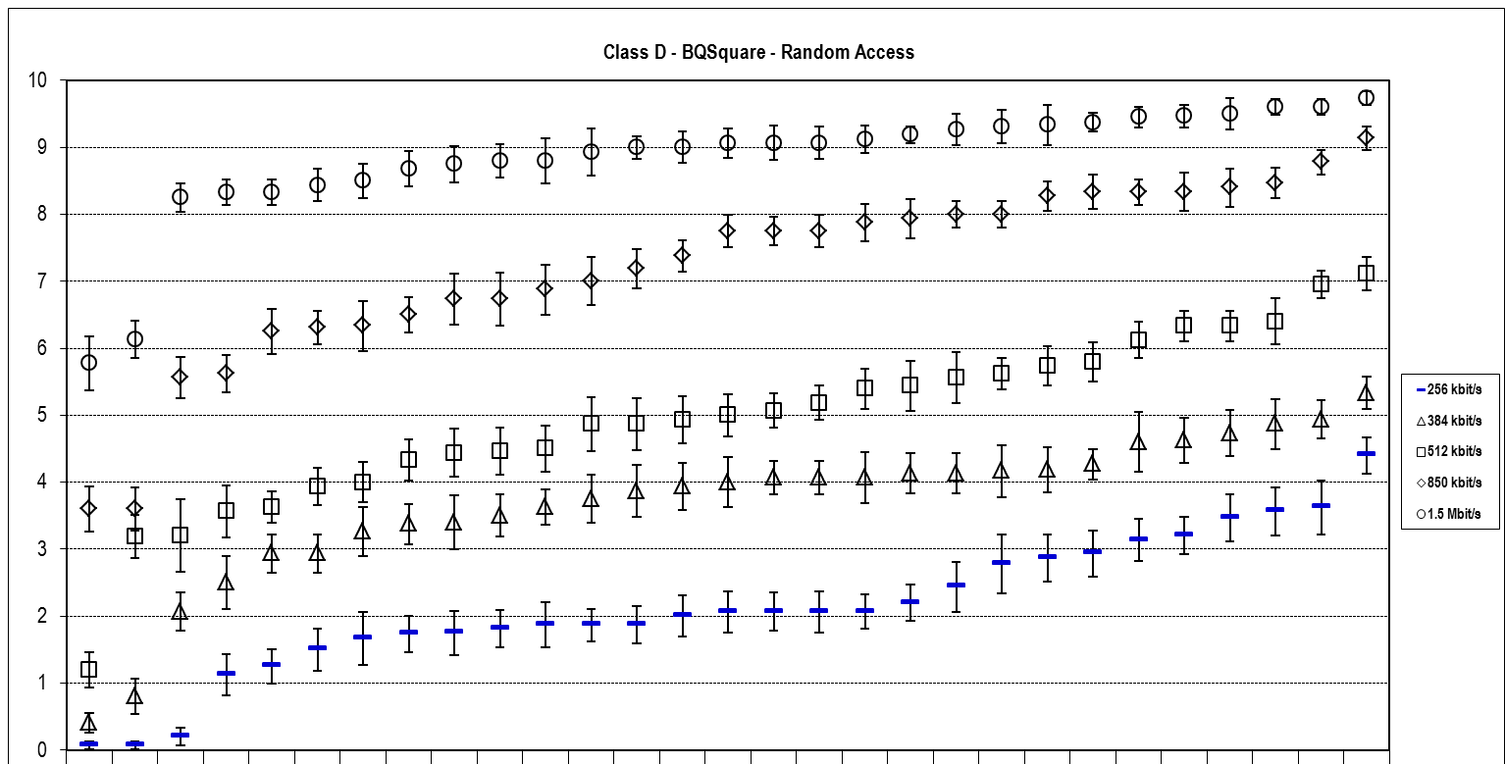
Figure 21 – Summary results for "BQSquare" Class D sequence
with Random Access (constraint set 1) coding conditions

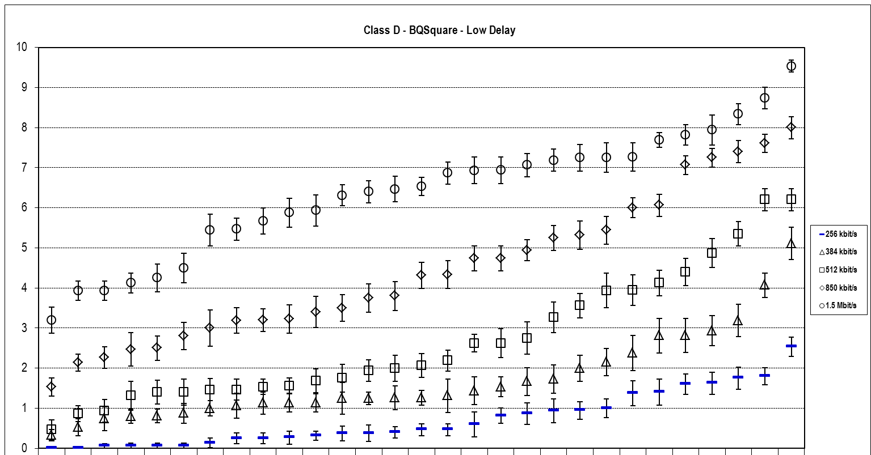
Figure 22 – Summary results for "BQSquare" Class D sequence
with Low Delay (constraint set 2) coding conditions

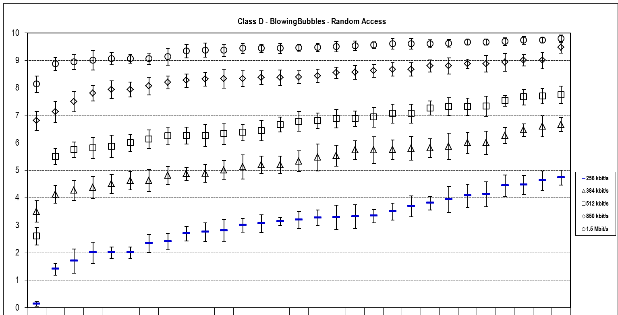
Figure 23 – Summary results for "BlowingBubbles" Class D sequence
with Random Access (constraint set 1) coding conditions

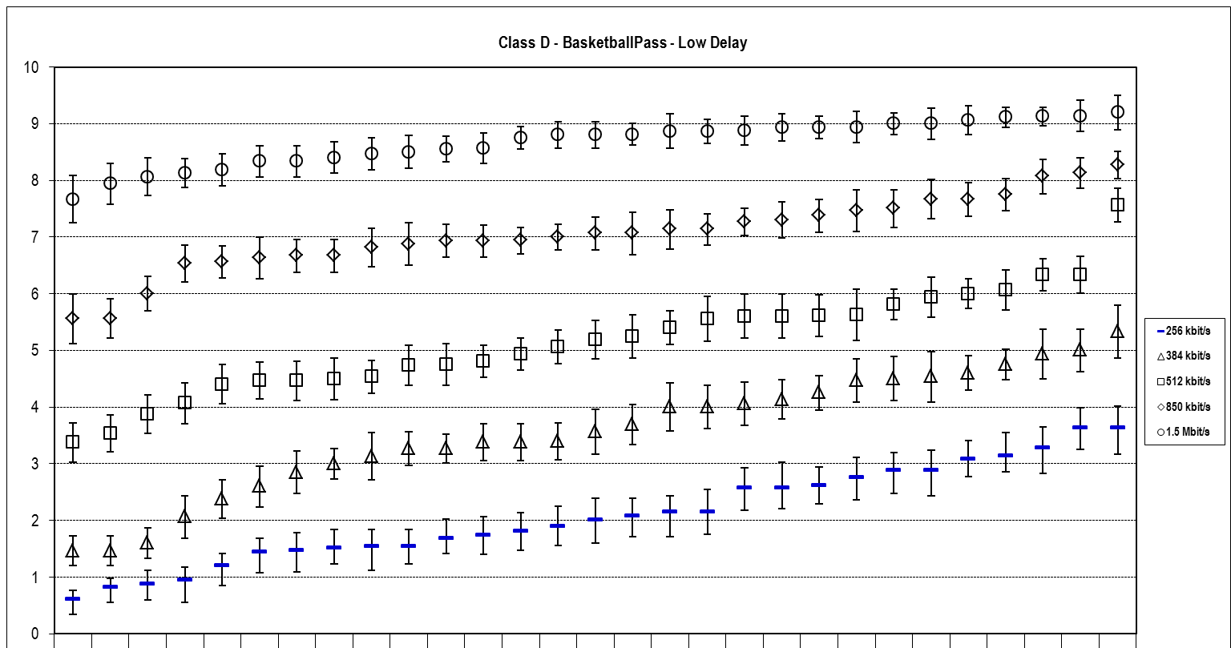
Figure 24 – Summary results for "BlowingBubbles" Class D sequence
with Low Delay (constraint set 2) coding conditions

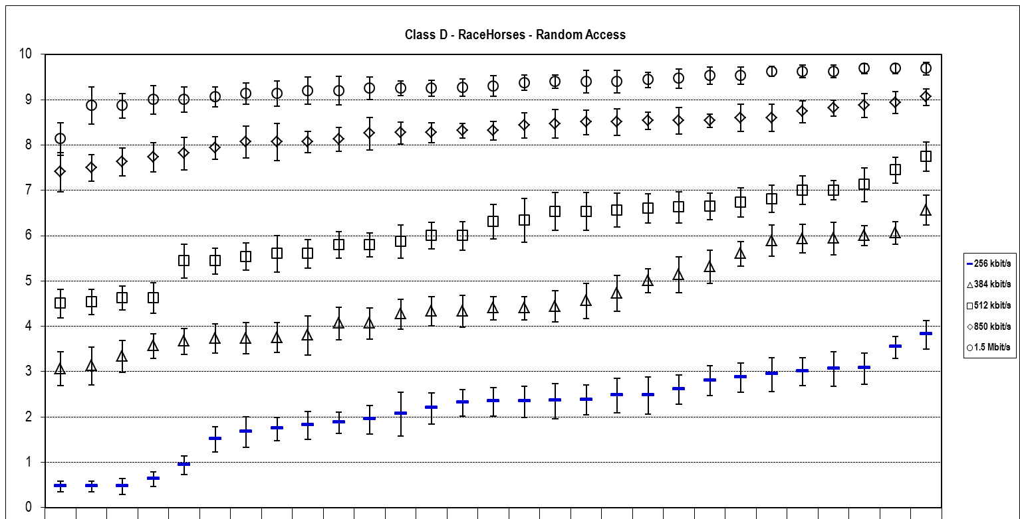
Figure 25 – Summary results for "RaceHorses" Class D sequence
with Random Access (constraint set 1) coding conditions

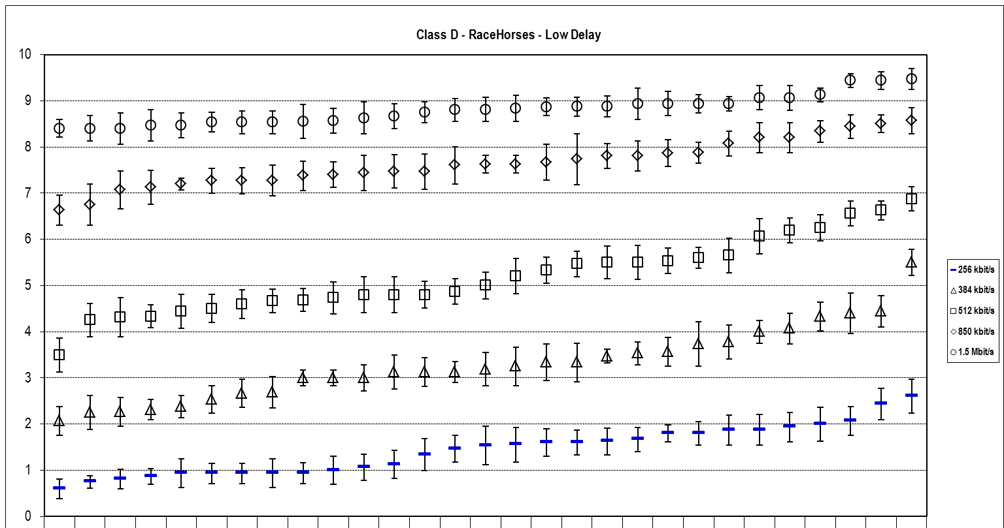
Figure 26 – Summary results for "RaceHorses" Class D sequence
with Low Delay (constraint set 2) coding conditions

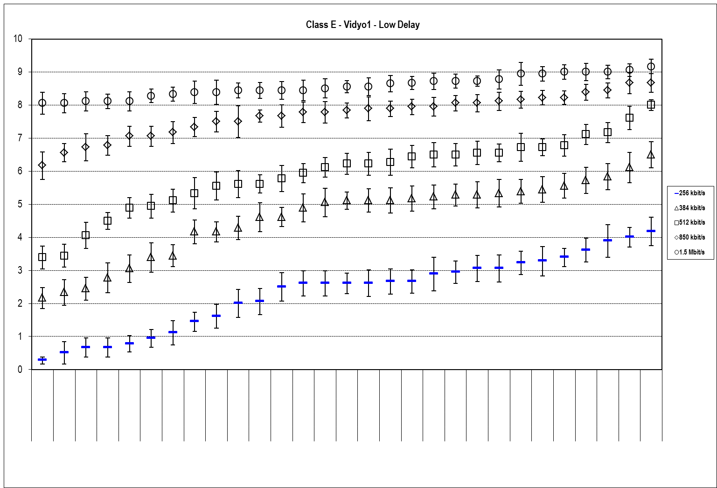
Figure 27 – Summary results for "Vidyo1" Class E sequence
with Low Delay (constraint set 2) coding conditions

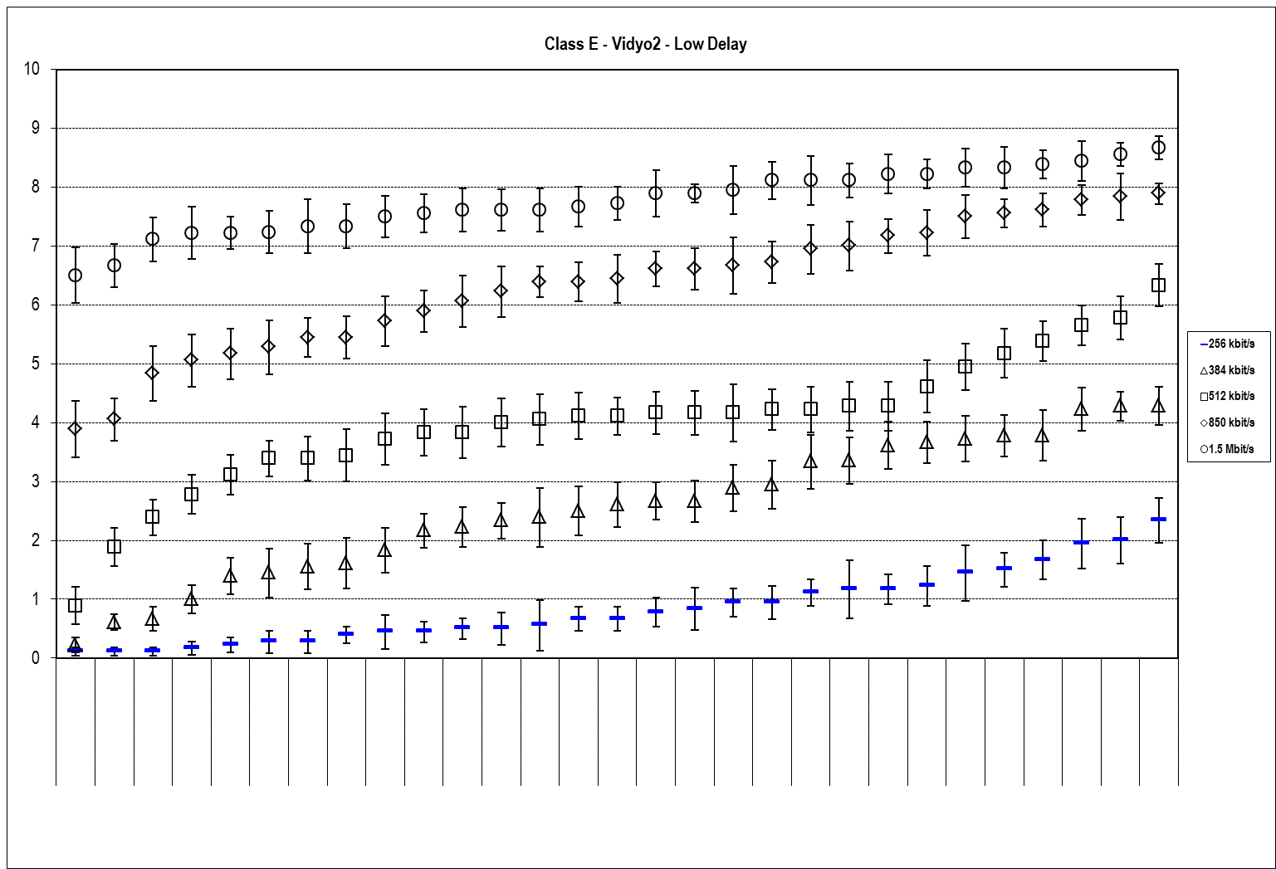
Figure 28 – Summary results for "Vidyo2" Class E sequence
with Low Delay (constraint set 2) coding conditions

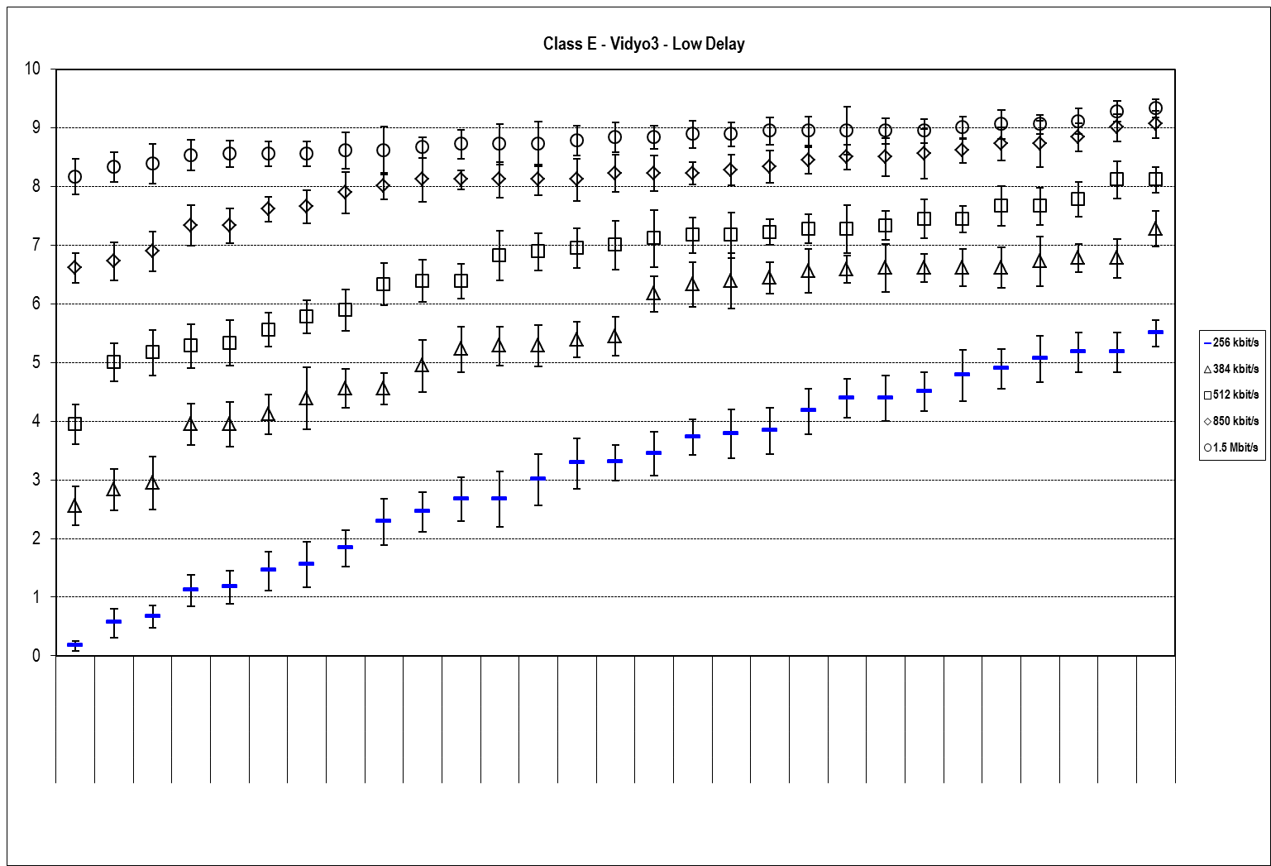
Figure 29 – Summary results for "Vidyo3" Class E sequence
with Low Delay (constraint set 2) coding conditions

The “Average MOS” graphs in Figures 30 through 39 show (un-weighted) averages over individual classes and constraint cases, as well as global summaries. Proposals are ordered for each case ranked by their average MOS performance; i.e. in the same column for different cases, not necessarily the same proposal appears.

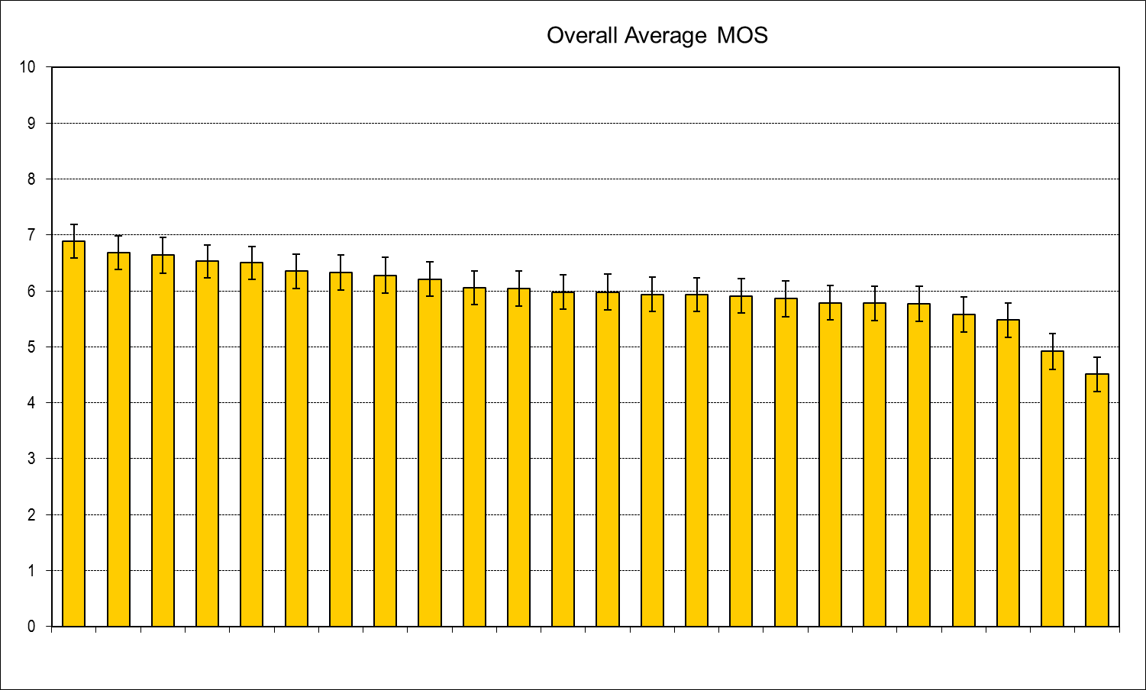
Figure 30 – Overall global average MOS results over all Classes and coding conditions

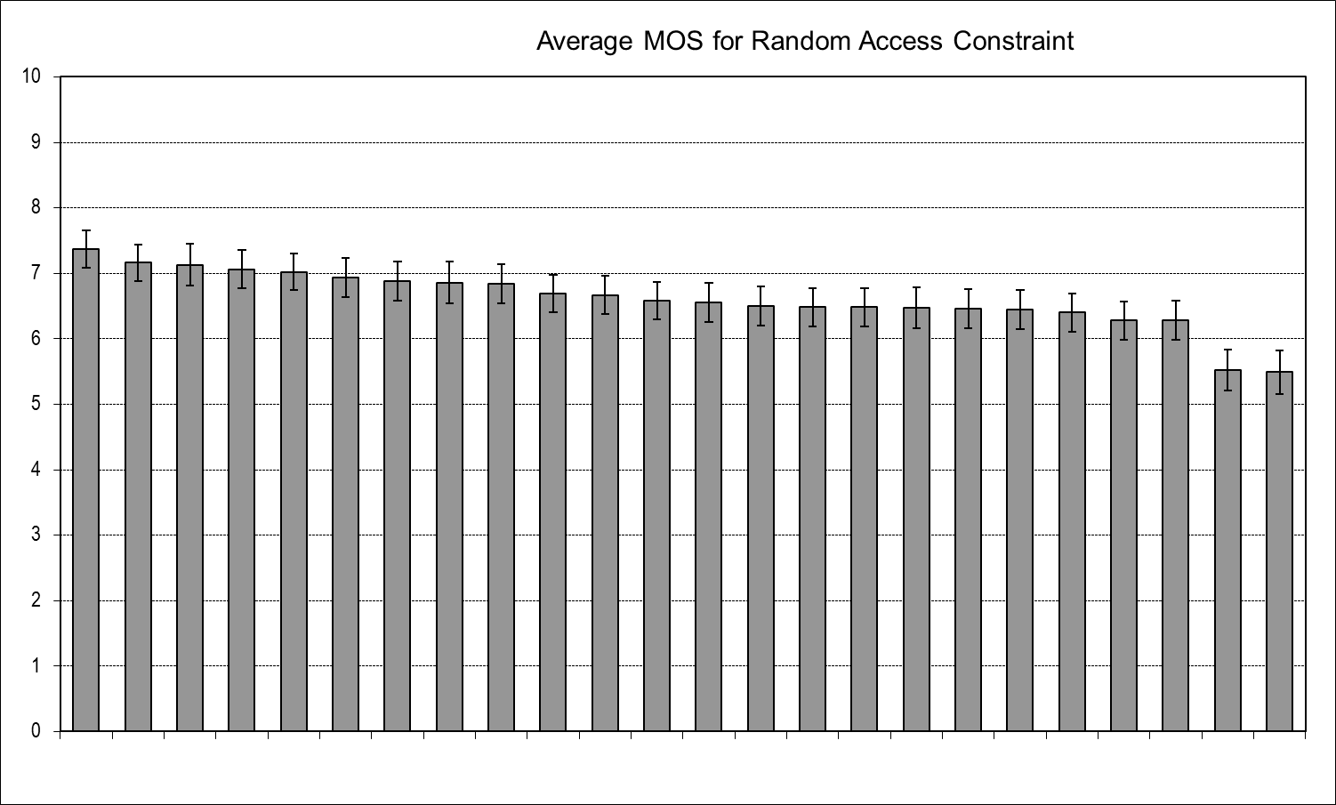
Figure 31 – Overall average MOS results over all Classes
for Random Access (constraint set 1) coding conditions

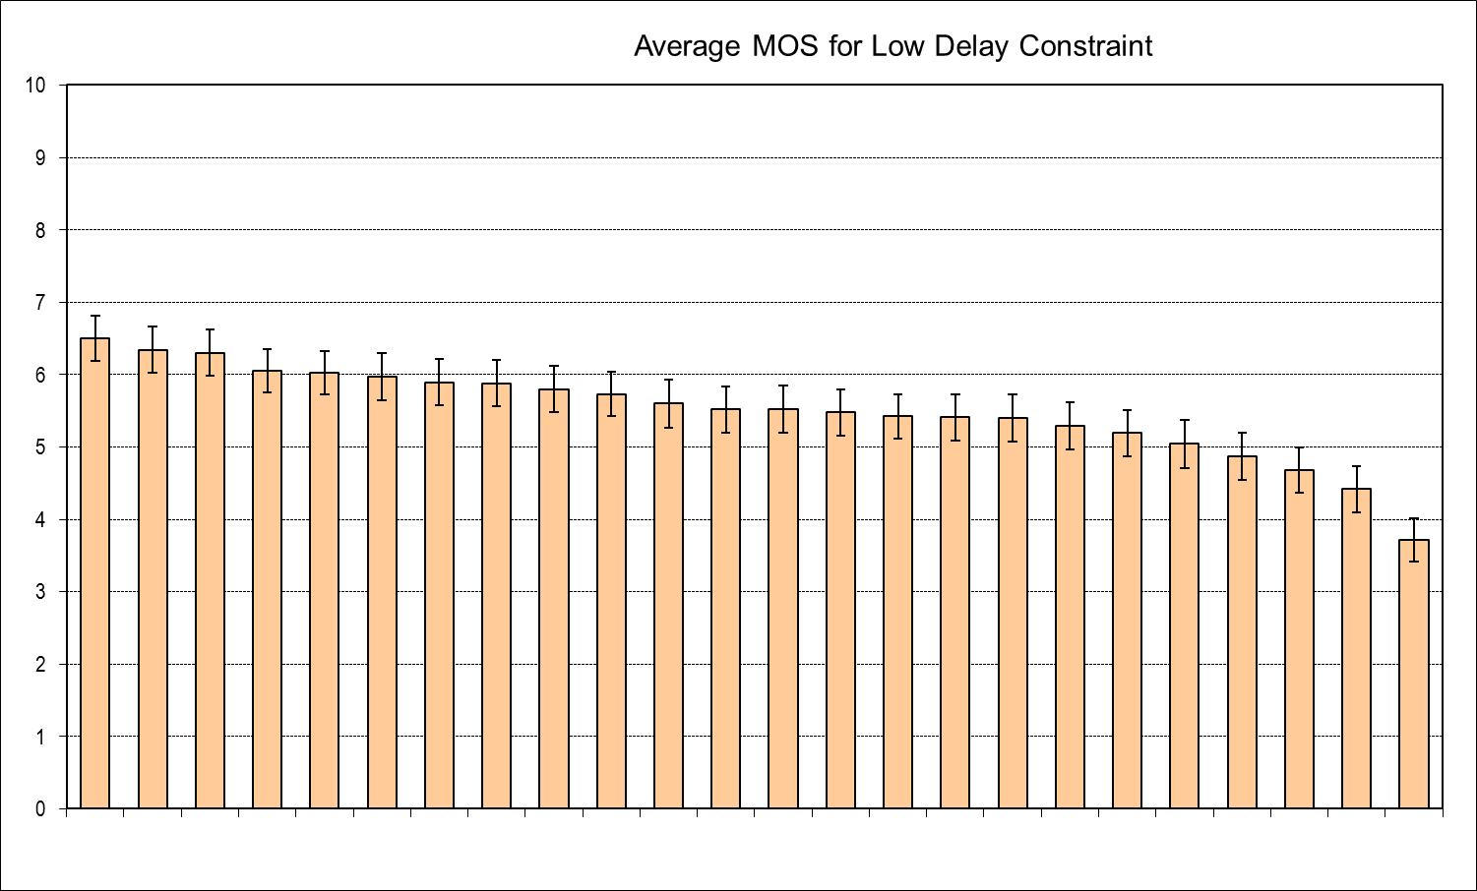
Figure 32 – Overall average MOS results over all Classes
for Low Delay (constraint set 2) coding conditions

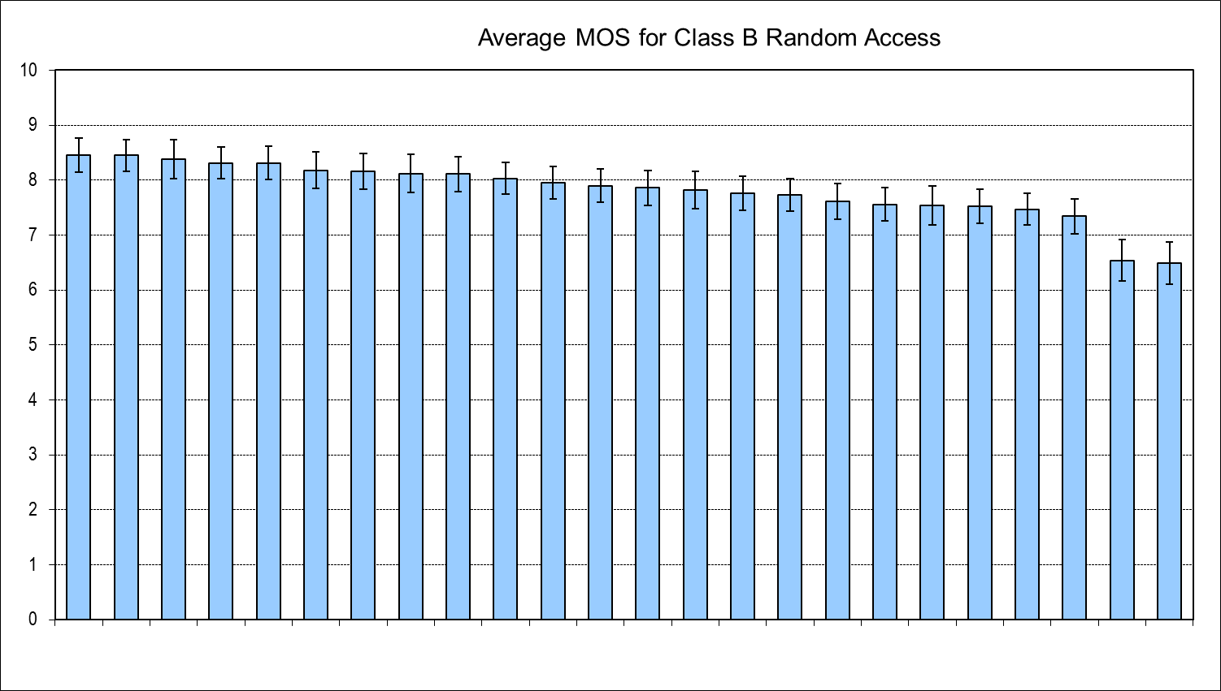
Figure 33 – Overall average MOS results for sequences in Class B
with Random Access (constraint set 1) coding conditions

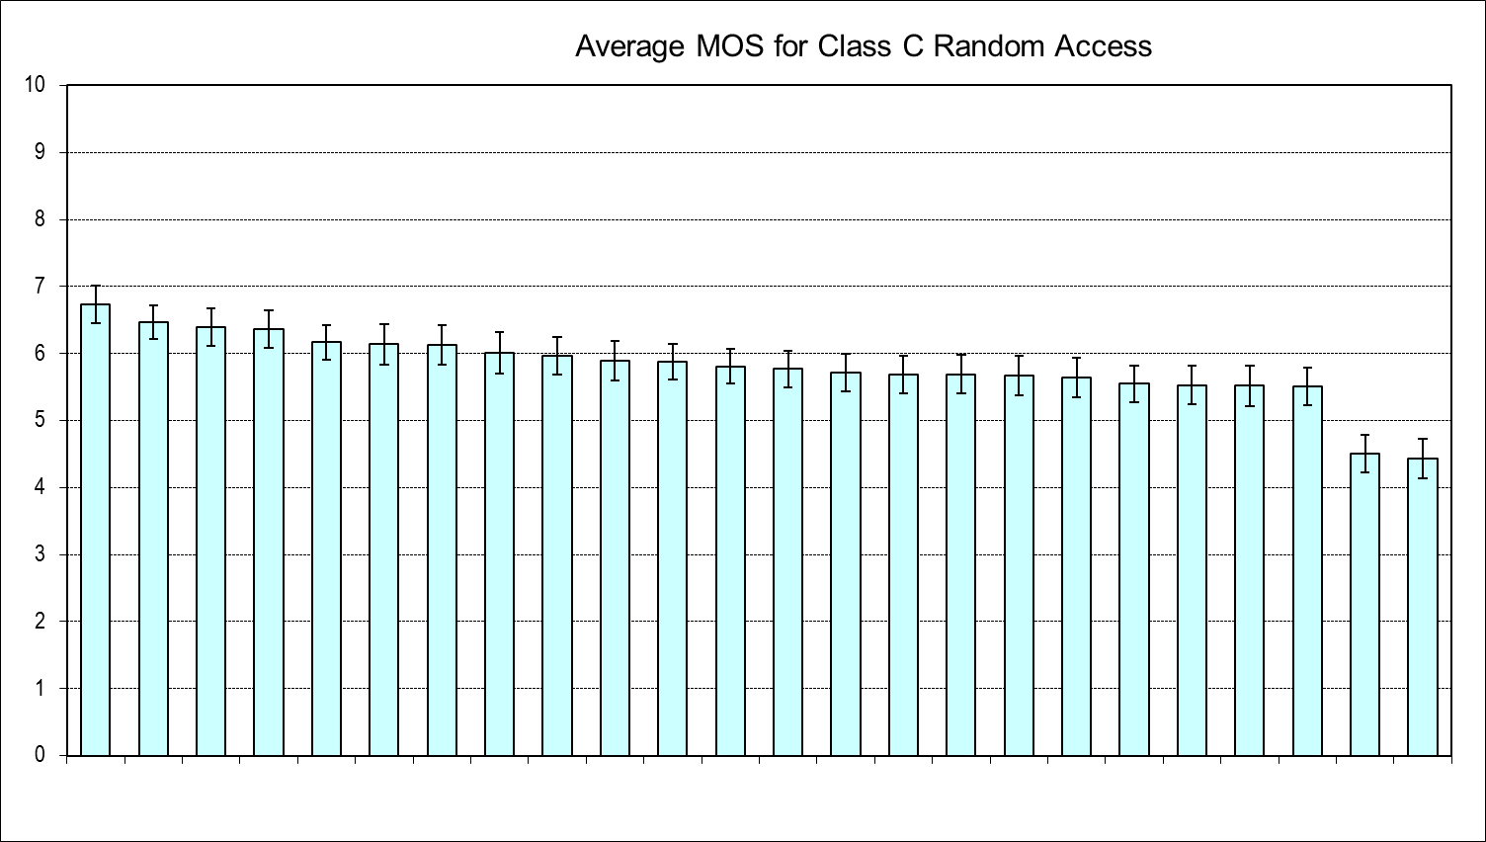
Figure 34 – Overall average MOS results for sequences in Class C
with Random Access (constraint set 1) coding conditions

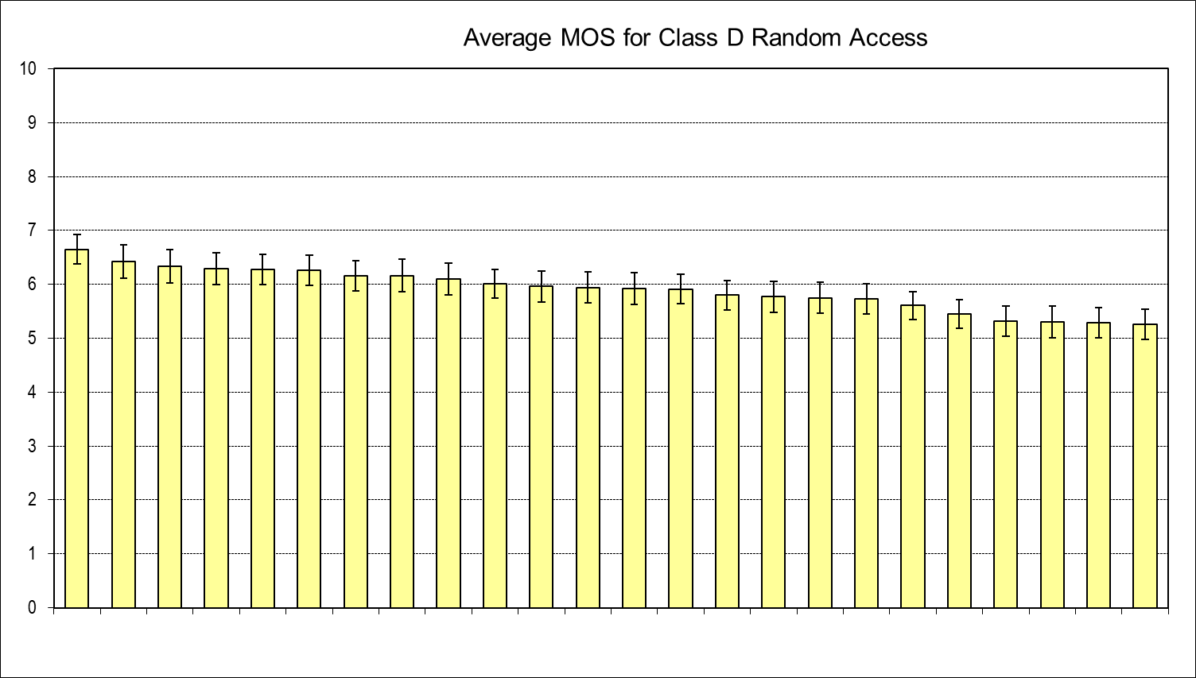
Figure 35 – Overall average MOS results for sequences in Class D
with Random Access (constraint set 1) coding conditions

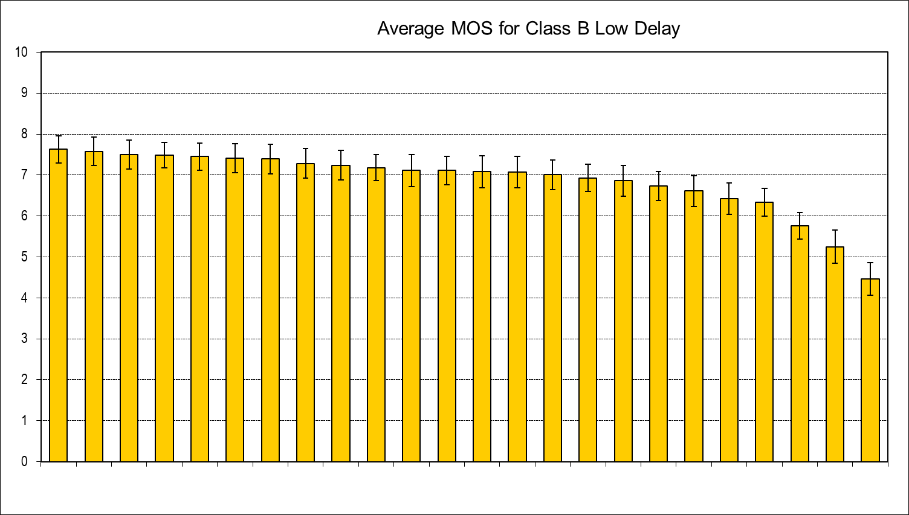
Figure 36 – Overall average MOS results for sequences in Class B
with Low Delay (constraint set 2) coding conditions

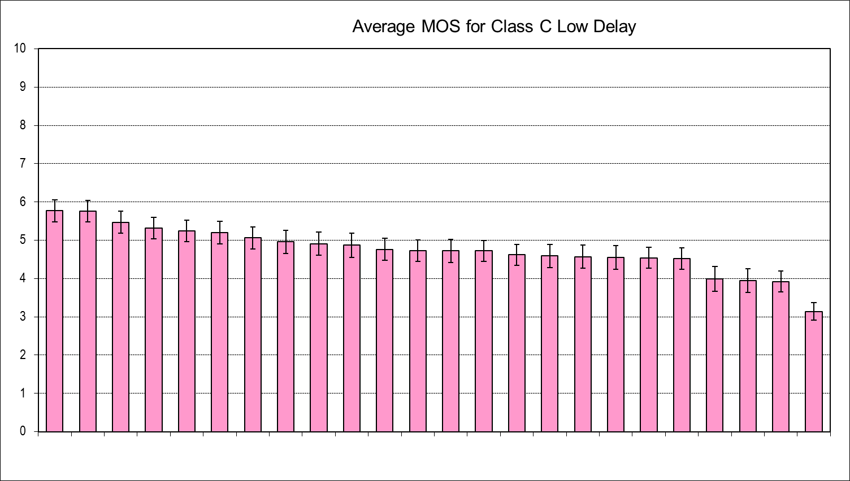
Figure 37 – Overall average MOS results for sequences in Class C
with Low Delay (constraint set 2) coding conditions

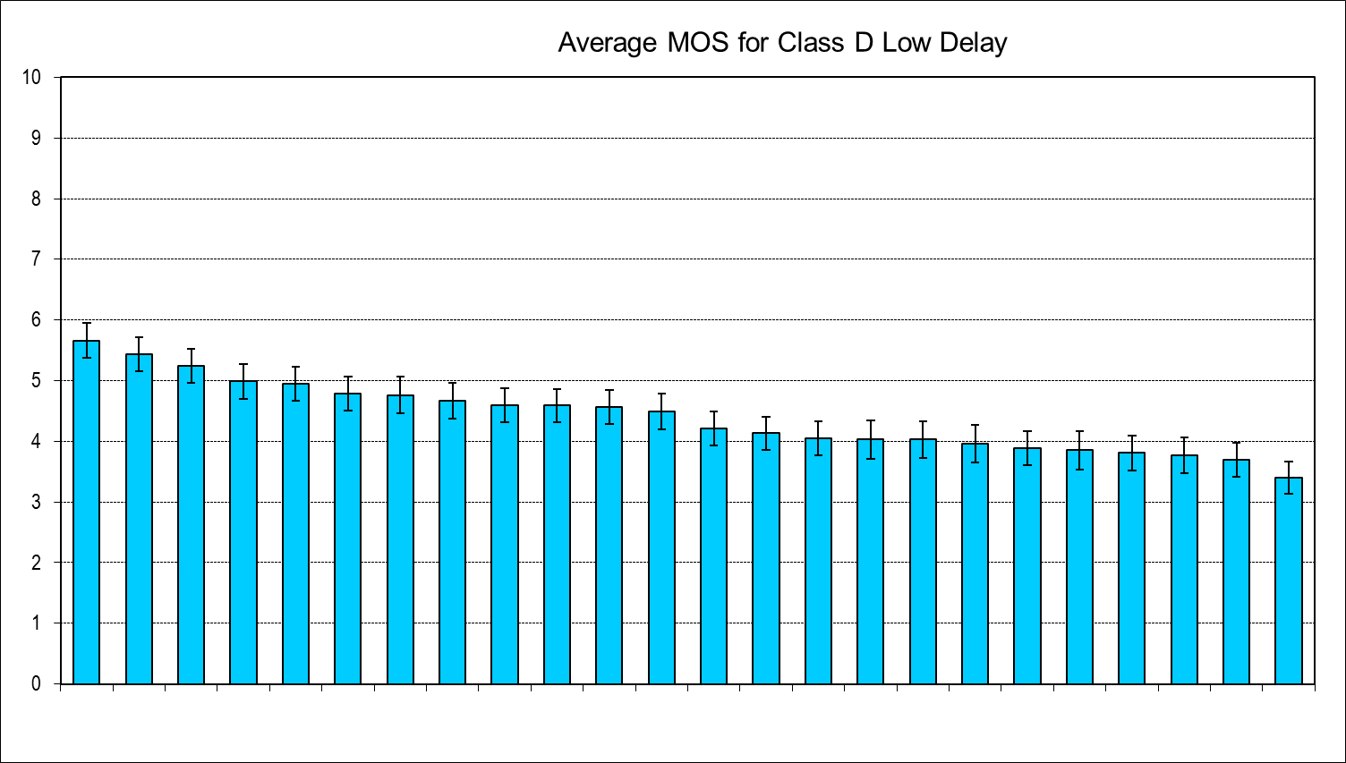
Figure 38 – Overall average MOS results for sequences in Class D
with Low Delay (constraint set 2) coding conditions

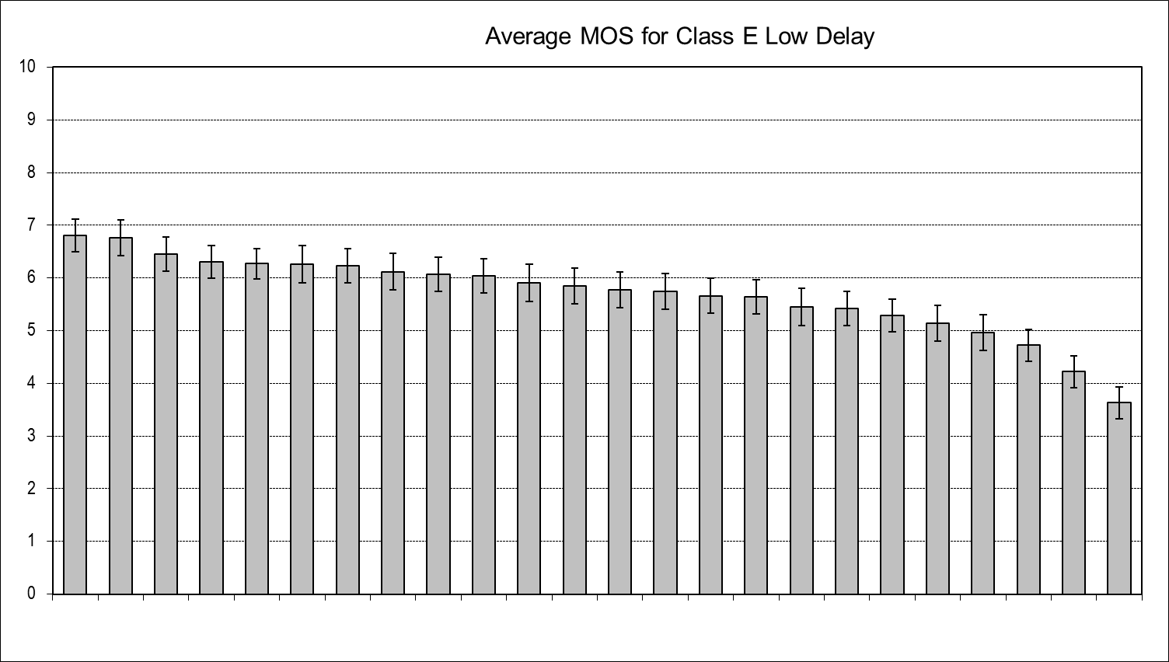
Figure 39 – Overall average MOS results for sequences in Class E
with Low Delay (constraint set 2) coding conditions

Conclusions from the Call for Proposals (CfP) testing
The subjective test results indicate that a clear quality improvement has been achieved by many proposals, as compared to the quality of the AVC anchors, for both constraint conditions (Random Access and Low Delay). For a considerable number of test points, the subjective quality of the proposal encoding was as good, for the best performing proposals, as the quality of the anchors with roughly double the bit rate. Even when considering the fact that some proposals certainly used more advanced encoder optimization than the AVC anchors, a substantial gain can be identified for a prospective starting point of the new generation of video coding standard to be developed in the HEVC initiative.
The technical assessment of the proposed technology, as it was performed at the first JCT-VC meeting held in Dresden, Germany, between 15 and 13 April 2010, revealed that all proposed algorithms were based on the traditional hybrid coding approach combining motion-compensated prediction between video frames with intra-picture prediction, closed-loop operation with in-loop filtering, 2D transformation of the spatial residual signals, and advanced adaptive entropy coding. Many specific candidate technology improvements have been identified as has been summarized in [5][6]. As an initial step toward moving forward into collaborative work, a Test Model under Consideration (TMuC) document [7] was produced, combining identified key elements from a group of seven well-performing proposals. The TMuC is intended to become the basis of a first software implementation, which after its development will enable more rigorous assessment of the coding tools that it contains as well as additional tools to be investigated within a process of Core Experiments.
The tentative anticipated plan is to have the development of the first version of the new HEVC standard generation completed by mid 2012.

References
- ISO/IEC JTC1/SC29/WG11 and ITU-T Q6/16, "Joint Call For Proposals on Video Compression Technology", WG11 document N11113 and Q6/16 document VCEG-AM91, Kyoto, January 2010.
- ISO/IEC JTC1/SC29/WG11 and ITU-T SG16, "Terms of Reference of the Joint Collaborative Team on Video Coding Standard Development", WG11 document N11112 and Q6/16 document VCEG-AM90, Kyoto, January 2010.
- Gisle Bjøntegaard, "Calculation of Average PSNR Differences between RD curves", ITU-T SG16/Q6, 13th VCEG Meeting, Austin, Texas, USA, April 2001, Doc. VCEG-M33.
- Gisle Bjøntegaard, "Improvements of the BD-PSNR model", ITU-T SG16/Q6, 35th VCEG Meeting, Berlin, Germany, 16th - 18th July, 2008, Doc.VCEG-AI11.
- JCT-VC, "Architectural Outline of Proposed High Efficiency Video Coding Design Elements", document JCTVC-A202, Dresden, April 2010.
- JCT-VC, "Table of Proposal Design Elements for High Efficiency Video Coding (HEVC)", document JCTVC-A203, Dresden, April 2010.
- JCT-VC, "Test Model under Consideration", document JCTVC-A205, April 2010.
___________________

