    Joint Collaborative Team on Video Coding (JCT-VC)  of ITU-T SG16 WP3 and ISO/IEC JTC1/SC29/WG11  1st Meeting: Dresden, DE, 15-23 April, 2010 | Document: JCTVC-A116

Title: | Description of video coding technology proposal by Fraunhofer HHI
Status: | Input Document to JCT-VC
Purpose: | Proposal
Authors: | Martin Winken, Sebastian Boße, Benjamin Bross, Philipp Helle, Tobias Hinz, Heiner Kirchhoffer, Haricharan Lakshman, Detlev Marpe, Simon Oudin, Matthias Preiß, Heiko Schwarz, Mischa Siekmann, Karsten Sühring, and Thomas Wiegand
Contact: | Thomas Wiegand  Fraunhofer HHI  Einsteinufer 37  10587 Berlin, Germany | Tel:  Email: | +49-30-31002-617  wiegand@hhi.de
Source: | Fraunhofer HHI
_____________________________

Abstract
This document gives a description of the video coding technology proposal by Fraunhofer HHI. The proposed algorithm is based on the hybrid video coding approach using temporal and spatial prediction followed by transform coding of the residual and entropy coding.

Reportedly, the conceptual design can be considered as a generalization of H.264/AVC. While the individual building blocks of the hybrid coding approach are kept simple similarly as in H.264/AVC, the flexibility of the block partitioning for prediction and transform coding is increased. The use of two nested and pre-configurable quadtree structures is proposed, such that the spatial partitioning for temporal and spatial prediction as well as the space-frequency resolution of the corresponding prediction residual can be adapted to the given video signal in a highly flexible way. As another notable feature of the Fraunhofer HHI proposal, new entropy coding concepts have been integrated allowing a parallelization of the entropy decoding and/or the use of variable-length codes with the efficiency of arithmetic codes.

Objective gains of 29.9% in terms of average BD-rate improvement have been achieved for constraint set 1. For constraint set 2, the average BD-rate improvements are 22.1% relative to the beta anchor and 42.4% relative to the gamma anchor.

Contents
Abstract 1
Contents 2
1 Introduction 4
1.1 Overview 4
1.2 Partitioning of the input picture for prediction 4
1.2.1 Plane grouping 4
1.2.2 Quadtree-based partitioning 4
1.3 H.264/AVC compliant high level syntax (SPS, PPS) 5
2 Algorithm description 5
2.1 Motion representation 6
2.1.1 Motion vector prediction 6
2.1.2 Fractional sample interpolation 7
2.1.3 Block merging process 9
2.2 Intra-frame prediction 10
2.2.1 Directional intra prediction 11
2.2.2 DC prediction mode 11
2.3 Spatial transforms 11
2.4 Quantization 12
2.5 In-loop filtering 12
2.5.1 Deblocking filtering 12
2.5.2 Adaptive In-Loop filter 12
2.6 Entropy coding 14
2.6.1 Novel entropy coding concept 14
2.6.2 Version 1: Arithmetic coding 15
2.6.3 Version 2: Variable length codes 15
2.6.4 Binarization and context modeling 16
3 Compression performance discussion 18
3.1 Constraint set 1 configuration relative to Alpha anchor 18
3.1.1 Class A 18
3.1.2 Class B 18
3.1.3 Class C 19
3.1.4 Class D 20
3.1.5 Overall 20
3.2 Constraint set 2 configuration relative to Beta and Gamma anchors 23
3.2.1 Class B 23
3.2.2 Class C 24
3.2.3 Class D 25
3.2.4 Class E 25
3.2.5 Overall 26
4 Complexity analysis 31
4.1 Encoding time and measurement methodology 31
4.2 Decoding time and measurement methodology and comparison vs. anchor bitstreams decoded by JM 17.0 34
4.3 Description of computing platform used to determine encoding and decoding times reported in sections 4.1 and 4.1 37
4.4 Expected memory usage of encoder 37
4.5 Expected memory usage of decoder 38
4.6 Complexity characteristics of encoder motion estimation and prediction segmentation selection 38
4.6.1 Motion estimation 38
4.6.2 Prediction segmentation selection / Mode decision 39
4.7 Complexity characteristics of decoder motion compensation 40
4.8 Complexity characteristics of encoder intra-frame prediction type selection 40
4.9 Complexity characteristics of decoder intra-frame prediction operation 40
4.10 Complexity characteristics of encoder transforms and transform type selection 40
4.11 Complexity characteristics of decoder inverse transform operation 42
4.12 Complexity characteristics of encoder quantization and quantization type selection 42
4.13 Complexity characteristics of decoder inverse quantization 42
4.14 Complexity characteristics of encoder in-loop filtering type selection 42
4.15 Complexity characteristics of decoder in-loop filtering operation 42
4.16 Complexity characteristics of encoder entropy coding type selection 43
4.17 Complexity characteristics of decoder entropy decoding operation 43
4.18 Degree of capability for encoder parallel processing 43
4.19 Degree of capability for decoder parallel processing 43
5 Algorithmic characteristics 43
5.1 Random access characteristics 43
5.2 Delay characteristics 44
5.3 Remark regarding the hierarchical prediction structure 44
6 Software implementation description 44
7 Patent rights declaration(s) 44

Introduction
This document describes the video coding algorithm as proposed by Fraunhofer HHI. The algorithm is based on the hybrid approach, using spatial and temporal (motion compensated) prediction, followed by DCT-based transform coding of the residual, and entropy coding of the transform coefficients and the other coding parameters.

Overview
In the following, a short overview of the most relevant aspects of the video coding algorithm as proposed by Fraunhofer HHI is given.
- Entropy coding: a novel entropy coding scheme is employed that supports a high degree of decoder parallel processing and that can be configured to operate at a complexity level of variable-length coding without any loss in coding efficiency relative to the use of arithmetic codes.
- Variable block size prediction: the size of the prediction blocks can adaptively be chosen by using a quadtree-based partitioning. Maximum and minimum admissible block size are not fixed, but specified in the bitstream. For the submitted bitstreams we used a block size range from 4×4 to 64×64.
- Variable block size residual coding: analogous the block size used for DCT coding of the residual is also derived by using quadtree-based partitioning of the corresponding prediction block. For the transform, we also used a block size range from 4×4 to 64×64.
- Merging of neighbouring prediction blocks: In order to reduce the number of bits required for signaling the prediction parameters, neighbouring prediction blocks can be merged into one region, such that the prediction parameters have to be transmitted only once for the whole region.
- Fractional sample interpolation filter using Maximal Order Minimum Support (MOMS) algorithm: For interpolating the fractional sample positions for motion-compensated prediction, a fixed point implementation of the MOMS algorithm is used.
- Adaptive in-loop filtering: Additional to the deblocking filter two 1-D Wiener filter are applied within the motion-compensated prediction-loop. These filters are applied to chosen regions of the de-blocking filter output in horizontal and vertical direction, respectively.
- H.264/AVC compliant high level syntax: The NAL unit syntax and parameter sets (SPS, PPS) as specified in H.264/AVC are used by our video codec.

Partitioning of the input picture for prediction

Plane grouping
The video sequence is encoded picture by picture, where coding order and display order of the pictures do not have to be the same. Each picture is given in the form of one or multiple “planes”. Typically 3 planes are used to represent the Y, Cb, and Cr channels. One or multiple planes grouped together constitute a so-called “plane group”. For example, all three planes (Y, U, V) could be grouped into one single plane group. Alternatively, the luma plane could constitute one plane group, and the two chroma planes could constitute a different plane group. The division of the picture into smaller variable-size blocks for prediction and residual coding is done independently for each plane group. For the bitstreams in our submission, we used one single plane group consisting of all the three planes (Y, U, V).

Quadtree-based partitioning
For each plane group, the picture is divided into a number of square blocks of equal size, so-called treeblocks. These treeblocks represent the maximum possible prediction block size. The size of these treeblocks must be a power of two and is specified as side information in the bitstream. This enables to adapt the maximum prediction block size to the video material. Typically, high resolution video sequences benefit from a larger prediction block size. A treeblock can be further subdivided into smaller blocks by usage of a quadtree structure. Each treeblock corresponds to the root node of a quadtree. Fig. 1 shows exemplary how a treeblock is first divided into its four subblocks (a), then the lower left subblock is further divided into four small subblocks (b), and finally the upper right block of these smaller subblocks is once more divided into four blocks with one eighth the width and height of the original treeblock (c).

Fig. 1: Quadtree-based partitioning of a single treeblock.

In Fig. 2 the underlying quadtree structure for this exemplary block division is shown on the left side. In our example, the quadtree has four levels, with level 0 corresponding to the full treeblock size (maximum prediction block size), and with level 3 corresponding to a block size of one eighth of the full treeblock size. Generally, subblocks at level i always have a block size which is 2^{-i} times the full treeblock size. The maximum number of levels, and therefore the minimum possible prediction block size, is also specified as side information in the bitstream. Consequently, maximum and minimum possible prediction block size can freely be chosen, depending on the application, the video material, the resolution etc. For the bitstreams in our submission, we used 4×4 and 64×64 as minimum and maximum possible prediction block sizes.
Fig. 2: Quadtree structure for the example given in Fig. 1

For the purpose of mode decision, transmission of the data associated with each block etc. all treeblocks are traversed in raster scan order (left-to-right, top-down), and within each treeblock, the subblocks are traversed in depth-first order. For the example given, this means that the blocks in Fig. 2 are traversed in alphabetical order (a..j). Using depth-first traversal has the benefit, that both the left neighbouring block(s) and the top neighbouring block(s) are always encoded/transmitted before the current block. Thus, the data already transmitted in these blocks can be used to facilitate the encoding of the current block (e.g. for motion vector prediction or context modeling in entropy coding).

H.264/AVC compliant high level syntax (SPS, PPS)
Our video codec uses the NAL unit syntax of H.264/AVC. For transmitting global parameters (e.g. resolution of the video sequence, chroma format, maximum number of reference picture, initial Qp value), the syntax and semantics of the H.264/AVC Sequence Parameter Set (SPS) and Picture Parameter Set (PPS) is used. The syntax and semantics of the slice header follow the H.264/AVC slice header syntax and semantics very closely, with some extensions needed for new coding tools.

Algorithm description
Each prediction block is coded using either inter or intra prediction. I, P, and B slices with the same meaning as in H.264/AVC are supported. For inter prediction, one or more motion vectors, each together with a reference index, are transmitted per prediction block. The reference index specifies the reference picture to be used for motion compensated prediction. The reference picture buffer uses a sliding operation, i.e. whenever a new picture is to enter the reference picture buffer and the buffer is full, the picture which has been in the buffer for the longest time is removed from the buffer. The maximum size of the buffer is specified as side information in the bitstream.

Motion representation
The prediction blocks are either intra-predicted or they are predicted by motion-compensated prediction. Motion-compensated blocks are associated with one or two sets of motion parameters, where each set of motion parameters consist of a reference picture order count refPoc and a translational displacement vector (or motion vector) mv. A motion vector consists of a horizontal component mv[ 0 ] and a vertical component mv[ 1 ]. When a prediction block is associated with more than one set of motion parameters, the final block prediction signal is generated as superposition of the motion-compensated prediction signals that are generated using the individual sets of motion parameters. It should be noted that the proposed coding scheme supports more than two sets of motion parameters for a prediction block (i.e., multi-hypothesis prediction with more than two hypothesis); but, for the submitted bitstreams, the number of motion parameters sets for a block was limited to two (i.e., bi-prediction).

Both components of a motion vector are represented with the same accuracy. The accuracy of the motion vectors can be signaled at a slice level; it can be set to units of $2^{−n}$ luma samples (with $n≥0$). For the submitted bitstreams, the motion vector accuracy was set to units of quarter luma samples.

Motion vector prediction
In order to reduce the bit rate required for transmitting the motion vectors, we employ a concept in which the prediction and coding of the components of a motion vector is interleaved. In a first step, the vertical motion vector component is predicted using conventional median prediction and the difference between the actual vertical component and its prediction is coded. Then, only the motion vectors of the neighborhood for which the absolute difference between their vertical component and the coded vertical component for the current motion vector is minimized are used for the prediction of the horizontal component.

In the following, we consider the prediction and reconstruction of a motion vector currMv for a prediction block. The reference picture order count that is associated with the motion vector shall be denoted by currRefPoc. The location of the top-left luma sample of the prediction block, relative to the top-left luma sample of the picture, is denoted by ( x0, y0 ). The width and height of the prediction block are given by currW and currH, respectively. Given the transmitted motion vector difference mvDiff (with horizontal component mvDiff[ 0 ] and vertical component mvDiff[ 1 ]), the prediction and reconstruction of the motion vector currMv is done as described in the following.

As first step, the vertical component mvPred[ 1 ] of the prediction vector mvPred is derived as specified by the following ordered steps:
- A list listMvCompY of vertical motion vector components is derived as follows.
    - Let blkA, blkB, and blkC be the prediction blocks that contain the luma samples at locations ( x0 − 1, y0 ), ( x0, y0 − 1 ), and ( x0 + currW, y0 − 1), respectively.
    - When blkC is not contained in the same slice as the current block, or it follows the current block in coding order, or none of the reference picture order counts associated with blkC is equal to currRefPoc, blkC is replaced with the prediction block that contains the luma sample at location ( x0 − 1, y0 − 1 ).
    - For each of the prediction blocks blkX (with X being replaced by A, B, and C), the following applies:
If the block blkX represents a motion-compensated block that is contained in the same slice as the current block and precedes the current block in coding order, the following applies with nX being the number of motion parameter sets that are associated with blkX and refPocX[ i ] and mvX[ i ], with i = 0..nX − 1, being the reference picture order count and motion vectors that are associated with blkX:
For i proceeding over the range of 0 to nX − 1, inclusive, if refPocX[ i ] is equal to currRefPoc, the vertical motion vector component mvX[ i ][ 1 ] is inserted into the list listMvCompY.
- Let numCompY be the number of entries in the list listMvCompY and let listMvCompY[ k ], with k = 0..numCompY − 1, be the entries of the list listMvCompY. Depending on numCompY, the vertical component mvPred[ 1 ] of the motion vector predictor is derived as follows.
- If numCompY is equal to 0, mvPred[ 1 ] is set equal to 0.
- Otherwise, if numCompY is equal to 1, mvPred[ 1 ] is set equal to listMvCompY[ 0 ].
- Otherwise, if numCompY is equal to 2, mvPred[ 1 ] is set equal to ( listMvCompY[ 0 ] + listMvCompY[ 1 ] + 1 ) >> 1.
- Otherwise (numCompY is greater than 2), the entries in listMvCompY are sorted in increasing order and then mvPred[ 1 ] is set equal to listMvCompY[ numCompY >> 1 ].

Given the predictor mvPred[ 1 ] for the vertical motion vector component, the vertical motion vector component currMv[ 1 ] of the current motion vector is reconstructed by setting currMv[ 1 ] equal to ( mvPred[ 1 ] + mvDiff[ 1 ] ). Then, given the reconstructed vertical motion vector component currMv[ 1 ], the predictor mvPred[ 0 ] for the horizontal motion vector component is derived as follows:
- Let setOfBlks be the set of neighboring prediction blocks that are contained in the same slice as the current block, precede the current block in coding order, and contain a luma sample at any of the following locations:
- ( x0 − 1, y ) with y = 0..currH
- ( x, y0 − 1 ) with x = −1..currW + 1
- A list listMv of motion vectors is derived as follows:
For each block blkX of the set setOfBlks, the following applies with nX being the number of motion parameter sets that are associated with blkX and refPocX[ i ] and mvX[ i ], with i = 0..nX − 1, being the reference picture order count and motion vectors that are associated with blkX:
For i proceeding of the range of 0 to nX − 1, inclusive, if refPocX[ i ] is equal to currRefPoc and the list listMv does not already contain the motion vector mvX[ i ], the motion vector mvX[ i ] is inserted into the list listMv.
- Let numMv be the number of entries in the list listMv. If numMv is equal to 0, the predictor mvPred[ 0 ] for the horizontal motion vector component is set equal to 0; otherwise, mvPred[ 0 ] is derived as specified in the following with listMv[ k ] (k = 0..numMv − 1) representing the k-th entry in the list listMv:
  - The variable compY is initially set equal to listMv[ 0 ][ 1 ] and the variable minDelta is set equal to abs( listMv[ 0 ][ 1 ] − currMv[ 1 ] ), where abs( ) specifies the absolute value of the argument.
  - For i proceeding over the range of 1 to numMv − 1, inclusive, the following applies:
When abs( listMv[ i ][ 1 ] − currMv[ 1 ] ) is less than minDelta or (abs( listMv[ i ][ 1 ] − currMv[ 1 ] ) is equal to minDelta and listMv[ i ][ 1 ] is less than compY), compY is set equal to listMv[ i ][ 1 ].
  - The list listMvCompX is derived as follows.
For i proceeding over the range of 0 to numMv − 1, inclusive, if listMv[ i ][ 1 ] is equal to compY, the value listMv[ i ][ 0 ] is inserted into the list listMvCompX.
  - Let numCompX be the number of entries in the list listMvCompX and let listMvCompX[ k ], with k = 0..numCompX − 1, be the entries of the list listMvCompX. Depending on numCompX, the horizontal component mvPred[ 0 ] of the motion vector predictor is derived as follows.
    - If numCompX is equal to 1, mvPred[ 0 ] is set equal to listMvCompX[ 0 ].
    - Otherwise, if numCompX is equal to 2, mvPred[ 0 ] is set equal to ( listMvCompX[ 0 ] + listMvCompX[ 1 ] + 1 ) >> 1.
    - Otherwise (numCompX is greater than 2), the entries in listMvCompX are sorted in increasing order and then mvPred[ 0 ] is set equal to listMvCompX[ numCompX >> 1 ].

Given the predictor mvPred[ 0 ] for the horizontal motion vector component, the horizontal motion vector component currMv[ 0 ] of the current motion vector is reconstructed by setting currMv[ 0 ] equal to ( mvPred[ 0 ] + mvDiff[ 0 ] ).

Fractional sample interpolation
In this section, the process of upsampling the decoded picture to achieve quarter-sample accuracy is described. The upsampling is based on Maximal Order Minimum Support (MOMS) algorithm [1] and implemented in fixed point arithmetic.

Each color plane of the decoded picture is upsampled separately according to the block diagram in Fig. 3. The upsampling consists of IIR and FIR filtering stages, called prefiltering and interpolation, respectively. The 2D prefilter and interpolation kernel are separable and are implemented as a sequence of 1D horizontal and vertical filtering steps.

Horizontal
IIR Filter
Vertical
IIR Filter
Horizontal
FIR Filter
Vertical
FIR Filter
Prefilter
Interpolation
Fig. 3: Block diagram of upsampling process.

Let the width and height of the input plane $r[x,y]$ be denoted as $W$and$H$, respectively, where $x∈[0,W−1]$ and$y∈[0,H−1]$. The upsampled output plane is denoted as $s[m,n]$, where $m∈[0,4W−1]$ and $n∈[0,4H−1]$.

Prefilter
The prefiltering stage involves IIR filtering in horizontal and vertical directions. Both directions use the same IIR filter with transfer function$B(z)$.

The transfer function of the1D IIR filter is defined as follows:
$$B(z)=\left(\frac{1}{1−z_{1}z^{−1}}\right)\left(\frac{−z_{1}}{1−z_{1}z}\right),$$
where, the pole $z_{1}=−\text{11726}$.
The factorization of $B(z)$ shown above is implemented as a first order causal and a first order anti-causal filter. The filter is applied row-wise on $r[x,y]$ for obtaining $c'[x,y]$ and later column-wise on $c'[x,y]$ to get$c[x,y]$.

Interpolation
The Interpolation stage involves 4-tap FIR filtering in horizontal and vertical directions. Both directions use the same 1D FIR filter. The FIR filter for 4 adjacent samples is described in the 4x4 matrix below:

$$K=\left[\begin{matrix}\text{6242} & \text{20285} & \text{6242} & 0 \\ \text{2889} & \text{19078} & \text{10520} & \text{280} \\ \text{1073} & \text{15311} & \text{15311} & \text{1073} \\ \text{280} & \text{10520} & \text{19078} & \text{2889}\end{matrix}\right]$$
In the Horizontal FIR stage, the prefilter output $c[x,y]$ is interpolated in the horizontal direction resulting in $s'[m,y]$, whose size is $4W×H\text{.}$ The row-wise 1D interpolation for$y∈[0,H−1]$ is performed according to the following matrix-vector multiplication,
$\left[\begin{matrix}s'[m+0,y] \\ s'[m+1,y] \\ s'[m+2,y] \\ s'[m+3,y]\end{matrix}\right]=g×\text{rnd}\left(K⋅\left[\begin{matrix}c[x−1,y] \\ c[x+0,y] \\ c[x+1,y] \\ c[x+2,y]\end{matrix}\right]\right),$ $\begin{aligned}x=0\text{.}\text{.}\text{.}W−1, \\ m=x\text{<<}2\end{aligned}$
where, $c[x,y]$ is extended beyond plane boundaries according to mirror symmetry and the kernel gain $g=\text{21}$.
In the Vertical FIR stage, the Horizontal filter output $s'[m,y]$ is interpolated in the vertical direction resulting in $s[m,n]$ whose size is $4W×4H\text{.}$ The interpolation for$m∈[0,4W−1]$ is performed according to the same matrix-vector multiplication as described above but along columns instead of rows. The samples of the final upsampled plane $s[m,n]$ are stored in 16-bit.

References
[1] T. Blu, P. Thévenaz, M. Unser, “MOMS: Maximal-Order Interpolation of Minimal Support”, IEEE Tran. Img. Proc., Vol. 10, No. 7, July 2001.

Block merging process
For each inter predicted block, individual motion parameters are transmitted. In order to achieve an improved coding efficiency, the block merging process enables to merge neighbouring blocks into so-called regions. By doing so, the motion parameters do not need to be transmitted for each block of the region individually, but instead the parameters are transmitted only for once for the whole region.

For each prediction block, the set of all prediction blocks that are coded before that block in processing order is called the “set of causal blocks”. The set of blocks that is admissible for merging with a particular block is called the “set of available blocks” and is always a subset of the set of causal blocks. If a particular block is encoded and its set of available blocks is not empty, it is signaled whether this block is to be merged with one block out of this set and if so, with which of them. Otherwise, merging cannot be used for this block.

Derivation of the set of available blocks
The set of available blocks is formed as follows. Starting from the top-left sample position of the current block, its left neighbouring sample position and its top neighbouring sample position is derived. The set of available blocks can have only up to two elements, namely those blocks out of the set of causal blocks that contain one of the two sample positions. Thus the set of available blocks can only have the two direct neighbouring blocks of the top-left sample position of the current block as its elements. Note that only inter predicted blocks can be members of the set of available blocks.

Signaling
If the set of available blocks is not empty, one flag called merge_flag is signaled, specifying whether the current block is merged with any of the available blocks. Otherwise, or if the merge_flag is equal to 0 (for “false”), this block is not merged with one of its causal blocks and all parameters are transmitted ordinarily. If the merge_flag is equal to 1 (for “true”), the following applies. If the set of available blocks contains one and only one block, this block is used for merging. Otherwise the set of available blocks contains exactly two blocks. If the motion parameters of these two blocks are identical, these motion parameters are used for the current block. Otherwise (the two blocks have different motion parameters), a flag called merge_left_flag is signaled. If merge_left_flag is equal to 1 (for “true”), the block containing the left neighbouring sample position of the top-left sample position of the current block is selected out of the set of available blocks. If merge_left_flag is equal to 0 (for “false”), the other (i.e., top neighbouring) block out of the set of available blocks is selected. The motion parameters of the selected block are used for the current block.

Illustrating example
Fig. 4: Two examples illustrating the set of causal blocks (grey) and the set of available blocks (A, B).

Fig. 4 shows two examples for a quadtree-based division of a picture into prediction blocks. On the left side of Fig. 4, the top two blocks of the biggest size are so-called treeblocks, i.e., they are prediction blocks of the maximum possible size. The other blocks in this left figure are obtained as a subdivision of their corresponding treeblock. The current block is marked with an “X”. All the grey-shaded blocks are encoded before the current block, so they form the set of causal blocks. As explicated in the description of the derivation of the set of available blocks, only the blocks containing the direct (i.e. top or left) neighbouring samples of the top-left sample position of the current block can be members of the set of available blocks. Thus the current block can be merged with either block “A” or block “B”. If merge_flag is equal to 0 (for “false”), the current block “X” is not merged with any of the two blocks. If blocks “A” and “B” have identical motion parameters, no distinction needs to be made, since merging with any of the two blocks will lead to the same result. So, in this case, the merge_left_flag is not transmitted. Otherwise, if blocks “A” and “B” have different prediction parameters, merge_left_flag equal to 1 (for “true”) will merge blocks “X” and “B”, whereas merge_left_flag equal to 0 (for “false”) will merge blocks “X” and “A”.

In Fig. 4 (right) another example is shown. Here the current block “X” and the left neighbour block “B” are treeblocks, i.e., they have the maximum allowed block size. The size of the top neighbour block “A” is one quarter of the treeblock size. The blocks which are element of the set of causal blocks are grey-shaded. Note that the current block “X” can only be merged with the two blocks “A” or “B”, not with any of the other top neighbouring blocks.

Intra-frame prediction
To compute an intra-frame prediction for a particular block, already coded and reconstructed samples of the same picture are used. Fig. 5 shows a block of size n x m to be predicted together with its neighboring reconstructed samples.
Fig. 5 Block to be predicted (in grey) together with neighboring reconstructed samples (in light blue).

The original block to be predicted consists of the n x m array of samples
$O=\left[\begin{matrix}o_{0,0} & ⋯ & o_{0,m−1} \\ ⋮ & ⋱ & ⋮ \\ o_{n−1,0} & ⋯ & o_{n−1,m−1}\end{matrix}\right]$.
The block of samples that forms the prediction of the original block O is denoted as the n x m array
$P=\left[\begin{matrix}p_{0,0} & ⋯ & p_{0,m−1} \\ ⋮ & ⋱ & ⋮ \\ p_{n−1,0} & ⋯ & p_{n−1,m−1}\end{matrix}\right]$.
Reconstructed sample values of preceding blocks (in encoding and decoding order) relative to the current block O are used as reference samples for the prediction block P. Fig. 5 shows the reconstructed sample values that are potentially available for referencing. In particular, these are the left neighboring reconstructed sample values consisting of the vector
$$l={\left[\begin{matrix}l_{0} & ⋯ & l_{n−1}\end{matrix}\right]}^{T}$$
the top neighboring reconstructed sample values consisting of the vector
$$t={\left[\begin{matrix}t_{0} & ⋯ & t_{m−1} & ⋯\end{matrix}\right]}^{T}$$
and the top-left neighboring reconstructed sample value a. These elements of that l, t, and a that are coded before the current block, are marked as ‘available’.

Directional intra prediction
As in H.264/AVC, eight different directional intra-prediction modes are allowed. The corresponding directions are depicted in Fig. 6 as eight rays that start at a particular element p_{x,y} of the prediction array P. Each of these rays cross one of two further rays denoted as top reference-ray and left reference-ray. All elements of vectors l, t, and a lie on one of these two rays. To calculate a prediction for a particular block, one direction is selected (which needs to be signaled in the bit stream). At the crossing point of the ray corresponding to the selected direction with one of the reference-rays, a value is interpolated or extrapolated by applying an FIR-filter to the surrounding sample values along the reference-rays. This interpolated or extrapolated value is used as prediction value p_{x,y}.
Fig. 6 Intra prediction directions

In addition, a smoothing operation can be applied to the elements of l, t, and a as a pre-processing step before calculating P. This smoothing operation corresponds to applying an FIR-filter with low-pass characteristics to the samples along the two reference-rays. Whether this smoothing operation is used is determined by the encoder and signaled in the bit stream.

DC prediction mode
As a fallback prediction mode, the so-called DC prediction mode provides a constant prediction value p_{x,y} given as the average (DC or expected value) of all elements of a and vectors t and l that are coded before the current block.

Spatial transforms
Like the whole picture is divided into prediction blocks, one prediction block can be subdivided into multiple residual blocks of variable size for transform coding. The transform blocks are non-overlapping and their dimensions are constrained by the boundaries of the prediction block. The used transform is an integer approximation to the two dimensional DCT-II (Discrete Cosine Transform type II). Each of the sub blocks is transform coded using the integer 2D-DCT of the blocks size.
Like the partitioning used for prediction, the partitioning of a single prediction error block into transform blocks is represented by quad trees. The greatest applicable transform size and the maximum depth of such quad trees (giving the minimum applicable size) are variable and are signaled in the bit stream. Transform blocks with an edge length of any positive power of two can be employed. For the submitted bit streams, the used transform block sizes were constrained to the range 4x4 to 64x64 (for chroma, also 2x2 transforms may be used)..
The exact partitioning used for coding is decided in an RD-optimized manner. The employed algorithm is the same as is used to decide the tree structure for prediction partitioning.

Quantization
For quantization of the transform coefficients of a block, we employ a method of rate-distortion optimized quantization (RDOQ), which is similar to the approach presented in [1] and supported in the JM software [2].

For the submitted bitstreams, only a single QP value (which is fixed for a picture) is evaluated for each block of transform coefficients. Hence, the quantization is done only once for each transform block.

The actually implemented version of RDOQ can be basically considered to consist of two steps. In a first step, for each transform coefficient t[ i ] of a NxN transform block, the transform coefficient level l[ i ] is derived by minimizing a Lagrangian cost measure D( l[ i ] ) + λ · R( l[ i ] ), where D( l[ i ] ) represents the squared difference between the original and reconstructed transform coefficient, R( l[ i ] ) represents an estimate for the number of bits that is required for coding the transform coefficient level l[ i ], and λ is the Lagrangian multiplier. The rate estimates R( l[ i ] ) are determined via a look-up table using the states of the CABAC contexts before coding the current block of transform coefficients.
In the second step, the position p (with p = −1..N²−1) of the last coded transform coefficient (i.e., the position of the last transform coefficient level in scanning order that is not equal to 0) is determined, given the previously determined transform coefficient levels l[ i ]. The derivation of the position p is done by minimizing a Lagrangian cost measure
$\sum_{i=0}^{p}{D(l\left[i\right])+\sum_{i=p+1}^{N^{2}−1}{(t[i])^{2}+λ⋅R(l[i=0\text{.}\text{.}p]}})$
where D( l[ i ] ) represents the squared difference between the original and reconstructed transform coefficient and R( l[ i = 0..p ] ) represents an estimate for the number of bits that are required for transmitting the transform coefficient levels l[ i ] with i = 0..p. The rate estimate is determined via table look-ups using the states of the CABAC contexts before coding the current block of transform coefficients. Finally, all transform coefficient level l[ i ] with i = p+1..N²−1 are set equal to 0.

[1] M. Karczewicz, Y. Ye, I. Chong, "Rate distortion optimized quantization," ITU-T SG16/Q.6, doc. VCEG-AH21, Antalya, TR, Jan. 2008.
[2] JM 17.0 software, available at http://iphome.hhi.de/suehring/tml/download/jm17.0.zip.

In-loop filtering

Deblocking filtering
Our proposal uses the in-loop deblocking filter as specified in H.264/AVC. The filtering operation and the derivation of filter strength and transmission of filter parameters (alpha/beta offset) are done as described in H.264/AVC.

Adaptive In-Loop filter
Additional to the de-blocking filter a separable Wiener filter is applied within the motion-compensated prediction-loop. This filter is applied to chosen regions of the de-blocking filter output.

Vertical filtering
The vertical filter coefficients are determined for the different vertical filter lengths $k$ by solving
$R_{\text{xx}}^{v,k}⋅c^{v,k}=r_{\text{xy}}^{v,k}$,
where $R_{\text{xx}}^{v,k}$ is the vertical auto-correlation matrix of the original plane and $r_{\text{xy}}^{v,k}$is the vertical cross-correlation for the original plane and the reconstructed plane.
The reconstructed plane $y$is vertically filtered by the obtained filter taps $c^{v,k}$, the output of the filter is the vertically filtered plane ${y^{'}}_{k}$. Possible filter length are $k∈\left\{0,3,5,7,9,\text{11}\right\}$, where $k=0$indicates no vertical filtering.

Horizontal Filtering
For every vertical filter length$k$, a horizontal filter is calculated. The horizontal filter coefficients are determined for the different horizontal filter lengths $l$ by solving
$R_{\text{xx}}^{h,l}⋅c^{h,k,l}=r_{xy_{k}^{'}}^{h,l}$,
where $R_{\text{xx}}^{h,l}$ is the horizontal auto-correlation matrix of the original plane and $r_{xy_{k}^{'}}^{h,l}$is the cross-correlation for the original plane and the reconstructed, vertically filtered plane ${y^{'}}_{k}$.
The reconstructed and vertically filtered plane ${y^{'}}_{k}$is horizontally filtered by the obtained filter taps $c^{h,l}$, the filter output is the vertically and horizontally filtered plane ${y^{''}}_{k,l}$ . Possible filter length are$l∈\left\{0,3,5,7,9,\text{11}\right\}$, where $l=0$indicates no horizontal filtering.

Filter Length Decision
The horizontal and the vertical filter length are chosen based on the Lagrangian RD-cost, taking into account the transmission of the filter coefficients $c^{h,l}$and $c^{v,k}$ and the distortion of the filtered plane${y^{''}}_{k,l}$.

Inter-Plane Filter Reuse
Already found filters are applied to other planes as well. If the RD-performance achieved by the reuse of filter coefficients, the filter of an earlier filtered plane of the same frame is reused.

Regional filtering:
Due to statistical instationarities the filter is not applied to the whole frame, but only to regions chosen by the encoder. The subdivision into regions is represented by a quad-tree. Thereby a decision is made for each leaf-node whether the representing block should be filtered or not. This is done by comparing the distortion of the filtered block with the distortion of the corresponding block of the non filtered frame. A rate-distortion decision is used for each node to test, whether a further subdivision is reasonable.

Re-estimation of filter coefficients:
Based on the subdivision of the picture into regions the filter coefficients $c^{h,l}$and $c^{v,k}$are re-estimated for the found lengths $k$and$l$, respectively.

Therefore, only pixels of blocks marked for filtering are used to estimate the correlation matrices$R_{\text{xx}}^{v,k}$,$R_{\text{xx}}^{h,l}$and the cross-correlations $r_{\text{xy}}^{v,k}$,$r_{xy_{k}^{'}}^{h,l}$, respectively.

Encoding of filter parameters:
The filter coefficients are predicted by a static predictor where the value 1 predicts the central filter tap and the value 0 the remaining filter taps. The filter coefficients are quantized with 14 bits and CABAC entropy encoded afterwards. The vertical and horizontal filter lengths are transmitted CABAC encoded. The encoding of the quad-tree structure is done in the same way as described earlier.

[1] T. Chujoh, G. Yasuda, N. Wada, T. Watanabe and T. Yamakage, “Block-based Adaptive Loop Filter”, ITU-T Q.6/SG16 Doc., VCEG-AI18, Berlin, July 2008.

Entropy coding
For entropy coding, a variation of CABAC (as found in H.264/AVC) is employed. The binarization and context modeling are basically the same as in CABAC of H.264/AVC, except from a few modifications and additions as further explained below. However, the actual coding of the bins is based on a novel concept that has been introduced in order to support parallelized implementations of entropy encoding and decoding as well as for decreasing the computational complexity of the entropy decoding.

Fig. 7 Illustration of the novel entropy coding concept

Novel entropy coding concept
In Fig. 7, the basic entropy coding concept is illustrated. If a syntax element does not already represent a binary syntax element, it is first binarizied, i.e., it is mapped onto a sequence of binary decisions (bins). For each bin a context is selected. A context represents a (binary) probability model for a class of bins; it is characterized by the probability and the value of the less significant bin (LPB). As in H.264/AVC, the LPB probability is represented by one out of 64 states. At the beginning of the encoding/decoding of a slice, the probability models are initialized using fixed values (as in CABAC of H.264/AVC). And after encoding/decoding a bin with a particular model, the model (i.e., the corresponding probability and value of the LPB) is updated. The probability model update, i.e., the probability estimation process is the same as in CABAC of H.264/AVC. The association of a bin with a context model is also similar as in CABAC of H.264/AVC. It depends on the syntax element, the bin number, and, for some bins, the values of neighboring syntax elements.

The above described binarization and association of the bins with context models is basically the same as in CABAC of H.264/AVC. The main difference is the next step. Instead of arithmetically coding the bins with the associated probability models using a single arithmetic coding engine as in CABAC of H.264/AVC, the estimated LPB probabilities are quantized, i.e., they are mapped onto a small number of LPB probability intervals and for each of these probability intervals a separate bin encoder/decoder is operated. In our implementation, we used 12 probability intervals and thus 12 different bin encoders/decoders. Each bin encoder/decoder operates at a fixed LPB probability, which can be considered as the representative probability for an LPB interval. The selection of a bin encoder/decoder is implemented via a look-up table that associates a bin encoder with each of the 64 state indices for the LPB probability. Hence, the 64 states that are used for estimating the LPB probability of a context model are mapped onto 12 probability classes, for each of which a separate bin encoder/decoder is operated. The partial bitstreams that are generated by the bin encoders can be written to different partitions of a NAL unit (with the partitioning of the NAL unit being indicated in the slice header) or they can be interleaved into a single bitstream.

For the bin encoders and decoders two alternatives have been implemented. In a first version, the bin encoders and decoders represent arithmetic encoding and decoder engines, respectively, which are similar to the arithmetic coding engines used in CABAC of H.264/AVC. In a second version, the bin encoders and decoders represent simple variable length codes, by which a variable number of bins is mapped onto variable length codewords and vice versa. Both versions have a very similar coding efficiency. For the submitted bitstreams, we used the arithmetic coders; but the bitstreams can be losslessly transcoded using the variables length coders without exceeding the target bit rates specified in the Call for Proposals.

Version 1: Arithmetic coding
As mentioned above, we used 12 arithmetic coding engines (similar to the coding engines that are used for CABAC in H.264/AVC) for the submitted bitstreams. The corresponding 12 arithmetic codewords are written to different partitions of the slice data NAL units; the corresponding partitioning information is transmitted in the slice header. An obvious advantage of this approach is that the arithmetic decoding can be parallelized. All 12 arithmetic decoding engines can be operated in parallel and write the sequences of decoded bins into particular bin buffers. The remaining entropy decoding process can then simply read the bins from the corresponding 12 bin buffers without the need to wait until a bin is arithmetically decoded before proceeding with the next bin. This is in particular a very useful feature for slice data NAL units that contain a large number of bits.

For small slice data NAL units, a parallelized decoding is usually not required. And since the partitioning information can represent a significant amount of the overall number of bits of a NAL unit, we adaptively switch between the presented coding with 12 arithmetic coding engines (and codewords) and the coding with a single arithmetic coding engines with variable LPB probabilities as it is found in CABAC of H.264/AVC. It is signaled in the slice header which of these variants is used. For the submitted bitstreams, we use the concept with 12 arithmetic coding engines and fixed probabilities if the expected size of a NAL unit is greater than or equal to 12 000 bytes, and we used a single arithmetic coding engine with variable probabilities (as in CABAC of H.264/AVC if the expected size of a NAL unit is less than 12 000 bytes.

Version 2: Variable length codes
Instead of using arithmetic coding for the bin encoders (cp. Fig. 7), it is also possible to employ simple variable lenght codes. It should be again noted that each bin encoder operates at a fixed LPB probability. And for a fixed LPB probability, we can simple construct a code that maps a variable number of bins onto a variable length codeword and vice versa. As a particular example, the following table shows an example for such a mapping. In the example the bins "0" represent the more probable bin values and the bins "1" represent the less probable bin values. The example code has been designed for a LPB probability of 0.15 and it yields a redundancy of only 0.25 % relative to the entropy limit for this probability. Generally, it is possible to get closer to the entropy limit when the table size is increased.

Table 1: Example for a mapping between a variable number of bins and variable length codewords
sequence of bins  (bin order is from left to right) | codewords  (bits order is from left to right)
0000 | 1
01 | 001
10 | 010
001 | 011
0001 00 | 0001
11 | 0000 1
0001 1 | 0000 00
0001 01 | 0000 01

At the end of a slice, it is possible that a bin sequence does not represent any bin sequence that is associated with a codeword. In order to terminate the codeword, the shortest codeword for a bin sequence that contains the current bin sequence as prefix is written. At the decoder side, the additionally decoded bins are discarded. As an example, we could use the mapping in the above table and have a bin sequence "00" at the end of a slice. Then we would write the codeword "1" (corresponding to the bin sequence "0000"). At the decoder side, the codeword "1" would be translated into the bin sequence "0000", but the decoder would discard (ignore) the last two decoded bins.

Similarly to the above presented concept with arithmetic coding engines, the partial bitstreams can be written to different partitions of the slice data NAL unit (with transmitting the partitioning information in the slice header). It is, however, also possible to interleave the codewords into one single bitstream with any overhead. This is in particular beneficial for small slice data NAL units, for which parallelized bin decoding is not required. In order to realize such an interleaving a codeword buffer for variable-length codewords can be introduced at the encoder side. When a particular bin encoder starts the encoding of a new bin sequence (i.e., the bin encoder receives the first bin after the previous codeword has been written), it reserves the next variable-length codeword entry in the codeword buffer. And when the bin sequence is finished (i.e., when the received bins represent a bin sequence that corresponds to a codeword), the codeword is written to the previously reserved codeword entry. Examples for the codeword buffer status are illustrated in Fig. 8. At the decoder side, the codewords can be directly read from the bitstream in decoding order.

Fig. 8 Examples for the codeword buffer status

It is also possible to combine the codeword interleaving with a low-delay buffer control. That means, we can suitably restrict the buffer delay that is introduced by the codeword interleaving. With such a low-delay control, a particular codeword is terminated when the maximum number of bits (this maximum number of bits represents the maximum codeword length for a particular bin encoder and is given by the corresponding mapping table) that are associated with the reserved or completed buffer entries following the buffer entry for the particular codeword is greater than a particular threshold. At the decoder side, the extra decoded bins must be discarded; this can be done by using the same measure of the maximum number of bits as at the encoder side.

We have losslessy transcoded all submitted bitstreams with the VLC design using interleaved codewords. On average, the transcoded bitstreams have a bit rate that is 0.18 % less than the corresponding bit rate of the submitted bitstreams. When restricting the buffer delay to 64 Bytes, the bit rates for the transcoded bitstreams are on average 0.10 % less than the bit rates of the corresponding submitted bitstreams.

Binarization and context modeling
As already mentioned above, we have reused the binarization and context modeling schemes of H.264/AVC CABAC for most syntax elements in our video coding algorithm, especially for those which have already been present in H.264/AVC like, e.g., syntax elements related to intra prediction modes or motion parameters. For entropy coding of novel syntax elements like, e.g., flags indicating the quadtree structure, suitable context models have been designed. In addition, for coding of syntax elements related to transform coefficients of larger block sizes, an improved context modeling scheme has been employed.

Improved context modeling scheme for coding of transform coefficients
The novel context modeling scheme applies to the syntax elements significant_coeff_flag, last_significant_coeff_flag, and coeff_abs_level_minus_one of blocks of size 8x8 and larger, and it is complemented by an adaptive switching of the scan during encoding/decoding of the significance map (specifying the locations of non-zero transform coefficient levels).

Coding of the significance map
Coding of the syntax elements significant_coeff_flag and the last_significant_coeff_flag, as constituting the significance map, is improved by an adaptive scan and a new context modeling based on a defined neighborhood of already coded scan positions. This turned out to be beneficial especially for large block sizes.

Fig. 9 Illustration of the two scanning patterns for the significance map

Scanning order
The scanning order for coding the significance map is adapted by switching between two predefined scan patterns. For the first scanning pattern, the diagonal sub-scans are scanned from bottom-left to top-right (left illustration of Fig. 9), and for the second scanning pattern, the diagonal sub-scans are scanned from top-right to bottom-left (right illustration of Fig. 9). The coding of the significance map starts with the second scanning pattern. While coding the syntax elements, the number of significant transform coefficient values is counted by two counters c₁ and c₂. The first counter c₁ counts the number of significant transform coefficients that are located in the bottom-left part of the transform block; i.e., this counter is incremented by one when a significant transform coefficient level is coded/decoded for which the horizontal coordinate x inside the transform block is less than the vertical coordinate y. The second counter c₂ counts the number of significant transform coefficients that are located in the top-right part of the transform block; i.e., this counter is incremented by one when a significant transform coefficient level is coded/decoded for which the horizontal coordinate x inside the transform block is greater than the vertical coordinate y. At the end of each diagonal sub-scan, it is decided whether the first or the second of the predefined scanning patterns is used for the next diagonal sub-scan. This decision is based on the values of the counters c₁ and c₂. When the counter for the bottom-left part of the transform block is greater than the counter for the bottom-left part, the scanning pattern that scans the diagonal sub-scans from bottom-left to top-right is used; otherwise (the counter for the bottom-left part of the transform block is less than or equal to the counter for the bottom-left part), the scanning pattern that scans the diagonal sub-scans from top-right to bottom-left is used.

Context modeling
For 4x4 blocks, the context modeling for the syntax elements significant_coeff_flag is done as specified in H.264. For 8x8 blocks, the transform block is decomposed into 16 sub-blocks of 2x2 samples, and each of these sub-blocks is associated with a separate context. The context model selection for larger transform blocks (e.g., for blocks greater than 8x8) is based on the number of already coded significant transform coefficients in a predefined neighborhood (inside the transform block). For coding of the last_significant_coeff_flag, a context modeling has been designed that depends on a distance measure of the current scan position to the top-left corner of the given transform block. To be more specific, the context model for coding the last_significant_coeff_flag is chosen based on the scan diagonal on which the current scan position lies (i.e., it is chosen based on x + y, where x and y represent the horizontal and vertical location of a scan position inside the transform block, respectively). To avoid overfitting, the distance measure x + y is mapped on a reduced set of context models in a certain way (e.g. by quantizing x + y).

Coding of absolute values of transform coefficient levels
The coding process for absolute transform coefficient levels maps each quadratic (or rectangular) block of size 8x8 and larger onto an ordered set (vector) of 4x4 sub-blocks by using a forward zig-zag scan; while the transform coefficient levels inside a sub-block are processed in a reverse zig-zag scan. Following the handling of 4x4 blocks in H.264/AVC CABAC, the context model set for each sub-block consists of two times five context models with five models for both the first bin and all remaining bins (up to and including the 14. bin) of the coeff_abs_level_minus_one syntax element, where the selection of context models is done exactly as in the original CABAC. However, as a novel feature, different sub-blocks may select different sets of context models, where the choice of the context model set for a sub-block depends on certain statistics of one or more already coded sub-blocks.

Compression performance discussion

Constraint set 1 configuration relative to Alpha anchor

Class A
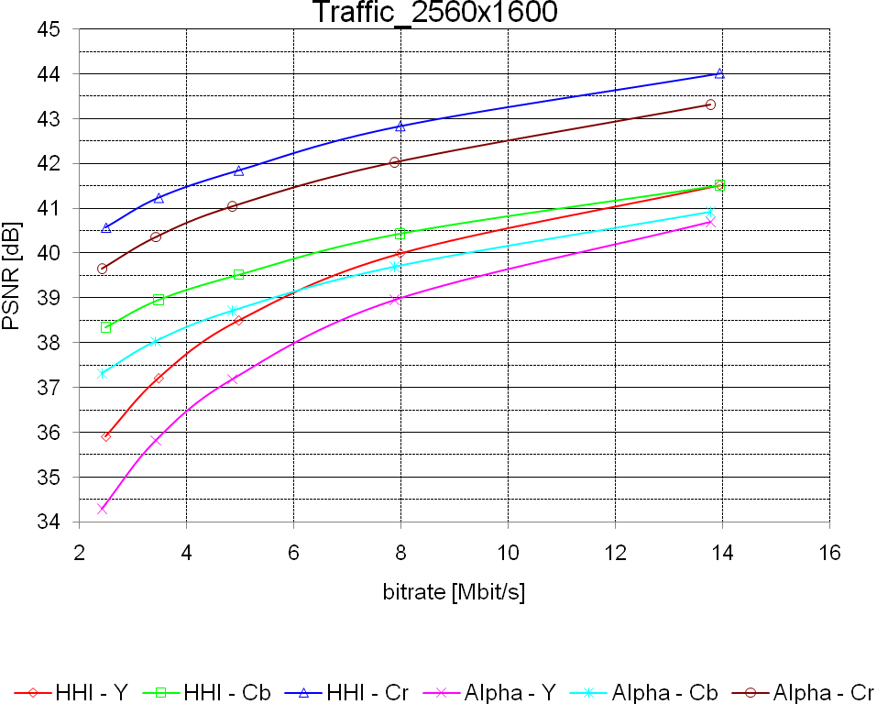 | 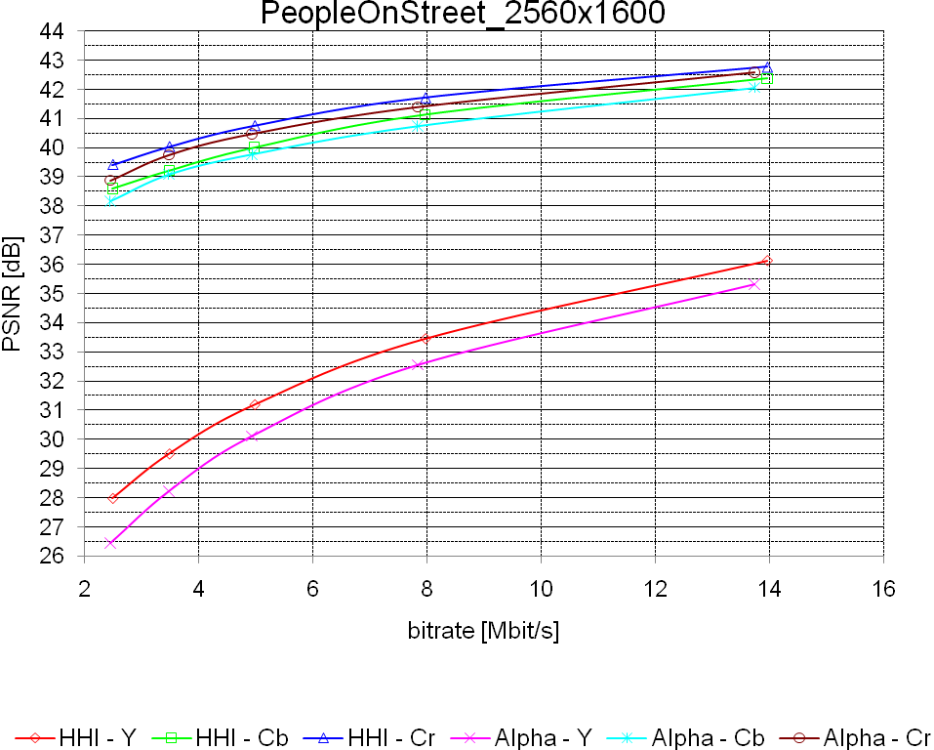

Class B
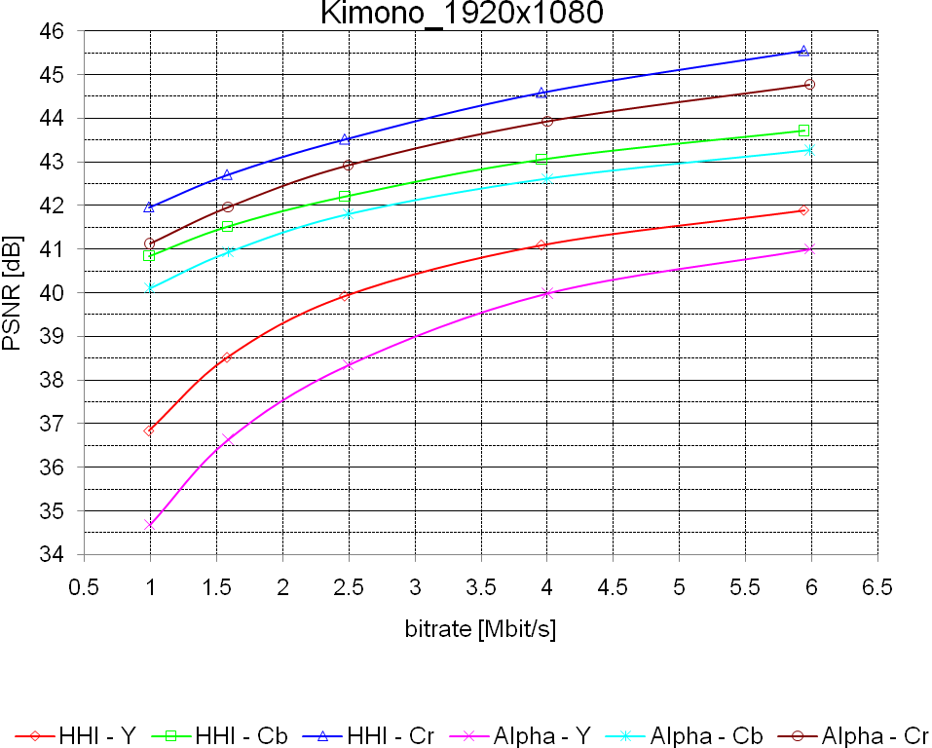 | 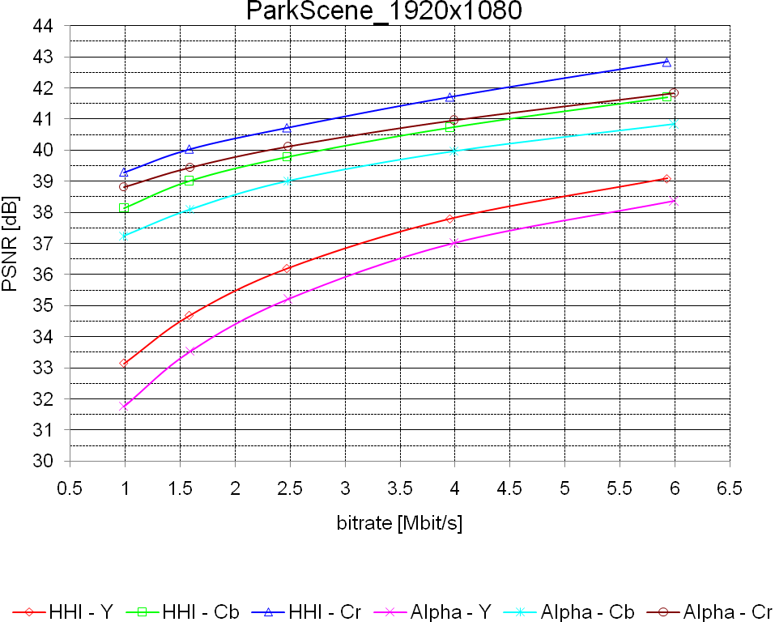
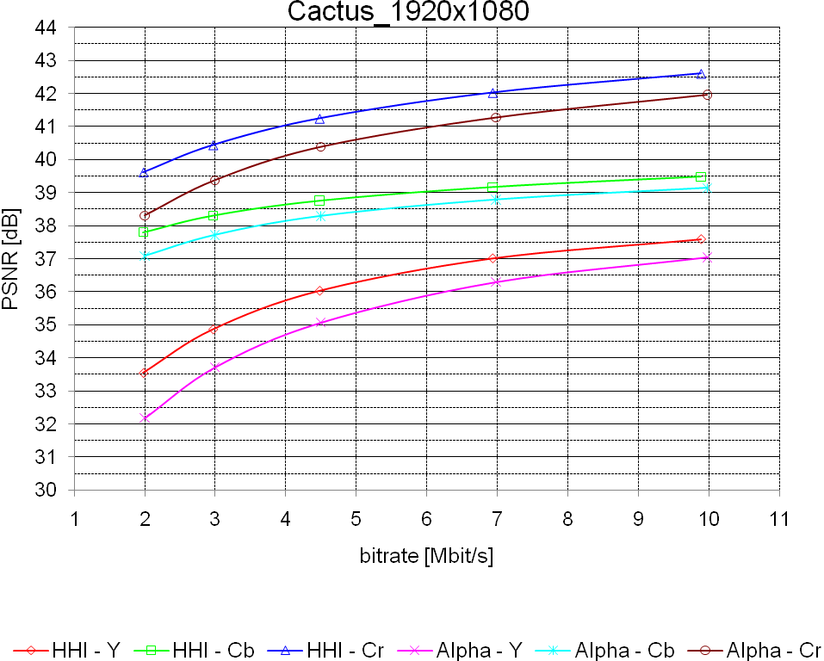 | 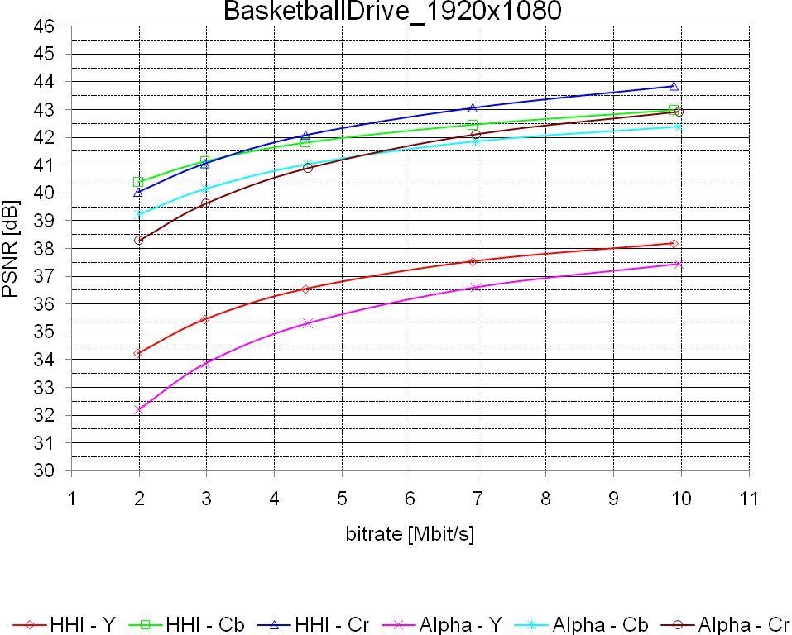
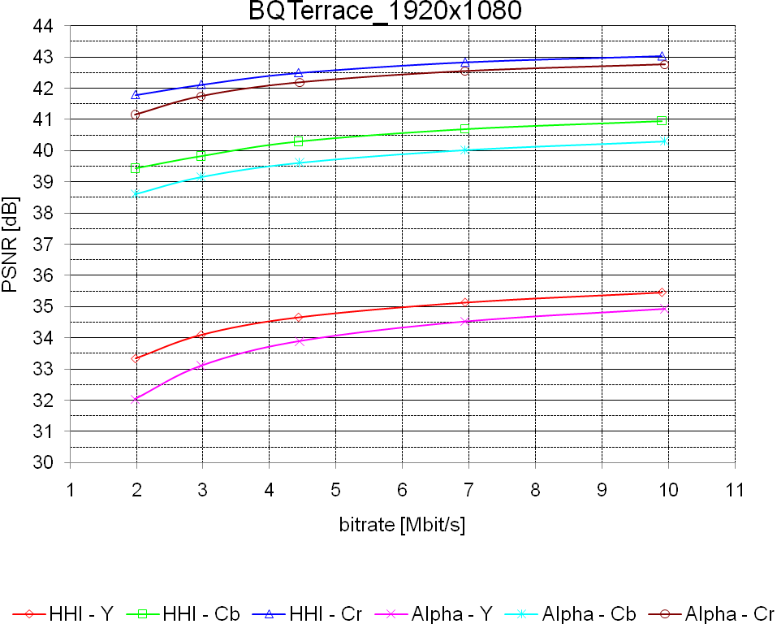

Class C
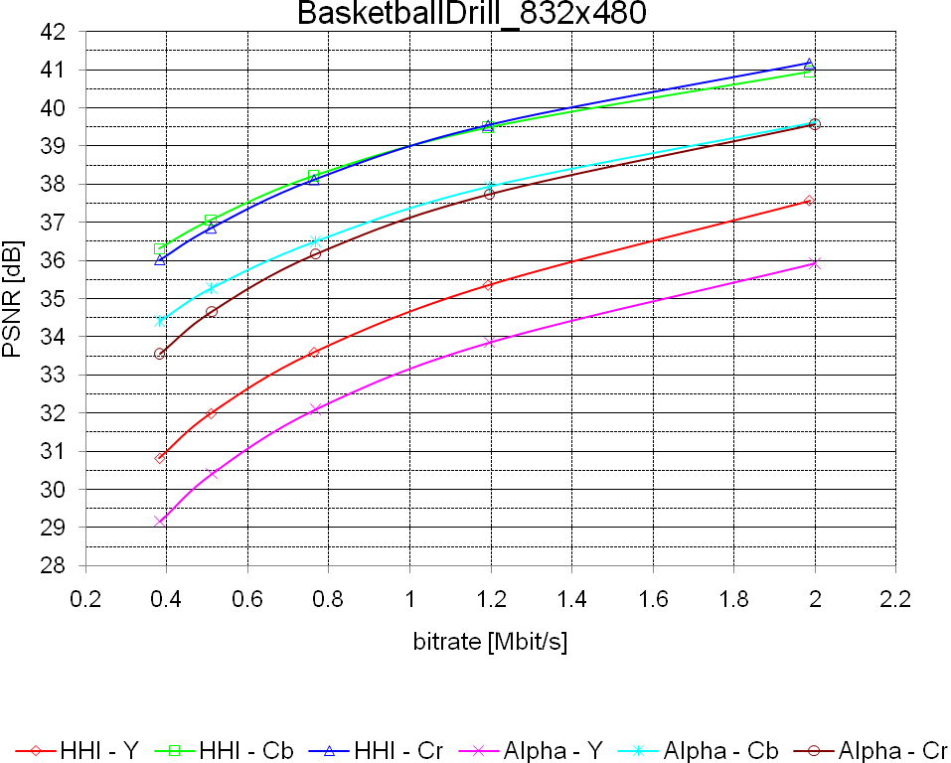 | 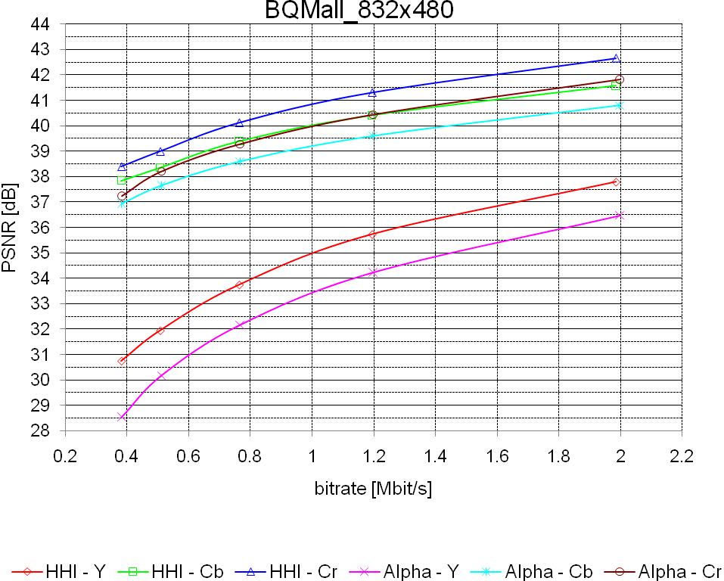
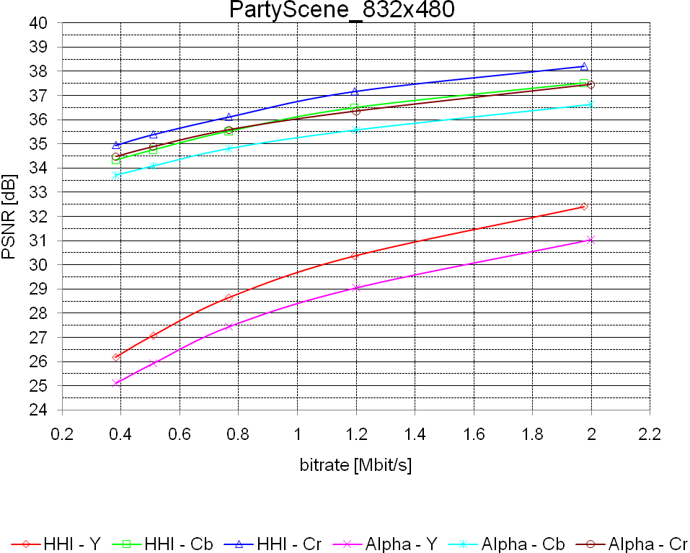 | 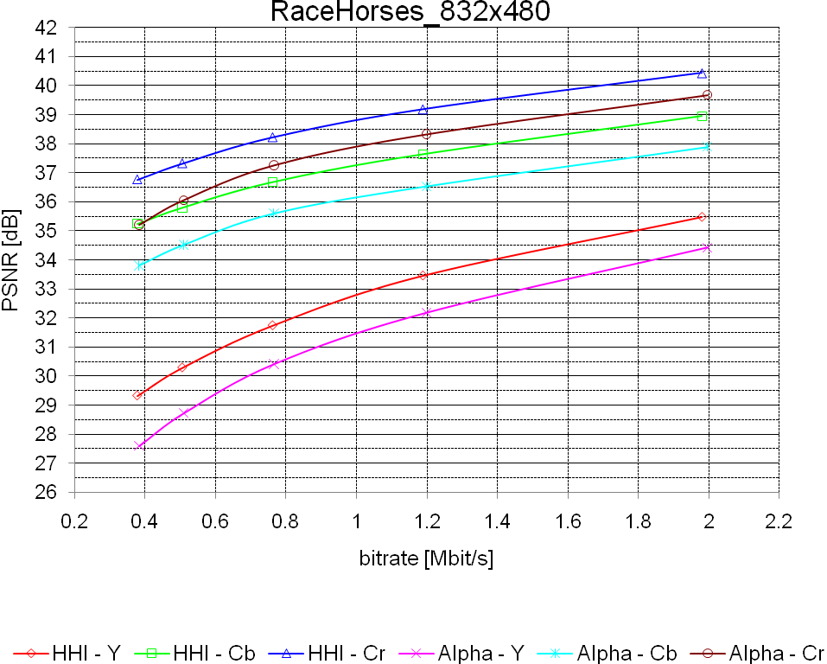

Class D
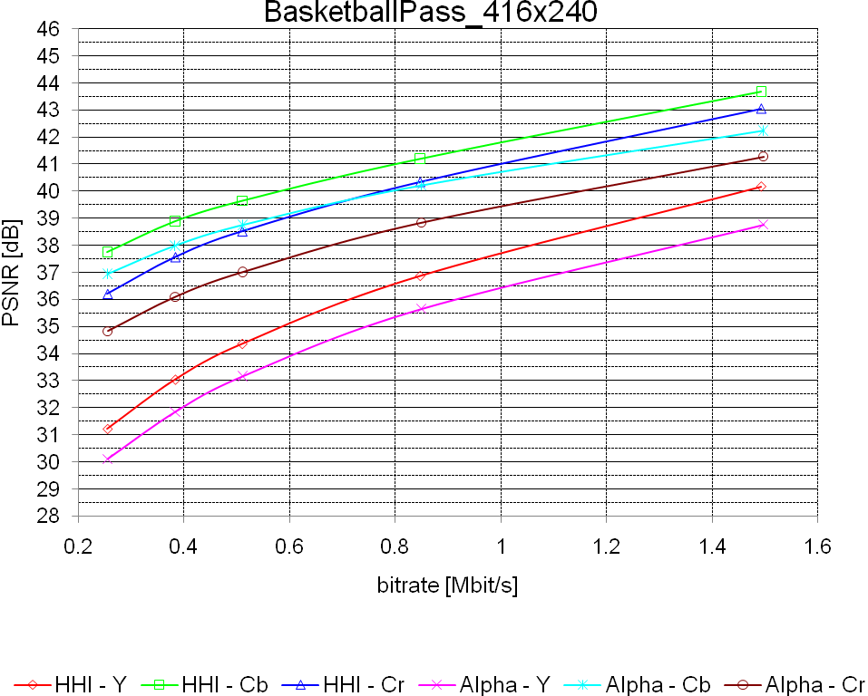 | 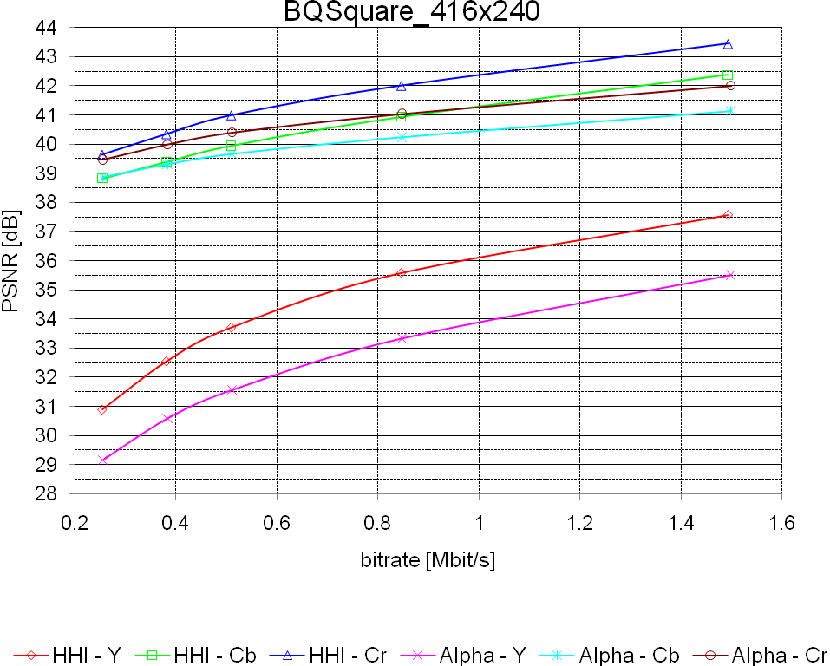
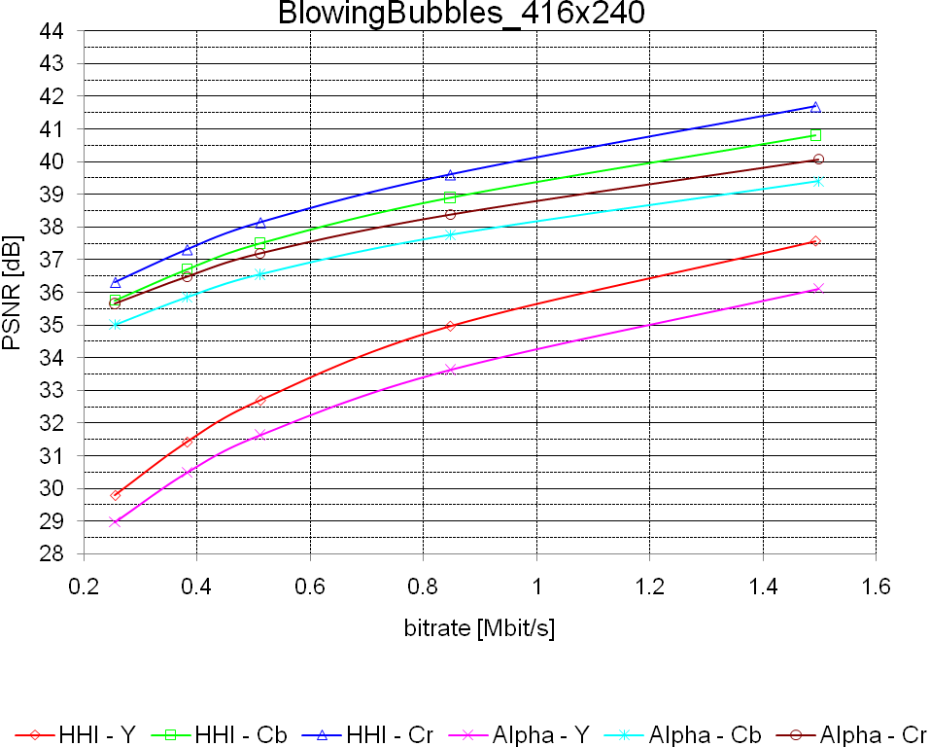 | 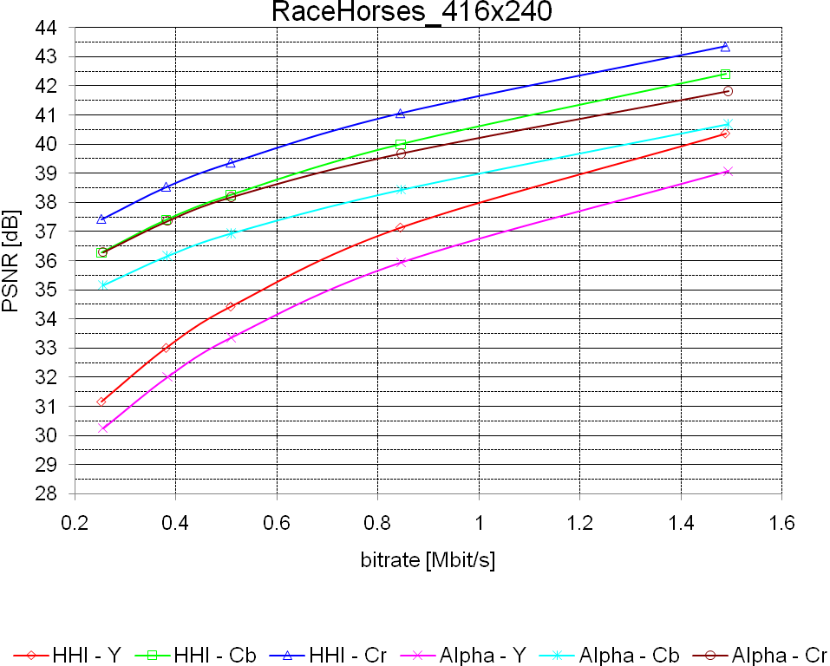

Overall
The following table of the overall results for constraint set 1 presents the BD-Rate and BD-PSNR performance of the proposal against the alpha anchors for the Y plane.

Sequence | BD-Rate Low | BD-PSNR Low | BD-Rate High | BD-PSNR High
Class A:
Traffic | -28.49 | 1.2473 | -27.35 | 1.0582
PeopleOnStreet | -19.51 | 1.1115 | -16.33 | 0.9051
Average | -24.00 | 1.1794 | -21.84 | 0.9817
Class B1:
Kimono | -39.27 | 1.7251 | -37.32 | 1.3924
ParkScene | -25.79 | 1.0830 | -22.76 | 0.9227
Average | -32.53 | 1.4041 | -30.04 | 1.1576
Class B2:
Cactus | -29.60 | 1.0671 | -28.84 | 0.8649
BasketballDrive | -36.92 | 1.4352 | -35.01 | 1.1395
BQTerrace | -41.09 | 0.8958 | -42.75 | 0.7180
Average | -35.87 | 1.1327 | -35.53 | 0.9075
Class C:
BasketballDrill | -31.93 | 1.5561 | -31.84 | 1.5483
BQMall | -30.31 | 1.7070 | -29.12 | 1.5451
PartyScene | -27.49 | 1.1947 | -28.68 | 1.2844
RaceHorses | -31.05 | 1.4545 | -28.29 | 1.3276
Average | -30.20 | 1.4781 | -29.48 | 1.4264
Class D:
BasketballPass | -22.52 | 1.1879 | -21.43 | 1.2483
BQSquare | -42.66 | 2.0618 | -45.26 | 2.1719
BlowingBubbles | -21.95 | 1.0333 | -25.24 | 1.2498
RaceHorses | -19.51 | 1.0589 | -19.77 | 1.1689
Average | -26.66 | 1.3355 | -27.93 | 1.4597
Average | -29.87 | 1.3213 | -29.33 | 1.2363

The following table of the overall results for constraint set 1 presents the BD-Rate and BD-PSNR performance of the proposal against the alpha anchors for the Cb plane.
Sequence | BD-Rate Low | BD-PSNR Low | BD-Rate High | BD-PSNR High
Class A:
Traffic | -35.47 | 0.8136 | -30.14 | 0.7255
PeopleOnStreet | -9.6 | 0.2342 | -11.97 | 0.2817
Average | -22.54 | 0.5239 | -21.06 | 0.5036
Class B1:
Kimono | -25.53 | 0.5304 | -22.92 | 0.4589
ParkScene | -35.91 | 0.8549 | -32.41 | 0.8133
Average | -30.72 | 0.6927 | -27.67 | 0.6361
Class B2:
Cactus | -35.24 | 0.5388 | -33.92 | 0.4432
BasketballDrive | -37.43 | 0.8925 | -35.03 | 0.7356
BQTerrace | -46.24 | 0.6917 | -50.82 | 0.6733
Average | -39.64 | 0.7077 | -39.92 | 0.6174
Class C:
BasketballDrill | -44.54 | 1.7485 | -41.19 | 1.6185
BQMall | -28.21 | 0.7992 | -29.51 | 0.8009
PartyScene | -32.39 | 0.727 | -34.89 | 0.8331
RaceHorses | -39.94 | 1.1877 | -39.17 | 1.1247
Average | -36.27 | 1.1156 | -36.19 | 1.0943
Class D:
BasketballPass | -27.87 | 0.8981 | -26.56 | 1.0253
BQSquare | -12.39 | 0.2548 | -28.2 | 0.6202
BlowingBubbles | -30.62 | 0.9247 | -33.38 | 1.1086
RaceHorses | -36.28 | 1.3083 | -35.53 | 1.4983
Average | -26.79 | 0.8465 | -30.92 | 1.0631
Average | -31.84 | 0.8270 | -32.38 | 0.8507

The following table of the overall results for constraint set 1 presents the BD-Rate and BD-PSNR performance of the proposal against the alpha anchors for the Cr plane.
Sequence | BD-Rate Low | BD-PSNR Low | BD-Rate High | BD-PSNR High
Class A:
Traffic | -33.88 | 0.7959 | -30.64 | 0.7662
PeopleOnStreet | -12.77 | 0.2946 | -12.2 | 0.2604
Average | -23.33 | 0.5453 | -21.42 | 0.5133
Class B1:
Kimono | -28.94 | 0.6999 | -26.31 | 0.6737
ParkScene | -31.1 | 0.5988 | -29.91 | 0.7045
Average | -30.02 | 0.6494 | -28.11 | 0.6891
Class B2:
Cactus | -36.25 | 0.9907 | -34.84 | 0.8369
BasketballDrive | -37.56 | 1.3191 | -35.52 | 1.1137
BQTerrace | -29.83 | 0.3654 | -30.78 | 0.301
Average | -34.55 | 0.8917 | -33.71 | 0.7505
Class C:
BasketballDrill | -45.29 | 2.0626 | -42.55 | 1.8825
BQMall | -27.13 | 0.8748 | -27.61 | 0.8543
PartyScene | -26.44 | 0.5655 | -29.52 | 0.6989
RaceHorses | -35.23 | 1.1108 | -32.15 | 0.9444
Average | -33.52 | 1.1534 | -32.96 | 1.0950
Class D:
BasketballPass | -35.64 | 1.4711 | -32.46 | 1.5357
BQSquare | -24.1 | 0.5359 | -38.45 | 0.8921
BlowingBubbles | -29.55 | 0.9158 | -34.04 | 1.1768
RaceHorses | -33.72 | 1.2086 | -33.03 | 1.3417
Average | -30.75 | 1.0329 | -34.50 | 1.2366
Average | -31.16 | 0.9206 | -31.33 | 0.9322

Constraint set 2 configuration relative to Beta and Gamma anchors

Class B
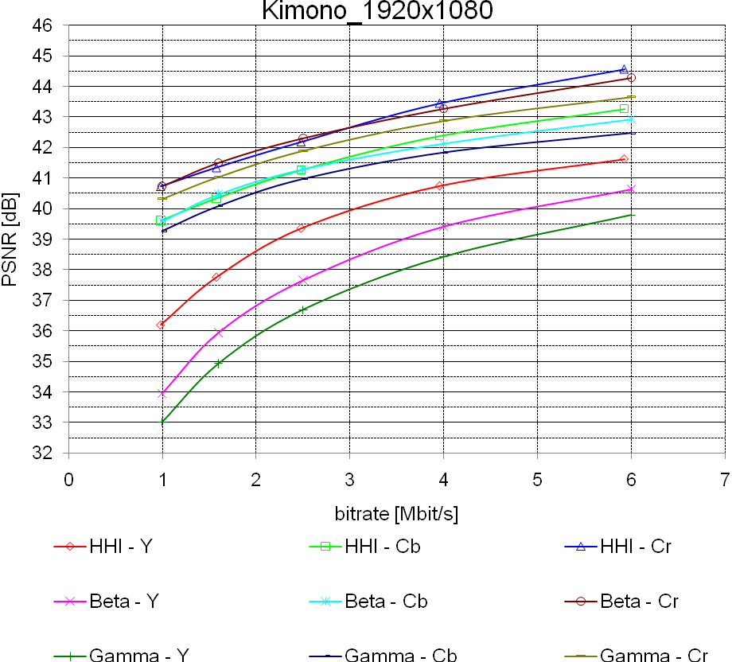 | 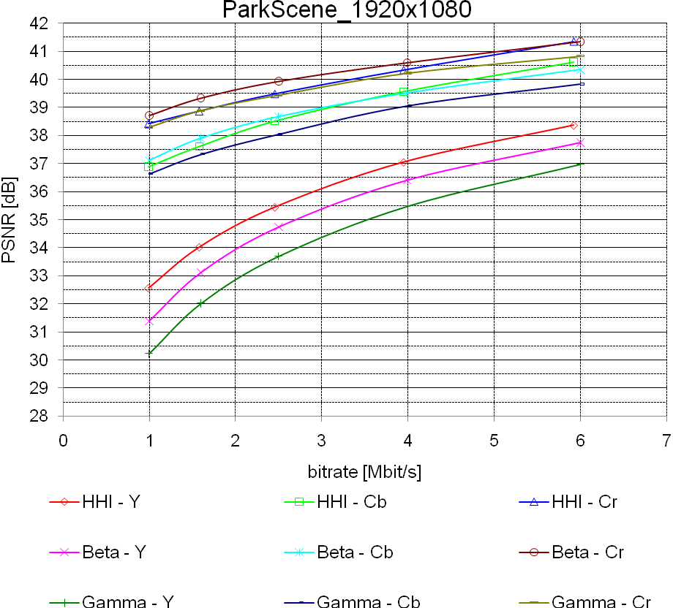
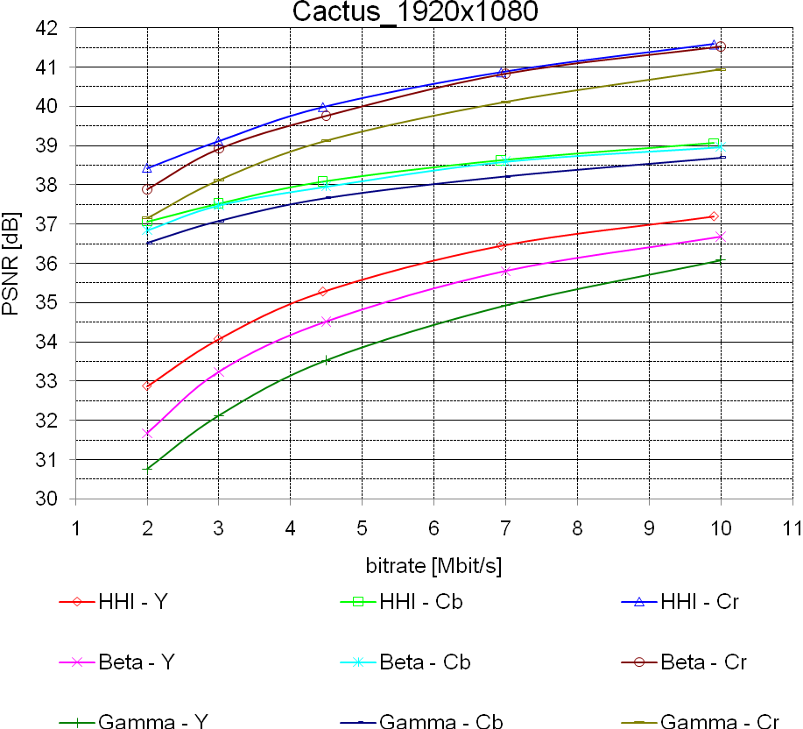 | 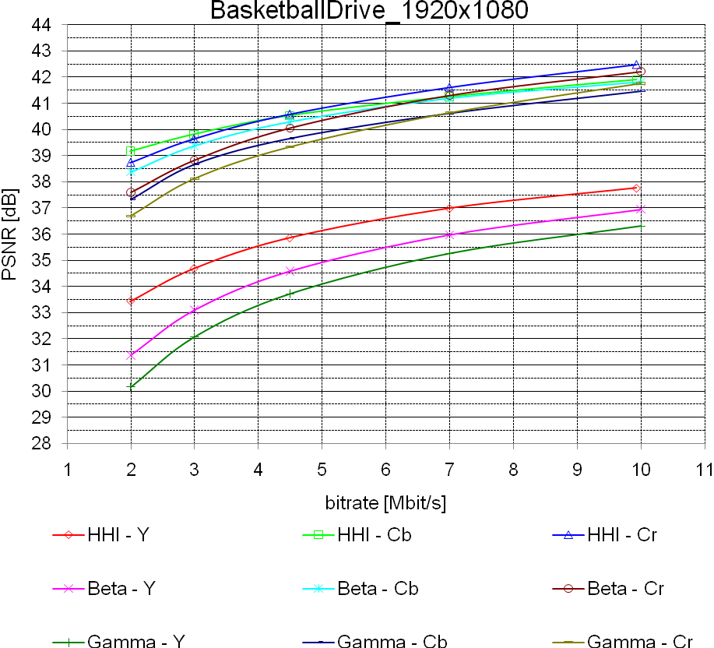
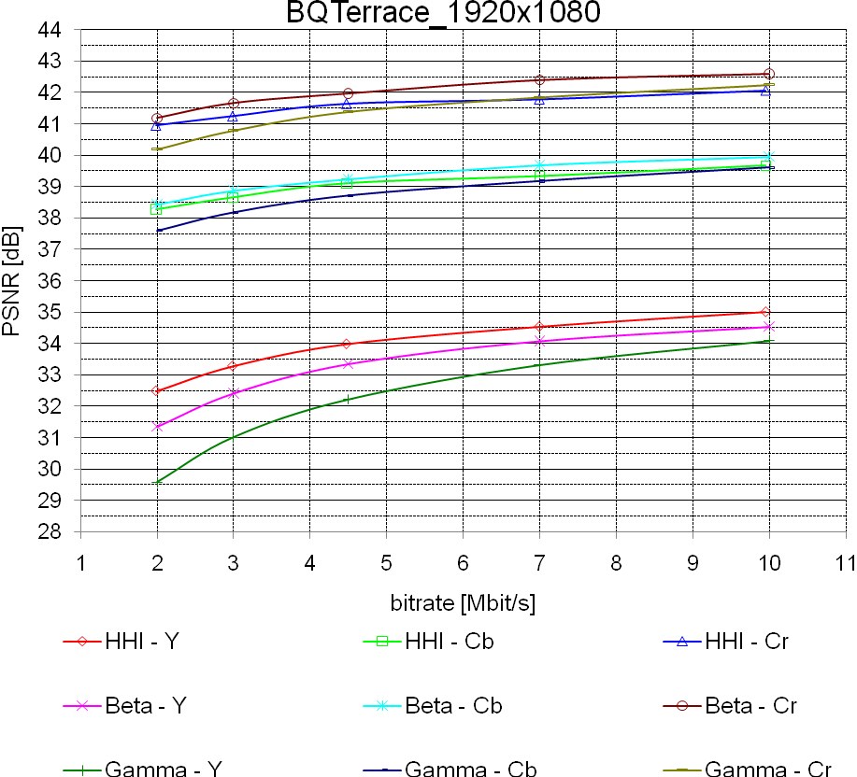

Class C
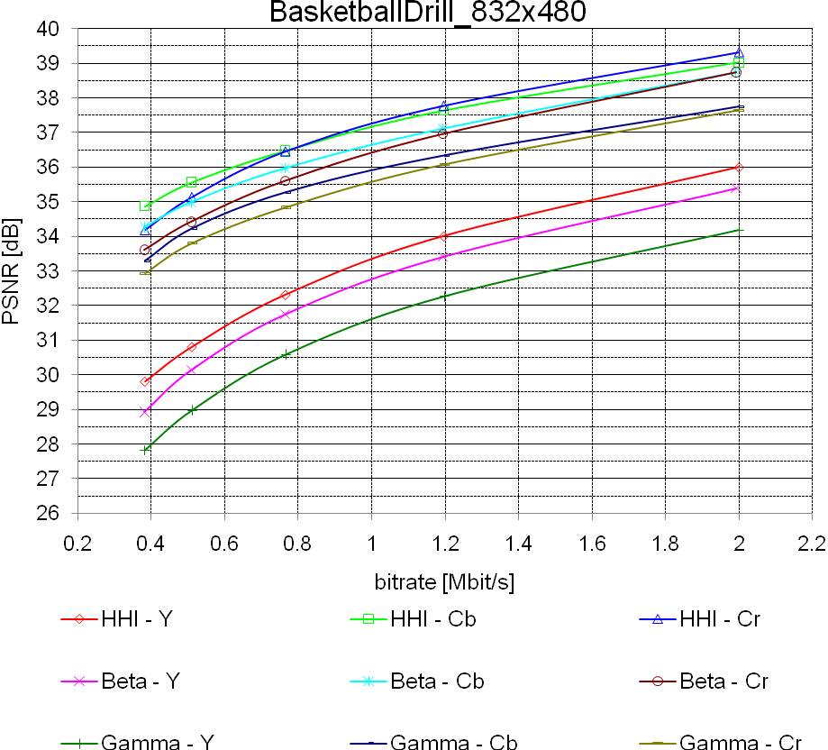 | 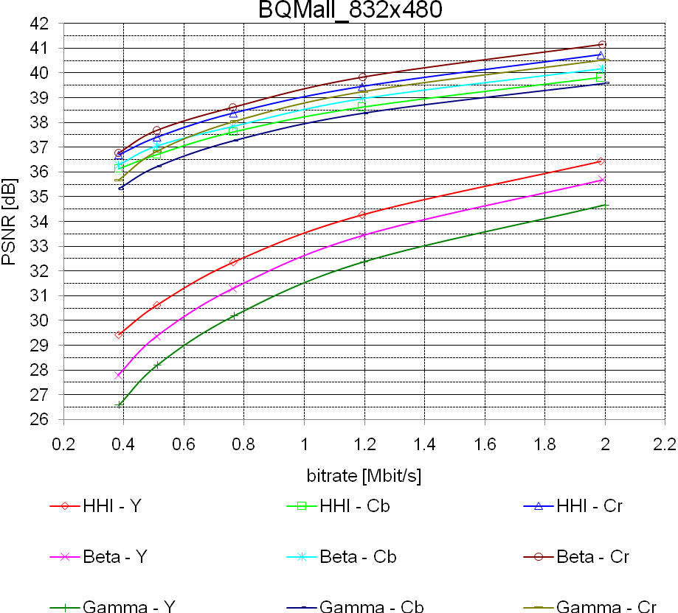
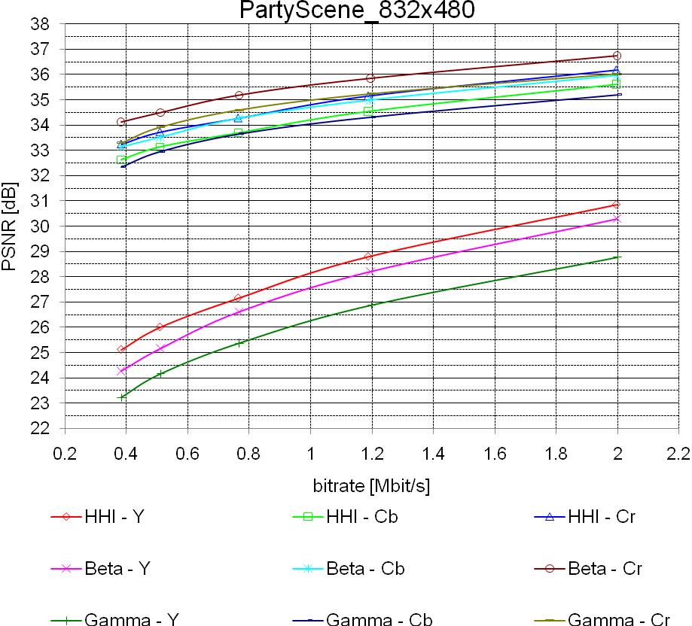 | 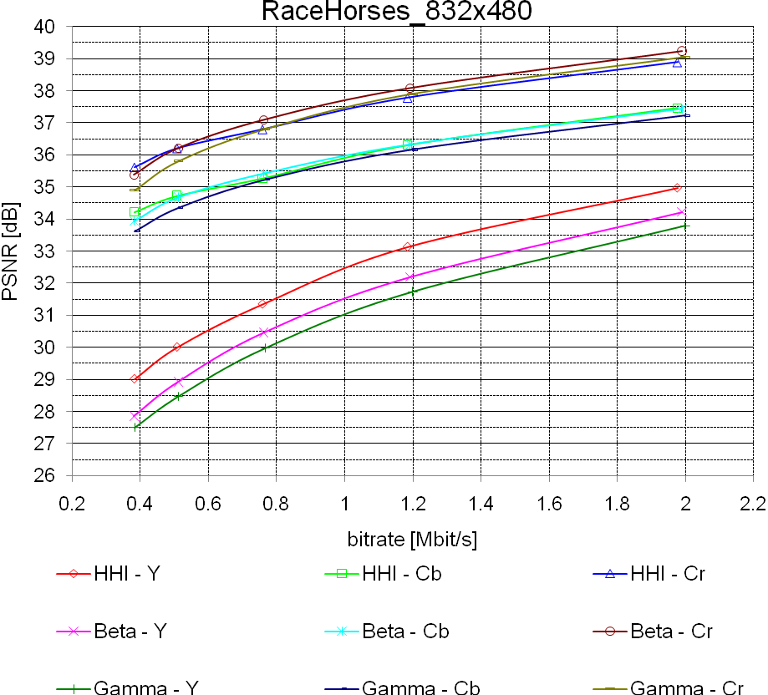

Class D
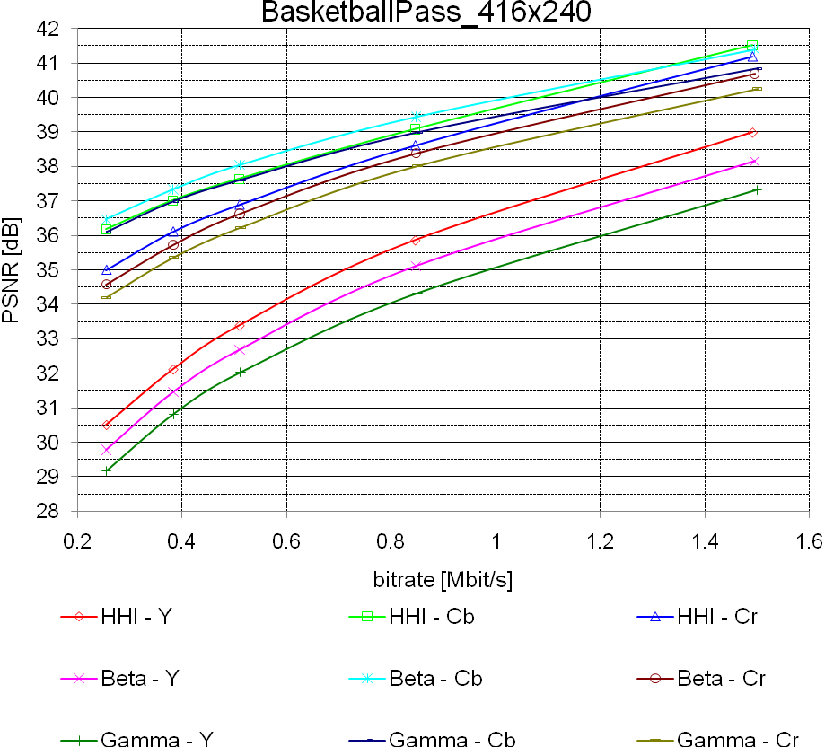 | 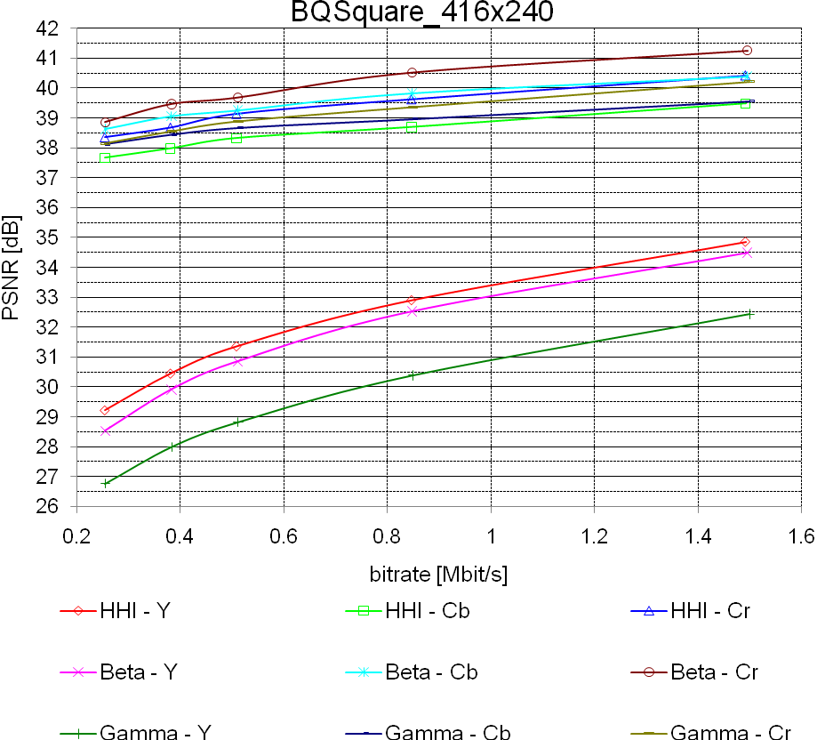
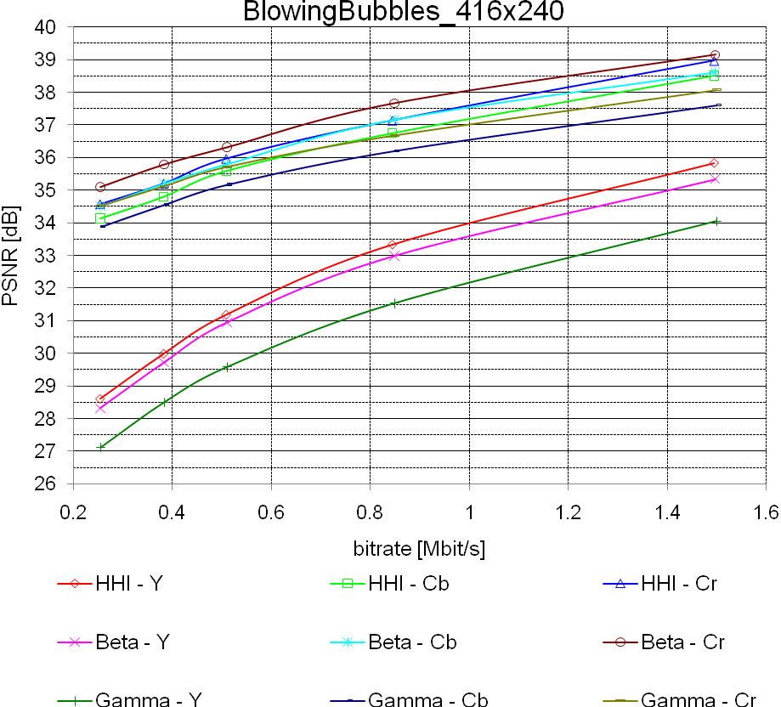 | 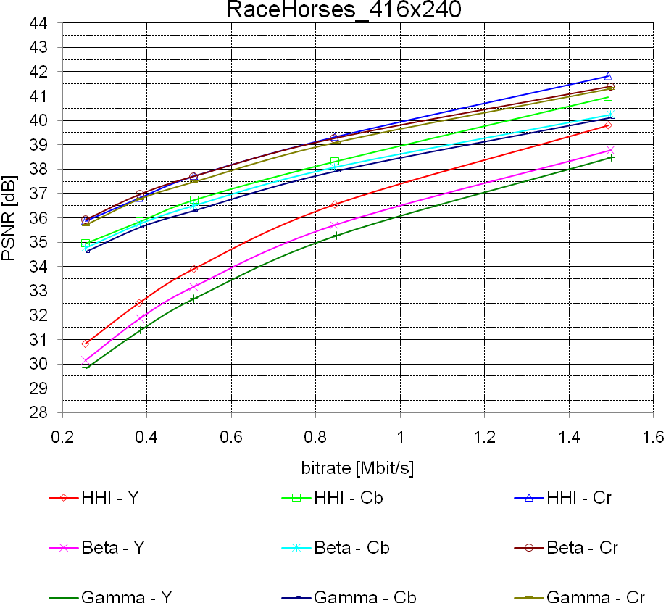

Class E
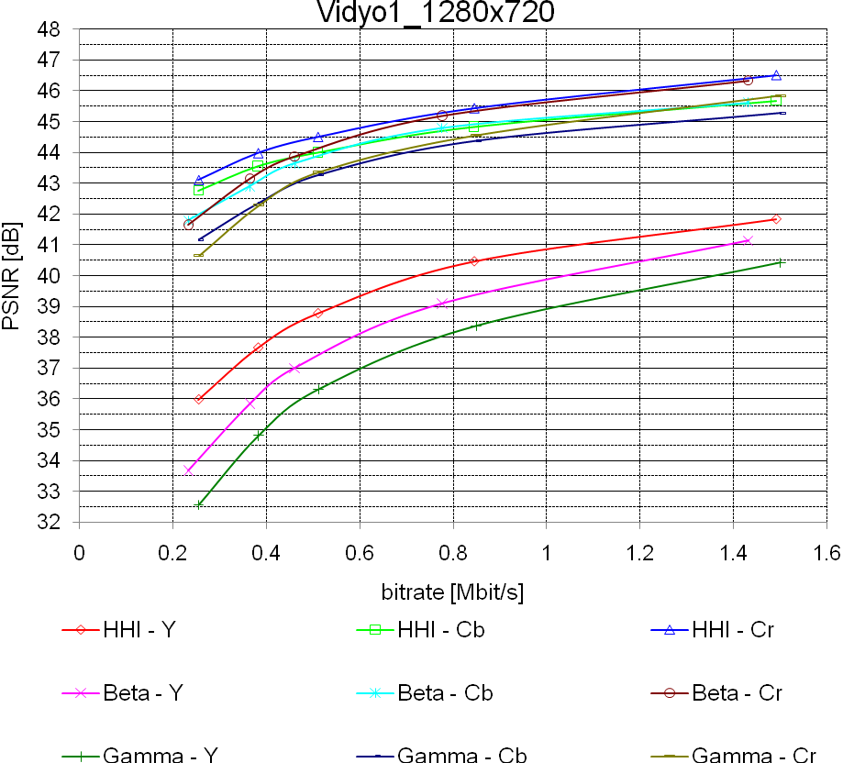 | 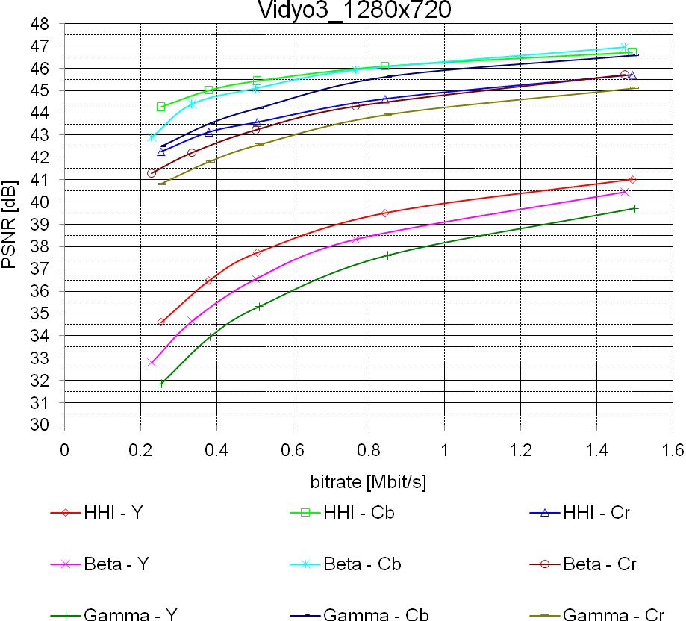
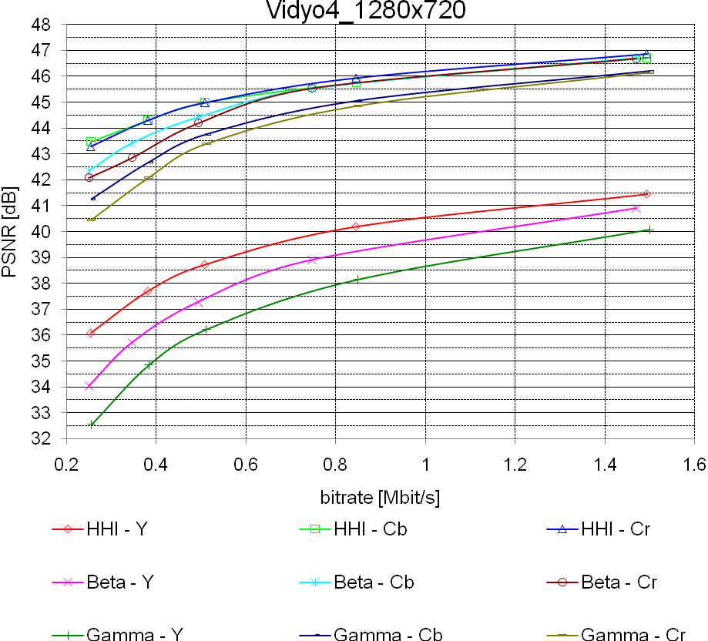

Overall
The following table of the overall results for constraint set 2 presents the BD-Rate and BD-PSNR performance of the proposal against the beta anchors for the Y plane.

Sequence | BD-Rate Low | BD-PSNR Low | BD-Rate High | BD-PSNR High
Class B1:
Kimono | -38.99 | 1.8080 | -37.24 | 1.5376
ParkScene | -22.23 | 0.8834 | -19.46 | 0.7488
Average | -30.61 | 1.3457 | -28.35 | 1.1432
Class B2:
Cactus | -23.61 | 0.8467 | -23.25 | 0.7279
BasketballDrive | -35.59 | 1.4507 | -33.24 | 1.1702
BQTerrace | -31.71 | 0.7511 | -31.19 | 0.5769
Average | -30.30 | 1.0162 | -29.23 | 0.8250
Class C:
BasketballDrill | -15.03 | 0.6368 | -14.45 | 0.5981
BQMall | -21.92 | 1.1554 | -19.03 | 0.9585
PartyScene | -17.65 | 0.6775 | -15.45 | 0.6230
RaceHorses | -23.18 | 0.9917 | -21.60 | 0.9350
Average | -19.45 | 0.8654 | -17.63 | 0.7787
Class D:
BasketballPass | -14.75 | 0.7096 | -14.00 | 0.7541
BQSquare | -15.28 | 0.5361 | -12.07 | 0.4305
BlowingBubbles | -6.89 | 0.2843 | -7.99 | 0.3542
RaceHorses | -14.04 | 0.7120 | -14.42 | 0.8177
Average | -12.74 | 0.5605 | -12.12 | 0.5891
Class E:
Vidyo1 | -29.04 | 1.4604 | -27.93 | 1.1319
Vidyo3 | -23.11 | 1.1545 | -22.05 | 0.8832
Vidyo4 | -30.35 | 1.4428 | -26.95 | 0.9872
Average | -27.50 | 1.3526 | -25.64 | 1.0008
Average | -22.71 | 0.9688 | -21.27 | 0.8272

The following table of the overall results for constraint set 2 presents the BD-Rate and BD-PSNR performance of the proposal against the beta anchors for the Cb plane.

Sequence | BD-Rate Low | BD-PSNR Low | BD-Rate High | BD-PSNR High
Class B1:
Kimono | 0.55 | 0.1219 | -5.4 | -0.0045
ParkScene | 9.11 | -0.0226 | 1 | -0.1683
Average | 4.83 | 0.0497 | -2.20 | -0.0864
Class B2:
Cactus | -7.44 | 0.0889 | -6.82 | 0.1058
BasketballDrive | -14.69 | 0.1859 | -8.61 | 0.356
BQTerrace | 21.49 | -0.2413 | 31.29 | -0.1941
Average | -0.21 | 0.0112 | 5.29 | 0.0892
Class C:
BasketballDrill | -19.68 | 0.4882 | -16.96 | 0.5357
BQMall | 12 | -0.2987 | 13.73 | -0.2559
PartyScene | 36.5 | -0.4595 | 28.76 | -0.4966
RaceHorses | 3.67 | -0.0345 | 1.25 | -0.0214
Average | 8.12 | -0.0761 | 6.70 | -0.0596
Class D:
BasketballPass | 16.31 | -0.2905 | 9.34 | -0.3545
BQSquare | 209.8 | -1.0439 | 187.62 | -0.9992
BlowingBubbles | 13.25 | -0.3149 | 13.74 | -0.3089
RaceHorses | -6.9 | 0.2836 | -6.69 | 0.183
Average | 58.12 | -0.3414 | 51.00 | -0.3699
Class E:
Vidyo1 | -9.78 | 0.0201 | 0.78 | 0.294
Vidyo3 | -17.1 | 0.0681 | -4.19 | 0.3568
Vidyo4 | -18.46 | 0.1321 | -5.6 | 0.5646
Average | -15.11 | 0.0734 | -3.00 | 0.4051
Average | 14.29 | -0.0823 | 14.58 | -0.0255

The following table of the overall results for constraint set 2 presents the BD-Rate and BD-PSNR performance of the proposal against the beta anchors for the Cr plane.

Sequence | BD-Rate Low | BD-PSNR Low | BD-Rate High | BD-PSNR High
Class B1:
Kimono | 3.84 | -0.07 | -1.88 | 0.0401
ParkScene | 33.46 | -0.3962 | 17.55 | -0.3089
Average | 18.65 | -0.2331 | 7.84 | -0.1344
Class B2:
Cactus | -9.93 | 0.2401 | -6.8 | 0.1514
BasketballDrive | -21.58 | 0.6883 | -15.62 | 0.4679
BQTerrace | 50.83 | -0.3789 | 100.6 | -0.4584
Average | 6.44 | 0.1832 | 26.06 | 0.0536
Class C:
BasketballDrill | -22.42 | 0.7722 | -22.48 | 0.7735
BQMall | 10.18 | -0.2462 | 13.62 | -0.3222
PartyScene | 71.12 | -0.8303 | 51.13 | -0.7367
RaceHorses | 8.39 | -0.1438 | 12.21 | -0.253
Average | 16.82 | -0.1120 | 13.62 | -0.1346
Class D:
BasketballPass | -9.35 | 0.319 | -7.78 | 0.3049
BQSquare | 79.56 | -0.6443 | 81.49 | -0.7944
BlowingBubbles | 19.83 | -0.449 | 19.17 | -0.4335
RaceHorses | 0.37 | -0.0261 | -1.71 | 0.0857
Average | 22.60 | -0.2001 | 22.79 | -0.2093
Class E:
Vidyo1 | -17.25 | 0.5251 | -7.39 | 0.1942
Vidyo3 | -17.01 | 0.4382 | -6.52 | 0.1802
Vidyo4 | -23.49 | 0.8403 | -12.54 | 0.3246
Average | -19.25 | 0.6012 | -8.82 | 0.2330
Average | 9.78 | 0.0399 | 13.32 | -0.0490

The following table of the overall results for constraint set 2 presents the BD-Rate and BD-PSNR performance of the proposal against the gamma anchors for the Y plane.

Sequence | BD-Rate Low | BD-PSNR Low | BD-Rate High | BD-PSNR High
Class B1:
Kimono | -53.29 | 2.7965 | -52.62 | 2.5086
ParkScene | -42.12 | 1.9443 | -38.21 | 1.7242
Average | -47.71 | 2.3704 | -45.42 | 2.1164
Class B2:
Cactus | -44.03 | 1.8532 | -42.88 | 1.6480
BasketballDrive | -50.05 | 2.3968 | -47.86 | 1.9800
BQTerrace | -57.91 | 2.0121 | -55.21 | 1.5391
Average | -50.66 | 2.0874 | -48.65 | 1.7224
Class C:
BasketballDrill | -37.45 | 1.8028 | -37.28 | 1.7746
BQMall | -38.97 | 2.2989 | -36.25 | 2.0574
PartyScene | -45.23 | 1.8510 | -41.61 | 1.9212
RaceHorses | -32.98 | 1.4676 | -30.76 | 1.4209
Average | -38.66 | 1.8551 | -36.48 | 1.7935
Class D:
BasketballPass | -27.11 | 1.3892 | -26.77 | 1.5215
BQSquare | -56.51 | 2.5250 | -54.49 | 2.5220
BlowingBubbles | -33.62 | 1.6096 | -34.62 | 1.7493
RaceHorses | -22.34 | 1.1847 | -21.40 | 1.2745
Average | -34.90 | 1.6771 | -34.32 | 1.7668
Class E:
Vidyo1 | -45.67 | 2.6612 | -45.96 | 2.1812
Vidyo3 | -42.47 | 2.4614 | -41.61 | 2.0255
Vidyo4 | -48.63 | 2.6938 | -48.74 | 2.1535
Average | -45.59 | 2.6055 | -45.44 | 2.1201
Average | -42.40 | 2.0593 | -41.02 | 1.8751

The following table of the overall results for constraint set 2 presents the BD-Rate and BD-PSNR performance of the proposal against the gamma anchors for the Cb plane.

Sequence | BD-Rate Low | BD-PSNR Low | BD-Rate High | BD-PSNR High
Class B1:
Kimono | -15.5 | 0.457 | -18.49 | 0.3411
ParkScene | -19.69 | 0.5205 | -21.51 | 0.3955
Average | -17.60 | 0.4888 | -20.00 | 0.3683
Class B2:
Cactus | -27.97 | 0.4242 | -28.28 | 0.4505
BasketballDrive | -37.9 | 0.7719 | -31.21 | 1.0554
BQTerrace | -31.85 | 0.2845 | -25.72 | 0.428
Average | -32.57 | 0.4935 | -28.40 | 0.6446
Class C:
BasketballDrill | -40.84 | 1.2746 | -39.56 | 1.2944
BQMall | -15.61 | 0.32 | -12.26 | 0.4384
PartyScene | -6.3 | 0.1942 | -10.1 | 0.1281
RaceHorses | -7.33 | 0.173 | -7.69 | 0.2239
Average | -17.52 | 0.4905 | -17.40 | 0.5212
Class D:
BasketballPass | -2.06 | 0.1649 | -4.48 | 0.051
BQSquare | 53.71 | -0.2733 | 35.15 | -0.3696
BlowingBubbles | -15.54 | 0.5405 | -19.59 | 0.3717
RaceHorses | -13.73 | 0.4723 | -11.54 | 0.3802
Average | 5.60 | 0.2261 | -0.12 | 0.1083
Class E:
Vidyo1 | -33.08 | 0.6009 | -26.33 | 0.944
Vidyo3 | -45.03 | 0.6966 | -28.22 | 1.2617
Vidyo4 | -39.42 | 0.894 | -34.27 | 1.4055
Average | -39.18 | 0.7305 | -29.61 | 1.2037
Average | -18.63 | 0.4697 | -17.76 | 0.5500

The following table of the overall results for constraint set 2 presents the BD-Rate and BD-PSNR performance of the proposal against the gamma anchors for the Cr plane.

Sequence | BD-Rate Low | BD-PSNR Low | BD-Rate High | BD-PSNR High
Class B1:
Kimono | -16.44 | 0.3612 | -17.74 | 0.4766
ParkScene | -4.58 | 0.0577 | -6.43 | 0.1386
Average | -10.51 | 0.2095 | -12.09 | 0.3076
Class B2:
Cactus | -34.05 | 0.9597 | -32 | 0.8373
BasketballDrive | -40.26 | 1.4199 | -33.87 | 1.1403
BQTerrace | -25.31 | 0.3501 | -15.59 | 0.1233
Average | -33.21 | 0.9099 | -27.15 | 0.7003
Class C:
BasketballDrill | -40.33 | 1.5208 | -43.07 | 1.6332
BQMall | -14.71 | 0.4748 | -10.72 | 0.3069
PartyScene | 15.01 | -0.2174 | 7.44 | -0.1206
RaceHorses | -5.12 | 0.1838 | 0.89 | -0.0036
Average | -11.29 | 0.4905 | -11.37 | 0.4540
Class D:
BasketballPass | -20.38 | 0.7084 | -16.87 | 0.6995
BQSquare | -17.3 | 0.2237 | -19.48 | 0.2439
BlowingBubbles | -10.02 | 0.2279 | -16.44 | 0.453
RaceHorses | -7.11 | 0.1853 | -6.44 | 0.2635
Average | -13.70 | 0.3363 | -14.81 | 0.4150
Class E:
Vidyo1 | -41.63 | 1.4323 | -36.12 | 0.9996
Vidyo3 | -39.03 | 1.1152 | -29.82 | 0.8325
Vidyo4 | -44.8 | 1.8533 | -41.65 | 1.2716
Average | -41.82 | 1.4669 | -35.86 | 1.0346
Average | -21.63 | 0.6785 | -19.87 | 0.5810

Complexity analysis

Encoding time and measurement methodology
For encoding time measurement one single coding process with one thread is used for encoding all sequences in constraint set 1 and 2. The time in following tables are measured on the same machine described in 4.3. For comparison the anchors are encoded with JM 16.2 (without any modifications) on the same machine.

 |  | Constraint set 1 |  |  |  | Constraint set 2
 |  | Encoding Time (h:m:s) |  |  |  | Encoding Time (h:m:s)
 |  | JM 16.2 | HHI | Factor |  | JM 16.2 | HHI | Factor
Class A:
Traffic | R1 | 3:45:08 | 6:56:32 | 1.85
Traffic | R2 | 3:50:26 | 7:18:48 | 1.90
Traffic | R3 | 3:42:57 | 8:06:23 | 2.18
Traffic | R4 | 3:50:45 | 9:20:47 | 2.43
Traffic | R5 | 4:02:31 | 11:41:38 | 2.89
PeopleOnStreet | R1 | 4:08:04 | 16:53:34 | 4.09
PeopleOnStreet | R2 | 4:08:06 | 17:08:20 | 4.14
PeopleOnStreet | R3 | 4:20:18 | 17:15:07 | 3.98
PeopleOnStreet | R4 | 4:21:03 | 18:35:00 | 4.27
PeopleOnStreet | R5 | 4:08:57 | 20:57:16 | 5.05
Class B1:
Kimono | R1 | 3:14:24 | 9:42:56 | 3.00 |  | 3:32:08 | 7:03:35 | 2.00
Kimono | R2 | 3:26:40 | 10:45:10 | 3.12 |  | 3:31:40 | 7:36:19 | 2.16
Kimono | R3 | 3:31:06 | 12:02:59 | 3.42 |  | 3:22:09 | 8:29:04 | 2.52
Kimono | R4 | 3:39:04 | 14:06:06 | 3.86 |  | 3:28:38 | 9:56:24 | 2.86
Kimono | R5 | 3:44:37 | 16:24:03 | 4.38 |  | 3:35:39 | 11:37:23 | 3.23
ParkScene | R1 | 3:13:11 | 7:11:58 | 2.24 |  | 4:16:19 | 6:14:54 | 1.46
ParkScene | R2 | 3:18:32 | 7:33:34 | 2.28 |  | 4:02:24 | 6:23:19 | 1.58
ParkScene | R3 | 3:24:37 | 8:16:36 | 2.43 |  | 4:06:39 | 6:50:36 | 1.66
ParkScene | R4 | 3:32:17 | 9:31:20 | 2.69 |  | 4:24:57 | 7:43:48 | 1.75
ParkScene | R5 | 3:40:20 | 11:08:55 | 3.04 |  | 4:48:07 | 8:48:33 | 1.83
Class B2:
Cactus | R1 | 6:55:53 | 17:39:11 | 2.55
Cactus | R2 | 6:59:55 | 18:52:46 | 2.70
Cactus | R3 | 7:12:26 | 20:30:39 | 2.85
Cactus | R4 | 7:24:52 | 23:12:42 | 3.13
Cactus | R5 | 7:42:33 | 25:50:03 | 3.35
BasketballDrive | R1 | 7:28:45 | 24:22:39 | 3.26
BasketballDrive | R2 | 7:18:08 | 26:13:48 | 3.59
BasketballDrive | R3 | 7:21:29 | 28:14:53 | 3.84
BasketballDrive | R4 | 7:23:59 | 31:43:30 | 4.29
BasketballDrive | R5 | 7:53:46 | 35:07:43 | 4.45
BQTerrace | R1 | 8:03:47 | 21:46:58 | 2.70
BQTerrace | R2 | 8:10:10 | 23:44:47 | 2.91
BQTerrace | R3 | 8:23:09 | 25:57:27 | 3.10
BQTerrace | R4 | 8:27:55 | 29:07:31 | 3.44
BQTerrace | R5 | 8:41:31 | 32:11:19 | 3.70
Class C:
BasketballDrill | R1 | 1:15:51 | 4:54:00 | 3.88 |  | 1:00:10 | 3:10:59 | 3.17
BasketballDrill | R2 | 1:16:29 | 5:01:42 | 3.94 |  | 0:57:51 | 3:14:25 | 3.36
BasketballDrill | R3 | 1:18:56 | 5:22:47 | 4.09 |  | 0:57:13 | 3:27:14 | 3.62
BasketballDrill | R4 | 1:21:46 | 6:04:28 | 4.46 |  | 0:59:21 | 3:43:56 | 3.77
BasketballDrill | R5 | 1:24:36 | 6:50:06 | 4.85 |  | 1:00:21 | 4:15:21 | 4.23
BQMall | R1 | 1:34:27 | 6:44:33 | 4.28 |  | 1:15:43 | 4:41:16 | 3.71
BQMall | R2 | 1:35:53 | 6:46:37 | 4.24 |  | 1:13:25 | 4:46:26 | 3.90
BQMall | R3 | 1:38:51 | 6:48:35 | 4.13 |  | 1:12:13 | 4:48:22 | 3.99
BQMall | R4 | 1:39:49 | 7:08:31 | 4.29 |  | 1:09:48 | 4:57:00 | 4.25
BQMall | R5 | 1:43:45 | 7:58:10 | 4.61 |  | 1:08:52 | 5:30:45 | 4.80
PartyScene | R1 | 1:21:39 | 5:09:55 | 3.80 |  | 1:18:32 | 3:33:52 | 2.72
PartyScene | R2 | 1:26:18 | 5:12:30 | 3.62 |  | 1:17:03 | 3:35:45 | 2.80
PartyScene | R3 | 1:27:53 | 5:14:23 | 3.58 |  | 1:10:19 | 3:40:36 | 3.14
PartyScene | R4 | 1:30:14 | 5:19:14 | 3.54 |  | 1:08:29 | 3:51:48 | 3.38
PartyScene | R5 | 1:34:33 | 5:53:39 | 3.74 |  | 1:06:04 | 3:58:57 | 3.62
RaceHorses | R1 | 0:50:16 | 4:21:16 | 5.20 |  | 0:43:37 | 2:47:14 | 3.83
RaceHorses | R2 | 0:51:35 | 4:29:43 | 5.23 |  | 0:43:01 | 2:50:51 | 3.97
RaceHorses | R3 | 0:53:29 | 4:45:02 | 5.33 |  | 0:43:04 | 2:58:28 | 4.14
RaceHorses | R4 | 0:56:04 | 5:12:33 | 5.57 |  | 0:43:43 | 3:09:47 | 4.34
RaceHorses | R5 | 0:59:36 | 5:54:45 | 5.95 |  | 0:44:34 | 3:29:26 | 4.70
Class D:
BasketballPass | R1 | 0:21:30 | 1:49:40 | 5.10 |  | 0:16:35 | 1:01:58 | 3.74
BasketballPass | R2 | 0:21:59 | 1:57:19 | 5.34 |  | 0:16:54 | 1:06:01 | 3.91
BasketballPass | R3 | 0:22:18 | 2:03:29 | 5.54 |  | 0:16:55 | 1:12:54 | 4.31
BasketballPass | R4 | 0:23:38 | 2:18:06 | 5.84 |  | 0:17:09 | 1:16:33 | 4.46
BasketballPass | R5 | 0:25:06 | 2:39:32 | 6.36 |  | 0:18:30 | 1:28:06 | 4.76
BQSquare | R1 | 0:25:34 | 1:16:16 | 2.98 |  | 0:12:34 | 0:53:48 | 4.28
BQSquare | R2 | 0:26:20 | 1:28:16 | 3.35 |  | 0:12:05 | 0:57:15 | 4.74
BQSquare | R3 | 0:26:35 | 1:39:47 | 3.75 |  | 0:11:43 | 1:03:04 | 5.38
BQSquare | R4 | 0:27:32 | 2:03:47 | 4.50 |  | 0:12:06 | 1:09:23 | 5.73
BQSquare | R5 | 0:28:54 | 2:35:04 | 5.36 |  | 0:12:05 | 1:18:50 | 6.52
BlowingBubbles | R1 | 0:21:42 | 1:11:42 | 3.30 |  | 0:16:59 | 0:55:21 | 3.26
BlowingBubbles | R2 | 0:22:27 | 1:15:27 | 3.36 |  | 0:17:12 | 0:57:15 | 3.33
BlowingBubbles | R3 | 0:22:50 | 1:21:39 | 3.58 |  | 0:17:03 | 1:00:28 | 3.55
BlowingBubbles | R4 | 0:24:21 | 1:35:45 | 3.93 |  | 0:16:45 | 1:06:45 | 3.98
BlowingBubbles | R5 | 0:25:14 | 1:59:58 | 4.75 |  | 0:17:21 | 1:16:30 | 4.41
RaceHorses | R1 | 0:14:16 | 1:17:30 | 5.43 |  | 0:11:13 | 0:47:21 | 4.22
RaceHorses | R2 | 0:15:06 | 1:25:41 | 5.67 |  | 0:11:23 | 0:51:09 | 4.50
RaceHorses | R3 | 0:15:09 | 1:29:35 | 5.91 |  | 0:11:30 | 0:53:11 | 4.62
RaceHorses | R4 | 0:15:54 | 1:41:18 | 6.37 |  | 0:12:00 | 0:59:38 | 4.97
RaceHorses | R5 | 0:17:28 | 2:00:47 | 6.91 |  | 0:12:37 | 1:10:21 | 5.58
Class E:
Vidyo1 | R1 |  |  |  |  | 2:19:07 | 3:58:01 | 1.71
Vidyo1 | R2 |  |  |  |  | 2:14:56 | 4:02:23 | 1.80
Vidyo1 | R3 |  |  |  |  | 2:01:13 | 4:17:30 | 2.12
Vidyo1 | R4 |  |  |  |  | 1:59:46 | 4:51:01 | 2.43
Vidyo1 | R5 |  |  |  |  | 2:03:54 | 5:35:38 | 2.71
Vidyo3 | R1 |  |  |  |  | 3:03:21 | 4:08:30 | 1.36
Vidyo3 | R2 |  |  |  |  | 2:24:36 | 4:11:12 | 1.74
Vidyo3 | R3 |  |  |  |  | 2:18:22 | 4:19:10 | 1.87
Vidyo3 | R4 |  |  |  |  | 2:17:27 | 4:50:38 | 2.11
Vidyo3 | R5 |  |  |  |  | 2:14:00 | 5:28:47 | 2.45
Vidyo4 | R1 |  |  |  |  | 2:40:15 | 4:12:31 | 1.58
Vidyo4 | R2 |  |  |  |  | 2:37:56 | 4:21:29 | 1.66
Vidyo4 | R3 |  |  |  |  | 2:36:27 | 4:35:09 | 1.76
Vidyo4 | R4 |  |  |  |  | 2:51:50 | 5:09:46 | 1.80
Vidyo4 | R5 |  |  |  |  | 2:49:06 | 5:52:35 | 2.09

Constraint Set 1 | Factor |  | Constraint Set 2 | Factor
BasketballDrill | 4.24 |  | BasketballDrill | 3.63
BasketballDrive | 3.89 |  | BasketballDrive
BasketballPass | 5.64 |  | BasketballPass | 4.24
BlowingBubbles | 3.78 |  | BlowingBubbles | 3.71
BQMall | 4.31 |  | BQMall | 4.13
BQSquare | 3.99 |  | BQSquare | 5.33
BQTerrace | 3.17 |  | BQTerrace
Cactus | 2.91 |  | Cactus
Kimono | 3.56 |  | Kimono | 2.55
ParkScene | 2.53 |  | ParkScene | 1.66
PartyScene | 3.65 |  | PartyScene | 3.13
PeopleOnStreet | 4.31 |  | RaceHorses | 4.78
RaceHorses | 6.06 |  | RaceHorses | 4.20
RaceHorses | 4.46 |  | Vidyo1 | 2.15
Traffic | 2.25 |  | Vidyo3 | 1.91
 |  |  | Vidyo4 | 1.78
Class A | 3.28
Class B1 | 3.05 |  | Class B1 | 2.11
Class B2 | 3.32 |  | Class B2
Class C | 4.42 |  | Class C | 3.77
Class D | 4.87 |  | Class D | 4.51
 |  |  | Class E | 1.95
Total | 3.98 |  | Total

Decoding time and measurement methodology and comparison vs. anchor bitstreams decoded by JM 17.0

Decoding time of JM 17.0 and the proposal is done on the same machine. One single process with one thread is used for decoding time measure. Four runs are made, while the mean is taken. It is to note that there is no significant variance in speed is tracked. The increase of decoding time relative to the beta anchor bitstreams decoded by JM 17.0 is presented in following table.

 |  | Constraint set 1 |  |  | Constraint set 2
 |  | Decoding Time (s) |  |  | Decoding Time (s)
 |  | JM 17.0 | HHI | Factor | JM 17.0 | HHI | Factor
Class A:
Traffic | R1 | 15.4 | 36.8 | 2.4
Traffic | R2 | 15.5 | 39.8 | 2.6
Traffic | R3 | 16.2 | 44.4 | 2.7
Traffic | R4 | 17.5 | 52.0 | 3.0
Traffic | R5 | 19.7 | 67.2 | 3.4
Traffic | Avg. | 16.9 | 48.0 | 2.8
PeopleOnStreet | R1 | 15.7 | 42.7 | 2.7
PeopleOnStreet | R2 | 16.4 | 46.3 | 2.8
PeopleOnStreet | R3 | 17.0 | 51.2 | 3.0
PeopleOnStreet | R4 | 18.3 | 59.4 | 3.3
PeopleOnStreet | R5 | 20.1 | 76.0 | 3.8
PeopleOnStreet | Avg. | 17.5 | 55.1 | 3.1
Average |  | 17.2 | 51.6 | 3.0
Class B1:
Kimono | R1 | 17.2 | 29.9 | 1.7 | 14.5 | 32.5 | 2.2
Kimono | R2 | 18.7 | 34.2 | 1.8 | 15.9 | 36.2 | 2.3
Kimono | R3 | 19.2 | 38.3 | 2.0 | 16.8 | 40.7 | 2.4
Kimono | R4 | 20.5 | 43.8 | 2.1 | 18.2 | 45.6 | 2.5
Kimono | R5 | 21.8 | 50.1 | 2.3 | 19.3 | 54.1 | 2.8
Kimono | Avg. | 19.5 | 39.3 | 2.0 | 16.9 | 41.8 | 2.4
ParkScene | R1 | 16.9 | 29.4 | 1.7 | 13.7 | 32.0 | 2.3
ParkScene | R2 | 18.0 | 35.8 | 2.0 | 14.9 | 36.8 | 2.5
ParkScene | R3 | 19.1 | 40.9 | 2.1 | 15.9 | 44.2 | 2.8
ParkScene | R4 | 20.2 | 48.3 | 2.4 | 17.2 | 53.9 | 3.1
ParkScene | R5 | 21.6 | 57.7 | 2.7 | 18.6 | 64.5 | 3.5
ParkScene | Avg. | 19.1 | 42.4 | 2.2 | 16.1 | 46.3 | 2.8
Average |  | 19.3 | 40.8 | 2.1 | 16.5 | 44.1 | 2.6
Class B2:
Cactus | R1 | 31.5 | 59.3 | 1.9 | 27.1 | 64.8 | 2.4
Cactus | R2 | 32.3 | 68.2 | 2.1 | 28.5 | 74.0 | 2.6
Cactus | R3 | 33.4 | 74.6 | 2.2 | 30.3 | 83.0 | 2.7
Cactus | R4 | 35.2 | 85.1 | 2.4 | 32.2 | 96.1 | 3.0
Cactus | R5 | 37.2 | 96.7 | 2.6 | 34.1 | 108.9 | 3.2
Cactus | Avg. | 33.9 | 76.8 | 2.2 | 30.4 | 85.3 | 2.8
BasketballDrive | R1 | 36.6 | 61.8 | 1.7 | 28.8 | 68.0 | 2.4
BasketballDrive | R2 | 37.5 | 71.4 | 1.9 | 31.2 | 76.6 | 2.5
BasketballDrive | R3 | 38.8 | 81.2 | 2.1 | 34.3 | 86.1 | 2.5
BasketballDrive | R4 | 40.8 | 94.4 | 2.3 | 36.9 | 98.2 | 2.7
BasketballDrive | R5 | 42.6 | 105.5 | 2.5 | 38.8 | 110.1 | 2.8
BasketballDrive | Avg. | 39.2 | 82.9 | 2.1 | 34.0 | 87.8 | 2.6
BQTerrace | R1 | 43.7 | 72.5 | 1.7 | 35.7 | 75.8 | 2.1
BQTerrace | R2 | 44.7 | 80.2 | 1.8 | 37.4 | 83.7 | 2.2
BQTerrace | R3 | 45.1 | 90.1 | 2.0 | 39.0 | 93.6 | 2.4
BQTerrace | R4 | 46.9 | 100.8 | 2.1 | 41.6 | 109.3 | 2.6
BQTerrace | R5 | 48.6 | 114.5 | 2.4 | 44.4 | 124.0 | 2.8
BQTerrace | Avg. | 45.8 | 91.6 | 2.0 | 39.6 | 97.3 | 2.4
Average |  | 39.7 | 83.8 | 2.1 | 34.7 | 90.1 | 2.6
Class C:
BasketballDrill | R1 | 3.5 | 9.8 | 2.8 | 2.5 | 10.5 | 4.2
BasketballDrill | R2 | 3.6 | 10.7 | 2.9 | 2.7 | 11.8 | 4.3
BasketballDrill | R3 | 3.9 | 12.6 | 3.3 | 3.0 | 13.8 | 4.6
BasketballDrill | R4 | 4.2 | 15.5 | 3.7 | 3.6 | 16.6 | 4.7
BasketballDrill | R5 | 4.7 | 19.8 | 4.2 | 4.3 | 21.0 | 4.9
BasketballDrill | Avg. | 4.0 | 13.7 | 3.4 | 3.2 | 14.7 | 4.5
BQMall | R1 | 4.6 | 11.4 | 2.5 | 3.3 | 12.1 | 3.7
BQMall | R2 | 4.9 | 12.5 | 2.6 | 3.5 | 13.4 | 3.8
BQMall | R3 | 5.2 | 14.6 | 2.8 | 3.9 | 15.6 | 4.1
BQMall | R4 | 5.5 | 17.5 | 3.2 | 4.4 | 18.9 | 4.3
BQMall | R5 | 6.0 | 21.9 | 3.6 | 5.1 | 23.5 | 4.6
BQMall | Avg. | 5.2 | 15.6 | 2.9 | 4.0 | 16.7 | 4.1
PartyScene | R1 | 4.0 | 10.6 | 2.7 | 2.6 | 10.4 | 4.0
PartyScene | R2 | 4.2 | 11.8 | 2.8 | 2.9 | 11.6 | 4.0
PartyScene | R3 | 4.5 | 13.9 | 3.1 | 3.4 | 13.6 | 4.0
PartyScene | R4 | 4.9 | 16.8 | 3.4 | 3.9 | 16.9 | 4.3
PartyScene | R5 | 5.5 | 20.9 | 3.8 | 4.7 | 22.2 | 4.7
PartyScene | Avg. | 4.6 | 14.8 | 3.2 | 3.5 | 14.9 | 4.2
RaceHorses | R1 | 2.9 | 7.1 | 2.5 | 2.1 | 8.3 | 4.0
RaceHorses | R2 | 3.0 | 8.0 | 2.6 | 2.3 | 9.4 | 4.1
RaceHorses | R3 | 3.3 | 9.6 | 2.9 | 2.6 | 11.4 | 4.4
RaceHorses | R4 | 3.6 | 11.9 | 3.3 | 3.0 | 14.0 | 4.6
RaceHorses | R5 | 4.0 | 15.7 | 3.9 | 3.6 | 18.2 | 5.1
RaceHorses | Avg. | 3.3 | 10.5 | 3.1 | 2.7 | 12.2 | 4.4
Average |  | 4.3 | 13.6 | 3.1 | 3.4 | 14.7 | 4.3
Class D:
BasketballPass | R1 | 1.1 | 3.5 | 3.2 | 0.9 | 3.7 | 4.2
BasketballPass | R2 | 1.2 | 4.1 | 3.4 | 1.0 | 4.5 | 4.5
BasketballPass | R3 | 1.3 | 4.7 | 3.6 | 1.1 | 5.1 | 4.5
BasketballPass | R4 | 1.5 | 5.9 | 4.0 | 1.4 | 6.6 | 4.9
BasketballPass | R5 | 1.8 | 8.1 | 4.6 | 1.7 | 8.5 | 5.1
BasketballPass | Avg. | 1.4 | 5.3 | 3.8 | 1.2 | 5.7 | 4.6
BQSquare | R1 | 1.3 | 4.5 | 3.5 | 1.0 | 4.6 | 4.5
BQSquare | R2 | 1.4 | 5.3 | 3.7 | 1.2 | 5.6 | 4.8
BQSquare | R3 | 1.5 | 6.1 | 4.1 | 1.3 | 6.4 | 5.1
BQSquare | R4 | 1.7 | 7.6 | 4.4 | 1.5 | 8.3 | 5.4
BQSquare | R5 | 2.0 | 10.4 | 5.1 | 1.9 | 10.9 | 5.7
BQSquare | Avg. | 1.6 | 6.8 | 4.2 | 1.4 | 7.2 | 5.1
BlowingBubbles | R1 | 1.0 | 3.7 | 3.6 | 0.9 | 4.0 | 4.6
BlowingBubbles | R2 | 1.1 | 4.4 | 3.9 | 1.0 | 4.7 | 4.6
BlowingBubbles | R3 | 1.2 | 5.0 | 4.2 | 1.1 | 5.4 | 4.8
BlowingBubbles | R4 | 1.4 | 6.5 | 4.6 | 1.4 | 7.2 | 5.2
BlowingBubbles | R5 | 1.7 | 8.7 | 5.2 | 1.7 | 9.8 | 5.6
BlowingBubbles | Avg. | 1.3 | 5.7 | 4.3 | 1.2 | 6.2 | 5.0
RaceHorses | R1 | 0.9 | 2.7 | 3.1 | 0.7 | 3.2 | 4.5
RaceHorses | R2 | 1.0 | 3.4 | 3.5 | 0.8 | 4.0 | 4.9
RaceHorses | R3 | 1.0 | 4.1 | 4.0 | 0.9 | 4.9 | 5.2
RaceHorses | R4 | 1.2 | 5.4 | 4.4 | 1.1 | 6.3 | 5.6
RaceHorses | R5 | 1.5 | 7.4 | 4.8 | 1.4 | 8.2 | 5.8
RaceHorses | Avg. | 1.1 | 4.6 | 4.0 | 1.0 | 5.3 | 5.2
Average |  | 1.3 | 5.6 | 4.0 | 1.2 | 6.1 | 5.0
Class E:
Vidyo1 | R1 |  |  |  | 6.5 | 20.6 | 3.2
Vidyo1 | R2 |  |  |  | 6.9 | 22.4 | 3.2
Vidyo1 | R3 |  |  |  | 7.3 | 24.3 | 3.3
Vidyo1 | R4 |  |  |  | 7.8 | 28.4 | 3.6
Vidyo1 | R5 |  |  |  | 8.8 | 35.0 | 4.0
Vidyo1 | Avg. |  |  |  | 7.5 | 26.1 | 3.5
Vidyo3 | R1 |  |  |  | 6.5 | 21.5 | 3.3
Vidyo3 | R2 |  |  |  | 6.7 | 23.8 | 3.5
Vidyo3 | R3 |  |  |  | 7.2 | 26.3 | 3.7
Vidyo3 | R4 |  |  |  | 7.6 | 29.7 | 3.9
Vidyo3 | R5 |  |  |  | 8.7 | 36.0 | 4.2
Vidyo3 | Avg. |  |  |  | 7.3 | 27.5 | 3.7
Vidyo4 | R1 |  |  |  | 6.7 | 20.8 | 3.1
Vidyo4 | R2 |  |  |  | 7.0 | 22.7 | 3.2
Vidyo4 | R3 |  |  |  | 7.4 | 24.3 | 3.3
Vidyo4 | R4 |  |  |  | 7.8 | 27.8 | 3.6
Vidyo4 | R5 |  |  |  | 8.7 | 32.2 | 3.7
Vidyo4 | Avg. |  |  |  | 7.5 | 25.6 | 3.4
Average |  |  |  |  | 7.4 | 26.4 | 3.5
Overall average |  | 14.3 | 34.2 | 3.0 | 11.1 | 32.5 | 3.8

Description of computing platform used to determine encoding and decoding times reported in sections 4.1 and 4.1
The following machine is used for encoding and decoding time measurement. One single process with one thread is started for encoding and decoding of a rate point.

CPU | Intel Xeon X5770, 8 Core with HT, 2.93 GHz, 8 MB Second Level Cache, 6.40 GT/s QPI
Memory | 8 x 4GB Dual Rank RDIMMs (1333 Mhz)
HDD | 250GB 3.5” SATA 7200 rpm
OS | Ubuntu Linux

The platform for time measurement is a standard personal computer with an eight core Intel Xeon X5570 (2.93 GHz, 8MB Cache, 6.40 GT/s QPI, Turbo, HT). As memory eight banks of 4GB Dual Rank RDIMMs with a clock of 1333 MHz are installed. For hard disk, a 250GB SATA 3.5” with 7200 rpm is installed. For all run time measurements, no parallel processing was used. Only one core is occupied by the encoder or decoder. As OS, the 64bit Ubuntu Linux distribution is used.

Expected memory usage of encoder
The following table presents the measured memory usage of the encoder on the machine described before.

Constraint Set 1 | Peak (MB) | Constraint Set 2 | Peak (MB)
BasketballDrill | 375.18 | BasketballDrill | 359.48
BasketballDrive | 1583.72 | BasketballDrive | 1529.45
BasketballPass | 156.31 | BasketballPass | 151.51
BlowingBubbles | 157.49 | BlowingBubbles | 152.09
BQMall | 384.65 | BQMall | 360.10
BQSquare | 158.14 | BQSquare | 152.42
BQTerrace | 1589.45 | BQTerrace | 1533.54
Cactus | 1584.13 | Cactus | 1526.58
Kimono | 1576.96 | Kimono | 1527.60
ParkScene | 1589.66 | ParkScene | 1529.86
PartyScene | 376.23 | PartyScene | 360.86
PeopleOnStreet | 2829.93 | RaceHorses (Class D) | 151.97
RaceHorses (Class D) | 154.94 | RaceHorses (Class C) | 361.28
RaceHorses (Class C) | 373.11 | Vidyo1 | 720.37
Traffic | 2834.84 | Vidyo3 | 719.84
 |  | Vidyo4 | 720.03
Class A | 2832.38
Class B1 | 1583.31 | Class B1 | 1528.73
Class B2 | 1585.77 | Class B2 | 1529.86
Class C | 377.29 | Class C | 360.43
Class D | 156.72 | Class D | 152.00
 |  | Class E | 720.08
Total | 1048.32 | Total | 741.06

Expected memory usage of decoder
The following table presents the measured memory usage of the decoder of the machine described before.

Constraint Set 1 | Peak (MB) | Constraint Set 2 | Peak (MB)
BasketballDrill | 59.63 | BasketballDrill | 53.29
BasketballDrive | 312.67 | BasketballDrive | 293.19
BasketballPass | 17.07 | BasketballPass | 16.15
BlowingBubbles | 19.24 | BlowingBubbles | 15.58
BQMall | 63.23 | BQMall | 53.57
BQSquare | 19.24 | BQSquare | 15.61
BQTerrace | 316.76 | BQTerrace | 298.69
Cactus | 306.07 | Cactus | 275.83
Kimono | 305.38 | Kimono | 295.60
ParkScene | 316.28 | ParkScene | 293.70
PartyScene | 66.44 | PartyScene | 52.72
PeopleOnStreet | 474.59 | RaceHorses (Class D) | 16.38
RaceHorses (Class D) | 18.11 | RaceHorses (Class C) | 54.70
RaceHorses (Class C) | 62.44 | Vidyo1 | 111.76
Traffic | 473.27 | Vidyo3 | 116.15
 |  | Vidyo4 | 112.41
Class A | 473.93
Class B1 | 310.83 | Class B1 | 294.65
Class B2 | 311.83 | Class B2 | 289.24
Class C | 62.93 | Class C | 53.57
Class D | 18.42 | Class D | 15.93
 |  | Class E | 113.44
Total | 188.70 | Total | 129.71

Complexity characteristics of encoder motion estimation and prediction segmentation selection

Motion estimation
Motion estimation for a block is performed using the well-known Lagrangian approach, which is also used in the JM, JSVM, and JMVC software. Given a set S of candidate motion vectors, the translational motion vector m_{x} for a block is selected by

$$m_{x}=\text{arg}\underset{m∈S}{\text{min}} D_{\text{SAD}}(m)+λ_{\text{SAD}}⋅R(m)$$

where λ_{SAD} represents the Lagrangian multiplier. D_{SAD}(m) represents the sum of absolute differences between the samples of current original block and the corresponding samples of the block in the reconstructed reference frame that is determined by the motion vector m. R(m) represents the number of bits that are required for transmitting the motion vector m. The Lagrangian multiplier is derived based on the quantization parameter; the relationship between the Lagrangian multiplier λ_{SAD} and the quantization parameter is the same as the one that is used in the JM software.
The motion search consists of two steps: a search on integer sample positions and a refinement search on sub-sample positions around the chosen integer sample position. For the integer search, we employ the same fast (sub-optimal) search strategy that is used in the JSVM and JMVC software. Given the chosen integer sample position in the reference picture, the final sub-sample accurate motion vector is determined by a refinement search on a 7x7 grid of sub-sample positions around the chosen integer position. As an alternative, the sub-sample refinement search can also be performed by a first refinement search on the eight half-sample positions around the chosen integer sample position and then a second refinement search on the eight quarter-sample positions around the chosen half-sample or integer sample position.
In summary, the complexity of the motion search algorithm for our proposal is comparable with the complexity of the motion search in the JM, JSVM, and JMVM implementations.

Prediction segmentation selection / Mode decision
Similarly as for motion estimation, we employ the Lagrangian approach for prediction segmentation selection and mode decision. The basic concept is similar to the mode decision strategies that are implemented in the JM, JSVM, and JMVC software. Given a set P of mode parameters for a given block, the mode parameter p_{x} for the block is selected by

$$p_{x}=\text{arg}\underset{p∈P}{\text{min}} D_{\text{SSD}}(p)+λ_{\text{SSD}}⋅R(p)$$

where λ_{SSD} represents the Lagrangian multiplier. D_{SSD}(p) represents the sum of squared differences between the original and reconstructed samples of the block, if the block is coded with the mode parameter p. R(p) represents the number of bits that are required for coding the mode parameter p, the corresponding side information (such as motion vectors, reference indices, intra prediction modes) and the residual (i.e., the transform coefficient levels). In general, the determination of the Lagrangian cost functional for a block of a particular size and a coding mode p includes the determination of side information parameters such as motion vectors (if applicable), the calculation of the prediction signal, the calculation and transformation of the residual signal, the quantization of the transform coefficients, the scaling of the transform coefficient levels, the inverse transformation of the reconstructed transform coefficients.
For a block of a particular size, the Lagrangian cost functionals are calculated for all supported coding modes and the coding mode p that minimized the Lagrangian cost functional is selected. For decreasing the complexity of the algorithm, we added an abort criterion. For a block of a particular size, first the Lagrangian cost for the inter mode is derived. And if all transform coefficient levels are equal to 0 for the inter mode and all transform coefficients are below a particular threshold t, the decision process for the block of a particular size is terminated and the inter mode is chosen for the block. The threshold t is determined depending on the quantization step size (e.g., it can be equal to the quantization steps size).
As described in sec. 1.2 our proposed design is based on a quadtree partitioning. Hence, we have to derive the partitioning in addition to the codes modes for particular block sizes. This decision is also based on the Lagrangian cost functionals described above. We employ a top-to-bottom and depth-first decision strategy with an abort criterion (see above). In the following, the decision process is explained on the example of Fig. 10, which shows a decision tree for a 16x16 block.

Fig. 10: Decision tree example.

The evaluation of the Lagrangian costs starts with the largest supported block size (which is 64x64 for the submitted bitstreams and 16x16 for the example in Fig. 10). In the first step, the mode decision is performed for the 16x16 block A (i.e., a coding mode is selected for this block size and the associated Lagrangian cost functional is calculated). If all transform coefficient levels are equal to 0 for the 16x16 block A and all transform coefficients for block A are below a particular threshold t, the decision process is terminated and the 16x16 block with the corresponding coding mode is selected. The threshold t is determined depending on the quantization step size (e.g., it can be equal to the quantization steps size). If the decision process is not terminated, the evaluation of the Lagrangian costs proceeds with the 8x8 block B. And if the search is not aborted for the 8x8 block B (using the same abort criterion as for block A), the 4x4 blocks C, D, E, and F are evaluated. Then, the Lagrangian cost of the 8x8 block B is compared with the sum of the Lagrangian costs for the 4x4 blocks C, D, E, and F; the partitioning (one 8x8 block or four 4x4 blocks) with the minimum cost is selected for the 8x8 block B. In the same way as for block B, the partitionings for the 8x8 blocks G, H, and I are determined. Finally, the Lagrangian cost of the 16x16 block A is compared with the sum of the Lagrangian costs for the 8x8 blocks B, G, H, and I. If the cost for block A is smaller than the sum of the costs for blocks B, G, H, and I, the block size 16x16 is selected; otherwise, the partitioning of the 16x16 block A into four 8x8 blocks (and the corresponding derived partitionings of the 8x8 blocks) is selected. The algorithm can be extended in a straightforward way for larger block sizes and a larger number of decision levels.
In summary, the complexity of our strategy for mode decision and prediction segmentation selection is comparable to that of the JM, JSVM, and JMVM. At this, it should be noted that our design supports more (and larger) block sizes and thus potentially more coding modes and partition sizes have to be evaluated for determining the partitioning of root block. However, we have added an abort criterion to the mode decision and prediction segmentation selection process, which usually reduces the run time of the encoding process by about 70-85% compared to the decision process without the abort criterion (i.e., the encoder with the abort criterion requires only about 15-30% of the run time for the encoder without the abort criterion).

Complexity characteristics of decoder motion compensation
In H.264/AVC, the half pel positions are generated using a 6-tap FIR filter in each direction (X direction and Y direction) and the quarter pel positions are generated using a 2-tap FIR filter. In our proposal the reference picture is IIR filtered using a 2-tap IIR filter two times (causal filtering and anti-causal filtering) for each direction followed by a 4-tap FIR filter for each direction. On the whole, the upsampling in our proposal is similar in complexity compared to H.264/AVC. In fast hardware/software decoders where on-the-fly upsampling is preferred, our system has lower complexity compared to H.264/AVC (approx. 2-taps lesser than H.264/AVC).

Complexity characteristics of encoder intra-frame prediction type selection
In the encoding-process, for each block that is considered for intra-prediction, each of the eight available directional intra-predictions is computed with the smoothing operation enabled. For each of these intra-predictions, the residual estimation process is invoked. The distortion between the resulting “coded block” (prediction plus residual) and the original block is computed for each prediction. Furthermore, the total bit rate that a prediction mode consumes (that is the sum of the bit rate for coding the prediction parameters and the residual coding bit rate) is computed. The mode that minimizes the Lagrangian rate distortion cost (using SSD distortion measure) is tentatively selected. A prediction is computed for this mode with the smoothing operation disabled. Also for this prediction, the residual estimation process is invoked and the rate distortion cost is computed. Furthermore, the DC prediction mode is computed and the residual estimation process is invoked and the rate distortion is computed. Out of all modes tested so far (the eight directional modes with smoothing operation, the best out of these with disabled smoothing operation, and the DC mode), the one that minimizes the rate distortion cost is finally selected as intra-prediction mode.

Complexity characteristics of decoder intra-frame prediction operation
Complexity of computing the directional intra-prediction modes for a block of size 4x4 in the decoder is comparable to the complexity of computing the directional intra-prediction modes of H.264/AVC for the same block size. For larger blocks, the complexity is only slightly increased since the prediction sample values recur along the direction of the intra prediction mode. The complexity for computing the DC prediction mode is similar to the complexity of computing the DC prediction mode in H.264/AVC.

Complexity characteristics of encoder transforms and transform type selection
Our designs supports the usage of transforms sizes of 4x4, 8x8, 16x16, 32x32, and 64x64 samples (for chroma also 2x2 transforms are supported). All transform represent separable transforms. The transform kernels represent integer approximations of the corresponding DCT-II kernels. The forward transforms have been implemented using 32-bit integer arithmetic. Symmetries in the transform basis functions are employed in this implementation. The complexity of the transform increases with the transform size.
The current implementation is not optimized with respect to the encoding complexity. Furthermore, the integer basis functions represent a simple rounded version of the real-valued DCT-II basis functions. The transform is implemented using multiplications and additions. We haven't investigated variations of the transform kernels that can be implemented with computationally less complex operations (as only additions and bit shifts).

As described in sec. 2.6.3, we used a quadtree partitioning of the prediction blocks into transform blocks. The derivation of the partitioning of a prediction block into transform blocks in the encoder follows the same approach as the derivation of the partitioning of a treeblock into prediction blocks, which is described in sec. 4.6.2. The decision are based on the Lagrangian cost functional

$$D_{\text{SSD}}(t_{\text{NxN}})+λ_{\text{SSD}}⋅R(t_{\text{NxN}})$$

where λ_{SSD} represents the Lagrangian multiplier. D_{SSD}(t_{NxN}) represents the sum of squared differences between the original and reconstructed samples of a block, if the block is coded using a transform of size NxN. R(t_{NxN}) represents the number of bits that are required for coding the subdivision information and the transform coefficient levels for the NxN transform. In general, the determination of the Lagrangian cost functional for a block includes the transformation of the residual signal, the quantization of the transform coefficients, the scaling of the transform coefficient levels, and the inverse transformation of the reconstructed transform coefficients.
We employ a top-to-bottom and depth-first decision strategy with an abort criterion. In the following, the decision process is explained on the example of Fig. 11, which shows a decision tree for a 16x16 prediction block.

Fig. 11: Decision tree example for the transform quadtree.

The evaluation of the Lagrangian costs starts with the largest supported block size, which is usually identical to the prediction block size (16x16 for the example in Fig. 11). In the first step, the Lagrangian cost functional is calculated for the 16x16 transform of block A. If all transform coefficient levels are equal to 0 for the 16x16 block A and all transform coefficients for block A are below a particular threshold t, the decision process is terminated and the 16x16 transform selected. The threshold t is determined depending on the quantization step size (e.g., it can be equal to the quantization steps size). If the decision process is not terminated, the evaluation of the Lagrangian costs proceeds with the 8x8 block B. I.e, the Lagrangian cost is calculated for the 8x8 transforms of the 8x8 block B. And if the search is not aborted for the 8x8 block B (using the same abort criterion as for block A), the 4x4 transforms for the 4x4 blocks C, D, E, and F are evaluated. Then, the Lagrangian cost for the 8x8 transform of the 8x8 block B is compared with the sum of the Lagrangian costs for the 4x4 transforms of the 4x4 blocks C, D, E, and F; the partitioning (one 8x8 transform of an 8x8 block or four 4x4 transforms of the 4x4 blocks) with the minimum cost is selected for the 8x8 block B. In the same way as for block B, the partitionings/transforms for the 8x8 blocks G, H, and I are determined. Finally, the Lagrangian cost of the 16x16 transform for the 16x16 block A is compared with the sum of the Lagrangian costs for the 8x8 transforms of the 8x8 blocks B, G, H, and I. If the cost for block A is smaller than the sum of the costs for blocks B, G, H, and I, the 16x16 transform is selected; otherwise, the partitioning of the 16x16 block A into four 8x8 blocks (and the corresponding derived partitionings/transforms of the 8x8 blocks) is selected. The algorithm can be adapted in a straightforward way for different prediction block sizes and a different number of decision levels.

We believe that the complexity of our strategy for transform size selection is comparable to that of the JM, JSVM, and JMVM. It should, however, be noted that our design supports more (and larger) transform sizes and thus potentially more Lagrangian cost functionals have to be evaluated for determining the partitioning of prediction block into transform blocks. However, we have added an abort criterion to the transform size selection process, which usually reduces the run time of the encoding process compared to the decision process without the abort criterion.

Complexity characteristics of decoder inverse transform operation
We use transforms sizes of 4x4, 8x8, 16x16, 32x32, and 64x64 (for chroma also 2x2 transforms are used). All two-dimensional transforms represent separable transforms. The inverse transform kernels represent integer approximations of the corresponding DCT-II kernels. The inverse transforms have been implemented using 32-bit integer arithmetic. Symmetries in the transform basis functions are employed in this implementation. The complexity of the inverse transform increases with the transform size.

The current implementation is not optimized with respect to the decoding complexity. Furthermore, the integer basis functions represent a simple rounded version of the real-valued DCT-II basis functions. The inverse transform is implemented using multiplications and additions. We haven't investigated variations of the transform kernels that can be implemented with computationally less complex operations (as only additions and bit shifts).

Complexity characteristics of encoder quantization and quantization type selection
As described in sec. 2.4, we employ a method of rate-distortion optimized quantization (RDOQ), which is similar to the RDOQ strategy that is implemented in the JM software. For the submitted bitstreams, we tested only a single quantization parameter for each block; hence, we did not use any quantization type selection process in our encoding algorithm.

Complexity characteristics of decoder inverse quantization
In our proposed design, we use a scalar quantizer without an extra dead zone (as in H.264/AVC). The inverse quantization process consists of a multiplication of the transform coefficient levels with an integer value that corresponds to the quantization step size. The complexity of the inverse quantization is the same as in H.264/AVC.

Complexity characteristics of encoder in-loop filtering type selection
The first step in selection of the adaptive in-loop filter type is the estimation of the auto-correlation matrix of the reconstructed image and the estimation of the cross-correlation of the reconstructed and the original image. The cross-correlation and the auto-correlation are only calculated for the longest horizontal and vertical filter lengths $l_{\text{max}}$. Thereby, the calculation of the auto-correlation matrix performs with $l_{\text{max}}^{2}⋅m⋅n$ multiplications and the same number additions for the two one-dimensional filters, with $m$ and being the frame width and frame height. The cross-correlation is calculated with $2⋅l_{\text{max}}⋅m⋅n$multiplications and additions for the two filters.
Since the correlations for shorter filter length can be deduced directly from the calculation of the maximal filter lengths, the correlations need to be estimated only once.
The filter coefficients for the two filters are found for every filter length by solving the resulting equation systems using the Gaussian elimination algorithm. This has to be done once for each filter length in each dimension.
For each possible filter combination, the reconstructed image is filtered (see: Complexity of decoder in-loop filtering operation). The filter results are compared on a rate-distortion evaluation, where the coding of the filter lengths and the filter coefficients is taken into account for the estimation of the rate.
After the filters are chosen, the regions to be filtered are selected in a quadtree-based structure by a simple PSNR comparision of filtered and not filtered blocks.
The reestimation of the filter coefficients is based on the auto-correlation and cross-correlation of the selected image regions. Analogous to the first correlation calculation, $l_{x}^{2}⋅p+l_{y}^{2}$ multiplications and additions are necessary for the auto-correlation, where $l_{x}$and $l_{y}$ are the chosen filter length in horizontal and vertical direction and $p$is the total number of pixels to be filtered.

Complexity characteristics of decoder in-loop filtering operation
The complexity of decoder in-loop filtering depends on the chosen filter length and the number of pixels to be filtered. In the worst case regarding complexity, the number of pixels to be filtered is equal to the number of pixels in the frame. Each pixel is filtered horizontally and vertically with the corresponding filter lengths $l_{x}$and $l_{y}$.
With $m$and $n$being the frame height and frame width, thereby the maximal number of operations is $l_{x}⋅l_{y}⋅m⋅n$per frame.

Complexity characteristics of encoder entropy coding type selection
In our submitted bitstreams, only one type of entropy coding (a variation of CABAC) is used. However, it is adaptively decided whether the single-codeword CABAC approach (as in H.264/AVC) or the multi-codeword CABAC approach (cp. sec. 2.6.2) is used for a slice. As described in sec. 2.6.2, this decision is based on the estimated number of bits for a slice. For this estimate of the number of bits, we re-used the values that are calculated during the mode decision process, so that the complexity is not increased. Hence, the entropy coding type selection consists basically of a single comparison operation.

Complexity characteristics of decoder entropy decoding operation
As described in sec. 2.6.2, the entropy coding approach that we have used for the submitted bitstreams represents a variation of the CABAC framework as found in H.264/AVC. The only difference is that for large slice data NAL units, multiple arithmetic coding engines are used. Hence, the complexity of the decoding process is similar to that of CABAC in H.264/AVC. However, the multi-codeword CABAC framework that is used for large slice data NAL units provides the possibility to parallelize the arithmetic decoding process (cp. 4.19.

Furthermore, we believe that the entropy decoding complexity can be reduced when the arithmetic coding is replaced by a simple variable length coding as described in sec. 2.6.3. Our transcoding experiments showed that the usage of the multiple variable-length coders does not increase the bitrate relative to the employed arithmetic coding.

Degree of capability for encoder parallel processing
In some prediction structures, there might be pictures which can be encoded independently from each other. One particular example for this are the “leaves” of a hierarchical prediction structure. The encoder allows taking advantage of such prediction structures by encoding these pictures in parallel using multiple encoding threads.

Degree of capability for decoder parallel processing
When a slice is encoded using the multi-codeword arithmetic coding scheme, its bitstream packet consists of twelve arithmetic codewords. These codewords are independently decodable into twelve sequences of bins which are then input to the remaining parsing process. The degree of parallel processing at the decoder can be flexibly adjusted by setting up one to twelve arithmetic decoding engines that independently decode the twelve arithmetic codewords. Furthermore, it is possible to interleave the arithmetic decoding of the twelve codewords with the parsing process such that a certain portion of each of the twelve arithmetic codewords is decoded and then the parsing process is ran until the one of the twelve decoded bin portions of the arithmetic decoding engines is exhausted. In parallel, the next twelve portions can be arithmetically decoded and the parsing process can be continued.

Algorithmic characteristics

Random access characteristics
Our video codec supports the same random access characteristics as H.264/AVC. Basically, the random access characteristics are determined by the application by adapting the frequency of intra coded pictures across which no pictures are referenced for motion-compensated prediction. For the submitted bitstreams for constraint set 1, we used a hierarchical B picture coding structure with a GOP size of 8 (corresponding to 4 levels). The intra period was set depending on the number of frames per second for each sequence. We used the following intra periods:

Frame rate (fps) | Intra period in frames | Intra period in seconds
24 | 24 | 1
30 | 32 | 1.067
50 | 48 | 0.96
60 | 64 | 1.067

Delay characteristics
Our codec has the same delay characteristics as H.264/AVC, i.e. the structural delay depends on the chosen prediction structure. For the submitted bitstreams for constraint set 1, we used a hierarchical B picture coding structure with a GOP size of 8 (corresponding to 4 levels). This results in a structural delay of 8 pictures.

Remark regarding the hierarchical prediction structure
For constraint set 1, we used a hierarchical B picture coding structure with 4 layers, corresponding to a GOP size of 8 pictures. Note that we also used B pictures for the so-called “key pictures” (i.e. the layer 0 pictures) in case there was at least one more key picture between the current picture and the preceding intra picture. These key B pictures only use preceding key pictures as reference pictures, i.e. only forward prediction.

Software implementation description
The software is written in standard C++ programming language. It is structured based on the object-oriented software development paradigm. Focus has been on modular design and easy extensibility for coding tools evaluation purposes, not on speed. It has been compiled and run successfully under Microsoft Windows using the Visual Studio 2008 and 2009 C++ compiler and under Ubuntu Linux using g++, both Windows and Linux in their 64 bit and 32 bit variants. The encoder supports a multi-threaded operation mode, where independent pictures can be encoded in parallel (e.g. the “leaves” of a hierarchical B picture structure). For this multi-threaded operation, the Boost library is required. It is possible to compile the software without use of the Boost library, disabling the multi-threading feature.

Patent rights declaration(s)
Fraunhofer-Gesellschaft zur Förderung der angewandten Forschung e. V. may have IPR relating to the technology described in this contribution and, conditioned on reciprocity, is prepared to grant licenses under reasonable and non-discriminatory terms as necessary for implementation of the resulting ITU-T Recommendation | ISO/IEC International Standard (per box 2 of the ITU-T/ITU-R/ISO/IEC patent statement and licensing declaration form).

