    Joint Collaborative Team on Video Coding (JCT-VC)  of ITU-T SG16 WP3 and ISO/IEC JTC1/SC29/WG11  1st Meeting: Dresden, DE, 15-23 April, 2010 | Document: JCTVC-A114-Annex B

Annex B
CDCM Video Codec:
Reference Encoding Model

Table of Contents
1 Introduction 4
1.1 A word on notation 4
2 Algorithmic description 4
2.1 Frame order and type 5
2.1.1 Frame coding order 5
2.1.2 Frame coding order without reordering 5
2.1.3 Frame type 5
2.1.3.1 Step 1: I-frame 6
2.1.3.2 Step 2: B-frame 6
2.1.3.3 Step 3: B-frame with bi-prediction only 6
2.1.3.4 Step 4: P-frame 6
2.1.3.5 Decision 6
2.2 Spatial prediction 7
2.3 Motion estimation 7
2.3.1 Rate computation 8
2.3.2 Distortion computation 9
2.3.3 Rate-distortion cost computation for intra mode 10
2.3.4 Initial motion estimation 10
2.3.4.1 Main motion vector search loop 11
2.3.4.2 Block motion vector search loop 12
2.3.4.3 Single-list ME loop 13
2.3.4.4 Integer pel search 14
2.3.4.5 Sub-pel search 15
2.3.4.6 Intensity compensation parameters search 15
2.3.5 Refine motion estimation 16
2.3.5.1 Step 1: Initial best 16
2.3.5.2 Step 2: Neighbor copy 16
2.3.5.3 Step 3: Neighbor weight copy 17
2.3.5.4 Step 4: Spatial variations 17
2.3.5.5 Step 5: Intensity variation 17
2.3.5.6 Step 7: Intra mode 18
2.3.6 Trellis motion estimation 18
2.3.6.1 Intra mode 18
2.3.6.2 Spatial variations of motion vectors 18
2.3.6.3 Intensity compensation variations 19
2.3.6.4 Reference index variations 19
2.3.6.5 Prediction mode variations 19
2.3.6.6 Neighbor candidates 19
2.3.6.7 Optimization process 20
2.3.7 Region motion estimation 20
2.3.7.1 Current vector 21
2.3.7.2 Spatial variations of motion vectors 21
2.3.7.3 Scaled variations of motion vectors for BI_PRED 21
2.3.7.4 Intensity variations 21
2.3.7.5 Reference index variations 21
2.3.7.6 Neighboring vectors 22
2.3.8 Simplification of motion estimation loop 22
2.4 Interpolation Filter 23
2.4.1 Interpolation filter type 23
2.4.2 Determination of filter coefficients for SAIF_HALF 23
2.4.3 Sub-pel position dependent RD optimization for SAIF_HALF 24
2.4.4 1/8 pel interpolation 24
2.5 Mode decision using actual coding bit 25
2.6 Frame coding mode selection mechanism 26
2.7 Transformation 26
2.7.1 4x4 transform 26
2.7.2 8x8 transform 26
2.7.3 16x16 transform 27
2.7.4 KLT transforms 27
2.7.5 Transform selection 29
2.8 Quantization 29
2.8.1 Quantization parameter 29
2.8.1.1 Modulation based on frame position and type 29
2.8.1.2 Modulation based on spatial content 30
2.8.1.3 Quantization parameter for chroma 31
2.8.2 Quantization of individual coefficients 31
2.8.2.1 Quantization step 31
2.8.2.2 Scaling Matrixes 31
2.8.2.3 Offset Matrixes 32
2.8.2.4 Adaptive quantization 32
2.8.2.5 Rate distortion optimized quantization; RDOQ 33
2.9 Entropy encoder 35
2.9.1 Zerotree coding 35
2.10 Arithmetic encoder 37
2.10.1 Initialization of probabilities 37
2.10.1.1 Initialization of suffix sizes 38
2.10.2 Initialization 39
2.10.3 Encoding a symbol 39
2.10.3.1 Outputting a bit 39
2.10.3.2 Renormalization 40
2.10.3.3 Probability estimate update 41
2.10.3.4 Suffix size update 42
2.10.3.5 Binary equiprobable symbol 42
2.10.3.6 Binary symbol 43
2.10.3.7 Unary symbol 43
2.10.4 Termination of core engine 44
2.11 Loop filter 45
2.11.1 Non-linear denoising filter 45
2.11.2 Adaptive denoising filter 45
2.11.3 Deblocking filter 45
2.12 Decoder Refresh 45
3 References 46

Introduction
Traditionally, video codecs are standardized by precisely defining the behavior of a compliant decoder. The design of an encoder is deliberately left open such as enable the evolution of the standard with the emergence of ever better encoders. Similarly, the CDCM codec is defined by the behavior of its decoder. The purpose of this document is to describe a particular encoding method that is implemented in the reference software. The reader should be familiar with JCTVC-A114-Annex A “Decoder Specification” and the concepts used by the CDCM codec [1].

A word on notation
In this document, syntax elements are represented in bold, such as mv_pred_dir, and parameters of the encoder configuration file are represented in italics, such as melq_base.

Algorithmic description
In this section, the algorithms used in the encoder model are described. The fundamental modules of the encoder model are shown by the block diagram in Figure 1 and belong to a typical block base predictive transform codec. The YUV signal is represented with 8 bit precision per component for the input and output of the codec. The YUV signal in the internal data path is represented with 14 bit precision per sample as shown in Figure 1.

Figure 1: Encoder Block Diagram

Frame order and type
One of the basic choices an encoder needs to make is to determine in which order to encode frames and what frame type (I, P, or B, but also disposable or reference) to use for each frame. The choice of the order is important as it determines the relationships between frames and error propagation (Note: ‘error’ is used to refer to the difference between an original frame and its reconstructed counterpart after an encoding and decoding cycle).

Frame coding order
Frame coding order follows a hierarchical order. Figure 2 shows an exemplary frame coding order for a group of eight frames by applying frame reordering.

0
4
3
53
6
8
1
2
75
Figure 2: Frames in display order where numbers indicate the related coding order. Primary reference frames are blue, intermediate reference frames white, and disposable frames gold.

Rationale:
The reason for using this hierarchical coding order is that it can provide significant improvements in coding efficiency. Indeed, the quantization step can easily be adapted for each frame depending on how many other frames potentially refer to it. Note that every other frame is disposable, thereby easily enabling temporal scalability where the frame rate can be halved.

Frame coding order without reordering
Hierarchical coding can also be achieved without frame reordering. All frames are coded in their display order. Figure 3 shows an exemplary frame coding order for a group of eight frames.

0
1
2
3
6
7
8
4
5
Figure 3: Frames in display order where numbers indicate the related coding order. Primary reference frames are blue, intermediate reference frames white, and disposable frames yellow.

Rationale:
The reason for using this hierarchical coding order is that it can provide significant improvements in coding efficiency. Indeed, the quantization step can easily be adapted for each frame depending on how many other frames potentially refer to it. Note that every other frame is disposable, thereby easily enabling temporal scalability where the frame rate can be halved.

Frame type
To maximize coding efficiency each frame is encoded multiple times with different parameters. The encoding that yields the lowest rate-distortion cost is retained and added to the bit stream. Note that there is no backtracking: future frames (considering the coding order) are not considered when encoding the current frame.

Step 1: I-frame
In the first step, the frame is coded as an I-frame in condition that intra16x16 equals to 0. When coding a frame as an I-frame, no motion estimation is performed (all blocks are determined to use the intra mode). Nine Spatial Intra Prediction (based on the 4x4 MPEG-4 AVC / H.264 Intra Prediction) and two 4x4 Template Matching Averaging modes [1] are used for the intra prediction.

Step 2: B-frame
In a second step, the frame is coded as a B-frame and in bi-prediction mode, list 0 prediction mode, or list 1 prediction mode can be selected for each 8x8 block in all the motion estimation steps. This step is skipped in the default condition as described in 2.6.

Step 3: B-frame with bi-prediction only
In a third step, the frame is coded as a B-frame and the bi-prediction mode is selected for all 8x8 blocks in the initial motion estimation. This mode is further described in section 2.3.4. This step is skipped when the current frame is an DDR frame or IDR frame as described in section 2.12, or an Edge frame or Disposable frame (p) as described in section 2.6.

Step 4: P-frame
In a fourth step, two or four frames are coded as a P-frame. This step is skipped when the current frame is an DDR frame or IDR frame as described in section 2.12, or an Disposable frame (b) as described in section 2.6.

Decision
The frame with the lowest rate-distortion cost is selected as the coded frame. The rate-distortion cost C is computed as follows:

$$C=R+λ´D_{Y}+λ_{C}´\left(D_{\text{Cr}}+D_{\text{Cb}}\right)$$

where R is the rate in bits of a coded frame, $D_{Y}$is the sum of squared errors for the luma component, and $D_{\text{Cr}}$ and $D_{\text{Cb}}$ the sums for each chroma component. The error is defined as the difference between the original frame and the reconstructed frame.
The variable $λ$ is determined based on the value of the quantization parameter used to encode the frame:

$$λ=2^{−\frac{2´{\text{qp}}_{Y}+{\text{lambdaq}}_{\text{base}}+{\text{lq}}_{\text{offset}}}{\text{16}}}$$

where lambdaq_base is equal to -49 by default, and lq_offset is equal to 0 for reference frames and equal to lambdaq_offset (default = 0) for disposable frames.

The variable $λ_{C}$ is computed in a similar fashion:

$$λ_{C}=2^{−\frac{2´{\text{qp}}_{C}+{\text{lambdaq}}_{\text{base}}+{\text{lq}}_{\text{offset}}}{\text{16}}}$$

where ${\text{qp}}_{C}$ is the value of the quantization parameter used for chroma, as derived in section 2.8.1.3.

When a P-frame or B-frame has the lowest cost and more than 75% of blocks in that frame are coded in intra block mode, I-frame is selected as the coded frame and it is re-encoded in condition that intra16x16 equals to 1.

Spatial prediction
Spatial prediction consists of predicting the intra block using past reconstructed pixels. There are two possible partition types for a 16x16 intra block: one partition comprising one 16x16 intra block and one partition comprising four 8x8 intra blocks. There are 4 possible partition types for an 8x8 Intra block, each comprising of four 4x4, 2x8 and 8x2 partitions, or of one 8x8 partition, respectively. For the 4x4, the 8x8 and the 16x16 partitions, nine Spatial Intra Prediction and two 4x4 Template Matching Averaging modes are used for the intra prediction, one of the nine Spatial Intra Prediction modes being a DC prediction mode or an edge prediction mode depending on the properties of the neighboring past reconstructed blocks. For the 2x8 or 8x2 partitions, nine Spatial Intra Prediction and one 2x8 or 8x2 Template Matching Averaging modes are used for the intra prediction, respectively, one of the nine Spatial Intra Prediction modes being a DC prediction mode or an edge prediction mode depending on the properties of the neighboring past reconstructed blocks. [1]

For the intra block mode selection, the following rate-distortion cost function C is used:

$$\begin{aligned}C_{Y}=λ_{\text{mod}e}×R+D_{Y} \\ C_{c}=λ_{\text{mod}e}×R+D_{\text{Cr}}+D_{\text{Cb}}\end{aligned}$$

where $λ_{\text{mod}e}$is a Lagrange multiplier, R is sum of actual bit cost, $D_{Y}$ is the sum of square error (SSE) for the luma component in a current block and $D_{\text{Cr}}$ and $D_{\text{Cb}}$ are SSE for the chroma components. The Lagrange multiplier $λ_{\text{mod}e}$ is a function of the quantization parameter and its value is given by the following equation:
$λ_{\text{mod}e}=L×2^{\frac{({\text{qp}}_{\text{jm}}−\text{12})}{3}}$,
where ${\text{qp}}_{\text{jm}}={6×{\text{qp}}_{Y}}/{\text{16}}+4$ for luma and ${\text{qp}}_{\text{jm}}={6×{\text{qp}}_{c}}/{\text{16}}+4$ for chroma,
and L =0.57 for I-picture when intra16x16 is enabled; L=0.40 for I-picture when intra16x16 is disabled, L=0.85 for P- or B-picture

For each of the four 8x8 intra blocks of a 16x16 intra block, four rate-distortion costs are calculated, each one corresponding to the cost of the 8x8 intra block encoded with one of the partition types. The four rate-distortion costs using 4x4, 2x8, 8x2 and 8x8 partitions are compared and the partition type that results in the lowest cost for the considered 8x8 intra block is selected.

For a 16x16 intra block, two rate-distortion costs are calculated: one corresponding to the cost of the 16x16 intra block encoded with a 16x16 partition; one corresponding to the cost of the 16x16 intra block encoded with four 8x8 partitions, each one of the four 8x8 partitions being encoded with the best partition type that was previously selected. The two rate-distortion costs are compared and the partition that results in the lowest cost is selected.

For each 16x16 intra block, the selected partition type (one 16x16 partition or four 8x8 partitions) is sent to the decoder. If the selected partition type is the one made of four 8x8 partitions, the four selected partition types of the 8x8 partitions (four 4x4, 2x8, 8x2 partitions or one 8x8 partition) are sent to the decoder.

Motion estimation
Motion estimation consists of four steps:

- Initial where an initial motion field is determined;
- Refine where the motion field is refined one block at a time;
- Trellis where the motion field is refined one row or column of blocks at a time; and
- Region where the motion field is refined one homogenous region at a time.

The motion estimation is rate-constrained in all steps. The following rate-distortion cost function C is used:

$$C=λ_{\text{ME}}´R+D_{Y}+w´\left(D_{\text{Cr}}+D_{\text{Cb}}\right)$$

where $λ_{\text{ME}}$is a Lagrange multiplier, R is the estimated rate, $D_{Y}$ is the distortion for the luma component (see computation of distortion in Section 2.3.2), $w$ is a weighting factor, and $D_{\text{Cr}}$ and $D_{\text{Cb}}$ are the distortions for the chroma components. The Lagrange multiplier $λ_{\text{ME}}$ is a function of the quantization parameter and its value is given by the following equation:

$$λ_{\text{ME}}=2^{\frac{{\text{qp}}_{Y}+{\text{melq}}_{\text{base}}}{\text{16}}}$$

where the melq_base parameter has a default value of -8.

The weighting factor $w$ depends on the difference between the quantization parameter values for luma and chroma:

$w=2^{\frac{{\text{qp}}_{Y}−{\text{qp}}_{C}}{\text{16}}}$.

Motion estimation is conducted for each 8x8 block.

8x8 block motion estimation
Figure 4: Block size of motion estimation.

Rate computation
The rate computation estimates the cost of coding the following syntax elements for an 8x8 block: prediction_mode[i][j], mv[i][j], ref_index, mv_pred_dir and mvshare_size[i][j]. The rate for the block is defined as the sum of the rate for each syntax element.
Note that mvshare_size [i][j] is not included in the rate computation, when mvshare_type (i, j) is zero (see [1]). And mvshare_size [i-1][j][0], mvshare_size [i-1][j][1], mvshare_size [i][j-1][0] and mvshare_size [i][j-1][1] are set to zero when the rate computation for the block is calculated in initial and trellis ME. mvshare_size [i][j][0/1] of all 8x8 blocks in a frame is reset before each ME step (initial, refine, trellis or region estimation).

The rate estimation is based on the initial or stored probabilities assigned to each context of the arithmetic encoder. The rate R is related to the probability p by equation:

$$R\text{=-}{\text{log}}_{2}p$$

where p is equal to the initial or stored probability assigned to a context.

Rationale:
The present method represents a significant reduction of the complexity of estimating the rate as the rate can be estimated by a single table look-up (to avoid the computation of a logarithm). Furthermore it enables consistent multi-pass optimization.

The probabilities of coding elements for intra and inter prediction are stored when a right-bottom block in a frame is encoded.
When the interpolation filter type is selected as SAIF_HALF, the stored probability is assigned to a context.
Otherwise; initial probability is assigned to a context when pyramid_coding is 0 and the stored probability of a same frame coding mode, defined in 2.6, is assigned to a context when pyramid_coding is not zero.

The process to store and reset the probabilities for ME process is described in the following:

1. Basic process
- Store and update probabilities for side information and zero tree of motion data after a frame coding.
- Probabilities are updated whenever a frame coding mode is tested.
- Use stored probabilities before a ME process
- When the 1st loop of frame coding mode is tested, the probabilities stored at previous coding frame is utilized for the ME process if pyramid_coding is not 0. When pyramid_coding is 0, probabilities for zero tree of motion data is reset to initial probabilities for the 1st loop of frame coding and initial probabilities are utilized for the ME process.
- When the 2nd or later loop of frame coding mode (N) is tested, the probabilities stored at N-1 frame coding mode is utilized for the ME process
- During the ME process, probabilities are not updated.
- Reset all probabilities for a frame coding (prediction and residual coding) after ME process

- Separation of update probabilities
- Probabilities are separately stored in frame type, picture hierarchy and MV precision
■ P-picture, Primary reference, 1/4 pel ■ B-picture, Primary reference, 1/4 pel
■ P-picture, Intermediate reference, 1/4 pel ■ B-picture, Intermediate reference, 1/4 pel
■ P-picture, disposable picture, 1/4 pel ■ B-picture, disposable picture, 1/4 pel
■ P-picture, Primary reference, 1/8 pel ■ B-picture, Primary reference, 1/8 pel
■ P-picture, Intermediate reference, 1/8 pel ■ B-picture, Intermediate reference, 1/8 pel
■ P-picture, disposable picture, 1/8 pel ■ B-picture, disposable picture, 1/8 pel

Distortion computation
The distortion is defined as the Sum of Absolute Transformed Differences (SATD). It is obtained by first calculating the difference between the target and the motion compensated blocks. Then 8x8, 4x4, 2x8, 8x2 or 2x2 Hadamard transform is applied to the difference.

In case of 8x8 block motion estimation, for a luma block, an 8x8 Hadamard transforms is applied in an 8x8 block. For a chroma block, two 4x4 Hadamard transforms are applied, one for each chroma component. Finally the sum of absolute values of the coefficients in the transformed blocks is computed to obtain the distortion value.

Rationale:
This may be a better distortion measure than the traditional SAD since the cost of coding a difference block is tightly correlated with the sum of absolute differences in the transform domain (assuming a Laplace distribution of difference coefficients). The use of a Hadamard transform instead of a full-blown DCT transform is mainly motivated by complexity considerations. The reference software of MPEG-4 AVC / H.264 uses a similar approach. For comparison, the SAD measure can be selected using the parameter hadamard=0 and it has been shown that the SATD is always superior.

It is also noted that the size of the Hadamard transform used need not match to the coding transform as implied above. However, it has been shown that the effectiveness of the Hadamard transform is more related to the resolution of the sequence. Therefore, in the design of the encoder, there is an automatic selection of the Hadamard transform to use based on the resolution of the sequences. The 8x8 Hadamard transform is used when both the width and height are greater than 832 and 480 pixels, respectively.

At very low bitrate however, the SATD is not as good a measure as the SSD. The SSD is a valid measure of the distortion when there is no residual being coded. This is especially true for B pictures and large QP values. The RD curve for using the SSD crosses over at lower bitrate and performs better than the SATD. The encoder therefore has the option to switch to using the SSD for B and or P pictures (disposable only or disposable and reference) instead of the SATD. The switching point is controlled by the parameters ssd_qp_P and ssd_qp_B.

Rate-distortion cost computation for intra mode
Motion estimation also includes the intra versus inter decision for each block. A rate-distortion cost thus needs to be established for the intra mode. The rate for the intra mode is determined by the cost of signaling the derivation method of most probable mode [1] as well as the cost of coding the intra prediction residual of the block (this cost is affected by the mode used in neighboring blocks).

The distortion is obtained by computing the SATD where the prediction is given by the best intra prediction mode selected based on an RD cost that involves the cost of the mode bits and intra prediction residual bits and the distortion. Note that the best intra prediction mode, the most probable mode and the distortion for every block are collected when the frame is coded as an I-frame. They are used in the process of motion estimation for B- and P-pictures with the lowest number of “frame coding mode” defined in 2.5. And they are updated in the block mode decision specified in 2.5 when the frame is coded as a P/B-frame.

In case of 8x8 intra or 4x4 intra for a luma block, a 4x4 Hadamard transforms is applied for each 4x4 subblock in an 8x8 block. In case of 2x8 or 8x2 intra, 2x8 or 8x2 Hadamard transforms are applied for each subblock, respectively. For a chroma block, a 2x2 Hadamard transforms is applied, one for each chroma component. Finally the sum of absolute values of the coefficients of the transformed blocks for all subblocks is computed to obtain the distortion value for the 8x8 block.

Initial motion estimation
The purpose of the initial motion estimation is to generate a motion field from scratch by using fast search techniques. This initial search comprises two steps:
- Searching motion vectors with single- and double-list prediction for blocks of size 8x8 to 64x64
- Searching intensity compensation parameters for blocks of size 8x8

Figure 5 describes the flowchart of initial motion estimation. In the initial motion estimation, mvshare_size[i][j] is set to zero for all 8x8 blocks in a frame.

Figure 5: Flow chart of initial motion estimation.

Main motion vector search loop
The main loop for searching motion vectors consists of a loop over non-overlapping NxN blocks in a picture. By default the size of these NxN blocks is 64x64. It can be modified by setting the lime_size parameter where the size is derived to be 8*lime_size x 8*lime_size. Figure 6 describes the flowchart of this main loop. For each NxN block the block motion vector search loop is invoked. This search loop is described in the next section.

Figure 6: Flow chart of main ME loop

Block motion vector search loop
The block ME loop is recursive: it is recursively executed for blocks of smaller sizes, down to 8x8. For example, if the current block has size 64x64, the procedure is recursively applied to the 4 non-overlapping 32x32 blocks contained in the current block. If the current block size is larger than 8x8 a first motion field for the current block is thus obtained. Next motion vectors for list 0 and list 1 (if B-picture) are searched using the EstimateOneList procedure described in the next section. For a B-picture, the motion vectors for list 0 and list 1 are then combined, resulting in a single motion vector. The cost of the block using this motion vector is then compared to the total cost of the motion field derived for smaller blocks and the best motion field is retained. Figure 7 describes this procedure.

Figure 7: Flow char of block ME loop

Single-list ME loop
The single-list ME loops over all reference pictures for a given list. For each reference picture in the list an integer-pel search is performed followed by a subpel refinement. Both these procedures are decribed in sections below. Finally the motion vector / reference picture combination yielding the lowest cost is selected and returned. Figure 8 describes this procedure.

Figure 8: Flow chart of single-list ME loop

Integer pel search
The integer pel search proceeds as follows: first a center motion vector is derived based on previously derived motion vectors (for blocks to the left, top, and top-left). Next, a list of candidate motion vectors is constructed including collocated and scaled (according to pictures distances) motion vectors from the previously encoded picture, motion vectors from neighboring blocks in the current picture, and a constellation of motion vectors centered around the center motion vector. From this list of candidates, the two motion vectors yielding the lowest cost are determined. Local refinement searches are then conducted around those two motion vectors. The local refinement search is based on a diamond search algorithm. Finally the motion vector with the lowest cost is determined and returned. When this search is done for a block size larger than 8x8, the sum of the costs for each individual 8x8 block within the block is considered. Figure 9 describes this procedure.

Figure 9: Flow chart of integer pel search

Sub-pel search
The sub-pel ME iteratively tests the 8 motion vectors arranged in a square and centered around the current best motion vector, and updates the best motion vector as appropriate. First half-pel displacement are considered, followed by quarter-pel and so on. Figure 10 describes this procedure.

Figure 10: Flow chart of subpel ME

Intensity compensation parameters search
In the previous steps, the brightness compensation parameters are left to their default values (zero). Depending on the outcome of the previous search either two (single-list prediction) or three (bi-prediction) parameters are estimated.

In the case of single-list prediction, one scale and one offset parameters are estimated. For each scale value in the [-64,…,64] range, several offset values are tested:

- The value 0
- The offset value of the block above (if applicable)
- The offset value of the block to the left (if applicable)
- The offset that yields the lowest distortion value (rounded towards minus infinity)
- The value above plus 1

A maximum of 129 × 5 = 645 combinations of scale and offset may thus be tested and the combination resulting in the lowest rate-distortion cost is selected.

In the case of bi-prediction, two scale and one offset parameters are estimated. For each first scale value in the [-64,…,64] range, several offset values are tested:

- The value 0
- The offset value of the block above (if applicable)
- The offset value of the block to the left (if applicable)
- The offset x that yields the lowest distortion value (rounded towards minus infinity)
- The value x plus 1

where the second scale value is set to 0. The process is repeated for each second scale value in the [-64,…,64] range where the first scale value is set to 0. A maximum of 2 × 129 × 5 = 1290 combinations of scale and offset may thus be tested and the combination resulting in the lowest rate-distortion cost is selected.

Nonzero parameters are selected only if the distortion is decreased compared to the “all-zero” parameters case.

Rationale:
The above represents a fairly exhaustive search of intensity compensation parameters. The candidates for offset values that are tested either try to minimize the rate or the distortion. It may be possible to design search techniques that test fewer parameter combinations without sacrificing coding efficiency.

Refine motion estimation
In the refine step, prediction data is optimized one block at a time. Blocks are visited in raster-scan order and updated one-by-one. In the computation of the rate-distortion function, the rates of the blocks lying below, to the right, and to the right below are also considered. And then, the best mvshare_size[][] which is determined on the lowest rate-distortion cost is also considered. Multiple iterations may be performed, as defined by the variable me_loops_1 (default value is 2). An early termination procedure is in place such that if no changes are made in one iteration, the refine procedure is stopped (doing additional iterations wouldn’t change the result). For each block a sequence of steps is performed as further described below. This step is skipped in the current default setting.

Rationale:
The purpose of the refine procedure is to locally improve the motion field in a rate-distortion sense. By taking into account the effects of changes on the rate of neighboring blocks the overall rate-distortion cost is guaranteed to never increase.

Step 1: Initial best
An initial best combination of motion vector is first determined. By default it is the vector currently assigned to the block. If the block is an intra block, then a zero motion vector is used instead.

Step 2: Neighbor copy
The second step consists of testing the combination of motion vectors (including the prediction mode and reference indices) assigned to each of the blocks within a 3-by-3 window centered around the current block. Figure 11 shows the neighboring blocks to be tested. If any of these vectors yields a smaller rate-distortion cost for the current 8x8 block, it becomes the new best vector.

8x8 block motion estimation
Figure 11: Neighboring blocks to be tested

Rationale:
This operation may smooth the vector field thereby reducing the rate cost while not significantly increasing distortion.

Step 3: Neighbor weight copy
The third step is specific to the case where weighted prediction is used. It is similar to the previous step but the intensity compensation parameters are copied from neighbors (i.e. displacement vectors remain unchanged).

Rationale:
This operation may smooth the vector field thereby reducing the rate cost while not significantly increasing distortion.

Step 4: Spatial variations
In this step, small spatial variations of the current motion vector are tested. In the case of bi-prediction, the procedure is applied separately for each prediction direction.

In case of 8x8 motion estimation, a first loop iterates over all possible reference indices for the current list. For each reference index, variations of the motion vector are considered as follows. A second loop within the first loop iterates over a variable range from 3 down to 0. The nine motion vectors obtained by adding the elements in

$$\left\{−2^{\text{range}},{0,2}^{\text{range}}\right\}´\left\{−2^{\text{range}},{0,2}^{\text{range}}\right\}$$

to the current best motion vector are then tested and the best vector is retained as the current best motion vector. When the tested reference index is different from the reference index of the current best motion vector, motion vectors are scaled according to temporal distances between frames prior to adding the delta described above.

Rationale:
Modifying the motion vector components to search in a local neighborhood may improve the rate-distortion cost.

Step 5: Intensity variation
Two cases are distinguished: where the current best motion vector uses single-list prediction and where it uses bi-prediction.

Where single-list prediction is used, let the current scale value be equal to s. Scale values in the range [s-me_refine_s0, s-me_refine_s0+1, …, s+me_refine_s0] are searched (default value of me_refine_s0 is 2) for each scale value. For each scale value a number of offset values are considered:

- The offset value of the block above (if applicable)
- The offset value of the block to the left (if applicable)
- The offset value of the block to the right (if applicable)
- The offset value of the block below (if applicable)
- The offset x that yields the lowest distortion value (rounded towards minus infinity)
- The value x plus 1
- The value x minus 1

If any of the above combinations of scale and offset yield a lower rate-distortion cost, the combination is assigned to the current best motion vector.

Where bi-prediction is used, let the current scale values be equal to s1 and s2. Scale values in the range [s1-me_refine_s1,…,s1+me_refine_s1] x [s2-me_refine_s2,…,s2+me_refine_s2] are searched (default values for me_refine_s1 and me_refine_s2 are 2) for each scale value. For each combination of scale values a number of offset values are considered:

- The offset value of the block above (if applicable)
- The offset value of the block to the left (if applicable)
- The offset value of the block to the right (if applicable)
- The offset value of the block below (if applicable)
- The offset x that yields the lowest distortion value (rounded towards minus infinity)
- The value x plus 1
- The value x minus 1

If any of the above combinations of scales and offset yield a lower rate-distortion cost, the combination is assigned to the current best motion vector.

Rationale:
This procedure aims to find combinations of scales and offsets within a neighborhood of current values such as to reduce the rate-distortion cost.

Step 7: Intra mode
In this last step the intra mode is tested. If the intra mode yields a lower rate-distortion cost, it is assigned to the current block.

Trellis motion estimation
In trellis motion estimation, rows and columns of motion vectors are optimized jointly. The algorithm proceeds by first optimizing all even rows (0, 2, 4,…), followed by odd rows (1, 3, 5,…), even columns, and finally odd columns. Multiple iterations are possible, as defined by the variable me_loops_2 (default value is 2).

For each block in a row or column, if the block size of motion estimation is 8x8, candidates are inserted in a candidate list following the order described below. When a candidate is already in the list, it is not inserted a second time. When a candidate contains values that are out of range (e.g., motion vector exceeds search range after rescaling when changing reference index), it is not inserted into the list either. Furthermore the size of the list is constrained to treillis_ncand candidates: once the list contains treillis_ncand candidates, any further generated candidates are not inserted into the list.

Intra mode
The first candidate is the one corresponding to the intra mode. This candidate is always inserted in the list.

Spatial variations of motion vectors
In the case of bi-prediction, the 25 deltas in the set

$$\left\{(0,0),(0,1),(0,−1),(1,0),(−1,0)\right\}´\left\{(0,0),(0,1),(0,−1),(1,0),(−1,0)\right\}$$

are added to the current motion vector and the resulting vectors are added to the candidate list.
Note: The first set of numbers represents the delta (horizontal, vertical) added to the list 0 motion displacement and the second set of numbers represents the delta added to the list 1 motion displacement.

In the case of single-list prediction, the 9 deltas in the set

$$\left\{0,1,−1\right\}´\left\{0,1,−1\right\}$$

are added to the current motion vector and the resulting vectors are added to the candidate list.

This step is skipped if the current mode is intra.

Intensity compensation variations
In the case of bi-prediction combinations of $(d_{1},d_{2})$ in the set

$$\left\{−{\text{me}}_{{\text{trellis}}_{s1}},\text{.}\text{.}\text{.},{\text{me}}_{{\text{trellis}}_{s1}}\right\}´\left\{−{\text{me}}_{{\text{trellis}}_{o1}},\text{.}\text{.}\text{.},{\text{me}}_{{\text{trellis}}_{o1}}\right\}$$

are used to generate candidates where $d_{1}$ is added to the first scale parameter and $d_{2}−2d_{1}$ is added to the offset parameter. Furthermore, combinations in the set

$$\left\{−{\text{me}}_{{\text{trellis}}_{s2}},\text{.}\text{.}\text{.},{\text{me}}_{{\text{trellis}}_{s2}}\right\}´\left\{−{\text{me}}_{{\text{trellis}}_{o1}},\text{.}\text{.}\text{.},{\text{me}}_{{\text{trellis}}_{o1}}\right\}$$

are used to generate candidates where $d_{1}$ is added to the second scale parameter and $d_{2}$ is added to the offset parameter.

In the case of single-list prediction combinations of $(d_{1},d_{2})$ in the set

$$\left\{−{\text{me}}_{{\text{trellis}}_{s0}},\text{.}\text{.}\text{.},{\text{me}}_{{\text{trellis}}_{s0}}\right\}´\left\{−{\text{me}}_{{\text{trellis}}_{o0}},\text{.}\text{.}\text{.},{\text{me}}_{{\text{trellis}}_{o0}}\right\}$$

are used to generate candidates where $d_{1}$ is added to the first scale parameter and $d_{2}−2d_{1}$ is added to the offset parameter.

This step is skipped if the current mode is intra.

Reference index variations
In this step candidates are generated by changing the reference index. One candidate is generated for each possible reference index. In the case of bi-prediction, only one reference index is modified at a time. Additionally motion vectors are scaled with respect to the frame order of each reference frame. Intensity compensation parameters are kept intact.

This step is skipped if the current mode is intra.

Prediction mode variations
If the current prediction mode is bi-prediction, two candidates using single-list prediction are added to the list, wherein intensity compensation parameters are set to 0.

If the current prediction mode is single-list prediction, a bi-prediction candidate is added to the list where the opposite of the current prediction list is set as follows:

- The motion vector is set to (0,0)
- The reference index is set to 0
- Intensity compensation parameters are set to 0

This step is skipped if the current mode is intra.

Rationale:
This gives the opportunity to change modes.

Neighbor candidates
Copying motion data from neighboring blocks.

Optimization process
In the following the optimization of a row of blocks is described. Optimization of a column of blocks is done in a similar way.

Let $z_{\text{ij}}$ be the j-th candidate of the i-th block in the row. The $u_{i}$ be the data pertaining to the i-th block in the row above the current one, and $l_{i}$ the data pertaining to the i-th block in the row below the current one.

A backtracking index is recursively computed for each block i from 2 to N:

$$b_{\text{ij}}=\text{arg}\underset{k}{\text{min}}r\left(z_{\text{ij}}|z_{i−1,k},u_{i},u_{i−1}\right)+r\left(l_{i}|l_{i−1},z_{\text{ij}},z_{i−1,k}\right)+c_{i−1,k}$$

where r(x|e,f,g) represents the rate cost (including the Lagrange multiplier) for coding x with neighbors e, f and g and $c_{\text{ij}}$ is a partial cost defined by:

$$c_{\text{ij}}=c_{i−1,b_{\text{ij}}}+r\left(z_{\text{ij}}|z_{i−1,b_{\text{ij}}},u_{i},u_{i−1}\right)+r\left(l_{i}|l_{i−1},z_{\text{ij}},z_{i−1,b_{\text{ij}}}\right)+d\left(z_{\text{ij}}\right)$$

where d(z) is the distortion (for luma and chroma, including any weight factors) associated with candidate z. When $b_{\text{ij}}$is computed, the bit cost of mvshare_size[][] is not included in r(⋅). When $c_{\text{ij}}$ is computed for candidate z, the best mvshare_size[][], which is determined on the lowest rate-distortion cost, is considered to obtain d(z) and r(z). Here, r(z) is updated in condition that mvshare_size[][] of neighbor blocks is zero. For the first block, the partial cost is defined by:

$$c_{1j}=r\left(z_{1j}|Æ,u_{1},Æ\right)+r\left(l_{1}|Æ,z_{1j},Æ\right)+d\left(z_{1j}\right)$$

Once the partial costs and backtracking indices have been computed for all blocks, the index of the best candidate for last block N is determined based on the lowest total cost:

$$s_{N}=\text{arg}\underset{k}{\text{min}}c_{\text{Nk}}$$

The best candidates for the other blocks are recursively determined using the backtracking indices:

$$s_{i}=b_{i+1,s_{i+1}}$$

Finally the best candidates are assigned to their respective blocks:

$$m_{i}=z_{{\text{is}}_{i}}$$

Region motion estimation
In region motion estimation, the motion vector field is first partitioned into regions that share a same motion vector for 8x8 block motion estimated blocks. Then for each region a set of motion vector candidates is computed. Each vector in the set is then tested for the region, and the best one in the rate-distortion sense is assigned to the region. When the rate-distortion cost of a block in the region is computed, the best mvshare_size[][] which is determined on the lowest rate-distortion cost is considered. Then the algorithm proceeds to the next region. Multiple iterations are possible, as defined by the variable me_loops_3 (default value is 2).

Candidates are inserted in a candidate list for each region following the order described below. When a candidate is already in the list, it is not inserted a second time. When a candidate contains values that are out of range (e.g., motion vector exceeds search range after rescaling when changing reference index), it is not inserted into the list either. Furthermore the size of the list is constrained to region_ncand candidates: once the list contains region_ncand candidates, any further generated candidate is not inserted into the list.

Current vector
The first candidate to be generated is the current motion vector.

Spatial variations of motion vectors
Next, spatial variations are added. In the case of bi-prediction, the 80 variations within a 3x3x3x3 hypercube are added. In other words, all combinations resulting from modifying the vertical and/or horizontal motion component of list 0 and/or list 1 motion vectors by plus or minus 1 are added as candidates. In the case of single-prediction, the 8 variations within a 3x3 square are added.

This step is skipped if the current mode is intra.

Scaled variations of motion vectors for BI_PRED
In the case of bi-prediction, the following motion vector set is added when the motion vector of current block are MV_list0= (MV0x, MV0y), MV_list1= (MV1x, MV1y).

Candidate # | List 0 vector | List 1 vector
0 | (0,0) | (0,0)
1 | (MV0x, MV0y) | (Scaled MV0x, Scaled MV0y)
2 | (Scaled MV1x, Scaled MV1y) | (MV1x, MV1y)

Scaling is conducted based on the distance of reference frame of each list.

Intensity variations
In the case of bi-prediction combinations of $(d_{1},d_{2})$ in the set

$$\left\{−{\text{me}}_{{\text{region}}_{s1}},\text{.}\text{.}\text{.},{\text{me}}_{{\text{region}}_{s1}}\right\}´\left\{−{\text{me}}_{{\text{region}}_{o1}},\text{.}\text{.}\text{.},{\text{me}}_{{\text{region}}_{o1}}\right\}$$

are used to generate candidates where $d_{1}$ is added to the first scale parameter and $d_{2}−2d_{1}$ is added to the offset parameter. Furthermore, combinations in the set

$$\left\{−{\text{me}}_{{\text{region}}_{s2}},\text{.}\text{.}\text{.},{\text{me}}_{{\text{region}}_{s2}}\right\}´\left\{−{\text{me}}_{{\text{region}}_{o1}},\text{.}\text{.}\text{.},{\text{me}}_{{\text{region}}_{o1}}\right\}$$

are used to generate candidates where $d_{1}$ is added to the second scale parameter and $d_{2}$ is added to the offset parameter.

In the case of single-list prediction combinations of $(d_{1},d_{2})$ in the set

$$\left\{−{\text{me}}_{{\text{region}}_{s0}},\text{.}\text{.}\text{.},{\text{me}}_{{\text{region}}_{s0}}\right\}´\left\{−{\text{me}}_{{\text{region}}_{o0}},\text{.}\text{.}\text{.},{\text{me}}_{{\text{region}}_{o0}}\right\}$$

are used to generate candidates where $d_{1}$ is added to the first scale parameter and $d_{2}−2d_{1}$ is added to the offset parameter.

This step is skipped if the current mode is intra.

Reference index variations
In this step candidates are generated by changing the reference index. One candidate is generated for each possible reference index. In the case of bi-prediction, only one reference index is modified at a time. Additionally motion vectors are scaled with respect to the frame order of each reference frame. Intensity compensation parameters are set to zero.

This step is skipped if the current mode is intra.

Neighboring vectors
Finally motion vectors from blocks adjacent (horizontally or vertically) to the current region are added to the candidate list.

Rationale:
Adding these candidates enables the algorithm to merge regions.

Simplification of motion estimation loop
As defined in 2.5, the several frame coding modes are tested for each frame. The initial, refine, trellis and region ME described in 2.3.4 to 2.3.7 are conducted on condition that the filter type of interpolation is MPEG-4 AVC / H.264 Standard filter and the accuracy of motion vector is 1/4 pel. In other cases, the initial and refine ME are skipped except for the B- and P-pictures with the lowest number of “frame coding mode” as shown in Table 1 in order to reduce the encoding time.
When the initial and refine ME are skipped, a motion field detected at “frame coding mode” tested immediately before is used as initial data of Trellis ME after the initialization of mvshare_size[][] to zero.

Additionally, when the accuracy of motion vector is changed to 1/8pel, motion vectors in the motion field are scaled to eighth pixel accuracy before encoding of the first frame coding mode with 1/8 pel MC.

Table 1: Simplification of ME loop
Interpolation filter | Accuracy of MV | Initial ME | Refine ME | Trellis ME | Region ME
MPEG-4 AVC / H.264 | 1/4 |  |  |  | 
SAIF_HALF | 1/4 | - | - |  | 
MPEG-4 AVC / H.264 | 1/8 | (MV scaling ) | - |  | 
SAIF_HALF | 1/8 | - | - |  | 

When initial and refine ME are conducted, the trellis and region ME can be repeated as shown in Figure 12. Multiple repeats are possible, as defined by the variable me_repeat_edge for a primary reference frame (default value is 0), me_repeat_intref_p for intermediate reference P-frame (default value is 0), me_repeat_intref_b for intermediate reference B-frame (default value is 1), me_repeat_disposable_p for a disposable P-frame (default value is 1) or me_repeat_disposable_b for a disposable B-frame (default value is 1). Multiple iterations of each ME level are possible, as defined by the variable me_loops2_edge, me_loop2_interef or me_loop2_disposable for trellis ME and me_loop3_edge, me_loop3_intref or me_loop3_disposable for region ME (default value is 2).

Figure 12: ME repeats of trellis and Region ME

Interpolation Filter
In the case that the motion vector refers to a fractional-pel position, the reference image has to be interpolated. For this purpose, MPEG-4 AVC / H.264 applies fixed filters. By using fixed interpolation filters, only a limited care is taken about effects such as aliasing, quantization errors, errors from inaccurate motion estimation, camera noise, etc. Thus, the accuracy of the motion compensated prediction is limited. The concept of adaptive interpolation filtering addresses these effects resulting in an improved motion compensated prediction, but also increased amount of overhead information to be transmitted. In order to achieve the best coding efficiency, considering improvement of prediction and transmission of overhead information, it is switched adaptively between interpolation filters with fixed coefficients (MPEG-4 AVC / H.264 filter) and filters with adaptive coefficients. The detail selection process is described in section 2.6.

Interpolation filter type
MPEG-4 AVC / H.264 filter: 1/2-pel positions are created by applying a vertical and horizontal 1D 6-tap symmetrical filter (1, -5, 20, 20, -5, 1) to the integer pel positions. 1/4-pel positions are then created by bilinear interpolation filter to the adjacent integer and 1/2-pel positions. This is invariant for all sequences and for all frames, but only signaling of the filter type per frame is required.
SAIF_HALF: Each 1/2-pel position sample is interpolated by using a filter with adaptive coefficients. Each quarter-pel position sample is interpolated by using a filter with fixed coefficients or by using a filter with adaptive coefficients, according to the supported modes specified in [1]. In case of applying filters with adaptive coefficients, up to 51 filter coefficients per frame are transmitted. An additional filter offset is applied for each sub-pel position which is interpolated with a filter with adaptive coefficients, resulting in a set of up to 11 filter offsets to be transmitted.

Determination of filter coefficients for SAIF_HALF

In case of SAIF_HALF, up to 51 filter coefficients w are calculated according to [3]. The coefficients of the horizontal filters are calculated analytically for each fractional-pel position by minimization of the prediction error E according to the following equation:

$$E^{2}=\sum_{x,y}{{\left(S_{x,y}−\sum_{\text{ci}}{w_{\text{ci}}⋅P_{\tilde{x}+\text{ci},\tilde{y}}}\right)}^{2}}$$ | (2-4-2-1)

where S is the original image, P the previously decoded reference image, x and y representing the current position in the original image, x̃=x+MVx-FilterOffset with MVx as the horizontal quarter-pel component of the obtained motion vector and FilterOffset equal to the horizontal filter length divided by 2, ỹ=y+MVy with MVy as the vertical integer-pel component of the obtained motion vector, w represents the horizontal filter coefficients to be determined and 0 ≤ ci < 6.

Minimization of eq. (2-4-2-1) in dependence of the filter coefficients results in a set of equations equal to the number of filter coefficients that has to be solved. This process is done for each fractional-pel position in horizontal direction independently. After solving the equation systems, three horizontal 6-tap filters are obtained. With these filters, the interpolation of the horizontal fractional-pel positions is performed.

The determination of vertical filter coefficients is done after the horizontal filtering. Therefore, the integer-pel values are applied as well as the already calculated horizontal fractional-pel samples. By applying this two-step approach, the determination of the vertical filter coefficients results in solving a linear problem. Thus, the coefficients of the vertical filter can be determined by minimization of following equation:

$$E^{2}=\sum_{x,y}{{\left(S_{x,y}−\sum_{\text{cj}}{w_{\text{cj}}⋅{\hat{P}}_{\tilde{x},\tilde{y}+\text{cj}}}\right)}^{2}}$$ | (2-4-2-2)

where S is the original image, $\hat{P}$ the previously decoded and horizontal filtered reference image, x and y representing the current position in the original image, x̃=4·x+MVx with MVx as the horizontal quarter-pel component of the obtained motion vector, ỹ=y+MVy-FilterOffset with MVy as the vertical quarter-pel component of the obtained motion vector and FilterOffset equal to the filter length divided by 2, w represents the vertical filter coefficients to be calculated and 0 ≤ cj < 6.

In order to find the filter coefficients, also eq. (2-4-2-2) is minimized. This is done for each fractional-pel position in vertical direction. After solving the equation systems, 8 vertical 6-tap filters are obtained. With these filters the interpolation of the vertical fractional-pel position is performed.

Additional filter offsets are determined together with the related filter coefficients, applying the same minimization criterion.

Sub-pel position dependent RD optimization for SAIF_HALF
Coefficients of the adaptive filters for each sub-pel position are determined according to section 2.4.2. A additional rate distortion optimization with low computational complexity - similar to the scheme used in motion estimation - is applied to adaptively switch between the three different SAIF_HALF modes, indicated by AIF_mode_flag1 and AIF_mode_flag2. For each mode, the rate distortion cost is calculated according to the following:

A block-based motion compensation (including both the predefined fixed filters and the derived adaptive filters) is performed with the scheme of the currently tested SAIF_HALF mode by applying the existing motion vectors and the already calculated filter coefficients. For each motion compensated luma block, the sum of absolute transformed differences (D_{y}) is calculated with respect to the original luma block (see also section 2.3.2). All values are summed for one frame. Furthermore, the bit rate R for signaling of the currently tested SAIF_HALF mode and the filter coefficients to be transmitted is calculated. The final rate distortion cost (C) for the currently tested SAIF_HALF mode is calculated by applying a Lagrange multiplier λ_{ME} as specified in section 2.2:

$$C=λ_{\text{ME}}×R+D_{Y}$$

Finally, the SAIF_HALF mode with the lowest rate distortion cost C is selected and signaled in the bitstream by AIF_mode_flag1 and AIF_mode_flag2.

Rationale:
The applied selection scheme offers the following advantages:
- Low-complex rate distortion optimization
- Multiple encoding of frames is not necessary by applying SATD like in motion estimation
- Only three additional motion compensation steps are necessary in the encoder to select the best SAIF_HALF mode

1/8 pel interpolation
The interpolation from ¼ pel to 1/8 pel resolution is done by applying a bilinear interpolation filter.

The motion estimation decision for 1/8 pel is performed as in the case of the ¼ pel. The range of the motion search as described by me_ramge remains the same in pixel units but the number of search points are doubled in each direction compared to ¼ pel interpolation. There are different options for the fractional pel search as explained in the User manual under the parameter me_subpel.

The syntax supports switching between motion compensation with ¼-pel or 1/8-pel resolution. It is referred to section 2.2 for details about the selection process in the encoder and to the parameters P_subpel and B_subpel in the User Manual for further information.

Mode decision using actual coding bit
The block mode decision is performed based on the block-based coding architecture after Motion Estimation (ME loop) described in 2.2 using the actual bit cost calculated by the process of 2.7, 2.7.5, 2.9 and 2.10 (coding loop). Since the motion parameters in a coding block are optimized in the Trellis ME defined in 2.3.6, they should be updated in the process of this block mode decision. To reduce the complexity computation, bit cost for side information of neighboring blocks of a target block is counted instead of performing ME. The flow chart of block mode decision is shown in Figure 13.

Figure 13: Block mode selection

For the block mode selection, the following rate-distortion cost function C is used:

$$C=λ_{\text{mod}e}×R+D_{Y}+ω×\left(D_{\text{Cr}}+D_{\text{Cb}}\right)$$

where $λ_{\text{mod}e}$is a Lagrange multiplier, R is the sum of actual bit cost shown in Figure 13, $D_{Y}$ is the sum of square error (SSE) for the luma component in a current block $w$ is a weighting factor, and $D_{\text{Cr}}$ and $D_{\text{Cb}}$ are SSE for the chroma components. The Lagrange multiplier $λ_{\text{mod}e}$ is a function of the quantization parameter and its value is given by the following equation:

$λ_{\text{mod}e}=0\text{.}\text{85}×2^{\frac{{\text{qp}}_{\text{jm}}−\text{12}}{3}}$, where ${\text{qp}}_{\text{jm}}={6×{\text{qp}}_{Y}}/{\text{16}}+4$
The weighting factor $w$ depends on the difference between the quantization parameter values for luma and chroma:
$ω=2^{\frac{{\text{qp}}_{Y}−{\text{qp}}_{C}}{8}}$.

Frame coding mode selection mechanism
The encoder decides the coding type of a frame (hereafter called, “frame coding mode”) by examining different combinations of prediction tools on the rate-distortion cost specified in 2.1.3.5. Table 2 shows the list of “frame coding mode” with the default coding condition, B_subpel=1, P_subpel=3 and AIF=1. The second to fifth column indicates elements of "frame coding mode", which is composed of
- Frame type (I-frame, B-frame, B-frame with bi-prediction only or P-frame)
- Number of reference frames (one or four)
- Interpolation filter (MPEG-4 AVC / H.264, SAIF_HALF)
- Accuracy of motion estimation (1/4pel or 1/8pel)

Table 2: Frame_coding_mode with the default coding condition
Frame coding mode Nr. | Frame type | Nr. of ref. frames | Interpolation  filter | Accuracy  of motion  estimation | Hierarchy
 |  |  |  |  | Edge frame | Intermediate frame | Disposable frame (p) | Disposable frame (b)
1 | I-frame | - | - | - | executed | executed | executed | executed
2 | B-frame  (bi-prediction only in initial ME) | four | MPEG-4 AVC / H.264 filter | 1/4pel | - | executed | - | executed
3 | P-frame | four | MPEG-4 AVC / H.264 filter | 1/4pel | executed | executed | executed | -
4 | P-frame | four | SAIF_HALF | 1/4pel | executed | executed | - | -
5 | P-frame | four | MPEG-4 AVC / H.264 filter | 1/8pel | executed | - | executed | -
6 | P-frame | four | SAIF_HALF | 1/8pel | executed | - | - | -

Transformation

4x4 transform
The forward transform H is

$$H=\frac{1}{2}\left(\begin{matrix}1 & 1 & 1 & 1 \\ \frac{5}{4} & \frac{1}{2} & −\frac{1}{2} & −\frac{5}{4} \\ 1 & −1 & −1 & 1 \\ \frac{1}{2} & −\frac{5}{4} & \frac{5}{4} & −\frac{1}{2}\end{matrix}\right)$$

Given a 4x4 block A, a transformed block B is obtained as:

$$B=H⋅A⋅H^{T}$$

8x8 transform
For the 8x8 forward transform, H is

16x16 transform
For the 16x16 forward transform, H is

KLT transforms

If the adaptive transform selection algorithm is enabled, then KLTs are used besides the previous DCT transforms. The forward KLTs are determined by the following matrices and the proper scaling in order to re-use the quantization tables of the DCT transform of the same size.

Intra KLT 4x4:
26 81 156 184
105 181 32 -122
175 -3 -153 106
141 -144 123 -60

Inter KLT 4x4:
62 134 169 123
157 124 -68 -121
149 -88 -101 160
105 -144 140 -89

Intra KLT 8x8 for 8x2 and 2x8 blocks:
10 31 77 142 207 248 265 247
164 266 303 238 87 -50 -134 -149
132 162 61 -123 -199 -103 80 211
244 180 -159 -245 70 260 46 -211
234 -19 -250 82 223 -166 -166 181
266 -199 -80 249 -212 -26 226 -144
136 -200 152 -59 -58 171 -194 91
108 -180 216 -232 237 -230 188 -86

Intra KLT 2x2 for 8x2 and 2x8 blocks:
106 233
233 -106

Intra KLT 8x8:
50 95 155 224 289 332 354 346
226 349 389 309 135 -70 -236 -306
243 256 82 -171 -269 -152 82 255
394 147 -300 -288 122 355 86 -306
344 -135 -319 205 260 -246 -230 251
297 -349 31 331 -335 -37 339 -206
145 -252 228 -102 -92 267 -290 130
127 -251 320 -359 360 -311 219 -87

Inter KLT 8x8:
126 217 293 356 356 280 186 91
234 340 296 110 -130 -328 -367 -251
238 238 30 -222 -229 17 233 239
351 123 -331 -243 223 305 -107 -361
314 -84 -326 206 219 -320 -96 331
316 -318 -19 337 -334 20 288 -286
182 -264 205 -78 -67 226 -293 188
147 -265 316 -340 337 -306 245 -132

Two additional Inter KLT 8x8 (smooth and DC) can be selected, indicated by parameter alt8x8_trans_idx. The first one has a smooth first basis function and the second one a flat first basis function.

Inter KLT 8x8 (smooth):
243 247 263 270 270 263 247 243
246 352 308 123 -117 -316 -355 -240
187 185 -36 -300 -305 -43 187 193
355 127 -326 -235 231 310 -104 -358
296 -106 -359 165 178 -352 -114 317
316 -318 -20 336 -335 19 288 -286
175 -275 189 -97 -86 210 -302 183
147 -265 316 -340 336 -306 245 -132

Inter KLT 8x8 (DC):
256 256 256 256 256 256 256 256
246 353 308 122 -118 -317 -355 -239
178 177 -44 -309 -314 -50 179 184
355 127 -326 -235 231 310 -104 -358
294 -108 -363 160 173 -356 -116 315
316 -319 -20 336 -335 19 288 -286
175 -274 190 -96 -85 211 -302 183
147 -265 316 -340 336 -306 245 -132

Intra KLT 16x16:
6 9 12 15 19 22 27 30 33 36 39 41 43 44 45 44
24 31 37 40 42 42 39 33 24 13 1 -12 -23 -32 -39 -41
37 43 41 36 24 7 -13 -30 -40 -43 -36 -22 -2 18 35 43
40 41 29 8 -19 -37 -43 -33 -9 20 39 43 31 6 -25 -45
54 42 0 -37 -49 -32 3 34 40 22 -6 -31 -35 -17 12 34
35 14 -22 -40 -20 19 41 27 -12 -42 -34 3 42 48 0 -51
45 6 -45 -36 16 44 20 -27 -40 -8 38 35 -13 -42 -17 35
41 -15 -48 2 41 16 -31 -30 15 41 8 -44 -24 41 31 -36
43 -31 -39 35 29 -29 -28 22 31 -14 -39 12 45 -17 -42 30
31 -39 -10 49 -13 -42 24 34 -25 -35 36 25 -45 -1 38 -22
25 -41 14 32 -47 0 52 -31 -32 49 -1 -40 25 13 -31 17
24 -38 26 2 -34 40 -4 -41 44 1 -43 41 -2 -37 45 -19
19 -39 37 -12 -20 41 -39 9 26 -44 38 -10 -25 47 -45 20
20 -39 43 -38 22 6 -33 49 -43 17 11 -29 38 -39 29 -11
12 -27 39 -46 48 -40 24 -9 -10 27 -38 42 -41 33 -21 8
5 -12 18 -25 33 -39 43 -47 47 -44 41 -37 30 -20 11 -4

Transform selection

CDCM can select between the DCT and a KLT transform using an RD criterion. For a transform size smaller than 16x16, the transform selection flag is hidden within the transform coefficients themselves to save the overhead. At the decoder, the transform coefficients are first recovered and the parity of their sum is computed. If the parity is even, the inverse DCT transform is applied; if the parity is odd, the inverse KLT transform is applied. When the transform size is 16x16, an explicit flag is used to indicate which transform is used. The decision on whether to embed or explicitly signal the transform selection flag is a tradeoff of distortion and bitrate.

The transform selection is only applied to the luma component.

Quantization
Quantization comprises several steps as follows:
- Derivation of a quantization parameter for luma based on frame type and position
- Adjustment of the quantization parameter based on content
- Derivation of quantization parameters for chroma and intra DC
- Quantization of individual coefficients

Quantization parameter
The syntax currently restricts the quantization parameter to be constant over a frame. There is thus no “QP modulation” within a frame. The quantization parameter for a frame is determined based on two factors: the position of the frame within a group of pictures and the spatial content of the frame.

Modulation based on frame position and type
In the assignment of a quantization parameter value to a frame, four types of frames are distinguished:

- Primary reference frames
- Intra frames
- Intermediate reference frames
- Disposable frames

For primary reference frames, the quantization parameter for luma is derived as follows:

$${\text{qp}}_{Y}=\text{qp}$$

where qp is defined in the encoder configuration file. For the intra frame the quantization parameter for luma is derived as follows:

$${\text{qp}}_{Y}=\text{qp}+{\text{qp}}_{{\text{off}}_{\text{intra}}}$$

where qp_off_intra is defined in the encoder configuration file and has a default value of 0. For intermediate reference pictures the quantization parameter for luma is derived as follows:

$${\text{qp}}_{Y}=\text{qp}+{\text{qp_off}}_{\text{intref}}$$

where qp_off_intref is defined in the encoder configuration file and has a default value of 10. For disposable frames the quantization parameter for luma is derived as follows:

$${\text{qp}}_{Y}=\text{qp}+{\text{qp_off}}_{\text{intdisp}}$$

where qp_off_intdisp is defined in the encoder configuration file and has a default value of 18.

Rationale:
Primary reference frames are typically referenced more often by other frames and should thus have a lower quantization parameter value than intermediate reference frames. It is often beneficial to code this intra picture better as other pictures will inherit the benefit from the better coded background whilst the additional cost is spread out to the entire sequence. Disposable frames are never references by other frames and are thus assigned a higher quantization parameter value.

Modulation based on spatial content
For each 4x4 block j (luma and chroma), an adjustment value is computed as:

$$s_{j}=\text{16}´{\text{log}}_{2}\left(1+\sqrt{\sum_{i}{(x_{i}−\bar{x})^{2}}}\right)$$

where the constant 16 comes from the fact that the quantization step doubles every 16 values of the quantization parameter. The quantization parameter value of the frame is adjusted by an amount $D\text{qp}$:

$${\text{qp}}_{Y}¬{\text{qp}}_{Y}+D\text{qp}$$

where $D\text{qp}$ is computed as follows:

$$D\text{qp}=\text{round}\left(\frac{\text{round}(s')−\text{56}}{2}\right)$$

where s’ is the average value of s over all blocks, and round() is a rounding function that rounds to the nearest integer. The division by 2 was added to limit the amount of variation introduced by this method.

Rationale:
The purpose is to approximately maintain the SNR value, by choosing a quantization step value that is proportional to the average signal amplitude.

Quantization parameter for chroma
The quantization parameter for chroma is derived as follows:

${\text{qp}}_{C}={\text{qp}}_{Y}−\left\lfloor \frac{{\text{qp}}_{Y^{3}}+2^{\text{15}}}{2^{\text{16}}}\right\rfloor +{\text{bc}}_{{\text{offset}}_{\text{plus}}}\text{16}−C$.

where C = 18 for intra pictures, 16 for reference pictures and 12 for disposable pictures.

Rationale:
It is necessary to use lower quantization parameter values for chroma, especially for larger quantization values. This technique is similar to what is used in MPEG-4 Part 2 and in MPEG-4 AVC / H.264 (although both these standards use table look-ups). The bc_offset_plus16 allows a further offset to be specified like in the MPEG-4 AVC / H.264 besides the qp dependent adjustment. A different constant, C, was also used for intra, reference and disposable pictures as we could further trade off the quality of the chroma in disposable pictures.

Quantization of individual coefficients

Quantization step
The quantization step is essentially equal to:

$$Δ_{i}=2^{\frac{\text{qp}}{\text{16}}}×m_{i}$$

where $m_{i}$ is a scaling factor that accounts for the norm of the corresponding basis function and scaling due to internal implementation.

For example, for a 4x4 transform, the quantization step $D$ for the i-th coefficient (in the raster-scan order) is determined according to:

where $n_{i}$ is a scaling factor that accounts for the fact that not all basis functions have equal norm, and “16” is the scaling for internal representation. is the i-th element in the 4x4 transform is defined by the vector

n = $\left(1,\sqrt{\frac{\text{29}}{\text{32}}},1,\sqrt{\frac{\text{29}}{\text{32}}},\sqrt{\frac{\text{29}}{\text{32}}},\frac{\text{29}}{\text{32}},\sqrt{\frac{\text{29}}{\text{32}}},\frac{\text{29}}{\text{32}},1,\sqrt{\frac{\text{29}}{\text{32}}},1,\sqrt{\frac{\text{29}}{\text{32}}},\sqrt{\frac{\text{29}}{\text{32}}},\frac{\text{29}}{\text{32}},\sqrt{\frac{\text{29}}{\text{32}}},\frac{\text{29}}{\text{32}}\right)$.

Scaling Matrixes
Quantization scaling matrixes can be used to adjust the quantization step size for individual coefficients. The quantization step for the i-th coefficient is adjusted by the corresponding value of the scaling matrix.

The new quantization step is computed as:

$$Δ_{i}=2^{\frac{\text{qp}}{\text{16}}}×m_{i}s_{i}\text{16}$$

where $s_{i}$ is a quantization scaling matrix value corresponding to the i-th coefficient.

Offset Matrixes
Quantization offset matrixes can be used to adjust scaled representation values for individual coefficients. The scaled representation value for the i-th coefficient is adjusted by the corresponding value of the offset matrix.

The adjustment factor $δ_{i}$ of the i-th coefficient is computed as:

$$δ_{i}=\left(\text{16}−O_{i}\right)/\text{16}×Δ_{i}$$
where $O_{i}$is the quantization offset matrix value and $Δ_{i}$is the quantization step size for the i-th coefficient.

The adjusted absolute value $q_{i}$ of i-th coefficient $x_{i}$is computed as:

$q_{i}=\left\{\begin{matrix}\left|x_{i}\right|+δ_{i} \text{if}\left|x_{i}\right|+δ_{i}≥0 \\ 0 \text{Otherwise}\end{matrix}\right.$

And the scaled representation $a_{i}$ is computed as
$$a_{i}=\frac{q_{i}+ω_{i}}{Δ_{i}}$$
where $ω_{i}$is the rounding value for the i-th coefficents.

Adaptive quantization
Here, the coded blocks are classified into two categories as follows:
- Category I: P-blocks in a frame which are coded as reference frame where more than or equal to 50% of blocks have non-zero motion vector(s), and I-blocks
- Category II: Otherwise, P-blocks which do not belong to Category I

A scaled representation $a_{i}$ of a coefficient $x_{i}$ is computed as:

$$a_{i}=\frac{\left|x_{i}\right|}{D_{i}}$$

and then rounded according to:
Blocks in category I
$$b_{i}=\left\lfloor a_{i}+ω_{1i}\right\rfloor$$
Blocks in category II
$$b_{i}=\left\{\begin{matrix}\left\lfloor a_{i}+w_{0i}\right\rfloor & \text{if }a_{i}<1 \\ \left\lfloor a_{i}+w_{1i}\right\rfloor & \text{otherwise}\end{matrix}\right.$$

where $w_{\text{mi}}$ are offsets. Separate sets of offsets are kept for each of four categories of coefficients: intra luma, intra chroma, inter luma and inter chroma. The initial values of the offsets are given by the parameters q_offsetLIinI, q_offsetCIinI, q_offsetLIinP, q_offsetCIinP, q_offsetLP, and q_offsetCP.

Finally the quantized coefficient $y_{i}$ is obtained as:

$$y_{i}=\text{sign}(x_{i})´b_{i}$$

When $a_{i}$ is larger than or equal to 1.0 for blocks in category I, or $a_{i}$ is larger than or equal to 1.5 for blocks in category II, the offset $w_{1i}$ is adapted according to the following rule:

$$ω_{1i}=\text{clip}\left(ω_{1i}+\frac{a_{i}−b_{i}}{\text{1024}},0,0\text{.}5\right)$$

Rationale:
By adapting the rounding offset to the underlying distribution, it is possible to improve the performance of the quantizer. The effect of the adaptation is to lead to an average rounding error equal to zero. More details on rounding adaptation may be found in [2]. The technique described therein is different, but the underlying principles remain the same.

Rate distortion optimized quantization; RDOQ
There is a further option in the encoder that is enabled by the encoding parameter, q_rdoffset.
In this option, at first, the second candidate of quantized coefficients l_{k} in a 4x4, 8x2 or 2x8 luma block and 4x4 chroma block is determined by minimizing the total RD cost J(λ), in addition to the first candidate of quantized coefficients $y_{k}$ for each 4x4, 8x2 or 2x8 block.
$J\left(λ\right)=\sum_{k=0}^{\text{15}}{\left[{\left(r_{k}−c_{k}\right)}^{2}+λ⋅\text{bits}\left(l_{k}\right)\right]}+λ⋅\text{bits}(\text{zero tree})$,
where c_{k} is the normalized representation of a coefficient x_{k} and r_{k} is the normalized representation of a reconstructed coefficient,
$c_{k}={x_{k}}/{n_{k}}$
$r_{k}={l_{k}⋅2^{\text{16}}}/{{\text{quant}}_{\text{scale}}}[{\text{sip}}_{\text{type}}][k]/{n_{k}}$,
where quant_scale[sip_type][k] is ${2^{\text{16}}}/{Δ_{k}}$ and n_{k} is a scaling factor that accounts for the fact that not all basis function in the 4x4, 8x2 or 2x8 transform have equal norm.
Then the quantized coefficients in a 4x4, 8x2 or 2x8 block are selected from the first candidate, the set of$y_{k}(k=0−\text{15})$, and second one, the set of $l_{k}(k=0−\text{15})$.

The second candidate of quantized coefficients, l_{k} (k=0…15), are obtained through the following three steps:
- 16 of coefficients are classified into 4 groups based on the float value of coefficient level to speed up,
- the last non-zero coefficients are searched in the zero tree orders and
- 16 of quantized coefficients are assigned based on the RD cost of a coefficient and a zero tree.
The estimated number of bits to code a bin is the entropy of the probability p for the context of this bin.

- Step1 (Grouping);
16 coefficients are classified to 4 groups;
(a) $l_{k}^{\text{float}}<0\text{.}5$, where $l_{k}^{\text{float}}=x_{k}⋅{\text{quant}}_{\text{scale}}[{\text{sip}}_{\text{type}}][k]/{2^{\text{16}}}$
(b) $0\text{.}5≤l_{k}^{\text{float}}<1\text{.}0$
(c) $l_{k}^{\text{float}}−l_{k}^{\text{floor}}<l_{k}^{\text{ceil}}−l_{k}^{\text{float}}$ if $l_{k}^{\text{float}}≥1\text{.}0$, where $\begin{matrix}l_{k}^{\text{floor}}=\text{floor}\left(l_{k}^{\text{float}}\right), & l_{k}^{\text{ceil}}=\end{matrix}l_{k}^{\text{floor}}+1$
(d) Others.

- Step2 (First pass)
At the first pass, it is determined which coefficient should be the last non-zero coefficient in zero tree order. Only coefficients $c_{i_{0}},\text{.}\text{.}\text{.}\text{.},c_{i_{1}}$are considered, where
(1) $i_{1}$ is the largest value of i which $l_{i}^{\text{float}}>0\text{.}5$,
(2) $i_{0}(≥0)$ is the largest value of i which $l_{i}^{\text{float}}>1$ and
(3) $i_{0}=i_{0}+1$ if $l_{0}^{\text{float}}>1\text{.}5$.
As the initialization, $J\left(λ\right)$ is calculated on the condition $c_{i_{0}}=\text{.}\text{.}\text{.}\text{.}=c_{i_{1}}=0$, min_cost is set to $J\left(λ\right)$ and the last non-zero coefficient is set to $i_{0}$.
The last non-zero coefficient will be decided thought the following four sub-steps. However, the following sub-steps in the first pass are skipped if $i_{0}=i_{1}=0$.
I. if $c_{i_{0}}$ is not zero, $J\left(λ\right)$ is calculated on the condition $c_{i_{0}+1}=\text{.}\text{.}\text{.}\text{.}=c_{i_{1}}=0$,
II. if $J\left(λ\right)<\text{min_cost}$, the last non-zero coefficient is set to $i_{0+1}$ and min_cost is set to $J\left(λ\right)$,
III. if $J\left(λ\right)≥\text{min_cost}$and intra or the frequency of blocks with zero MV in a frame is smaller than 50%, $c_{i_{0}}$ is set to 0 in the first pass and
IV. $i_{0}$ is updated to $i_{0}=i_{0}+1$until $i_{0}$comes to $i_{1}$.
If the last non-zero coefficient < 15, coefficients $c_{{\text{last}}_{\text{non}}−{\text{zero}}_{\text{coefficient}}+1},\text{.}\text{.}\text{.}\text{.},c_{\text{15}}$ are set to zero in zero tree order.

- Step 3 (Second pass);
The coefficient level l_{k} is assigned for each coefficient x_{k} of group (a), (b), (c) and (d);
(a) $l_{k}=0$,
(b) $l_{k}=0$ if $J_{k}^{\left(0\right)}<J_{k}^{\left(1\right)}$ and
$l_{k}=1$ if $J_{k}^{\left(1\right)}≤J_{k}^{\left(0\right)}$,
where $\begin{aligned}J_{k}^{\left(0\right)}={\left(c_{k}\right)}^{2}+λ⋅\text{bits}\left(\text{zero tree}\right) \\ J_{k}^{\left(1\right)}={\left({2^{\text{16}}}/{{\text{quant}}_{\text{scale}}}[{\text{sip}}_{\text{type}}][k]/{n_{k}}−c_{k}\right)}^{2}+λ⋅\text{bits}\left(1\right)+λ⋅\text{bits}\left(\text{zero tree}\right)\end{aligned}$,
(c) $l_{k}=l_{\text{floor}}$ ($J_{k}^{\text{floor}}<J_{k}^{\text{ceil}}$ is expected) and
(d) $l_{k}=l_{\text{floor}}$ if $J_{k}^{\text{floor}}<J_{k}^{\text{ceil}}$ and
$l_{k}=l_{\text{ceil}}$ if $J_{k}^{\text{ceil}}≤J_{k}^{\text{floor}}$ ,
where $\begin{aligned}J_{k}^{\text{floor}}={\left({l_{k}^{\text{floor}}⋅2^{\text{16}}}/{{\text{quant}}_{\text{scale}}}[{\text{sip}}_{\text{type}}][k]/{n_{k}}−c_{k}\right)}^{2}+λ⋅\text{bits}\left(l_{k}^{\text{floor}}\right) \\ J_{k}^{\text{ceil}}={\left({l_{k}^{\text{ceil}}⋅2^{\text{16}}}/{{\text{quant}}_{\text{scale}}}[{\text{sip}}_{\text{type}}][k]/{n_{k}}−c_{k}\right)}^{2}+λ⋅\text{bits}\left(l_{k}^{\text{ceil}}\right)\end{aligned}$.

- Final step (Selection quantized coefficients of a target block)
Finally, quantized coefficients of a target 4x4, 8x2 or 2x8 block are chosen from the first candidate, the set of$y_{k}(k=0−\text{15})$, and second one, the set of $l_{k}(k=0−\text{15})$.
In this step, the total RD cost of first and second candidates, $J_{1}\left(λ\right)=D_{1}+λ×R_{1}$and $J_{2}\left(λ\right)=D_{2}+λ×R_{2}$ are calculated. If one of the following conditions satisfied, the first candidates,$y_{i}$, are selected. Otherwise, the second candidates, $l_{i}$, are selected.
• $J_{1}\left(λ\right)<J_{2}\left(λ\right)$, the frequency of blocks with zero MV in a frame is larger than or equal to 50%, and block mode is not intra
• $J_{1}\left(λ\right)<J_{2}\left(λ\right)$ and $D_{1}<D_{2}$
• all the quantized coefficients of second candidate $i_{i}$are zero and the following equation is satisfied $J_{2}(λ)>D_{1}×\left(1+\frac{λ×R_{1}}{D_{2}}\right)$
• all the conditions are satisfied
frame_type is P-picture and reference,
the frequency of blocks with zero MV in a frame is larger than or equal to 50 %,
$D_{1}<D_{2}$,
Number of non-zero coefficients in $l_{k}(k=0−\text{15})$ is smaller than that of $y_{k}(k=0−\text{15})$
$l_{0}=y_{0}$,
Intra block, or inter block where the $y_{0}=0$ and
$$J_{2}(λ)>D_{1}×\left(1+\frac{λ×R_{1}}{D_{2}}\right)$$

In this option, the following Lagrange multiplier $λ$ is used:
$λ=L×2^{\frac{{\text{qp}}_{\text{jm}}−\text{12}}{3}}$,
where ${\text{qp}}_{\text{jm}}=6×({\text{qp}}_{Y}−\text{offset})/{\text{16}}+4$ for luma block and ${\text{qp}}_{\text{jm}}=6×({\text{qp}}_{c}−\text{offset})/{\text{16}}+4$ for chroma block,
where $\text{offset}={{\text{qp}}_{Y^{3}}}/{2^{\text{16}}}$ for intra luma block, $\text{offset}={{\text{qp}}_{c^{3}}}/{2^{\text{16}}}$ for intra luma block, and offset =0 for inter block.
When a block type is intra, L=0.57 for luma blocks, and 0.3 for chroma blocks.
For inter block, if the frequency of blocks with zero MV in a frame is smaller than 50%, L=0.57 for reference picture and 0.68 for disposable picture.
Otherwise, L=0.68 for reference picture and 0.85 for disposable picture.

Entropy encoder
Arithmetic coding is the entropy coding method used in the codec. It is further described in Section 2.10. On a higher level, the zerotree method is used to encode transform coefficients and motion data.

Rationale:
The zerotree method is a more general method than run-length coding that is traditionally used for transform coefficient. The added generality may enhance coding efficiency but also provides a consistent method for coding texture and motion data.

Zerotree coding
The actual structure of the zerotree can be specified at the sequence level using the ztree_size[i], ztree_structure[i][j], ztree_leaf_index[i][j], and ztree_initial_prob[i][j] elements (i=4 for single list, 5 for bi-prediction).

Using the single list case as an example, ztree_size[4]=4 since there are only 4 elements. The tree is partitioned for motion vectors to be separated from scaling parameters, as shown in Figure 14. This corresponds to ztree_structure[4]={1,1,0,0,1,0,0}, with ztree_leaf_index[4] = {0,1,2,3}.

Figure 14: Example tree structure organization for 8x8 Single List Motion Vectors
Similarly, the zerotree for the bi-prediction case is shown in Figure 15, which corresponds to parameters ztree_size[5]=7, ztree_structure[5]={1,1,1,0,0,1,0,0,1,0,1,0,0}, with ztree_leaf_index[5] = {0,2,1,3,4,5,6}. Note that in this example displacement motion vectors have been grouped based on dimension component and not list.

Figure 15: Example tree structure organization for Bi-Prediction Motion Vectors
The zerotrees are also used for signaling which transform coefficients are non-zeroes, in the same manner as the significance pass of the CABAC coding in MPEG-4 AVC / H.264. Figure 16 shows an example of the zerotree with 16 leaves which corresponds to the indexes of transform coefficients of a 4x4 block.

Figure 16: Tree structure organization for a 4x4 block of transform coefficients

The zerotree for the 8x8 transform coefficient is similar to the 4x4 but has 64 leaves.

The zerotree for 16x16 transform coefficients is based on cutting the zero-tree and re-using iteratively the cut part of the tree. The CUTE zerotree can avoid using a 16x16 tree, which would dramatically increase the number of contexts and can easily be extended to larger block sizes.

The CUTE zerotree uses the same number of contexts as the 8x8 tree, but it can be applied to all the coefficients in a larger transform without a need of sending additional zero-block flags. The 8x8 tree structure is applied by changing the cut sub-tree formed by the last 16 leave nodes and an extra leave is added to the cut sub-tree so it can be iteratively used.

Transform coefficients are scanned in a zig-zag order. After that, the CUTE zerotree is applied. The initial coefficients in the scanning order are the most important ones and the most frequently significant. These coefficients are encoded with a dedicated probability. The rest of the coefficients are almost always zero and share similar statistics. So the same sub-tree and the same contexts can be re-used.

Arithmetic encoder
This section describes the arithmetic encoder.

Initialization of probabilities
The initial probability for each context is determined by the content of the probability file.
For each context two values a and b are read from the file. Then a variable z is computed as follows:

$$z=\frac{4´a+\text{qp}´b−\text{16384}}{\text{1024}}$$

where qp is the value of the quantization parameter provided in the encoder configuration file. Then, if z is negative, the initial probability p is derived according to:

$$p=2^{z−1}$$

Otherwise, if z is positive, the initial probability p is derived according to:

$$p=1−2^{−1−z}$$

Finally, a fixed-point value q of p is obtained by:

$q=\left\lfloor \text{65536}´p+\frac{1}{2}\right\rfloor$.

Note: the initial probability represents the probability of a ‘0’ symbol.

Rationale:
This method of initialization emulates the method used in MPEG-4 AVC / H.264. Indeed CABAC also first computes a linear combination preCtxState of two values m and n. If preCtxState is smaller than or equal to 63, the initial probability is:

$$p=1−\frac{1}{2}α^{\text{63}−\text{preCtxState}}$$

where $α$ is a constant equal to about 0.9492. Otherwise the initial probability is:

$$p=\frac{1}{2}α^{\text{preCtxState}−\text{64}}$$

It would thus be possible to determine a mapping between the values m and n used in MPEG-4 AVC / H.264 and a and b used here.

Initialization of suffix sizes
For syntax elements that are of unary nature, an initial suffix size is determined based on the initial probability. The initial probability is adjusted accordingly. Figure 17 describes the procedure.

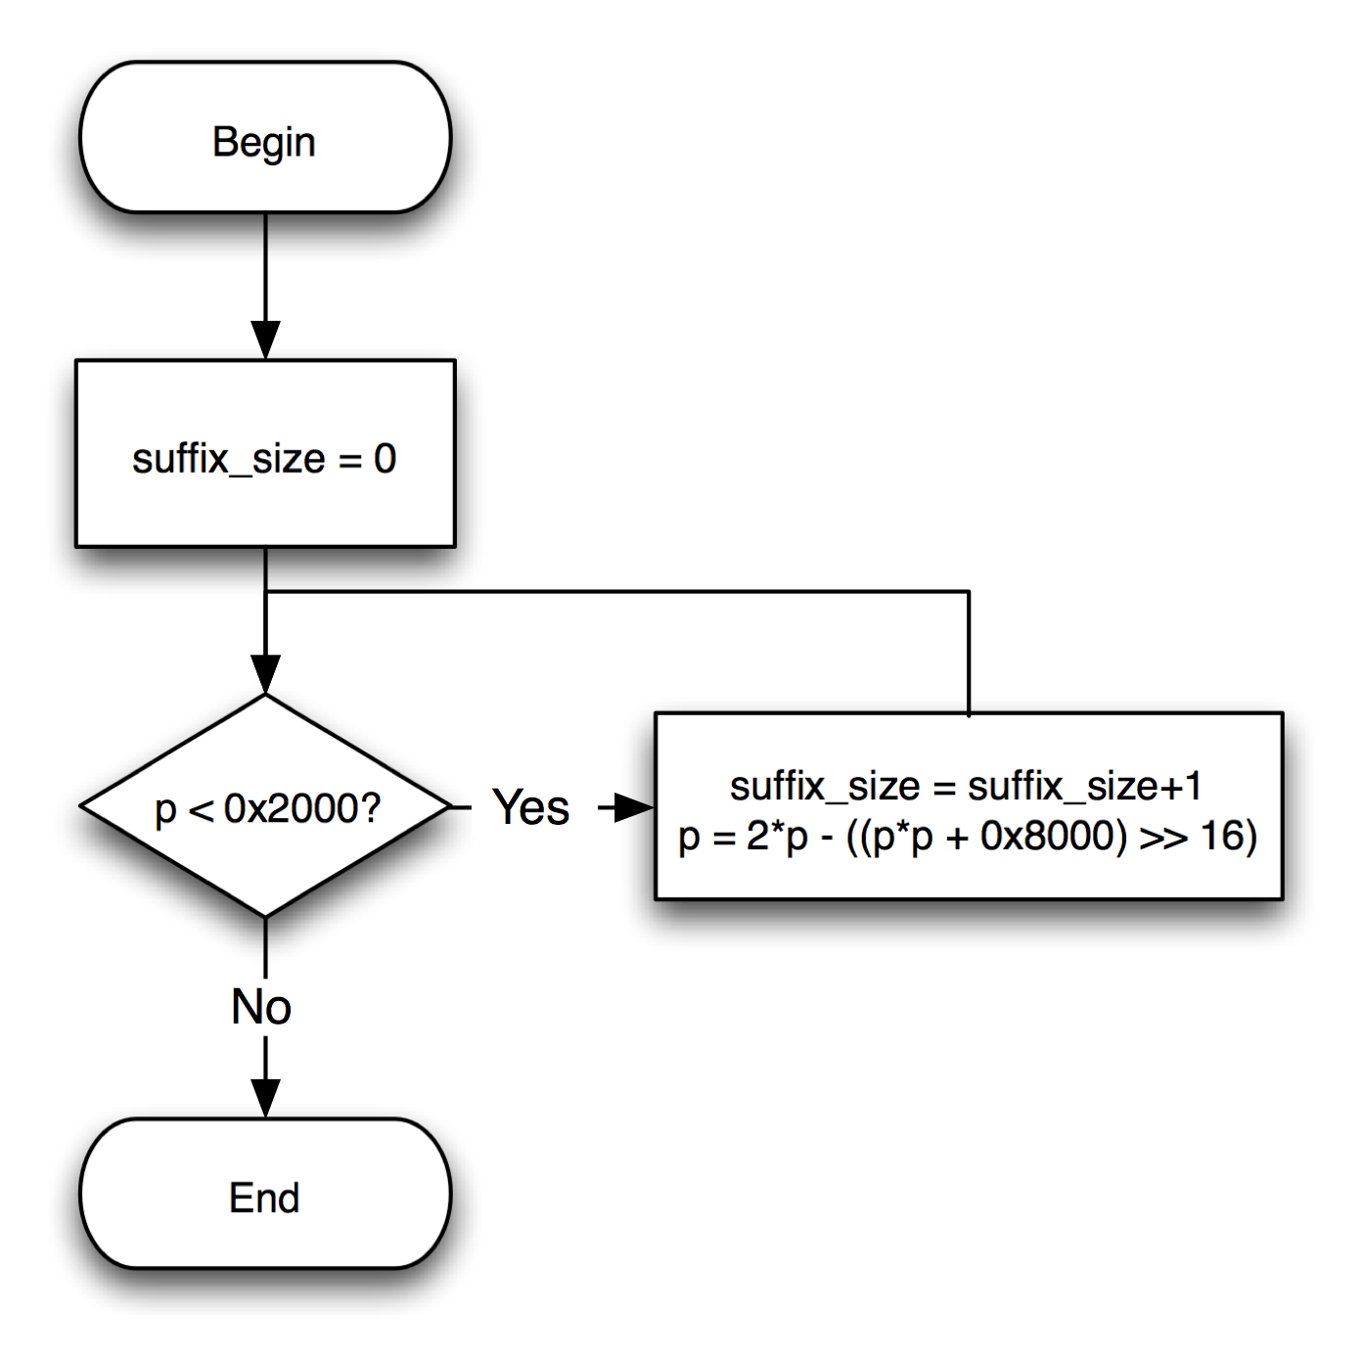
Figure 17: Initialization of suffix_size
Rationale:
The use of a variable size suffix has two goals: maximize coding efficiency and limit the number of arithmetic coding operations.

Initialization
The arithmetic coding core engine uses several internal registers: R, L, and bits_outstanding. Figure 18 describes how these are initialized.

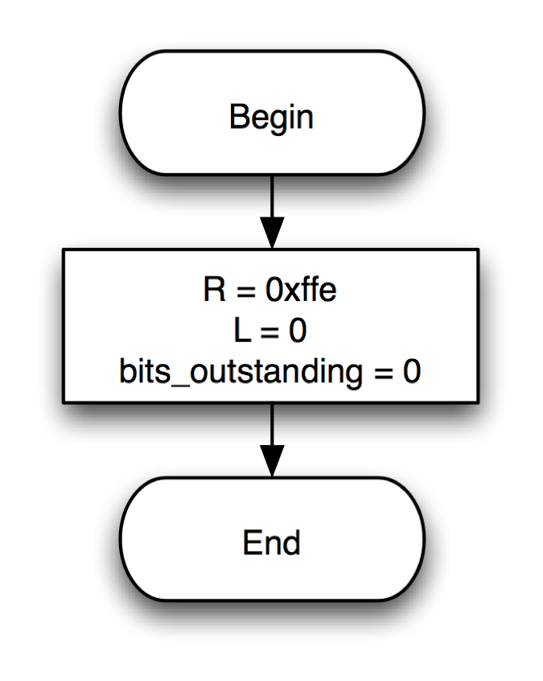
Figure 18: Initialization of the core engine
Rationale/note:
This initialization process is similar to the arithmetic coder used in MPEG-4 AVC / H.264.

Encoding a symbol
This section describes the encoding of a symbol. Three classes of symbols are considered: equiprobable, binary, and unary. Each class has its own encoding method as further described below. Supporting methods for bit outputting, renormalization and probability adaptation are also described.

Outputting a bit
Outputting of a bit may be delayed in an arithmetic encoder because of potential carry propagation. When called, the bit outputting method may thus write one or more bits into the bitstream, as determined by the bits_outstanding variable. Figure 19 describes the method.
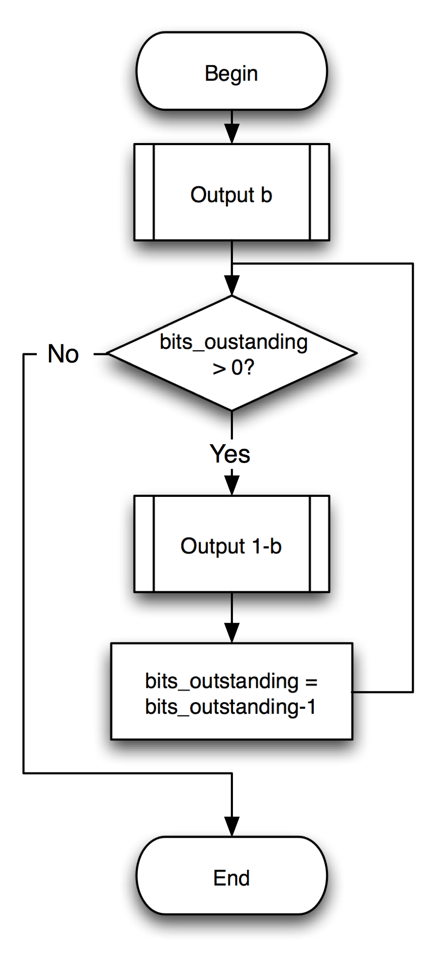
Figure 19: Function for outputting a bit
Rationale/note:
MPEG-4 AVC / H.264 uses a similar method to address the carry propagation issue.

Renormalization
Renormalization is the process by which the arithmetic encoder determines how many bits to output and what their values should be. Figure 20 describes the method.
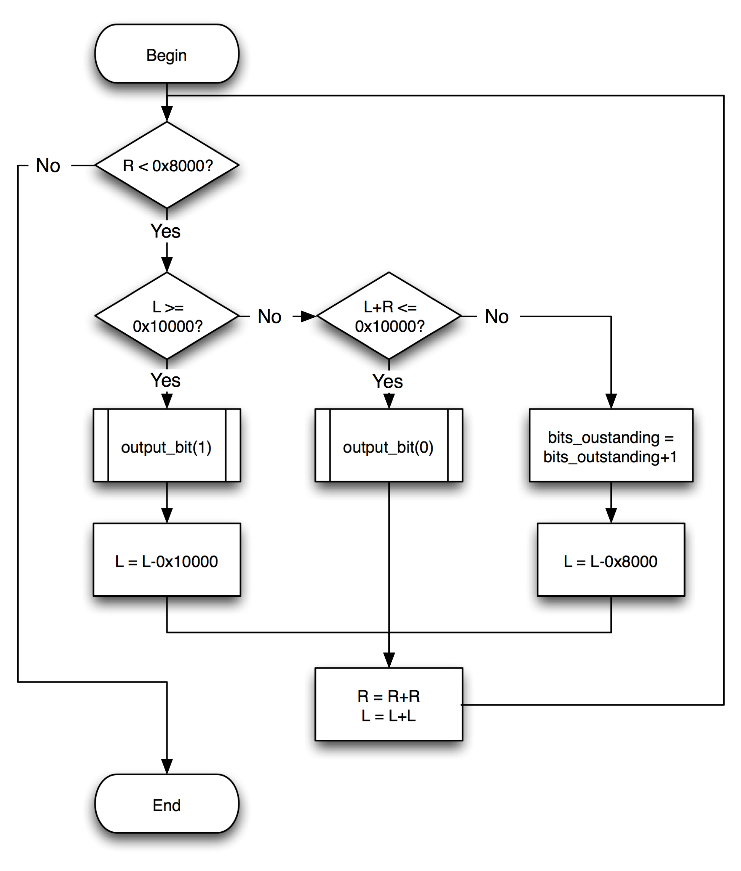
Figure 20: Function for renormalizing
Rationale/note:
MPEG-4 AVC / H.264 uses a similar renormalization procedure.

Probability estimate update
After encoding a symbol, probabilities may be updated according to the value of the coded symbol. In the present case a simple method based on exponential decay memory is used. Figure 21 describes the method. Parameter δ stabilizes the arithmetic coder avoiding highly skewed probabilities.
Figure 21: Probability update
Rationale:
This adaptation procedure is based on the same principles as the one used in MPEG-4 AVC / H.264. However it does not require any look-up table and relies on simple mathematical operations.

Suffix size update
When adapting the probability associated with a unary symbol, the size of the suffix may be adapted as well. When the probability becomes too low, the suffix size is increased, and when the probability becomes too high, the suffix size is decreased (if nonzero). Figure 22 describes the method.

Figure 22: Suffix size update

Binary equiprobable symbol
An equiprobable symbol is a symbol that has equal probability (50%) of having value 0 or 1. This encoding method typically used for encoding sign values. It is a simplification of the generic binary symbol encoding method. Figure 23 describes the method.
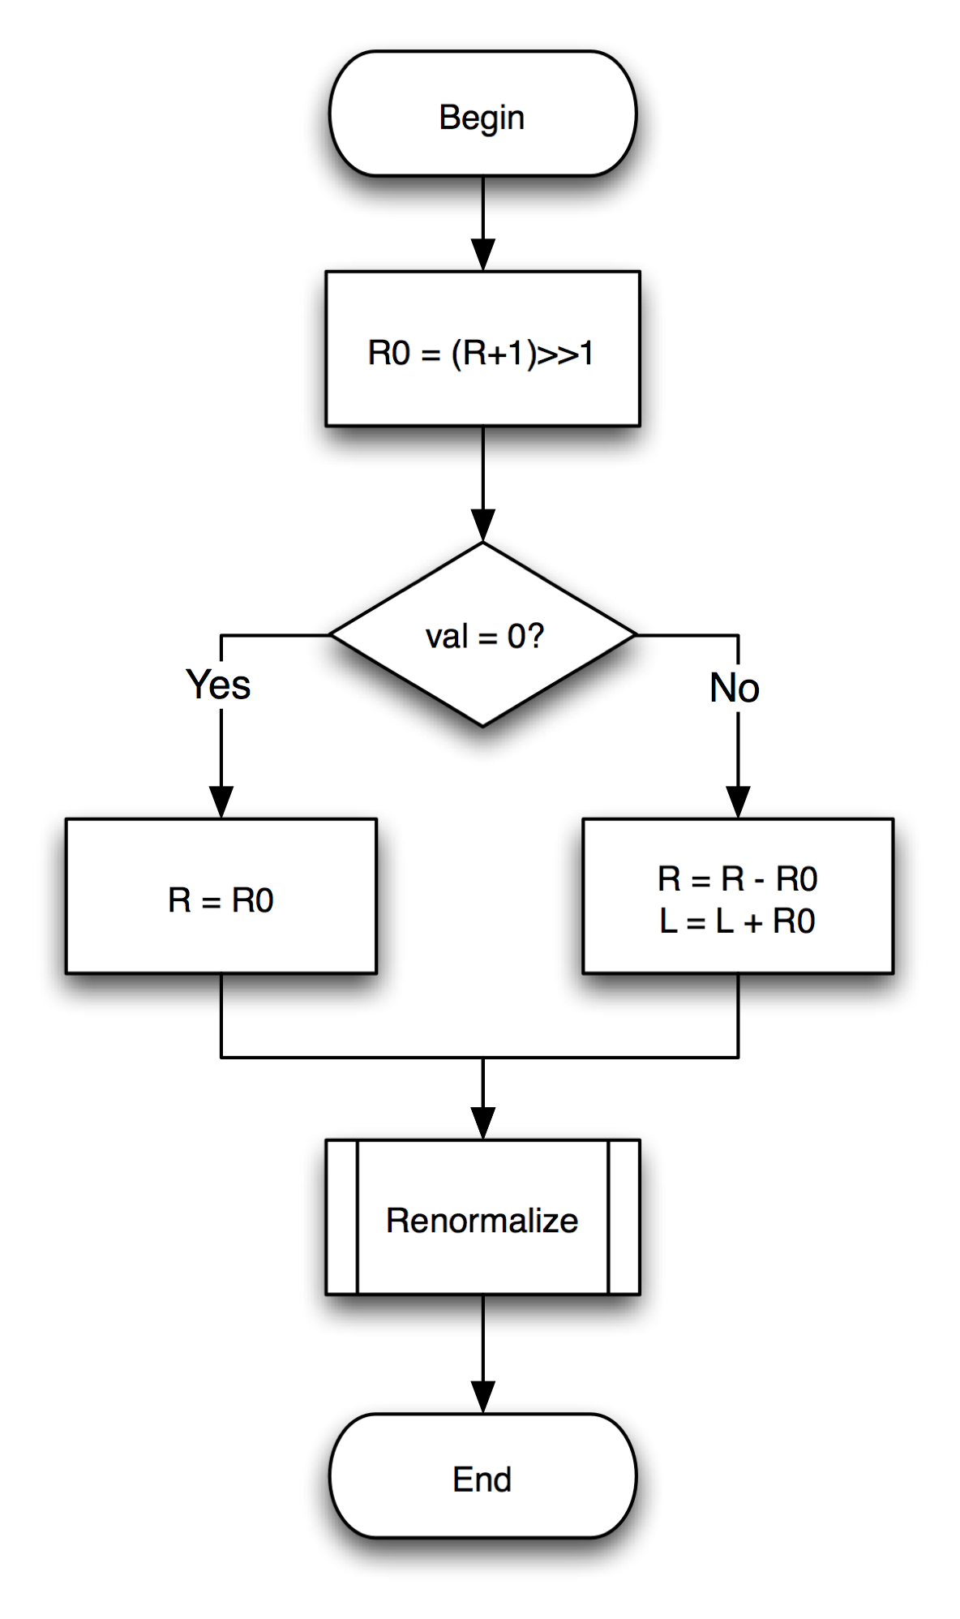
Figure 23: Encoding an equiprobable symbol
Rationale/note:
This method is similar to the one used in MPEG-4 AVC / H.264.

Binary symbol
Encoding a generic binary symbol essentially consists of four steps: computing a range for the symbol 0, adjusting registers, renormalizing, and adapting the probability. Figure 24 describes the method.
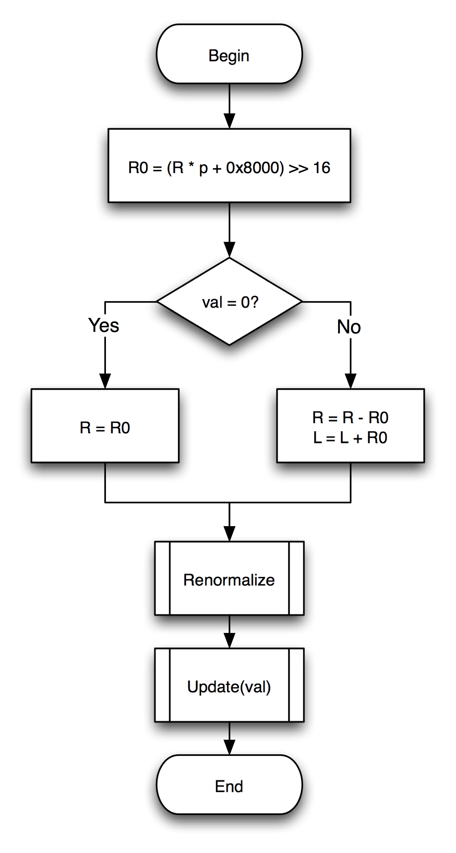
Figure 24: Encoding a binary symbol
Rationale/note:
This method is similar to the one used in MPEG-4 AVC / H.264. However the range computation uses a multiplication operation instead of a table look-up.

Unary symbol
Encoding a unary symbol comprises the steps on encoding a prefix and encoding a suffix. The encoding of the prefix uses the generic binary symbol encoding method while encoding the suffix uses the equiprobable symbol encoding method. Figure 25 describes the method.
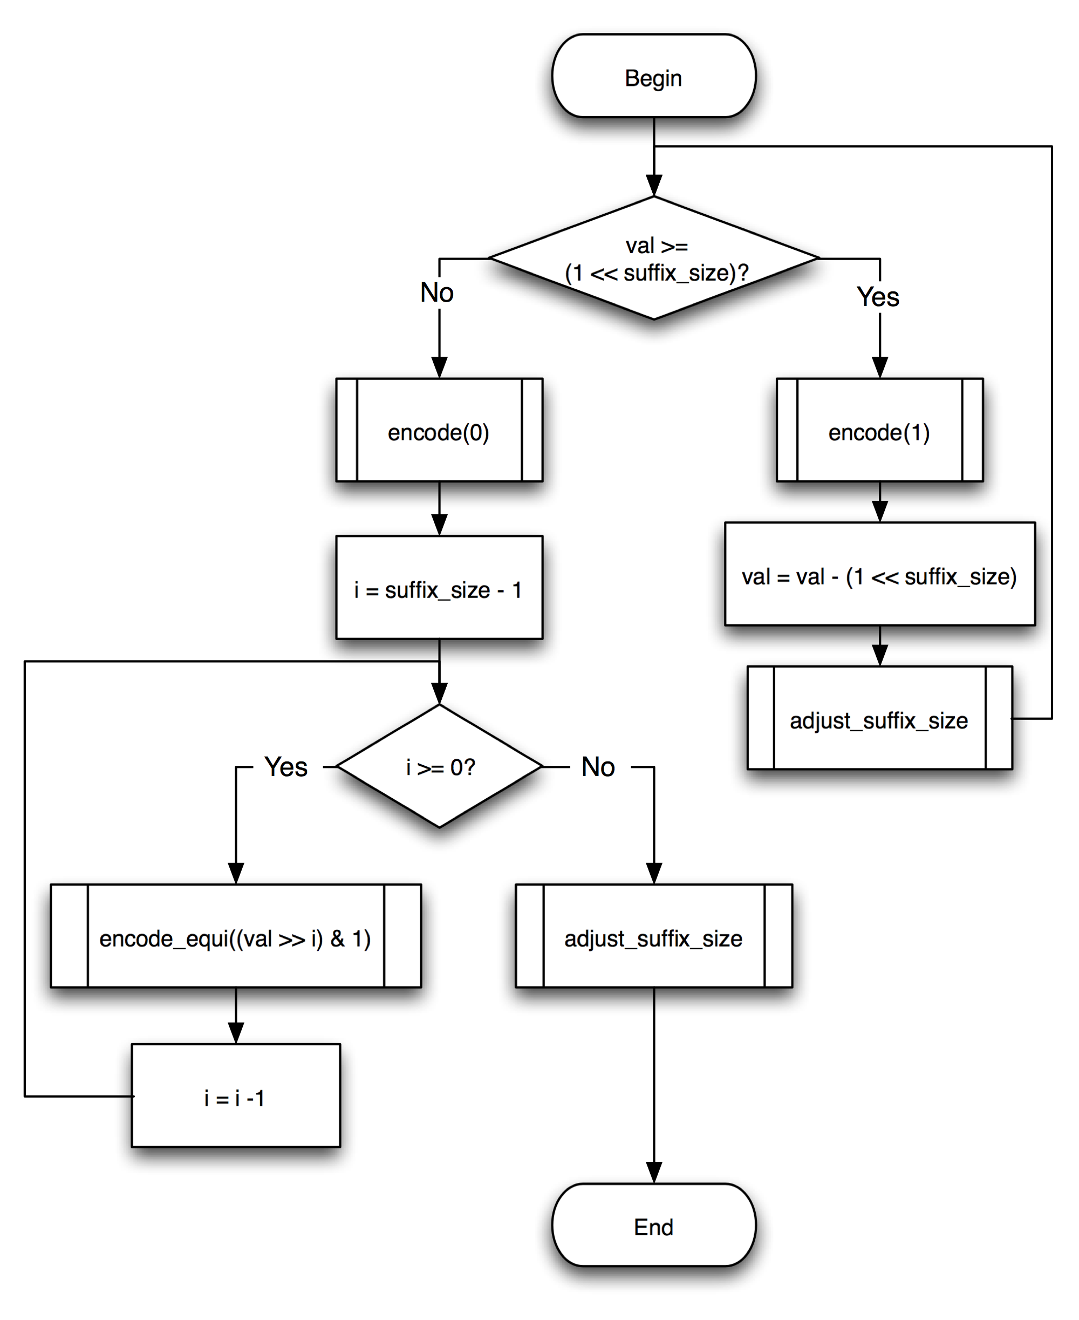
Figure 25: Encoding a unary symbol
Rationale/note:
This method for encoding unary symbol tries to maximize coding efficiency while limiting the number of arithmetic encoder operations in an encoder.

Termination of core engine
The core engine needs to be terminated such as to enable a decoder to properly reconstruct all symbols. Figure 26 describes the method.
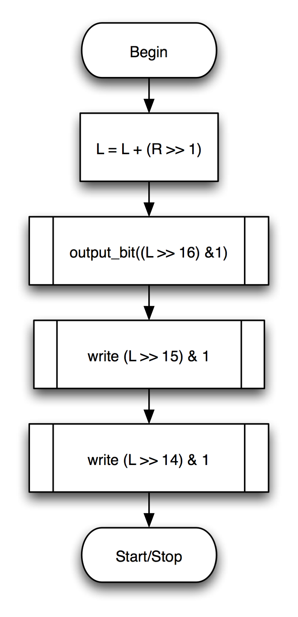
Figure 26: Termination
Rationale/note:
This termination procedure is similar to the one used in most arithmetic encoders.

Loop filter

Non-linear denoising filter
The process for the non-linear denoising is identical in both encoder and decoder. The effect of the non-linear denoising is not taken into account in any of the encoder optimizations. The method of non-linear denoising filter is described in [1].

Adaptive denoising filter
The parameters for the adaptive denoising are estimated in the encoder and transmitted to the decoder. The adaptive denoising process is performed in the internal decoder of the encoder and in the decoder in an identical way.
The coefficients of the adaptive denoising filter and their precision are estimated by minimization of the mean squared reconstruction error, see e.g. [4]. The size of the adaptive denoising filter is estimated by minimization of the Lagrangian costs of overall data rate $R$ and mean squared reconstruction error $D$:

$$R⋅λ_{\text{mod}e}+D→\text{min}$$

As Lagrangian multiplier, $λ_{\text{mod}e}$is used.
It is applied within the prediction loop.

Deblocking filter
The deblocking process is performed requiring no specific encoding strategy.

Decoder Refresh
For video encoding with multiple reference frames, the encoder and decoder must have the same deterministic set of reference frame buffers. This allows better error resilience and capability of a play-back application to do random access. CDCM defines an Instantaneous Decoder Refresh (IDR) frame in order to provide random access and prevent error propagation.

An IDR frame is an INTRA frame which also signals an initialization of the reference frame buffer and other necessary state in the decoder. Hence frames following the IDR frame have no correlation with the preceding frames, allowing random access from the location of the IDR frame and stops error propagation.

However, reference frame buffers are purged immediately when an IDR is received. This may not be desirable during sequential play as frames following the IDR frame may B frames which is to be displayed before the IDR frames. These frames can be coded more efficiently with more reference frames. Hence the Deferred Decoder Refresh (DDR) frame is introduced, which instruct the decoder to only purge the reference frames when a frame later then the DDR frame is to be processed. DDR still retains random access capability and error resilience while improving video coding efficiency for sequential play.

The following illustrates the use of IDR and DDR:

References
- JCTVC-A114-Annex A “CDCM Video Codec: Decoder Specification”
- G. Sullivan, “Adaptive quantization encoding technique using an equal expected-value rule”, JVT-N011, January 2005
- S. Wittmann, T. Wedi “Separable adaptive interpolation filter for video coding”, Proc. ICIP2008, IEEE International Conference on Image Processing, San Diego, California, USA, October 2008
- S. Wittmann, T. Wedi, "Transmission of Post-Filter Hints for Video Coding Schemes", Proc. Of IEEE International Conference on Image Processing (ICIP 2007), San Antonio, Texas, USA, September 2007

