    Joint Collaborative Team on Video Coding (JCT-VC)  of ITU-T SG16 WP3 and ISO/IEC JTC1/SC29/WG11  1st Meeting: Dresden, DE, 15-23 April, 2010 | Document: JCTVC-A111

Title: | Description of video coding technology proposal by Huawei Technologies & Hisilicon Technologies
Status: | Input Document to JCT-VC
Purpose: | Proposal
Author(s) or  Contact(s): | Haitao Yang, Jiali Fu, Sixin Lin, Jin Song,  Dong Wang, Mingyuan Yang,  Jiantong Zhou, Haoping Yu  Huawei Technologies Co., Ltd.  Section B1, Huawei Industrial Base,  Bantian Longgang Shenzhen, China  Changcai Lai, Yongbin Lin, Lingzhi Liu,  Jianhua Zheng, Xiaozhen Zheng  Hisilicon Technologies Co., Ltd.  Section B2, Huawei Industrial Base,  Bantian Longgang Shenzhen, China | Tel:  Email: | +86 755 28789935  haitaoyang@huawei.com  haopingyu@huawei.com  +86 755 28422062  xiaozhenzheng@hisilicon.com
Source: | Huawei Technologies Co., Ltd. & Hisilicon Technologies Co., Ltd.
_____________________________

Abstract
In response to the Joint Call for Proposal (CfP) on Video Compression Technology, Huawei Technologies together with Hisilicon Technologies proposes a new video codec to JCT-VC for evaluation. This document describes the proposed codec in details, which includes descriptions of the new coding algorithms and their implementations, discussions of the coding performance in terms of subjective and objective quality compared with the JCT-VC CfP anchors, and complexity evaluation and analysis of these new tools.

Contents
Abstract 1
Contents 2
1 Introduction 3
2 Algorithm description 3
2.1 Motion representation 4
2.1.1 Template based motion derivation 4
2.1.2 Flexible macroblock partition 6
2.2 Intra-frame prediction 7
2.2.1 Resample-based intra prediction 7
2.2.2 Line based intra prediction 8
2.3 Inter-frame residual prediction 9
2.3.1 Inter DC offset 9
2.3.2 Second order prediction 9
2.4 Spatial transforms 10
2.4.1 Rate-distortion optimized transform for intra-prediction residual 10
2.4.2 Directional transform for inter-prediction residual 11
2.5 Quantization 11
3 Compression performance discussion 12
3.1 Objective versus subjective compression performance 12
3.2 Constraint set 1 configuration relative to Alpha anchor 13
3.2.1 Class A 13
3.2.2 Class B 13
3.2.3 Class C 13
3.2.4 Class D 13
3.2.5 Overall 14
3.3 Constraint set 2 configuration relative to Beta and Gamma anchors 14
3.3.1 Class B 14
3.3.2 Class C 14
3.3.3 Class D 15
3.3.4 Class E 15
3.3.5 Overall 15
4 Complexity analysis 15
4.1 Encoding time and measurement methodology 15
4.2 Decoding time and measurement methodology and comparison vs. anchor bitstreams decoded by JM 17.0 16
4.3 Description of computing platform used to determine encoding and decoding times reported in sections 4.1 and 4.2 16
4.4 Expected memory usage of encoder 17
4.5 Expected memory usage of decoder 17
4.6 Complexity characteristics of encoder motion estimation and motion segmentation selection 18
4.7 Complexity characteristics of decoder motion compensation 18
4.8 Complexity characteristics of encoder intra-frame prediction type selection 18
4.9 Complexity characteristics of decoder intra-frame prediction operation 18
4.10 Complexity characteristics of encoder inter residual prediction and prediction type selection 19
4.11 Complexity characteristics of decoder inter residual prediction 19
4.12 Complexity characteristics of encoder transforms and transform type selection 19
4.13 Complexity characteristics of decoder inverse transform operation 19
4.14 Complexity characteristics of encoder quantization and quantization type selection 19
4.15 Complexity characteristics of decoder inverse quantization 19
5 Algorithmic characteristics 20
5.1 Random access characteristics 20
5.2 Delay characteristics 20
6 Software implementation description 20
7 Closing remarks 20
8 References 21
9 Patent rights declaration(s) 21
10 Appendix: snapshots for comparison of subjective quality 22

Introduction
The existing state-of-the-art video coding standard is MPEG4-AVC/H.264, which was jointly developed by Motion Picture Expert Group (MPEG) and Video Coding Expert Group (VCEG). The original version of this standard was published in 2003 [1][2], and since then the standard has been revised many times and been widely used in many applications such as digital video broadcast, digital cinema, digital entertainment, video conference, surveillance, etc..

In recent years, applications based on high quality video have emerged. In comparison with the popular YUV420 formats such as CIF at 15 fps or SD at 30fps, the high quality video is characterized by higher temporal and spatial resolution (e.g. 60fps, HD or 4Kx2K with 4:4:4 color sampling) and greater pixel dynamic range (e.g. 10bits/sample). As the data volume of high quality video exceeds the capacity of the current network or storage medium, a new video coding standard with better compression efficiency is needed for delivering high quality video services over the current communication networks and storage media [3]. To develop such a new video coding standard, ISO/IEC JTC1/SC29/WG11 and ITU-T SG16 WP3 have established Joint Collaborative Team on Video Coding (JCT-VC), and issued the Call for Proposal [4].

As a response to the call for proposal, this document proposes a video codec and describes the following new coding tools as well as their implementations in Section 2:
- Template based motion derivation
- Flexible macroblock partition for inter-frame prediction
- Resample-based intra prediction
- Line based intra prediction
- Inter-frame DC offset
- Second order prediction for inter-prediction residual
- Rate-distortion optimized transform for intra-prediction residual
- Directional transform for inter-prediction residual
- Adaptive frequency weighting quantization

The coding performance in terms of subjective and objective quality is presented and discussed in Section 3. Complexity evaluation and analysis are provided in Section 4.

The proposed codec is based on the KTA2.6r1 software. KTA2.6r1 was developed from the MPEG4-AVC/H.264 reference software JM11.0, with additional coding tools such as adaptive loop filter, adaptive interpolation filter, mode dependent direction transform, etc.. The software implementation details can be found in Section 6.

Algorithm description
Since the proposed codec is developed from the MPEG4-AVC/H.264 conformant software, the same notations as specified in MPEG4-AVC/H.264 standard are used hereinafter to describe the proposed video coding algorithms. Unless otherwise specified, the implementation is the same as KTA2.6r1. It should be noted that though large macroblock segmentation is implemented in KTA 2.6r1, it is switched off in the proposed codec. Therefore by macroblock (MB) we mean 16x16 blocks in the following description.

Motion representation

Template based motion derivation
Using MPEG4-AVC/H.264 for video coding, motion information comprises a considerable portion of the compressed bitstream. Especially for low bit rate and high resolution video sequences, more than 50% of the bitstream is motion information. To save bits for coding motion information, a template based motion derivation (TBMD) method is proposed, which derives the motion information at the decoder in the same way as at the encoder. Thus no motion information needs to be written into the bitstream. To make TBMD suitable for practical applications, candidate based template matching is employed.

TBMD is also incorporated into MPEG4-AVC/H.264 B direct mode as an improvement. Since both spatial and temporal candidates are used for the template matching, the TBMD for B direct mode is also called spatial-temporal direct mode (STDM).

TBMD for non-direct coding modes
Currently, TBMD is integrated into coding modes P16x16, P16x8, P8x16, P8x8, B16x16, B16x8, and B8x16. For P16x16, P16x8, P8x16 and P8x8, only a flag is used to indicate whether the current motion partition uses TBMD. For B16x16, B16x8, and B8x16, additional side information, i.e., the selection of the prediction direction needs to be coded in the same way as in MPEG4-AVC/H.264 standard. MB-level rate-distortion (RD) evaluation is performed to decide whether TBMD mode is used. The motion vectors and the selection of the reference pictures are derived as described below.

- Template composition
As illustrated in Fig. 1, an L-shaped symmetric region around the upper-left corner of the target block is selected as the template. The size of the template is denoted by W, which is set to 4 in the current implementation as a tradeoff between performance and complexity.

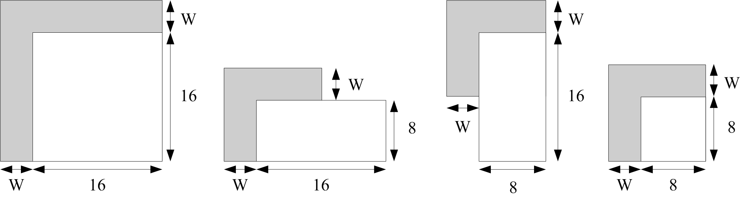
Fig. 1 Template composition for block partitions with different size

A certain region inside the template for a motion partition may not be available before the reconstruction of other motion partitions in the same macroblock, as an example shown in Fig. 2. In such a case, the prediction signal instead of the reconstructed signal of that region is used to compose the template. In this way, the motion partition can perform TBMD process without the reconstructed signal of the other motion partitions in the same MB.

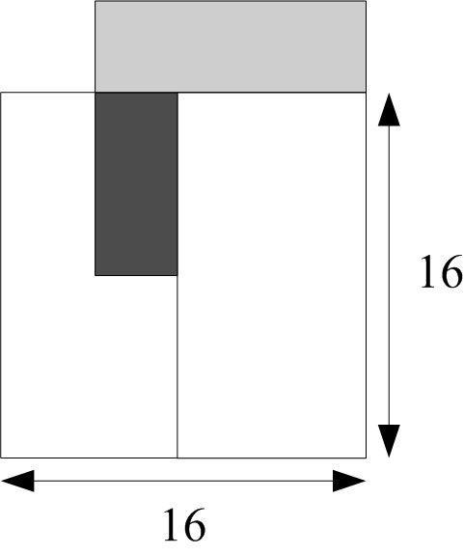
Fig. 2 Template composition when a part of the template is not available

- Candidate based template matching
Some existing template based motion vector derivation methods perform template matching within a search region in the reference frame. The motion vector (in case of unidirectional prediction) or motion vector pair (in case of bidirectional prediction) that yields the minimum matching error is selected. The matching error is measured by the sum of absolute difference (SAD). However, the complexity is too high for practical applications. To reduce the complexity, a motion vector candidate set with only two motion vectors is composed and is used for template matching. To maximize the dissimilarity between the two motion vector candidates, the left block A and the upper-right block B are selected as the two candidates as illustrated in Fig. 3. In case block B does not exist, block B’ is used instead, which is similar to the motion vector prediction process specified in MPEG4-AVC/H.264 standard.

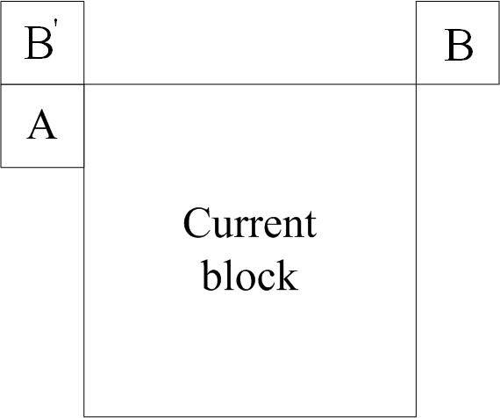
Fig. 3 Composition of candidate motion vector set

- Multiple reference pictures and multi-hypothesis prediction
By scaling the two (pairs of) motion vectors in the candidate set according to the temporal distance of the current frame and each reference frame (pair), two (pairs of) motion vectors pointing to each reference frame (pair) can be derived. Consequently, the new candidate set with 2N (pairs of) motion vectors is composed, where N is the number of reference frames. For blocks in P frames, template matching is applied to find two optimal motion vectors out of the new candidate set, and then multi-hypothesis prediction is performed. For blocks in B frames, the optimal motion vector pair is found out, and bidirectional prediction specified in MPEG4-AVC/H.264 standard is performed.

Spatial-temporal direct mode
STDM is proposed to replace existing B_SKIP, B_DIRECT_16x16 and B_DIRECT_8x8 modes, thus no additional side information is added in the MB level. A flag is written into the slice header to indicate whether STDM is used. The motion vectors of B_SKIP and B_DIRECT_16x16 modes are derived by applying the STDM procedure described below. The motion vectors for B_DIRECT_8x8 mode are the motion vectors derived for the macroblock containing the 8x8 block.

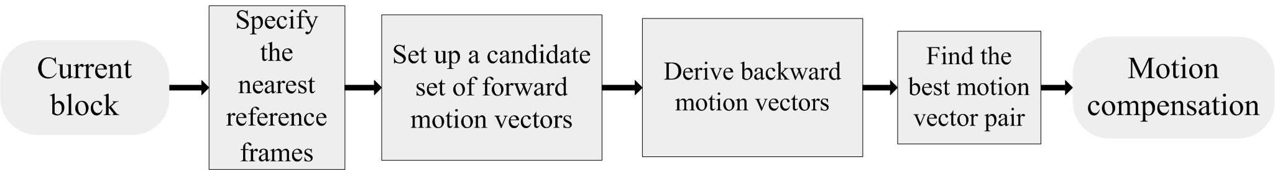
Fig. 4 Procedures of STDM

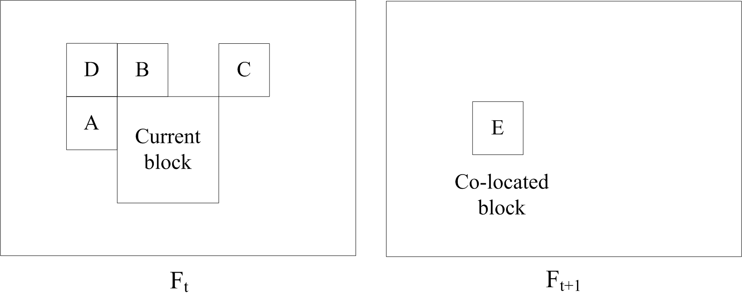
Fig. 5 Spatial-temporal neighboring blocks used for deriving candidate motion vectors

The procedure of STDM is shown in Fig. 4. Firstly, for the current MB, the nearest reference frame in List0 and List1 are denoted as forward and backward reference frame. Then the motion vector candidate set is set up, which consists of four spatial and one temporal motion vectors of neighboring blocks as shown in Fig. 5. The forward motion vectors of the four spatial neighboring blocks are scaled to get the corresponding backward motion vectors. The forward motion vector of the co-located block is scaled to get both the forward motion vector and the backward motion vector. Thus a set of motion vector pairs can be obtained. Be noted that the scaling is based on the assumption that the velocity of moving objects is constant, and it is performed according the temporal distance of the current frame and its forward and backward reference frame. According to each pair of motion vectors, the two reference blocks and the two templates around these two reference blocks as well as the template around the current coding block are obtained and are used to calculate the cost function in (1). Among all motion vector pairs, the one that minimize the cost function is selected as the motion vectors of the current block.
(1)
In equation (1), calculates the sum of absolute difference of two blocks and , and are the corresponding reference blocks in the forward and the backward reference frames, respectively. , and are the templates around , and the current coding block, respectively. The weighting factor is set to 1 in the current implementation.

Flexible macroblock partition
In natural images, the boundary separating two moving objects may be along any direction. Conventional quad-tree structured representation of motion partitions can not deal with this situation efficiently. To solve the problem, a flexible macroblock partition (FMP) method is proposed.

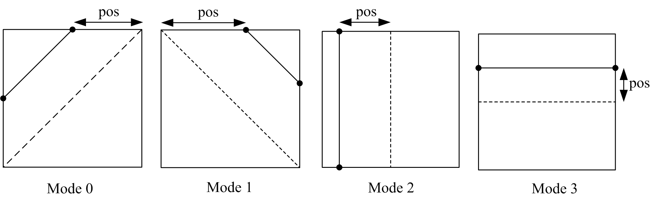
Fig. 6 Four FMP mode

The FMP algorithm contains four motion partition modes as illustrated in Fig. 6, each mode dividing the macroblock into two irregular regions. Different from regular motion partition modes specified in MPEG4-AVC/H.264, the two regions can be two non-rectangular blocks in mode 0 and 1, or two rectangles with different size in mode 2 and 3. In each mode, a parameter is used to indicate the position of the partition boundary. For Mode 2 and 3, can not be 0. The precision of the position parameter is 4-pel for mode 0 and 1, and is 2-pel for mode 2 and 3.

Currently, the four FMP modes are implemented for P frames. To be compatible with the quad-tree structure used in MPEG4-AVC/H.264, FMP reuses the MB type of P16x16, P16x8, and P8x16 to identify the FMP modes. To indicate the usage of FMP mode 0 and 1, P16x16 mode is reused. Specifically, a flag is used to specify whether the FMP mode 0 and 1 are used, and another flag is used to distinguish the two modes. The P8x16 and P16x8 modes are reused to indicate the usage of the FMP mode 2 and 3, respectively. In this case, only one flag is used to indicate whether these two modes are used. The four FMP modes compete with other inter-modes, the one with minimum RD cost is selected as the inter prediction for the coding macroblock. The position parameter of a block with FMP mode is predictive coded. If the left and above blocks use the same FMP mode as the current block, the position parameters of the two neighboring blocks are used to form the predictor for that of the current block. The motion vector prediction scheme specified in MPEG4-AVC/H.264 standard is modified to accommodate the four FMP modes [8]. Following residual coding process is not changed in the current implementation.

Detailed information can be found in [8].

Intra-frame prediction

Resample-based intra prediction
A resample-based intra prediction (RIP) technique is proposed for intra-frame coding, which aims to improve coding efficiency by taking full advantage of the correlation of pixels instead of blocks. Combined with hierarchical decomposition, three RIP modes in all are proposed as illustrated in Fig. 7, of which one uses one-level decomposition and the others use two-level decomposition. These three new modes as well as the traditional intra MB modes are employed for intra coding. The finally selected MB mode is determined through RD optimization (RDO) at the MB level. Two flags, use_RIP_flag and hierarchical_structure_flag, are combined with original transform_size_8x8_flag to indicate the selection of the intra coding modes.

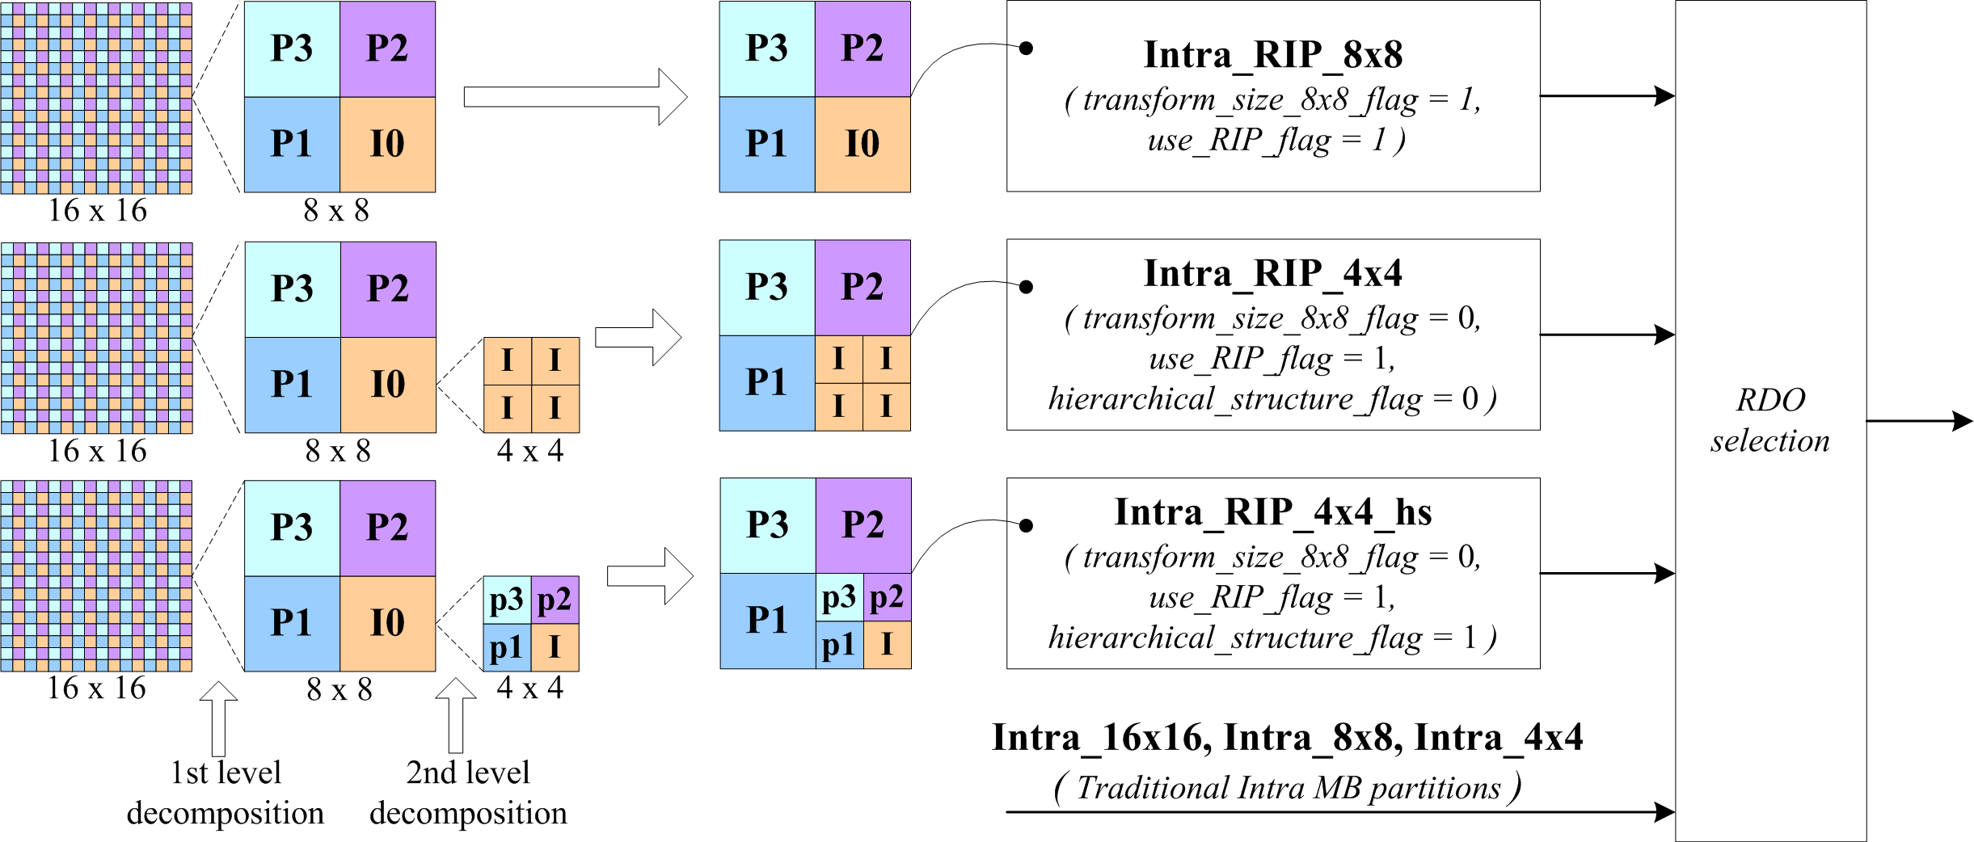
Fig. 7 Block diagram of the proposed resample-based intra prediction technique

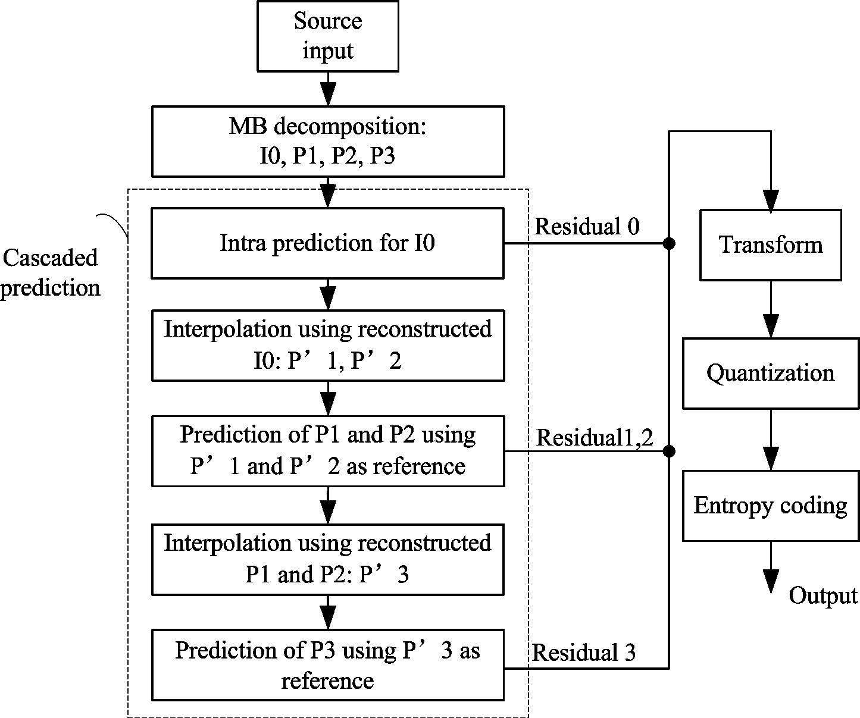
Fig. 8 Procedure of the proposed resample-based intra prediction

Taking the Intra_RIP_8x8 mode as an example, the block diagram of the proposed RIP algorithm is illustrated in Fig. 8. Dyadic decimation is performed to decompose the original MB into four sub-blocks I0, P1, P2, and P3 as shown in Fig. 8. The reference pixels for the current MB is decimated in the same way to obtain the reference pixels for I0, and then I0 is intra predictive coded as the traditional intra 8x8 prediction mode specified in MPEG4-AVC/H.264 standard. Applying the 4-tap interpolation filter [-1, 5, 5, -1] to the reconstructed I0 vertically and horizontally as illustrated in Fig. 9, the interpolated block P’1 and P’2 are obtained as the prediction of P1 and P2. Then P1 and P2 are predictive coded. To get the prediction P’3 for block P3, the value of each pixel in P’3 is calculated using its four neighboring pixels which come from the reconstructed P2 and P3 as illustrated in Fig. 9. Then P3 is predictive coded.

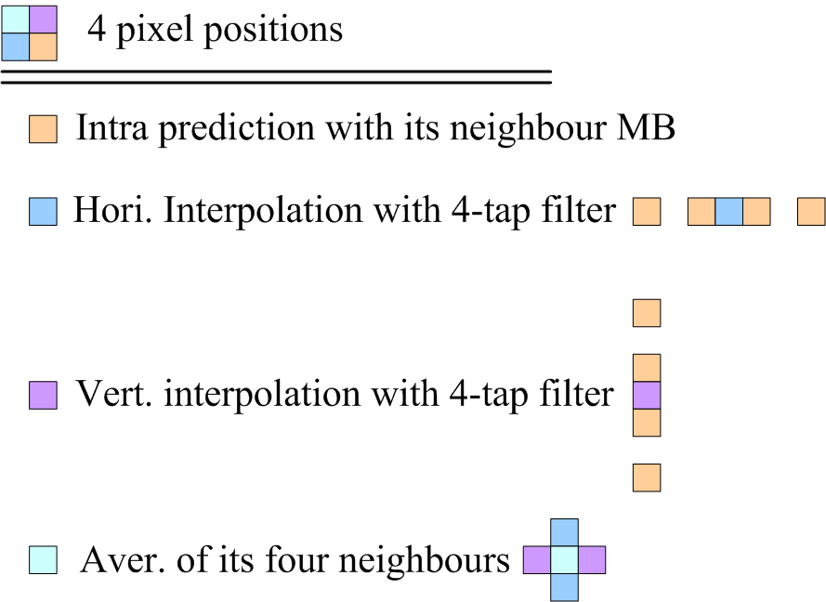
Fig. 9 Prediction for each pixel in sub-block P1, P2, and P3

The same prediction and coding scheme are applied to both the first and the second level decomposed blocks for RIP mode Intra_ RIP_4x4hs. In the second level decomposition of RIP mode Intra_RIP_4x4, I0 is further simply segmented into four sub-blocks, and each sub-block is encoded by applying the intra 4x4 coding mode specified in MPEG4-AVC/H.264 standard. To achieve higher coding performance, the block based QP shift scheme is used to assign smaller QP to the reference blocks. The loop filter inside a MB is disabled if the MB is encoded with RIP modes.

Detailed information can be found in [9].

Line based intra prediction
Intra predictions in MPEG4-AVC/H.264 perform zero-order extrapolation using the adjacent boundary pixels of reconstructed neighboring blocks to get the prediction of the entire coding block. One problem of such an intra prediction design is that the prediction error increases as the distance from the reference pixel to the current prediction pixel increases. To solve the problem, a line based intra prediction (LIP) coding method is proposed.

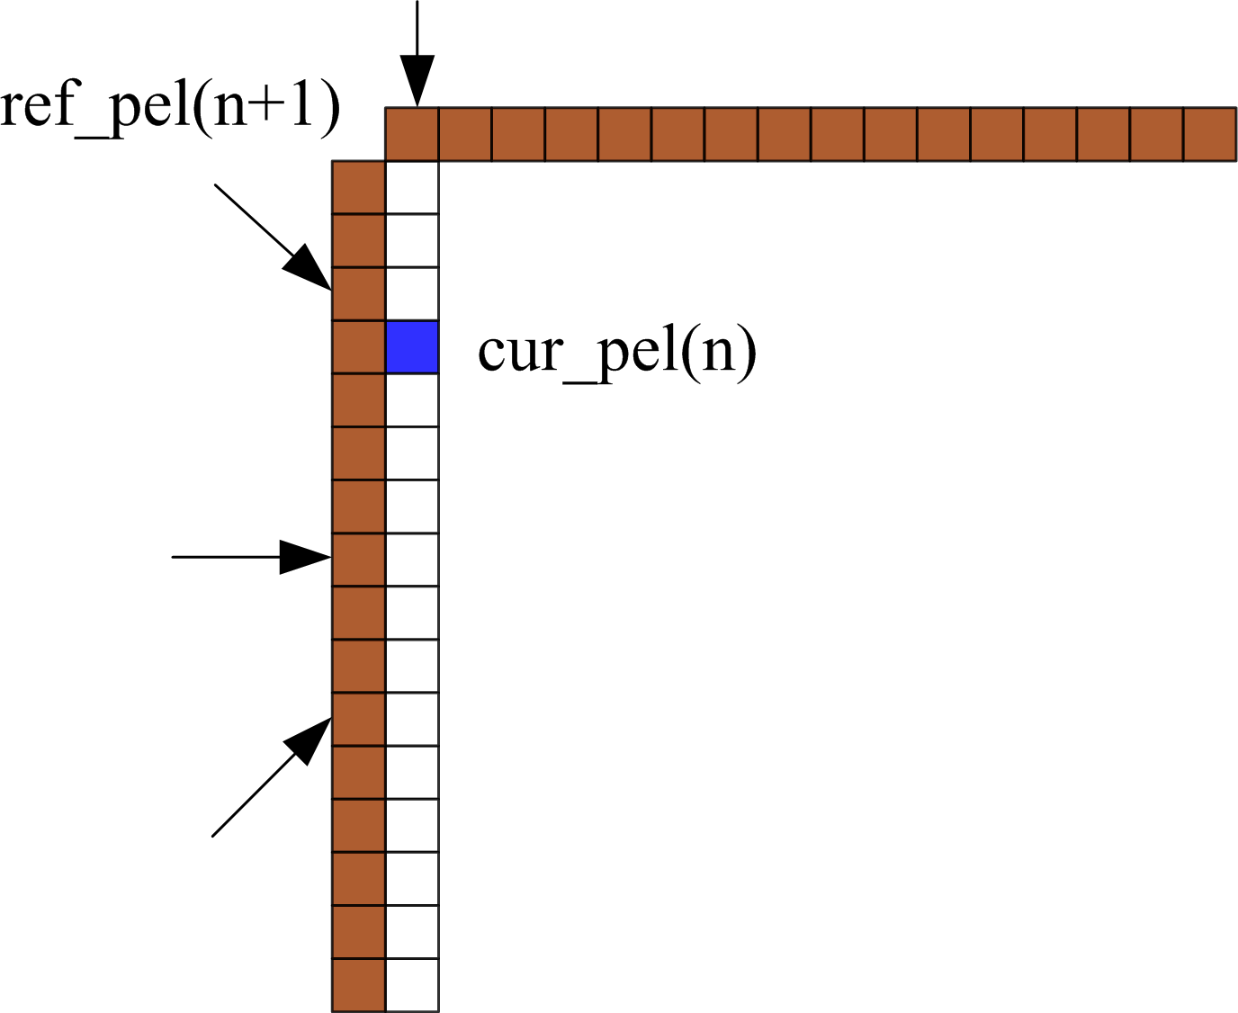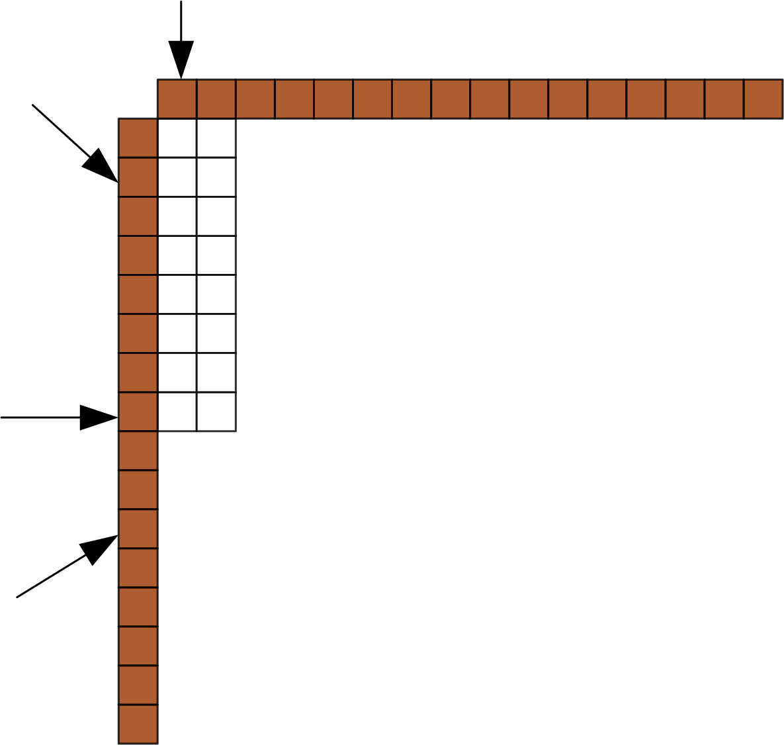
Fig. 10 Directional prediction of the proposed LIP mode 1x16 and mode 2x8

The LIP algorithm consists of 4 modes, i.e., 1x16, 16x1, 2x8 and 8x2 modes. For each intra MB, a flag is used to indicate whether LIP is used. And a symbol is used to specify the selected LIP mode. Mode selection is based on RD evaluation. The LIP mode 16x1 and 8x2 are illustrated in Fig. 10. For each LIP mode, nine directional predictions are performed, and the one with minimum RD cost is selected as the prediction direction. For horizontal and vertical prediction, the prediction is set the value of the reference pixel. For other directions, the reference pixel that lies on the prediction direction and its two neighboring reference pixels are low-pass filtered to get the prediction value. For instance, for the 1x16 mode shown in Fig. 10, the predicted value for the current pixel in the illustrated direction can be calculated as
(2)
where, n is the vertical coordinate that is used to denote a pixel.

According to the LIP mode used, DCT of size 1x16, 16x1, 2x8 or 8x2 is applied. The zigzag scan order is changed accordingly for coefficient blocks of size 8x2 and 2x8. Following quantization and entropy coding scheme are not changed.

Detailed information can be found in [9].

Inter-frame residual prediction

Inter DC offset
In order to estimate the local brightness variation and to compensate it in a more efficient way than the weighted prediction in MPEG4-AVC/H.264, the inter DC offset (IDCO) is proposed. IDCO estimates the DC difference of the current block and its prediction block by calculating the DC difference of the templates surrounding these two blocks. Then the estimated DC offset value is subtracted from the residual signal of current block to get the final residual signal. Currently the IDCO algorithm is only implemented in P16X16 mode, and one flag is added into the MB header to indicate whether it is used. If the RD performance of the IDCO mode is higher than other MB modes, the IDCO mode will be selected. The procedure of IDCO in the encoding and decoding process is shown in Fig. 11.

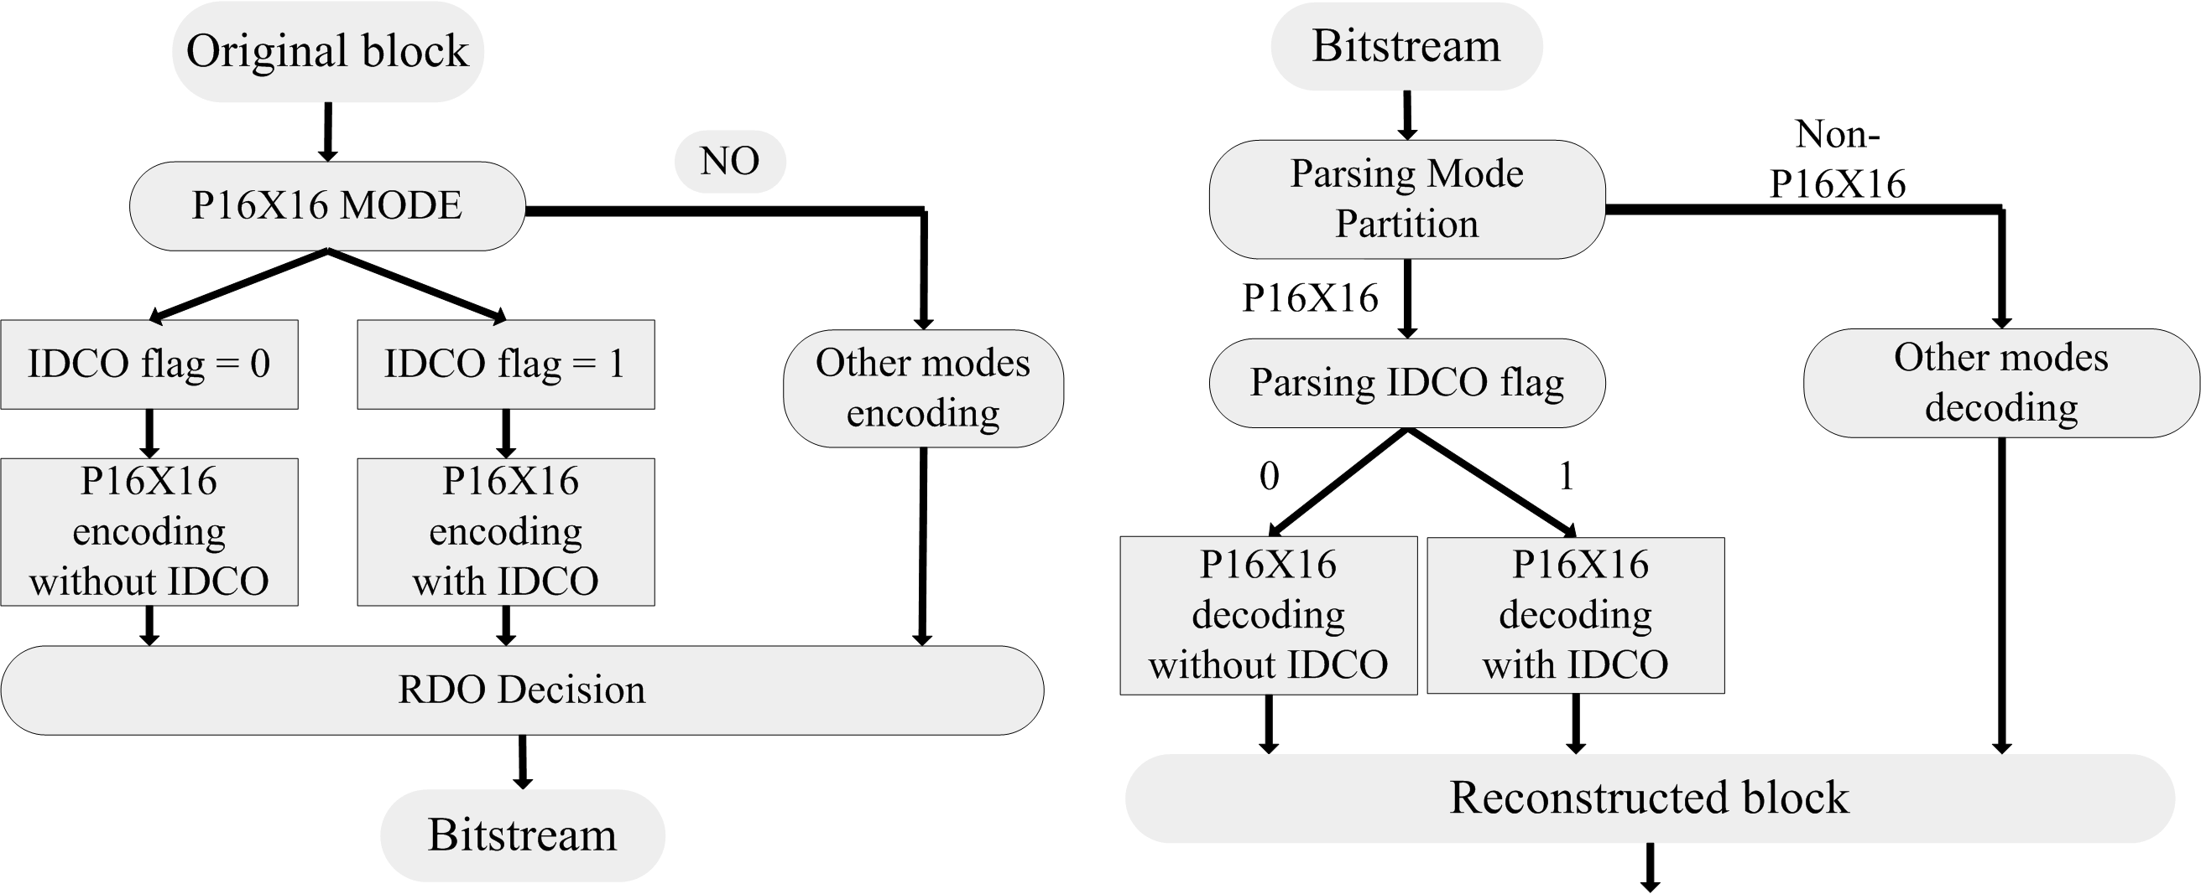
Fig. 11 Encoding and decoding process of IDCO

Second order prediction
Second order prediction (SOP) is used to exploit the redundancy in the residual. Intra prediction modes for 4x4 and 8x8 blocks in MPEG4-AVC/H.264 are applied to get the prediction for the first order residual, which are obtained after motion compensation. Then the prediction is subtracted from the first order residual to get the second order residual, which are the final residual. Accordingly, the block is reconstructed by
(2)
Where, is the reconstructed block, is the first order prediction which is obtained by motion compensation, is the first order residual which is further decomposed into the second order prediction and the second order residual .

To apply the intra prediction in SOP, the value of reference pixels around the current block need to be calculated. The reference pixels around are subtracted from those around the coding block to get the reference pixels for SOP, as illustrated in equation (3).
(3)
Where, is an integer within when , and is an integer within when , and is the motion vector of the current block.

A flag in the MB header is used to indicate the usage of SOP. 4x4 transform and 8x8 transform are applied to the residual of 4x4 prediction and 8x8 prediction, respectively. Therefore, no additional side information other than transform_size_8x8_flag is needed. The Sobel operator is applied to the first order predictor of each block in the current MB to judge the directionality, which is used as the most probable SOP mode. One flag is needed for each block to indicate whether the RDO selected mode is the same as the probable mode. If not, additional 3 bits are used to specify which one in the remaining 8 intra modes is used.

For more details, please refer to [7].

Spatial transforms

Rate-distortion optimized transform for intra-prediction residual
Mode dependant directional transform (MDDT) is proposed in [5] to compress the directional textures reside the in intra-prediction residual. However, it is observed that even for the same intra-prediction mode, the residual usually present different statistical characteristics. Therefore, we propose to use different transforms to the residual obtained by each intra-prediction mode, which is the key difference between MDDT and the proposed technique as illustrated in Fig. 12. Since the final transform matrix pair is selected via rate-distortion optimization, the proposed technique is called RDOT. There are 2 candidate matrices for both column and row transform for I4MB coding mode, 4 candidate matrices for I8MB coding mode, and 8 candidate matrices for I16MB coding mode.

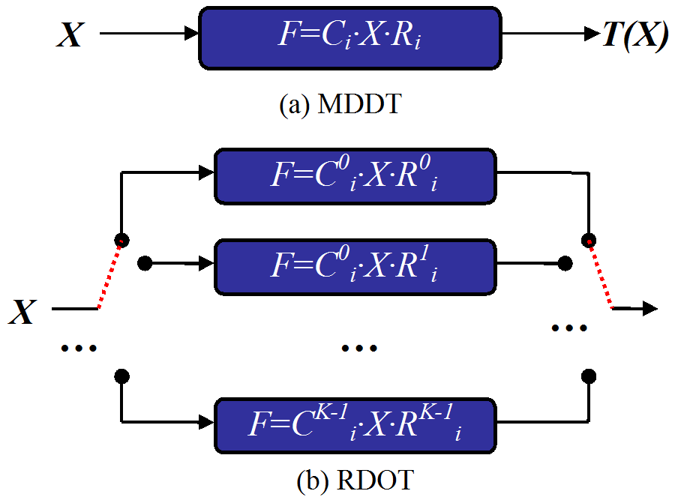
Fig. 12 Key difference between MDDT and the proposed RDOT

The proposed RDOT is applied to all intra-prediction modes in MPEG4-AVC/H.264 standard. A flag is put in the MB header to indicate if RDOT is used. In case RDOT is used, additional bits are used to specify the index of the selected transform matrix for both column and row transform, respectively. For more details, please refer to [6].

Directional transform for inter-prediction residual
Although the intensity of inter-prediction residual is much less than that of intra-prediction residual, it is observed that structured textures still exists in the residual images after motion compensation. It appears as the false edge along object boundaries, and is caused by imperfect motion compensation. The motion compensation can not be perfect since the assumption of rigid and translational motion is not always true. Besides, the motion vector with limited precision and the imperfect interpolation filter also make perfect motion compensation impossible. Therefore, directional transform (DT) is proposed to represent the false edges in a more efficient way than the DCT.

As an initial try on this topic, a set of directional non-separable KLT matrices is used for the transform of 8x8 blocks. The number of the directions is 8. The optimal DT matrix is selected through RD evaluation. The side information, including a flag to indicate the use of DT and a mode index to specify the direction of the selected transform matrix if DT is used, is taken into account of the rate calculation. Since the side information is actually a part of the residual information, it is coded and transmitted to the decoder only if the current block has non-zero coefficients.

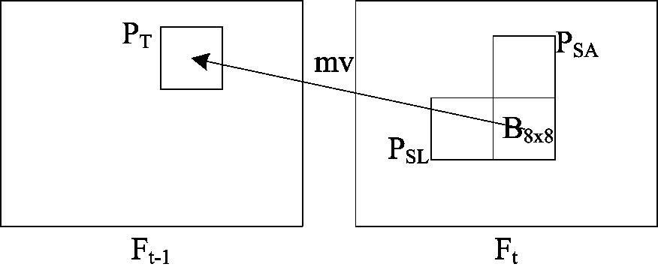
Fig. 13 Spatial-temporal predictors for the direction of current block B_{8x8}

Along with DT, the spatial-temporal predictive coding of the direction information is also proposed. As illustrated in Fig. 13, there are two spatial predictors P_{SA} and P_{SL}, and one temporal predictor P_{T} for the direction information of the current block. Spatial predictor is the mode index of neighboring blocks encoded with DT. Temporal predictor is the texture direction of the prediction block, which is derived based on the normalized block gradient along all directions. The prevailing direction among the three predictors is selected as the predicted direction, and then the cyclic difference between the RDO selected direction and the predicted direction is calculated and coded.

Quantization
Natural images may contain diversified textures, and thus the quantization step for different frequency components should adapt to the local texture characteristics. To achieve the target, an adaptive frequency weighting quantization (AFWQ) technique is proposed.

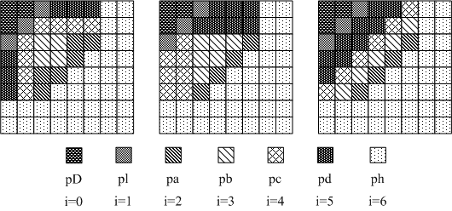
Fig. 14 Three typical 7-parameter frequency band distribution models

Based on the frequency response feature of human visual system, three typical 7-parameter frequency band distribution models are devised as shown in Fig. 14 by taking into consideration of the diversity of textures. Two sets of frequency band weighting parameters are calculated for the textured region and the flat region, respectively. In addition, one set of weighting parameters for the uniform quantization is also used. Thus totally three sets of frequency band weighting parameters are employed, which have different capability of preserving texture details.

Applying the three sets of parameters into one specified frequency band distribution model, three AFWQ matrices are derived for each slice. For each macroblock, one of them is adaptively selected according to the coding parameters of spatially neighboring MBs, and thus no MB level overhead is needed to indicate the selection of AFWQ matrices. Specifically, the coding parameter used is the motion partition mode of inter-coded blocks and the intra prediction mode of intra-coded blocks. The principles of such an adaptation scheme are: a) preserve more high frequency components for the blocks belonging to the highly textured region, which can be identified by small motion partitions or the use of small intra prediction blocks; b) preserve more low frequency components for blocks belonging to the flat region, which can be identified by large motion partitions or large intra prediction blocks.

The selection of the frequency band distribution model and the two sets of weighting parameters are specified in the slice header. Because there are three distribution models, a 2-bit index is used to indicate the selection. Be noted that the set of parameters for uniform quantization does not need to be encoded, because it is a set of constant values and is predefined at both the encoder and the decoder. The other two sets of weighting parameters are predicted by the default matrices which are predefined at both the encoder and the decoder, and then the prediction error is encoded. The two sets of weighting parameters can be calculated based on the characteristics of the coding frame, while they are read from the configuration file in the current implementation.

Detailed information can be found in [10].

Compression performance discussion

Objective versus subjective compression performance
Informal subjective video quality assessment is conducted to compare the subjective quality of the submitted and the anchor video streams. The subjective quality enhancement is consistent with the objective quality improvement by our observation.

For constraint set 1 configuration, the viewing experience can be significantly improved especially at middle to low rate points. At the lowest rate point, the video decoded from the anchor streams show severe blocking artifact and jitter artifact, with blurry regions floating on the picture. Besides, the regions with fast moving objects are easily broken. In contrast, in the video decoded from the submitted streams, the abovementioned artifacts can be greatly reduced. The reconstruction of region containing fast moving objects tends to be continuous, and the object boundary is more intact and natural.

For constraint set 2 configuration, the hierarchical P prediction is not implemented in the proposed codec. So the objective quality improvement relative to the anchor is not as good as that for constraint set 1. Consistently, the subjective quality enhancement relative to the anchor is not as significant as that for constraint set 1.

A set of snapshots are given in appendix to give a rough idea of the view experience enhancement by the proposed codec.

Constraint set 1 configuration relative to Alpha anchor
Detailed coding performance and RD curves can be found in the accompany Excel file JCTVC-A111-AlphaRDChart.xls.

Class A
Video Sequences | BD-PSNR [dB] |  | BD-Bitrate [%]
Video Sequences | Low Rate | High Rate | Low Rate | High Rate
PeopleOnStreet_2560x1600 | 1.43 | 1.17 | -24.57 | -20.97
Traffic_2560x1600 | 1.04 | 0.82 | -24.45 | -21.83
Average | 1.24 | 1.00 | -24.51 | -21.40

Class B
Video Sequences | BD-PSNR [dB] |  | BD-Bitrate [%]
Video Sequences | Low Rate | High Rate | Low Rate | High Rate
Kimono1_1920x1080_24 | 1.10 | 0.90 | -26.49 | -24.81
ParkSene_1920x1080_24 | 0.77 | 0.62 | -19.11 | -15.84
BasketballDrive_1920x1080_50 | 0.83 | 0.66 | -22.40 | -20.97
BQTerrace_1920x1080_60 | 0.61 | 0.49 | -28.65 | -30.11
Cactus_1920x1080_60 | 0.87 | 0.68 | -24.95 | -23.31
Average | 0.84 | 0.67 | -24.32 | -23.01

Class C
Video Sequences | BD-PSNR [dB] |  | BD-Bitrate [%]
Video Sequences | Low Rate | High Rate | Low Rate | High Rate
RaceHorses_832x480_30 | 1.04 | 0.95 | -22.94 | -21.14
PartyScene_832x480_50 | 1.23 | 1.26 | -28.84 | -28.81
BQMall_832x480_60 | 1.67 | 1.41 | -30.38 | -27.54
BasketballDrill_832x480_50 | 1.30 | 1.26 | -27.53 | -27.23
Average | 1.31 | 1.22 | -27.42 | -26.18

Class D
Video Sequences | BD-PSNR [dB] |  | BD-Bitrate [%]
Video Sequences | Low Rate | High Rate | Low Rate | High Rate
RaceHorses_416x240_30 | 0.91 | 0.86 | -17.54 | -15.40
BlowingBubbles_416x240_50 | 1.02 | 1.05 | -22.75 | -22.65
BQSquare_416x240_60 | 1.43 | 1.33 | -34.58 | -31.92
BasketballPass_416x240_50 | 1.08 | 1.00 | -21.03 | -17.97
Average | 1.11 | 1.06 | -23.98 | -21.99

Overall
It should be noted that the lowest four rate points are used to calculate the BD-PSNR and BD-Bitrate for the low rate interval, and the highest four rate points are used to calculate the BD-PSNR and BD-Bitrate for the high rate interval.

The BD-PSNR for the low rate interval is 1.09 dB on average, and the maximum is 1.67 dB for BQMall sequence. The BD-PSNR for the high rate interval is 0.97 dB on average, and the maximum is 1.41 dB for also BQMall sequence. The BD-Bitrate for the low rate interval is -25.08% on average, and the maximum is -34.58% for BQSquare. The BD-Bitrate for the low rate interval is -23.37% on average, and the maximum is -31.92% for also BQSquare.

From the tables listed above, we observed that the rate-distortion performance in the low rate interval is a little bit better than that in the high rate interval. Beside, the rate-distortion performance of the proposed codec is not affected by the spatial resolution of testing sequences.

Constraint set 2 configuration relative to Beta and Gamma anchors
Detailed coding performance and RD curves can be found in the accompany Excel file JCTVC-A111-BetaRDChart.xls.

Class B
Video Sequences | BD-PSNR [dB] |  | BD-Bitrate [%]
Video Sequences | Low Rate | High Rate | Low Rate | High Rate
Kimono1_1920x1080_24 | 1.08 | 1.05 | -24.37 | -25.78
ParkScene_1920x1080_24 | 0.25 | 0.22 | -6.66 | -6.20
Cactus_1920x1080_50 | 0.57 | 0.52 | -16.05 | -16.88
BasketballDrive_1920x1080_50 | 0.96 | 0.87 | -23.59 | -24.79
BQTerrace_1920x1080_60 | 0.51 | 0.48 | -20.93 | -23.23
Average | 0.67 | 0.63 | -18.32 | -19.38

Class C
Video Sequences | BD-PSNR [dB] |  | BD-Bitrate [%]
Video Sequences | Low Rate | High Rate | Low Rate | High Rate
BasketballDrill_832x480_50 | 0.79 | 0.85 | -17.74 | -19.75
PartyScene_832x480_50 | -0.03 | -0.09 | 0.82 | 2.38
BQMall_832x480_60 | 0.73 | 0.67 | -13.88 | -13.68
RaceHorses_832x480_30 | 0.70 | 0.75 | -16.40 | -17.19
Average | 0.55 | 0.55 | -11.80 | -12.06

Class D
Video Sequences | BD-PSNR [dB] |  | BD-Bitrate [%]
Video Sequences | Low Rate | High Rate | Low Rate | High Rate
BasketballPass_416x240 | 0.69 | 0.67 | -14.50 | -12.70
BlowingBubbles_416x240 | -0.19 | -0.17 | 5.12 | 4.26
BQSquare_416x240 | -0.19 | -0.20 | 5.94 | 6.20
RaceHorses_416x240 | 0.64 | 0.68 | -12.93 | -12.44
Average | 0.24 | 0.25 | -4.09 | -3.67

Class E
Video Sequences | BD-PSNR [dB] |  | BD-Bitrate [%]
Video Sequences | Low Rate | High Rate | Low Rate | High Rate
Vidyo1_1280x720 | 0.82 | 0.91 | -15.86 | -20.80
Vidyo3_1280x720 | 0.81 | 0.83 | -15.84 | -19.44
Vidyo4_1280x720 | 0.57 | 0.56 | -12.21 | -14.93
Average | 0.73 | 0.77 | -14.64 | -18.39

Overall
The BD-PSNR for the low rate interval is 0.54 dB on average, and the maximum is 1.08 dB. The BD-PSNR for the high rate interval is 0.54 dB on average, and the maximum is 1.05 dB. The BD-Bitrate for the low rate interval is -12.44% on average, and the maximum is -24.37%. The BD-Bitrate for the low rate interval is -13.44% on average, and the maximum is -25.78%. The best coding gains are achieved for Kimono1 sequences.

It can be observed that the rate-distortion performance in the low rate interval is almost the same as that in the high rate interval. Beside, the rate-distortion performance of the proposed codec seems not affected by the spatial resolution of testing sequences.

For sequences BlowingBubbles, BQSquare, and PartyScene, the proposed codec performs even a little worse than the anchor. Additional tests show that this is caused by the hierarchical P prediction (HP) structure which is used to generate anchor bitstreams but not implemented in the proposed codec. The HP can achieve about 20% ~ 30% bitrate reductions for the three sequences while it has much smaller coding gains for other sequences.

Complexity analysis

Encoding time and measurement methodology
The encoding time of the proposed codec for all the sequences at all the rate points can be found in the Excel file JCTVC-A111-encoding_time.xls.

It should be noted that the proposed codec is based on the KTA software (version 2.61) which originates from JM11.0 software. The proposed codec includes some KTA tools, which will increase the encoding time significantly. In order to evaluate the proposed coding tools described in Section 2, the encoding time of the proposed codec is compared with that of the KTA2.6r1 software as well as that of the JM11.0 software for one sequence. The measurement methodology is as follows:
- For JM11.0 encoder, KTA2.6r1 encoder, and the proposed codec, the encoding time is obtained from the report of the encoder.
- For JM11.0 encoder, the configuration specified in the CfP is used for the simulation.
- For KTA2.6r1, the configuration satisfying the constraint set 1 and 2 are used. Besides, some KTA coding tools are enabled as specified in Section 6.
- For the proposed encoder, the same configuration for generating the submitted bitstreams is used.

The comparison result is shown in JCTVC-A111-encoding_time.xls, where the xxx times means that the encoding time of the encoder 1 is xxx times of that of the encoder 2. Such a number is the average value for all the testing rate points.

Decoding time and measurement methodology and comparison vs. anchor bitstreams decoded by JM 17.0
The decoding time of the proposed codec for all the sequences at all the rate points can be found in the Excel file JCTVC-A111-decoding_time.xls. Decoding time is measured by the same methodology as below
- YUV output is enabled and reference input disabled
- For the JM decoder, and the proposed decoder, the decoding time is obtained from the report of the decoder.

The comparison of the decoding time between the proposed decoder and the JM 17.0 decoder is shown in the table below. In the table, the xxx times means the decoding time of the decoder 1 is xxx times of that of decoder 2. Such a number is the average value for all sequences at all rate points. It should be noted that the proposed decoder is based on the KTA decoder (version 2.6r1), which originates from JM11. JM17 speeds up the software greatly compared to JM11, which can be seen from the table that JM17 decoding time is only one quarter of JM11. Therefore the comparison between the proposed decoder and the JM11 decoder is fairer in order to evaluate the new techniques implemented in the proposed decoder, although the comparison between the proposed decoder and JM17 is shown here as required.

It should be noted that:
- The proposed decoder includes several KTA coding tools, which bring more decoding time. Through experiments, it is found that these KTA tools introduce about 90% more decoding time based on JM11.0 software. Thus, the new techniques implemented in the proposed decoder actually bring about half of the decoding time overhead as reported, compared to JM11.0 software.
- The actual speed of the proposed decoder should be faster, as no optimization is done for the new techniques implemented.

Decoder 1 | Decoder 2 | Constraint Set 1 | Constraint Set 2
JM 11.0 | JM17.0 | 4.10 times | 4.19 times
Proposed decoder | JM17.0 | 41.80 times | 19.80 times
Proposed decoder | JM11.0 | 10.15 times | 4.83 times

Description of computing platform used to determine encoding and decoding times reported in sections 4.1 and 4.2
- Encoder
The configuration of the computing platform is described as below. It should be noted that the 32bit executable is used in the 32bit platform, and the 64bit executable is used in the 64bit platform. In 32bit platforms, one CPU core and 2G memory are assigned to each encoding process. In 64bit platforms, one CPU core and 4G memory are assigned to each encoding process.

 | Platform 1 | Platform 2 | Platform 3 | Platform 4 | Platform 5
CPU | Intel Core 2 CPU 6600@2.40GHz | Intel Xeon E5520 | Intel Xeon E5350 | Intel Xeon E5310 | AMD 2.8GHz
Memory | 2GB RAM | 48GB | 16GB | 16GB | 32GB
Hard Drive | SATA | SAS | SAS | SATA | SAS
OS | Windows XP 32bits | Windows XP 64bits | Windows XP 64bits | Windows Server 2003 64bits | Windows Server 2003 64bits

- Decoder
The configuration of the computing platform is described as below. All the video streams are decoded in the Windows XP 64bit operating system using the 32bit executable. Two decoding process are rum simultaneously in one computing platform. There is no extra parallel processing implemented in both the JM decoder and the proposed decoder. As observed, the two decoding only occupy about 25% of the total CPU resources, which corresponds to the 2 CPU cores resources in this 8 core computer.

Computer model | Dell Workstation T7500
CPU | 2 x Intel Xeon E5520 (4 cores per CPU)
Memory | 48GB 12x4(DDR3-1066 ECC DIMM)
Hard Drive | 4 x 450G SAS；Raid 1+0

Expected memory usage of encoder
The memory usage of the proposed encoder is shown in the table below. It should be noted that the memory usage is obtained by observing the commit charge of the memory in the windows system. These numbers are not exactly precise value, and are used here to give a rough view of the memory usage of the encoding process.

Class | Constraint Set 1 | Constraint Set 2
A | 4322MB
B | 2272MB | 2136MB
C | 445MB | 416MB
D | 170MB | 150MB
E |  | 1144MB

Expected memory usage of decoder
The memory usage of the proposed decoder and the JM11 decoder is shown in the table below. It should be noted that the memory usage is obtained by observing the commit charge of the memory in the windows system. These numbers are not exactly precise value, and are used here to give a rough view of the memory usage of decoding process.

It should be noted that, by switching off the proposed new techniques and keeping those KTA tools switched on, the memory usage is very close to the proposed memory usage listed in the table below. Actually, we can see from Section 2 that the new techniques do not bring significant memory overhead.

Class | Constraint Set 1 |  | Constraint Set 2
Class | Proposed | JM11 | Proposed | JM11
A | 1003MB | 630MB
B | 687MB | 464MB | 605MB | 389MB
C | 180MB | 101MB | 160MB | 100MB
D | 89MB | 53MB | 82MB | 59MB
E |  |  | 300MB | 194MB

Complexity characteristics of encoder motion estimation and motion segmentation selection
Because the same template based motion derivation as in the decoder side is performed, the complexity of TBMD and STDM is the same as 4.7.

For FMP, 2x6(Mode2 and Mode3)+2x7(Mode0 and Mode1)=26 new partition schemes in all are added into the ME process. However, since the fast decision algorithm is used, the computational complexity can be reduced by about 40%.

Complexity characteristics of decoder motion compensation
As described in 2.1.1.1, if TBMD is used, the decoder checks 2N (pairs of) motion vectors to find out the optimal one, and then uses the derived motion vector (pair) to perform motion compensation. Furthermore, when candidate based predictive template matching is applied, no sub-pixel motion search is needed, which can further speed up the TBMD process. As described in 2.1.1.2, if STDM is used, equation (1) is evaluated for five times to derive the motion information, and then motion compensation is performed.

For motion compensation, the use of FMP approximately brings no additional complexity in the decoder. For memory usage, the FMP mode 0 and 1 divide a macroblock into two irregular regions, which will increase memory usage compared with 16x16, 16x8 and 8x16 MB partitions. The FMP modes are supposed to be selected at the object boundaries where 8x8 partitions or even smaller size partitions are usually selected when MPEG4-AVC/H.264 is used. Therefore, the complexity of the FMP modes should be compared with that of MB modes with 8x8 and smaller motion partitions. Because the sub-pel interpolation requires loading additional samples other than the number of samples inside the reference block, the memory usage increases when smaller motion partitions are used. By our analysis, the memory usage of the proposed FMP modes is nearly the same as that of the MB modes with 8x8 partitions and is less than that of the MB modes with 4x4 partitions. And therefore the memory usage of the proposed FMB modes is approximately the same as that of the MB partition modes in MPEG4-AVC/H.264.

Complexity characteristics of encoder intra-frame prediction type selection
The complexity of the intra prediction and the block reconstruction is the same as described in 4.9. In terms of MB-level mode decision, totally 7 extra mode need to be evaluated because of the use of RIP and LIP.

Complexity characteristics of decoder intra-frame prediction operation
The major increased complexity of RIP is the interpolation process of the intra-coded block(s). In the current implementation, the 4-tap filter [-1, 5, 5, -1] is used for the interpolation in both vertical and horizontal directions, which needs 5 additions and 3 shift operations for one pixel. In addition, the prediction of P3 block is implemented by averaging its four neighboring pixels, which needs 3 additions and 1 shift operation per pixel. The total complexity can be calculated accordingly.

As for LIP, the complexity is approximately the same as 4x4 intra prediction modes in MPEG4-AVC/H.264 standard.

Complexity characteristics of encoder inter residual prediction and prediction type selection
IDCO is incorporated into the ME in the current implementation, which means the DC offset calculation and compensation described in 4.11 is performed for each search point. The complexity of ME is approximately doubled by this. SOP process is added after the ME and MC to all inter-coding modes except skip mode, and the RDO based intra mode selection is performed. So the complexity of SOP is proportional to the number of inter prediction modes.

Complexity characteristics of decoder inter residual prediction
For IDCO, the mean values of all pixels in the two templates are computed, and subtraction is performed to get the DC offset. Then the DC offset is used to compensate the decoded residual. For SOP, the extra complexity has mainly three parts: a) implementation of Sobel operator on the first order prediction to get the most probable intra prediction mode when the most probable mode flag is set to 1; b) intra prediction; c) reconstruction of the first order residual by adding and together.

Complexity characteristics of encoder transforms and transform type selection
The complexity of the forward transform is the same as that of the inverse transform, which is described in 4.13. RD evaluation is performed to select best transform (pair). In case of intra coding, three additional MB coding modes I4MB_RDOT, I8MB_RDOT and I16MB_RDOT are implemented. For all blocks in each coding mode, the encoder exhaustively checks all the possible combinations of candidate matrices to find out the optimal pair of matrices for the separable transform. In case of inter-coding, after ME and MC, the encoder exhaustively checks all transform matrices to find out the best one for each prediction mode.

Complexity characteristics of decoder inverse transform operation
In case of intra-coding, 9×(2+2)×16+9×(4+4)×64+4×(8+8)×256=21.568KB of memories is needed to store the transform matrices of all intra prediction modes. Additional 9×(2×2)×16+9×(4×4)×64=9.792KB is needed to store the accompany coefficient scanning orders. In case of inter-coding, 2x8x64x64=64KB for the transform matrices and 8x64=512B for the scan order are needed. To perform direction prediction, normalized block gradient along all the eight directions are calculated to derive the temporal predictor. In the current implementation, integer multiplication and addition is required to perform matrix multiplication. Obviously, the complexity of non-separable transform for inter residual coding is high and needs to be simplified in further investigation.

Complexity characteristics of encoder quantization and quantization type selection
The two sets of weighting parameters are specified in the configuration file in current implementation and the corresponding weighting matrices needs to be calculated for each slice. The selection of quantization matrix for each MB is the same as the decoder. Therefore almost no extra complexity is introduced.

Complexity characteristics of decoder inverse quantization
The decoder needs to parse related syntax elements in the slice header to derive the three quantization matrices. When decoding each MB, the coding parameters of neighboring MBs are analyzed to derive the quantization matrix for the current MB. Then the inverse quantization is performed, which nearly brings no extra complexity to the decoder.

Algorithmic characteristics

Random access characteristics
The random access strategy of the JM17.0 software is incorporated into the proposed codec. Therefore, the video stream obtained by the proposed codec can achieve the same random access capability as the anchor stream. Because the adaptive loop filter (ALF) module in the KTA software is switched on with the temporal prediction of filter coefficients enabled, the base coefficients of ALF are initialized to the values predefined at both the encoder and the decoder at the random access point.

It should be noted that with random access, the performance of the encoder is slightly degraded, which is about 0.8% of bit rate increase.

Delay characteristics
The techniques described in Section 2 do not introduce extra delay in the decoding process. Therefore, the delay characteristics are the same as the anchor bitstream.

Software implementation description
Our software is based on the KTA software (version 2.6r1). All the source codes are written in C programming language. The following KTA tool specific encoder parameters were set for all simulations.

- UseAdaptiveFilter = 5
- ImpType = 0
- AdaptiveFilterDecision = 0
- MVResolution = 0
- APEC_in_FD_and_SD = 0
- SD_Quantizer = 1
- MVCompetition = 0
- UseAdaptiveQuantMatrix = 0
- UseIntraMDDT = 1
- UseHPFilter = 1
- UseAdaptiveLoopFilter = 1
- ALFPredCoefMode = 0
- UsePostFilter = 0
- SimplifiedRDPicDecision = 0

Except for the modifications by the techniques described in Section 2, following modifications are made:
- The open GOP prediction structure is implemented in order to support the random access, as described in Section 5.1.
- The ‘ChangeQP’ scheme similar to that in the anchor bitstream is implemented, In order to meet the bitrate requirement

Closing remarks
From the simulation results, we can see that the performance of the state-of-the-art MPEG4-AVC/H.264 video coding technique can be greatly improved by the proposed codec.

All of the proposed new coding tools work together within the framework of rate-distortion optimization. Due to lack of time, the encoder is not tuned to get the best performance. Though each coding tool performs well individually, the overall coding gain of the codec is less than the sum of the individual gains because some coding tools are designed to exploit the same type of redundancy. For instance, the SOP and the DT are both designed to represent the directional textures in the inter-frame prediction residuals in a more efficient way than DCT. Another example is that the DC mode in the SOP can compensate luminance variation between the adjacent two frames, which is also the target of IDCO. The interaction of these new tools has not been fully understood, and the mode decision in the current implementation is not optimized. This compromises the coding performance, and also brings heavy computational complexity in the encoder. Therefore, the proposed codec needs to be tuned so that the compromise between different coding tools can be minimized, which will be done next.

References
- MPEG4-AVC/H.264 standard.
- T. Wiegand, G. J. Sullivan, G. Bjøntegaard, A. Luthra, “Overview of the H.264/AVC video coding standard,” IEEE Trans. Circuits Syst. Video Technol., vol.13, no. 7, pp.560-576, Jul. 2003.
- ISO/IEC JTC1/SC29/WG11, “Vision, Applications and Requirements for High-Performance Video Coding”, ISO/IEC JTC1/SC29/WG11 document N11096, Jan. 2010.
- JCT-VC, “Joint call for proposals on video compression technology”, ISO/IEC JTC1/SC29/WG11 document N11113, Jan. 2010.
- Y. Ye and M. Karczewicz, “Improved H.264 intra coding based on bi-directional intra prediction, directional transform, and adaptive coefficient scanning,” Proceedings of the 2008 IEEE International Conference on Image Processing (ICIP), pp. 2116-2119, Oct. 2008.
- Xin Zhao, Li Zhang, Siwei Ma, Wen Gao, “ Rate-Distortion Optimized Transform”, ISO/IEC JTC1/SC29/WG11 document M12926, Oct. 2009.
- Shangwen Li, Sijia Chen, Jianpeng Wang, Lu Yu, “Second order prediction on H.264/AVC”, Proceedings of the 27th conference on Picture Coding Symposium, Chicago, 2009.
- X. Zheng (Hisilicon), H Yu (Huawei), “Flexible Macroblock Partition for inter-frame coding”, JCTVC-A029, Apr. 2010.
- C. Lai (Hisilicon), Y. Lin (Huawei), “New intra prediction using the correlation between pixels and lines”, JCTVC-A025, Apr. 2010.
- J. Zheng (Hisilicon & Huawei), “Adaptive frequency weighting quantization”, JCTVC-A028, Apr. 2010.

Patent rights declaration(s)
Huawei Technologies and Hisilicon Technologies may have IPR relating to the technology described in this contribution and, conditioned on reciprocity, is prepared to grant licenses under reasonable and non-discriminatory terms as necessary for implementation of the resulting ITU-T Recommendation | ISO/IEC International Standard (per box 2 of the ITU-T/ITU-R/ISO/IEC patent statement and licensing declaration form).

Appendix: snapshots for comparison of subjective quality
Seq_frame | Anchor | Proposal
S04R1C1_119 |   PsnrY=31.221dB PsnrU=36.981dB PsnrV= 38.662dB |   PsnrY=32.865dB PsnrU=37.119 dB PsnrV=38.619 dB
S04R1C1_125 | 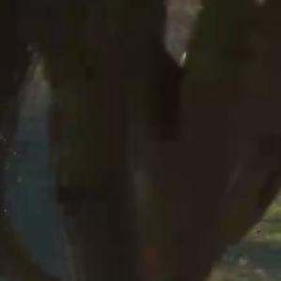  PsnrY=31.142dB PsnrU=36.982 dB PsnrV=38.677 dB | 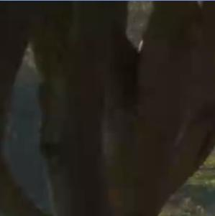  PsnrY=32.542dB PsnrU=36.920 dB PsnrV=38.549 dB
S09R1C1_77 |   PsnrY=26.630dB PsnrU=36.867 dB PsnrV=34.171 dB |   PsnrY=29.402dB PsnrU=37.116 dB PsnrV=36.351 dB
S10R1C1_81 | 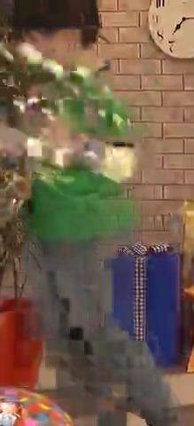  PsnrY=24.181dB PsnrU=33.629 dB PsnrV=33.383 dB | 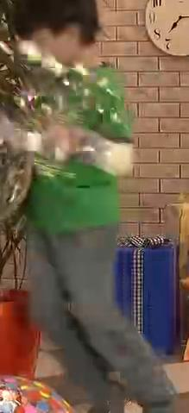  PsnrY=25.941dB PsnrU=33.409 dB PsnrV=33.585 dB
S12R1C1_417 |   PsnrY=28.004dB PsnrU=36.309 dB PsnrV=32.769 dB |   PsnrY=29.939dB PsnrU=36.082 dB PsnrV=33.767 dB
S06R1C2_14 | 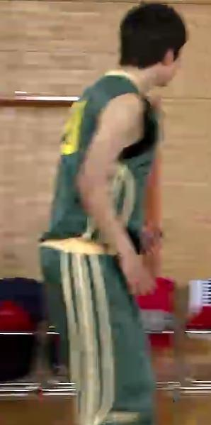  PsnrY=33.185dB PsnrU=39.762 dB PsnrV=38.765 dB |   PsnrY=34.435dB PsnrU=39.091 dB PsnrV=38.546 dB
S11R2C2_61 | 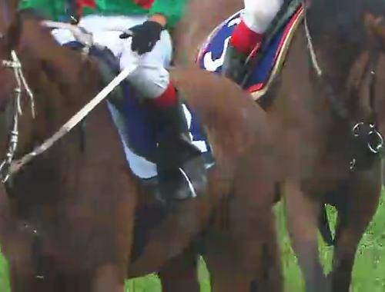  PsnrY=27.747dB PsnrU=35.205 dB PsnrV=35.612 dB | 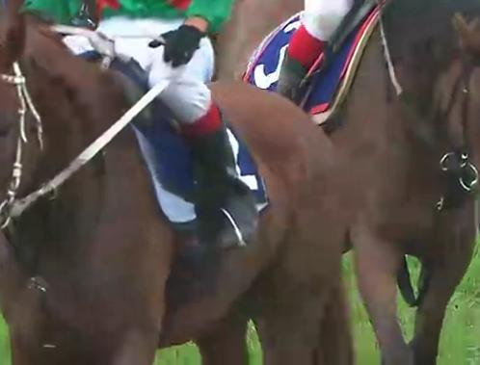  PsnrY=28.653dB PsnrU=35.113dB PsnrV=35.600 dB
S12R1C2 _279 |   PsnrY=29.013dB PsnrU=36.340dB PsnrV=33.747dB | 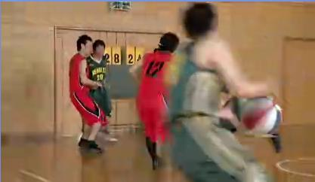  PsnrY=30.050dB PsnrU=35.465dB PsnrV=34.225 dB
S16R3C2_302 |   PsnrY=36.670dB PsnrU=43.529dB PsnrV=43.909dB |   PsnrY=38.335dB PsnrU=42.866dB PsnrV=43.105dB
S18R2C2_18 |   PsnrY=36.070dB PsnrU=43.944 dB PsnrV=43.483 dB |   PsnrY=37.501dB PsnrU=43.753 dB PsnrV=43.780 dB

