    Joint Collaborative Team on Video Coding (JCT-VC)  of ITU-T SG16 WP3 and ISO/IEC JTC1/SC29/WG11  1st Meeting: Dresden, DE, 15-23 April, 2010 | Document: JCTVC-A110

Title: | Description of video coding technology proposal by LG Electronics
Status: | Input Document to JCT-VC
Purpose: | Proposal
Author(s) or  Contact(s): | ByeongMoon Jeon  SeungWook Park  JungSun Kim  JoonYoung Park  Multimedia Lab., LG Electronics Inc.  221 Yangje-dong, Seocho-gu  Seoul, Korea | Tel:  Email: | +82-10-8203-1126  bm.jeon@lge.com  seungwook.park@lge.com  jungsun.kim@lge.com  jy.park@lge.com
Source: | LG Electronics
_____________________________

Abstract
This document proposes a new video coding scheme with substantially increased compression capability as a response to JCT-VC’s “Joint Call for Proposals on Video Compression Technology” [1]. While our model is based on the same coding framework as MPEG-4 AVC/H.264, it provides a number of significant components that distinguish it from its predecessor.
In order to achieve efficient coding performance for high resolutions like 720p, 1080p, 2K and 4K, our model is primarily based on macroblock of 32x32 unit which is capable of being expanded up to 64x64 and employs various transforms of 4x4, 8x8, 16x8, 8x16, and 16x16 sizes. On the basis of a large macroblock structure, lots of coding tools are newly devised, which include partial skip mode with variable block size, IIMM (Inter-Intra Mixed Mode) in a macroblock, MIM (Mixed Intra Mode) in a macroblock, SMVP (Scaled Motion Vector Predictor), template-based IC (Illumination Compensation), border handling scheme, ADF (Adaptive Deblocking Filter), and modified chroma intra prediction. Besides, some efficient KTA coding tools such as MVC (Motion Vector Competition), SIFO (Switched Interpolation Filter Offset), and QALF (Quad-tree based Adaptive Loop Filter) are migrated into our model with some modifications.
In order to remove the color blurring effect which is frequently found in JM alpha anchor especially in low bit rates in PartyScene and BasketballDrill of class C, the reason was investigated and the color blurring effect is eliminated by considering both rate and distortion of chroma components in the RD cost calculation in encoder side. Our model also results in good coding efficiency for relatively low resolution video like WVGA and WQVGA.
Experimental results show that the proposed model outperforms the JM anchor, averaging 25.83% bit rate reduction for all classes under the constraint set 1 and 37.01% bit rate reduction for all classes under the constraint set 2. For each constraint set, the proposed model provides great improvement in coding efficiency performance. Under the constraint set 1, 30.57% bit rate reduction is achieved on average for class B (1080p) sequences. Under the constraint set 2, about 45.01% bit rate reduction is achieved on average for class E (720p) sequences.

Contents
Abstract 1
Contents 2
1 Introduction 3
2 Algorithm description 3
2.1 Motion representation 3
2.2 Intra-frame prediction 7
I_32x32 prediction 8
I_mixed prediciton : MIM (Mixed Intra Mode) 8
Chroma intra prediction 9
2.3 Spatial transforms 11
2.4 Quantization 12
2.5 In-loop filtering 12
2.6 Entropy coding 12
2.7 Other tools 13
3 Compression performance discussion 14
3.1 Objective versus subjective compression performance 15
3.2 Constraint set 1 configuration relative to Alpha anchor 16
3.2.1 Class A 16
3.2.2 Class B 16
3.2.3 Class C 17
3.2.4 Class D 17
3.2.5 Overall 17
3.3 Constraint set 2 configuration relative to Beta and Gamma anchors 17
3.3.1 Class B 17
3.3.2 Class C 18
3.3.3 Class D 18
3.3.4 Class E 18
3.3.5 Overall 18
4 Complexity analysis 18
4.1 Encoding time and measurement methodology 18
4.2 Decoding time and measurement methodology and comparison vs. anchor bitstreams decoded by JM 16.1 20
4.3 Description of computing platform used to determine encoding and decoding times reported in sections 4.1 and 4.2 21
4.4 Expected memory usage of encoder 21
4.5 Expected memory usage of decoder 21
4.6 Complexity characteristics of encoder motion estimation and motion segmentation selection 22
4.7 Complexity characteristics of decoder motion compensation 25
4.8 Complexity characteristics of encoder intra-frame prediction type selection 25
4.9 Complexity characteristics of decoder intra-frame prediction operation 28
4.10 Complexity characteristics of encoder transforms and transform type selection 28
4.11 Complexity characteristics of decoder inverse transform operation 32
4.12 Complexity characteristics of encoder quantization and quantization type selection 32
4.13 Complexity characteristics of decoder inverse quantization 32
4.14 Complexity characteristics of encoder in-loop filtering type selection 32
4.15 Complexity characteristics of decoder in-loop filtering operation 32
4.16 Complexity characteristics of encoder entropy coding type selection 32
4.17 Complexity characteristics of decoder entropy decoding operation 32
4.18 Degree of capability for encoder parallel processing 32
4.19 Degree of capability for decoder parallel processing 32
5 Algorithmic characteristics 33
5.1 Random access characteristics 33
5.2 Delay characteristics 33
6 Software implementation description 33
7 Highlighted aspects discussion 33
8 Closing remarks 33
9 Patent rights declaration(s) 33
10 References 33

Introduction
Even though the stat-of-art video coding standard such as MPEG-4 AVC/H.264 has shown good coding efficiency for various resolutions, for instance ranging from QCIF to 720p, a new video coding scheme especially for over HD resolutions still needs to be addressed. When the spatial resolution of input video goes higher (e.g., HD or super-HD video), MPEG-4 AVC/H.264 is not sufficiently efficient since the macroblock size of 16x16 is relatively small against the full image size [2], which means there is still a room to get better coding performance for high resolution video.
Focusing on the need for a new generation of video compression technology that has substantially higher compression capability than the existing MPEG-4 AVC/H.264, ITU-T SG16 Q.6 (VCEG) and ISO/IEC JTC1/SC29/WG11 (MPEG) have jointly issued the call for proposal (CfP) on the new video compression technology and JCT-VC (Joint Collaborative Team on Video Coding) has been established. As a response to JCT-VC’s “Joint Call for Proposals on Video Compression Technology”, this document presents a new video coding scheme with substantially increased compression capability.
It is known that in terms of coding efficiency, large motion block size is more efficient for large resolution sequences. Therefore we adopted the large macroblock structure (up to 64x64 for inter prediction and up to 32x32 for intra prediction) in our model. To maximize the benefits of the large motion block, we also employed large size transform, which provides better energy compaction and less quantization error in large resolution video like 720p, 1080p, 2K, and 4K. Besides we also employed new tools such as partial skip mode with variable block size, IIMM (Inter-Intra Mixed Mode) in a macroblock, MIM (Mixed Intra Mode) in a macroblock, SMVP (Scaled Motion Vector Predictor), template-based IC (Illumination Compensation), border handling scheme, ADF (Adaptive Deblocking Filter), and modified chroma intra prediction, which are also advantageous to low resolution video like WVGA and QVGA. In addition to those tools, several new tools and schemes are employed for coding performance enhancement as well as subjective quality enhancement. Furthermore, some efficient KTA tools such as MVC, SIFO, and QALF are also integrated into our model with some modifications.
It is shown by experimental results that the proposed model can achieve a higher coding gain than MPEG-4 AVC/H.264. The results show that the proposed model outperforms the alpha anchor, averaging 25.83% bit rate reduction relative to JM alpha anchor under the constraint set 1 and 37.01% relative to the gamma anchor under the constraint set 2. Even though the proposed model outperforms MPEG-4 AVC/H.264, the current model will need to be further worked on because we have not yet implemented the additional tools introduced in section 2.7. Furthermore, the complexity optimization has not been done so far. Therefore we believe that our model can be further improved by exploiting those additional tools and expect more enhancements in terms of coding efficiency and complexity.

Algorithm description

Motion representation

macroblock structure for inter prediction
In our model, the unit of macroblock is 32x32 and a macroblock can be partitioned into 32x16, 16x32, 16x16, 16x8, 8x16, and 8x8. In addition to the block partitions, macroblocks can be clustered up to 64x64 to cope with the high resolution video compression. The clustered macroblock structure is designed to be disabled at each picture level. Fig. 1 shows all the block partitions for inter prediction in our model. Those block partition types are signaled by mb_type in the same way as MPEG-4 AVC/H.264. Each partitioned block has its own motion vector for inter prediction and reference index. In our model, the smallest unit for signaling both motion vector and reference index is 8x8.
Fig. 1. Block partitions for inter prediction

Partial skip mode with variable block size
As for skip mode, basically we share the common feature with MPEG-4 AVC/H.264. The skip mode in our model is applied to 32x32 macroblock and 64x64 clustered macroblock. Since the size of macroblock is larger than that of MPEG-4 AVC/H.264, the frequency of skip mode may decrease. Therefore we design the skip mode to be applied to variable blocks such as 64x32, 32x64, 32x16, 16x32 and 16x16 blocks. In other words, when one 32x32 macroblock or 64x64 clustered macroblock is determined to be paritioned into a few partitions, each partition can be coded with skip mode. For instance, if the 32x32 maroblock is divided into two 32x16 blocks, it is possible that one 32x16 block is coded normally, but the other 32x16 block is coded with skip mode.

IIMM (Inter-Intra Mixed Mode) in macroblock
In MPEG-4 AVC/H.264, a macroblock only has one of two prediction types, inter or intra. In our model, we allow both inter and intra prediction types in a 32x32 macroblock for better coding efficiency. For example, if mb_type is 16x16 inter prediction mode (P_16x16 or B_16x16), it is possible that submacroblocks 0 and 3 have inter prediction modes and submacroblocks 1 and 2 have intra prediction modes. To indicate whether a submacrobock is coded by intra or inter, 1 bit flag in each submacroblock is signaled. If the submacroblock is coded by intra mode, it may have one of I_4x4, I_8x8, and I_16x16 modes. Otherwise, it may have one of inter prediction modes such as 16x16, 16x8, 8x16, and 8x8. As shown in Fig. 2, each submacroblock can have different type of prediction, inter or intra prediction.

Fig. 2. Example of IIMM in a macroblock

Scaled Motion Vector Predictor (SMVP)
In MPEG-4 AVC/H.264, motion data of neighboring blocks are used to calculate the predicted motion vector of a current block. Even though the reference picture of the current block and that of the neighboring block are different, the temporal difference between two reference pictures is not considered for PMV. In our model, we scale the motion vector of the neighboring blocks by a factor of temporal distance and this scaled motion vector is used in the calculation of PMV.

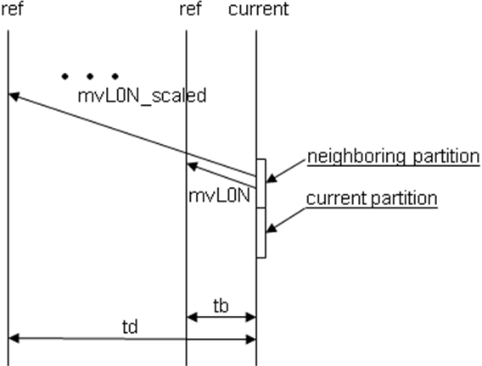
Fig. 3. Example for scaled predicted motion vector

From Fig. 3, mvL0N_scaled with N being replaced by neighboring block A, B, or C is calculated as below.

mvL0N_scaled = (td / tb) * mvL0N

where td is temporal distance between current picture and reference picture of the current block and tb is temporal distance between current picture and reference picture of the neighboring block. SMVP is applied not only to calculate the predicted motion vector in MVC (Motion Vector Competition) but also to derive the motion vector of the blocks coded with skip mode.

Template-based IC (Illumination Compensation)
In order to compensate an illumination change between pictures, the template-based illumination compensation is enabled for several inter macroblock types.
- 32x32, 32x32 P Skip, 64x64, 64x64 P Skip in P picture
- 32x32, 32x32 B Skip, 32x32 B Direct, 64x64, 64x64 B Skip, 64x64 B Direct in B picture

In this process, the reconstructed block, recBlk[ x, y ] is obtained as follows.

recBlk[ x, y ] = (predBlk[ x, y ] + offset) + resBlk[ x, y ]

where predBlk[ x, y ] is the predicted block, resBlk[ x, y] is the residual block, and offset is the offset value derived from the templates of the current and predicted blocks.
Fig. 4 shows how recBlk[ x, y ] is obtained from the illumination compensated block predBlk’[ x, y ].

Fig. 4. Template-based illumination compensation process

T_{cur} and T_{pred} are the templates of the current and reference blocks respectively. The offset value representing the illumination change between the current and predicted blocks is derived by subtracting the DC value of T_{pred} from that of T_{cur}. Because the offset value is derived from the templates which are already decoded, it is not necessary to transmit this value to the decoder. For the signaling of this tool, only 1 bit flag is sent to the decoder.

Border handling at P and B pictures
In MPEG-4 AVC/H.264, the width and height of video sequence should be multiple of 16 because macroblock of 16x16 is basic coding unit. Therefore, when the width or height is not multiple of 16, its size is extended to be aligned with multiple of 16 by padding the boundary pixels. Even though the padded regions should be encoded, those regions are not outputted for display, which results in bit rate increase. For instance, if the resolution of input sequence is 1920x1080, the height is extended to 1088 for encoding. After decoding the sequence, the padded regions at the encoder are cropped for display. Our model is designed to remove this redundancy generated by coding the padded regions.
Because the macroblock size of our model is 32x32, when a part of macroblock lies within the padded region, the macroblock is forced to be partitioned into four 16x16 submacroblocks. Among four submacroblocks, the submacroblocks which belong to the padded region are derived using skip mode.

Fig. 5. Border handling scheme for P and B pictures

Fig. 5 shows an example. Because the size of macroblock in our model is 32x32, when the resolution of input sequence is 416x240, it should be extended to 416x256, which generates extra 16 pixels in vertical direction. As shown in Fig. 5, the submacroblocks which belong to the padded region are coded as skip mode. Consequently any overhead is not transmitted for those submacroblocks. This method is beneficial because it helps to minimize the overhead which is not actually needed.

Modified MVC (Motion Vector Competition)
We adopted the concept of MVC of KTA to our model [3]. However the scheme is modified to be compatible with our motion model. First of all, the SMVP (Scaled Motion Vector Predictor) is used to get the predicted motion vector. The SMVP is applied not only to the calculation of median predictor but also to the other PMV candidates such as MV_{a}. Secondly, MVC is also applied to partial P-skip coded blocks.

SIFO (Switched Interpolation Filter Offset)
Without modification, we employed single pass SIFO of KTA [4].

Intra-frame prediction

Our model provides I_32x32 and I_mixed as intra macroblock type and especially each submacroblock in I_mixed macroblcok can be coded as one of I_4x4, I_8x8 and I_16x16 intra types as depicted in Fig. 6.

Fig. 6. Block partitions for intra prediction

I_32x32 prediction
In case that a macroblock is coded as I_32x32, one of 4 prediction modes such as Vertical, Horizontal, DC and Plane mode is applied as shown in Table 1.

Table 1. 4 modes of I_32x32 prediction
Intra32x32PredMode | Name of Intra32x32PredMode
0 | Intra_32x32_Vertical
1 | Intra_32x32_Horizontal
2 | Intra_32x32_DC
3 | Intra_32x32_Plane

For each mode, the derivation process is similar to Intra_16x16 prediction of MPEG-4 AVC/H.264.

I_mixed prediciton : MIM (Mixed Intra Mode)
In case that a macroblock is coded as I_mixed, an individual submacroblock can be coded as one of three intra prediction types, I_4x4, I_8x8, and I_16x16. The prediction type of each submacroblock can be decided by combination of two transform flags, transform_16x16_flag and transform_8x8_flag.
If transform_16x16_flag of a submacroblcok is equal to 1, it specifies that 16x16 transform (DCT or MDDT) is used in the submacroblock and the intra prediction of the submacroblock is I_16x16. The prediction modes of I_16x16 are specified in Table.2.

Table 2. 9 modes of I_16x16 prediction
Intra16x16PredMode[luma16x16BlkIdx ] | Name of Intra16x16PredMode[ luma16x16BlkIdx ]
0 | Intra_16x16_Vertical
1 | Intra_16x16_Horizontal
2 | Intra_16x16_DC
3 | Intra_16x16_Diagonal_Down_Left
4 | Intra_16x16_Diagonal_Down_Right
5 | Intra_16x16_Vertical_Right
6 | Intra_16x16_Horizontal_Down
7 | Intra_16x16_Vertical_Left
8 | Intra_16x16_Horizontal_Up

If transform_16x16_flag of a submacroblock is equal to 0 and transform_8x8_flag of the submacroblock is equal to 1, it specifies that 8x8 transform (DCT or MDDT) is used in the submacroblock and the intra prediction of the submacroblock is I_8x8.
If both transform_16x16_flag and transform_8x8_flag of the submacroblock are equal to 0, it means that 4x4 transform (DCT or MDDT) is used in the submacroblock and the intra prediction of the submacroblock is I_4x4. As in MPEG-4 AVC/H.264, both I_8x8 and I_4x4 have 9 prediction modes.

Chroma intra prediction
The unit of chroma intra prediction is 8x8 and we add a new chroma prediction mode (mode 0 of Table 3) into the existing chroma prediction modes of MPEG-4 AVC/H.264.

Table 3. 5 modes for chroma intra prediction
intra_chroma_pred_mode | Name of intra_chroma_pred_mode
0 | Intra_Chroma_Estimation
1 | Intra_Chroma_DC
2 | Intra_Chroma_Horizontal
3 | Intra_Chroma_Vertical
4 | Intra_Chroma_Plane

In the new mode, chroma prediction samples are derived from the reconstructed luma samples based on linear model as follows [5].

pred_{c}[ x, y ] = α * P_{L}[ 2*x, 2*y ] + β

where pred_{c}[ x, y ] indicates the predicted chroma samples and P_{L}[ 2*x, 2*y ] indicates the subsampled reconstructed luma samples, which are the gray samples in Fig. 7 (a). The gray block in Fig. 7 (b) is the chroma block to be predicted.

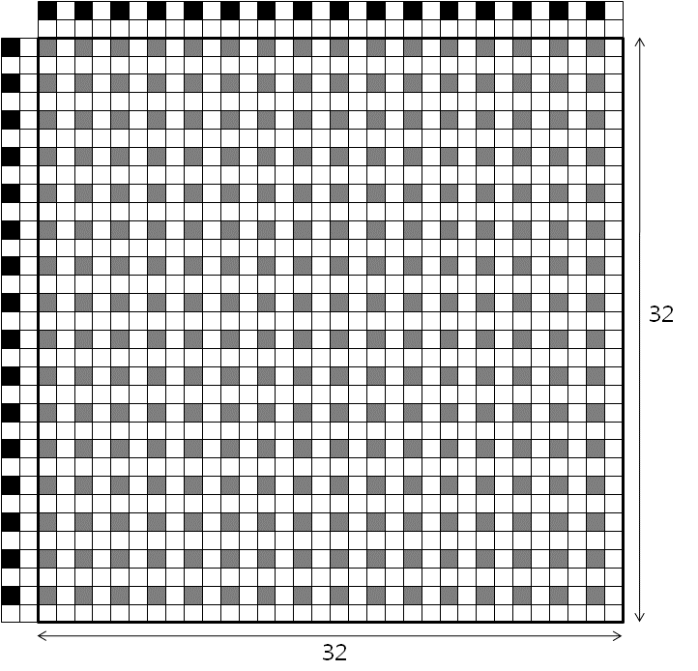
- Luma block

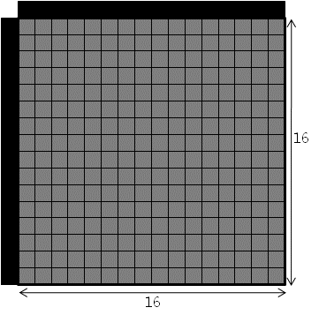
- Chroma block
Fig. 7. The luma and chroma samples used for the chroma estimation mode

The coefficients α and β are derived as follows.

$$\begin{aligned}α=\frac{R(P'_{L},P'_{C})}{R(P'_{L},P'_{L})} \\ β=\text{mean}(P'_{C})−α∗\text{mean}(P'_{L})\end{aligned}$$

where P’_{L} indicates pixels subsampled from the neighboring pixels of the luma block, which is the black sample in Fig. 7 (a), and P’_{C} indicates the neighboring pixels of the chroma block, the black samples in Fig. 7 (b), and R( A, B ) is a function that returns the correlation between A and B.

Border handling at I picture
Similar to the border handling scheme in P and B pictures, when a part of macroblock lies within the padded region, the macroblock is forced to be coded as I_mixed as shown in Fig. 8.

Fig. 8. Border handling scheme in I picture

As shown in Fig. 8, the submacroblocks which belong to the padded region are coded as I_16x16, and the submacroblocks which belong to the other region are coded normally. The prediction mode of the submacroblck which belongs to the padded region depends on its position. If it lies in the right border of the picture, horizontal mode is used. Otherwise, if it lies in the bottom border, vertical mode is used. Residual data is also not transmitted for those submacroblocks.

Spatial transforms

This section describes all features related to transform used in our model. In addition to 4x4 and 8x8 transforms used in MPEG-4 AVC/H.264, we introduce new transforms such as 16x16, 16x8, and 8x16 transforms to improve the coding efficiency.

Transforms for inter blocks
For the luma blocks equal to or larger than 16x16 such as 64x64, 64x32, 32x64, 32x32, 32x16, 16x32, and 16x16, one transform type among 4x4, 8x8, and 16x16 transforms is selected based on R-D optimization perspective. The luma blocks of 16x8 (or 8x16) size use one of 4x4, 8x8, and 16x8 (or 8x16) transforms and the luma blocks of 8x8 size use one of 4x4 and 8x8 transforms.
For the chroma blocks, only 4x4 transform is used and 2x2 or 4x4 DC hadamard is applied depending on the skip status of submacroblock. For example, if neither of submacroblock is skipped, 4x4 DC hadamard is used for the macroblock. Otherwise, 2x2 DC hadamard is used for each non-skipped submacroblock.

Transforms for intra blocks
Two kinds of transforms are available for intra predicted blocks; DCT and MDDT of KTA. Available sizes of transform are 4x4, 8x8, and 16x16. The transform size is the same as prediction block size except I_32x32 block. For I_32x32 prediction, we apply 16x16 DCT in DC prediction mode and 16x16 MDDT in the other prediction modes. We obtain MDDT kernels (4x4, 8x8, and 16x6) by training lots of sequences excluding CfP test sequences. Especially we generate two kinds of 16x16 MDDT kernels; one is for I_16x16 block which has 9 prediction modes and the other is for I_32x32 block which has 4 prediction modes.
For the chroma blocks, 4x4 transform and 4x4 DC hadamard transform are used regardless of prediction types.

Scan ordering
We use the adaptive scan ordering method with the new initial values which are trained with several sequences. The scan order is updated in each macroblock and the updated scan order is applied to the next macroblock. And the order is initialized in each slice.

Quantization
We use the similar quantization technique of MPEG-4 AVC/H.264. From the perspective of R-D performance, we exploit RDO-Q (R-D optimized quantization) and delta-QP of KTA [6].

In-loop filtering

Adaptive Deblocking Filter (ADF)
In the deblock filtering process of MPEG-4 AVC/H.264, one of pre-fixed filter sets are applied to each block boundary considering boundary strength at the reconstructed picture. These fixed filters can be beneficial if they are well matched to the picture characteristics but cause degradation in both subjective and objective qualities if not.
In order to improve this drawback, we developed the adaptive deblocking filter based on ‘Wiener filtering’ scheme. Filter coefficients are calculated by resolving MMSE (Minimum Mean Squared Error) between the original and the reconstructed pictures. They are obtained with respect to boundary strength and vertical/horizontal direction; of course the filter information needs to be transmitted. For the best R-D performance, one of the conventional deblocking filter and the ADF is utilized adaptively at the slice level.

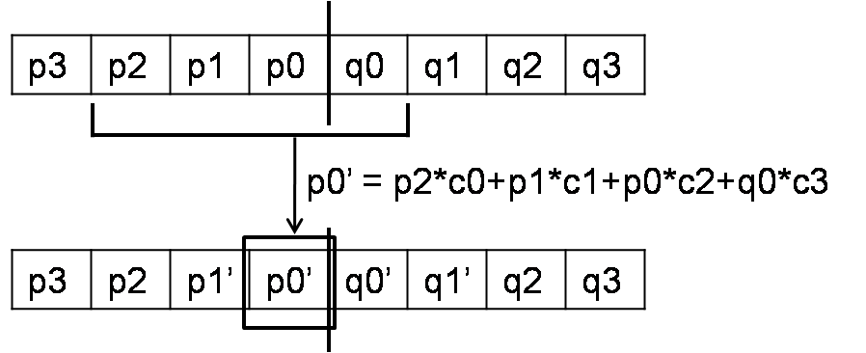
Fig. 9. Adaptive Deblocking filter

At Fig. 9, [c0, c1, c2, c3] represents the calculated wiener filter coefficients. Using these coefficients, the value of p0’ is obtained. The values of other pixels (p1’, q0’, q1’) around boundary are also obtained by each wiener filter coefficients.

Quad-tree based Adaptive Loop Filter (QALF)
Although ADF reduces blocking artifacts efficiently, the Gaussian noise, blurring and quantization noise still remain. In order to alleviate these artifacts, we adopt QALF of KTA.

Entropy coding

Context-Adaptive Binary Arithmetic Coding (CABAC)
For entropy coding, we adopt CABAC to our model because it outperforms CAVLC in coding performance and its complexity is affordable for the consumer devices today due to the evolution of technology.

Other tools

This section presents the tools being developed but not included in the model submitted in February 2010. Especially, both AWR and PAIF are introduced in detail in JCTVC-A21 with some experimental results.

Adaptive Warped Reference (AWR)
Adaptive warp reference (AWR) technique is devised to improve the coding efficiency when a video sequence contains complex motions such as scaling, rotation, sheering, and so on. Those complex motions cannot be described well by ME/MC techniques of MPEG-4 AVC/H.264 because the various motions of a block are modeled using only two-dimensional translation vectors.
AWR algorithm generates a new warped reference picture that compensates complex motions between a reference picture and the current picture to be encoded. The complex motions are modeled as a parametric warping function such as a homography. Then, the parameters of the warping function are quantized and encoded in bit streams at picture level. In order to find and compute the appropriate warping function, we used Kanade-Lucas-Tomasi feature tracker [7] to detect feature points and track them. (For details, refer to JCTVC-A21)
Even though this technique now provides good gain especially for the sequences containing zooming, rotation, and affine motion, we could unfortunately not include this solution into the model submitted in February because of submission time constraint.

Parametric Adaptive Interpolation Filter (PAIF)
Parametric adaptive interpolation filter (PAIF) scheme [8] is introduced for solving the trade-off between the accuracy of coefficients and the size of side information in AIF of KTA. The PAIF represents an interpolation filter using five parameters instead of many individual filter coefficients by approximating the interpolation filter with a parametric function. Compared with the existing AIF, it spends less bits for filter representation and it may be closer to the optimal filter than AIF. In the proposed PAIF method, we use a sophisticated parametric function and an offset value which is computed for each reference picture and encoded with the parameters.
Like AWR, we could unfortunately not include this solution into the model submitted in February because of submission time constraint. (For details, refer to JCTVC-A21)

MVC (Motion Vector Competition) with B skip/direct
MVC of KTA is integrated in our model. In the KTA software, MVC is utilized for most inter prediction modes except B Skip and B Direct modes. Therefore, in the submitted model, MVC is not utilized for B Skip and B Direct modes. We are currently working on the implementation of MVC for B Skip and B Direct and we expect that the benefit of MVC can be maximized.

Chroma estimation with phase shift
In video sequences using 4:2:0 sampling, the sampling locations of luma and chroma components are different as shown in Fig. 10.

Fig. 10. Vertical and horizontal locations of 4:2:0 luma and chroma sample in a frame

To enhance the proposed intra prediction method (Intra_Chroma_Estimation, mode 0 of Table 3) where the predicted chroma block is derived from the reconstructed luma sample, the derivation process for the predicted chroma block is modified considering the phase difference between luma and chroma samples as follows.

pred_{c}[ x, y ] = α *0.5* ( P_{L}[ 2*x, 2*y ] + P_{L}[ 2*x, 2*y + 1 ] ) + β

where pred_{c}[ x, y ] indicates the predicted chroma samples and P_{L}[ x, y ] indicates the reconstructed luma samples.
The derivation process for α and β is also modified as follows.
$$\begin{aligned}α=R(\frac{\overset{{\hat{}}_{L},P'_{C})}{P}}{R(\overset{{\hat{}}_{L},\overset{{\hat{}}_{L})}{P}}{P}}β=\text{mean}(P'_{C})−α∗\text{mean}(\overset{{\hat{}}_{L})}{P} \\ \end{aligned}$$

where R( A, B ) is a function that returns the correlation between A and B, P’_{C} inidcates the upper and left samples of the target chroma block, and $\overset{{\hat{}}_{L}}{P}$ indicates the interpolated luma samples considering the phase difference between luma and chroma samples, which is derived by

$\overset{{\hat{}}_{L}}{P}$[x, y] = 0.5 * ( P_{L}[ 2*x, 2*y ] + P_{L}[ 2*x, 2*y+1 ] )

Compression performance discussion
This subsection presents the experimental results for our model together with the coding environments and its analysis. The performance evaluation is carried out by comparing the two schemes, the JM anchor and the proposed model submitted in February 2010, in terms of BD rate and BD PSNR [9].
The results for our model is generated under the coding conditions (the constraint set 1 and the constraint set 2) specified in [1] by implementing all the features described in the above sections (except section 2.7), which are implemented on top of JM11.0 based on C programming language and compiled under MS Visual Studio 2008 platform.

Objective versus subjective compression performance
The compression performance of our model is summarized as follows.

Constraint set 1
Relative to the alpha anchor,
- The overall average gain for all classes is 25.83% bit rate reduction
- The maximum average gain is found in class B sequences, achieving 30.57% bit rate reduction
- The maximum gain for a sequence is found in BQTerrace in class B, achieving 36.15 % bit rate reduction

Constraint set 2
Relative to the gamma anchor,
- The overall average gain for all classes is 37.01% bit rate reduction
- The maximum average gain is found in class E sequences, achieving 45.01% bit rate reduction
- The maximum gain for a sequence is found in BQTerrace in class B, achieving 52.15% bit rate reduction

When comparing skip/direct-coded blocks with inter-coded blocks in constraint set 1 and 2, skip/direct-coded blocks are efficient at all bit rates of all classes (refer to Fig. 12 to 19), and our macroblock structure is also efficient at all bit rates of all classes. From this analysis, we conclude that our partial skip mode and macroblock structure are significantly efficient to obtain good coding gain.
We also have investigated the subjective quality of the results. After the investigation, we observed an artifact such as the propagation and blurring of chroma components, which is visible especially when the bitstream is coded with low bit rate. This artifact is obviously visible in PartyScene and BasketballDrill of class C. For example, Fig. 11 (a) shows the artifact in PartyScene and BasketballDrill at 512 kbps of the alpha anchor. We investigated the problem to remove this artifact and found that the chroma components were not considered in the submacroblock R-D cost calculation at encoder side and it caused such the severe color distortion. Therefore we included R-D values of chroma in the R-D cost calculation of submacroblock and as a result, the subjective quality is improved by minimizing the artifact without degradation in the objective performance as shown in Fig. 11 (b).

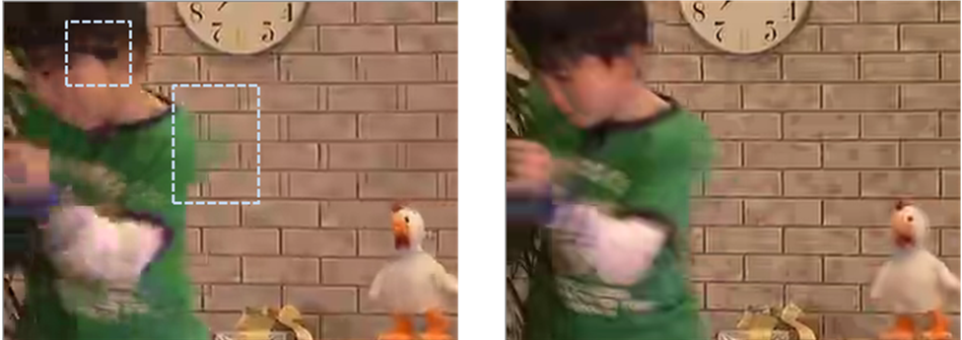

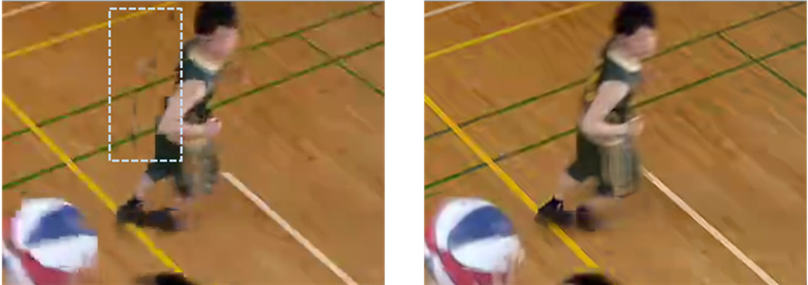

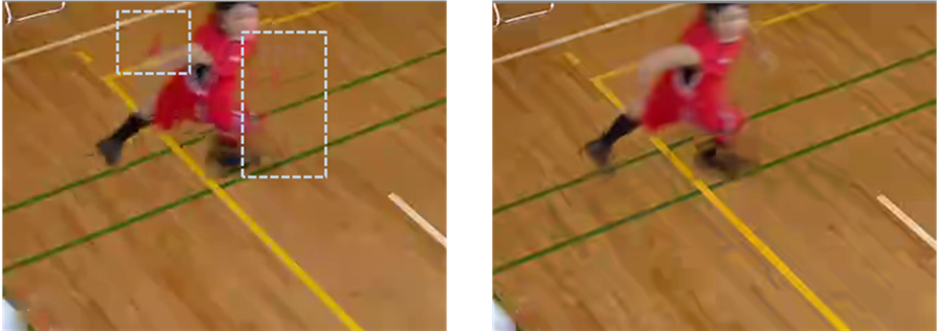

- JM (b) our model
Fig. 11. Enhanced subjective quality in our model

Constraint set 1 configuration relative to Alpha anchor
Because our software is implemented on top of JM11.0, the basic coding structure is same as that of the JM anchor. The same coding configuration of the alpha anchor which satisfies the constraint set 1 is obeyed except the following changes.
- Number of reference frames for P pictures=5
- Number of reference frames for B pictures=4 (2 reference pictures allowed for each list)
- Weighted prediction disabled
- 16x16, 16x8, 8x16, 8x8, 4x4 transforms enabled

Class A
Class | Sxx | Name | BD psnr | BD rate
A | S01 | Traffic | 1.17 | -29.06
A | S02 | People on Street | 1.06 | -18.82
A | Avg. |  | 1.11 | -23.94

Class B
Class | Sxx | Name | BD psnr | BD rate
B | S03 | Kimono | 1.42 | -35.68
B | S04 | ParkScene | 0.96 | -23.76
B | S05 | Cactus | 0.81 | -25.12
B | S06 | BasketballDrive | 1.14 | -32.14
B | S07 | BQTerrace | 0.71 | -36.15
B | Avg. |  | 1.01 | -30.57

Class C
Class | Sxx | Name | BD psnr | BD rate
C | S08 | BasketballDrill | 1.36 | -28.90
C | S09 | BQMall | 1.32 | -25.02
C | S10 | PartyScene | 1.19 | -27.97
C | S11 | RaceHorses | 1.17 | -25.53
C | Avg. |  | 1.26 | -26.85

Class D
Class | Sxx | Name | BD psnr | BD rate
D | S12 | BasketballPass | 0.84 | -15.97
D | S13 | BQSquare | 1.40 | -33.39
D | S14 | BlowingBubbles | 0.81 | -18.26
D | S15 | RaceHorses | 0.62 | -11.76
D | Avg. |  | 0.92 | -19.85

Overall
Class | BD psnr | BD rate
A | 1.11 | -23.94
B | 1.01 | -30.57
C | 1.26 | -26.85
D | 0.92 | -19.85
Avg. | 1.06 | -25.83

Constraint set 2 configuration relative to Beta and Gamma anchors
Because our software is implemented on top of JM11.0, the basic coding structure is same as that of the JM anchor. The same coding configuration of the gamma anchor which satisfies the constraint set 2 is obeyed except the following changes.
- Number of reference frames =5
- CABAC enabled
- 16x16, 16x8, 8x16, 8x8, 4x4 transforms enabled

Class B
Class | Sxx | Name | BD PSNR | BD RATE
B | S03 | Kimono | 2.42 | -49.54
B | S04 | ParkScene | 1.49 | -34.01
B | S05 | Cactus | 1.55 | -39.91
B | S06 | BasketballDrive | 2.08 | -46.49
B | S07 | BQTerrace | 1.68 | -52.15
B | Avg. |  | 1.85 | -44.42

Class C
Class | Sxx | Name | BD PSNR | BD RATE
C | S08 | BasketballDrill | 1.97 | -41.24
C | S09 | BQMall | 1.91 | -34.13
C | S10 | PartyScene | 1.30 | -32.08
C | S11 | RaceHorses | 1.20 | -27.15
C | Avg. |  | 1.60 | -33.65

Class D
Class | Sxx | Name | BD PSNR | BD RATE
D | S12 | BasketballPass | 1.31 | -24.92
D | S13 | BQSquare | 1.59 | -39.68
D | S14 | BlowingBubbles | 0.91 | -20.86
D | S15 | RaceHorses | 0.79 | -14.99
D | Avg. |  | 1.15 | -25.11

Class E
Class | Sxx | Name | BD PSNR | BD RATE
E | S16 | Vidyo1 | 2.46 | -46.74
E | S17 | Vidyo3 | 2.14 | -41.10
E | S18 | Vidyo4 | 2.32 | -47.20
E | Avg. |  | 2.31 | -45.01

Overall
Class | BD psnr | BD rate
B | 1.85 | -44.42
C | 1.60 | -33.65
D | 1.15 | -25.11
E | 2.31 | -45.01
Avg. | 1.70 | -37.01

Complexity analysis
In this section, we provide the results of the complexity analysis on our model. Unfortunately, we did not apply any code-level optimization.
Basically, the analysis is performed in three perspectives, time consumption, memory usage and CPU occupancy. In addition to these measurements, we add the diagrams of various distributions with bitrate change to show the complexity characteristic of our model.

Encoding time and measurement methodology
In order to measure the encoding time, we simply check the consumed time in the encoding process of JM and our model (refer to Table 8) in the same hardware platform and compile condition. Among the five target rate points specified in the Joint CfP document, we test two points, Rate2 and Rate5 due to the time limitation. We think those points are very practical rates among 5 points, because Rate2 is in the middle rate among them and Rate5 is the highest bitrate yielding the best visual quality.

Table 4. Encoding time (sec) under constraint set 1 (alpha)
class | seq. | Complexity ratio
A | PeopleOnStreet | 9.76
A | Traffic | 9.29
A | Avg. | 9.53
B | BasketballDrive | 9.62
B | BQTerrace | 8.30
B | Cactus | 8.64
B | Kimono | 9.05
B | ParkScene | 8.10
B | Avg. | 8.74
C | BasketballDrill | 8.85
C | BQMall | 9.62
C | PartyScene | 7.60
C | RaceHorses | 11.07
C | Avg. | 9.29
D | BasketballPass | 10.49
D | BlowingBubbles | 8.51
D | BQSquare | 8.12
D | RaceHorses | 10.97
D | Avg. | 9.52
Total Avg. |  | 9.27
Expected Avg.  (if implemented on JM16.1/17.0) |  | 4.64

Table 5. Encoding time (sec) under constraint set 2 (gamma)
class | seq. | Complexity ratio
B | BasketballDrive | 23.27
B | BQTerrace | 17.48
B | Cactus | 19.46
B | Kimono | 21.75
B | ParkScene | 18.38
B | Avg. | 20.07
C | BasketballDrill | 19.97
C | BQMall | 22.00
C | PartyScene | 17.92
C | RaceHorses | 21.96
C | Avg. | 20.46
D | BasketballPass | 18.69
D | BlowingBubbles | 12.81
D | BQSquare | 12.43
D | RaceHorses | 16.30
D | Avg. | 15.06
E | Vidyo1 | 19.55
E | Vidyo3 | 19.02
E | Vidyo4 | 19.45
E | Avg. | 19.34
Total Avg. |  | 18.73
Expected Avg.  (if implemented on JM16.1/17.0) |  | 9.37

In case of constraint set 1, our model consumes about 9 times more than JM16.1 high profile. Based on our complexity analysis, the additional motion estimation for clustered macroblocks and partial skip, the increased iteration number of mode decision for many transforms and mixed MB types, and the additional loop filter causes complexity increase.
And in constraint set 2, complexity ratio is increased to about 19 times more than JM16.1 constrained baseline profile. Main reason of complexity increase is the usage of CABAC as entropy coding as well as what we expressed in the constraint set 1. More detail analysis is described in section 4.6 through 4.11 and Annex.
Here, we should note that there is a large speed difference between JM 11.0 and the latest JM such as JM 16.1 or JM 17.0. According to the additional experiments, JM 11.0 encoder is about 2 times slower than the latest version. This fact implies that our model is possible to speed up about 2 times if applying the modification of the latest JM to our model.

Decoding time and measurement methodology and comparison vs. anchor bitstreams decoded by JM 16.1
Decoding time measurement is performed in the same manner of the encoder case. As encouraged in JCT e-mail reflector, we enable YUV output and disable reference input while the decoding time is measured.

Table 6. Decoding time(sec) under constraint set 1 (alpha)
class | seq. | Complexity ratio
A | PeopleOnStreet | 8.55
A | Traffic | 8.83
A | Avg. | 8.69
B | BasketballDrive | 8.37
B | BQTerrace | 8.43
B | Cactus | 6.66
B | Kimono | 10.13
B | ParkScene | 8.31
B | Avg. | 8.38
C | BasketballDrill | 5.09
C | BQMall | 7.86
C | PartyScene | 7.39
C | RaceHorses | 6.84
C | Avg. | 6.80
D | BasketballPass | 6.59
D | BlowingBubbles | 6.20
D | BQSquare | 8.14
D | RaceHorses | 6.67
D | Avg. | 6.90
Total Avg. |  | 7.69
Expected Avg.  (if implemented on JM16.1/17.0) |  | 2.20

Table 7. Decoding time(sec) under constraint set 2 (gamma)
class | seq. | Complexity ratio
B | BasketballDrive | 9.31
B | BQTerrace | 10.40
B | Cactus | 7.40
B | Kimono | 10.50
B | ParkScene | 10.05
B | Avg. | 9.53
C | BasketballDrill | 5.70
C | BQMall | 6.74
C | PartyScene | 6.65
C | RaceHorses | 7.60
C | Avg. | 6.67
D | BasketballPass | 5.80
D | BlowingBubbles | 6.54
D | BQSquare | 7.28
D | RaceHorses | 6.77
D | Avg. | 6.60
E | Vidyo1 | 5.74
E | Vidyo3 | 5.58
E | Vidyo4 | 5.65
E | Avg. | 5.65
Total Avg. |  | 7.11
Expected Avg.  (if implemented on JM16.1/17.0) |  | 2.03

In case of constraint set 1 and 2, our model consumes about 7 times more than JM16.1 high/constrained_baseline profiles. We analyzed and observed that In-loop process including QALF and ADF is dominant at class A and B in constraint set 1 and at class B in constraint set 2, MC process including SIFO is dominant at class C and D in both constraint set 1 and 2, and MC and transform processes are dominant at class E in constraint set 2. Consequently, main reason of the increased complexity is inferred as QALF, ADF, SIFO, and large transform. More detail analysis is described in section 4.6 through 4.11 and Annex.
We also should note that the speed difference between JM 11.0 decoder and the latest version is about 3.5 times. So we think it is possible that our decoder can be speeded up by 3.5 times than the current version, if the modification of the latest JM is applied.

Description of computing platform used to determine encoding and decoding times reported in sections Error: Reference source not found and Error: Reference source not found
Computing platform is summarized as follows.
- 32b executables are used in encoder and decoder.
- CPU : Intel Core i7 950 @ 3.07Ghz (quad core)
- Memory : 12 GB
- Harddisk : WD Caviar Black(1 TB, SATA 3 Gb/s, 32 MB cache, 7200 RPM)

This platform has quad core, but we use single core for the complexity measurement.

Expected memory usage of encoder
In this section, we describe the additional memory usage at the frame buffer level compared with JM. Additional tools using frame buffers are SIFO as MC interpolation filter and ADF/QALF as in-loop filter. In addition to these tools, we use one more reference picture in constraints set 1 and 3 more reference pictures in constraints set 2 than JM. Accordingly, our model uses one or three more DPB, and several frame buffers additionally.

Expected memory usage of decoder
In the decoder side, additional DPB is needed like the encoder. But the total memory size of additional DPB is largely reduced, because the upsampled version of reference is not needed in the decoder. This is applied to SIFO, too. And other tools use similar additional memory as they do in the encoder.

Complexity characteristics of encoder motion estimation and motion segmentation selection
In all the figures of this subsection, 64 Skip/Direct includes 64x64, 64x32, 32x64 skip/direct-coded blocks, 32 Skip/Direct includes 32x32, 32x16, 16x32 skip/direct-coded blocks, and 16 Skip/Direct includes 16x16 skip/direct-coded blocks. Clustered MB includes 64x64, 64x32, 32x64 inter-coded blocks, MB includes 32x32, 32x16, 16x32 inter-coded blocks, and subMB includes 16x16, 16x8, 8x16 inter-coded blocks.
When comparing skip/direct-coded blocks with inter-coded blocks in Fig. 12 to 15 in constraint set 1, skip/direct-coded blocks are dominant except at high bit rates in low resolution (class D). Especially, 64 skip/direct mode is dominant. From this analysis, we conclude that our partial skip mode is significantly efficient to obtain good coding gain.
On the other hand, clusteredMB is dominant at class A, B, and C in inter-coded blocks. Correspondingly, we conclude that our clusteredMB is efficient coding structure. As we expected, the distribution of subMB is increased as the resolution goes down and bit rate goes up.

Fig. 12. Constraint set 1 (alpha), Class A

Fig. 13. Constraint set 1 (alpha), Class B

Fig. 14. Constraint set 1 (alpha), Class C

Fig. 15. Constraint set 1 (alpha), Class D

When comparing skip/direct-coded blocks with inter-coded blocks in Fig. 16 to 19 in constraint set 2, skip/direct mode is dominant at class B and E. From this analysis, we conclude that our partial skip mode is significantly efficient at high resolution. On the other hand, clusteredMB and MB are dominant at low bit rates of all classes and subMB is dominant at high bit rates of all classes in inter-coded blocks.

Fig. 16. Constraint set 1 (gamma), Class B

Fig. 17. Constraint set 1 (gamma), Class C

Fig. 18. Constraint set 1 (gamma), Class D

Fig. 19. Constraint set 1 (gamma), Class E

Complexity characteristics of decoder motion compensation
According to the results of VTune [10] analysis (refer to ANNEX), it is reported that MC of our model is more complex than JM. We think this complexity increase comes from using complex interpolation filter like SIFO and MVC, which are absent in JM.

Complexity characteristics of encoder intra-frame prediction type selection
Our I_16x16 has 9 modes while JM has 4 modes. Besides we add I_32x32 to our model. We think these additional modes may increase the complexity of intra-frame prediction type selection process.

Fig. 20. Constraint set 1 (alpha), Class A

Fig. 21. Constraint set 1 (alpha), Class B

Fig. 22. Constraint set 1 (alpha), Class C

Fig. 23. Constraint set 1 (alpha), Class D

Fig. 24. Constraint set 2 (gamma), Class B

Fig. 25. Constraint set 2 (gamma), Class C

Fig. 26. Constraint set 2 (gamma), Class D

Fig. 27. Constraint set 2 (gamma), Class E

Complexity characteristics of decoder intra-frame prediction operation
No additional complexity increase is observed in the decoder side compared with JM decoder.

Complexity characteristics of encoder transforms and transform type selection
As we can expect, large transform such as T16 is dominant at the high resolution and low bitrate, and small transform such as T8 and T4 are dominant at the opposite cases as shown in Fig. 28 to 35.
According to ANNEX, our transform tool is more complex than JM. We think that it may come from using large transform which is not included in JM.

Fig. 28. Constraint set 1 (alpha), Class A

Fig. 29. Constraint set 1 (alpha), Class A

Fig. 30. Constraint set 1 (alpha), Class A

Fig. 31. Constraint set 1 (alpha), Class A

Fig. 32. Constraint set 2 (gamma), Class B

Fig. 33. Constraint set 2 (gamma), Class C

Fig. 34. Constraint set 2 (gamma), Class D

Fig. 35. Constraint set 2 (gamma), Class E

Complexity characteristics of decoder inverse transform operation
As we mentioned in subsection 4.10, large transform increases additional complexity compared with JM decoder transform operation (refer to ANNEX)

Complexity characteristics of encoder quantization and quantization type selection
Basically we use the same quantization technique of JM 11.0. So we think the complexity of quantization operation may be similar to JM.

Complexity characteristics of decoder inverse quantization
As we mentioned in subsection 4.12, decoder inverse quantization has similar complexity to JM.

Complexity characteristics of encoder in-loop filtering type selection
In our model, two typical in-loop filtering processes (ADF and QALF) are included for better coding efficiency. Two algorithms are based on Wiener filtering scheme, which needs somewhat complex calculation of correlation between pixels. And additional filtering process on each pixel causes high complexity increase than JM (refer to ANNEX).

Complexity characteristics of decoder in-loop filtering operation
As well as at the encoder side, the large complexity increase is observed at the in-loop filtering process of the decoder side. We believe these complex tools can be enhanced by our future tuning work.

Complexity characteristics of encoder entropy coding type selection
No specific comments.

Complexity characteristics of decoder entropy decoding operation
No specific comments.

Degree of capability for encoder parallel processing
No specific comments.

Degree of capability for decoder parallel processing
No specific comments.

Algorithmic characteristics

Random access characteristics
The random access characteristic of our model is same as that of MPEG-4 AVC/H.264. That is, we allow random access points using the IDR picture every 1 second for the constraint set 1. For the constraint set 2, I-P-P-P coding structure is used so IDR picture is used at the first coded picture.

Delay characteristics
Our model has the same structural delay characteristic as that of MPEG-4 AVC/H.264. For the constraint set 1, we use the hierarchical B coding structure with GOP size equal to 8 and IDR picture is used at the first picture of every third GOP in case fo 24fps and every seventh GOP in case of 60fps. For the constraint set 2, we use I-P-P-P coding structure so there is no deay.

Software implementation description
Our implementation was done on top of JM 11.0 and all the features described in the above sections, except section 2.7, were implemented. In addition, some changes have been made. For instance, the last GOP in JM 11.0 software was not coded when the total number of frames was not equal to the multiple of GOP size plus 1. Thus we fixed the software to code all pictures of CfP test sequences. Optimization for complexity reduction was not done due to the time limitation.

Highlighted aspects discussion
No specific comments.

Closing remarks
In this proposal, we present the detailed description of our model which was submitted as a response to the JCT-VC’s “Joint Call for Proposals on Video Compression Technology” together with the analysis of coding performance and complexity. Our model has substantially increased compression capability relative to MPEG-4 AVC/H.264 showing on average 25.83% and 37.01% bit rate reduction for all classes under the constraint set 1 and the constraint set 2 respectively. However, there are many new tools being developed but not yet implemented in the submitted model. The integration is underway and we believe that the performance of our model can be further improved by adopting those tools. We hope our model to contribute to the new standard and welcome all interesting parties to further develop our technology.

Patent rights declaration(s)
LG Electronics may have IPR relating to the technology described in this contribution and, conditioned on reciprocity, is prepared to grant licenses under reasonable and non-discriminatory terms as necessary for implementation of the resulting ITU-T Recommendation | ISO/IEC International Standard (per box 2 of the ITU-T/ITU-R/ISO/IEC patent statement and licensing declaration form).

References
[1] “Joint Call for Proposals on Video Compression Technology”, ITU-T Q.6/SG16 and ISO/IEC JCT1/SC29/WG11, N11113, Kyoto, Japan, Jan. 2010
[2] S. Ma and C.C. Jaykuo, "High-Definition Video Coding with. Super-Macroblocks", Proc. SPIE, vol. 6508 (part 1), No. 650816, Jan. 2007
[3] J. Jung and G. Laroche, “Competition-Based Scheme for Motion Vector Selection and Coding”, ITU-T Q.6/SG16 VCEG, VCEG-AC06, Klagenfurt, Austria, July 2006
[4] M. Karczewicz, Y. Ye, P. Chen, G. Motta, “Single Pass Encoding using Switched Interpolation Filters with Offset”, ITU-T Q.6/SG16 VCEG, VCEG- AJ29, San Diego, California, USA, Oct. 2008
[5] B.C. Song, Y.G.Lee, and N.H. Kim, “Block Adaptive Inter-Color Compensation Algorithm for RGB 4:4:4 Video Coding”, IEEE CSVT, vol. 18, no. 10, pp. 1447-1451, Oct. 2008
[6] M. Karczewicz and Y. Ye, “Rate-distortion optimized quantization,” ITU-T Q.6/SG16 VCEG, VCEG- AH21, Antalya, Turkey, Jan. 2008.
[7] C. Tomasi, T. Kanade, “Detection and Tracking of Point Features”, Technical Report CUM-CS-91-132, 1991
[8] Jie Dong and King Ngi Ngan, “ Parametric Interpolation Filter for Motion Compensated Prediction”, Int. Conf. Image Processing (ICIP), pp. 1021-1024, Nov. 2009
[9] Gisle Bjontegaard, “Improvements of the BD-PSNR model”, ITU-T Q.6/SG16 VCEG, VCEG-AI11, Berlin, Germany, July 2008
[10] “Intel VTune”, http://software.intel.com/en-us/intel-vtune/
ANNEX. Overall CPU occupancy comparison of encoder and decoder
Overall CPU occupancy comparison of encoder
In this annex, we provide the overall CPU occupancy results of JM and our model by using Intel VTune 9.0 software. This software can provide the CPU clockticks of each function after the encoding and decoding process is finished. All functions of encoder and decoder are categorized to typical coding tools for easy understanding.
For rapid analysis, we pick out some sequences which show the highest encoding and decoding time compared to JM (refer to Table A and C) and only 5 pictures are tested for encoding test.

Table A. Test sequence list for analysis of CPU usage
Constraitn2 (gamma)
Class | Sequence
B | BasketballDrive
C | BQMall
D | BasketballPass

Table B. CPU usage of coding tools (Constraints set 2: gamma)

Overall CPU occupancy comparison of decoder
In case of the decoder, we select some sequences in the same manner of the encoder case. And all frames of each bitstream are decoded for this test.

Table C. Test sequence list for analysis of CPU usage
Constraint1 (alpha) |  | Constraitn2 (gamma)
Class | Sequence | Class | Sequence
A | Traffic | B | Kimono
B | Kimono | C | RaceHorses
C | BQMall | D | BQSquare
D | BQSquare | E | Vidyo1

Table D. CPU usage of coding tools (Constraints set 1: alpha)

Table E. CPU usage of coding tools (Constraints 2: gamma)

