    Joint Collaborative Team on Video Coding (JCT-VC)  of ITU-T SG16 WP3 and ISO/IEC JTC1/SC29/WG11  1st Meeting: Dresden, DE, 15-23 April, 2010 | Document: JCTVC-A033

Title: | Suggestion for a Test Model
Status: | Input Document to JCT-VC
Purpose: | Proposal
Authors: | Thomas Davies¹, Kenneth R. Andersson², Rickard Sjöberg², Thomas Wiegand³, Detlev Marpe³, Kemal Ugur⁴, Justin Ridge⁴, Marta Karczewicz⁵, Peisong Chen⁵, Gaelle Martin-Cocher⁶, Ken McCann⁷, Woo-Jin Han⁷, Gisle Bjontegaard⁸, Arild Fuldseth⁸
Source: | BBC¹, Ericsson², Fraunhofer HHI³, Nokia⁴, Qualcomm⁵, RIM⁶, Samsung⁷, Tandberg⁸
_____________________________

Abstract
This document provides a suggestion for a provisional draft of the initial Test Model, following discussions between BBC, Ericsson, Fraunhofer HHI, Nokia, Qualcomm, Samsung, RIM and Tandberg during the Dresden JCT-VC meeting.
The aim of this document is to suggest a first Test Model that provides a coding efficiency close to the best performing proposals in the subjective test of the CfP and a complexity point that is close to the lowest complexity submissions.

Abstract 1
1 Overview 2
2 Unit definition 2
2.1 Coding Tree Block (CTB) 2
2.1 Prediction unit (PU) 3
2.2 Transform unit (TU) 6
3 Motion representation 6
3.1 Motion vector prediction for rectangular partitions 6
3.2 Motion vector prediction for geometric block partitions 9
3.3 Interpolation Methods 9
3.3.1 Single pass switched Interpolation Filters with offsets (single pass SIFO) 10
3.3.2 Choice of filter set and offsets 11
3.4 Adaptive Motion Vector Resolution 11
4 Intra-frame prediction 11
4.1 Adaptive reference sample smoothing 12
4.2 Planar prediction 12
4.3 Angular prediction 12
4.4 Arbitrary Directional Intra (ADI) 13
4.5 Combined Intra Prediction (CIP) 14
5 Spatial transforms 15
5.1 Large transform (16x16, 32x32, 64x64) 15
5.2 Rotational transform (ROT) 16
5.3 Mode dependent directional transforms for intra-prediction residuals 17
5.4 Quantization 18
6 Deblocking filter 19
Luma filtering 19
Chroma filtering 20
Planar mode filtering 20
7 In-loop filtering 21
8 Entropy Coding 21
8.1 Low-Complexity Entropy Coding 21
8.2 High Coding Efficiency Entropy Coding 24
8.2.1 Novel entropy coding concept 24
8.2.2 V2V codes 24
8.2.3 Load Balancing 26
8.2.4 Binarization and context modeling 28
8.2.5 Improved context modeling scheme for coding of transform coefficients 28
9 Software integration plan 29

Overview
This suggested Test Model provides a coding efficiency close to the best performing proposals in the subjective test of the CfP and a complexity point that is close to the lowest complexity submissions.

Unit definition

2.1 Coding Tree Block (CTB)
The coding unit (CTB) is defined as a basic unit which has a square shape. Although it has a similar role to the macroblock and sub-macroblock in H.264/AVC, the main difference lies in the fact that CTB can have various sizes, with no distinction corresponding to its size. All processing except frame-based loop filtering is performed on a CTB basis, including intra/inter prediction, transform, quantization and entropy coding. Two special terms are defined: the largest coding unit (LCTB) and the smallest coding unit (SCTB). For convenient implementation, LCTB size and SCTB size are limited to values which are a power of 2 and which are greater than or equal to 8.
It is assumed that a picture consists of non-overlapped LCTBs. Since the CTB is restricted to be a square shape, the CTB structure within a LCTB can be expressed in a recursive tree representation adapted to the picture. That is, CTB is characterized by LCTB size and the hierarchical depth in the LCTB that the CTB belongs to.
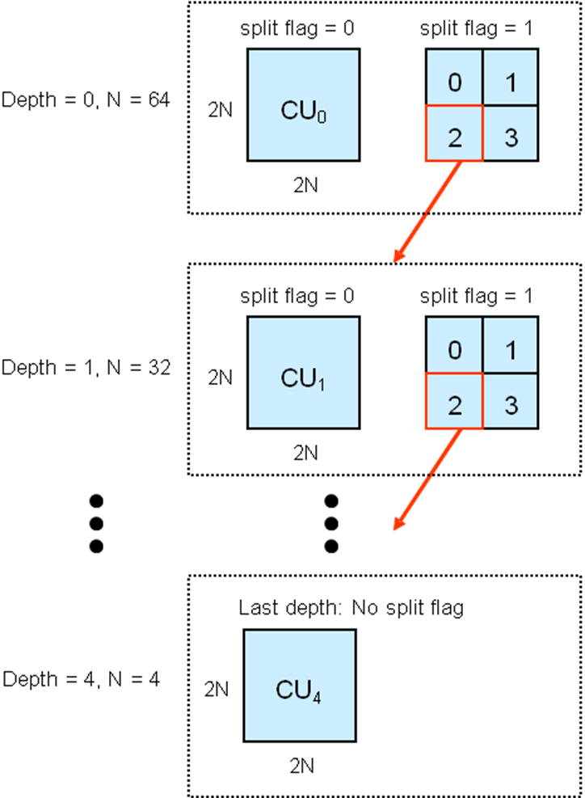
Fig. 1: Illustration of recursive CTB structure (LCTB size = 128, maximum hierarchical depth = 5)
Figure 1 shows an example where LCTB size is 128 and the maximum hierarchical depth is 5. The recursive structure is represented by a series of split flags. For CTB_{d}, which has depth d and size 2Nx2N, the coding of CTB is performed in the current depth when split flag is set to zero. When the split flag is set to 1, CTB_{d} is split into 4 independent CTB_{d+1} which have depth (d+1) and size NxN. In this case, CTB_{d+1} is called a sub-CTB of CTB_{d} similar to a sub-macroblock in H.264/AVC. Unless the depth of sub-CTB (d+1) is equal to the maximum allowed depth (4 in this case), each CTB_{d+1} is processed in a recursive manner. If the depth of sub-CTB (d+1) is equal to the maximum allowed depth, further splitting is not allowed. Note that a CTB can be further split into PUs.
The sizes of LCTB and SCTB are specified in the Sequence Parameter Set (SPS). The embedded information in the SPS is LCTB size (s) and the maximum hierarchical depth (h) in a LCTB. For example, if s = 128 and h = 5, then 5 kinds of CTB sizes are possible: 128x128 (LCTB), 64x64, 32x32, 16x16 and 8x8 (SCTB). If s = 16 and h = 2, then 16x16 (LCTB) and 8x8 (SCTB) are possible; this is a similar block structure to H.264/AVC. Therefore, if the LCTB size and maximum hierarchical depth are given, this defines the possible CTB sizes which are allowed.
This kind of arbitrary unit representation provides several major benefits. The first benefit comes from the support of CTB sizes greater than the conventional 16x16 macroblock. When the region of interest is homogeneous, a large CTB can represent the region in a smaller number of symbols than is possible in the case of several small blocks.
Furthermore, supporting arbitrary LCTB sizes enables the codec to be readily optimized for various content, applications and devices. Compared to the use of fixed size macroblock, support of various LCTB sizes is one of the major properties. It is especially useful for low resolution video services, which is still commonly used in the market. By choosing LCTB size and maximum hierarchical depth appropriately, the hierarchical block structure can be optimized in a better way for the targeted application. In the later stage of the standardization, the range of LCTB sizes could be specified in the Profiles and Levels section to match the requirements more specifically.
Finally, by eliminating the distinction between macroblock and sub-macroblock and using only one unit type, CTB, the multi-level hierarchical structure can be specified in a very simple and elegant way: LCTB size, maximum hierarchical depth and a series of split flags. Together with the proposed size-independent syntax representation, it’s sufficient to specify syntax items of one general size for the remaining coding tools. This kind of consistency can greatly simplify the specification effort as well as the actual parsing process.
The maximum depth for CTB hierarchy is arbitrary and potentially larger than the maximum depth allowed in the H.264/AVC block hierarchy. Therefore, the text includes a size-independent syntax representation which specifies all syntax elements in a consistent way independent of the CTB size. By contrast, in H.264/AVC block level syntax elements such as transform_8x8_mode_flag, coded_block_flag and intra_pred_modes are coded differently depending on whether the block size is 16, 8 or 4. The splitting process for the CTB can be specified recursively and all other syntax elements for the leaf CTB are defined in the same way independent on the CTB size. This kind of representation is very useful in terms of reduced parsing complexity and improved clarity if a large hierarchical depth is allowed.
For the purpose of mode decision, transmission of the data associated with each block etc. all CTBs are traversed in raster scan order (left-to-right, top-down), and within each CTB, the subblocks are traversed in depth-first order.

Prediction unit (PU)
Once the splitting process is done, prediction methods are specified for every CTB which is not further split i.e. the leaf nodes of the CTB hierarchical tree.
Coupled with CTB, a basic unit for the prediction mode is introduced: the prediction unit (PU). It should be noted that the PU is defined only for the last-depth CTB, i.e., the leaf nodes of the CTB-related quadtree and its size is limited to that of the CTB.
Similar to conventional standards, we define two different terms to specify the prediction method: the prediction type and the PU splitting. The prediction type is one of the values among intra or inter, which roughly describe the nature of the prediction method. After that, possible PU splittings are defined according to the prediction type.
The PU for intra has 2 different possible splittings: 2Nx2N (i.e. no split) and NxN (quarter split). The PU for inter has 8 different possible splittings: 4 symmetric splittings (2Nx2N, 2NxN, Nx2N, NxN) and 4 asymmetric splittings (2NxnU, 2NxnD, nLx2N and nRx2N). The number N is derived from the size of the CTB which the PU belongs to. For example, if the size of CTB is 128x128, then both 128x128 and 64x64 PUs for intra are possible. For inter prediction, 128x128, 128x64, 64x128, 64x64, 128x32 (for 2NxnU and 2NxnD), 128x96 (for 2NxnU and 2NxnD), 32x128 (for nRx2N and nLx2N) and 96x128 (for nRx2N and nLx2N) are possible.
Figure 1a shows an example where a 64x64 block is asymmetrically partitioned into 64x16, 64x48, 16x64, or 48x16 blocks, instead of two 64x32 or 32x64 blocks. Note that the motion partitions shown in the figure correspond to 2NxnU, 2NxnD, nLx2N, and nRx2N, respectively.

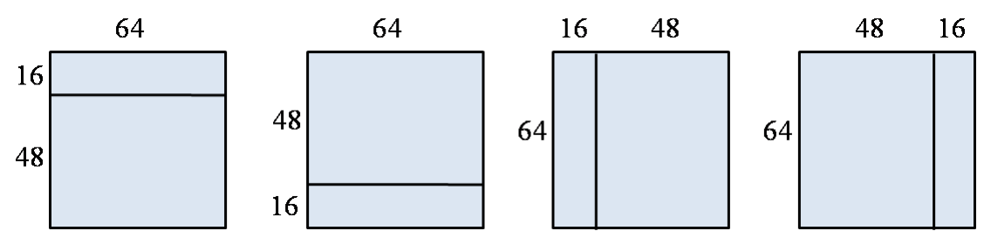
Figure 1a: Example of asymmetric motion partitions for 64x64 block

In addition, we have geometrical shapes for partitioning of inter PUs that are described as follows.
For each CTB, one type of PU splittings is defined by an arbitrary straight line across the CTB that divides the CTB into two regions. The boundary of the PU partition is defined by an angle subtended by a line perpendicular to the boundary with the X axis and the distance of the partition line from the origin . The equation of the line defining the partition boundary is specified as
Two 32 bit lookup tables are used, one to store the slope, , and the other to store the Y-intercept, . The region to which each pixel belongs is calculated on the fly.
At each level CTB, 32 different values of are defined (from 0 to in steps of ). The number of values that can take depends on the CTB size. For example, for CTB size of 16×16, takes 8 possible values (from 0 to 7 in steps of 1). For block sizes of 32×32 and 64×64, takes 16 and 32 possible values, respectively.
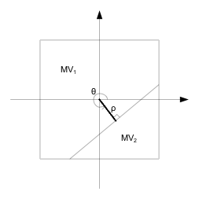
Figure 2: Parameters defining a geometry motion partition
For a CTB that is predicted in a manner described above, overlapped block motion compensation (OBMC) is applied. Let the two regions created by a geometry partition be denoted by region 1 and region 2. Let the corresponding motion vectors be denoted by and , respectively. A pixel from region 1 (2) is defined to be a boundary pixel if any of its four connected neighbors (left, top, right, and bottom) belongs to region 2 (1). Fig. 2 shows an example where light blue pixels belong to the boundary of region 1 and white pixels belong to the boundary of region2. If a pixel is not a boundary pixel, normal motion compensation is performed using the appropriate motion vector. If a pixel is a boundary pixel, the motion compensation is performed using a weighted sum of the motion predictions from the two motion vectors, and . The weights are for the region containing the boundary pixel and f for the other region.

Figure 3: Overlapped motion compensation for geometry partitions

All information related to prediction is signaled on a PU basis, for instance, the direction of intra prediction for intra or the motion vector difference and reference index for inter. Motion vector prediction and motion compensation are also performed on a PU basis.

For each inter predicted blocks, individual motion parameters are transmitted. In order to achieve an improved coding efficiency, the block merging process enables to merge neighbouring blocks into so-called regions. By doing so, the motion parameters do not need to be transmitted for each block of the region individually, but instead the parameters are transmitted only for once for the whole region.

For each inter prediction block, the set of all prediction blocks that are coded before that block in processing order is called the “set of causal blocks”. The set of blocks that is admissible for merging with a particular block is called the “set of available blocks” and is always a subset of the set of causal blocks. If a particular block is encoded and its set of available blocks is not empty, it is signaled whether this block is to be merged with one block out of this set and if so, with which of them. Otherwise, merging cannot be used for this block.
The set of available blocks is formed as follows. Starting from the top-left sample position of the current block, its left neighbouring sample position and its top neighbouring sample position is derived. The set of available blocks can have only up to two elements, namely those blocks out of the set of causal blocks that contain one of the two sample positions. Thus the set of available blocks can only have the two direct neighbouring blocks of the top-left sample position of the current block as its elements. Note that only inter predicted blocks can be members of the set of available blocks.
If the set of available blocks is not empty, one flag called merge_flag is signaled, specifying whether the current block is merged with any of the available blocks. Otherwise, or if the merge_flag is equal to 0 (for “false”), this block is not merged with one of its causal blocks and all parameters are transmitted ordinarily. If the merge_flag is equal to 1 (for “true”), the following applies. If the set of available blocks contains one and only one block, this block is used for merging. Otherwise the set of available blocks contains exactly two blocks. If the motion parameters of these two blocks are identical, these motion parameters are used for the current block. Otherwise (the two blocks have different motion parameters), a flag called merge_left_flag is signaled. If merge_left_flag is equal to 1 (for “true”), the block containing the left neighbouring sample position of the top-left sample position of the current block is selected out of the set of available blocks. If merge_left_flag is equal to 0 (for “false”), the other (i.e., top neighbouring) block out of the set of available blocks is selected. The motion parameters of the selected block are used for the current block.
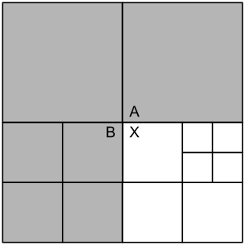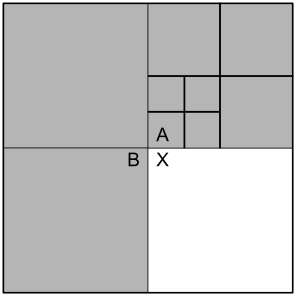
Fig. 3: Two examples illustrating the set of causal blocks (grey) and the set of available blocks (A, B).

Fig. 3 shows two examples for a quadtree-based division of a picture into prediction blocks. On the left side of Fig. 4, the top two blocks of the biggest size are so-called macroblocks, i.e., they are prediction blocks of the maximum possible size. The other blocks in this left figure are obtained as a subdivision of their corresponding macroblock. The current block is marked with an “X”. All the grey-shaded blocks are encoded before the current block, so they form the set of causal blocks. As explicated in the description of the derivation of the set of available blocks, only the blocks containing the direct (i.e. top or left) neighbouring samples of the top-left sample position of the current block can be members of the set of available blocks. Thus the current block can be merged with either block “A” or block “B”. If merge_flag is equal to 0 (for “false”), the current block “X” is not merged with any of the two blocks. If blocks “A” and “B” have identical motion parameters, no distinction needs to be made, since merging with any of the two blocks will lead to the same result. So, in this case, the merge_left_flag is not transmitted. Otherwise, if blocks “A” and “B” have different prediction parameters, merge_left_flag equal to 1 (for “true”) will merge blocks “X” and “B”, whereas merge_left_flag equal to 0 (for “false”) will merge blocks “X” and “A”.

In Fig. 4 (right) another example is shown. Here the current block “X” and the left neighbour block “B” are macroblocks, i.e., they have the maximum allowed block size. The size of the top neighbour block “A” is one quarter of the macroblock size. The blocks which are element of the set of causal blocks are grey-shaded. Note that the current block “X” can only be merged with the two blocks “A” or “B”, not with any of the other top neighbouring blocks.

Transform unit (TU)
In addition to the CTB and PU definitions, the transform unit (TU) for transform and quantization is defined separately. It should be noted that the size of the TU may be as large as the size of the CTB. Like the partitioning used for prediction, the partitioning of a single prediction error block into transform blocks is represented by quad trees. The greatest applicable transform size and the maximum depth of such quad trees (giving the minimum applicable size) are variable and are signaled in the bit stream. Transform blocks with an edge length of any positive power of two can be employed. Transform block sizes are constrained to the range 4x4 to 64x64 (for chroma, also 2x2 transforms may be used).

Motion representation

Motion vector prediction for rectangular partitions
A new method to form motion vector prediction is introduced. Unlike in H.264, this method takes the temporal distance of the reference frames into account for motion vector prediction. The neighboring blocks that are used for the prediction of the vertical components are illustrated in Figure 2.

Figure 2: Neighboring blocks used for motion vector prediction

But the motion vectors of neighboring blocks A, B, and C may point to different reference frames in the buffer. Therefore, the motion vectors are normalized based on their temporal distance from the current frame, before taking the median. This is illustrated in Figure 3 for an IPPP configuration. In the figure, blue colored frames are the reference frames stored in the buffer. Let refer to the reference frames corresponding to blocks A, B, C, and X, respectively. Let their temporal distances from the current frame be denoted by , respectively. Then, each of the neighboring motion vectors, is scaled as follows:
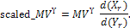

This scheme is applied to both P and B frames.

Figure 3: Reference frames and their temporal distances from the current frame

Furthermore, in order to reduce the bit rate required for transmitting the motion vectors, we employ a concept in which the prediction and coding of the components of a motion vector is interleaved. In a first step, the vertical motion vector component is predicted using conventional median prediction and the difference between the actual vertical component and its prediction is coded. Then, only the motion vectors of the neighborhood for which the absolute difference between their vertical component and the coded vertical component for the current motion vector is minimized are used for the prediction of the horizontal component.

In the following, we consider the prediction and reconstruction of a motion vector currMv for a prediction block. The location of the top-left luma sample of the prediction block, relative to the top-left luma sample of the picture, is denoted by ( x0, y0 ). The width and height of the prediction block are given by currW and currH, respectively. Given the transmitted motion vector difference mvDiff (with horizontal component mvDiff[ 0 ] and vertical component mvDiff[ 1 ]), the prediction and reconstruction of the motion vector currMv is done as described in the following. For the following description, only one reference list is considered. All motion vectors are motion vectors for this one reference list.

As first step, the vertical component mvPred[ 1 ] of the prediction vector mvPred is derived as specified by the following ordered steps:
- A list listMvCompY of vertical motion vector components is derived as follows.
    - Let blkA, blkB, and blkC be the prediction blocks that contain the luma samples at locations ( x0 − 1, y0 ), ( x0, y0 − 1 ), and ( x0 + currW, y0 − 1), respectively.
    - When blkC is not contained in the same slice as the current block, or it follows the current block in coding order, blkC is replaced with the prediction block that contains the luma sample at location ( x0 − 1, y0 − 1 ).
    - For each of the prediction blocks blkX (with X being replaced by A, B, and C), the following applies:
If the block blkX represents a motion-compensated block that is contained in the same slice as the current block and precedes the current block in coding order, the following applies with mvX being the motion vector that is associated with blkX:
The motion vector mvX is scaled as described above and inserted into the list listMvCompY.
- Let numCompY be the number of entries in the list listMvCompY and let listMvCompY[ k ], with k = 0..numCompY − 1, be the entries of the list listMvCompY. Depending on numCompY, the vertical component mvPred[ 1 ] of the motion vector predictor is derived as follows.
- If numCompY is equal to 0, mvPred[ 1 ] is set equal to 0.
- Otherwise, if numCompY is equal to 1, mvPred[ 1 ] is set equal to listMvCompY[ 0 ].
- Otherwise, if numCompY is equal to 2, mvPred[ 1 ] is set equal to ( listMvCompY[ 0 ] + listMvCompY[ 1 ] + 1 ) >> 1.
- Otherwise (numCompY is greater than 2), the entries in listMvCompY are sorted in increasing order and then mvPred[ 1 ] is set equal to listMvCompY[ numCompY >> 1 ].

Given the predictor mvPred[ 1 ] for the vertical motion vector component, the vertical motion vector component currMv[ 1 ] of the current motion vector is reconstructed by setting currMv[ 1 ] equal to ( mvPred[ 1 ] + mvDiff[ 1 ] ). Then, given the reconstructed vertical motion vector component currMv[ 1 ], the predictor mvPred[ 0 ] for the horizontal motion vector component is derived as follows:
- Let setOfBlks be the set of neighboring prediction blocks that are contained in the same slice as the current block, precede the current block in coding order, and contain a luma sample at any of the following locations:
- ( x0 − 1, y ) with y = 0..currH
- ( x, y0 − 1 ) with x = −1..currW + 1
- A list listMv of motion vectors is derived as follows:
For each block blkX of the set setOfBlks, the following applies with mvX being the motion vector that is associated with blkX:
The motion vector mvX is scaled as described above and inserted into the list listMv.
- Let numMv be the number of entries in the list listMv. If numMv is equal to 0, the predictor mvPred[ 0 ] for the horizontal motion vector component is set equal to 0; otherwise, mvPred[ 0 ] is derived as specified in the following with listMv[ k ] (k = 0..numMv − 1) representing the k-th entry in the list listMv:
  - The variable compY is initially set equal to listMv[ 0 ][ 1 ] and the variable minDelta is set equal to abs( listMv[ 0 ][ 1 ] − currMv[ 1 ] ), where abs( ) specifies the absolute value of the argument.
  - For i proceeding over the range of 1 to numMv − 1, inclusive, the following applies:
When abs( listMv[ i ][ 1 ] − currMv[ 1 ] ) is less than minDelta or (abs( listMv[ i ][ 1 ] − currMv[ 1 ] ) is equal to minDelta and listMv[ i ][ 1 ] is less than compY), compY is set equal to listMv[ i ][ 1 ].
  - The list listMvCompX is derived as follows.
For i proceeding over the range of 0 to numMv − 1, inclusive, if listMv[ i ][ 1 ] is equal to compY, the value listMv[ i ][ 0 ] is inserted into the list listMvCompX.
  - Let numCompX be the number of entries in the list listMvCompX and let listMvCompX[ k ], with k = 0..numCompX − 1, be the entries of the list listMvCompX. Depending on numCompX, the horizontal component mvPred[ 0 ] of the motion vector predictor is derived as follows.
    - If numCompX is equal to 1, mvPred[ 0 ] is set equal to listMvCompX[ 0 ].
    - Otherwise, if numCompX is equal to 2, mvPred[ 0 ] is set equal to ( listMvCompX[ 0 ] + listMvCompX[ 1 ] + 1 ) >> 1.
    - Otherwise (numCompX is greater than 2), the entries in listMvCompX are sorted in increasing order and then mvPred[ 0 ] is set equal to listMvCompX[ numCompX >> 1 ].

Given the predictor mvPred[ 0 ] for the horizontal motion vector component, the horizontal motion vector component currMv[ 0 ] of the current motion vector is reconstructed by setting currMv[ 0 ] equal to ( mvPred[ 0 ] + mvDiff[ 0 ] ).

Motion vector prediction for geometric block partitions
The process of forming motion vector prediction for a geometric block partition is shown Figure 2. Motion vectors of neighboring blocks are used to form the motion vector prediction. Depending on the partition, a subset of blocks from are used to form motion vector prediction. The choice of block for motion vector prediction depends upon whether they lie on the same side or opposite side of the geometry partition boundary.

Figure2: Motion vector prediction for a block having geometry partition

Let blkA, blkB, blkC, blkD, blkE and blkF be the prediction blocks that contain the luma samples at locations ( x0 − 1, y0 ), ( x0, y0 − 1 ), ( x0 + currW, y0 − 1), ( x0 − 1, y0 − 1 ), ( x0 + currW − 1, y0 − 1 ), and ( x0 − 1, y0 + currW − 1), respectively. For each partition, if blkX (X being replaced A, B, C, D, E and F) is sharing a boundary with the partition, blkX is used to derive the prediction motion vector.

The prediction motion vector mvPred is derived as specified by the folowing ordered steps:

If blkA, blkB and blkC are all connected to the current partition, median filter is used to derive mvPred.
- Otherwise, if blkA is connected to the current partition, mvPred = mvA
- Otherwise, if blkB is connected to the current partition, mvPred = mvB
- Otherwise, if blkE is connected to the current partition, mvPred = mvE
- Otherwise, if blkF is connected to the current partition, mvPred = mvF
- Otherwise, if blkC is connected to the current partition, mvPred = mvC
- Otherwise mvPred = (0,0)

Interpolation Methods
This text uses single pass switched interpolation filters with offsets (single pass SIFO). The 1/4th pixel motion positions are shown in the figure.

Single pass switched Interpolation Filters with offsets (single pass SIFO)
In this text, 7 different filter sets are defined. Each filter set consists of 15 filters, one for each fractional pixel position.

- Filter set 0: This filter set uses high precision filtering with the filters shown in the following table with the exception of position ‘g’, where a non-separable filter is used.
Table 1: 6-tap separable filters
1/4 | { 8, -32, 224, 72, -24, 8 } (8 additions, 4 shifts)
1/2 | { 8, -40, 160, 160, -40, 8 } (6 additions, 3 shifts)
3/4 | { 8, -24, 72, 224, -32, 8 } (8 additions, 4 shifts)

The filter coefficients are scaled by 256 and the intermediate data is kept in higher precision. For position ‘g’, the following filter is used (followed by right shift by 7 bits):
0 | 5 | 5 | 0
5 | 22 | 22 | 5
5 | 22 | 22 | 5
0 | 5 | 5 | 0
- Filter set 1: This filter set uses 12 tap filters for both horizontal and vertical filtering. The filter coefficients are scaled by 256. A higher bit depth of filter coefficients leads to more accurate interpolation; for comparison, H.264/AVC uses 5 bits for filter coefficients. Also, the intermediate values are maintained at higher bit precision.

Table 2: 12-tap separable filters
¼ | {-1, 5, -12, 20,-40, 229, 76, -32, 16, -8, 4,-1 } (18 additions, 6 shifts)
½ | {-1, 8, -16, 24,-48, 161, 161, -48, 24, -16, 8,-1 } (15 additions, 4 shifts)
¾ | {-1, 4, -8, 16, -32, 76, 229, -40, 20, -12, 5,-1 } (18 additions, 6 shifts)

- Filter set 2: This set of interpolation filter is referred to as the Directional Interpolation Filter (DIF) and is used for all 15 quarter-pixel positions. For each of the three horizontal positions and the three vertical positions which are aligned with full pixel positions, a single 6-tap filter is used. For the 9 innermost quarter-pixel positions two 6-tap filters at +45 degree and -45 degree angles are used.

The filter coefficients for DIF are
[3 -15 111 37 -10 2]/128 for ¼ displacement (and mirrored for ¾ displacement)
[3 -17 78 78 -17 3]/128 for ½ displacement

- Filter set 3: The third set of interpolation filters consists of Separable Filters (SF) where interpolated samples are calculated by first applying a 6-tap filter horizontally and then vertically.

The filter coefficients for SF are
[3 -15 111 37 -10 2]/128 for ¼ displacement (and mirrored for ¾ displacement)
[3 -17 78 78 -17 3]/128 for ½ displacement

- Filter set 4: Consists of a combination of a 2-tap pre-filter and a 4-tap interpolation filter.
  - The pre-filter is a 1D IIR filter in horizontal and vertical directions. The coefficients are given below:
    - Left-to-right filtering: [ 1 ] / [ 1, c ]
    - Right-to-left filtering: [ c ] / [ 1, c ]
where, the constant c = -11276. The pre-filter produces the same number of samples as the input to it. The filtering can be performed on the picture region to be interpolated.

  - The interpolation filter is implemented as a sequence of 1D horizontal and vertical filtering step. The FIR filters consist of 4-taps. The filter coefficients are the same for both horizontal and vertical directions. The filters used for different sub-pel positions are given below:
    - Full-pel: [6242, 20284, 6242, 0] / 32768
    - 1/4 pel : [2888, 19078, 10520, 280] / 32768
    - 1/2 pel : [1073, 15311, 15311, 1073] / 32768
    - 3/4 pel : [280, 10520, 19078, 2888] / 32768

- Filter set 5 and 6: For each set, positions a, b, and c use a six-tap horizontal filters. Positions d, h, and l use six-tap vertical filters. For the remaining fractional pixel positions, 4×4 non-separable filters are used. Each of the non-separable filters has horizontal, vertical or diagonal symmetry.

Choice of filter set and offsets
The choice of the filter and offset is signalled to the decoder for each slice. For each of the 15 fractional pixel positions, the choice of the filter is signalled using 3 bits. Before encoding a frame, the encoder selects a filter for each fractional pixel position based on statistics gathered from previously encoded frames. In this text, the filter that minimizes prediction error for the previously encoded frames is selected. For each fractional pixel position, the minimization is performed only on blocks whose motion vector points to that fractional pixel location. The choice of filter remains the same irrespective of the reference frame in which the motion search is being performed.
For reference frame 0 from each list, offsets are sent to the decoder for each of the 15 fractional pixel positions as well as the full pixel position For other reference frames only one frame offset is sent. The offsets are encoded using exponential Golomb codes.

Adaptive Motion Vector Resolution
For each region in a motion partition, the motion accuracy can be adaptively chosen to be 1/4th pixel or 1/8th pixel. We will refer to this as adaptive motion vector resolution. The choice of motion vector resolution is signaled to the decoder. For each motion vector, a motion vector resolution flag is encoded. If the flag is zero, the motion vector precision is 1/4th otherwise 1/8th. If the flag is 1 and motion vector is nonzero, refinement information for this motion vector is sent which specifies 1/8th pel precision.
The encoder always maintains the motion vector (MV) and MVD information at 1/8th pixel resolution. Then, the MV prediction for the current block is formed with 1/8th pixel accuracy. If the current block has only 1/4th pixel motion accuracy, the MV prediction is converted to 1/4th pixel accuracy. On the other hand if the current block has 1/8th pixel motion accuracy, the MVD is formed directly by subtracting the MV prediction from the motion vector for the current block. Once MVD is formed, if the current block has 1/4th pixel accuracy, for all the neighboring blocks used for determining the MVD contexts, the MVDs are converted to 1/4th pixel accuracy. Similar procedure is followed for 1/8th pixel accuracy.

Intra-frame prediction
For blocks of size 64x64 : 33 Directions (ADI+Planar)
For blocks of size 32x32 : 33 Directions (ADI+Planar)
For blocks of size 16x16 : 33 Directions (ADI+Planar)
For blocks of size 8x8 : 33 directions (Angular+Planar)
For blocks of size 4x4: 9 directions (AVC)

Adaptive reference sample smoothing
In addition, a smoothing operation can be applied to the reference samples as a pre-processing step before calculating the prediction. This smoothing operation corresponds to applying an FIR-filter (1,2,1)>>2 with low-pass characteristics to the samples along the two reference rays. Whether this smoothing operation is used is determined by the encoder and signaled in the bit stream.

Planar prediction
The planar prediction is designed to be able to reconstruct smooth image segments in a visually pleasing way. It provides maximal continuity of the image plane at the macroblock borders and is able to follow gradual changes of the pixel values by signalling a planar gradient for each macroblock coded in this mode. When a macroblock is coded in planar mode its bottom-right sample is signalled in the bitstream, the rightmost and bottom samples of the macroblock are linearly interpolated, and the middle samples are bilinearly interpolated from the border samples. When planar mode is signalled, the same algorithm is applied to luminance and both chrominance components separately with individual signalling of the bottom-right samples (16x16 based operation for luminance and 8x8 based for chrominance). The process is illustrated in the picture below.

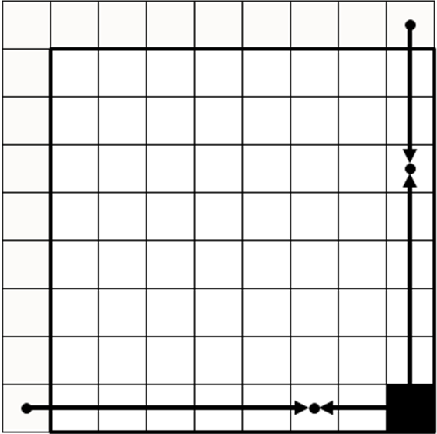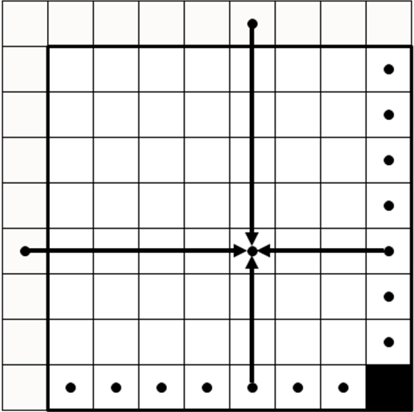
Planar prediction of an 8x8 (chrominance) block. Bottom-right sample is signalled in the bitstream, rightmost and bottom samples are interpolated linearly, and the middle samples are interpolated bi-linearly.

Angular prediction
In order to be able to accurately represent directional structures the Intra 8x8 coding mode provides a possibility to predict the blocks at any direction shown below.

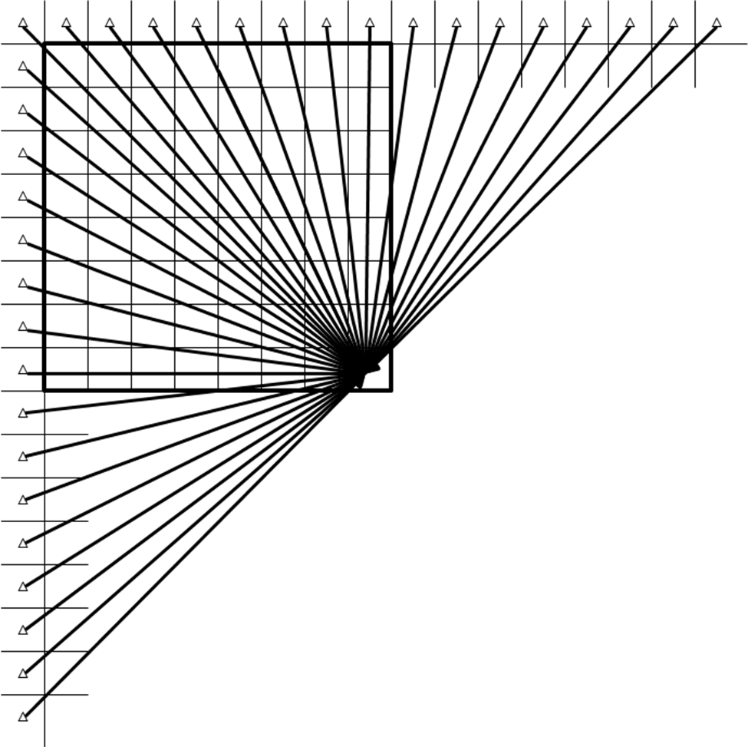
Available prediction directions in the angular mode of Intra 8x8 macroblocks.

In the angular mode the prediction direction is given by the displacement of the bottom row of the block and the reference row above the block in the case of vertical prediction or displacement of the rightmost column of the block and reference column left from the block in the case of the horizontal prediction. The displacement is signalled at 1 pixel accuracy. When projection of the predicted pixel falls inbetween reference samples, the predicted value for the pixel is linearly interpolated from the reference samples (at 1/8th pel accuracy). The process is illustrated in the picture below for the sixth row of the block when building vertical prediction at +1 pixel displacement.
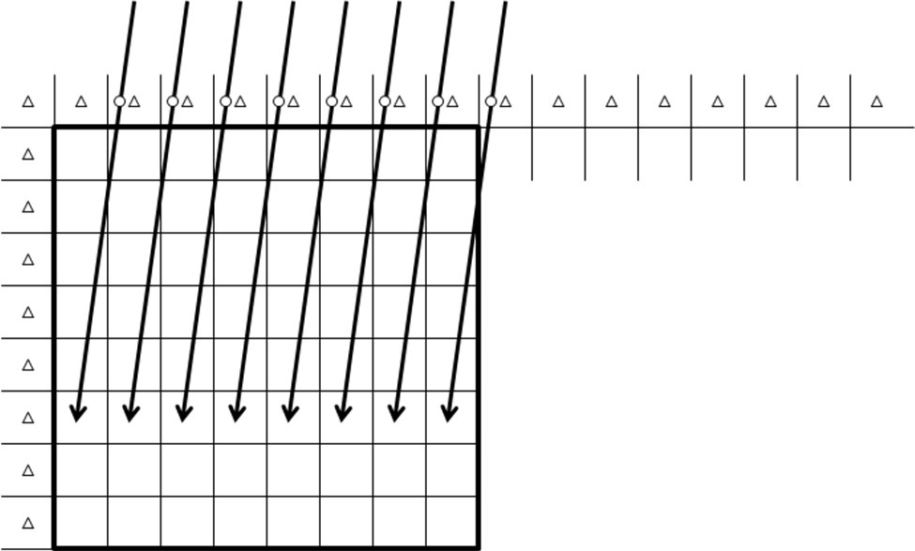
Figure 4 An example of angular prediction when operating the sixth row of the block with +1 pixel displacement. Projections of the pixels now fall at the 6/8 sub-pixel location (circles) in the reference row of pixels.

Arbitrary Directional Intra (ADI)
Arbitrary Directional Intra (ADI) generates prediction pixels by directional extrapolation or calculation using the nearest boundary pixels of the already decoded area. But in ADI, even boundary pixels from the left down region may be used as context pixels for prediction as depicted in below

Example of context pixels for ADI
Whilst the 9 prediction modes are defined separately as Vertical, Horizontal, DC, Diagonal Down-Left, Diagonal Down-Right, Vertical-Right, Horizontal-Down, Vertical-Left, and Horizontal-Up in H.264/AVC, most of prediction modes in ADI are defined by integer pair information (dx, dy). The (dx, dy) pair represents the direction which each mode uses for context pixel extrapolation

prediction methods defined by (dx, dy)

Combined Intra Prediction (CIP)
The CIP is a low-complexity tool for providing improved prediction, especially in large blocks where a directional linear prediction may not work well, even with the large range of angles available to ADI. CIP predictions comprise a weighted combination of an ADI prediction together with a pixel-by-pixel mean prediction. It provides pixel-by-pixel adaptation but is a simpler tool than, for example, local template matching approaches.
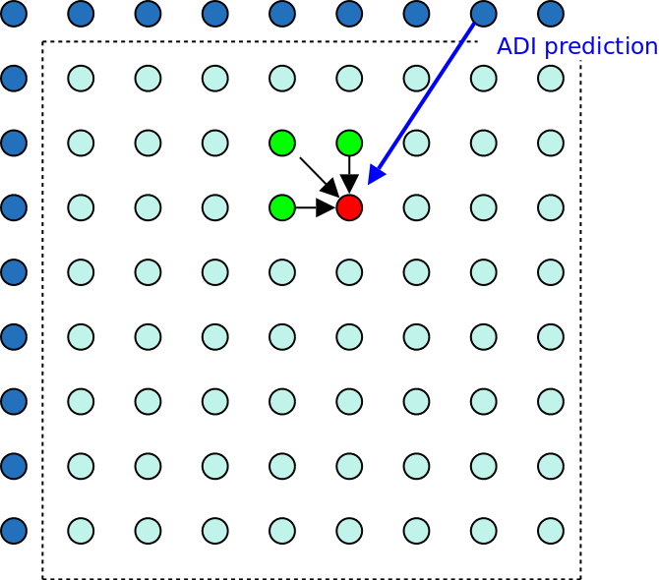
Figure 2-12 Example of Combined Intra Prediction utilizing a local mean and ADI prediction
The local mean is constructed as the average of pixel values to the left, top-left and above the current picture. In the decoder and within the local decoder in the encoder, these values are the reconstructed values after inverse quantization and transform. In the encoder, the reconstructed values are not available because quantization and transform of the prediction residue have not yet been performed, so original values are used This local mean prediction is therefore different between forward prediction (encoder only) and reconstruction (encoder and decoder).
The combination factor is a 5-bit number between 0 and 31/32 which determines the proportion of local mean in the prediction. Since this number is less than 1, the prediction/reconstruction difference noise is damped, and pixel-by-pixel prediction adaptation is possible without noise blow-up. The ADI component provides an overall prediction direction and the local mean prediction provides local adaptation.
For each CTB, a single CIP flag is sent for all PUs. If set, the flag indicates that CIP prediction is used, otherwise ADI prediction is used. The use of CIP is signaled in the SPS.

Spatial transforms

Large transform (16x16, 32x32, 64x64)
For smooth data, a large transform has several advantages such as better energy compaction and reduced quantization error. In HD sequences, most image patterns in a macroblock represent a small part of objects or backgrounds which can be described as homogeneous texture patterns with little variation. Therefore, the coding efficiency of high resolution video can be improved by the use of large transforms as well as large block sizes. By contrast, H.264/AVC supports only 4x4 and 8x8 transform sizes. Larger transform sizes can also be chosen (or set) for each coding unit (blocks or partitions). Transform sizes larger than the prediction unit can also be supported.
3 additional sizes of transform are included: 16x16, 32x32 and 64x64. In a large transform design, it is very important to minimise complexity. The transforms in this text are based on Chen’s fast DCT algorithm [10]. Chen’s algorithm is not the fastest one, but it has reduced implementation complexity due to the regular butterfly structure. Moreover, it is readily extensible to larger transform sizes.
Figure 2-1 Signal flow graph of Chen’s fast 16-point DCT transform
Figure 2-1 shows the signal flow graph of Chen’s fast factorization of a 16 point DCT transform. In this figure, multiplication constants are represented by sinusoidal functions of specific angles, requiring floating point operations. To solve this problem, we scale and approximate the factors by fixed precision using pre-defined values, which can be calculated by cost effective shift operations. The approximated constants are shown in Table 0., with pre-defined precision value 64 in this case. Here, the ak’s are approximated values of cos(k*pi/32) for k =1,2,…,15.
Table 0 Approximated constants for 16 point transform
a1 | a2 | a3 | a4 | a5 | a6 | a7 | a8 | a9 | a10 | a11 | a12 | a13 | a14 | a15
63/64 | 62/64 | 61/64 | 59/64 | 56/64 | 53/64 | 49/64 | 45/64 | 40/64 | 35/64 | 30/64 | 24/64 | 18/64 | 12/64 | 6/64

When the constant is approximated by the dyadic rational, the transform is no longer truly orthogonal. However, this minor non-orthogonality does not result in any perceptible negative effects on the compression performance, whilst the complexity can be significantly reduced.

Rotational transform (ROT)
DCT is the most widely used transform in block based video and image codecs. The input to the transform is the residual, i.e. the difference between the prediction and the original signal. But it is well-known that the DCT basis functions are not optimal for some types of residual signal. For example, the residual signal having strong diagonal components cannot be represented efficiently with the DCT basis vectors.
Typically, directional transform schemes are exploited to solve this problem since spatial domain rotation makes it dificult to maintain the original square shape of the block and generally requires many floating point operations. However, it’s hard to develop directional transform cores, especially since many transforms of different sizes are needed. This text uses mode dependent directional transforms (MDDT) for block sizes of 4×4 and 8×8, and uses ROT for the higher block sizes. ROT can be applied as a 2nd transform after the DCT operation for block sizes of 16×16 or higher.
The main idea of ROT is to change the coordination system of the transform basis, instead of direct rotation of the input source. For this purpose, the following matrices are defined as

where R_{vertical} and R_{horizontal} represent the rotation matrices for horizontal and vertical directions with the rotation angles of (α1, α2, α3) and (α4, α5, α6), respectively. In this text, only four out of all possible rotation angles are quantized and used, in order to minimize the encoder-side complexity. The chosen transform is signalled to the decoder using the chosen intra prediction direction as the context.

Furthermore, since ROT is a second transform, not all of the DCT coefficients are processed. For the TUs larger than 8×8, only 8x8 low-frequency areas are rotated by multiplying by the ROT matrix since most coefficients are already compacted into these low-frequency areas.

Mode dependent directional transforms for intra-prediction residuals
In this text, nine directional intra prediction modes are used for block size of 4×4 and 33 directional intra prediction modes are used for block sizes of 8×8 (INTRA4x4 and INTRA8x8). For each directional prediction mode, the prediction residual exhibits a different directionality. In addition, the magnitude of the error increases for predicted pixels farther away from the boundary pixels used for prediction. To take advantage of this, mode dependent directional transforms (MDDT) are used to encode 4×4 and 8×8 intra prediction residuals. The type of MDDT is coupled with the selected intra prediction direction, so is not explicitly signaled. We briefly describe design and implementation of the MDDT.
For the 8×8 block size, the 33 intra prediction directions are clustered into nine separate directions. Thus, for both 4×4 and 8×8 blocks, nine separate MDDT transforms are designed. The Karhunen-Loève transform (KLT) derived from the statistics of the intra prediction residuals for that mode, would be the optimal transform choice from a rate-distortion perspective. However, KLT is a non-separable transform. For a residual block of size $N×N$, the size of the KLT matrix is $N^{2}×N^{2}$. Thus, KLT is prohibitively expensive in term of storage and computational requirement. A separable directional transform is used, which can be described as
$Y=C_{i}{\text{XR}}_{i}$,
where X, Y, C, and R are all of size and i is the prediction mode. Singular Value Decomposition (SVD) is applied to the training set of residuals first in the row direction and then, in the column direction. A fixed-point approximation of the transform matrices to reduce computational cost is used.
Adaptive coefficient scanning
After applying separable directional transform, the 2-D transform coefficient matrix is converted to 1-D. In H.264, zigzag scanning order is used for this purpose. In the case of MDDT, even after separable directional transforms are applied, the resulting 2-D transform coefficient matrix still carries some directionality. For example, consider vertical prediction (mode 0). After prediction, transform and quantization, the nonzero coefficients tend to exist along the horizontal direction. By using coefficient scanning oriented in the horizontal direction instead of the zigzag scanning, the non-zero coefficients in the 2D matrix can be further compacted toward the beginning of the 1-D vector. This in turn improves entropy coding efficiency. Quantized transform coefficients of different prediction modes carry different statistics. Therefore, for each mode, adaptive coefficient scanning is used. This is accomplished as follows:
- At the beginning of each video slice, initialize the coefficient scanning order for each prediction mode;
- When a block is entropy-coded, for each non-zero coefficient coded, increment the count at the corresponding position by one;
- After each macroblock is coded, update the coefficient scanning order according to the statistics collected;
- Normalize the collected statistics if needed;
- Use the updated order for coding of future blocks. Go back to 2 until slice is finished.

Quantization
The basic principle for quantization and de-quantization of coefficients for large transforms is the same as that used in H.264/AVC, i.e. a scalar quantizer with dead-zone.

Deblocking filter
Deblocking filter operates across 8x8 block edges for luma as well as for chroma blocks.
p3₀ p2₀ p1₀ p0₀
p3₁ p2₁ p1₁ p0₁
p3₂ p2₂ p1₂ p0₂
A p3₃ p2₃ p1₃ p0₃
P3₄ p2₄ p1₄ p0₄
P3₅ p2₅ p1₅ p0₅
P3₆ p2₆ p1₆ p0₆
P3₇ p2₇ p1₇ p0₇

q0₀ q1₀ q2₀ q3₀
q0₁ q1₁ q2₁ q3₁
q0₂ q1₂ q2₂ q3₂
q0₃ q1₃ q2₃ q3₃ B
q0₄ q1₄ q2₄ q3₄
q0₅ q1₅ q2₅ q3₅
q0₆ q1₆ q2₆ q3₆
q0₇ q1₇ q2₇ q3₇

Notation of Block Edge for Deblocking

Luma filtering
The luma edge between blocks A and B can be filtered if one of the following conditions is true
- Block A or Block B has mbMode==INTRA
- or Block A or block B has nonzero transform coefficients
- or The absolute difference between the horizontal or vertical component of the motion vectors used for Block A and Block B is greater than or equal to 4 in units of quarter luma samples,
- and |p2₂ - 2*p1₂ + p0₂| + |q2₂ - 2*q1₂ + q0₂| + |p2₅ - 2*p1₅ + p0₅| + |q2₅ - 2*q1₅ + q0₅| < β

The luma edge between blocks A and B is not filtered if one of the following conditions is true.
- Block A and Block B belong to the same macroblock and mb_svt_flag==1
- or Block A and Block B belong to the same macroblock and (mbMode==INTER_16x16 or mbMode==INTRA) and transform 16x16 is used
- or the edge is an internal edge of a large macroblock LMB32
- or the edge is an internal edge of a large macroblock LMB64
- or the edge is a macroblock border and both Block A and Block B have planar_flag ==1.

If the edge between Block A and Block B is filtered, one of two types of filtering (weak or strong filtering) is performed. The choice between the strong and the weak filtering is done separately for each line depending on the following conditions. For each line i = 0,7, the strong filtering is performed if all the following conditions are true, otherwise, weak filtering is performed.
- d < (β>>2)
- and (|p3_{i} - p0_{i}| + |q0_{i} – q3_{i}|) < (β>>3)
- and |p0_{i} – q0_{i}| < ((5*t_{C} + 1)>>1),

where t_{C} and β depends on qp their relations are shown in Table 1. t_{C} is increased by 4 when one of Block A or Block B has mbMode==INTRA.

Table 1 Corr_qpc, tc and β
qp | 0 | 1 | 2 | 3 | 4 | 5 | 6 | 7 | 8 | 9 | 10 | 11 | 13 | 13 | 14 | 15 | 16 | 17
Corr_qpc | 0 | 0 | 0 | 0 | 0 | 0 | 0 | 0 | 0 | 0 | 0 | 0 | 0 | 0 | 0 | 0 | 0 | 0
t_{c} | 0 | 0 | 0 | 0 | 0 | 0 | 0 | 0 | 1 | 1 | 1 | 1 | 1 | 1 | 1 | 1 | 1 | 2
Β | 0 | 0 | 0 | 0 | 0 | 0 | 6 | 7 | 8 | 9 | 10 | 11 | 12 | 13 | 14 | 15 | 16 | 17
qp | 18 | 19 | 20 | 21 | 22 | 23 | 24 | 25 | 26 | 27 | 28 | 29 | 30 | 31 | 32 | 33 | 34 | 35
Corr_qpc | 0 | 0 | 1 | 1 | 1 | 1 | 2 | 2 | 2 | 3 | 3 | 4 | 4 | 5 | 5 | 6 | 6 | 6
tc | 2 | 2 | 2 | 3 | 3 | 3 | 3 | 4 | 4 | 4 | 5 | 5 | 6 | 6 | 7 | 8 | 9 | 9
Β | 18 | 20 | 22 | 24 | 26 | 28 | 30 | 32 | 34 | 36 | 38 | 40 | 42 | 44 | 46 | 48 | 50 | 52
qp | 36 | 37 | 38 | 39 | 40 | 41 | 42 | 43 | 44 | 45
Corr_qpc | 7 | 7 | 7 | 8 | 8 | 8
tc | 10 | 10 | 11 | 11 | 12 | 12 | 13 | 13 | 14 | 14
Β | 54 | 56 | 58 | 60 | 62 | 64

Weak filtering
Weak filtering mode filtering is performed based on the above conditions,

Δ = Clip(-t_{C},t_{C}, (13*(q0_{i} - p0_{i}) + 4*( q1_{i} - p1_{i}) - 5*( q2_{i} - p2_{i})+16)>>5)) i = 0,7
p0_{i} = Clip₀₋₂₅₅(p0_{i} + Δ) i = 0,7
q0_{i} = Clip₀₋₂₅₅(q0_{i} - Δ) i = 0,7
p1_{i} = Clip₀₋₂₅₅(p1_{i} + Δ/2) i = 0,7
q1_{i} = Clip₀₋₂₅₅(q1_{i} - Δ/2) i = 0,7

Strong filtering
Strong filtering mode is performed with the following set of operations.

p0₀=Clip₀₋₂₅₅((p2_{i} + 2*p1_{i} + 2*p0_{i} +2*q0_{i} + q1_{i} + 4)>>3); i = 0,7
q0₀=Clip₀₋₂₅₅((p1_{i} + 2*p0_{i} + 2*q0_{i} + 2*q1_{i} + q2_{i} + 4)>>3); i = 0,7
p1₀=Clip₀₋₂₅₅((p2_{i} + p1_{i} + p0_{i} + q0_{i} +2)>>2); i = 0,7
q1₀=Clip₀₋₂₅₅((p0_{i} + q0_{i} + q1_{i} + q2_{i} +2)>>2); i = 0,7
p2₀=Clip₀₋₂₅₅((2*p3_{i} + 3*p2_{i} + p1_{i} + p0_{i} + q0_{i} + 4)>>3); i = 0,7
q2₀=Clip₀₋₂₅₅((p0_{i} + q0_{i} + q1_{i} + 3*q2_{i} + 2*q3_{i} + 4)>>3); i = 0,7

Chroma filtering
The chroma edge between blocks A and B can be filtered if the following condition is true.
- Block A or Block B has mbMode==INTRA

The filtering is not applied if both following conditions are true.
- The edge is a macroblock edge
and both Block A and Block B have planar_flag==1.

If filtering is performed based on the above condition,

Δ = Clip(-t_{C},t_{C},((((q0_{i} - p0_{i}) << 2) + p1_{i} - q1_{i} + 4) >> 3)) i = 0,7
p0_{i} = Clip₀₋₂₅₅(p0_{i} + Δ) i = 0,7
q0_{i} = Clip₀₋₂₅₅(q0_{i} - Δ) i = 0,7

t_{C} depend on qp and their relations are shown in Table 1. For chroma filtering t_{C} is increased by 4.

Planar mode filtering
There is a special filtering mode which is applied to the macroblock edge when both macroblocks are encoded in intra planar mode. Luma and chroma edges between blocks A and B are filtered with planar filtering if all of the following conditions are true, otherwise normal filtering described in and are performed.
- Edge between Macroblock A and Macroblock B is a macroblock edge
- Both Macroblock A and Macroblock B have planar_flag==1

Planar luma filtering
The planar mode filtering for luma component is performed with the following set of operations.

p3_{i} = (7*p3_{i} + 3)/7 i = 0,15
p2_{i} = (6*p3_{i} + q3_{i} + 3)/7 i = 0,15
p1_{i} = (5*p3_{i} + 2*q3_{i} + 3)/7 i = 0,15
p0_{i} = (4*p3_{i} + 3*q3_{i} + 3)/7 i = 0,15
q0_{i} = (3*p3_{i} + 4*q3_{i} + 3)/7 i = 0,15
q1_{i} = (2*p3_{i} + 5*q3_{i} + 3)/7 i = 0,15
q2_{i} = (p3_{i} + 6*q3_{i} + 3)/7 i = 0,15
q3_{i} = (7*q3_{i} + 3)/7 i = 0,15

Planar chroma filtering
The planar mode filtering for chroma component is performed with the following set of operations.

p1_{i} = (4*p1_{i} + 2)/4 i = 0,7
p0_{i} = (3*p1_{i} + q1_{i} + 2)/4 i = 0,7
q0i = (2*p1i + 2q1i + 2)/4 i = 0,7
q1i = (p1i + 3*q1i + 2)/4 i = 0,7

In-loop filtering
The purpose of the adaptive loop filtering (ALF) process is to further reduce the distortion between the original picture and the reconstructed picture caused by complex lossy coding. Filters minimizing the distortion for both luma and chroma components are calculated using the Wiener filter approach. After filters are applied in a frame or coding units, filter coefficients are explicitly sent in the bitstream. This adaptive loop filter increases reconstructed picture quality as well as reference picture quality for the next picture coding. The filtering control basis is usually obtained independently from the prediction structure, which results in a large amount of information being sent to the decoder and its inability to access prediction information in its process.
In this text, Coding Block Tree (CBT) synchronized ALF is presented. By utilizing the coding unit structure, the amount of control information to be sent is reduced. Due to the flexible coding unit structure from large to small block, coding unit boundary provides great flexibility to be used as control basis in the adaptive loop filter process. Since the optimal coding unit boundary obtained from previous coding stages reflects objects’ boundaries having similar properties, like prediction and quantization error, a simple control scheme which infers filter control structure from the coding unit structure and the optimal control depth reduces the complexity of the optimal control map while achieving similar performance.
Once the control units for filtering are determined, a control flag indicating whether filtering is applied is sent to maximize filter performance and reduce complexity of filter application. Depending on the largest block size, the maximum depth, sequence property and coding parameters, the number of coding units can be too many to be used as filter control units itself. Thus the optimal control depth is sent to indicate the maximum depth (i.e., the smallest size) of a coding unit boundary to be used as filter control map.
The text uses M set of separable filters. The M sets of separable filters is transmitted to the decoder for each frame. Whenever the ALF segmentation map indicates that a block should be filtered, for each pixel, a specific set of filters is chosen based on a measure of local characteristic of an image, called activity measure. The text uses the sum-modified Laplacian measure. The sum-modified Laplacian for pixel is calculated as follows:
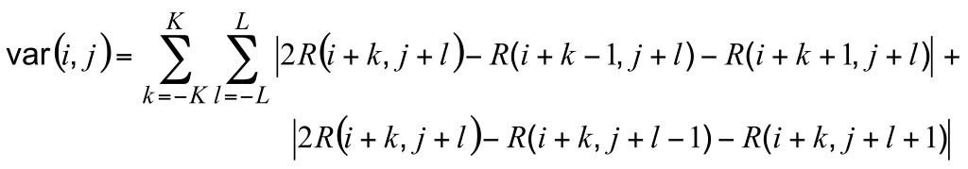.

Entropy Coding

Low-Complexity Entropy Coding
General
All syntax elements are encoded using either FLC or “UVLC-like” VLC tables. Each syntax element use one out of 10 pre-determined VLC tables that are designed for different probability distributions. All VLC tables are organized in the conventional way with the shortest binary codeword at the beginning.

Encoding of a parameter/event using a VLC table is typically done in three steps:
- Convert the parameter/event value to a table index by using some enumeration scheme.
- Use the table index to generate a code number through lookup in a sorting table. The purpose of the sorting table is to assign code numbers according to increasing probability so that parameters/events with the high probability are assigned a code number with a low value.
- Use the code number to generate a binary codeword by lookup in the pre-determined VLC table.
The VLC encoding process is illustrated in Figure 5, while the VLC decoding process is illustrated in Error: Reference source not found.
event
table_index
code number
binary codeword
e.g. inter/
16x16/
ref=0
e.g. 12
e.g. 7
e.g. 010
enumeration
sorting table
VLC table
Figure 5 VLC encoding process
code number

table_index

event
e.g. 010
e.g. 7
e.g. 12
e.g. inter/
16x16/
ref=0
inverse VLC table
inverse sorting table
’inverse enumeration’
Figure 5 VLC decoding process

Adaptivity
Two different forms of adaptivity are applied to VLC encoding:
- For some parameters/events, the particular VLC table to be used depends on the value of previously encoded parameters/events. A context variable is maintained that indicates expected probability distribution of the events. This variable is updated as the events are encoded and it is used to look-up VLC table number.
- For some parameters/events, the sorting table is made adaptive. This process is most easily described in terms of decoder operations as follows: For each binary codeword that is decoded into a code number, determine the corresponding table index by lookup into an inverse sorting table. Next, swap that entry in the inverse sorting table with the entry immediately above. This mechanism ensures that a table index value that occurs frequently eventually propagates towards the top of the inverse sorting table, corresponding to the most likely value and the shortest binary codeword. On the encoder side, both a sorting table and the corresponding inverse sorting table need to be updated simultaneously. Updating the inverse sorting table on the decoder side is illustrated in Figure 6.

code number = 7

before sorting:
after sorting:

12
3
9
3
12
9
0
6
7
0
6
7
table_index = 12

Figure 6 Update of inverse sorting table - example

Transform coefficients
Entropy coding of transform coefficients is performed by an improved version of CAVLC as follows:

  - Organize the quantized transform coefficients, each represented by a level and sign in a 1D array using the conventional zig-zag scan.
  - Coefficients are encoded backwards along the 1D array from the most high frequency coefficient towards the DC coefficients.
  - Each event (to be described below) is encoded using an “UVLC-like” table. Different VLC tables are used for different events.
  - First, the last significant coefficient (last_coeff) is coded in two steps:
    - Code the position (in backward scan order) of last_coeff (last_pos) and a flag (levelFlag = level>1) as a combined event.
    - If level>1 code the value of level as a single event
    - Code the sign as one bit
  - If level==1, continue encoding non-zero levels in run-mode.
  - If level>1, switch to level-mode if any of the following is true:
    - Cumulative sum of all level of coefficients coded so far >1 (excluding the level of last_coeff), is bigger than a threshold
    - The position of the current level is bigger than the threshold position
  - In run-mode, encode each non-zero coefficient using the preceding run and levelFlag as a combined event. Then encode the sign and level (if levelFlag==1).
  - In level-mode, encode each coefficient (including zero coefficients) as level and sign.

For the combined last_coeff/levelFlag event, an adaptive sorting table is used.

Side information
The following parameters are coded as a combined event for each macroblock:
- macroblock mode
- motion vector partition
- transform size
- macroblock level CBP information
- reference frame index for P frames
- dqp flag (indicating whether or not dqp is signalled for that MB)
For this combined event, an adaptive sorting table is used.

The following side information parameters are encoded separately as single events:
- block level CBP
- motion vector differences
- reference frame index for B frames
- intra prediction modes
Block level CBP is encoded using an adaptive sorting table.

High Coding Efficiency Entropy Coding

For entropy coding, a variation of CABAC (as found in H.264/AVC) is employed. The binarization and context modeling are basically the same as in CABAC of H.264/AVC, except from a few modifications and additions as further explained below. However, the actual coding of the bins is based on a novel concept that has been introduced in order to support parallelized implementations of entropy encoding and decoding with load balancing.

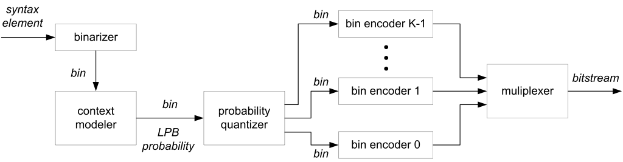
Fig. 7 Illustration of the novel entropy coding concept

Novel entropy coding concept
In Fig. 7, the basic entropy coding concept is illustrated. If a syntax element does not already represent a binary syntax element, it is first binarized, i.e., it is mapped onto a sequence of binary decisions (bins). For each bin a context is selected. A context represents a (binary) probability model for a class of bins; it is characterized by the probability and the value of the less probable bin (LPB). As in H.264/AVC, the LPB probability is represented by one out of 64 states. At the beginning of the encoding/decoding of a slice, the probability models are initialized using fixed values (as in CABAC of H.264/AVC). And after encoding/decoding a bin with a particular model, the model (i.e., the corresponding probability and value of the LPB) is updated. The probability model update, i.e., the probability estimation process is the same as in CABAC of H.264/AVC. The association of a bin with a context model is also similar as in CABAC of H.264/AVC. It depends on the syntax element, the bin number, and, for some bins, the values of neighboring syntax elements.

The above described binarization and association of the bins with context models is basically the same as in CABAC of H.264/AVC. The main difference is the next step. Instead of arithmetically coding the bins with the associated probability models using a single arithmetic coding engine as in CABAC of H.264/AVC, the estimated LPB probabilities are quantized, i.e., they are mapped onto a small number of LPB probability intervals and for each of these probability intervals a separate bin encoder/decoder is operated. In one implementation, we used 12 probability intervals and thus 12 different bin encoders/decoders. Each bin encoder/decoder operates at a fixed LPB probability, which can be considered as the representative probability for an LPB interval. The selection of a bin encoder/decoder is implemented via a look-up table that associates a bin encoder with each of the 64 state indices for the LPB probability. Hence, the 64 states that are used for estimating the LPB probability of a context model are mapped onto 12 probability classes, for each of which a separate bin encoder/decoder is operated. The partial bitstreams that are generated by the bin encoders can be written to different partitions of a NAL unit (with the partitioning of the NAL unit being indicated in the slice header) or they can be interleaved into a single bitstream.

The bin encoders and decoders represent simple variable length bin to variable length (V2V) codes, by which a variable number of bins is mapped onto variable length codewords and vice versa.

In the case where parallel processing at the decoder is desired, a load balancing scheme is provided to distribute the computational load onto multiple bin decoders evenly.

V2V codes
For the bin encoders (cf. Fig. 7), we employ simple V2V codes. It should be again noted that each bin encoder operates at a fixed LPB probability. And for a fixed LPB probability, we can simply construct a code that maps a variable number of bins onto a variable length codeword and vice versa. As a particular example, the following table shows an example for such a mapping. In the example the bins "0" represent the more probable bin values and the bins "1" represent the less probable bin values. The example code has been designed for a LPB probability of 0.15 and it yields a redundancy of only 0.25 % relative to the entropy limit for this probability. Generally, it is possible to get closer to the entropy limit when the table size is increased.

Table 1: Example for a mapping between a variable number of bins and variable length codewords
Sequence of bins  (bin order is from left to right) | codewords  (bits order is from left to right)
0000 | 1
01 | 001
10 | 010
001 | 011
0001 00 | 0001
11 | 0000 1
0001 1 | 0000 00
0001 01 | 0000 01

At the end of a slice, it is possible that a bin sequence does not represent any bin sequence that is associated with a codeword. In order to terminate the codeword, the shortest codeword for a bin sequence that contains the current bin sequence as prefix is written. At the decoder side, the additionally decoded bins are discarded. As an example, we could use the mapping in the above table and have a bin sequence "00" at the end of a slice. Then we would write the codeword "1" (corresponding to the bin sequence "0000"). At the decoder side, the codeword "1" would be translated into the bin sequence "0000", but the decoder would discard (ignore) the last two decoded bins.

The partial bitstreams can be written to different partitions of the slice data NAL unit (with transmitting the partitioning information in the slice header). It is also possible to combine the partial bitstreams into one single bitstream. Let L_{k} be the encoded length of the kth partial bitstream, where 0 <= k < 64. We define a prefix code C the following way:
If n < 128, then C(n) = n << 1;
Else if n < 16512, then C(n) = ((n - 128) << 2) | 1;
Else if n < 2113664, then C(n) = ((n - 16512) << 3) | 3;
Else C(n) = ((n - 2113664) << 3) | 7;
where "<<" is a right shift, and "|" is a bit-wise OR.
The output of the parallel framework is the concatenation of the following:
1. [Header] C(L_{k}) for 0 <= k < 64,
2. [Payload] The encoded sequence for bitstream k (0 <= k < 64).
The decoder first decodes the L_{k} values from the header, and uses these values to find the starting point of the encoded sequence k within the payload. After this, the 64 bitstreams can be decoded independently of each other from the payload, hence parallel decoding is feasible.
It is also possible to interleave the codewords from different partial bitstreams. This is in particular beneficial for small slice data NAL units, for which parallelized bin decoding is not required. In order to realize such an interleaving, a codeword buffer for variable-length codewords can be introduced at the encoder side. When a particular bin encoder starts the encoding of a new bin sequence (i.e., the bin encoder receives the first bin after having written the previous codeword), it reserves the next variable-length codeword entry in the codeword buffer. When the received bins represent a bin sequence that corresponds to a codeword, this codeword is written to the previously reserved codeword entry. Examples for the codeword buffer status are illustrated in Fig. 8. At the decoder side, the codewords can be directly read from the bitstream in decoding order.

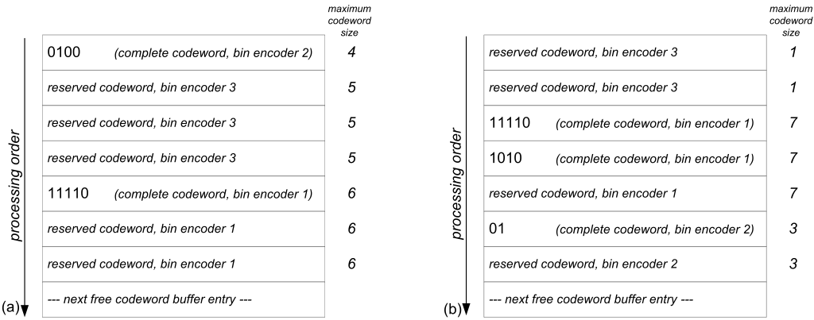
Fig. 8 Examples for the codeword buffer status

It is also possible to combine the codeword interleaving with a low-delay buffer control. That means, we can suitably restrict the buffer delay that is introduced by the codeword interleaving. With such a low-delay control, a particular codeword is terminated when the maximum number of bits (this maximum number of bits represents the maximum codeword length for a particular bin encoder and is given by the corresponding mapping table) that are associated with the reserved or completed buffer entries following the buffer entry for the particular codeword is greater than a particular threshold. At the decoder side, the extra decoded bins must be discarded; this can be done by using the same measure of the maximum number of bits as at the encoder side.

Load Balancing
In this section we describe an extension to the parallel framework described in Figure 7 above. The parallel framework makes provisions for the encoded video stream being decodable starting at various offsets, thereby enabling parallel decoding, but the positions of these offsets do not guarantee that computational load on multiple bin decoders is distributed evenly. In fact, it is likely in practical scenarios that most of the bin decoders will sit idly, having already done their chores, while the rest of them are still busy decoding the appropriate encoded source streams. In the present section we provide for the parallel framework an improvement, which aims at balancing the computational load at decoding time, for an arbitrary (possibly unknown) number of bin decoders.
The solution has two parts: the encoding and the decoding of the data. In this section all length values are expressed in bits, unless stated otherwise.
The encoding part creates the encoded bit streams S’_{k} of length M’_{k} for each of the input bitstreams S_{k}, k=0,…,63, with the given entropy coder. If the entropy coder is properly designed, M’_{k} should be close enough to M_{k}= L_{k}*(p_{k}*log(1/p_{k}) + (1-p_{k})*log(1/(1-p_{k}))).
The output of the load balancing extension to the parallel framework is the concatenation of the following:

- [First part of the header] C(M’_{k}) for k = 0,…,63,
- [Second part of the header, which depends on the V2V codes]
- [Payload] S’_{k} (k=0,…,63)

Part 1 is identical to Part 1 in Section 1.1.2. Part 3 is identical to Part 2 in Section 1.1.2. The code C() is the same as defined in Section 1.1.2.
The format and content of the second part of the header depends on the V2V codes used to encode the S_{k} sequences, and a distributor function. This part is a self-delimiting sequence.
Let D(a, b) be the set of all (v₁,…,v_{b}) vectors, for which v_{k} is a positive integer (k=1,…,b), and v₁ + v₂ + … + v_{b} = a. Let S’ = S’₀ + … + S’₆₃. Then, using the notations above, the distributor function is a function of the form F : {0,1}^K -> D(K, b). The distributor partitions the concatenated encoded sequences into b units, such that decoding each unit would take approximately the same time.
In this form, the distribution function gives the lengths of the decodable segments. We shall also make use of the starting positions of these segments, given by the associated function F’(x), where for F(x)= (v₁,…,v_{b}), F’(x)=(0, v₁, v₁+v₂, v₁+v₂+v₃, …, v₁+…+v_{b}). Obviously, the functions F and F’ mutually determine each other.
Example: the uniform distributor assumes that the decoding complexity of any S’_{k} depends only on M’_{k}, that is, the length of S’_{k}. Then, for the concatenated encoded bit stream x of length S’, F(x) = (S’/b, S’/b, …, S’/b) (the division may be rounded up or down to meet the final sum M’₀+…+M’₆₃). This distributor may be applied to any entropy coding algorithm.
Example: the weighted distributor assumes that the decoding complexity of any S’_{k} is uniform within S’_{k}, but may vary according to k. Let w_{k} be this complexity for S’_{k}, and W=w₀*M’₀ + … + w₆₃*M’₆₃. Then the distributor assigns the values F’(x) = (v₁,…,v_{b}) such that for any k < b: the decoding complexity of the segment x[v_{k},…,v_{k+1}-1] is W/b. This distributor may be applied to any entropy coding algorithm.
We now describe the format of the second part of the header. Consider a V2V bin encoder. For all k=1,…,b-1, let B_{k} be the number of bits, which we have to read ahead from F’(x)[k] to arrive at the start of the next codeword. That is, B_{k}=0 if a codeword starts right at F’(x)[k], B_{k}=1 if the next codeword starts at F’(x)[k+1], and so on. Then Part 2 of the header is the concatenation of the values C(B_{k}) for k=1,…,b-1.
After this, the encoder output is fully specified.
The decoder first decodes the M’_{k} values from the header, then uses these values and the known distributor function to compute F(x)[k], k=1,…,b. Once these values are known, the decoder distributes the F(x) segments among the d available bin decoders, using the following load balancing algorithm. Let G_{k} be the number of F(x) segments given to the k^{th} processor, k=1,…,d. Then
- if d >= b (there is at least one processor for each segment):
G_{k} = 1 for k=1,…,b and G_{k}=0 for k>b (the last d-b processors are unused)
- if d < b (there are more segments than processors):
B₀=b
G₀=0
B_{k}=B_{k-1}-G_{k-1}
G_{k}=[B_{k}/(d-k+1)] (here the [] operator means rounding)

Using the output of the algorithm, the first G₁ segments are assigned to the first bin decoder, the next G₂ segments to the second bin decoder, and so on. This algorithm creates the best equalized load for d bin decoders, provided the b segments are already equalized for decoding complexity.
The starting points for the encoded segments within the encoded bitstream x are identified using the contents of Part 2 of the header. After this, each bin decoder is given a pointer to the start of its respective stream, its variables are initialized (optionally, as is in the case of arithmetic coding, from the header), and simultaneous, independent decoding of x can commence.
The load balancing algorithm provides optimal performance for any specific set of b segments and d bin decoders; however, some sets obviously perform better than others. The best performance among all (b, d) values is reached when b is a multiple of d.
Example. If d divides b, then the load balancing algorithm simplifies to G_{k}=b/d for all k=1,…,d.
The general method works with the case when the encoder has no information about the number d of bin decoders at the side of the decoder. In the case that the encoder has a knowledge of some potential candidates d₁, d₂, …, d_{k} for the number of bin decoders, we present the following improvement: let b be a number which is a multiple of all of d₁, …, d_{k} (the least common multiple of the numbers d₁, …, d_{k} is adequate). In this case, for all the candidates the load distribution algorithm simplifies to the previous example, while for all other bin decoder numbers it resorts to the general algorithm.
Example. Suppose that the encoder knows that target decoders may be equipped with any one of 1, 2, 3, 4, 6, 8, 10, 12 or 16 bin decoders. The least common multiple of these numbers is 240, so the encoder should set b=240.
Example. If the encoder sets b=2^{t}, then optimal load balancing is achieved for each of 1, 2, 4, 8, …, 2^{t} bin decoders.

Binarization and context modeling
As already mentioned above, we have reused the binarization and context modeling schemes of H.264/AVC CABAC for most syntax elements in this video coding algorithm, especially for those which have already been present in H.264/AVC like, e.g., syntax elements related to intra prediction modes or motion parameters. For entropy coding of novel syntax elements like, e.g., flags indicating the quadtree structure, suitable context models have been designed. In addition, for coding of syntax elements related to transform coefficients of larger block sizes, an improved context modeling scheme has been employed.

Improved context modeling scheme for coding of transform coefficients
The novel context modeling scheme applies to the syntax elements significant_coeff_flag, last_significant_coeff_flag, and coeff_abs_level_minus_one of blocks of size 8x8 and larger, and it is complemented by an adaptive switching of the scan during encoding/decoding of the significance map (specifying the locations of non-zero transform coefficient levels).

Coding of the significance map
Coding of the syntax elements significant_coeff_flag and the last_significant_coeff_flag, as constituting the significance map, is improved by an adaptive scan and a new context modeling based on a defined neighborhood of already coded scan positions. This turned out to be beneficial especially for large block sizes.

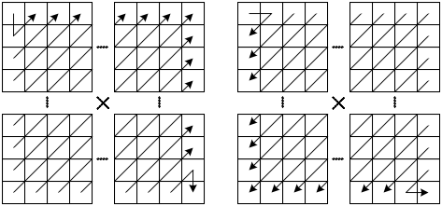
Fig. 9 Illustration of the two scanning patterns for the significance map

Scanning order
The scanning order for coding the significance map is adapted by switching between two predefined scan patterns. For the first scanning pattern, the diagonal sub-scans are scanned from bottomleft to topright (left illustration of Fig. 9), and for the second scanning pattern, the diagonal subscans are scanned from topright to bottomleft (right illustration of Fig. 9). The coding of the significance map starts with the second scanning pattern. While coding the syntax elements, the number of significant transform coefficient values is counted by two counters c₁ and c₂. The first counter c₁ counts the number of significant transform coefficients that are located in the bottom-left part of the transform block; i.e., this counter is incremented by one when a significant transform coefficient level is coded/decoded for which the horizontal coordinate x inside the transform block is less than the vertical coordinate y. The second counter c₂ counts the number of significant transform coefficients that are located in the top-right part of the transform block; i.e., this counter is incremented by one when a significant transform coefficient level is coded/decoded for which the horizontal coordinate x inside the transform block is greater than the vertical coordinate y. At the end of each diagonal sub-scan, it is decided whether the first or the second of the predefined scanning patterns is used for the next diagonal sub-scan. This decision is based on the values of the counters c₁ and c₂. When the counter for the bottom-left part of the transform block is greater than the counter for the bottom-left part, the scanning pattern that scans the diagonal sub-scans from bottom-left to top-right is used; otherwise (the counter for the bottom-left part of the transform block is less than or equal to the counter for the bottom-left part), the scanning pattern that scans the diagonal sub-scans from topright to bottom-left is used.

Context modeling
For 4x4 blocks, the context modeling for the syntax elements significant_coeff_flag is done as specified in H.264. For 8x8 blocks, the transform block is decomposed into 16 sub-blocks of 2x2 samples, and each of these sub-blocks is associated with a separate context. The context model selection for larger transform blocks (e.g., for blocks greater than 8x8) is based on the number of already coded significant transform coefficients in a predefined neighborhood (inside the transform block). For coding of the last_significant_coeff_flag, a context modeling has been designed that depends on a distance measure of the current scan position to the top-left corner of the given transform block. To be more specific, the context model for coding the last_significant_coeff_flag is chosen based on the scan diagonal on which the current scan position lies (i.e., it is chosen based on x + y, where x and y represent the horizontal and vertical location of a scan position inside the transform block, respectively). To avoid overfitting, the distance measure x + y is mapped on a reduced set of context models in a certain way (e.g. by quantizing x + y).

Coding of absolute values of transform coefficient levels
The coding process for absolute transform coefficient levels maps each quadratic (or rectangular) block of size 8x8 and larger onto an ordered set (vector) of 4x4 sub-blocks by using a forward zig-zag scan; while the transform coefficient levels inside a sub-block are processed in a reverse zig-zag scan. Following the handling of 4x4 blocks in H.264/AVC CABAC, the context model set for each sub-block consists of two times five context models with five models for both the first bin and all remaining bins (up to and including the 14. bin) of the coeff_abs_level_minus_one syntax element, where the selection of context models is done exactly as in the original CABAC. However, as a novel feature, different sub-blocks may select different sets of context models, where the choice of the context model set for a sub-block depends on certain statistics of one or more already coded sub-blocks.

Software integration plan

The software packages of proposals JCTVC-A116, JCTVC-A119, JCTVC-A120, JCTVC-A121, JCTVC-A124, and JCTVC-A125 have been identified for further development.

Preliminary discussions indicate the possibility that these can be combined to form a single software code base. Key requirements for such a code base that will be balanced include:
- Well-structured and extensible code (‘hooks’ to facilitate testing of new tools);
- Inclusion of identified tools, so as to provide an acceptable ‘starting point’ in terms of performance, i.e. compression efficiency will be towards the higher end of the CfP results;
- Low-complexity capability, i.e. the software shall be configurable to run with compression efficiency and encoder/decoder speed close to the fastest CfP performers;
- Written in the C programming language, or C++ in the style of procedural C.

The proposed timeline is as follows:
- 3 weeks after meeting:
Complete a technical analysis of software.
- 8 weeks after meeting:
Initial combination of software

Patent rights declarations

The British Broadcasting Corporation may have IPR relating to the technology described in this contribution and, conditioned on reciprocity, is prepared to grant licenses under reasonable and non-discriminatory terms as necessary for implementation of the resulting ITU-T Recommendation | ISO/IEC International Standard (per box 2 of the ITU-T/ITU-R/ISO/IEC patent statement and licensing declaration form).

LM Ericsson may have IPR relating to the technology described in this contribution and, conditioned on reciprocity, is prepared to grant licenses under reasonable and non-discriminatory terms as necessary for implementation of the resulting ITU-T Recommendation | ISO/IEC International Standard (per box 2 of the ITU-T/ITU-R/ISO/IEC patent statement and licensing declaration form).

Fraunhofer-Gesellschaft zur Förderung der angewandten Forschung e. V. may have IPR relating to the technology described in this contribution and, conditioned on reciprocity, is prepared to grant licenses under reasonable and non-discriminatory terms as necessary for implementation of the resulting ITU-T Recommendation | ISO/IEC International Standard (per box 2 of the ITU-T/ITU-R/ISO/IEC patent statement and licensing declaration form).

Nokia Corporation may have IPR relating to the technology described in this contribution and, conditioned on reciprocity, is prepared to grant licenses under reasonable and non-discriminatory terms as necessary for implementation of the resulting ITU-T Recommendation | ISO/IEC International Standard (per box 2 of the ITU-T/ITU-R/ISO/IEC patent statement and licensing declaration form).

Qualcomm may have IPR relating to the technology described in this contribution and, conditioned on reciprocity, is prepared to grant licenses under reasonable and non-discriminatory terms as necessary for implementation of the resulting ITU-T Recommendation | ISO/IEC International Standard (per box 2 of the ITU-T/ITU-R/ISO/IEC patent statement and licensing declaration form).

Samsung may have IPR relating to the technology described in this contribution and, conditioned on reciprocity, is prepared to grant licenses under reasonable and non-discriminatory terms as necessary for implementation of the resulting ITU-T Recommendation | ISO/IEC International Standard (per box 2 of the ITU-T/ITU-R/ISO/IEC patent statement and licensing declaration form).

Research In Motion Limited may have IPR relating to the technology described in this contribution and, conditioned on reciprocity, is prepared to grant licenses under reasonable and non-discriminatory terms as necessary for implementation of the resulting ITU-T Recommendation | ISO/IEC International Standard (per box 2 of the ITU-T/ITU-R/ISO/IEC patent statement and licensing declaration form).

Tandberg Telecom may have IPR relating to the technology described in this contribution and, conditioned on reciprocity, is prepared to grant licenses under reasonable and non-discriminatory terms as necessary for implementation of the resulting ITU-T Recommendation | ISO/IEC International Standard (per box 2 of the ITU-T/ITU-R/ISO/IEC patent statement and licensing declaration form).

