    Joint Collaborative Team on Video Coding (JCT-VC)  of ITU-T SG16 WP3 and ISO/IEC JTC1/SC29/WG11  1st Meeting: Dresden, DE, 15-23 April, 2010 | Document: JCTVC-A031

Title: | Tools for proposal evaluations
Status: | Input Document to JCT-VC
Purpose: | Information
Author(s) or  Contact(s): | S. Pateux  Orange Labs  4, rue du clos Courtel  35 512 Cesson Sevigne, FRANCE | Tel:  Email: | +33 2 99 12 41 77  stephane.pateux@orange-ftgroup.com
Source: | Orange Labs
_____________________________

Abstract
This document presents a set of tools proposed for performing objective analysis of answers to the Call for Proposal of JCT-VC. A first tool is proposed for helping performing proponents' cross-check. It allows regenerating PSNR template file to be filed by proponents by re-computing frame PSNR from provided decoded YUV files. The second tool proposed is an excel sheet with advance customization functionalities that allows to compute and graph various objective metrics (e.g. BD-rate, BD-PSNR, …). It is intended to help JCT-VC group to analyze the results of the Call for Proposal.

Tool for helping proponents' cross check
A first tool is proposed for helping performing proponents' cross-check. It allows regenerating PSNR template file to be filed by proponents by re-computing frame PSNR from provided decoded YUV files.

This tool is provided in attached archive JCTVC-A031_CrossCheckTool.zip. A readme file is there to inform people how to use such tool.

Revision r1: following cross checks performed during Dresden meeting on thursday, some bugs occurs with the proposed script due to internalionalization problems (PSNR "33,5" to be interpreted as 33.5 and not 33500!). A revision is thus proposed here for correcting this issue for interested parties.

Tool for performing objective analysis
The second tool proposed is an excel sheet with advance customization functionalities that allows to compute and graph various objective metrics (e.g. BD-rate, BD-PSNR, …). It is intended to help JCT-VC group to analyze the results of the Call for Proposal.

Figure below is an example of a generated output from that tool:
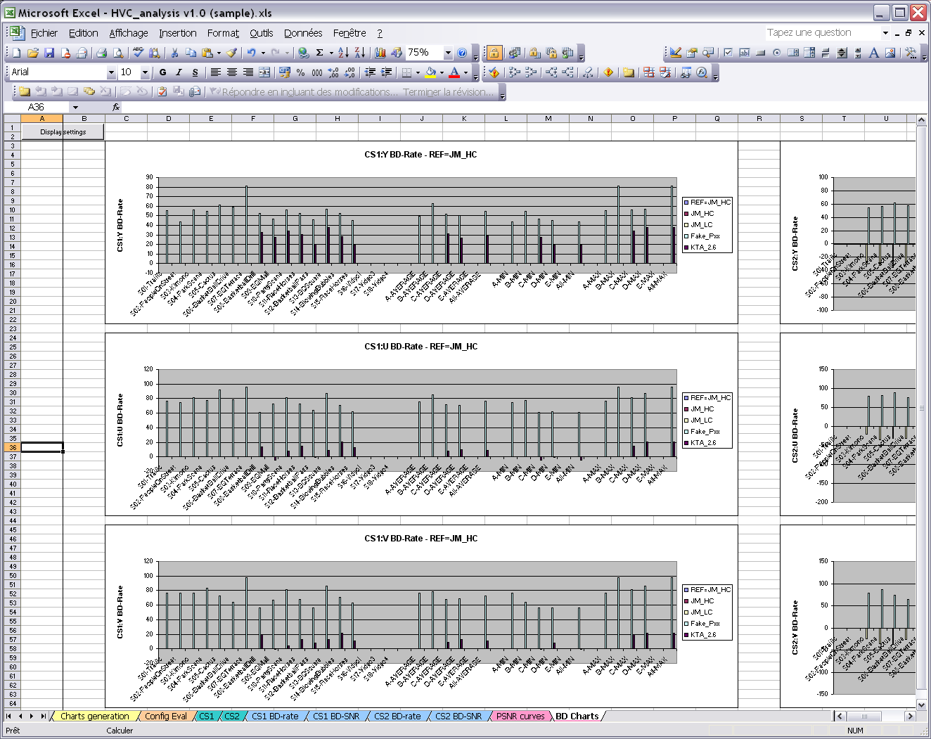

This tool is provided in attached archive JCTVC-A031_AnalysisTool.zip. It contains a user manual document to introduce with the use of that tool.

Patent rights declaration(s)
(NOTE – Activities in the JCT-VC and contributions to the JCT-VC are subject to the common patent policy for ITU-T/ITU-R/ISO/IEC. A statement of that policy can be found at
http://www.itu.int/ITU-T/dbase/patent/patent-policy.html, with further information available at http://www.itu.int/ITU-T/ipr/index.html and in the ISO/IEC Directives. The form to be used for the formal reporting of patent rights to ITU-T/ITU-R/ISO/IEC can be found at http://www.itu.int/ITU-T/ipr/index.html. Contributions to the JCT-VC proposing normative technical content shall contain a non-binding informal notice of whether the submitter may have patent rights that would be necessary for implementation of the resulting standard. The provided informal notice shall indicate the category of anticipated licensing terms according to the ITU-T/ITU-R/ISO/IEC patent statement and licensing declaration form. This obligation to provide an informal notice is supplemental to, and does not replace, any existing obligations of parties with technology included in a final or draft standard to submit formal IPR declarations to ITU-T/ITU-R/ISO/IEC. An example of an informal IPR notification statement for a contribution is provided below.)

Orange may have IPR relating to the technology described in this contribution and, conditioned on reciprocity, is prepared to grant licenses under reasonable and non-discriminatory terms as necessary for implementation of the resulting ITU-T Recommendation | ISO/IEC International Standard (per box 2 of the ITU-T/ITU-R/ISO/IEC patent statement and licensing declaration form).

