    Joint Collaborative Team on Video Coding (JCT-VC)  of ITU-T SG16 WP3 and ISO/IEC JTC1/SC29/WG11  1st Meeting: Dresden, DE, 15-23 April, 2010 | Document: JCTVC-A029

Title: | Flexible macroblock partition for inter-frame coding
Status: | Input Document to JCT-VC
Purpose: | Proposal
Author(s) or  Contact(s): | Xiaozhen Zheng, Haoping Yu  Hisilicon, Huawei Technologies Co., Ltd  Section B, Huawei Industrial Base,  Bantian Longgang Shenzhen, China | Tel:  Email: | Tel: +86-755-28422062  Email: xiaozhenzheng@huawei.com
Source: | Hisilicon, Huawei Technologies Co., Ltd.
_____________________________

Abstract
This contribution presents a macroblock partition technique for inter-frame coding by considering object’s boundary and contour. Unlike traditional block partitioning, the proposed technique can divide a macroblock into two triangles, or a triangle and a pentagon, or two unsymmetrical size rectangles.

The proposed technique, which is called flexible macroblock partition (FMP), has been proposed by JCTVC-A111. This contribution provides some further information about FMP algorithm.

Introduction
In natural images, object’s boundary or contour separating two moving objects may be along any direction. Conventional quad-tree structured representation of motion partitions can not deal with this situation efficiently. To solve the problem, a flexible macroblock partition (FMP) method is proposed. It has show satisfied coding gain for inter-frame coding, especially in the blocks that contain different object’s content.

Algorithm description
The FMP algorithm contains four motion partition modes as illustrated in Fig. 1a ~ Fig. 1d, each mode dividing the macroblock into two irregular regions. Different from regular motion partition modes specified in MPEG4-AVC/H.264, the two regions can be two non-rectangular blocks in mode 0 and 1, or two rectangles with different size in mode 2 and 3. In JCTVC-A111, the coding of FMP modes is integrated into MPEG4-AVC/H.264 quad-tree’s design. A parameter is used to indicate the position of the partition boundary. In this proposal, another solution for FMP mode is provided, which can provide more flexible coding.

As illustrated at Fig 1a to Fig 1d, the boundary between two irregular blocks can be controlled by the point A and B. FMP mode can be parsed after getting point A and B’s position. Since point A and B locate at one image block’s boundary, only one position parameter need to be coded for point A and B. Thus, the irregular block partition mode can be described by the two position parameters.
Define xpos as point A’s position parameter.
Define ypos as point B’s position parameter.

Use the values of xpos and ypos, and the signs of xpos and ypos, the macroblock’s partitioning can be identified. Other than identifying the limited number of partitioning, e.g partitioning along with horizontal, vertical, +/-45 degree direction, the proposed method can also identify more flexible partitioning, e.g. +/-22.5 degree partitioning.

The position parameter xpos and ypos are predictive coded. If the left and above blocks use the same FMP mode as the current block, the position parameters of the two neighboring blocks are used to form the predictor for that of the current block.
Figure 1a Figure 1b

Figure 1c Figure 1d

To accommodate the flexible macroblock partition, motion vector prediction mechanism is also modified. As illustrated at Fig. 2, blockE is the current macroblock; blockA, blockB and blockC are the neighboring blocks of blockE. If one of blockA, blockB and blockC has same FMP mode as blockE’s mode, the block’s motion vector is used for blockE’s motion vector coding.

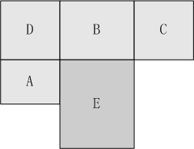
Figure 2 An image block and its neighbor blocks

Compression performance discussion
Fig. 3 is an illustration of the areas that uses FMP algorithm. The blocks with red and greed painted are the areas which are suitable for flexible block partition. It can be found that the blocks locate at object’s boundary or contour prefer using more flexible block partitioning. FMP usually can get efficient coding result at those areas.

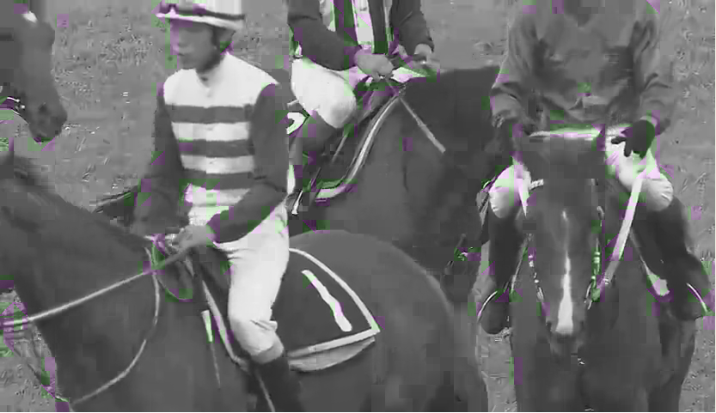
Figure 3: Illustration of flexible macroblock partition coding

The proposed technique has been integrated into KTA2.6r1 software. It is noted that the proposed technique is applied to P frame currently. A block with 16x16 size is divided into two irregular blocks. Both luma and chroma have used the proposed technique.

To test the proposed technique’s compression efficiency, CfP common test sequences are chose as the testing set. The anchor data is generated by KTA2.6r1. The encoding parameters of anchor and proposal are configured according to CfP Beta’s configuration. The full length of CfP sequences is tested. CABAC entropy coding mode is enabled; RDO and RDOQ are enabled. 5 QP points used in the experiment are the same as CfP Beta anchors Error: Reference source not found. +/-45 degree partitioning, vertical partitioning and horizontal partitioning are used at the experiment.

Table 1 shows the experimental results at low-bitrate and high-bitrate. Average PSNR gain and bitrate reduction are calculated based on VCEG-M33 Error: Reference source not found and VCEG-AE07 [3]. It shows that average 2.73% bitrate reduction for lot-bitrate range is achieved and average 2.64% bitrate reduction for high-bitrate range is achieved.

Table 1: Simulation results (Beta configuration)
 | low-bitrate range |  | high-bitrate range
sequence | BD-bitrate | BD-PSNR | BD-bitrate | BD-PSNR
BasketballPass_416x240_50 | -3.92% | 0.18 | -2.67% | 0.13
BlowingBubbles_416x240_50 | -1.01% | 0.04 | -1.15% | 0.05
BQSquare_416x240_60 | -0.91% | 0.04 | -2.20% | 0.08
RaceHorses_416x240_30 | -3.77% | 0.17 | -2.85% | 0.15
Average WQVGA | -2.40% | 0.11 | -2.22% | 0.10
BasketballDrill_832x480_50 | -2.44% | 0.12 | -3.56% | 0.14
BQMall_832x480_60 | -2.47% | 0.13 | -3.07% | 0.15
PartyScene_832x480_50 | -2.12% | 0.07 | -1.88% | 0.07
RaceHorses_832x480_30 | -4.48% | 0.18 | -4.43% | 0.18
Average WVGA | -2.88% | 0.13 | -3.24% | 0.14
Average | -2.64% | 0.21 | -2.73% | 0.19

Closing remarks
FMP is currently implemented as inter-frame coding tool. It has considered natural image’s texture information. The compression improvement is satisfied and can be further improved after integrating the proposed technique to 8x8 block and larger block, e.g. 32x32.

Reference
- ITU-T Q6/16 and ISO/IEC JTC1/SC29/WG11, “Joint Call for Proposals on Video Compression Technology,” MPEG document w11113, 91st MPEG meeting, Kyoto, Japan, Jan. 2010
- Gisle Bjontegaard, “Calculation of average PSNR differences between RD curves,” VCEG document VCEG-M33, ITU-T Q.6/SG16, 13th VCEG Meeting, Austin, Texas, USA, Apr. 2001
- Stéphane Pateux, Joel Jung, “An excel add-in for computing Bjontegaard metric and its evolution” VCEG document VCEG-AE07, 31st VCEG Meeting, Marrakech, MA, 15-16 January, 2007

Patent rights declaration(s)
Huawei Technologies Co.,Ltd. may have IPR relating to the technology described in this contribution and, conditioned on reciprocity, is prepared to grant licenses under reasonable and non-discriminatory terms as necessary for implementation of the resulting ITU-T Recommendation | ISO/IEC International Standard (per box 2 of the ITU-T/ITU-R/ISO/IEC patent statement and licensing declaration form).

