    Joint Collaborative Team on Video Coding (JCT-VC)  of ITU-T SG16 WP3 and ISO/IEC JTC1/SC29/WG11  1st Meeting: Dresden, DE, 15-23 April, 2010 | Document: JCTVC-A023

Title: | 7680 × 4320 format test sequences for JCT-VC
Status: | Input Document to JCT-VC
Purpose: | Information
Author(s) or  Contact(s): | Shinichi Sakaida  Yoshiaki Shishikui  Atsuro Ichigaya  Yasutaka Matsuo  Kazuhisa Iguchi  Takahiro Toyoda  1-10-11, Kinuta, Setagaya-ku, Tokyo 157-8510, JAPAN | Tel:  Email: | +81-3-5494-3355  sakaida.s-gq@nhk.or.jp
Source: | NHK (Japan Broadcasting Corporation)
_____________________________

Introduction
This document describes and introduces a set of 7680 × 4320 format video sequences that will be made available to JCT-VC and parent bodies by NHK. NHK proposes to adopt these sequences for developing and testing JCT-VC standards.

Content description
Two video sequences will be provided. These sequences are in 7680 × 4320 / 60p format and are 5 seconds long. Table 1 shows the specifications of the sequences.

Table 1 Specification of 7680 × 4320 format sequences
Resolution | 7680 × 4320
Frame rate | 60 fps, progressive
Bit depth | 10
Color format | YUV 4:2:0
Duration | 5 seconds (300 frames)

A brief description of the sequences is listed in Table 2, and selected frames are shown in Figure 1 and 2.

Table 2 Brief description of the sequences
No. | Title of sequence | Brief description
1 | Steam locomotive train | A steam locomotive train passing from right to left at high speed.
2 | Nebuta festival | Huge and colorful “Nebuta” figures moving in night view.

The format of the sequences is used in a Super Hi-Vision (SHV) system. This SHV system is being developed by NHK Science & Technology Research Laboratories as a future broadcasting system [1].

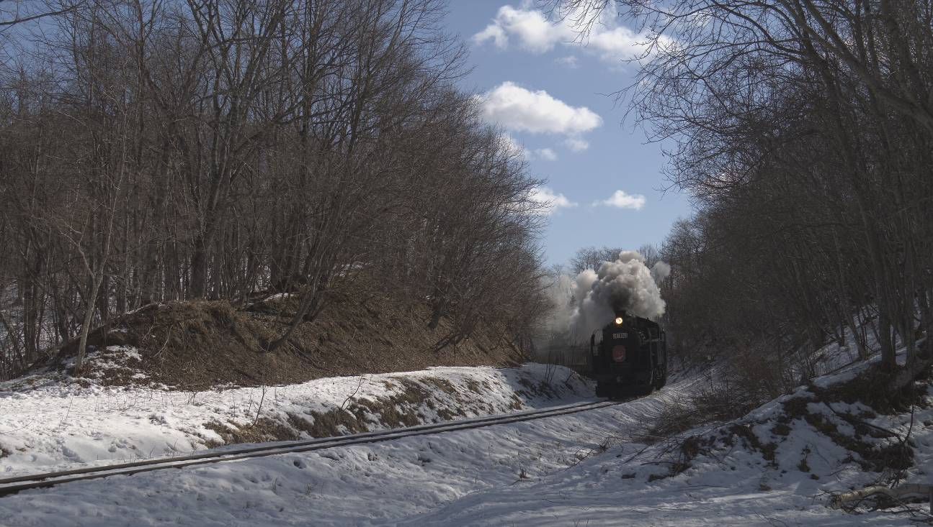
(a) First frame

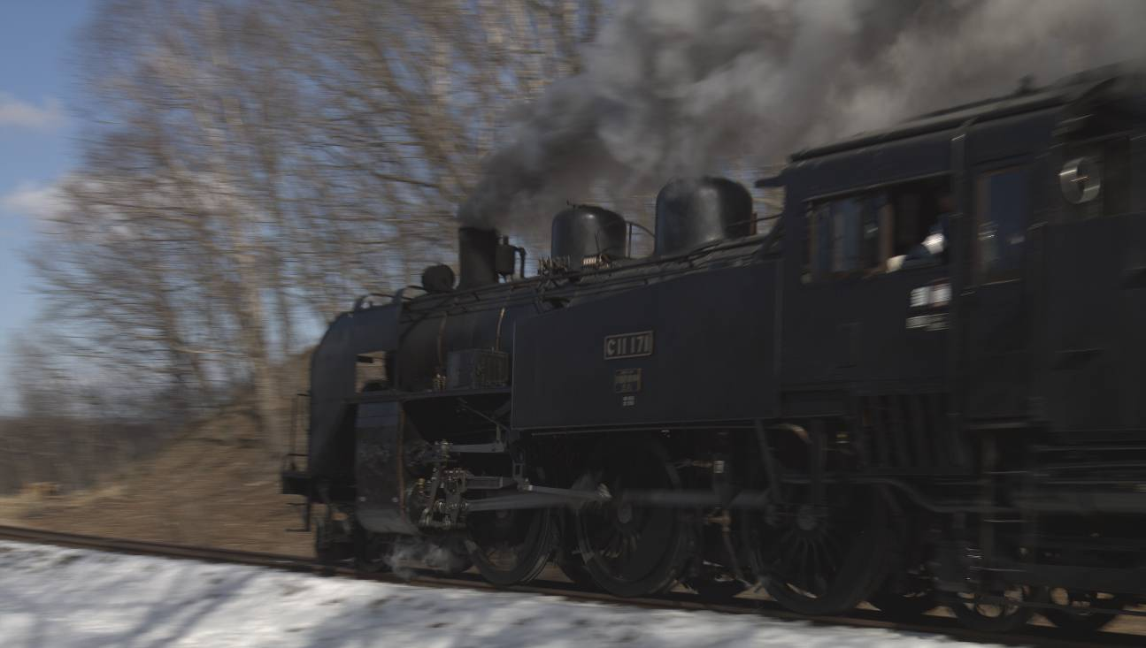
(b) Last frame
Figure 1 Steam locomotive train

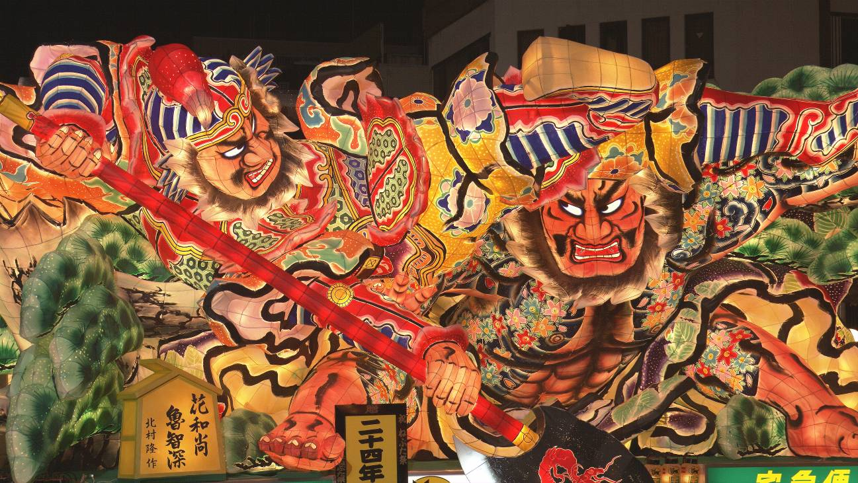
(a) First frame

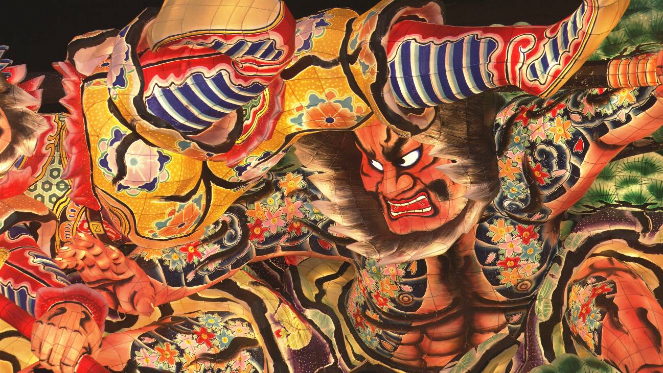
(b) Last frame
Figure 2 Nebuta festival

Conditions of Use – Copyright and Release Notes
These sequences have been generated by Japan Broadcasting Corporation (NHK), and all intellectual property rights remain with NHK. These materials shall only be used for developing high performance video coding standards and for testing the standards for Super Hi-Vision in JCT-VC and in the parent bodies. The sequences should be processed in the original resolution.
This copyright and permission notice shall be duplicated whenever the data are copied or distributed. These materials cannot be distributed with charge. NHK makes no warranties with respect to the material and expressly disclaims any warranties regarding its fitness for any purpose. Unless the above conditions are agreed to by the recipient, no permission is granted for any use, copying, modification, and distribution of the data. By using these sequences the user agrees to the conditions of this copyright and disclaimer.

The sequences have been captured by a provisional imaging system and do not have the full resolution of SHV. Upon delivery of the SHV sequences with full resolution, the data of these sequences should be disposed.
The copyright statement is attached to the end of the test sequences in SHV format. Upon duplication of the data, all the frames should be copied. However, the final frame is not subject to signal processing.

Delivery of the Sequences
NHK will provide the sequences by copying them to a hard disk drive because the amount of sequence data is very large (approximately 60 Gbytes in total). Details of the delivery procedure will be announced directly to the party who wants to use the sequences. To decide the details of the procedure, applicants are asked to contact the following person via e-mail by the end of April 2010.

Contact person
Shinichi Sakaida
NHK Science and Technology Research Laboratories
sakaida.s-gq@nhk.or.jp

Reference
[1] Y. Shishikui, Y. Fujita, and K. Kubota, “Super Hi-Vision – the star of the show!”, EBU Technical review, Jan. 2009.

