    Joint Collaborative Team on Video Coding (JCT-VC)  of ITU-T SG16 WP3 and ISO/IEC JTC1/SC29/WG11  1st Meeting: Dresden, DE, 15-23 April, 2010 | Document: JCTVC-A021

Title: | Coding tools using parametric representations to improve coding efficiency
Status: | Input Document to JCT-VC
Purpose: | Proposal
Author(s) or  Contact(s): | Joonyoung Park, Seungwook Park, and Byeongmoon Jeon
Author(s) or  Contact(s): | 221, Yangjae-Dong, Seocho-Gu, Seoul, Korea | Tel:  Email: | jy.park@lge.com  seungwook.park@lge.com  bm.jeon@lge.com
Source: | LG Electronics
_____________________________

Abstract
This document presents two coding tools using parametric representations. The first tool is an adaptive warped reference (AWR) method to handle complex motions of the video sequence. The AWR method generates warped reference pictures that compensate complex motions between a recently decoded reference picture and a current picture to encode. The complex motions are modeled as a parametric image transformation function such as a homography transformation function. Then, the parameters of the transformation function are quantized and encoded in bit streams so that a decoder can warp the recently decoded reference picture in the same way as the encoder did. The second tool is a parametric adaptive interpolation filter (PAIF) method that is one of advanced AIFs. The PAIF represents an interpolation filter using a few parameters instead of many individual filter coefficients by approximating the interpolation filter with a parametric function. It is known that PAIF needs bits less than conventional AIFs to represent a filter and that its representation is closer to the optimal filter than those of conventional AIFs. In the proposed PAIF method, we used our parametric function and an offset value, which is computed for each reference frame
These tools were used to further improve LG’s response model to the CfP. However, the evaluation of the LG’s response model was done without these tools because they were under development during the evaluation period.

Introduction
Approximating a complex function with a parametric function provides a compact representation. In video coding problems, the compact representation is an important factor because it reduces the amount of data to be encoded. A good example is the adaptive interpolation filter (AIF) technique. Conventional AIF techniques represent a interpolation filter using a large number of individual coefficients whereas it can be represented by a few parameters if the interpolation filter is approximated with a parametric function.
In this document, we introduce two coding tools using parametric representations: adaptive warped reference (AWR) and parametric adaptive interpolation filter (PAIF), which have been developed to further improve LG’s response model to CfP. Details of the two tools are explained in the following sections.

Tool I (AWR)
Motion estimation and compensation are efficient tools to exploit and reduce the correlation between consecutive frames, so that it has been incorporated in the most video coding standards like MPEG-1, MPEG-2, MPEG-4 and MPEG-4 AVC/H.264. However, these coding tools consider simple translational motion, which is not sufficient to express complex motions such as zooming, rotation, shearing and so on.
Recently, BTZMCP (block-matching translation and zoom motion compensated prediction) method was proposed [1], which covers zooming motion as well as translational motion within the conventional framework. Although this model showed good coding efficiency, it cannot describe complex motions such as 2D and 3D rotation.
The proposed AWR method takes the benefits of parametric representation to represent the complex motions as descrbed in the following sections.

Proposed Method
The proposed AWR algorithm generates a warped reference picture that compensates complex motions between a reference image and a current image to encode, where the complex motions are modeled as a parametric image transformation function. To improve the coding efficiency using this method, we have to find optimal warping parameters that matches well to the complex motions in the video sequence and encode the warping parameters in an efficient manner as well.

Computation of warping parameters
To compute a warping function that is appropriate for the pair of images, we use KLT feature tracker [2] in order to detect feature points in the current picture and track them in the reference picture resulting many pairs of feature points. Because a video sequence can be composed of different kinds of motions, the feature point pairs are segmented into several groups so that the feature point pairs in a group to be explained by one parametric function. We use homography transformation function as the parametric function. The homography transformation function is a non-linear mapping function that maps a point (x,y) to (x’,y’) as
$\left[\begin{matrix}x' \\ y' \\ 1\end{matrix}\right]=H\left[\begin{matrix}x \\ y \\ 1\end{matrix}\right]=\left[\begin{matrix}h_{\text{11}} & h_{\text{12}} & h_{\text{13}} \\ h_{\text{21}} & h_{\text{22}} & h_{\text{23}} \\ h_{\text{31}} & h_{\text{32}} & 1\end{matrix}\right]\left[\begin{matrix}x \\ y \\ 1\end{matrix}\right]$, (1)
where H is a 3x3 matrix that contains 8 parameters of the homography transformation matrix H.
The feature point pairs are grouped by a segmentation algorithm based on a region growing approach [3]. Then, for each group of feature point pairs, we compute the 8 parameters of the homography transformation function using normalized direct linear transform algorithm [4]. Fig. 1 shows an example of five feature point pairs in a group.

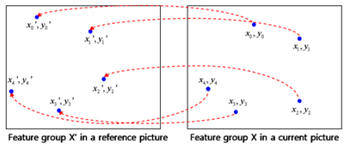
Fig. 1 Example of grouped feature point pairs; five pairs are grouped into one group.

Next, we warp the reference picture using the warping parameters computed for each group. For example, Fig. 2 shows (a) a reference picture, (b) a current picture, (c) a wapred reference picture corresponding to 0th group, and (d) another warped reference picture corresponding to 1st group. In this example, the first and second warped reference pictures explain two motions of the static background region, and the rotating trump cards, respectively.

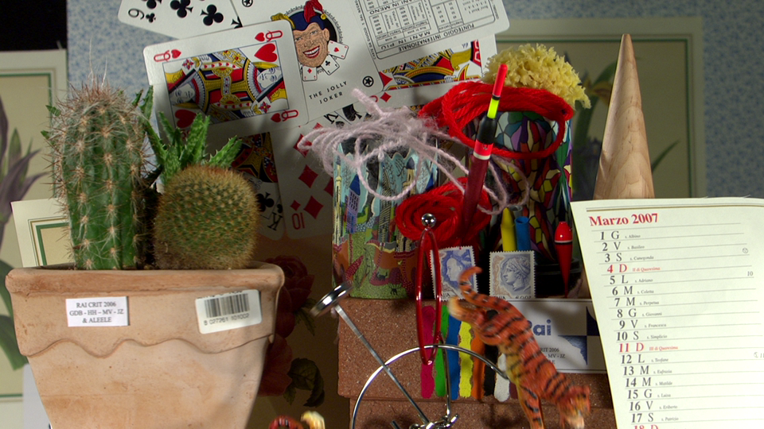  - a reference picture | 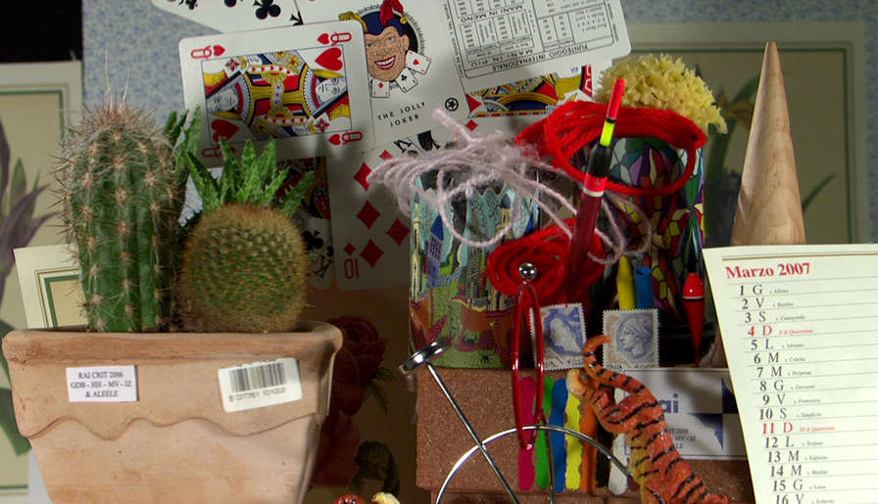  - a current picture
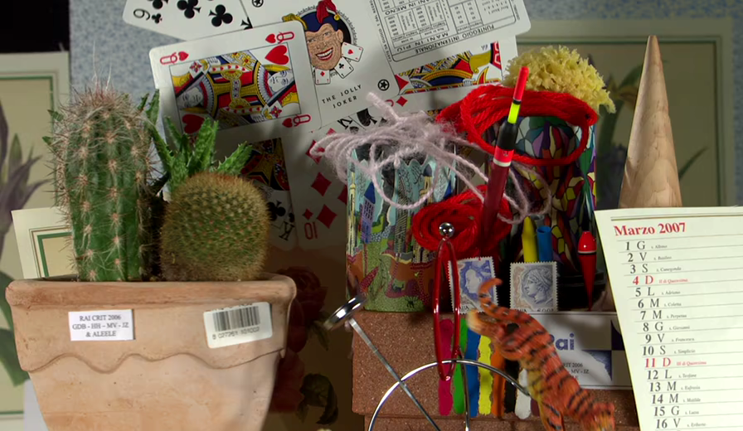  - the first warped reference picture (by 0th group) | 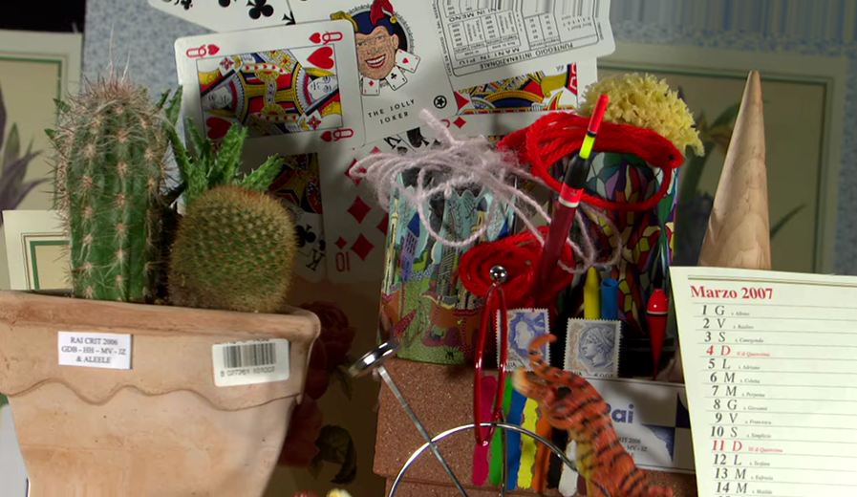  - the second warped reference picture (by 1st group)

Fig. 2 Example of two warped reference pictures corresponding to two groups of features identified between a reference picture (a) and a current picture (b); the first and second groups correspond to backgroud (c) and rotating trump cards (d), respectively.

Reordering of the reference picture list
The warped reference pictures should be inserted to the reference picture list to be used in the motion estimation and motion compensation processes. To increase the selection ratio of warped reference pictures, we reorder the reference pictures as follows. If n warped reference pictures are generated from i’th reference picture, then the n warped reference pictures are inserted right after the i’th reference picture. Fig. 3 shows an example of reordered reference picture list when the first (0th) reference picture is used to generate one warped reference picture.

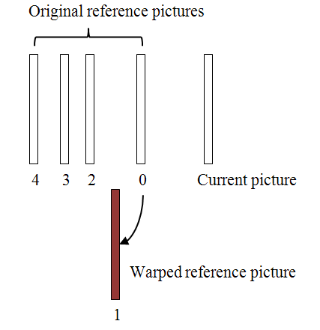
Fig. 3 Reordering of the reference picture list.

Selection of the best warped reference
Although we can generate multiple warped references to explain the complex motions in the video sequence, neither all the warped reference pictures are useful nor the significant level of them are known. So, we made a criterion to estimate how much gains can be obtained from each warped reference picture when compared to the first reference picture. Using this criterion, we chose the best warped reference picture among the multiple candidate warped reference pictures and insert the selected warped reference picture into reference picture list. The other warped reference pictures are ignored. Actually, the selected warped reference picture is saved in a temporary buffer and the indices of the original reference pictures and the inserted warped reference picture are manipulated to work correctly.

Encoding of the motion parameters
When the homography transformation function is used as the parametric motion model, the 8 floating point numbers should be encoded. However, the warping results were too sensitive to the quantization errors of the 8 parameters; small quantization errors make large differences to the warping results. In order to minimize the influence of the quantization errors and reduce the size of side information (parameters) to encode, we use another representation of the homography transform function. We apply the homography transformation function to the 4 corner points of the current picture to obtain transformed coordinates of them. Then, we encode the 4 motion vectors of the 4 corner points instead of the 8 parameters. This representation makes the warping results less sensitive to the quantization errors and has smaller range of values than using the 8 parameters of the homography transformation function.

Encoding complexity and a fast decision rule
We use 2-pass coding structure where the AWR is used in the second pass and one of the two coding results is selected based on RD criterion. However, the 2-pass coding structure is inefficient for some sequences that do not contain complex motions; we have to encode 2 times for every pictures of the sequences although most of the pictures may not take the coding results using the AWR.
When constraint set 1 is used, the encoding complexity can be efficiently reduced as follows. We use a fast decision rule that checks if the previously coded upper level picture in a same GOP used the AWR or not. If the AWR is not selected, then the AWR is not considered for the current picture, i.e., current picture is coded in 1-pass. For example, if the AWR is not selected for the previouls coded P picture, then all B pictures in the same GOP are coded in 1-pass.

Experimental Results
We implemented the AWR method on the LG’s response model and measured the performance of AWR under the constraint set 1 condition where we used one warped reference picture in addition to the original refrence pictures as depicted in Fig. 3. Experiments with the constraint set 2 was not performed because of the limited time.

Experiments with 2-pass coding structure
In this experiment, the 2-pass coding structure (without the fast decision rule) was used to obatin the best performance of the AWR.
We used BD_rate computation tool [5] to measure the performance. Table 1 shows the experimental results. Maximum gain among all test sequences was 7.08% at the Cactus sequence, where the RD curve of Cactus is shown in Fig. 4. The average gains for the three classes B, C, and D in constraint set 1 were 1.31%, 0.12%, and 0.14%, respectively. The reason of high gain at the Cactus sequence was that the sequence contains in-plane rotating motion which could be efficiently compensated by the proposed AWR. On the other hand, there was no evident loss at any sequence when the proposed method was applied.
Another good test sequence for AWR was Jets (1280x720p, 60Hz) test sequence, which is composed of zooming out and panning camera motion. For the Jets test sequence (first 100 frames were used in this experiment), AWR showed 8.22% gain, where the RD curve is shown in Fig. 5.

Table 1. BD rate (%) reduction of AWR (anchor is LG’s response model, 2-pass coding structure without fast decision rule
Class | seq. | BD-rate(%)
B | BasketballDrive | -0.09
B | BQTerrace | 0.53
B | Cactus | -7.08
B | Kimono | 0.05
B | ParkScene | 0.05
Class B Avg. |  | -1.31
C | BasketballDrill | -0.10
C | BQMall | 0.06
C | PartyScene | -0.14
C | RaceHorses | -0.29
Class C Avg. |  | -0.12
D | BasketballPass | -0.15
D | BlowingBubbles | -0.09
D | BQSquare | -0.17
D | RaceHorses | -0.14
Class D Avg. |  | -0.14

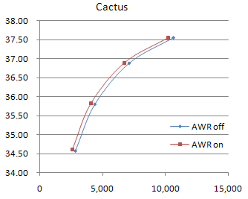
Fig. 4 R-D curve of Cactus test sequence

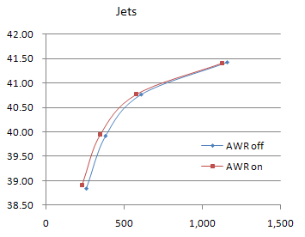
Fig. 5 R-D curve of Jets test sequence.

Experiments with 2-pass coding structure using the fast decision rule
In this experiment, 2-pass coding structure with fast decision rule was used. Some of the test sequences in Table 1 were used for this expeirment, where the results are summarized in Table 2. The third column of the Table 2 represents the relative encoding time of the AWR when compared to that of the anchor. This table shows that the fast decision rule efficiently reduced the encoding time of the AWR. For the D class sequences the encoding time did not increase at all although the performance was decreased slightly; the relative encoding time were 1.0 for both BasketballPass and BQSquare. For the Cacus and Jets sequences, the relative encoding time were measured as 2.28 and 2.17, respectively. The coding gains of the two sequences were preserved well.
Further study is under going to implement the AWR in 1-pass coding structure to reduce the encoding complexity and to enhance the coding performance.

Table 2. BD rate (%) reduction of AWR (anchor is LG’s response model, 2-pass coding structure with fast decision rule)
Class | seq. | BD-rate(%) | Encoding time
- | Jets 720p60  (100 frames) | -11.35 | 2.28
B | Cactus  (50frames) | -6.17 | 2.17
D | BasketballPass  (full sequence) | 0.09 | 1.00
D | BQSquare  (full sequence) | -0.04 | 1.00

Tool II (PAIF)
In the KTA model, adaptive interpolation filter (AIF) scheme is included to reduce the energy of prediction error [6]. Due to the characteristic of the AIF, this scheme adds a significant amount of additional complexity and side-information. In order to resolve this, many advanced AIF methods have been introduced in [7] and [8]. But the conventional AIF still has the trade-off between the accuracy of coefficients and the size of side information.
Another kind of adaptive filter has been developed for solving this trade-off in the conventional AIF. The PAIF represents an interpolation filter using five parameters instead of many individual filter coefficients by approximating the interpolation filter with a parametric function [9]. The proposed PAIF scheme enhances the existing AIF scheme by reducing quantization error of AIF coefficients and also reducing the side-information for coding AIF coefficients. We designed a parameterized impulse response function of a filter on an experimental basis, and float-valued offset is additionally introduced for delivering supplementary coding gain.

Proposed method
A parameterized function, representing all the coefficients for each sub-pel, has to be designed for changing the conventional AIF into a parameterized filter. This function can be regarded as the impulse response of PAIF. We modeled the function on an experimental basis as follows.
$h(m,n)=N(m,n)\text{sinc}(α_{1}m)\text{sinc}(α_{2}n)[γ+\text{sinc}(β_{1}m)\text{sinc}(β_{2}n)]$ (2)
where $α_{1},α_{2},β_{1},β_{2},\text{ and }γ$ are the five parameters to be transmitted. The values of $N(m,n)$ are constants. Because the lightness changes or fading may exist in the sequences, we do not restrict the gain of filter to be 1 for each sub-pel. As a result, the filter coefficients may have more flexible values reflecting the characteristic of the interpolated reference frame. This modeling function is motivated from Lanczos function. It basically follows the shape of the standard 6-tap MPEG-4 AVC/H.264 filter as shown in Fig. 6.
Fig. 6 Impulse response of PAIF with initial parameters

The parameter set has to be determined at every frame and coded for each frame using PAIF. Experimentally, the range of parameter set and initial values are given as follows.
$α_{1}\text{ and }α_{2}$ : [0.5, 1.0], initially π/4
$β_{1}\text{ and }β_{2}$ : [0, π/11], initially π/12
$γ$ : [-0.1, 0.1], initially 0
We need to find the optimal parameters that minimize the mean squared prediction error between original and motion-compensated pictures. In order to find them, we use the numerical optimization method. Initial values are determined to be close to the standard MPEG-4 AVC/H.264 filter. And also, Broyden–Fletcher–Goldfarb–Shanno (BFGS) Quasi-Newton method with a Golden section search is applied to find the optimal parameter set [10]. The example is shown in figure 7 as follows.

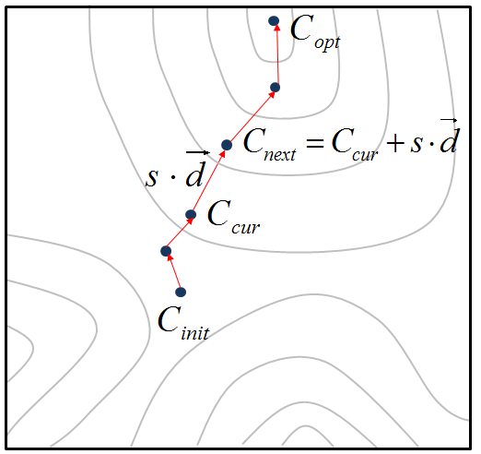
Fig. 7 Graphical representation for parameter estimation

In figure 7, the contours represent the line having same prediction error, and $C$ represents the parameter set to be estimated. For current parameter set $C_{\text{cur}}$, the direction $\vec{d}$ is obtained by BFGS method, and the step size s is obtained by Golden section search method. And then, we can calculate the next parameter set $C_{\text{next}}$. Starting from the parameter set $C_{\text{init}}$ which have initial values, the parameter set $C$ is moved by the above process, until it is converged. And we finally get the optimized parameter set $C_{\text{opt}}$.

Before coded, the 5 parameters are quantized by fixed length coding. The magnitude of $β_{1}\text{ ,}β_{2},\text{ and }γ$is uniformly quantized to 8196 steps and coded as 13-bit. And the magnitude of $α_{1}\text{ and }α_{2}$ is also uniformly quantized to 2048 steps, coded as 11-bit. For $γ$, one additional bit is required to represent the sign value.

In addition, we use the offset value in the motion compensation process. In the recently proposed filtering technique such as SIFO and enhanced AIF, they usually include the offset in addition to newly designed filters. We also add offset values to a PAIF filter. In the similar way to the offset usage in case of the weighted prediction in MPEG-4 AVC/H.264, we added one offset value for each reference frame. And also the precision of the offset value is set to be not integer but 0.1 in order to secure more accuracy.

Experimental results
The PAIF scheme was implemented based on LG CfP model and the constraint set 1 condition was used to test the performance of the PAIF scheme. Table 2 shows the performance of the PAIF scheme in terms of BD rate reduction [5]. We compared the performance of PAIF with SIFO (single pass) and 2D-AIF for class C and D. High precision MPEG-4 AVC/H.264 filter was used as the anchor. Maximum gain among all test sequences was 8.89% at BQSquare sequence in class D whose RD curve is shown in Fig. 8. The average bit rate reduction of class C was 0.76% (up to 1.79%) and that of class D was 2.67% (up to 8.89%). PAIF showed better performance than single pass SIFO and 2D-AIF at most of the sequences.
The PAIF used two pass encoding structure like other known AIF techniques in order to obtain the motion compensated picture, which was used to compute the optimized parameter set of the interpolation filter. The PAIF requires a parameter estimation process, but the complexity of the process was negligible.

Table 2: BD rate (%) reduction relative to anchor (high precision MPEG-4 AVC/H.264 filter)
Class | seq. | SIFO  vs.  HPIF | 2D-AIF  vs.  HPIF | PAIF  vs.  HPIF
C | BasketballDrill | -0.46 | -0.31 | -0.56
C | BQMall | -0.25 | -0.40 | -0.68
C | PartyScene | -0.71 | -0.90 | -1.79
C | RaceHorses | -0.37 | -0.48 | -0.02
Class C Avg. |  | -0.45 | -0.52 | -0.76
D | BasketballPass | 0.42 | -0.08 | -0.13
D | BlowingBubbles | -0.32 | 0.28 | -1.83
D | BQSquare | -2.72 | -1.19 | -8.89
D | RaceHorses | 0.64 | 0.04 | 0.15
Class D Avg. |  | -0.49 | -0.24 | -2.67

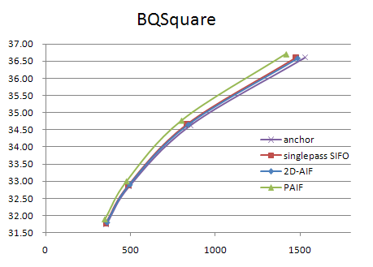
Fig. 8 R-D curve of BQSquare test sequence

Conclusion
Two parametric coding tools are proposed. The proposed AWR showed high coding efficiency for the sequence with evident complex motions: -7.08% for Cactus and -8.22% for Jets when 2-pass coding structure was used under the constraint set 1. The complexity could be efficiently reduces by the fast decision rule. This rule reduced the computational burden of the AWR to neglibible level when the AWR was not useful for the video sequence. When high coding efficiency was obtained by the AWR, the encoding complexity increased up to about 2.2 times. So, the average of the increased complexity is small.
The proposed PAIF showed high coding efficiency for most sequence in class C and D: -0.76% for class C and -2.67% for class D in average. The maximum was -8.89% for BQSquare sequence. The PAIF showed more effect than just reducing the side information; if it’s effect is just to reduce the side information, it should show high performance at low bit rate. However, it showed high performance at high bit rate as well as at low bit rate. The encoding complexity of PAIF is similar to other AIF techniques which use 2-pass encoding.
Although the performance of proposed two tools were tested using LG’s reference model, they can improve the coding performance irrespective of the anchor model.

Patent rights declaration(s)

(NOTE – Activities in the JCT-VC and contributions to the JCT-VC are subject to the common patent policy for ITU-T/ITU-R/ISO/IEC. A statement of that policy can be found at
http://www.itu.int/ITU-T/dbase/patent/patent-policy.html, with further information available at http://www.itu.int/ITU-T/ipr/index.html and in the ISO/IEC Directives. The form to be used for the formal reporting of patent rights to ITU-T/ITU-R/ISO/IEC can be found at http://www.itu.int/ITU-T/ipr/index.html. Contributions to the JCT-VC proposing normative technical content shall contain a non-binding informal notice of whether the submitter may have patent rights that would be necessary for implementation of the resulting standard. The provided informal notice shall indicate the category of anticipated licensing terms according to the ITU-T/ITU-R/ISO/IEC patent statement and licensing declaration form. This obligation to provide an informal notice is supplemental to, and does not replace, any existing obligations of parties with technology included in a final or draft standard to submit formal IPR declarations to ITU-T/ITU-R/ISO/IEC. An example of an informal IPR notification statement for a contribution is provided below.)

LG Electronics may have IPR relating to the technology described in this contribution and, conditioned on reciprocity, is prepared to grant licenses under reasonable and non-discriminatory terms as necessary for implementation of the resulting ITU-T Recommendation | ISO/IEC International Standard (per box 2 of the ITU-T/ITU-R/ISO/IEC patent statement and licensing declaration form).

References

[1] K. Wong, L. Po, K. Cheung, and K. Ng, “Block-Matching Translation and Zoom Motion-Compensated Prediction by Subsampling,” IEEE International Conference on Image Processing, pp. 1597-1600, 2009.
[2] C. Tomasi, T. Kanade, “Detection and Tracking of Point Features”, Technical Report CUM-CS-91-132, 1991.
[3] S. J. Pundlik, S. T. Birchfield, “Motion Segmentation at Any Speed”, British Machine Vision Conference, Sept. 2006.
[4] H. Richard. Z. Andrew, Multiple view geometry in computer vision, Cambridge University Press, UK., 2000.
[5] G. Bjontegaard, “Calculation of Average PSNR Differences between RD curves”, ITU-T SC16/Q6, 13th VCEG Meeting, Austin, Texas, USA, April 2001, Doc. VCEG-M33.
[6] Yuri Vatis, Bernd Edler, Diew Thanh Nguyen, and Jörn Ostermann, “Two-dimensional non-separable Adaptive Wiener Interpolation Filter for H.264/AVC”, ITU-T SC16/Q6, 26th VCEG Meeting, Busan, Korea, April 2005, Doc. VCEG-Z17.
[7] Matsushita, "Separable Adaptive Interpolation Filter", COM16-C219 July 2007.
[8] D. Rusanovskyy, K. Ugur, J. Lainema, "Adaptive Interpolation with Directional Filters", ITU-T Q.6/SG16 VCEG, VCEG-AG21 , October 2007
[9] Jie Dong, King Ngi Ngan, “Parametric interpolation filter for motion compensated prediction”, IEEE International Conference on Image Processing, Nov., 2009
[10] J. Nocedal, S. J. Wright, “Numerical optimization”, Springer New York, 2006

