Joint Video Team (JVT) of ISO/IEC MPEG & ITU-T VCEG  (ISO/IEC JTC1/SC29/WG11 and ITU-T SG16 Q.6)  16th Meeting: Poznań, PL, 24-29 July, 2005 | Document: JVT-P106  Filename: input.doc

Title: | CE8 report: Perceptual Region-of-interest (ROI) based Scalable Video Coding
Status: | Input Document to JVT
Purpose: | Proposal and report
Author(s) or  Contact(s): | Zhongkang Lu  Zhengguo Li  Jinghong Zheng  Wei Yao  Weisi Lin  Keng Pang Lim  Xiao Lin  Susanto Rahardja  Institute for Infocomm Research,  21 Heng Mui Keng Terrace,  Singapore 119613 | Tel:  Email: | +65 6874 6720  zklu@i2r.a-star.edu.sg  ezgli@i2r.a-star.edu.sg  jzheng@i2r.a-star.edu.sg  wyao@i2r.a-star.edu.sg  wslin@i2r.a-star.edu.sg  kplim@i2r.a-star.edu.sg  linxiao@i2r.a-star.edu.sg  rsusanto@i2r.a-star.edu.sg
Source: | Institute for Infocomm Research
_____________________________
Abstract: This document reports the progress on CE8 test 1, which is to implement CGS SNR scalability on JSVM. Adaptive QP and motion estimation control are used to achieve a better subjective quality by balancing distortions inside and outside of ROI. Moreover, to implement changing ROI, a scalable description of ROI is also introduced in the report. Subjective and objective comparison between JSVM1 and perceptual ROI-based JSVM1 are to be presented in the report. Because the subjective viewing test is scheduled to hold on Saturday (23rd July 2005) afternoon, a revised version with the comparison on subjective quality will be uploaded later.

1. Introduction

This document is to report the progress and experimental results on applying perceptual region-of-interest (ROI) concept into scalable video coding (SVC) [1]. According to the Busan CE8 proposal, two test sets are to be developed [2]. This report is focus on the progress on test set 1, which is to evaluate the improvement on subjective quality and SNR scalability. Spatial and temporal scalability is not included in current stage.

2. SNR scalability by perceptual ROI in JSVM

The SNR scalability by perceptual ROI in JSVM is realized by QP and motion estimation control. Generally, the QP values inside ROI region is smaller to outside ROI and the motion vectors are refined in ROI regions in upper layer. The distribution of QP is determined by the description of perceptual ROI. Correspondently, the motion estimation refining is also dependent on the QP values in ROI regions.

The implementation of perceptual ROI into JSVM follows the requirement document of JSVM [3], which can be outlined as:

- Rectangle (4 parameters) is used to describe a ROI region in a frame.
- MB (16x16) resolution is used for QCIF sequences, and 32x32 resolution is for CIF sequences.
- The implementation of perceptual ROI is compatible to type 2 slice definition in FMO.

Moreover, enhanced from type 2 slice definition in FMO, the improvements are:

- The slice size and position are adaptive from frame to frame.
- A parameter is added into steam head to indicate if the stream has changing slices.
- The description of perceptual ROI includes two parameters that indicate the PQSM (importance) value and gradient width of ROI region, and the description of rectangle ROI region.
- Instead of re-writing PPS data to each frame, a new scheme is developed:
  - Only one slice is used in base layer, which is to make sure the implementation is compatible to H.264;
  - The perceptual ROI in base layer is realized by in each macroblock, and only upper layer are separated into slices.
  - Every ROI slices contains smoothing gradient belt to minimize perceptual annoyance on slice border.
  - For each frame, only description of perceptual ROI (PQSM value, gradient width and rectangle ROI information) for each slice are written into stream just after the MB whose MB_index=0 (temporarily) .
  - The MB index list for each slice can be reconstructed by the perceptual ROI description.
  - A temporal scalable description method is used to describe the perceptual ROI parameters (PQSM value, gradient value, and rectangle description).
- QP distribution on enhancement layer is reconstructed by perceptual ROI description and the fixed QP.
- In current implementation, ROI slice always has motion vector enhancement, while background slice doesn’t. The motion vectors of background slice just copy from base layer.

2.1 Determining QP in each MB

The QP values in each MB in upper layer are determined by the fixed QP of sequence and the PQSM (importance) map, which is re-constructed by perceptual ROI description.
Let denotes the PQSM value of the ROI, denotes the gradient width, and denote the top-left and bottom-right points of the rectangle ROI. and are both in MB resolution. By using linear gradient function, we have
(1)
(2)
(3)
where represents the QP values inside of the rectangle ROI, represents the QP values outside of gradient belt, and represents the QP values on gradient belt. D is the distance from current MB to ROI closest border.
Then, let denotes the fixed QP value of sequence, then the QP values in each MB can be obtained by:
(4)

2.2 Determining MB index list in overlapping condition

Assume and represents the and ROI slice in one frame, and there exists overlapping between them. To avoid putting the overlapped MBs into stream twice, these MBs should be separated. In this proposal, PQSM values of each MB are used to fulfill the separation. Let denotes the PQSM value of MB to and denotes the PQSM value of MB , then if , the MB belongs to , else it belongs to .

2.3 Temporal scalable description of perceptual ROI

The diagram of temporal scalable decomposition on perceptual ROI description is shown in figure 1, which is very similar to MCTF decomposition. In the condition of no delay constraints (as shown in figure 1(a)), we have:
.

With maximal 4 frames delay constraint, we have:

.

In current experiment, PQSM value and gradient width do not change.
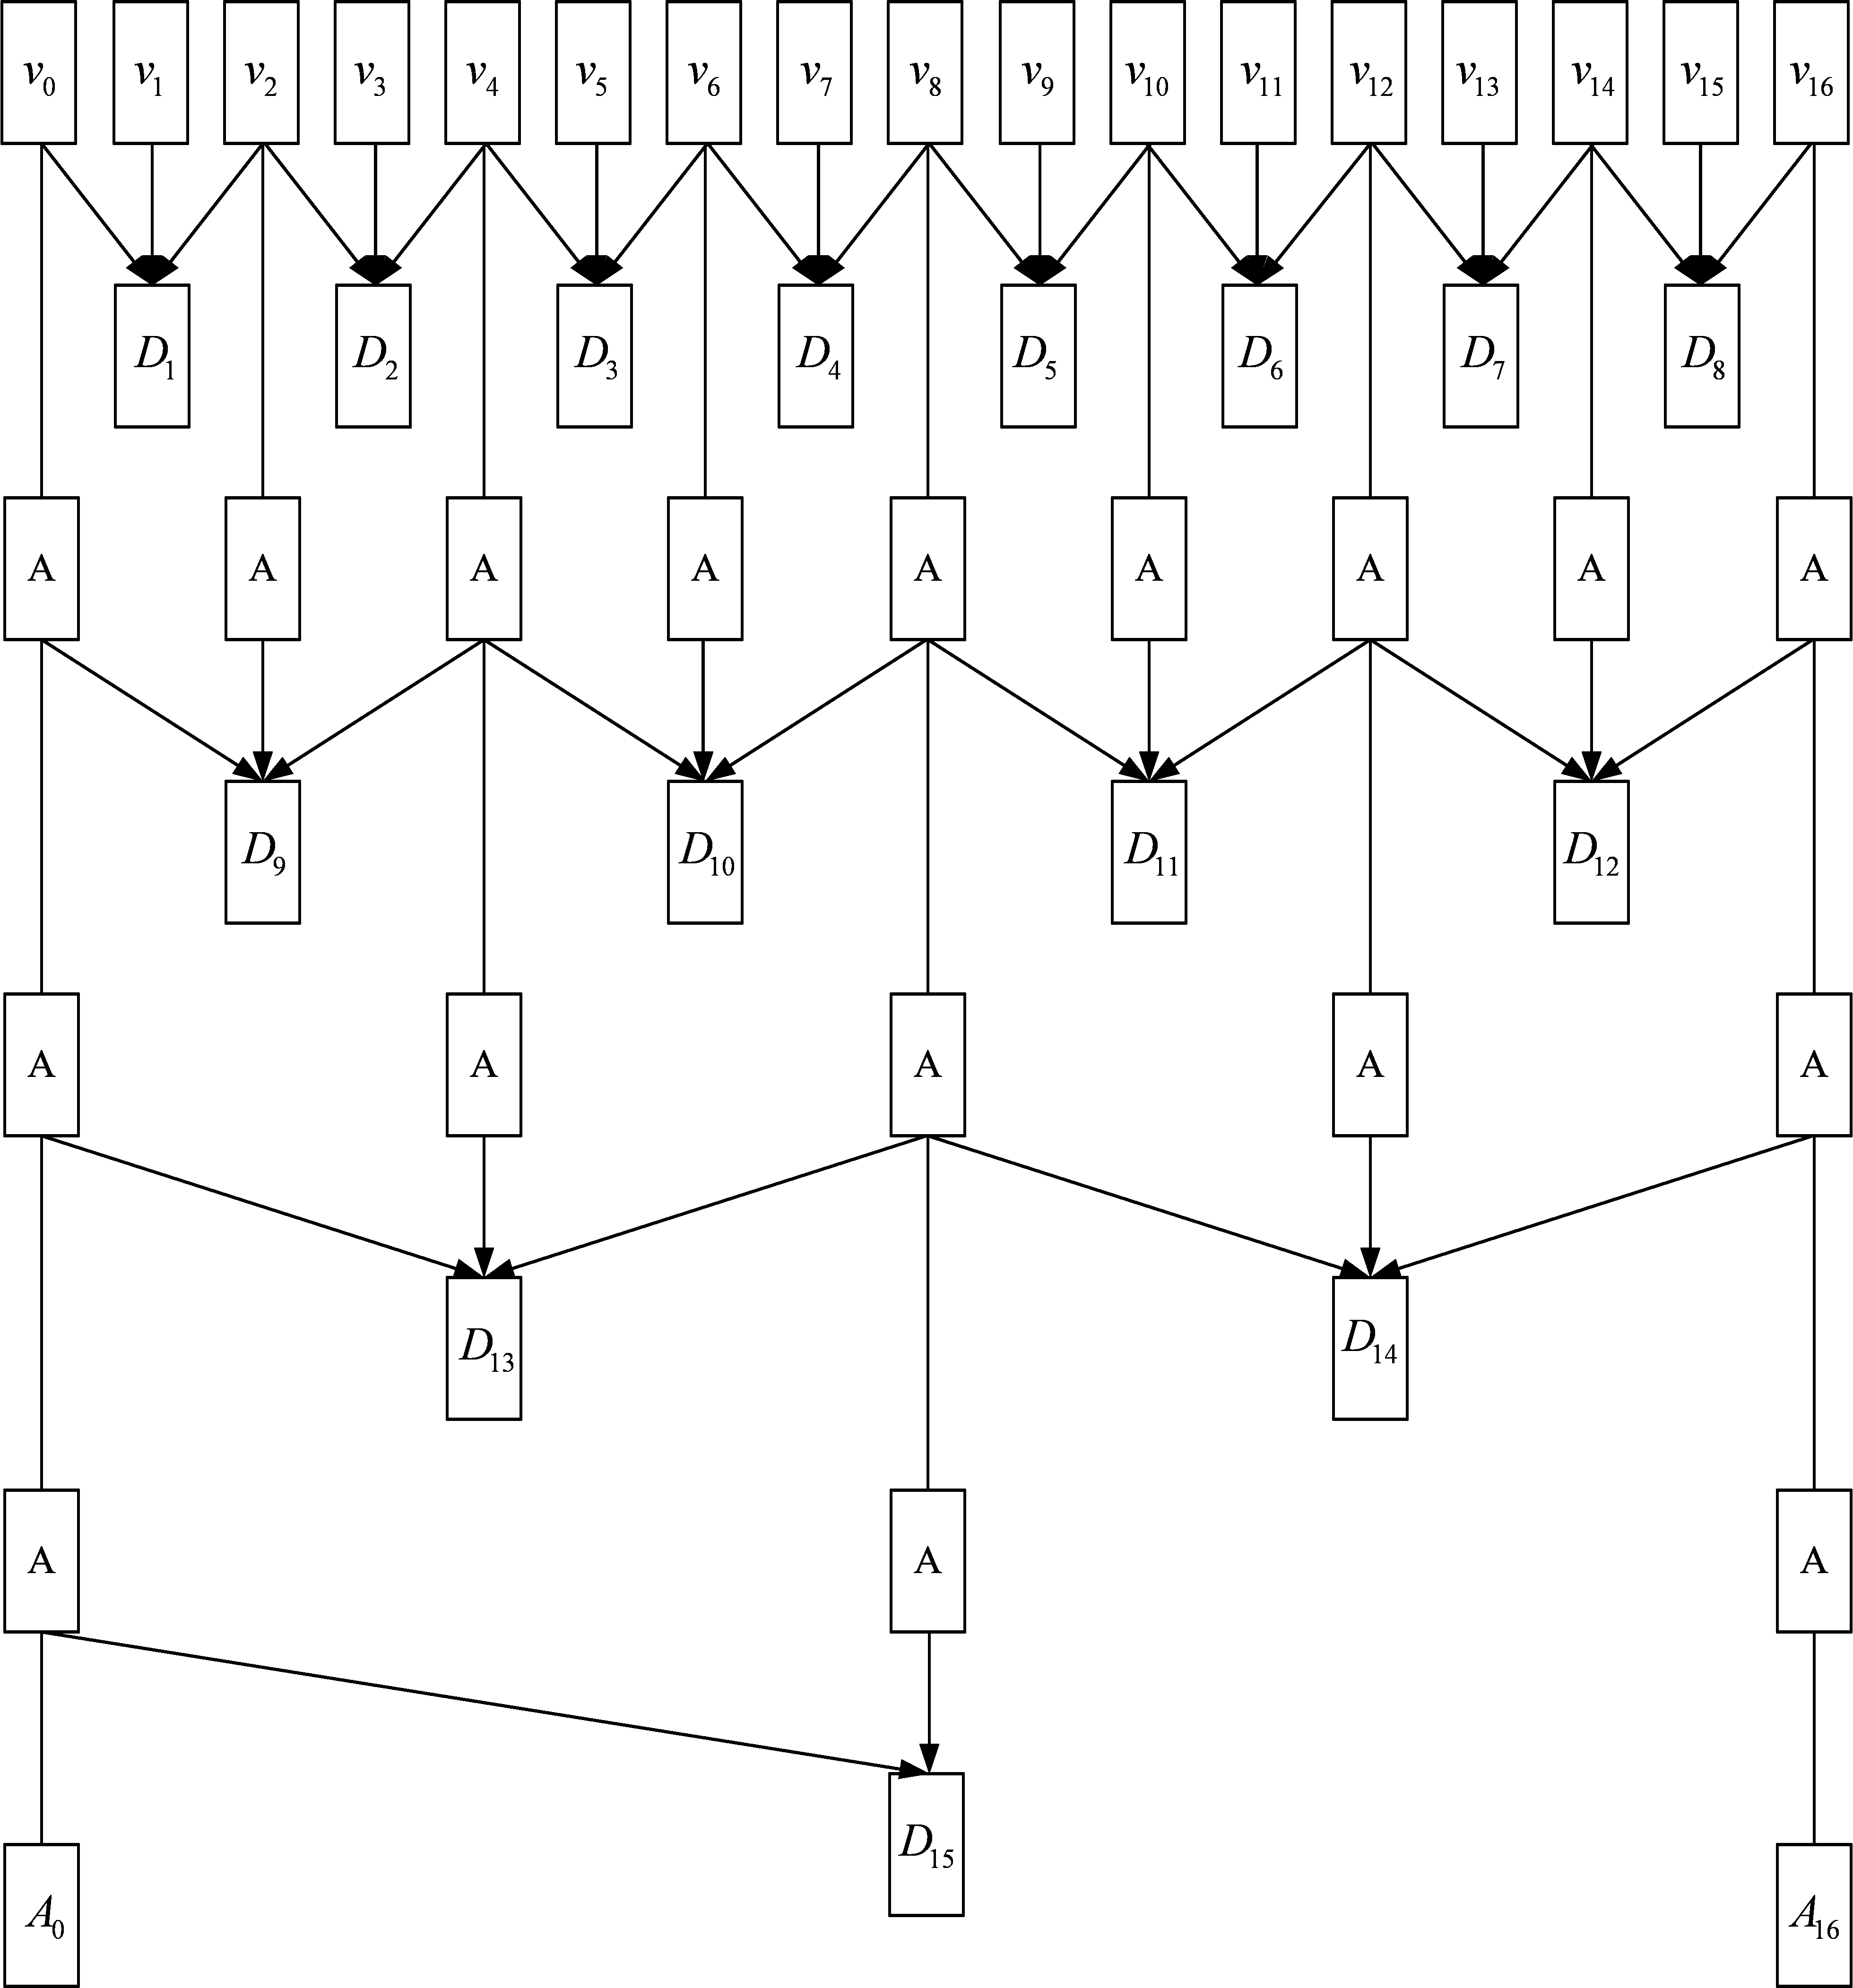
(a)

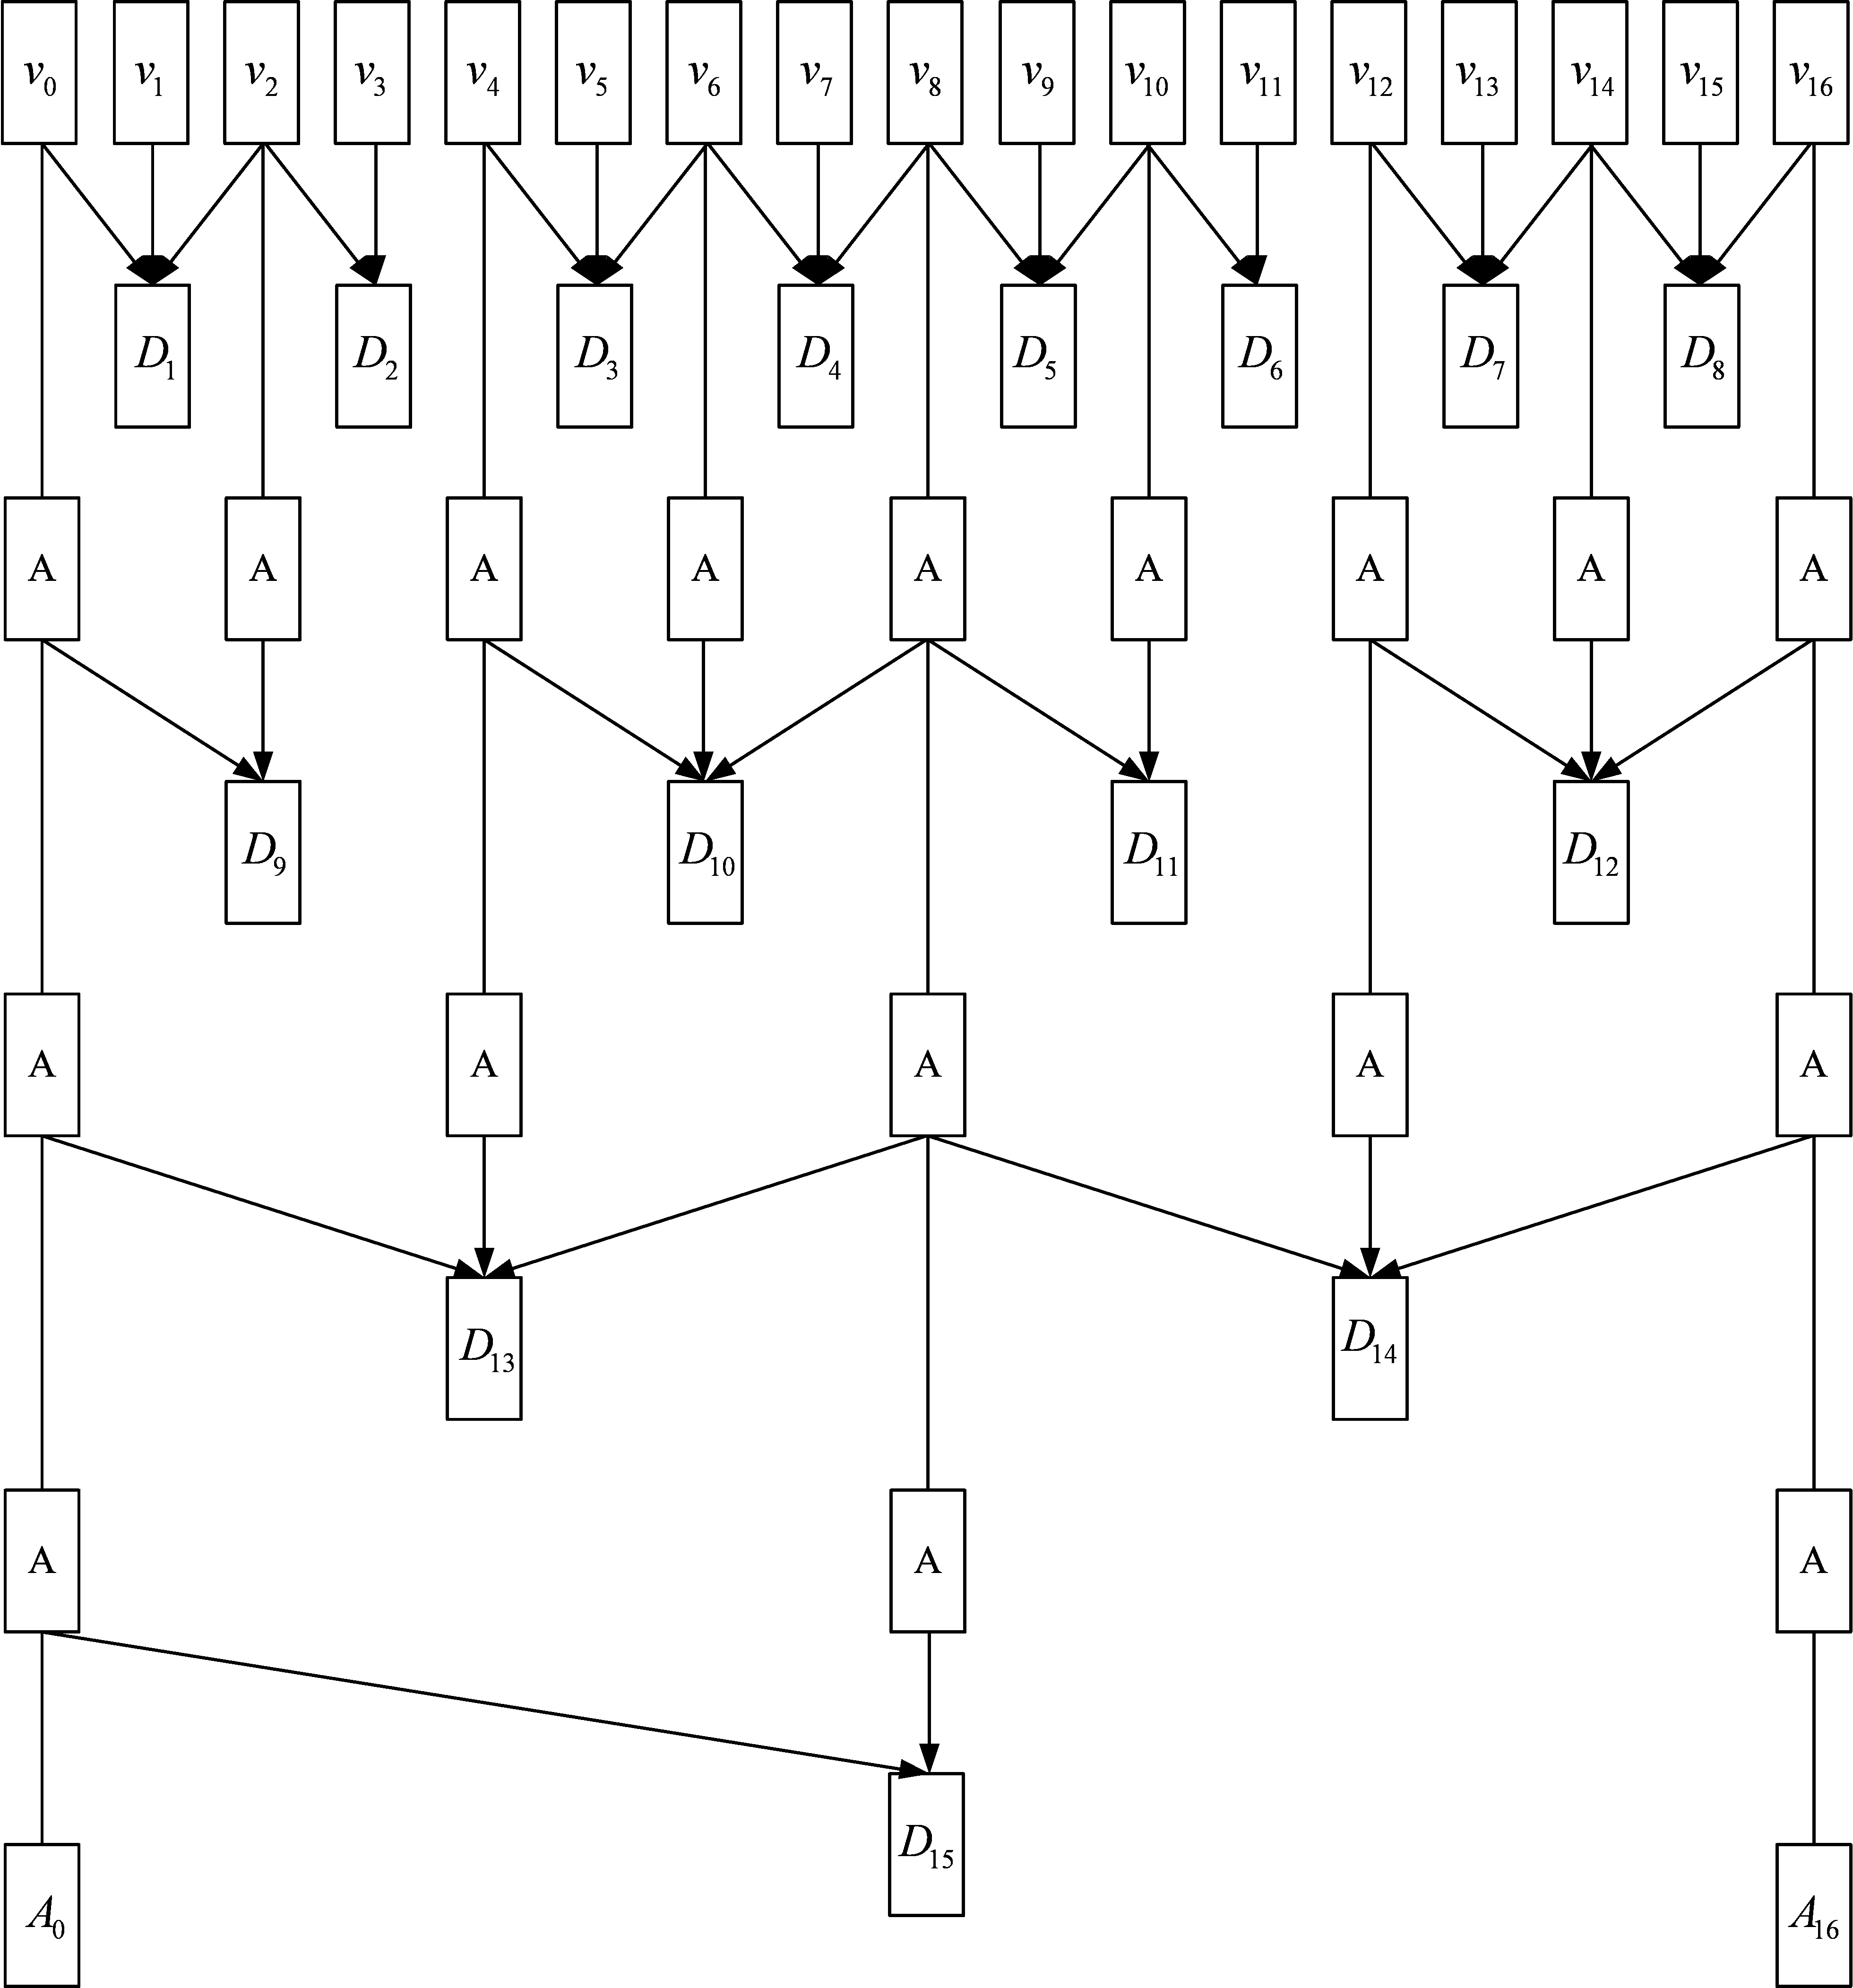
(b)

Figure 1, Diagram of temporal scalable decomposition of perceptual ROI description: (a) without delay constraints; and (b) with a maximum structural encoding-decoding delay of 4 frames of signals.

3. Test Scenarios

The test scenarios for performance evaluation are described in the following. Four test sequences are used in the comparison: ‘Coastguard’, ‘Foreman’, ‘News’ and ‘Stefan’. The test conditions are shown in table 1. Spatial scalability and temporal scalability are not considered at present, the base layer and enhancement layer have the same frame size and frame rate. We can see that the test cover various conditions of ROI. The implementation is based on JSVM1 software.

Table 1. Test conditions
 |  | Coastguard | Foreman | News | Stefan
Sequence length |  | 125 | 125 | 125 | 125
Frame size |  | CIF | QCIF | QCIF | CIF
Frame rate |  | 15Hz | 15Hz | 15Hz | 15Hz
ROI number |  | 2 | 1 | 2 | 1
Fixed ROI or moving ROI |  | moving | moving | fixed | moving
Overlap or not |  | Overlap | No | No | No
Test points  (k bits/sec) | Base layer | 300 | 24 | 24 | 160
Test points  (k bits/sec) | Enhance layer | 450 | 36 | 36 | 240

4. Experimental results

Subjective viewing test is executed to evaluate the subjective quality with perceptual ROI against without ROI. The results, MOS (Mean Opinion Scores) are list in table 2. Moreover, the PSNR values in ROI areas of the reconstructed sequences are also list in table 3. The 60th frames of these sequences are also shown in figure 3-6.

Table 2. Comparison of MOS values between reconstructed without ROI and with ROI.
 | Coastguard |  | Foreman |  | News |  | Stefan
 | layer0 | Layer1 | layer0 | Layer1 | layer0 | Layer1 | layer0 | Layer1
w/o ROI
/w ROI

Table 3. Comparison of PSNR values of ROI areas.
 | Coastguard |  | Foreman |  | News |  | Stefan
 | layer0 | Layer1 | layer0 | Layer1 | layer0 | Layer1 | layer0 | Layer1
w/o ROI | 24.388 | 25.808 | 28.126 | 29.21 | 36.06 | 37.368 | 21.591 | 22.932
/w ROI | 25.089 | 26.479 | 28.848 | 30.247 | 36.67 | 38.527 | 22.172 | 23.554

5. References

[1]. Zhongkang Lu, Weisi Lin, Zhengguo Li, Keng Pang Lim, Xiao Lin, Susanto Rahardja, Ee Ping Ong and Susu Yao, “Perceptual Region-of-interest (ROI) based Scalable Video Coding”, Joint Video Team, Document JVT-O056, April 2005.
[2]. “CE8: ROI-based Scalable Video Coding,” JVT document JVT-O308, April 2005, Busan, Korea.
[3]. “Meeting Report of 15th JVT Meeting (Busan, KR 16-22 April 2005),” JVT document JVT-O001, April 2005, Busan, Korea.

(a)(b)

(c)(d)

Figure 3. The 60th frame of reconstructed ‘Coastguard’ sequences: (a) 300 Kbits/s without ROI; (b) 300 Kbits/s with ROI; (c) 450 Kbits/s without ROI; and (d) 450 Kbits/s with ROI.

(a)(b)

(c)(d)

Figure 4. The 60th frame of reconstructed ‘Foreman’ sequences: (a) 24 Kbits/s without ROI; (b) 24 Kbits/s with ROI; (c) 36 Kbits/s without ROI; and (d) 36 Kbits/s with ROI.

(a)(b)

(c)(d)

Figure 5. The 60th frame of reconstructed ‘News’ sequences: (a) 24 Kbits/s without ROI; (b) 24 Kbits/s with ROI; (c) 36 Kbits/s without ROI; and (d) 36 Kbits/s with ROI.

(a)(b)

(c)(d)

Figure 3. The 60th frame of reconstructed ‘Stefan’ sequences: (a) 160 Kbits/s without ROI; (b) 160 Kbits/s with ROI; (c) 240 Kbits/s without ROI; and (d) 240 Kbits/s with ROI.

(Append for Proposal Documents)

JVT Patent Disclosure Form

International Telecommunication Union  Telecommunication Standardization Sector | International Organization for Standardization | International Electrotechnical Commission
 |  | 
Joint Video Coding Experts Group - Patent Disclosure Form
(Typically one per contribution and one per Standard | Recommendation)

Please send to:
JVT Rapporteur Gary Sullivan, Microsoft Corp., One Microsoft Way, Bldg. 9, Redmond WA 98052-6399, USA
Email (preferred): Gary.Sullivan@itu.int Fax: +1 425 706 7329 (+1 425 70MSFAX)

This form provides the ITU-T | ISO/IEC Joint Video Coding Experts Group (JVT) with information about the patent status of techniques used in or proposed for incorporation in a Recommendation | Standard. JVT requires that all technical contributions be accompanied with this form. Anyone with knowledge of any patent affecting the use of JVT work, of their own or of any other entity (“third parties”), is strongly encouraged to submit this form as well.

This information will be maintained in a “living list” by JVT during the progress of their work, on a best effort basis. If a given technical proposal is not incorporated in a Recommendation | Standard, the relevant patent information will be removed from the “living list”. The intent is that the JVT experts should know in advance of any patent issues with particular proposals or techniques, so that these may be addressed well before final approval.

This is not a binding legal document; it is provided to JVT for information only, on a best effort, good faith basis. Please submit corrected or updated forms if your knowledge or situation changes.

This form is not a substitute for the ITU ISO IEC Patent Statement and Licensing Declaration, which should be submitted by Patent Holders to the ITU TSB Director and ISO Secretary General before final approval.

Submitting Organization or Person:
Organization name | Institute for Infocomm Research
Mailing address | 21 Heng Mui Keng Terrace, Singapore 119613
Country | Singapore
Contact person | Zhongkang Lu
Telephone | +65 6874 6720
Fax | +65 6774 4998
Email | zklu@i2r.a-star.edu.sg
Place and date of submission | Poznan, Poland, July 2005
Relevant Recommendation | Standard and, if applicable, Contribution:
Name (ex: “JVT”) |  | JVT
Title |  | Perceptual Region-of-interest (ROI) based Scalable Video Coding
Contribution number

(Form continues on next page)

Disclosure information – Submitting Organization/Person (choose one box)
2.0 The submitter is not aware of having any granted, pending, or planned patents associated with the technical content of the Recommendation | Standard or Contribution.

or,
The submitter (Patent Holder) has granted, pending, or planned patents associated with the technical content of the Recommendation | Standard or Contribution. In which case,

2.1 The Patent Holder is prepared to grant – on the basis of reciprocity for the above Recommendation | Standard – a free license to an unrestricted number of applicants on a worldwide, non-discriminatory basis to manufacture, use and/or sell implementations of the above Recommendation | Standard.
2.2 The Patent Holder is prepared to grant – on the basis of reciprocity for the above Recommendation | Standard – a license to an unrestricted number of applicants on a worldwide, non-discriminatory basis and on reasonable terms and conditions to manufacture, use and/ or sell implementations of the above Recommendation | Standard.

Such negotiations are left to the parties concerned and are performed outside the ITU | ISO/IEC.
2.2.1 The same as box 2.2 above, but in addition the Patent Holder is prepared to grant a “royalty-free” license to anyone on condition that all other patent holders do the same.
2.3 The Patent Holder is unwilling to grant licenses according to the provisions of either 2.1, 2.2, or 2.2.1 above. In this case, the following information must be provided as part of this declaration:
- patent registration/application number;
- an indication of which portions of the Recommendation | Standard are affected.
- a description of the patent claims covering the Recommendation | Standard;
In the case of any box other than 2.0 above, please provide the following:
Patent number(s)/status
Inventor(s)/Assignee(s)
Relevance to JVT
Any other remarks:
(please provide attachments if more space is needed)

(form continues on next page)
Third party patent information – fill in based on your best knowledge of relevant patents granted, pending, or planned by other people or by organizations other than your own.

Disclosure information – Third Party Patents (choose one box)
3.1 The submitter is not aware of any granted, pending, or planned patents held by third parties associated with the technical content of the Recommendation | Standard or Contribution.

3.2 The submitter believes third parties may have granted, pending, or planned patents associated with the technical content of the Recommendation | Standard or Contribution.

For box 3.2, please provide as much information as is known (provide attachments if more space needed) - JVT will attempt to contact third parties to obtain more information:

3rd party name(s)
Mailing address
Country
Contact person
Telephone
Fax
Email
Patent number/status
Inventor/Assignee
Relevance to JVT

Any other comments or remarks:

