Joint Video Team (JVT) of ISO/IEC MPEG & ITU-T VCEG  (ISO/IEC JTC1/SC29/WG11 and ITU-T SG16 Q.6)  16th Meeting: Poznań, PL, 24-29 July, 2005 | Document: JVT-P077  Filename: input.doc

Title: | Complexity reduction by simplified chroma update step
Status: | Input Document to JVT
Purpose: | Proposal
Author(s) or  Contact(s): | Doe Hyun Yoon,  Byeong-Moon Jeon,  Ji-Ho Park,  Seung-Wook Park  DM Research Lab., LG Electronics  Inc., 16 Woomyeon-dong, Seocho-gu  Seoul, Korea | Email:  Tel:  Fax: | dhyoon@lge.com  jeonbm@lge.com  scottie@lge.com  beatitude@lge.com  +82-2-526-4369  +82-2-526-4283
Source: | LG Electronics Inc.
_____________________________

Abstract
Scalable video codec (SVC) is based on motion compensated temporal filtering (MCTF) and MCTF is composed of the motion compensated prediction and update. Although MCTF provides both the coding efficiency and the scalability, it is pointed out that the update step, which is a conceptually new tool to hybrid video codec, introduces additional complexity both for encoder and decoder. Therefore, reducing the complexity of update step, while keeping the coding efficiency, has been considered to be very desirable.
In this proposal, the update step for chroma signal is simplified by quantizing chroma update motion vector to integer-pel unit. This simplification does not introduce any noticeable degradation but the overall complexity of update step is reduced because fractional pixel interpolation could be avoided. Besides that, skipping of chroma update is also proposed, and this feature could be controlled by using disable_chroma_update_flag. Since the whole chroma update step is not used, the coding penalty seems to be allowable.

- Chroma update step in JSVM 2
In JSVM 2 [1], The luma motion vectors for the luma update are derived using those of the neighborhood high-pass pictures, and the chroma motion vectors are derived from the luma update motion vector by using derivation process for chroma motion vectors defined in S.8.4.1.4, which is the same procedure used for the motion compensated prediction.
By using the derived chroma update motion vectors, the motion compensation, which is identical to the motion compensated prediction, is applied to the chroma update, i.e., the bi-linear interpolation up to 1/8th pel accuracy is employed for the fractional pixel interpolation process.

- Simplified chroma update step
Since the visual quality is less sensitive to the chroma samples than the luma samples, it is expected that simplifying chroma update would not degrade the coding performance much. Two different methods are proposed in this contribution in order to reduce the complexity of update step.

  - Method 1: Chroma update using integer pel unit chroma motion vector
In this method, the derived chroma motion vectors are quantized to integer-pel unit so that no fractional pixel interpolation is required during the chroma update.
Therefore, the chroma update motion vector mvCLX is derived from luma motion mvLX as follows.
mvCLX[0] = ( ( mvLX[0] + 4 ) >> 3 ) << 3
mvCLX[1] = ( ( mvLX[1] + 4 ) >> 3 ) << 3
Note that mvLX is quarter-pel unit and mvCLX is 1/8th-pel unit.

  - Method 2: Skipping chroma update
It is proposed that only luma components are updated and chroma pixels are remained unchanged during the motion compensated update process. Since no operation regarding chroma update is performed, a considerable amount of the complexity in regards to the motion compensated update step could be reduced. If a syntax element disable_chroma_update_flag is defined, then this feature could be applied optionally.

- Experiments and evaluation
Both methods described in section 2 are implemented in JSVM 2 software [2], and they are compared with the performance of JSVM with low complexity update step using Munich configuration.

  - Objective quality comparison
    - Luminance PSNR
The following graphs show the coding performance in luminance PSNR. As shown in these graphs, both the skipping chroma update and integer chroma update motion vector affect only negligible amount of coding performance.

    - Chrominance PSNR
The coding performance in chrominance PSNR are shown in the following graphs ( U component in section 3.1.2.1 and V component in section 3.1.2.2 ). The coding performance of integer chroma update motion vector does not degrade much, and in some cases, PSNR is slightly increased. Skipping chroma update introduces some loss in chrominance PSNR, but this loss seems to be allowable because the considerable amount of complexity reduction could be gained by skipping the whole chroma update.

      - U component

      - V component

  - Visual quality comparison
For the visual quality evaluation, key pictures of temporal level 0 in CIF sequences are shown here. All pictures are decoded from CIF 30Hz layer-4 bitstream using Munich configuration. It is hard to find any noticeable artifacts for the simplified chroma update cases, even for the case that the whole chroma update is skipped.

- the 3rd key pictures of Bus sequence (temporal level = 0)

(a) JSVM2 (b) Integer chroma MV (c) Skipping chroma update
- the 6th key pictures of Football sequence (temporal level = 0)
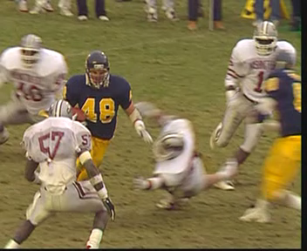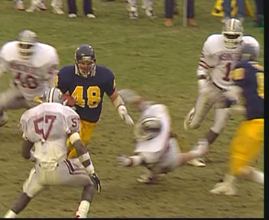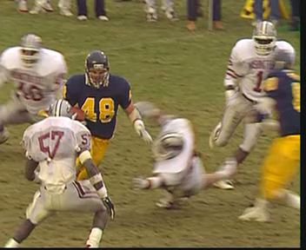
(a) JSVM2 (b) Integer chroma MV (c) Skipping chroma update
- the 6th key pictures of Foreman sequence (temporal level = 0)

(a) JSVM2 (b) Integer chroma MV (c) Skipping chroma update
- the 9th key pictures of Mobile sequence (temporal level = 0)
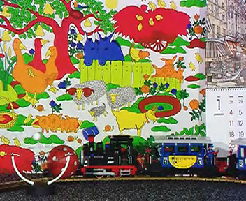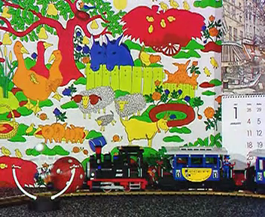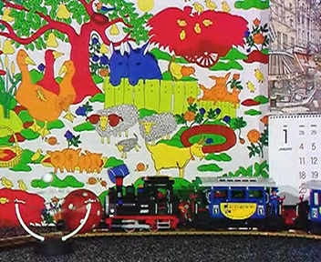
(a) JSVM2 (b) Integer chroma MV (c) Skipping chroma update

- Conclusion
The experimental results of the simplified chroma update step can be summarized as follows.
- It is true that the coding performance in luminance PSNR is nearly not affected by the simplified chroma update step even if the chroma update is not performed at all.
- The coding penalty of method 1, which is quantizing chroma update motion vector to integer pel, in chroma PSNR is negligible.
- The coding performance of method 2, which is skipping chroma update, in chroma PSNR ranges between about 0.5dB to 1dB in general. But this degradation could be considered as tradeoff with the complexity reduction. Besides that the performance degradation is sometimes very small for a sequence such as Football.
- No visible artifact is introduced by applying the proposed tools.

Therefore, based on the experimental results shown in this proposal, the fractional pixel interpolation of chroma pixels for update could be eliminated by using the proposed integer-pel unit chroma update motion vector with the reduced the complexity of update step while keeping coding performance almost identical, and disable_chroma_update_flag in SPS can control the skipping of chroma update so that the low-complexity decoding could be possible. The proposed modification is described in the appendix of this proposal in detail.
Moreover, also we suggest that the core experiment regarding the complexity reduction of the chroma signal processing should be established for the further study. Through the core experiment, the more simplified weighting process of chroma update signal could be studied further.

Reference:
- JVT-O202, “Joint Scalable Video Model JSVM-2,” Busan, April, 2005.
- JVT-O203, “Joint Scalable Video Model JSVM-2 Software,” Busan, April, 2005.

Appendix: the proposed modification to JSVM annex.S
- modification to sub clause S.7.3.2.1 Sequence parameter set RBSP syntax
seq_parameter_set_rbsp( ) { | C | Descriptor
profile_idc | 0 | u(8)
constraint_set0_flag | 0 | u(1)
constraint_set1_flag | 0 | u(1)
constraint_set2_flag | 0 | u(1)
constraint_set3_flag | 0 | u(1)
reserved_zero_4bits /* equal to 0 */ | 0 | u(4)
level_idc | 0 | u(8)
seq_parameter_set_id | 0 | ue(v)
if( profile_idc = = 83 ) {
nal_unit_extension_flag | 0 | u(1)
if( nal_unit_extension_flag = = 0 ) {
number_of_simple_priority_id_values_minus1 | 0 | ue(v)
for( i = 0; i <= number_of_simple_priority_id_values_minus1; i++ ) {
priority_id | 0 | u(6)
temporal_level_list[ priority_id ] | 0 | u(3)
dependency_id_list[ priority_id ] | 0 | u(3)
quality_level_list[ priority_id ] | 0 | u(2)
}
}
low_complexity_update_flag | 0 | u(1)
disable_chroma_update_flag | 0 | u(1)
}
==== the remaining parts are identical to JSVM 2 ====

- modiciation to sub clause S.7.4.2.1 Sequence parameter set RBSP semantics
Insert the following after the item low_complexity_update_flag.
disable_chroma_update_flag specifies whether to skip the chroma update step. If disable_chroma_update_flag is equal to 1, the motion compensated update process for chroma signal is skipped; otherwise (disable_chroma_update_flag is equal to 0), the chroma update shall be performed.

- add a new sub clause for the derivation process for chroma update motion vectors
This process shall only be invoked when chroma_format_idc is not equal to 0 (monochrom) and disable_chroma_update_flag is not equal to 1.
Inputs to this process are a luma update motion vector mvLX and a reference index refIdxLX.
Output of this process is a chroma update motion vector mvCLX.
A chroma update motion vector is derived from the corresponding update luma motion vector.
The precision of the chroma update motion vector components is 1 ÷ (4 * SubWidthC ) horizontally and 1 ÷ (4 * SubHeightC ) vertically.
For example, since the accuracy of luma motion vectors is one-quarter sample and 4:2:0 chroma format chroma has half horizontal and vertical resolution compared to luma, the accuracy of chroma motion vectors is one-eighth sample in 4:2:0 chroma format, i.e., a value of 1 for the chroma motion vector refers to a one-eighth sample displacement.
Note – For example, when the luma motion vector applies to 8x16 luma samples, the corresponding chroma vector in 4:2:0 chroma format applies to 4x8 chroma samples and when the luma vector applies to 4x4 luma samples, the corresponding chroma vector in 4:2:0 chroma format applies to 2x2 chroma samples.
For the derivation of the motion vector mvCLX, the following applies.
- if chroma_format_idc is not equal to 1 or the current macroblock is a frame macroblock, the horizontal and vertical components of the chroma motion vector mvCLX are derived by multiplying the corresponding components of luma motion vector mvLX by SubWidthC and SubHeightC and are quantized to the integer-pel unit, through mapping one-quarter sample mvLX units to the units used for mvCLX
mvCLX[0] = ( ( mvLX[0] + r0 ) >> h ) << h
mvCLX[1] = ( ( mvLX[1] + r1 ) >> v ) << v
h = log₂( 4 * SubWidthC ), v = log₂( 4 * SubHeightC ), r0 = 2 * SubWidthC, and r1 = 2 * SubHeightC
- Otherwise (chroma_format_idc is equal to 1 and the current macroblock is a field macroblock, …
derivation process for a field macroblock is not yet specified.

- modify both the update step (S.8.8.3 Motion-compensated update process and S.8.8.3.3 Low-complexity motion-compensated update process)
All the process related to chroma update shall be performed only when disable_chroma_update_flag is equal to 0.
chroma update motion vector mvCLX is derived using the sub clause defined above instead of sub clause S.8.4.2.2

(Append for Proposal Documents)

JVT Patent Disclosure Form

International Telecommunication Union  Telecommunication Standardization Sector | International Organization for Standardization | International Electrotechnical Commission
 |  | 
Joint Video Coding Experts Group - Patent Disclosure Form
(Typically one per contribution and one per Standard | Recommendation)

Please send to:
JVT Rapporteur Gary Sullivan, Microsoft Corp., One Microsoft Way, Bldg. 9, Redmond WA 98052-6399, USA
Email (preferred): Gary.Sullivan@itu.int Fax: +1 425 706 7329 (+1 425 70MSFAX)

This form provides the ITU-T | ISO/IEC Joint Video Coding Experts Group (JVT) with information about the patent status of techniques used in or proposed for incorporation in a Recommendation | Standard. JVT requires that all technical contributions be accompanied with this form. Anyone with knowledge of any patent affecting the use of JVT work, of their own or of any other entity (“third parties”), is strongly encouraged to submit this form as well.

This information will be maintained in a “living list” by JVT during the progress of their work, on a best effort basis. If a given technical proposal is not incorporated in a Recommendation | Standard, the relevant patent information will be removed from the “living list”. The intent is that the JVT experts should know in advance of any patent issues with particular proposals or techniques, so that these may be addressed well before final approval.

This is not a binding legal document; it is provided to JVT for information only, on a best effort, good faith basis. Please submit corrected or updated forms if your knowledge or situation changes.

This form is not a substitute for the ITU ISO IEC Patent Statement and Licensing Declaration, which should be submitted by Patent Holders to the ITU TSB Director and ISO Secretary General before final approval.

Submitting Organization or Person:
Organization name
Mailing address
Country
Contact person
Telephone
Fax
Email
Place and date of submission
Relevant Recommendation | Standard and, if applicable, Contribution:
Name (ex: “JVT”)
Title
Contribution number

(Form continues on next page)

Disclosure information – Submitting Organization/Person (choose one box)
2.0 The submitter is not aware of having any granted, pending, or planned patents associated with the technical content of the Recommendation | Standard or Contribution.

or,
The submitter (Patent Holder) has granted, pending, or planned patents associated with the technical content of the Recommendation | Standard or Contribution. In which case,

 | 2.1 The Patent Holder is prepared to grant – on the basis of reciprocity for the above Recommendation | Standard – a free license to an unrestricted number of applicants on a worldwide, non-discriminatory basis to manufacture, use and/or sell implementations of the above Recommendation | Standard.
 | 2.2 The Patent Holder is prepared to grant – on the basis of reciprocity for the above Recommendation | Standard – a license to an unrestricted number of applicants on a worldwide, non-discriminatory basis and on reasonable terms and conditions to manufacture, use and/ or sell implementations of the above Recommendation | Standard.  Such negotiations are left to the parties concerned and are performed outside the ITU | ISO/IEC.
 | 2.2.1 The same as box 2.2 above, but in addition the Patent Holder is prepared to grant a “royalty-free” license to anyone on condition that all other patent holders do the same.
2.3 The Patent Holder is unwilling to grant licenses according to the provisions of either 2.1, 2.2, or 2.2.1 above. In this case, the following information must be provided as part of this declaration:
- patent registration/application number;
- an indication of which portions of the Recommendation | Standard are affected.
- a description of the patent claims covering the Recommendation | Standard;
In the case of any box other than 2.0 above, please provide the following:
Patent number(s)/status
Inventor(s)/Assignee(s)
Relevance to JVT
Any other remarks:
(please provide attachments if more space is needed)

(form continues on next page)
Third party patent information – fill in based on your best knowledge of relevant patents granted, pending, or planned by other people or by organizations other than your own.

Disclosure information – Third Party Patents (choose one box)
3.1 The submitter is not aware of any granted, pending, or planned patents held by third parties associated with the technical content of the Recommendation | Standard or Contribution.

3.2 The submitter believes third parties may have granted, pending, or planned patents associated with the technical content of the Recommendation | Standard or Contribution.

For box 3.2, please provide as much information as is known (provide attachments if more space needed) - JVT will attempt to contact third parties to obtain more information:

3rd party name(s)
Mailing address
Country
Contact person
Telephone
Fax
Email
Patent number/status
Inventor/Assignee
Relevance to JVT

Any other comments or remarks:

