Joint Video Team (JVT) of ISO/IEC MPEG & ITU-T VCEG  (ISO/IEC JTC1/SC29/WG11 and ITU-T SG16 Q.6)  PExt Ad Hoc Group Meeting 22-24 July, 2003, Trondheim | Document: JVT-I012  Filename: JVT-I012r2.doc

Title: | Proposal for the unsolved issues in Professional Extensions
Status: | Input Document to JVT
Purpose: | Proposal
Author(s) or  Contact(s): | Woo-Shik Kim,  Dae-Sung Cho,  Hyun Mun Kim  Multimedia Lab. Samsung AIT  P.O.Box 111, Suwon 440-600  Korea | Tel:  Email: | 82-31-280-9204  hyunmun27.kim@samsung.com
Source: | Samsung AIT
_____________________________
- Introduction

This proposal addresses issues that were not resolved from the previous meeting in Geneva [1]. It includes RGB, XYZ and YUV coding for the extended bit depth in 4:4:4 Chroma formats. Also there were issues regarding the MC interpolation method, loop filtering, CBP coding for 4:4:4 and 4:4:4:4 Chroma formats. On top of these topics, we also propose a mathematically lossless RGB coding for archive uses, and bit-depth adaptive wegihted prediction. For each of this issue we provide solutions that need minimal syntax changes while giving better compression efficiency. In the subsequent sections we describe the proposed solutions in detail.

- Proposed Methods

In this section, we summarize the proposed method for the issues aforementioned.

  - RGB Coding

For RGB coding we use the same method as proposed from the previous meeting. The proposed method supports any color space equally well by introducing a flag to signal the DPCM coding of residual images [2]. It avoids the color distortion due to the rounding errors resulting from the color space conversion involved when coded in YUV space. Simulation results clearly show that due to the color space conversion there exists an achievable PSNR limit when coded in YUV space. By applying DPCM we achieve more than 40% coding gain when compared with the case without DPCM.

  - Lossless RGB Coding

The lossless coding is required for the archive usage. To support mathematically lossless coding, we propose to use the RGB color space with 4:4:4 chroma format without transformation and quantization. To increase the coding efficiency we also apply the same DPCM coding described in section 2.1. No color space conversion should be allowed to be lossless.

  - MC Interpolation for 4:4:4 Chroma formats

We conducted an extensive simulation to compare the performances between 6-tab filter and bilinear transform for various 4:4:4 chroma format contents both in YUV and RGB spaces. Table 1 shows the summary of MC interpolation results when we apply the filtering to high resolution images and low resolution images in both spaces.

Table1: Selection of best performance for MC interpolation comparison
 | High Resolution (HD) | Low Resolution (SD)
RGB space | Bilinear Transform (BT) | 6-tab filter
YUV space | BT | Y:6-tab UV:BT

It shows that bilinear transform gives better performance for more correlated images such as high resolution images or UV components. For low resolution images, 6-tab shows better results for RGB images while 6-tab for Y and bilinear transform for UV shows better performance. In RGB space each component shows the similar characteristics among components. But in YUV space Y component and UV components show the different characteristics. To handle all the cases equally well we propose to use 6-tab for all the RGB components while to use 6-tab for Y and bilinear transform for UV components.

  - Loop Filtering for 4:4:4 Chroma formats

It shares the same rationale that in RGB space each component shows the similar characteristics while in YUV space Y component and UV components show the different characteristics. So we propose as follows:
For RGB images, we apply the same Luma loop filtering to all the components. For YUV 4:4:4 format we apply the same filtering except that the Chroma deblocking filter is performed on four 16 sample edges since the resolution for Chroma format has increased. For 10-bit images we scale all the thresholds linearly as Dolby proposed [3].

  - CBP Coding for 4:4:4 Chroma formats

In this application we propose how we code the coded_block_pattern efficiently in 4:4:4 chroma formats in YUV or RGB color spaces. We further handle the possible 4:4:4:4 cases that include the possible alpha channel. Depending on the partitions, the bit saving gain differs. For example as shown in Figure 1, we can assign coded_block_pattern bit independently for each 8x8 block from YUV components. In this case we have $2^{\text{12}}$ different cases to code the coded_block_pattern. On the other hand, we can combine the coded_block_pattern bit for the collocated 8x8 blocks in UV components as shown in Figure 2. In this case there are $2^{8}$ different cases. To compare the coding efficiency we need to estimate the bit saving gain for each possible partition.

Figure 1: 12 independent Coded Block Pattern coding

Figure 2: 8 independent Coded Block Pattern coding (4 for Y and 4 for UV components)

For this purpose, we formulate the bit saving gain as follows:

$\text{Gain}=4×A−(H+1)×N$ (1)

where A is the number of not coded 8x8 blocks, H is the entropy of the coded_block_pattern and N is the number of macroblocks. Here we assume that we need (H+1) bits to code the coded_block_pattern for each macroblock and 1 bit to code each coded_block_flag. The number of not coded 8x8 blocks differs depending on the partitions. For example in Figure 1, any block that is not coded is counted while in Figure 2, both of the collocated 8x8 blocks in UV components should not be coded to be counted as not coded blocks. Using this method, we estimated the bit saving gain for the following partitions.
- 12x1 (combined coding using 12 8x8 blocks)
- 4+8 (separate coding for Y and UV components using 12 8x8 blocks)
- 4+4+4 (separate coding for YUV components using 12 8x8 blocks)
- 8x1 (combined coding using 8 8x8 blocks)
- 4+4 (separate coding for Y and UV components using 8 8x8 blocks)
- 6x1 (current scheme for 4:2:0 format)

For cases 1-3 we use the partition in Figure 1 while for cases 4-5 we use the partition in Figure 2. The difference between case 1 and 2 is that we use separate codebook for Y component and UV component in case (2) while we use one codebook to represent the $2^{\text{12}}$ cases in case (1). We use the following formula if separate coding is involved as in cases 2, 3 and 5.

$\text{Gain}=4×A−N×\sum_{i}{(H_{i}+1)}$ (2)

where i is the number of independent cases.

Using (1) and (2) we run the test for several images. The simulation results show that case 1 shows the best performance followed by case (4). Even though cases 2 and 3 have more not coded blocks, their gain is decreased due to the increased entropy for separate coding. It is more efficient to generate codewords for groups or sequences of symbols rather than generating a separate codeword for each symbol in a sequence.
To compare the case 1 and 4 we need to consider the several factors other than the coding gain. The current JVT coding uses the either context adaptive arithmetic coding (CABAC) or Exp-Golomb code. The CABAC is not affected by the long sequence of symbols because we don’t have to generate codewords for all sequences of the given length. But the Exp_Golomb code should generate codewords for all sequences of the given length (12 for case 1). But this approach is impractical when we try to obtain codewords for long sequences of symbols. Another factor is that as we decrease the quantization step size, the number of not coded blocks decreases more rapidly than the entropy. So the coding gain order is reversed between (1) and (4). For 4:4:4 chroma formats, we assume that the popular quantization step size will be lower than that of 4:2:0 formats. So we propose case (4) for coded_block_pattern coding in 4:4:4 chroma formats. It will give the better coding efficiency for lower quantization step sizes along with the compressed codebook for Exp-Golomb code. The 6-bit assignment for the coded_block_pattern as in the 4:2:0 chroma format case [4] shows poor performance due to the increased resolution of the UV components.

We also need to consider the case of 4:4:4:4 chroma formats to include the possible alpha channel. In this case we propose to use 4+8 coded_block_pattern coding to separate the alpha channel from the other YUV components as shown in Figure 3. Using this method, we can avoid the problem of longer sequences due to the added alpha channel.

Figure 3: Proposed method (4+8 independent Coded Block Pattern coding: 4 for alpha channel and 8 for Y and UV components)

  - Bit-depth adaptive Weighted prediction

To support N-bit weighted prediction, the prediction process described in section 8.4.2.3.2 in [4] should be changed. There are two possible solutions:

- Use the weighting values (logWD, o₀, o₁, w₀, w₁) of 8-bit case multiplied by 2^{(N-8)}.
- Modify the range of the weighting values (logWD, o₀, o₁, w₀, w₁).

Since the DistScaleFactor is independent on the bit-depth, the solution 1 would be suitable for the implicit mode. Therefore, the weighting values become

  - logWD = 5+(N−8)
  - o₀ = o₁ = 0
  - w₀ = w₁ = 32 <<(N−8) or
w₀ = (64− (DistScaleFactor>>2)) << (N−8),
w₁ = (DistScaleFactor>>2) << (N−8).

In the explicit mode, we also propose to use solution 1. This will change the specification as below

  - For luma samples,
    - logWD = luma_log2_weight_denom << (N−8)
    - w₀ = luma_weight_10[refIdxL0WP] << (N−8)
    - w₁ = luma_weight_11[refIdxL1WP] << (N−8)
    - o₀ = luma_offset_10[refIdxL0WP] << (N−8)
    - o₁ = luma_offset_11[refIdxL1WP] << (N−8)
  - For chroma samples, same modification is applied as luma case.

The advantage of using solution 1 in the explicit mode is that the code length for the weighting values is bit-depth independent.

- Experimental Results

This section summarizes the simulation results. It clearly shows the efficiency of the inter-plane prediction. Figure 4 shows that there exists an achievable PSNR results if we code images by converting them into YUV space.

  - Further results on RGB coding (8 bits material)
Test conditions:
- Test sequences: Crew, Harbour (1280x720@60p, 8 bit)
- QP: 4, 12, 18, 24, 30
- Search range: 32
- Entropy coding: CABAC
- RD-optimized mode selection: On
- Number of reference frames: 3
- GOP structure: N 30, M 3 (IBBP…)

Table2: RGB coding Results (8 bit)

Seq. | QP | RGB |  | YCbCr |  | New
Seq. | QP | bitrate  (Mbps) | Avg.  PSNR (dB) | bitrate  (Mbps) | Avg.  PSNR (dB) | bitrate  (Mbps) | Avg.  PSNR (dB)
Crew | 4 | 467 | 54.3 | 253 | 48.3 | 351 | 54.6
Crew | 12 | 242 | 47.8 | 119 | 44.9 | 179 | 48.3
Crew | 18 | 116 | 43.1 | 48 | 40.9 | 89 | 43.5
Crew | 24 | 39 | 39.2 | 13 | 37.8 | 32 | 39.4
Crew | 30 | 13 | 36.5 | 4 | 35.5 | 10 | 36.7
Harbour | 4 | 569 | 53.8 | 284 | 48.1 | 388 | 54.5
Harbour | 12 | 332 | 47.3 | 152 | 44.6 | 214 | 48.0
Harbour | 18 | 189 | 42.4 | 79 | 40.5 | 122 | 42.9
Harbour | 24 | 87 | 37.8 | 32 | 36.5 | 58 | 38.2
Harbour | 30 | 37 | 34.2 | 12 | 32.9 | 27 | 34.3

Figure 4: RGB coding Results (8 bit)

  - Further results on RGB coding (10 bits material)

Test conditions:
- Test sequences: Tomatoes, Man_in_car (1920x1088@24p, 10 bit)
- QP: -8, 0, 6, 12 (4, 12, 18, 24)
- Search range: 32
- Entropy coding: CABAC
- RD-optimized mode selection: On
- Number of reference frames: 3
- GOP structure: N 30, M 3 (IBBP…)

Table3: RGB coding Results (10 bit)

Seq. | QP | RGB |  | New
Seq. | QP | bitrate  (Mbps) | Avg.  PSNR (dB) | bitrate  (Mbps) | Avg.  PSNR (dB)
Tomatoes | -8 | 780 | 65.8 | 654 | 65.9
Tomatoes | 0 | 537 | 58.7 | 425 | 58.9
Tomatoes | 6 | 364 | 52.9 | 279 | 53.4
Tomatoes | 12 | 204 | 47.4 | 161 | 48.0
Man in Car | -8 | 673 | 65.8 | 588 | 65.9
Man in Car | 0 | 431 | 58.7 | 363 | 59.0
Man in Car | 6 | 267 | 53.3 | 225 | 53.7
Man in Car | 12 | 138 | 48.4 | 122 | 48.7

Figure 5: RGB coding Results (10 bit)

  - Color distortion due to the color space conversion

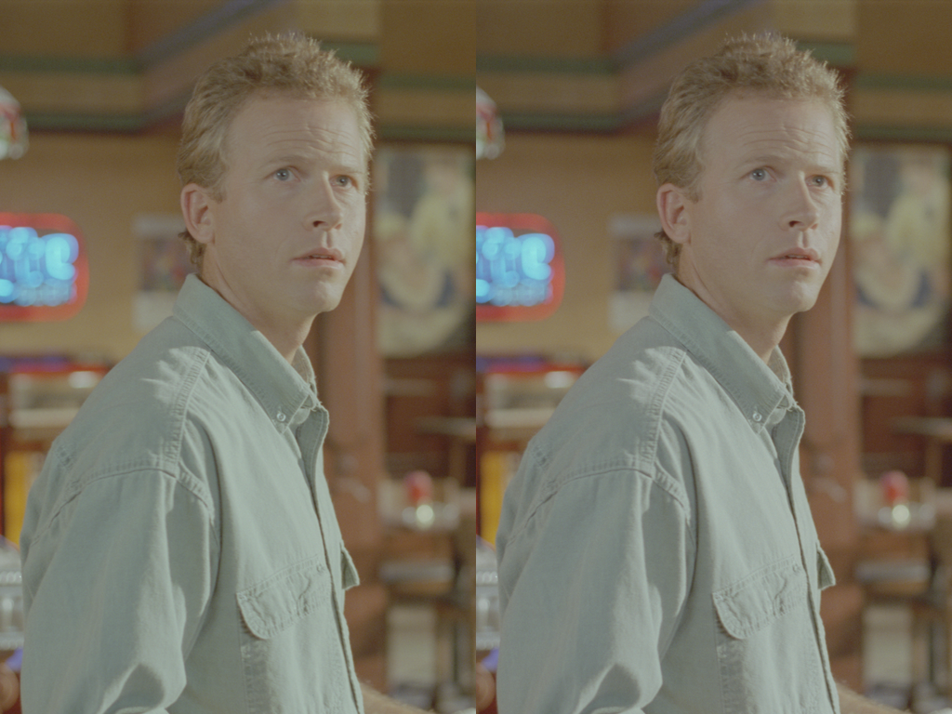

Figure 6: Color distortion due to the color space conversion (Man in Restaurant, 300th frame, 8 bit, clipped from 1920x896 to 1024x768). The left side is the original image and the right side is the distorted image due to color space conversion. It clearly shows the distorted color in the face and shirts. The distorted image is obtained by converting the RGB components into YUV components using floating point operation followed by rounding and converted back to RGB space using the same operation without any coding involved.

  - Lossless coding
Test conditions: Same as in section 3.1 except QP values.

Table4: Lossless RGB coding Results
Bit-depth | Seq. | Bitrate (Mbps) |  | gain (%)
Bit-depth | Seq. | RGB | New | gain (%)
10 bit | Crew | 1001 | 884 | 13.29
10 bit | Harbour | 1185 | 921 | 28.60
8 bit | Crew | 625 | 552 | 13.15
8 bit | Harbour | 756 | 602 | 25.50

- Conclusions

We provided solutions for the unsolved issues from the previous meeting. The introduction of DPCM coding for residue images in RGB space achieves great coding efficiency while avoiding the color distortion resulting from the color space conversion. Applying multi-generaton coding to the images clearly shows the color distortion. The Chroma_residue_pred_flag that signals the usage of DPCM makes the proposed codec universal for any color spaces. We also proposed mathematically lossless RGB coding using the same DPCM coding while removing the transformation part. It makes the proposed JVT codec a complete package for various needs of video compression.

References
[1] “Report – Prof. Ext. Issues of Investigation,” ITU-T SG16 Q.6 Document JVT-H038, May 2003
[2] W. Kim, D. Cho and H. M. Kim, “Color Format Extension,” ITU-T SG16 Q.6 Document JVT-H018, May 2003
[3] “Draft Prof. Ext. Amendment,” ITU-T SG16 Q.6 Document JVT-H037, May 2003
[4] “Final Draft International Standard Joint Video Specification (ITU-T Rec. H.264 | ISO/IEC 14496-10 AVC)” ISO/IEC JTC1/SC29/WG11 and ITU-T SG16 Q.6 Document JVT-G050r1, May 2003

(Append for Proposal Documents)

JVT Patent Disclosure Form

International Telecommunication Union  Telecommunication Standardization Sector | International Organization for Standardization | International Electrotechnical Commission
 |  | 
Joint Video Coding Experts Group - Patent Disclosure Form
(Typically one per contribution and one per Standard | Recommendation)

Please send to:
JVT Rapporteur Gary Sullivan, Microsoft Corp., One Microsoft Way, Bldg. 9, Redmond WA 98052-6399, USA
Email (preferred): Gary.Sullivan@itu.int Fax: +1 425 706 7329 (+1 425 70MSFAX)

This form provides the ITU-T | ISO/IEC Joint Video Coding Experts Group (JVT) with information about the patent status of techniques used in or proposed for incorporation in a Recommendation | Standard. JVT requires that all technical contributions be accompanied with this form. Anyone with knowledge of any patent affecting the use of JVT work, of their own or of any other entity (“third parties”), is strongly encouraged to submit this form as well.

This information will be maintained in a “living list” by JVT during the progress of their work, on a best effort basis. If a given technical proposal is not incorporated in a Recommendation | Standard, the relevant patent information will be removed from the “living list”. The intent is that the JVT experts should know in advance of any patent issues with particular proposals or techniques, so that these may be addressed well before final approval.

This is not a binding legal document; it is provided to JVT for information only, on a best effort, good faith basis. Please submit corrected or updated forms if your knowledge or situation changes.

This form is not a substitute for the ITU ISO IEC Patent Statement and Licensing Declaration, which should be submitted by Patent Holders to the ITU TSB Director and ISO Secretary General before final approval.

Submitting Organization or Person:
Organization name | Samsung Elctronics. Co. Ltd.
Mailing address | POBox 111 Suwon Samsung AIT Multimedia
Country | Korea
Contact person | Hyun Mun Kim
Telephone | 82-31-280-9204
Fax | 82-31-280-9207
Email | hyunmun27.kim@samsung.com
Place and date of submission | Geneva, CH, 23-27 May, 2003
Relevant Recommendation | Standard and, if applicable, Contribution:
Name (ex: “JVT”) |  | JVT
Title |  | Color Format Extension
Contribution number |  | JVT-H018

(Form continues on next page)

Disclosure information – Submitting Organization/Person (choose one box)
2.0 The submitter is not aware of having any granted, pending, or planned patents associated with the technical content of the Recommendation | Standard or Contribution.

or,
The submitter (Patent Holder) has granted, pending, or planned patents associated with the technical content of the Recommendation | Standard or Contribution. In which case,

 | 2.1 The Patent Holder is prepared to grant – on the basis of reciprocity for the above Recommendation | Standard – a free license to an unrestricted number of applicants on a worldwide, non-discriminatory basis to manufacture, use and/or sell implementations of the above Recommendation | Standard.
2.2 The Patent Holder is prepared to grant – on the basis of reciprocity for the above Recommendation | Standard – a license to an unrestricted number of applicants on a worldwide, non-discriminatory basis and on reasonable terms and conditions to manufacture, use and/ or sell implementations of the above Recommendation | Standard.

Such negotiations are left to the parties concerned and are performed outside the ITU | ISO/IEC.
X | 2.2.1 The same as box 2.2 above, but in addition the Patent Holder is prepared to grant a “royalty-free” license to anyone on condition that all other patent holders do the same.
2.3 The Patent Holder is unwilling to grant licenses according to the provisions of either 2.1, 2.2, or 2.2.1 above. In this case, the following information must be provided as part of this declaration:
- patent registration/application number;
- an indication of which portions of the Recommendation | Standard are affected.
- a description of the patent claims covering the Recommendation | Standard;
In the case of any box other than 2.0 above, please provide the following:
Patent number(s)/status
Inventor(s)/Assignee(s)
Relevance to JVT
Any other remarks:
(please provide attachments if more space is needed)

(form continues on next page)
Third party patent information – fill in based on your best knowledge of relevant patents granted, pending, or planned by other people or by organizations other than your own.

Disclosure information – Third Party Patents (choose one box)
X | 3.1 The submitter is not aware of any granted, pending, or planned patents held by third parties associated with the technical content of the Recommendation | Standard or Contribution.
 | 3.2 The submitter believes third parties may have granted, pending, or planned patents associated with the technical content of the Recommendation | Standard or Contribution.
For box 3.2, please provide as much information as is known (provide attachments if more space needed) - JVT will attempt to contact third parties to obtain more information:

3rd party name(s)
Mailing address
Country
Contact person
Telephone
Fax
Email
Patent number/status
Inventor/Assignee
Relevance to JVT

Any other comments or remarks:

