Joint Video Team (JVT) of ISO/IEC MPEG & ITU-T VCEG  (ISO/IEC JTC1/SC29/WG11 and ITU-T SG16 Q.6)  7th Meeting: Pattaya II, Thailand, 7-14 March, 2003 | Document: JVT-G029  Filename: JVT-G029.doc

Title: | A New Adaptive Rood Pattern Search For Fast Block-matching Motion Estimation in The JVT/H.264
Status: | Input Document to JVT
Purpose: | Information
Author(s) or  Contact(s): | Kai-Kuang Ma and Gang Qiu  School of Electrical Electronic Engineering  Nanyang Technological University  Block S2, Nanyang Avenue  Singapore 639798 | Tel:  Email: | +65-6790-6366  ekkma@ntu.edu.sg
Source: | Nanyang Technological University, Singapore
_____________________________

Introduction

In the current video coding standards, block-matching motion estimation (BMME) is an indispensable part of the encoding process to remove temporal redundancy among the adjacent video frames. However, it is also the most time-consuming process that normally takes majority of the total encoding time. The key philosophy of developing a practical BMME algorithm is to strike an optimum balance among multiple considerations, mainly, computational gain (or speed-up ratio), coding efficiency, video quality, and implementation cost/complexity, and the trade-off intimately depends on the application's objectives and requirements.

Among the existing fast BMME algorithms, diamond search (DS) [2] and motion vector field adaptive search technique (MVFAST) [4] have been adopted by the MPEG-4 standard in [5] and [6], respectively. Recently, another derivative based on DS and star search (SS) [3], called adaptive rood pattern search (ARPS) [7], has been proposed. In ARPS, a novel adaptive rood pattern (ARP) is exploited in the initial search stage on each macroblock search and performed once, followed by using a unit-size rood pattern (URP) (i.e., small diamond of DS) repeatedly in the refinement (or local) stage until the motion vector of the current macroblock is found. In [7], ARPS has been implemented and incorporated into the MPEG-4 Verification Model (VM) encoder for demonstrating its superior performance to DS on both computational gain (two times, generally) and peak-signal-to-noise ratio (PSNR).

With on-going state-of-the-art JVT/H.264 JM encoder [9], it is our interests to incorporate ARPS into this platform and report the performance. Furthermore, a new version of ARPS, called unequal-arm ARPS, is introduced, which shows appreciable performance gain beyond ARPS, based on the JVT/H.264 JM-6.1a platform.

Foundations and Insights

2.1. The JVT/H.264 Motion Estimation Framework

The JVT/H.264 [1] is a block-based motion-compensated hybrid transform coder ⎯ similar to the previous video coding standards in spirit, but different in many specifics that considerably affect the design, performance and complexity of the motion estimation process. For example, rather than exploiting a fixed block size (i.e., 16×16) in the existing standards, H.264 supports a variety of block sizes (denoted as modes), varying from 16×16, 8×16, 16×8, 8×8, 8×4, 4×8 to 4×4 pixels. Multi-frame motion-compensated prediction [8] is also supported, allowing the encoder to use more than one previously decoded picture as the reference frames for the encoding of the current picture. Furthermore, in the current JVT/H.264 JM encoder, the rate-constrained motion estimation is utilized, where the criterion to find the optimum motion vector is to minimize a Lagrangian cost functional:
J (m, λ_{MOTION} )=SAD(s, c(m))+ λ_{MOTION} × R(m-p) (1)

where m=(m_{x}, m_{y})^{T} is the current MV, p=(p_{x}, p_{y})^{T} is the predicted MV, and λ_{MOTION} is the Lagrangian multiplier for motion estimation process. The SAD stands for the sum of absolute difference, which is used for the distortion measurement, and the rate term R(m-p) represents the number of bits required to encode the difference between the current MV m and the predicted MV p.

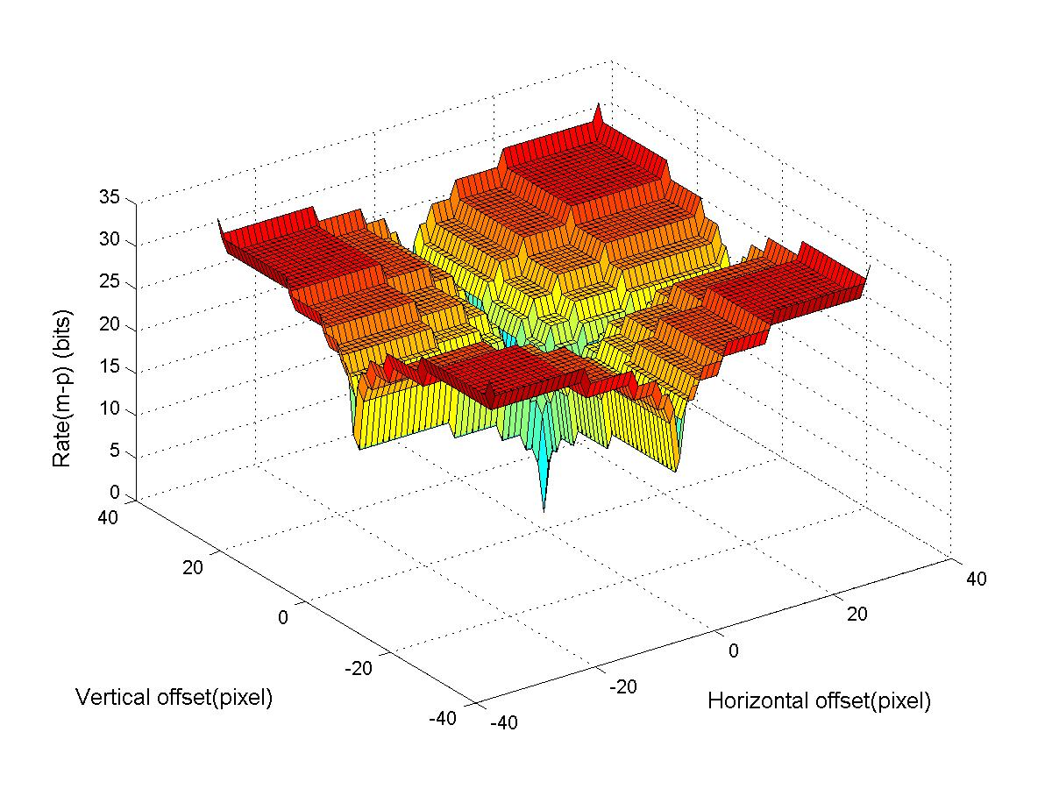

Fig. 1. A typical value surface of the rate term R(m-p).

To have an appreciation regarding how the rate term R(m-p) consumes the bits, Fig. 1 demonstrates an example, which shows a typical value (in terms of bits) surface yielded by the JM-6.1a encoder. Note that R(m-p) gives a much smaller value when at least one of the components of MV m has the same value as that of the corresponding component of MV p, (i.e., m_{x} = p_{x} or/and m_{y} = p_{y}). Note that while SAD has typically been exploited as the distortion measurement metric for fast BMAs, in H.264 it is the Lagrangian cost functional J(m,λ_{MOTION}) used as the yardstick to find the optimum motion vector. Since the Lagrangian formulation can be viewed as imposing a smoothness constraint to regularize the motion displacement field, the value of R(m-p) could yield noticeable effects according to the distribution of the motion vectors, which is to be investigated in the following section.

2.2. The distribution of MVs bears a rood shape

Let d = m-p be the displacement (or prediction error), where m is the true MV found by the full search (FS) algorithm, and p is the predicated MV via the current block's neighboring blocks. We view the prediction error as the inter-block motion correlation, since the larger the error, the less the correlation, and vice versa. The distributions of the motion-vector displacements based on several test sequences Container, Foreman, Mobile, and Tempete, are shown in Fig. 2. For illustration, only the motion vectors of block size 8×8 are depicted. The search range is ±16 pixels around the predicted MV. Other test conditions are according to [10]. From these diagrams, we can clearly see that the true motion vectors are not only highly correlated with their predicted motion vectors, respectively, but also have a higher concentration along the vertical and the horizontal directions ⎯ together, bearing a rood-shaped pattern. It can be viewed as the regularization effect contributed from the rate term R(m-p) [11]. Thus, the local-minima effect is somewhat alleviated and the global minimum of J(m,λ_{MOTION}) as the minimum matching error (MME) point, will be very likely positioned along the rood arms.

The above-mentioned crucial insights convincingly justify the validity and efficiency of the rood-shaped search patterns exploited in ARPS [7]. Furthermore, an improved version of ARPS, denoted as unequal-arm ARPS, is developed and described in the following section.

(a) | (b)
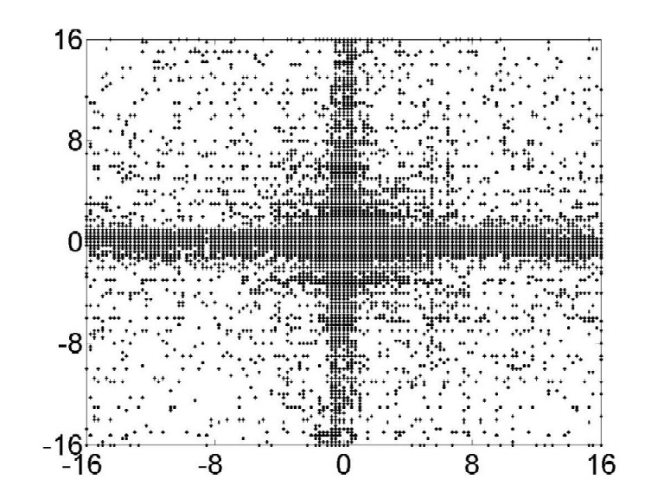  (c) | 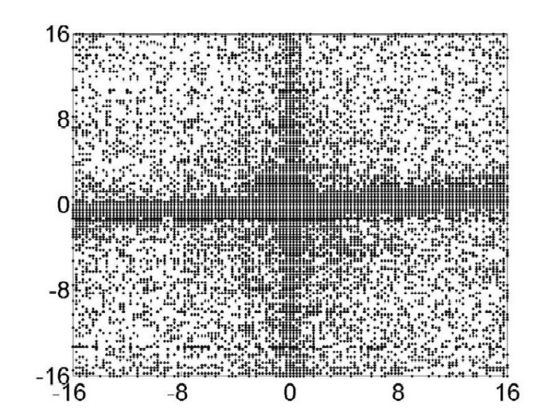  (d)

Fig. 2. Motion vector distribution for 8×8 block type by the full search (FS) algorithm. The test video sequences are (a) Container, (b) Foreman, (c) Mobile, and (d) Tempete.

Unequal-arm ARPS

3.1 Prediction of the target MV

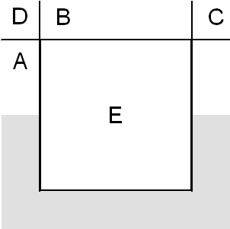 | 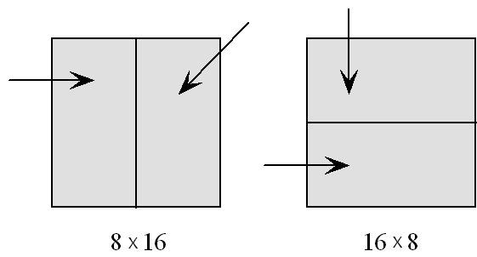

Fig. 3. Motion vector prediction methods. (a) Median prediction; (b) Directional segmentation prediction.

In the Draft JVT/H.264, two kinds of prediction methods are introduced for conducting the differential coding for the MVs: median prediction and directional segmentation prediction [1] as shown in Fig. 3. Generally speaking, the latter is used when the block-size mode is in 16×8 or 8×16; otherwise, the median prediction will be used.
3.2 Unequal-arm ARP for the initial search

The proposed unequal-arm ARP employs the search pattern as illustrated in Fig. 3. The center point of the unequal-arm ARP $\vec{{\text{MV}}_{0}}$ is placed on the predicted position (hence, unequal-arm ARP does not have the prediction arm as in ARP) because generally the true motion vectors have a high correlation with the predicted MV. In contrast, the center point of ARP is positioned on the origin point [0,0]. Another difference is that the distance of the four vertex points of the unequal-arm ARP are independently decided by the dynamic range of the local motion movement in the respective directions, while all four arms of ARP are of equal length.

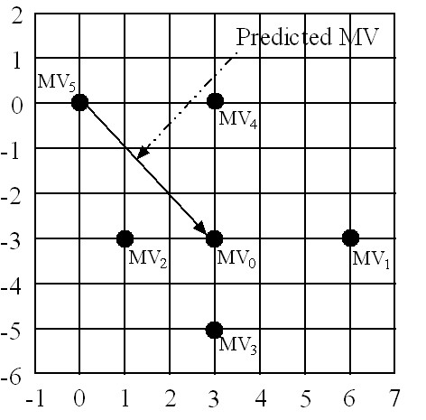
Fig. 4. Unequal-arm adaptive rood pattern

Among the MVs available in neighboring blocks, it is straightforward that the maximum and the minimum values of MVs could be considered as estimated deviations from the predicted MV; thus, they can be used as an accurate estimation of the arm size to represent the motion dynamic range in the respective directions. That is,

$\left\{\begin{matrix}\vec{{\text{MV}}_{1}}=[\text{max}({\text{MV}}_{x}),{\text{MV}}_{0_{y}}] \\ \vec{{\text{MV}}_{2}}=[\text{min}({\text{MV}}_{x}),{\text{MV}}_{0_{y}}] \\ \vec{{\text{MV}}_{3}}=[{\text{MV}}_{0_{x}}\text{,min}({\text{MV}}_{y})] \\ \vec{{\text{MV}}_{4}}=[{\text{MV}}_{0_{x}}\text{,max}({\text{MV}}_{y})]\end{matrix}\right.$ (2)

where MV_{o_x} and MV_{0_y} are the horizontal and vertical components of $\vec{{\text{MV}}_{0}}$, respectively, MV_{x} and MV_{y} are the horizontal and vertical components of all the MVs in the neighboring blocks, respectively. Operators “max” and “min” are used to find the maximum value and the minimum value, respectively, among those available MVs in the neighboring blocks. For the robustness of the algorithm, the origin point $\vec{{\text{MV}}_{5}}$ = [0, 0] is also included in the unequal-arm ARP. Note that the ARP could be shrunk to the URP, if all the four arm lengths are less than 2, or even to the center point itself, if the lengths are 0.

3.3 URP for the refined local search

The new search center identified in the initial search stage is expected to be quite close to the global minimum. Therefore, a smaller search pattern is more appropriate for the refined local search. For that, the unit-size rood pattern (URP) [7] (i.e., small diamond search pattern of DS [2]; see Fig. 5) is also used in this paper.

3.4 Summary of new ARPS search algorithm

- Step 1 [Prediction]: The median prediction based on the neighboring blocks as shown in Fig. 3 is performed for finding the predicted MV.

- Step 2 [Initial Global Search]: Place the center of the unequal-arm ARP on the position of the predicted MV found in Step 1. In unequal-arm ARP, the locations of four vertex points are calculated by (2). Compute the J(m,λ_{MOTION}) of all five points of the unequal-arm ARP and the [0,0] point. (This step is executed only once.)

- Step 3 [Iteratively Refined Local Search]: Place the center point of URP on the position that incurs the minimum J(m,λ_{MOTION}) found in the Step 2 and check its points. If the new minimum J(m,λ_{MOTION}) is not incurred at the center of the current URP, repeat this step; otherwise, the MV is found as the minimum matching error (MME) point.

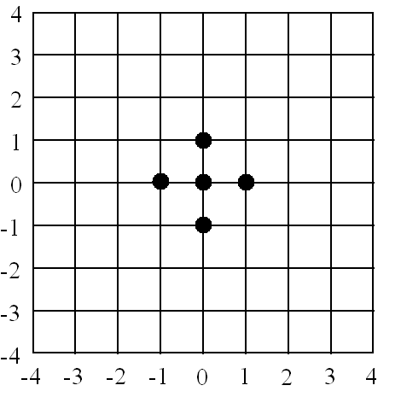

Fig. 5. Unit-size rood pattern (URP) [7] (i.e., small diamond search pattern of diamond search [2]).

EXPERIMENTS AND RESULTS

Our proposed unequal-arm ARPS algorithm is integrated into H.264 JM-6.1a encoding platform to demonstrate its performance. The experimental results are compared with that of the FS and the DS, in terms of PSNR objective measurement (in dB), bit-rates, and computational costs.

4.1 Test conditions

The experimental conditions specified in [10] are used to evaluate the performance of the proposed algorithm. The motion vector search range is 32 pels around the predicted MV, and five reference frames are used for all test sequences. For each test sequence, only the first frame is coded as the I frame, and all the remaining frames are coded as the P frames. The test platform is SUN Ultra 450 with 2GB RAM and Solaris 7 operation system.

4.2 A new metric for computational costs

To evaluate the search efficiency, the previously used computational gain (⎯ in terms of the number of search points visited per macroblock) is, in fact, invalid to use in the JVT/H26L framework, due to its various block sizes (or modes) and multi-frame-based motion estimation. To have a fair computation, instead, for each block search, a platform-independent measurement yardstick, called normalized computational cost (NCC) and denoted as C(mode), is proposed as follows:

$C(\text{mode})=\frac{N_{\text{pts}}×W(\text{mode})}{N_{\text{mode}}×N_{\text{ref}}}$ (3)
where C(mode) denotes the normalized computational cost, N_{pts} denotes the total number of search points, and W(mode) denotes the weight of computational cost incurred for this block mode. N_{MODE} is the total number of modes involved (in JM-6.1a encoder, N_{MODE} = 7), and N_{ref} is the number of reference frames.

Since the computation of the SAD is directly proportionate with the block size and occupies the majority of computational load in computing J(m,λ_{MOTION}), the computational costs per search point for a 16×16 block can be defined as one- unit cost. Hence, the weight W(mode) becomes the ratio of the area of current block mode to that of the 16×16 mode. That is, for the 16×16 mode, the weight is 1, and accordingly, W=1/2 for the 16×8 and 8×16 modes, W=1/4 for the 8×8 mode, W=1/8 for the 8×4 and 4×8 modes, and W=1/16 for the 4×4 mode.

Note that our introduced NCC in (3) keeps equivalence to the search points, which means the number of search points required for each macroblock and is computed for the performance evaluation as done in the pervious video coding standards.

4.3 Experimental results

The results are shown in Tables 1 on the aspects of PSNR (in dB), bit-rates, and computational costs respectively. The relative improvements are shown in the respective column for the ease of comparison. One should bear in mind that the FS in JVT/H26L JM-6.1a is different from the FS found in the previous video coding standards. The H.264's FS is an exhaustive search, but follows a “spiral” search path initiated from the location of the predicted MV. Based on these results as shown, it can be concluded that the unequal-arm ARPS has achieved some appreciable performance improvement over the ARPS in newly developed JVT/H.264 JM-6.1a encoding platform in all three accounts.

Table 1. Unequal-arm ARPS compared with the FS using 5 reference frames
Sequ-ences | Frame rate | No. of frames | QP | PSNR  Y (FS) | Bit-rate (FS) | NCC of Enc. (FS) | PSNR  Y (ARP3) | Bit-rate (ARP3) | NCC of Enc. (ARP3) | Comp. Gain | Ave. bit increase | Ave. dB gain
Container  qcif | 10 | 100 | 16 | 45.168 | 171319 | 2045046.88 | 45.169 | 171270 | 4365.71 | 468.43 | 0.41% | -0.038
Container  qcif | 10 | 100 | 20 | 41.817 | 89372 | 1875174.5 | 41.794 | 89594 | 4261.32 | 440.05 | 0.41% | -0.038
Container  qcif | 10 | 100 | 24 | 38.703 | 44553 | 1670791.88 | 38.68 | 44790 | 4084.03 | 409.10 | 0.41% | -0.038
Container  qcif | 10 | 100 | 28 | 35.98 | 22085 | 1450017.38 | 35.951 | 22283 | 3889.11 | 372.84 | 0.41% | -0.038
News  qcif | 10 | 100 | 16 | 45.815 | 161371 | 1776526.62 | 45.798 | 161294 | 4598.16 | 386.36 | 0.67% | -0.069
News  qcif | 10 | 100 | 20 | 42.773 | 105545 | 1667618.5 | 42.763 | 105949 | 4575.48 | 364.47 | 0.67% | -0.069
News  qcif | 10 | 100 | 24 | 39.766 | 67842 | 1525772 | 39.72 | 68577 | 4535.76 | 336.39 | 0.67% | -0.069
News  qcif | 10 | 100 | 28 | 36.729 | 42807 | 1394591.12 | 36.727 | 43354 | 4447.14 | 313.59 | 0.67% | -0.069
Foreman  qcif | 10 | 100 | 16 | 44.962 | 332148 | 2213720.25 | 44.955 | 337007 | 8870.04 | 249.57 | 2.71% | -0.190
Foreman  qcif | 10 | 100 | 20 | 41.671 | 199397 | 2106967.5 | 41.655 | 203698 | 8733.15 | 241.26 | 2.71% | -0.190
Foreman  qcif | 10 | 100 | 24 | 38.65 | 117861 | 1960826.12 | 38.603 | 121585 | 8578.19 | 228.58 | 2.71% | -0.190
Foreman  qcif | 10 | 100 | 28 | 35.966 | 69094 | 1790511.38 | 35.872 | 71902 | 8337.83 | 214.75 | 2.71% | -0.190
Paris  cif | 15 | 150 | 16 | 44.778 | 1242422 | 1949808.88 | 44.775 | 1244604 | 4699.09 | 414.93 | 0.86% | -0.069
Paris  cif | 15 | 150 | 20 | 41.605 | 743241 | 1804823.75 | 41.586 | 746805 | 4664.28 | 386.95 | 0.86% | -0.069
Paris  cif | 15 | 150 | 24 | 38.453 | 472133 | 1682509.5 | 38.438 | 477390 | 4614.89 | 364.58 | 0.86% | -0.069
Paris  cif | 15 | 150 | 28 | 35.45 | 294997 | 1554492 | 35.43 | 299933 | 4543.85 | 342.11 | 0.86% | -0.069
Silent  qcif | 15 | 150 | 16 | 45.454 | 218674 | 1848358.12 | 45.456 | 219789 | 4963.27 | 372.41 | 1.14% | -0.087
Silent  qcif | 15 | 150 | 20 | 42.081 | 137904 | 1779562 | 42.08 | 139238 | 4945.76 | 359.82 | 1.14% | -0.087
Silent  qcif | 15 | 150 | 24 | 38.831 | 87110 | 1691527.62 | 38.817 | 88361 | 4917.09 | 344.01 | 1.14% | -0.087
Silent  qcif | 15 | 150 | 28 | 35.821 | 54108 | 1580280.62 | 35.805 | 54993 | 4865.08 | 324.82 | 1.14% | -0.087
Mobile  cif | 30 | 300 | 16 | 44.451 | 6111551 | 2253742 | 44.461 | 6101534 | 6179.93 | 364.69 | -0.02% | 0.004
Mobile  cif | 30 | 300 | 20 | 40.839 | 3979574 | 2188349.25 | 40.848 | 3976420 | 6149.55 | 355.86 | -0.02% | 0.004
Mobile  cif | 30 | 300 | 24 | 37.337 | 2444667 | 2104369.25 | 37.338 | 2445541 | 6112.12 | 344.29 | -0.02% | 0.004
Mobile  cif | 30 | 300 | 28 | 34.038 | 1382023 | 1993707.38 | 34.029 | 1383753 | 6067.35 | 328.60 | -0.02% | 0.004
Tempete  cif | 30 | 260 | 16 | 44.848 | 5212889 | 2182447.75 | 44.857 | 5215438 | 5912.53 | 369.12 | 0.18% | -0.012
Tempete  cif | 30 | 260 | 20 | 41.45 | 3285915 | 2091162.13 | 41.453 | 3291824 | 5802.43 | 360.39 | 0.18% | -0.012
Tempete  cif | 30 | 260 | 24 | 38.12 | 1951988 | 1977216.63 | 38.117 | 1957013 | 5698.85 | 346.95 | 0.18% | -0.012
Tempete  cif | 30 | 260 | 28 | 34.962 | 1070626 | 1824535.75 | 34.956 | 1073280 | 5620.31 | 324.63 | 0.18% | -0.012
Average |  |  |  |  |  |  |  |  |  | 347.48 | 0.85% | -0.066

CONCLUSION

Based on the observation of the rood-shape-like motion vector distribution in JVT/H.264 platform, unequal-arm adaptive rood pattern search algorithm is proposed in this paper. It is the first time that the regularization effect on the motion displacement field estimation of the Lagrangian formulation utilized in JVT/H.264 is studied and exploited for the initial search with a simple and yet quite effective modification on ARPS. Experiments conducted on the JVT/H.264 JM-6.1a platform have clearly shown that unequal-arm ARPS has achieved superb performance in all key aspects concerned in video coding.

References

- Joint Video Team (JVT) of ISO/IEC MPEG and ITU-T VCEG, “Joint final committee draft (JFCD) of joint video specification (ITU-T Rec. H.264|ISO/IEC 14496-10 AVC),” JVT-D157, Klagenfurt, Austria, 22-26 July 2002.

- S. Zhu and K.-K. Ma, “A new diamond search algorithm for fast block-matching motion estimation,” IEEE Trans. on Image Processing, vol. 9, no. 2, pp. 287-290, Feb. 2000.

- S. Zhu and K.-K. Ma, “A new star search algorithm for fast block-matching motion estimation,” Workshop on Very Low Bitrate Coding (VLBV), pp. 173-176, Oct. 8-9, 1998.

- K.-K. Ma and P. I. Hosur, “Core experiment results of fast motion estimation based on new test conditions (Q4a),” ISO/IEC JTC1/SC29/WG11, M4934, Vancouver, Canada, Jul. 1999.

- ISO/IEC JTC1/SC29/WG11, “MPEG-4 video verification model,” version 14.0, N2932, pp. 301-303, Oct. 1999.

- ISO/IEC JTC1/SC29/WG11, “Text of ISO/IEC 14496-7 CD registration and consideration (Optimized Code for MPEG-4 Visual Standards),” N3325, Noordwijkerout, Netherlands, Mar. 2000.

- Y. Nie and K.-K. Ma, “Adaptive rood pattern search for fast block-matching motion estimation,” IEEE Trans. on Image Processing, January 2003.

- K.-K. Ma and G. Qiu, “An improved adaptive rood pattern search for fast block-matching motion estimation in JVT/H.26L,” IEEE International Symposium on Circuits and Systems (ISCAS2003).

- T. Wiegand, B. Girod. Multi-Frame Motion-Compensation Prediction For Video Transmission, Kluwer Academic Publishers, USA, 2001.

- JVT/H.264 Joint Model 6.1a (JM-6.1a), available from ftp://imtc.org/jvt-exports/reference_software/

- G. J. Sullivan, “Recommended Simulation Common Conditions for H.264 Coding Efficiency Experiments on Low-Resolution Progressive-Scan Source Material,” VCEG-N81, Sept. 2001.

- G. J. Sullivan and T. Wiegand, “Rate-Distortion Optimization for Video Compression,” IEEE Signal Processing Magazine, Nov. 1998.

(Append for Proposal Documents)

JVT Patent Disclosure Form

International Telecommunication Union  Telecommunication Standardization Sector | International Organization for Standardization | International Electrotechnical Commission
 |  | 
Joint Video Coding Experts Group - Patent Disclosure Form
(Typically one per contribution and one per Standard | Recommendation)

Please send to:
JVT Rapporteur Gary Sullivan, Microsoft Corp., One Microsoft Way, Bldg. 9, Redmond WA 98052-6399, USA
Email (preferred): Gary.Sullivan@itu.int Fax: +1 425 706 7329 (+1 425 70MSFAX)

This form provides the ITU-T | ISO/IEC Joint Video Coding Experts Group (JVT) with information about the patent status of techniques used in or proposed for incorporation in a Recommendation | Standard. JVT requires that all technical contributions be accompanied with this form. Anyone with knowledge of any patent affecting the use of JVT work, of their own or of any other entity (“third parties”), is strongly encouraged to submit this form as well.

This information will be maintained in a “living list” by JVT during the progress of their work, on a best effort basis. If a given technical proposal is not incorporated in a Recommendation | Standard, the relevant patent information will be removed from the “living list”. The intent is that the JVT experts should know in advance of any patent issues with particular proposals or techniques, so that these may be addressed well before final approval.

This is not a binding legal document; it is provided to JVT for information only, on a best effort, good faith basis. Please submit corrected or updated forms if your knowledge or situation changes.

This form is not a substitute for the ITU ISO IEC Patent Statement and Licensing Declaration, which should be submitted by Patent Holders to the ITU TSB Director and ISO Secretary General before final approval.

Submitting Organization or Person:
Organization name
Mailing address
Country
Contact person
Telephone
Fax
Email
Place and date of submission
Relevant Recommendation | Standard and, if applicable, Contribution:
Name (ex: “JVT”)
Title
Contribution number

(Form continues on next page)

Disclosure information – Submitting Organization/Person (choose one box)
2.0 The submitter is not aware of having any granted, pending, or planned patents associated with the technical content of the Recommendation | Standard or Contribution.

or,
The submitter (Patent Holder) has granted, pending, or planned patents associated with the technical content of the Recommendation | Standard or Contribution. In which case,

2.1 The Patent Holder is prepared to grant – on the basis of reciprocity for the above Recommendation | Standard – a free license to an unrestricted number of applicants on a worldwide, non-discriminatory basis to manufacture, use and/or sell implementations of the above Recommendation | Standard.
2.2 The Patent Holder is prepared to grant – on the basis of reciprocity for the above Recommendation | Standard – a license to an unrestricted number of applicants on a worldwide, non-discriminatory basis and on reasonable terms and conditions to manufacture, use and/ or sell implementations of the above Recommendation | Standard.

Such negotiations are left to the parties concerned and are performed outside the ITU | ISO/IEC.
2.2.1 The same as box 2.2 above, but in addition the Patent Holder is prepared to grant a “royalty-free” license to anyone on condition that all other patent holders do the same.
2.3 The Patent Holder is unwilling to grant licenses according to the provisions of either 2.1, 2.2, or 2.2.1 above. In this case, the following information must be provided as part of this declaration:
- patent registration/application number;
- an indication of which portions of the Recommendation | Standard are affected.
- a description of the patent claims covering the Recommendation | Standard;
In the case of any box other than 2.0 above, please provide the following:
Patent number(s)/status
Inventor(s)/Assignee(s)
Relevance to JVT
Any other remarks:
(please provide attachments if more space is needed)

(form continues on next page)
Third party patent information – fill in based on your best knowledge of relevant patents granted, pending, or planned by other people or by organizations other than your own.

Disclosure information – Third Party Patents (choose one box)
3.1 The submitter is not aware of any granted, pending, or planned patents held by third parties associated with the technical content of the Recommendation | Standard or Contribution.

3.2 The submitter believes third parties may have granted, pending, or planned patents associated with the technical content of the Recommendation | Standard or Contribution.

For box 3.2, please provide as much information as is known (provide attachments if more space needed) - JVT will attempt to contact third parties to obtain more information:

3rd party name(s)
Mailing address
Country
Contact person
Telephone
Fax
Email
Patent number/status
Inventor/Assignee
Relevance to JVT

Any other comments or remarks:

