Joint Video Team (JVT) of ISO/IEC MPEG & ITU-T VCEG  (ISO/IEC JTC1/SC29/WG11 and ITU-T SG16 Q.6)  6th Meeting: Awaji, Island, JP, 5-13 December, 2002 | Document: JVT-F075  Filename: JVT-F075.doc

Title: | Demonstration of Main Profile Decoder on TI C64x
Status: | Input Document to JVT
Purpose: | Information
Author(s) or  Contact(s): | Anthony Joch  UB Video Inc.  400-1788 West 5th Ave  Vancouver, BC, V6J 1P2, Canada | Tel:  Email: | +1 604 737 2426  anthony@ubvideo.com
Source: | UB Video Inc.
_____________________________

Introduction
During the meeting period, we will arrange for demo sessions for UB Video’s Main Profile decoding solution running on the 600 MHz C64 Media Processor from Texas Instruments. The demo software processes coded progressive-scan content and includes all features of the current Main Profile, with the exception of those for coding interlaced material.

UBLive-264MP Demonstration Software: Description
UB Video’s UBLive-264MP decoder demonstration software runs on the 600 MHz C64 Media Processor that is part of the Network Video Developer’s Kit (NVDK) board from Texas Instruments. The bit stream to be decoded corresponds to wide screen DVD content that was encoded using UB Video’ UBLive-264MP encoder. A block diagram of the demo is shown in Figure 1. The UBLive-264MP decoder demonstration software works as follows: A bit stream is parsed by the decoder and YUV 4:2:0 frames are output (see Figure 2). The resolution of the frame is 720x352 for the luminance component and 360x176 for the chrominance components. Once a frame is decoded, it goes through a post-processing stage as shown in Figure 3. The chrominance vertical lines are duplicated leading to YUV 4:2:2 resolution and then a transformation to packed format is performed, followed by a 3:2 pull-down operation to up-sample the displayed frame rate to 30 frames per second. Each frame is delivered to the on-board display hardware for output to a TV monitor.
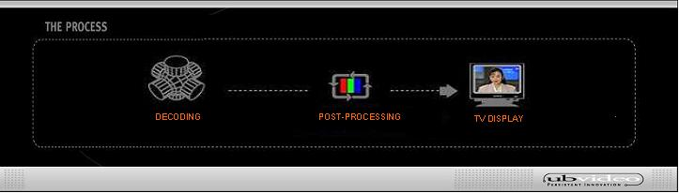

Figure 1. Block diagram of the UBLive-264MP demo.

Figure 2. Decoding process

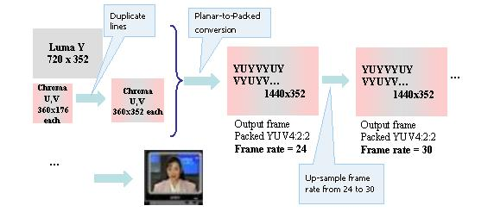

Figure 3. Post-processing process.

For more information on UBLive-264-MP, please visit www.ubvideo.com.

CABAC on the C64x
At the Geneva meeting, the question of the complexity of CABAC in relation to CAVLC was raised. It was stated that the difference is not large on current optimized PC implementations. However, it was also stated that on VLIW architectures, CABAC is expected to be much more complex and very inefficient due to the bit-serial nature of the CABAC engine, although no one had attempted such an implementation or could provide concrete results.

In our implementation of CABAC on the C64x, which is moderately optimized, we have found that CABAC decoding requires approximately 4 times the number of cycles as UVLC/CAVLC decoding at equivalent bit rates. This accounts for 35-70% of the total decode cycles, depending on the bitrate and the picture type (i.e. more for an I-picture).

