Joint Video Team (JVT) of ISO/IEC MPEG & ITU-T VCEG  (ISO/IEC JTC1/SC29/WG11 and ITU-T SG16 Q.6)  4th Meeting: Klagenfurt, Austria, 22-26 July, 2002 | Document: JVT-D115  Filename: JVT-D115.doc

Title: | Arbitrary Slice Order and Flexible Macroblock Order Impact of AVC Compliance and Implementation Complexity
Status: | Input Document to JVT
Purpose: | Proposal
Author(s) or  Contact(s): | Iole Moccagatta, LSI Logic  560 Cottonwood Dr.  Milpitas, CA, 95035  USA | Tel:  Email: | +1.408.954-3101  iole.moccagatta@lsil.com
Source: | Motorola, CableLabs, Scientific-Atlanta, LSI Logic,
_____________________________

Summary
This document analyzes the impact of the AVC Arbitrary Slice Order and Flexible Macroblock Order tools on AVC visual bitstreams’ compliance testing, and on AVC decoders’ implementation complexity Based on this analysis, we propose to: a) limit ASO within pictures, b) create a new profile that supports both these tools, and, c) relieve other decoders from supporting ASO and FMO by removing these two tools from the Baseline and Main profile.

Introduction

This document analyzes the impact of the AVC Arbitrary Slice Order and Flexible Macroblock Order tools on AVC visual bitstreams’ compliance testing, and on AVC decoders’ implementation complexity.

The current AVC CD does not constraint the order in which the video decoder can expect the NAL Units (NALUs) to appear. Even if the sei, the picture_layer, and the parameter_set NALUs are removed, and the syntax is modified so that each slice carries with it all the information needed for its decoding, not constraining the NALUs order means that the decoder need to support Arbitrary Slice Ordering (ASO).

If ASO across pictures (i.e. slices from different pictures are interleaved) is supported in AVC, serious issues on compliance arise. These issues, pointed out to our attention by a number of people, are summarized in Sec. 1. One possible way to solve these issues is to limit ASO within a picture, i.e. slices from different pictures are not interleaved. Still, slices that belong to a picture may still arrive in a non raster-scan order.

However, even if we limit ASO within a picture, the decoder complexity is significantly increased, as explained in Sec. 2. Because Flexible Macroblock Order (FMO) extend the concept of slices by allowing non-consecutive macroblocks to belong to the same slice, this section also addresses the decoder complexity introduced by FMO.

The conclusions of our analysis are drawn in Sec. 3. To avoid burdening some decoders with unnecessary implementation complexity, we propose to remove ASO and FMO from the Baseline and Main profiles. To alleviate the impact of ASO on bitstreams’ compliance testing and verification, we propose to limit ASO within a picture but only in other profiles.

1. Impact of ASO across pictures on AVC compliance

To explain the impact of ASO across pictures on AVC visual bitstreams’ compliance testing, we present a possible scenario.

An AVC encoder generates in order slices, and by doing so it produces a compliant stream, i.e. the encoder HRD compliance test was successful. However, the slices have been re-ordered during their transmission to the decoder side (by the transmission network, by the gateway, etc.) is such a way that a non-compliant stream is received by the decoder.

This means that a non-compliant stream has reached the decoder. At this point, we cannot distinguish between the case where a non-conformant stream was generated by the encoder from the case where the non-conformant stream was generated during the transmission. How can we know which one (the decoder, the network, or both) has to be fixed? Which type of tests should be designed to assure that a stream is compliant? Furthermore, how can the latency and memory requirements of a decoder be characterized? These are valid questions that have to be answered before deploying AVC.

In addition, the encoder may not know, or may decide to ignore, the nature and conditions of the network(s) over which its stream is transmitted. In other words, the encoder cannot, or may decide not to, provision for the worst network scenario when performing the HRD compliance test. Should testing the encoder ability to provision for the worst transmission scenario become part of the conformance tests? If so, how? Again, all these are valid questions that need to be answered.

In our view, all these issues can be solved in two ways.

The first solution consists in keeping the slice ordering operation outside the scope of the video standard by making ASO stream non-compliant. Decoders can, and have been designed to handle certain cases of non-compliant streams. A typical example consists of streams corrupted by transmission errors. However, corrupted streams are not compliant with the standard, and, therefore, video standards do not specify how to handle them. Arbitrary slice ordering can be dealt as an external functionality in the same way.

The second solution constraints the support for ASO to make possible to test a decoder and stream conformance. One of these restrictions should be that all the slices of one picture appear in the VCL bit stream before any slices from another picture appear. The HRD should remove entire coded pictures at one instant, and remove data in the order it entered the HRD buffer. This requires the restriction that pictures' slices are not interleaved.

2. Impact of FMO and ASO (within a picture) on AVC decoders complexity

This section analyzes the impact of FMO and ASO on AVC decoder complexity. To better understand the impact of both tools, first ASO alone is analyzed, followed by the analysis of ASO combined with FMO.

2.1. Impact of ASO on AVC decoders complexity

An example of how macroblocks can be associated to different slices is shown in Figure 1. When ASO is supported, the four slices of this example can be received by the decoder in a random order. Figure 2 shown the following receiving order: slice #4, slice #3, slice #1, and slice #2. The same figure presents the AVC decoder blocks required to support ASO decoding.

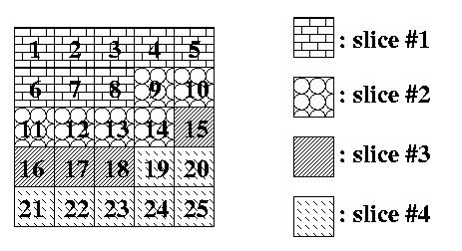
Figure 1: An example of macroblock assignment to four slices. Each slice is represented by a different texture.
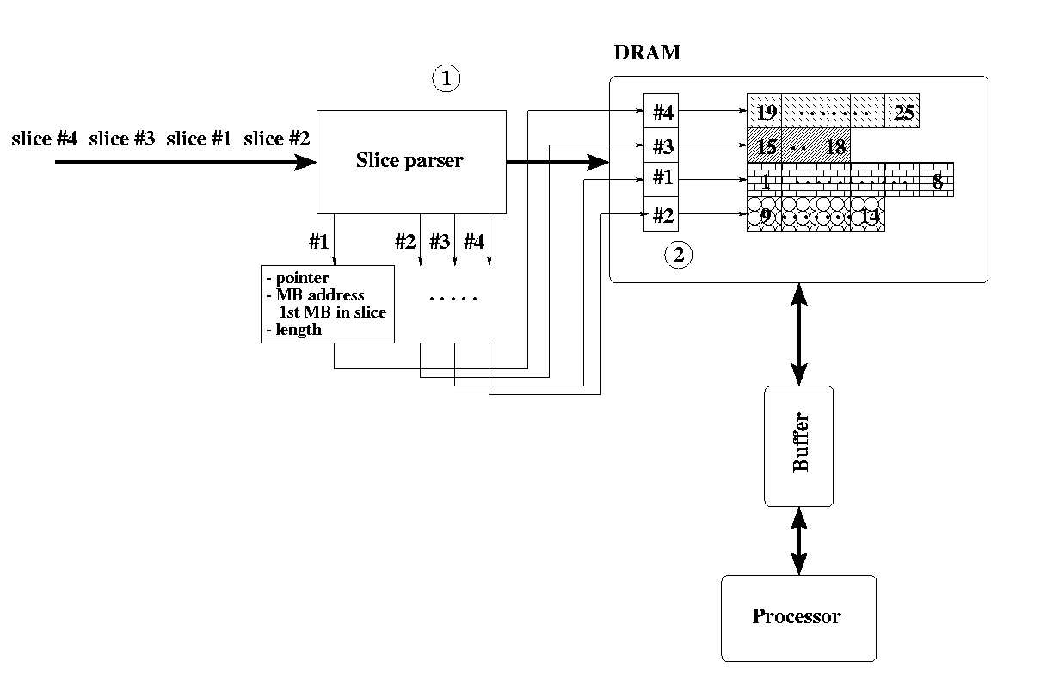
Figure 2: The AVC decoder blocks need to support ASO decoding.

For each slice, the slice length and the macroblock address (i.e. index with respect to the raster scan order) of the 1st macroblock (MB) of the slice are extracted by the slice parser ( in Figure 2). This informatios, together with the slice itself, is stored in memory (shown as DRAM). In addition, a list of pointers ( in Figure 2, a pointer for each slice, and each pointing to thM memory location where a slice is stored), should be generated. The list of pointers, together with the address of the 1st MB of the slice, will be used to navigate throuht the out of order slices. The slice length will be used to transfer the slice data from the DRAM to thsodecoder’l internal memor.

Faced with the necessity to decode out of order slices, a decoder may i) wait for all the slices of each picture to arrive before start decoding and de-blocking the picture, or ii) decode the slices in the order in which they come to the decoder.

The first method increases latency, but allows performing decoding and de-blocking in parallel. However, managing a large number of pointers (in the worst case, one pointer for each MB) and increasing the intelligence of the DRAM access unit increase the decoder complexity.

The second method hurts significantly the decoder performance. In addition, by performing the de-blocking in a second pass, the DRAM to processor’s memory bandwidth is increased.

to process at higher throughput andtohigher clockanoperation

pointer of the operationthat

aa, with the second method

in. However, thisbecause of the higher throughput requirement and and/or wider data access
Decodings in the order they are receivedhigher throughput requirements on the decoder andtohigher clockanoperationstoreds

Reference pictures required for motion compensationof the B pictures reside in their respectiveframestores in memory. to avoid incurring additional memorywhile However, since the framestore is shared, toperation’s pointerthat from memory

Accessto the shared framestore is coordinated to avoid the second B picture’s reconstructionfrom overtaking the display of the first B picture. For instancesmemory sSubsequent rows of macroblocks can becoordinated similarly.

ly practicedby

a,received a, with the second method

to support ASO withafter the first B picture. However, this. Specifically, it imposesa higher throughput requirement andand/or wider data access
Decoding slices in the order they are received can result in additional memory consumption or impose higher throughput requirements on the decoder and local memory to run at higher clock speed. Consider an application in which the display operation reads the pictures to be displayed right from the section of memory where the decoder stored the pictures.

Consider decoding consecutive disposable B pictures. Reference pictures required for motion compensation of the B pictures reside in their respective framestores in memory. Similar to current cost-effective MPEG-2 decoders, the memory repository for the first B picture is shared with the second B picture to avoid incurring additional memory. Thus, while the first B picture is being displayed, the second B picture is being decoded. However, since the framestore is shared, the reconstruction of the second B picture must not overcome the display operation’s pointer that reads the first B picture from memory.

Access to the shared framestore is coordinated to avoid the second B picture’s reconstruction from overtaking the display of the first B picture. For instance, once the first row of macroblocks in the first B picture has been displayed, the decoder re-appropriates the corresponding memory and proceeds to decode and store the first row of macroblocks of the second B picture. Subsequent rows of macroblocks can be coordinated similarly.

Therefore, the display of the first B picture and the reconstruction of the second B picture can be orchestrated to save memory and cost as commonly practiced by current MPEG-2 decoders.

Considering that with ASO the first row of macroblocks in a picture can be in the last received slice at the decoder, and that the first received slice can contain the last row of macroblocks in a picture, one can conclude that decoding and displaying consecutive B pictures with one framestore is difficult, if not impossible, with the second method.

It is evident that to support ASO with the second method, the decoder would need an additional framestore unless it could decode and reconstruct the second B picture during the vertical blanking interval after the first B picture. However, this is not acceptable since it imposes additional cost on silicon decoders. Specifically, it imposes a higher throughput requirement and memory at faster clock speeds and/or wider data access.

2.1. Impact of ASO and FMO on AVC decoders complexity

An example of how slices can be associated to different slice group is shown in Figure 3. When ASO and FMO are supported, the four slices of this example can be received by the decoder in a random order. Figure 2 shown the following order: slice #4, slice #2, slice #1, and slice #3. The same figure presents the AVC decoder blocks required to support ASO and FMO decoding.
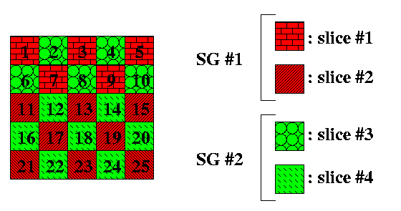
Figure 3: An example of macroblock assignment to four slices and to two Slice Group (SG in the figure). Each slice is represented by a different texture, and each SG is represented a different color.

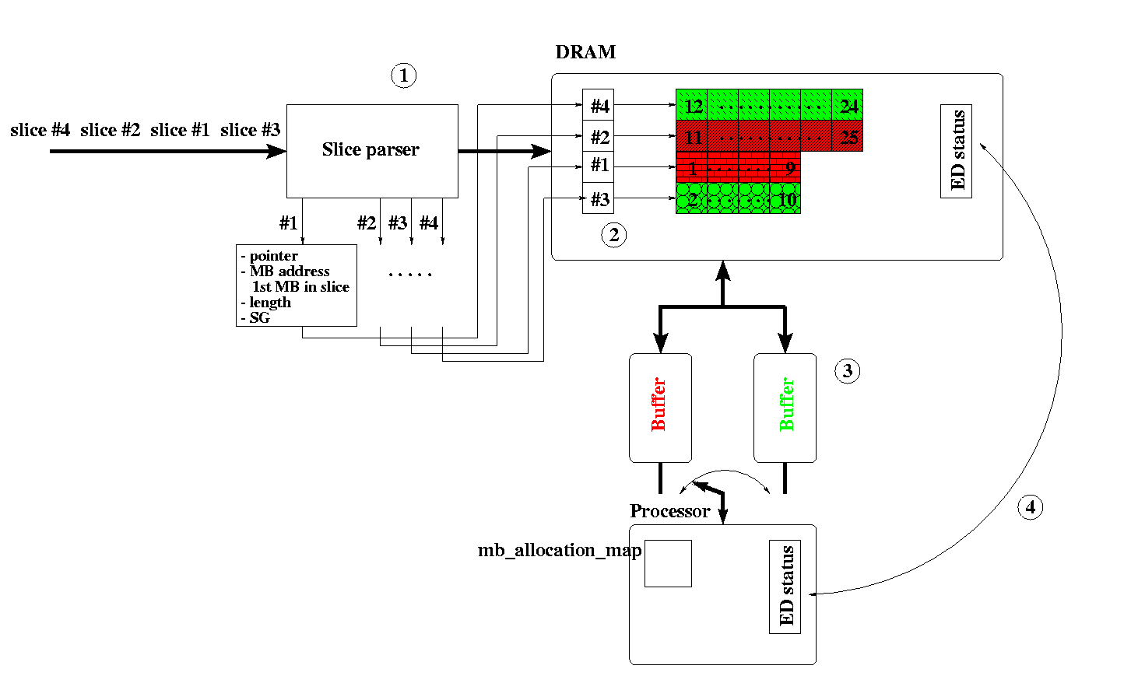
Figure 4: The AVC decoder blocks need to support ASO and FMO decoding.

In addition to the slice length and the macroblock address of the 1st macroblock (MB) of the slice, the slice parser ( in Figure 4) need to extract the Slice Group (SG) of each slice. These informations, together with the slice itself, are stored in DRAM. As in the ASO case, the list of pointers ( in Figure 4) should be generated.

The list of pointers, together with the address of the 1st MB of the slice, the SG, and the mb_allocation_map (stored in the processor’s local memory), will be used to navigate through the slices. The slice length will be used to transfer the slice data from the DRAM to the processor local memory.

Similarly to the ASO case, in the combined ASO and FMO case the decoder may i) wait for all the slices of each picture to arrive before start decoding and de-blocking the picture, or ii) decode the slices in the order in which they come to the decoder. Consequently, as described for the ASO case, both methods impose additional cost on silicon decoders.

The first approach is still the preferred one. Because of FMO, decoding MB in raster scan order may require to switch between different slices and/or slice groups. To speed up the DRAM access, one buffer for each SG must be used ( in Figure 4). This additional intelligence of the DRAM access unit further increase the decoder complexity. Moreover, switching between different slices and/or slice groups requires swapping the Entropy Decoder (ED) status information. In the worst case, swappingsoccurs after decoding each MB. If the entire ED status information is too large to be stored in the processor local memory, each ED status need to be loaded from and stored into DRAM, thus further increasing the DRAM to processor’s memory bandwidth ( in Figure 4).

3. Conclusions

In light of the following facts:

- ASO across pictures push the design of compliance test well beyond the range of action of a video standard;
- the complexity required to support ASO and FMO is too much of a burden for those decoders that do not expect to take advantages of the functionality enabled by ASO and FMO;
- FMO is mainly used to improve error resilience and to enable more efficient error concealment;

we propose to:

- limit ASO within pictures,
- create a new profile that supports both these tools, and
- relieve other decoders from supporting ASO and FMO by removing these two tools from the Baseline and Main profile.

(Append for Proposal Documents)

JVT Patent Disclosure Form

International Telecommunication Union  Telecommunication Standardization Sector | International Organization for Standardization | International Electrotechnical Commission
 |  | 
Joint Video Coding Experts Group - Patent Disclosure Form
(Typically one per contribution and one per Standard | Recommendation)

Please send to:
JVT Rapporteur Gary Sullivan, Microsoft Corp., One Microsoft Way, Bldg. 9, Redmond WA 98052-6399, USA
Email (preferred): Gary.Sullivan@itu.int Fax: +1 425 706 7329 (+1 425 70MSFAX)

This form provides the ITU-T | ISO/IEC Joint Video Coding Experts Group (JVT) with information about the patent status of techniques used in or proposed for incorporation in a Recommendation | Standard. JVT requires that all technical contributions be accompanied with this form. Anyone with knowledge of any patent affecting the use of JVT work, of their own or of any other entity (“third parties”), is strongly encouraged to submit this form as well.

This information will be maintained in a “living list” by JVT during the progress of their work, on a best effort basis. If a given technical proposal is not incorporated in a Recommendation | Standard, the relevant patent information will be removed from the “living list”. The intent is that the JVT experts should know in advance of any patent issues with particular proposals or techniques, so that these may be addressed well before final approval.

This is not a binding legal document; it is provided to JVT for information only, on a best effort, good faith basis. Please submit corrected or updated forms if your knowledge or situation changes.

This form is not a substitute for the ITU ISO IEC Patent Statement and Licensing Declaration, which should be submitted by Patent Holders to the ITU TSB Director and ISO Secretary General before final approval.

Submitting Organization or Person:
Organization name | LSI Logic
Mailing address | 560 Cottonwood Dr., Milpitas, CA 95035
Country | USA
Contact person | Iole Moccagatta
Telephone | +1.408.954-3101
Fax
Email | iole.moccagatta@lsil.com
Place and date of submission | Klagenfurt, AT, July 22, 2002.
Relevant Recommendation | Standard and, if applicable, Contribution:
Name (ex: “JVT”) |  | JVT
Title |  | Arbitrary Slice Order and Flexible Macroblock Order Impact of AVC Compliance and Implementation Complexity
Contribution number |  | JVT-D115

(Form continues on next page)

Disclosure information – Submitting Organization/Person (choose one box)
2.0 The submitter is not aware of having any granted, pending, or planned patents associated with the technical content of the Recommendation | Standard or Contribution.

or,
The submitter (Patent Holder) has granted, pending, or planned patents associated with the technical content of the Recommendation | Standard or Contribution. In which case,

2.1 The Patent Holder is prepared to grant – on the basis of reciprocity for the above Recommendation | Standard – a free license to an unrestricted number of applicants on a worldwide, non-discriminatory basis to manufacture, use and/or sell implementations of the above Recommendation | Standard.
2.2 The Patent Holder is prepared to grant – on the basis of reciprocity for the above Recommendation | Standard – a license to an unrestricted number of applicants on a worldwide, non-discriminatory basis and on reasonable terms and conditions to manufacture, use and/ or sell implementations of the above Recommendation | Standard.

Such negotiations are left to the parties concerned and are performed outside the ITU | ISO/IEC.
2.2.1 The same as box 2.2 above, but in addition the Patent Holder is prepared to grant a “royalty-free” license to anyone on condition that all other patent holders do the same.
2.3 The Patent Holder is unwilling to grant licenses according to the provisions of either 2.1, 2.2, or 2.2.1 above. In this case, the following information must be provided as part of this declaration:
- patent registration/application number;
- an indication of which portions of the Recommendation | Standard are affected.
- a description of the patent claims covering the Recommendation | Standard;
In the case of any box other than 2.0 above, please provide the following:
Patent number(s)/status
Inventor(s)/Assignee(s)
Relevance to JVT
Any other remarks:
(please provide attachments if more space is needed)

(form continues on next page)
Third party patent information – fill in based on your best knowledge of relevant patents granted, pending, or planned by other people or by organizations other than your own.

Disclosure information – Third Party Patents (choose one box)
3.1 The submitter is not aware of any granted, pending, or planned patents held by third parties associated with the technical content of the Recommendation | Standard or Contribution.

3.2 The submitter believes third parties may have granted, pending, or planned patents associated with the technical content of the Recommendation | Standard or Contribution.

For box 3.2, please provide as much information as is known (provide attachments if more space needed) - JVT will attempt to contact third parties to obtain more information:

3rd party name(s)
Mailing address
Country
Contact person
Telephone
Fax
Email
Patent number/status
Inventor/Assignee
Relevance to JVT

Any other comments or remarks:

