Joint Video Team (JVT) of ISO/IEC MPEG & ITU-T VCEG  (ISO/IEC JTC1/SC29/WG11 and ITU-T SG16 Q.6)  4th Meeting: Klagenfurt, Austria, 22-26 July, 2002 | Document: JVT-D079  Filename: JVT-D079.doc

Title: | Chroma Phase Shift for Interlaced Video
Status: | Input Document to JVT
Purpose: | Proposal
Author(s) or  Contact(s): | Kazushi Sato, Teruhiko Suzuki and Yoichi Yagasaki  Gate City Osaki East Tower 20F  1-11-1 Osaki, Shinagawa-ku  Tokyo, 141-0032, Japan | Tel:  Fax:  Email: | +81-3-5435-3669  +81-3-5435-3891  teruhiko@av.crl.sony.co.jp  kazushi@av.crl.sony.co.jp  yagasaki@av.crl.sony.co.jp
Source: | Sony Corp.
_____________________________

1. Introduction

Interlaced field scanning was introduced originally as an analog video compression technique. Although progressive picture scanning is generally regarded as superior for digital compression and display, the use of interlaced field scanning has persisted in many camera and display designs. In particular, except for movies nearly all entertainment video delivered to home televisions originates in interlaced form. The MPEG-2 standard has been used effectively now for several years to deliver this interlaced video over satellite, cable, and fiber. However, we are now receiving requirements to deliver that material at bit rates less than 2 Mbits/sec and are finding that MPEG-2 cannot deliver sufficient video quality at those rates. Since the video compression in H.26L seems likely to be able to provide ample quality at those rates, it is important to make sure that H.26L has adequate syntax to support the interlace needs for video.

In Geneva meeting we proposed chroma phase shift for 4:2:0 interlaced video with 6-tap FIR filter, which prevents severe image degradation that is typically observed in MPEG-2 video compression, and in Fairfax meeting, we showed that the proposed algorithm has a positive impact on sequences which contain motion in terms of coding efficiency, and that it does not have a negative impact on other sequences in terms of coding efficiency and computational complexity.
However, as current JM employs linear interpolation for chroma motion compensation, we expect a similar effect with 2-tap FIR (linear interpolation) chroma-phase-shift as the one with 6-tap FIR. In this contribution we showed that chroma phase shift with 2-tap FIR works as good as the previously proposed method. Moreover, the newly proposed method requires less frame memory bandwidth than the old one.

2. Proposed Algorithm
2.1 Problem with MPEG-2 Frame MC Mode

Fig. 2.1 illustrates phases of luminance and chrominance signals a frame-mc macroblock with mv_{vertical} =$±$2.0, $±$6.0, $±$10.0 … when the input signal is in 4:2:0 interlace format. In this case ideal chroma position is in the opposite field of the chroma phase in a frame memory, and it causes significant image degradation not only in the sense of PSNR but also of visual quality when the macloblock contains motion.
In Fig 2.2 and Fig 2.3 image degradations typically observed in the predicted images of MPEG-2 bit-stream due to this problem are shown.

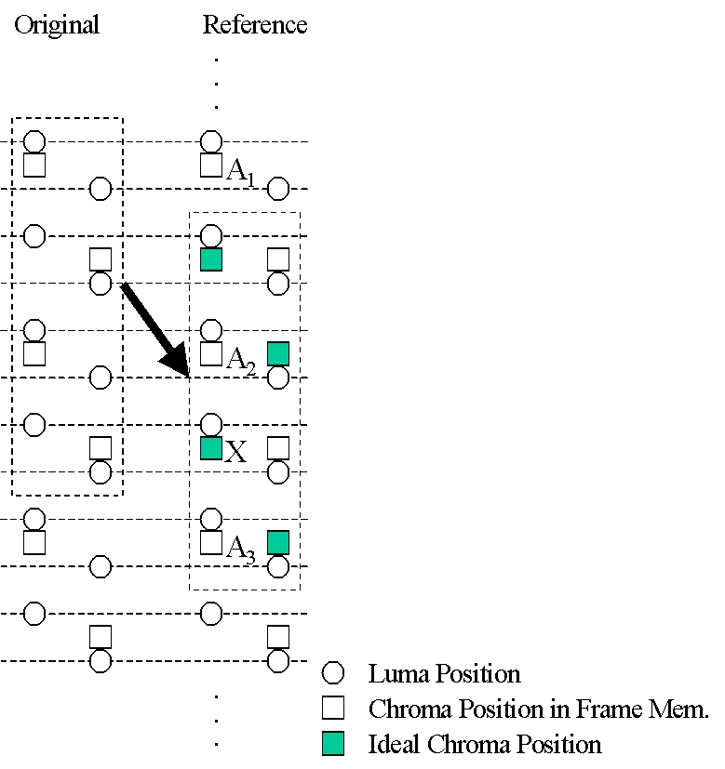

Fig 2.1

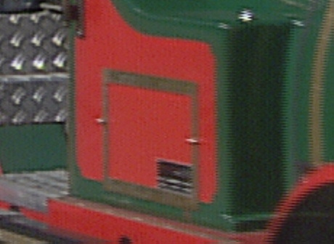

(a) Original Image

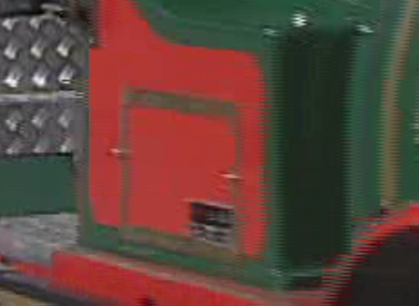

(b) Predicted Image (MPEG-2 TM-5 Encoder)

Fig 2.2

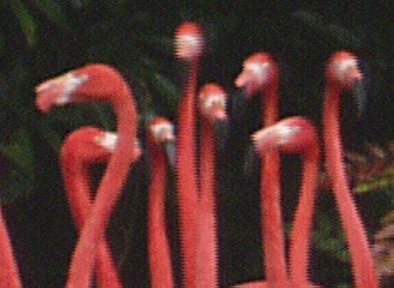

- Original Image

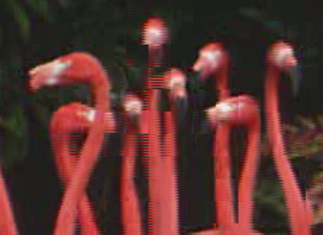

(b) Predicted Image (MPEG-2 TM-5 Encoder)

Fig 2.3

2.2 Solution of the Problem

To fix the problem shown in Fig 3.1, we proposed in Geneva meeting the following semantics change for motion compensation. No syntax change is necessary.
When the value of vertical component of the motion vector mv_{vertical} =$±$2.0, $±$6.0, $±$10.0 … , the pixel “X” in Fig 3.1 is generated by intra-field prediction. The following filter is used for this interpolation:
(2.1)
{1, -5, 20, 20, -5, 1} //32

In Fairfax meeting, we showed that the proposed algorithm has a positive impact on sequences which contain motion like “F1” or “Popple” in terms of coding efficiency, and that it does not have a negative impact on other sequences in terms of coding efficiency and computational complexity.
However, it was pointed out that employing a 6-tap FIR filter to chroma samples may cause a severe increase in memory bandwidth, as current JM employs linear interpolation for chroma motion compensation.
In this contribution we propose the 6-tap FIR filter (2.1) be replaced with the following linear interpolation:
(2.2)
{1, 1} // 2

3. Simulation

Simulation Condition:

Codec | JM2.0  JM2.0 with Chroma Phase Shift (2-tap FIR) ^{(*)}  JM2.0 with Chroma Phase Shift (6-tap FIR)
Sequence | Group A:  “F1” (720x576x25i) ^{(**)}  “Popple” (720x480x30i)  Group B:  “Canoa” (720x576x25i) ^{(**)}  “Rugby” (720x576x25i) ^{(**)}  “Tempete” (720x480x30i) ^{(**)}  “Football” (720x480x30i) ^{(**)}
GOP | - IPPP…  - IBBPBBP…  (Frame Structure)
QP | QP_{I} = QP_{P} = 16,20,24,28  QP_{B} = QP_{I} + 2
Entropy Coding | UVLC / CABAC
RD Optimization | On
Hadamard | On
Motion Compensation Accuracy | 1/4-pel
Reference Frames | 1/5
MV Search Range | ±16
Restricted Search Range | 2

(*) Only minor modification is needed in “macroblock.c”. In this contribution the modified version of “macroblock.c” is included. (2-tap FIR only.)
(**) Sequences specified as interlace common test conditions and can be obtained at www.vqeg.org.

Table 3.1

Simulation Result:

UVLC ref1 IPP

 |  | C.P.S with 2-tap FIR | C.P.S with 6-tap FIR
F1 | BD-PSNR
F1 | BD-Bitrate
Popple | BD-PSNR
Popple | BD-Bitrate
Canoa | BD-PSNR
Canoa | BD-Bitrate
Rugby | BD-PSNR
Rugby | BD-Bitrate
Tempete | BD-PSNR
Tempete | BD-Bitrate
Football | BD-PSNR
Football | BD-Bitrate

Table 3.2

UVLC ref1 IPB

 |  | C.P.S with 2-tap FIR | C.P.S with 6-tap FIR
F1 | BD-PSNR
F1 | BD-Bitrate
Popple | BD-PSNR
Popple | BD-Bitrate
Canoa | BD-PSNR
Canoa | BD-Bitrate
Rugby | BD-PSNR
Rugby | BD-Bitrate
Tempete | BD-PSNR
Tempete | BD-Bitrate
Football | BD-PSNR
Football | BD-Bitrate

Table 3.3

UVLC ref5 IPP

 |  | C.P.S with 2-tap FIR | C.P.S with 6-tap FIR
F1 | BD-PSNR
F1 | BD-Bitrate
Popple | BD-PSNR
Popple | BD-Bitrate
Canoa | BD-PSNR
Canoa | BD-Bitrate
Rugby | BD-PSNR
Rugby | BD-Bitrate
Tempete | BD-PSNR
Tempete | BD-Bitrate
Football | BD-PSNR
Football | BD-Bitrate

Table 3.4

UVLC ref5 IPB

 |  | C.P.S with 2-tap FIR | C.P.S with 6-tap FIR
F1 | BD-PSNR
F1 | BD-Bitrate
Popple | BD-PSNR
Popple | BD-Bitrate
Canoa | BD-PSNR
Canoa | BD-Bitrate
Rugby | BD-PSNR
Rugby | BD-Bitrate
Tempete | BD-PSNR
Tempete | BD-Bitrate
Football | BD-PSNR
Football | BD-Bitrate

Table 3.5

CABAC ref1 IPP

 |  | C.P.S with 2-tap FIR | C.P.S with 6-tap FIR
F1 | BD-PSNR
F1 | BD-Bitrate
Popple | BD-PSNR
Popple | BD-Bitrate
Canoa | BD-PSNR
Canoa | BD-Bitrate
Rugby | BD-PSNR
Rugby | BD-Bitrate
Tempete | BD-PSNR
Tempete | BD-Bitrate
Football | BD-PSNR
Football | BD-Bitrate

Table 3.6

CABAC ref1 IPB

 |  | C.P.S with 2-tap FIR | C.P.S with 6-tap FIR
F1 | BD-PSNR
F1 | BD-Bitrate
Popple | BD-PSNR
Popple | BD-Bitrate
Canoa | BD-PSNR
Canoa | BD-Bitrate
Rugby | BD-PSNR
Rugby | BD-Bitrate
Tempete | BD-PSNR
Tempete | BD-Bitrate
Football | BD-PSNR
Football | BD-Bitrate

Table 3.7

CABAC ref5 IPP

 |  | C.P.S with 2-tap FIR | C.P.S with 6-tap FIR
F1 | BD-PSNR
F1 | BD-Bitrate
Popple | BD-PSNR
Popple | BD-Bitrate
Canoa | BD-PSNR
Canoa | BD-Bitrate
Rugby | BD-PSNR
Rugby | BD-Bitrate
Tempete | BD-PSNR
Tempete | BD-Bitrate
Football | BD-PSNR
Football | BD-Bitrate

Table 3.8

CABAC ref5 IPB

 |  | C.P.S with 2-tap FIR | C.P.S with 6-tap FIR
F1 | BD-PSNR
F1 | BD-Bitrate
Popple | BD-PSNR
Popple | BD-Bitrate
Canoa | BD-PSNR
Canoa | BD-Bitrate
Rugby | BD-PSNR
Rugby | BD-Bitrate
Tempete | BD-PSNR
Tempete | BD-Bitrate
Football | BD-PSNR
Football | BD-Bitrate

Table 3.9

4. Conclusion

We previously proposed adaptive chroma phase shift for interlaced video with a 6-tap FIR filter and showed that the proposed algorithm will significantly improve coding efficiency with sequence which contains color component and vertical motions like F1 or Popple. We also verified that the proposed algorithm will not have a negative impact in terms of coding efficiency and computational complexity with other sequences.
However, as current JM employs linear interpolation for chroma motion compensation, we expect a similar effect with 2-tap FIR (linear interpolation) chroma-phase-shift as the one with 6-tap FIR. In this contribution we showed that chroma phase shift with 2-tap FIR works as good as the previously proposed method. Moreover, the newly proposed method requires less frame memory bandwidth than the old one.
In JVT field/frame adaptive will be adapted either on picture-level or on MB-level. In either case, the proposed algorithm can be adapted in frame mode and will contribute to the improvement in coding efficiency. Chroma mismatch described in this contribution is a bug in MPEG-2 specification, and in JVT it should definitely be fixed!

References
[1] ISO/IEC 13818-2:2000 Information technology -- Generic coding of moving pictures and associated audio information: Video
[2] “Working Draft Number 2, Revision 4 (WD-2 rev 5)”, T. Wiegand, JVT-B118r7, DRAFT ISO/IEC 14496-10, Geneva, CH, Feb 2002
[3] “New Interlace Coding Tools”, K. Sato, T. Suzuki and Y. Yagasaki, JVT-B068r1, Geneva, CH, Feb 2002
[4] “Core Experiment on Interlace Chroma Phase Shift”, K. Sato, T. Suzuki, Y. Yagasaki and Y. Suzuki, JVT-B116, Geneva, CH, Feb 2002
[5] “Result of Core Experiment on 4:2:0 Interlace Chroma Phase Shift”, , K. Sato, T. Suzuki and Y. Yagasaki, JVT-C050r1, Fairfax, USA, May 2002
[6] “Core Experiment on Interlaced Video Coding”, P. Borgwardt, ITU – Telecommunications Standardization Sector STUDY GROUP 16 Question 6, Video Coding Experts Group (VCEG) document, VCEG-N85r1, Septermber 2001
[7] “Calculation of average PSNR difference between RD-curves”, G. Bjontegaard, VCEG-M33, March 2001
[8] “Recommended Simulation Conditions for H.26L”, G. Bjontegaard, VCEG-M75, May 2001
[9] “TestModel5”, ISO/IEC,JTC/SC29/WG11/N0400, 1993

(Append for Proposal Documents)

JVT Patent Disclosure Form

International Telecommunication Union  Telecommunication Standardization Sector | International Organization for Standardization | International Electrotechnical Commission
 |  | 
Joint Video Coding Experts Group - Patent Disclosure Form
(Typically one per contribution and one per Standard | Recommendation)

Please send to:
JVT Rapporteur Gary Sullivan, Microsoft Corp., One Microsoft Way, Bldg. 9, Redmond WA 98052-6399, USA
Email (preferred): Gary.Sullivan@itu.int Fax: +1 425 706 7329 (+1 425 70MSFAX)

This form provides the ITU-T | ISO/IEC Joint Video Coding Experts Group (JVT) with information about the patent status of techniques used in or proposed for incorporation in a Recommendation | Standard. JVT requires that all technical contributions be accompanied with this form. Anyone with knowledge of any patent affecting the use of JVT work, of their own or of any other entity (“third parties”), is strongly encouraged to submit this form as well.

This information will be maintained in a “living list” by JVT during the progress of their work, on a best effort basis. If a given technical proposal is not incorporated in a Recommendation | Standard, the relevant patent information will be removed from the “living list”. The intent is that the JVT experts should know in advance of any patent issues with particular proposals or techniques, so that these may be addressed well before final approval.

This is not a binding legal document; it is provided to JVT for information only, on a best effort, good faith basis. Please submit corrected or updated forms if your knowledge or situation changes.

This form is not a substitute for the ITU ISO IEC Patent Statement and Licensing Declaration, which should be submitted by Patent Holders to the ITU TSB Director and ISO Secretary General before final approval.

Submitting Organization or Person:
Organization name | Sony Corp.
Mailing address | Gate City Osaki East Tower 20F  1-11-1 Osaki Shinagawa-ku,  Tokyo, 141-0032
Country | Japan
Contact person | Kazushi Sato
Telephone | +81 3 5435 3669
Fax | +81 3 5435 3891
Email | kazushi@av.crl.sony.co.jp
Place and date of submission | Tokyo, Japan on July 16, 2002
Relevant Recommendation | Standard and, if applicable, Contribution:
Name (ex: “JVT”) |  | JVT
Title |  | Chroma Phase Shift for Interlace Video
Contribution number |  | D079

(Form continues on next page)

Disclosure information – Submitting Organization/Person (choose one box)
2.0 The submitter is not aware of having any granted, pending, or planned patents associated with the technical content of the Recommendation | Standard or Contribution.

or,
The submitter (Patent Holder) has granted, pending, or planned patents associated with the technical content of the Recommendation | Standard or Contribution. In which case,

2.1 The Patent Holder is prepared to grant – on the basis of reciprocity for the above Recommendation | Standard – a free license to an unrestricted number of applicants on a worldwide, non-discriminatory basis to manufacture, use and/or sell implementations of the above Recommendation | Standard.
2.2 The Patent Holder is prepared to grant – on the basis of reciprocity for the above Recommendation | Standard – a license to an unrestricted number of applicants on a worldwide, non-discriminatory basis and on reasonable terms and conditions to manufacture, use and/ or sell implementations of the above Recommendation | Standard.

Such negotiations are left to the parties concerned and are performed outside the ITU | ISO/IEC.
2.2.1 The same as box 2.2 above, but in addition the Patent Holder is prepared to grant a “royalty-free” license to anyone on condition that all other patent holders do the same.
2.3 The Patent Holder is unwilling to grant licenses according to the provisions of either 2.1, 2.2, or 2.2.1 above. In this case, the following information must be provided as part of this declaration:
- patent registration/application number;
- an indication of which portions of the Recommendation | Standard are affected.
- a description of the patent claims covering the Recommendation | Standard;
In the case of any box other than 2.0 above, please provide the following:
Patent number(s)/status
Inventor(s)/Assignee(s)
Relevance to JVT
Any other remarks:
(please provide attachments if more space is needed)

(form continues on next page)
Third party patent information – fill in based on your best knowledge of relevant patents granted, pending, or planned by other people or by organizations other than your own.

Disclosure information – Third Party Patents (choose one box)
3.1 The submitter is not aware of any granted, pending, or planned patents held by third parties associated with the technical content of the Recommendation | Standard or Contribution.

3.2 The submitter believes third parties may have granted, pending, or planned patents associated with the technical content of the Recommendation | Standard or Contribution.

For box 3.2, please provide as much information as is known (provide attachments if more space needed) - JVT will attempt to contact third parties to obtain more information:

3rd party name(s)
Mailing address
Country
Contact person
Telephone
Fax
Email
Patent number/status
Inventor/Assignee
Relevance to JVT

Any other comments or remarks:

