Joint Video Team (JVT) of ISO/IEC MPEG & ITU-T VCEG  (ISO/IEC JTC1/SC29/WG11 and ITU-T SG16 Q.6)  4th Meeting: Klagenfurt, Austria, 22-26 July, 2002 | Document: JVT-D057  Filename: JVT-D057.doc

Title: | Motion vector prediction and prediction signal in B pictures
Status: | Input Document to JVT
Purpose: | Proposal
Author(s) or  Contact(s): | Byeong-Moon Jeon  16 Woomyeon-Dong, Secho-Gu  LG Electronics Inc. DM research Lab.  Seoul 137-724, Korea | Tel:  Email: | 82-2-526-4415  jeonbm@lge.com
Source: | LG Electronics Inc.
_____________________________
1. Introduction
This contribution clarifies two issues in B pictures, motion vector prediction and prediction signal using implicit weighting factor, under the assumption that the relative timing information is kept in video layer.

2. Motion vector prediction
According to subclause 11.4.1, forward motion vectors are predicted only from forward motion vectors in surrounding macroblocks, and backward motion vectors are predicted only from backward motion vectors in surrounding macroblocks, wherein the terms such as forward and backward imply the direction information. However, the current CD describes unclearly motion vector prediction (shortly, PMV) when any spatially neighboring macroblock has two motion vectors (MVFWD and MVBWD) taking the same direction or both directions, which can be obtained by bi-predictive mode or direct mode. This contribution introduces the solution to resolve this problem. The followings show three cases that two motion vectors in the neighboring block can have.

Case 1: Two motion vectors take forward and backward directions, respectively.
Only one motion vector taking the same direction as PMV does is used as a motion vector candidate predictor.

Case 2: Both of two motion vectors take one direction and the direction is identical to the direction of PMV
If both of two motion vectors point the same reference picture as the current block references, one motion vector is used for median operation, wherein this contribution selects MVFWD. If one of two motion vectors points the same reference picture as the current block references, the motion vector is used for median operation. Lastly, if neither of two motion vectors points the same reference picture as the current block references, one motion vector (MVFWD) is used for median operation.

Case 3: Both of two motion vectors take one direction and the direction is different from the direction of PMV
The motion vector candidate predictor is set to 0.

3. Prediction signal using implicit block weighting
According to subclause 11.5.1, if display order of ref_fwd <= display order of ref_bwd, the implicit bi-prediction weighting coefficient (1/2, 1/2, 0) is used. Otherwise, (2, -1, 0) is used. Assuming P1 is motion-compensated macroblock by MVFWD(=MV1) and P2 is motion-compensated macroblock by MVBWD(=MV2), Figure 1 shows the prediction signal P calculated by the condition in subclause 11.5.1. From Figure 1 (c), we can detect that the condition in subclause 11.5.1 is not appropriate when two reference pictures exist in the backward direction because the prediction signal P is an unexpected value, especially in fading scene.

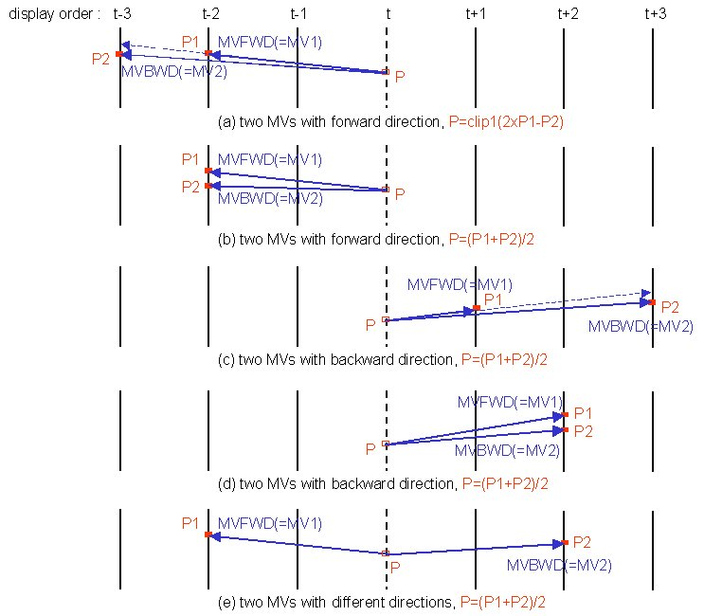
Figure 1. Prediction signal P using implicit weighting factor

Therefore, this contribution introduces the efficient way switching the implicit weighting factors: If two motion vectors of the current macroblock take different directions (in other words, if two reference pictures in the current macroblock exist in separate directions), ABP coefficient (1/2, 1/2, 0) is used. And if two motion vectors of the current macroblock take one direction and their reference pictures are different, ABP coefficient (2, -1, 0) is used. Lastly, if two motion vectors of the current macroblock take one direction and their reference pictures are same, ABP coefficient (1/2, 1/2, 0) is used.

4. Conclusion
The current CD still includes a few things derived from the viewpoint of the conventional B (bi-directional) picture. Therefore, it is necessary to clarify those things from the viewpoint of the current B (bi-predictive) picture. This contribution has proposed the clear way to resolve the ambiguity in both motion vector prediction and selection of implicit weighting factor.

(Append for Proposal Documents)

JVT Patent Disclosure Form

International Telecommunication Union  Telecommunication Standardization Sector | International Organization for Standardization | International Electrotechnical Commission
 |  | 
Joint Video Coding Experts Group - Patent Disclosure Form
(Typically one per contribution and one per Standard | Recommendation)

Please send to:
JVT Rapporteur Gary Sullivan, Microsoft Corp., One Microsoft Way, Bldg. 9, Redmond WA 98052-6399, USA
Email (preferred): Gary.Sullivan@itu.int Fax: +1 425 706 7329 (+1 425 70MSFAX)

This form provides the ITU-T | ISO/IEC Joint Video Coding Experts Group (JVT) with information about the patent status of techniques used in or proposed for incorporation in a Recommendation | Standard. JVT requires that all technical contributions be accompanied with this form. Anyone with knowledge of any patent affecting the use of JVT work, of their own or of any other entity (“third parties”), is strongly encouraged to submit this form as well.

This information will be maintained in a “living list” by JVT during the progress of their work, on a best effort basis. If a given technical proposal is not incorporated in a Recommendation | Standard, the relevant patent information will be removed from the “living list”. The intent is that the JVT experts should know in advance of any patent issues with particular proposals or techniques, so that these may be addressed well before final approval.

This is not a binding legal document; it is provided to JVT for information only, on a best effort, good faith basis. Please submit corrected or updated forms if your knowledge or situation changes.

This form is not a substitute for the ITU ISO IEC Patent Statement and Licensing Declaration, which should be submitted by Patent Holders to the ITU TSB Director and ISO Secretary General before final approval.

Submitting Organization or Person:
Organization name | LG Electronics Inc.
Mailing address | 16 Woomyeon-Dong, Seocho-Gu, Seoul 137-724, Korea
Country | Korea
Contact person | Byeong-Moon Jeon
Telephone | 82-2-526-4415
Fax | 82-2-3461-1347
Email | jeonbm@lge.com
Place and date of submission | 16/07/2002
Relevant Recommendation | Standard and, if applicable, Contribution:
Name (ex: “JVT”) |  | JVT
Title |  | Motion vector prediction and prediction signal in B pictures
Contribution number |  | JVT-D057

(Form continues on next page)

Disclosure information – Submitting Organization/Person (choose one box)
X
2.0 The submitter is not aware of having any granted, pending, or planned patents associated with the technical content of the Recommendation | Standard or Contribution.

or,
The submitter (Patent Holder) has granted, pending, or planned patents associated with the technical content of the Recommendation | Standard or Contribution. In which case,

2.1 The Patent Holder is prepared to grant – on the basis of reciprocity for the above Recommendation | Standard – a free license to an unrestricted number of applicants on a worldwide, non-discriminatory basis to manufacture, use and/or sell implementations of the above Recommendation | Standard.
2.2 The Patent Holder is prepared to grant – on the basis of reciprocity for the above Recommendation | Standard – a license to an unrestricted number of applicants on a worldwide, non-discriminatory basis and on reasonable terms and conditions to manufacture, use and/ or sell implementations of the above Recommendation | Standard.

Such negotiations are left to the parties concerned and are performed outside the ITU | ISO/IEC.
2.2.1 The same as box 2.2 above, but in addition the Patent Holder is prepared to grant a “royalty-free” license to anyone on condition that all other patent holders do the same.
2.3 The Patent Holder is unwilling to grant licenses according to the provisions of either 2.1, 2.2, or 2.2.1 above. In this case, the following information must be provided as part of this declaration:
- patent registration/application number;
- an indication of which portions of the Recommendation | Standard are affected.
- a description of the patent claims covering the Recommendation | Standard;
In the case of any box other than 2.0 above, please provide the following:
Patent number(s)/status
Inventor(s)/Assignee(s)
Relevance to JVT
Any other remarks:
(please provide attachments if more space is needed)

(form continues on next page)
Third party patent information – fill in based on your best knowledge of relevant patents granted, pending, or planned by other people or by organizations other than your own.

Disclosure information – Third Party Patents (choose one box)
3.1 The submitter is not aware of any granted, pending, or planned patents held by third parties associated with the technical content of the Recommendation | Standard or Contribution.

3.2 The submitter believes third parties may have granted, pending, or planned patents associated with the technical content of the Recommendation | Standard or Contribution.

For box 3.2, please provide as much information as is known (provide attachments if more space needed) - JVT will attempt to contact third parties to obtain more information:

3rd party name(s)
Mailing address
Country
Contact person
Telephone
Fax
Email
Patent number/status
Inventor/Assignee
Relevance to JVT

Any other comments or remarks:

