Joint Video Team (JVT) of ISO/IEC MPEG & ITU-T VCEG  (ISO/IEC JTC1/SC29/WG11 and ITU-T SG16 Q.6)  4th Meeting: Klagenfurt, Austria, 22-26 July, 2002 | Contribution: JVT-D056  Filename: JVT-D056.doc

Title: | Direct mode in B pictures
Status: | Input Contribution to JVT
Purpose: | Proposal
Author(s) or  Contact(s): | Byeong-Moon Jeon  16 Woomyeon-Dong, Secho-Gu  LG Electronics Inc. DM research Lab.  Seoul 137-724, Korea | Tel:  Email: | 82-2-526-4415  jeonbm@lge.com
Source: | LG Electronics Inc.
_____________________________
1. Introduction
The current CD still handles direct mode from the viewpoint of the conventional B (bi-directional) picture. Therefore, it is necessary to clarify unclear issues regarding direct mode from the viewpoint of the current B (bi-predictive) picture. This contribution introduces the expanded way to derive motion vectors of direct mode under the assumption that the relative timing information is kept in video layer.

2. Direct mode in current B picture
Direct mode does not require any bits for motion information because its motion vectors are derived directly from the motion vector used in the collocated macroblock of the temporally subsequent picture. So it can reduce bitrate significantly for a given quality. This feasibility comes from the temporal redundancy between consecutive pictures, especially for sequence with less motion or translational global motion.

In JVT model, B picture is allowed to be used as a reference picture and bi-predictive mode can have two motion vectors in the same direction or different directions. The facts lead us to meet the many conceivable situations as shown Figure 1.

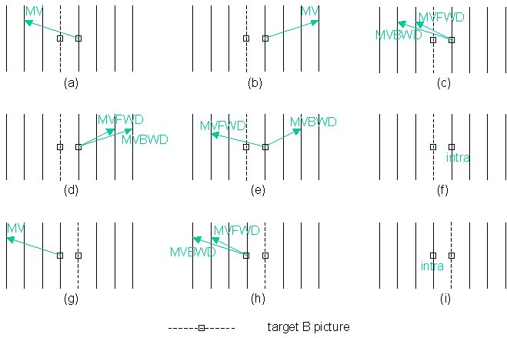
Figure 1. Conceivable situations for direct mode

First, basically, two motion vectors of direct mode can be derived by exploiting the temporal redundancy between two consecutive pictures. So the immediately temporally-following picture shall be used for direct mode (Figure 1. (a)~(f)). However, if decoding order is identical to display order, none of the temporally-following pictures is decoded yet. In this case, B picture shall use the immediately temporally-preceding picture for direct mode (Figure 1. (g)~(i)). Consequently, in this contribution, the immediately temporally-following picture is used for direct mode if decoding order is different from display order (i.e., the temporally-following pictures are already decoded) and the immediately temporally-preceding picture is used for direct mode if decoding order is identical to display order (i.e., None of the temporally-following pictures is decoded yet).

Second, the temporally adjacent picture can be B picture, so the number of motion vectors in collocated macroblock in the adjacent picture can be two and their directions are either the same direction (Figure 1. (c)(d)(h)) or different directions (Figure 1. (e)). Therefore, we need to define carefully the calculation of motion vectors of direct mode and this contribution includes the solution. .

Third, if all motion vectors in collocated macroblock of the temporally adjacent picture take an opposite direction against the direction of B picture (Figure 1. (b)(d)(g)(h)), the motion vectors of direct mode cannot be derived temporally because it is uncertain to say that a motion exists between B picture and the temporally adjacent picture. Furthermore, it is possible to guess that there is a scene change between two pictures. So this contribution introduces the way to estimate spatially a motion existence between two pictures by examining the direction of motion vectors in spatially adjacent macroblocks of target macroblock. For the reference, since the conventional B picture always has a P picture as a subsequent picture, this guarantees that a motion always exists between two pictures except that MB mode of collocated macroblock of the subsequent P picture is intra. Therefore, such the third situation did not happen in the conventional B picture.

Fourth, if MB mode of collocated macroblock of the temporally adjacent picture is intra (Figure 1. (f)(i)), the feature of temporal redundancy cannot be used for direct mode because it is uncertain that there is a motion between B picture and the temporally adjacent picture. In spite of such an uncertainty, the conventional B picture just assumed that the collocated macroblock has zero motion. This assumption makes MV_{f} and MV_{b} to be set as 0 whose corresponding reference pictures are the immediately temporally-preceding and temporally-following pictures, respectively. As you predict, it was reported that this assumption was not best solution, especially when there was a scene change between B picture and the temporally adjacent picture. In order to overcome those difficulties, this contribution introduces the efficient method to derive the motion vectors of direct mode by estimating spatially the motion existence between two pictures.

2.1 Coding scheme that decoding order is different from display order
2.1.1 One motion vector in forward direction (Figure 1. (a))
Since this situation guarantees that a motion exists between B picture and the immediately temporally-following picture, two motion vectors of direct mode are calculated temporally by
MV_{f} = MV x TR_{b} / TR_{d}
MV_{b} = MV x (TR_{b} - TR_{d} ) / TR_{d}
where MV is a motion vector in collocated macroblock of the immediately temporally-following picture, TR_{b} is the temporal distance between B picture and the reference picture pointed by MV, and TR_{d} is the temporal distance between the immediately temporally-following picture and the reference picture pointed by MV.

If and only if MV points the long-term reference picture, then two motion vectors of direct mode are defined as follows.
MV_{f} = MV
MV_{b} = 0

2.1.2 One motion vector in backward direction (Figure 1. (b))
Since it is impossible to judge temporally whether or not a motion exists between B picture and the immediately temporally-following picture, we decide the motion existence between two pictures through checking motion vectors in the spatially neighboring macroblocks of target macroblock. This feasibility comes from the spatial redundancy among the neighboring macroblocks. This contribution uses three neighboring macroblocks that are originally used for motion vector prediction. There are three cases that three neighboring macroblocks can have, as shown in Figure 2.

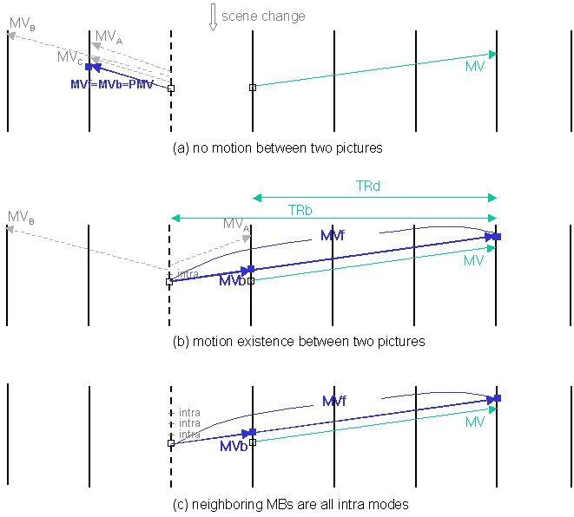
Figure 2. One motion vector in backward direction

Figure 2 (a) shows all the motion vectors of three neighboring macroblocks take a forward direction, wherein MV_{A}, MV_{B}, MV_{C} indicate the motion vectors of the neighboring macroblock A, B, C. That means the temporal correlation between the temporally-preceding pictures and B picture is so high, while temporal correlation between B picture and the temporally-following pictures is very low. In other words, it is possible to guess that there is a scene change between B picture and the temporally-following picture. In this contribution, the motion vector of direct mode is predicted spatially from the motion vectors in the neighboring macroblocks. So MV_{f} (= MV_{b}) is calculated through median{MV_{A}, MV_{B}, MV_{C}}. In addition to MV_{f}(= MV_{b}), the reference picture pointed by MV_{f} is required. This is also predicted spatially from reference pictures in the neighboring macroblocks. Consequently, prediction signal is generated by one motion vector (MV_{f} = MV_{b}) and one reference picture. The details for both the spatial calculation of motion vector and the prediction of reference picture are discussed in section 3.

Figure 2 (b) shows that there is at least one motion vector in backward direction from the neighboring macroblocks. That implies that a motion exists between B picture and the temporally-following pictures and so it is possible to derive motion vectors of direct mode temporally from MV. This contribution defines MV_{f} as a motion vector of target macroblock obtained from the reference picture pointed by MV and MV_{b} as a motion vector of target macroblock obtained from the immediately temporally-following picture. And the definition of TR_{b} and TR_{d} is same with section 2.1.1 and two motion vectors of direct mode are calculated by the same equations in section 2.1.1.

Lastly, Figure 2 (c) shows all the neighboring macroblocks have intra mode. In this case, we cannot estimate temporally and spatially the motion existence between B picture and the immediately temporally-following picture. Therefore, this contribution regards this case as the above case (Figure 2 (b)) and derives MV_{f} and MV_{b} from MV in the same manner as the above case.

2.1.3 Two motion vectors in forward direction (Figure 1. (c))
The fact that both of two motion vectors exist in the forward direction indicates that there is a motion between B picture and the immediately temporally-following pictures. So it is possible to derive temporally the motion vectors of direct mode from either MVFWD(=MV1) or MVBWD(=MV2). This contribution selects MVFWD(=MV1) and derives MV_{f} and MV_{b} as shown in Figure 3. The reason to select MVFWD(=MV1) is that MVFWD(=MV1) is more important than MVBWD(=MV2) since MVBWD(=MV2) is determined from the scaled MVFWD(=MV1). MV_{f} and MV_{b} are calculated by the same way in section 2.1.1. If two motion vectors point the long-term reference pictures, one motion vector is used, too.

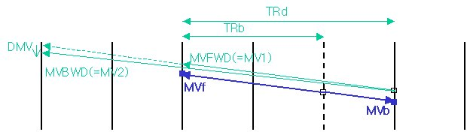
Figure 3. Two motion vectors in forward direction

2.1.4 Two motion vectors in backward direction (Figure 1. (d))
The only difference from section 2.1.2 is that there are two motion vectors in backward direction. This contribution selects MVFWD(=MV1) and the same way in section 2.1.2 is applied.

2.1.5 Two motion vectors in different directions (Figure 1. (e))
MVFWD indicates that a motion exists between B picture and the immediately temporally-following picture. Therefore, this contribution selects MVFWD and MV_{f} and MV_{b} are calculated temporally from MVFWD as section 2.1.1.

2.1.6 Intra mode (Figure 1. (f))
Since it is impossible to judge temporally whether or not a motion exists between B picture and the immediately temporally-following picture, we have to estimate the motion existence spatially. There are four cases that three neighboring macroblocks can have, as shown in Figure 4.

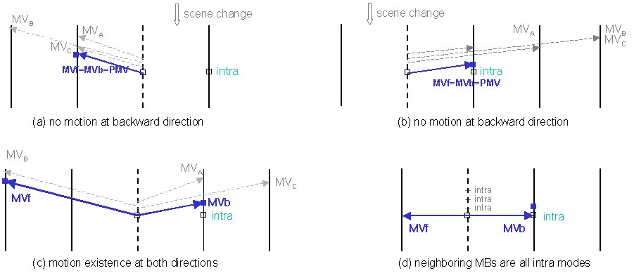
Figure 4. Intra mode

In Figure 4 (a), all the motion vectors in three neighboring macroblocks, including intra mode, take only forward direction and this fact indicates that there may be a scene change between B picture and the immediately temporally-following picture. In this contribution, the motion vector of direct mode taking forward direction is predicted spatially from the neighboring macroblocks. In addition to MV_{f}(= MV_{b}), the reference picture pointed by MV_{f} is also predicted spatially. The details for both the spatial calculation of motion vector and the prediction of reference picture are discussed in section 3.

Figure 4 (b) shows that all the motion vectors in three neighboring macroblocks, including intra mode, take only backward direction. This fact indicates that there is a motion between B picture and the immediately temporally-following picture and also there may be a scene change between B picture and the immediately temporally-preceding picture. In this contribution, the motion vector of direct mode taking backward direction is predicted from three neighboring macroblocks. In addition to MV_{f}(= MV_{b}), the reference picture pointed by MV_{f} is also predicted spatially.

Figure 4 (c) shows that some motion vectors in three neighboring macroblocks take forward direction and other motion vectors take backward direction. This fact indicates that a motion of target macroblock exists in any direction, and so this contribution calculates spatially two motion vectors in both directions from three neighboring macroblocks. Of course, the reference picture in each direction is also spatially calculated.

Figure 4 (d) shows all the neighboring macroblocks have intra mode. In this case, we cannot estimate temporally and spatially the motion existence between B picture and the temporally-following pictures. This contribution employs the same method as the conventional B picture: Under the assumption that the collocated macroblock has zero motion vector, MV_{f} and MV_{b} are set to zero and their corresponding reference pictures are the immediately temporally-preceding and temporally-following picture, respectively.

2.2 Coding scheme that decoding order is identical to display order
In this coding scheme, the immediately temporally-preceding picture has one or two motion vectors in only forward direction, in addition to intra mode. This fact makes it hard to judge temporally whether or not a motion exists between B picture and the immediately temporally-preceding picture. Therefore, the motion existence between two pictures is judged spatially from the neighboring macroblocks of target macroblock.

2.2.1 One motion vector in forward direction (Figure 1. (g))
There are two cases that three neighboring macroblocks can have, as shown in Figure 5.

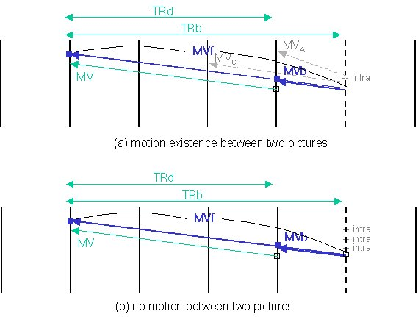
Figure 5. One motion vector in forward direction

Figure 5 (a) shows that there is at least one motion vector in forward direction from the neighboring macroblocks. That implies that a motion exists between B picture and the temporally-preceding pictures and so it is possible to derive temporally the motion vectors of direct mode from MV. This contribution defines MV_{f} as a motion vector of target macroblock obtained from the reference picture pointed by MV and MV_{b} as a motion vector of target macroblock obtained from the immediately temporally-preceding. TR_{b} is the temporal distance between B picture and the reference picture pointed by MV, and TR_{d} is the temporal distance between the immediately temporally-preceding picture and the reference picture pointed by MV. The motion vectors of direct mode are calculated by the same equations in section 2.1.1. And if MV points the long-term reference picture, then the motion vectors of direct mode are also obtained in the same manner as section 2.1.1.

Figure 5 (b) shows all the neighboring macroblocks have intra mode. In this case, we cannot estimate temporally and spatially a motion existence between two pictures. Therefore, this contribution regards this case as the above case (Figure 5 (a)) and derives directly MV_{f} and MV_{b} from MV in the same manner as the above.

2.2.2 Two motion vectors in forward direction (Figure 1. (h))
The only difference from section 2.2.1 is that there are two motion vectors in forward direction. This contribution selects MVFWD(=MV1) and the same way in section 2.2.1 is applied for the motion vectors of direct mode. If two motion vectors point the long-term reference pictures, one motion vector is used, too.

2.2.3 Intra mode (Figure 1. (i))
There are two cases that three neighboring macroblocks can have, as shown in Figure 6.

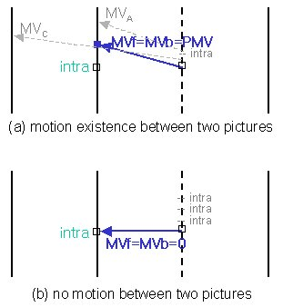
Figure 6. Intra mode

Figure 6 (a) shows that there is at least one motion vector in forward direction from the neighboring macroblocks, which indicates that a motion exists between B picture and the temporally-preceding pictures. In this contribution, the motion vector of direct mode taking forward direction is predicted spatially from the neighboring macroblocks. In addition to MV_{f}(= MV_{b}), the reference picture pointed by MV_{f} is also predicted spatially from the neighboring macroblocks.

Figure 6 (b) shows all the neighboring macroblocks have intra mode. In this case, we cannot estimate temporally and spatially a motion existence between two pictures. This contribution assumes that the collocated macroblock has zero motion vector, so MV_{f} (= MV_{b}) is set to 0 and its corresponding reference picture is the immediately temporally-preceding picture.

3. Summary
It depends on the coding scheme to decide which temporally adjacent picture will be used for direct mode: the immediately temporally-following picture is used if decoding order is different from display order (i.e., the temporally-following pictures are already decoded) and the immediately temporally-preceding picture is used if decoding order is identical to display order (i.e., none of the temporally-following pictures is decoded yet).

In this contribution, only one motion vector (MVFWD) is used to derive the motion vectors of direct mode if the collocated macroblock of the temporally adjacent picture has two motion vectors. And the motion existence between B picture and the temporal adjacent picture is judged by looking at the motion vector of the temporally collocated macroblock or by referencing the motion vectors of the spatially neighboring macroblocks.

Basically, two motion vectors of direct mode are derived temporally from the motion vector of the collocated macroblock if the collocated macroblock has a motion vector (or two motion vectors) and it is temporally or spatially estimated that a motion exists between B picture and the temporally adjacent picture (Figure 1. (a)(c)(e), Figure 1 (b)(d) considering Figure 2 (b), and Figure 1 (g)(h) considering Figure 5 (a)).

If the collocated macroblock has a motion vector (or two motion vectors) but it is temporally or spatially estimated that a motion does not exist between two pictures, one motion vector (MV_{f} = MV_{b}) in opposite direction against B picture direction and its reference picture are derived spatially from the neighboring macroblocks (Figure 1 (b)(d) considering Figure 2 (a)).

If the collocated macroblock has a motion vector (or two motion vectors) but it is impossible to judge temporally and spatially a motion existence between two pictures, two motion vectors of direct mode are derived temporally from the motion vector of the collocated macroblock (Figure 1 (b)(d) considering Figure 2 (c), and Figure 1 (g)(h) considering Figure 5 (b)).

If the mode of the temporally collocated macroblock is intra and all the motion vectors of the spatially neighboring macroblocks (including intra mode) take only one direction, one motion vector (MV_{f} = MV_{b}) in the direction and its reference picture are derived spatially from the neighboring macroblocks (Figure 1 (f) considering Figure 4 (a)(b), and Figure 1 (i) considering Figure 6 (a)).

If the mode of the temporally collocated macroblock is intra and the motion vectors of the spatially neighboring macroblocks (including intra mode) take both directions, two motion vectors in both directions and their reference pictures are derived spatially from the neighboring macroblocks (Figure 1 (f) considering Figure 4 (c)).

Finally, if the temporally collocated macroblock and the spatially neighboring macroblocks have intra modes, the collocated macroblock is assumed to be zero motion and MV_{f} (= MV_{b}) becomes 0. And their corresponding reference pictures are the immediately temporally-preceding and temporally-following pictures (Figure 1 (f) considering Figure 4 (d)) or only the immediately temporally-preceding picture (Figure 1 (i) considering Figure 6 (b)).

The method to calculate spatially the motion vector of direct mode is similar to the method for motion vector prediction: First, if any one among the neighboring macroblocks has intra mode, its motion vectors in both forward and backward directions are set to zero. And the motion vector of direct mode is calculated by the median operation of the motion vectors of the neighboring macroblocks, which exist in the same direction as the motion vector of direct mode takes. If any macroblock has two motion vectors (MVFWD and MVBWD) taking the same direction as the motion vector of direct mode does, this contribution selects one motion vector (MVFWD).

For the prediction of reference picture, it is simple to calculate the reference picture pointed by the motion vector of direct mode: To begin with, remember that the only reference pictures of the neighboring macroblocks are used, which exist in the same direction as the motion vector of direct mode takes. If each of the neighboring macroblocks has a separate reference picture, the reference picture with the smallest index is selected as a reference picture of the motion vector of direct mode. And if two among the neighboring macroblocks have an identical reference picture, the reference picture is selected as a reference picture of the motion vector of direct mode. Finally if all of the neighboring macroblocks have an identical reference picture, the reference picture is selected as a reference picture of the motion vector of direct mode.

4. Conclusion and further work
Since we already experienced in the past that the prediction from two motion signal provides better performance than one motion signal and the direct mode uses the predicted motion vectors so that it is necessary to use two motion vectors to get a correct prediction signal, this contribution has employed two motion vectors in the expanded definition of direct mode as possible as it can. This approach guarantees that direct mode can still provide the higher performance by generating more accurate prediction signal. However, unfortunately, we are currently implementing this expanded definition of direct mode. Because the current JM software does not fully support the bi-predictive mode and multi-reference picture buffer scheme with more than one backward reference pictures, we had to fix such the things at first. As further works, the integration of the expanded direct mode into JM software is left.

(Append for Proposal Contributions)

JVT Patent Disclosure Form

International Telecommunication Union  Telecommunication Standardization Sector | International Organization for Standardization | International Electrotechnical Commission
 |  | 
Joint Video Coding Experts Group - Patent Disclosure Form
(Typically one per contribution and one per Standard | Recommendation)

Please send to:
JVT Rapporteur Gary Sullivan, Microsoft Corp., One Microsoft Way, Bldg. 9, Redmond WA 98052-6399, USA
Email (preferred): Gary.Sullivan@itu.int Fax: +1 425 706 7329 (+1 425 70MSFAX)

This form provides the ITU-T | ISO/IEC Joint Video Coding Experts Group (JVT) with information about the patent status of techniques used in or proposed for incorporation in a Recommendation | Standard. JVT requires that all technical contributions be accompanied with this form. Anyone with knowledge of any patent affecting the use of JVT work, of their own or of any other entity (“third parties”), is strongly encouraged to submit this form as well.

This information will be maintained in a “living list” by JVT during the progress of their work, on a best effort basis. If a given technical proposal is not incorporated in a Recommendation | Standard, the relevant patent information will be removed from the “living list”. The intent is that the JVT experts should know in advance of any patent issues with particular proposals or techniques, so that these may be addressed well before final approval.

This is not a binding legal contribution; it is provided to JVT for information only, on a best effort, good faith basis. Please submit corrected or updated forms if your knowledge or situation changes.

This form is not a substitute for the ITU ISO IEC Patent Statement and Licensing Declaration, which should be submitted by Patent Holders to the ITU TSB Director and ISO Secretary General before final approval.

Submitting Organization or Person:
Organization name | LG Electronics Inc.
Mailing address | 16 Woomyeon-Dong, Seocho-Gu, Seoul 137-724, Korea
Country | Korea
Contact person | Byeong-Moon Jeon
Telephone | 82-2-526-4415
Fax | 82-2-3461-1347
Email | jeonbm@lge.com
Place and date of submission | 16/07/2002
Relevant Recommendation | Standard and, if applicable, Contribution:
Name (ex: “JVT”) |  | JVT
Title |  | Direct mode in B pictures
Contribution number |  | JVT-D056

(Form continues on next page)

Disclosure information – Submitting Organization/Person (choose one box)
X | 2.0 The submitter is not aware of having any granted, pending, or planned patents associated with the technical content of the Recommendation | Standard or Contribution.  or,
The submitter (Patent Holder) has granted, pending, or planned patents associated with the technical content of the Recommendation | Standard or Contribution. In which case,

 | 2.1 The Patent Holder is prepared to grant – on the basis of reciprocity for the above Recommendation | Standard – a free license to an unrestricted number of applicants on a worldwide, non-discriminatory basis to manufacture, use and/or sell implementations of the above Recommendation | Standard.
2.2 The Patent Holder is prepared to grant – on the basis of reciprocity for the above Recommendation | Standard – a license to an unrestricted number of applicants on a worldwide, non-discriminatory basis and on reasonable terms and conditions to manufacture, use and/ or sell implementations of the above Recommendation | Standard.

Such negotiations are left to the parties concerned and are performed outside the ITU | ISO/IEC.
 | 2.2.1 The same as box 2.2 above, but in addition the Patent Holder is prepared to grant a “royalty-free” license to anyone on condition that all other patent holders do the same.
2.3 The Patent Holder is unwilling to grant licenses according to the provisions of either 2.1, 2.2, or 2.2.1 above. In this case, the following information must be provided as part of this declaration:
- patent registration/application number;
- an indication of which portions of the Recommendation | Standard are affected.
- a description of the patent claims covering the Recommendation | Standard;
In the case of any box other than 2.0 above, please provide the following:
Patent number(s)/status
Inventor(s)/Assignee(s)
Relevance to JVT
Any other remarks:
(please provide attachments if more space is needed)

(form continues on next page)
Third party patent information – fill in based on your best knowledge of relevant patents granted, pending, or planned by other people or by organizations other than your own.

Disclosure information – Third Party Patents (choose one box)
3.1 The submitter is not aware of any granted, pending, or planned patents held by third parties associated with the technical content of the Recommendation | Standard or Contribution.

3.2 The submitter believes third parties may have granted, pending, or planned patents associated with the technical content of the Recommendation | Standard or Contribution.

For box 3.2, please provide as much information as is known (provide attachments if more space needed) - JVT will attempt to contact third parties to obtain more information:

3rd party name(s)
Mailing address
Country
Contact person
Telephone
Fax
Email
Patent number/status
Inventor/Assignee
Relevance to JVT

Any other comments or remarks:

