Joint Video Team (JVT) of ISO/IEC MPEG & ITU-T VCEG  (ISO/IEC JTC1/SC29/WG11 and ITU-T SG16 Q.6)  4th Meeting: Klagenfurt, Austria, 22-26 July, 2002 | Document: JVT-D038  Filename: JVT-D038.doc

Title: | Improved Loop-Filter Tables and Variable-Shift Table Indexing
Status: | Input Document to JVT
Purpose: | Proposal
Author(s) or  Contact(s): | Anthony Joch  400-1788 West 5th Avenue  Vancouver, B.C., Canada  V6J 1P2 | Tel:  Email: | +1 604 737 2426 .33  anthony@ubvideo.com
Source: | UB Video Inc.
_____________________________

Overview
One action item following the Fairfax meeting was to verify that values in the tables used in the loop filter are optimal in terms of the visual quality that they provide and to study the amount of flexibility that should be given to the encoder for adjusting the properties of the filter through these tables. As a result of the work that we have performed in this area, we are proposing modified default tables that improve subjective quality and fix an inconsistency that was found in the α-table. We are also proposing a new method of providing flexibility in the properties of the loop filter by allowing the encoder to specify offsets to the QP-based indices used to address these tables. This method, which we are calling Variable-Shift Table Indexing (VSTI), adds flexibility to the filter, making it more robust to different content, resolutions, and encoder decision characteristics, with minimal additional complexity.

Subjectively Tuned α- and β- Tables
The α- and β-tables of the loop filter are QP-dependent thresholds that define the maximum amount of activity at an edge for which the edge will still be filtered. At the Fairfax meeting, we committed to putting effort into tuning the values of α and β through objective and subjective study, since the values in the CD were stated to be “first guess” values. The modified α-table that we are proposing is based on our subjective evaluation of a number of sequences (focusing on those in the common conditions) over the entire QP scale. During this work, we initially found that the current α values tend to be too low when the QP is low (visible blocking artifacts remain, Figure 2) and become too large when QP is high (over-blurring, unnecessary filtering). Therefore, it seems that the growth in α with respect to QP is too fast. In the current table, α doubles roughly every 4 QP. However, it is intuitive that α should be related directly to the quantization step size, which doubles every 6 QP. Based on some discussions with Peter List, it seems that the current doubling rate of 4 QP is an inconsistency that should be fixed. Conveniently, the values that we had determined subjectively were doubling approximately every 6 QP.

Since we found that the α values at low QP’s should be higher than in the original tables, we also studied the choice of QP value below which α should be zero, and thus the filter is no longer used. In sequences with smooth areas, blocking artifacts are clearly visible using QP = 19 (QP = 7 in the old scale), which is the largest QP for which α is currently zero. By studying such sequences, we found that filtering should still take place for QP values as low as 16, since blocking artifacts are still visible in smooth areas. See Figure 3 for an example. The β- table was also extended at the low QP end to permit filtering at these QP values. The clipping table was not changed. Note that C0=0 for most Bs and QP combinations in this range. This allows for strong filtering, and for P₀ and Q₀ to be modified by the default filter, since C = C0 + a_{p} + a_{q}. However, P₁ and Q₁ are not modified by the default filter if C0=0. Figure 2 below shows an example of an image in which visible block artifacts are apparent using the current α-table at QP=16 (QP=4 in the old range).

Other than the extension at the low QP range, the β-table was not altered. Objective and subjective results showed that the existing table is suitable.

Common conditions (and more) results are given in the spreadsheet of document JVT-D037. A very small average improvement in the PSNR-based results is produced by the new tables.

We propose the following tables for α and β:

 | QP_{av}
 | 0 | 1 | 2 | 3 | 4 | 5 | 6 | 7 | 8 | 9 | 10 | 11 | 12 | 13 | 14 | 15 | 16 | 17 | 18 | 19 | 20 | 21 | 22 | 23 | 24 | 25
α | 0 | 0 | 0 | 0 | 0 | 0 | 0 | 0 | 0 | 0 | 0 | 0 | 0 | 0 | 0 | 0 | 4 | 4 | 5 | 6 | 7 | 8 | 9 | 10 | 12 | 13
β | 0 | 0 | 0 | 0 | 0 | 0 | 0 | 0 | 0 | 0 | 0 | 0 | 0 | 0 | 0 | 0 | 2 | 2 | 2 | 3 | 3 | 3 | 3 | 4 | 4 | 4

 | QP_{av}
 | 26 | 27 | 28 | 29 | 30 | 31 | 32 | 33 | 34 | 35 | 36 | 37 | 38 | 39 | 40 | 41 | 42 | 43 | 44 | 45 | 46 | 47 | 48 | 49 | 50 | 51
α | 15 | 17 | 20 | 22 | 25 | 28 | 32 | 36 | 40 | 45 | 50 | 56 | 63 | 71 | 80 | 90 | 101 | 113 | 127 | 144 | 162 | 182 | 203 | 226 | 255 | 255
β | 6 | 6 | 7 | 7 | 8 | 8 | 9 | 9 | 10 | 10 | 11 | 11 | 12 | 12 | 13 | 13 | 14 | 14 | 15 | 15 | 16 | 16 | 17 | 17 | 18 | 18

Figure 1: Current and Proposed α-tables


Figure 2: Foreman, CIF, QP=16 (28). Left α = 14, Right α = 20.
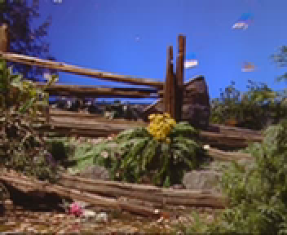

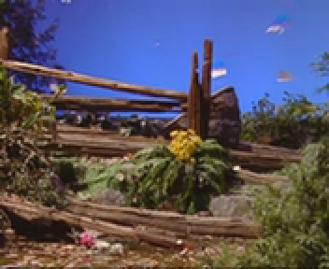
Figure 3:Tempete, QCIF (x2), QP=4(16). Top α = 0, Bottom α = 4.

Variable-Shift Table Indexing
The need to provide encoder designers with some flexibility in the properties of the loop filter has been understood to be an important issue for some time. A proposal from Panasonic for downloadable tables was presented at Fairfax, which allowed the values of α and β to be modified a positive offset, from 0 to +15 [3]. It was taken as a study item at Fairfax to determine whether fully downloadable tables are necessary, or if switching between a small number of different tables would be sufficient.

As a result of this study and the work that we have performed tuning the default α- and β-tables, we would like to propose an alternate solution that provides a good tradeoff between the amount of flexibility in the tables, the added complexity of allowing this flexibility, and the bit overhead required to modify the filter. The method is called Variable-Shift Table Indexing (VSTI). The idea is to allow the encoder to select an offset on a slice basis that will be added to the QP value used in indexing the α-, β-, and clipping (c0) tables.

Alpha = ALPHA_TABLE[clip3(0,51,QP + alpha_offset)]
Beta = BETA_TABLE [clip3(0,51,QP + beta_offset )]
C0 = CLIP_TABLE [clip3(0,51,QP + alpha_offset)]

The index used to access the tables is clipped to be within the range of valid QP values (0 to 51). The offset for indexing the clipping table is always the same as for the α-table. In our experiments, we’ve found that it is best if α and the clipping values remain in sync, but at times, a different offset for β is beneficial.

Although the additional complexity is very small, an implementation of this method can be simplified even further by applying the offset to the pointers that are used to access the tables. This way, the extra addition only occurs as often as the offset can be changed, not every time the table is accessed. Clipping of the index can be avoided by padding the tables.

A positive offset results in more filtering by shifting a curve to the left on a horizontal QP scale, while a negative offset results in less filtering by shifting a curve to the right. The proposed range of permitted offsets is -12 to +12, in increments of 2. This range is large enough to allow a properties of the filter to vary as widely as we’ve found to be necessary, but is limited to limit additional memory requirements and/or added complexity.

For both the α and β offsets, a single UVLC coded symbol is transmitted in the slice header with a value ranging from -6 to +6. The transmitted values are then multiplied by 2 to calculate the offset that is applied when indexing each table.

alpha_offset = alpha_offset_code * 2
beta_offset = beta_offset_code * 2

This variable-shift method provides several advantages over the downloadable method proposed by Panasonic:
- Both stronger and weaker filtering are possible. The Panasonic method proposed at Fairfax only allows α and β values larger than the defaults. However, there is a very important need for reduced filtering in some cases, particularly for detailed areas and for high-resolution pictures. (See the examples in Figure 4 and Figure 5).
- Greater flexibility in the range of values, with reasonable constraints on the amount of variation permitted in the filtering
- Less complexity
- Maintains doubling rate of 6 QP’s for α, consistent with the quantization step size
- The clipping and α values remain in sync with each other

The specific decision on the choice of offsets is complex, and highly dependent upon the content, resolution, and opinion of the viewer. We’ve found that PSNR is not generally a good indicator. Hence, we do not propose any automatic method to select these offsets, but instead offer some observations on the subject that we have made while performing this analysis.
Less filtering is generally needed for slowly changing, detailed areas and for high-resolution pictures. Some examples that illustrate how the use of negative offsets can lead to a visible increase in detail are shown below. We have observed that with higher resolution pictures, use of the default tables can sometimes cause fine details to appear washed out. For pictures at such resolutions, allowing the human visual system to do some of the filtering can provide a feeling of improved depth in the picture.

We have observed that more filtering (using positive offsets) is preferable for lower resolution pictures, especially with smooth areas and human faces. More filtering provides the viewer with a feeling of smoother motion. We have also found that it may be desirable to vary the amount of filtering based on certain encoder characteristics. For example, if more “isolated” coefficients are dropped by an encoder, stronger filtering may be required to remove all block artifacts.

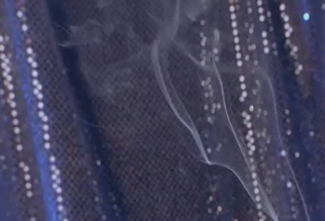

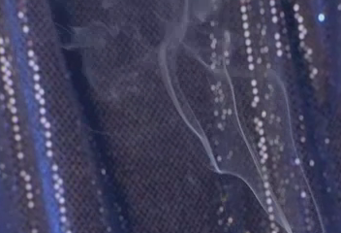
Figure 4: Technicolor Stress sequence, 720x480 (cropped), QP=14 (26). No offsets (top) and alpha_offset = beta_offset = -8 (bottom).

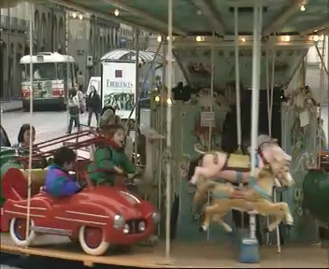
No offsets

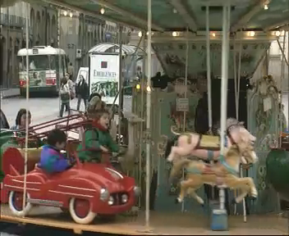
Figure 5: FunFair, CIF, QP=22 (34). No offsets (Top) and alpha_offset = beta_offset = -6 (bottom).

References
- T. Wiegand, Joint Committee Draft (CD), document JVT-C167, JVT of ISO/IEC MPEG & ITU-T VCEG, Fairfax, Virginia, USA, May 6 –10, 2002.
- J. Au, B. Lin, A. Joch and F. Kossentini, “Complexity Reduction and Analysis for Deblocking Filter,” document JVT-C094, JVT of ISO/IEC MPEG & ITU-T VCEG meeting, Fairfax, Virginia, USA, May 6 –10, 2002.
- Teck-Wee Foo, Sheng-Mei Shen, Shinya Kadono, “Revised Downloadable Threshold Tables for Loop-Filter,” document JVT-C111, JVT of ISO/IEC MPEG & ITU-T VCEG meeting, Fairfax, Virginia, USA, May 6 –10, 2002.

JVT Patent Disclosure Form

International Telecommunication Union  Telecommunication Standardization Sector | International Organization for Standardization | International Electrotechnical Commission
 |  | 
Joint Video Coding Experts Group - Patent Disclosure Form
(Typically one per contribution and one per Standard | Recommendation)

Please send to:
JVT Rapporteur Gary Sullivan, Microsoft Corp., One Microsoft Way, Bldg. 9, Redmond WA 98052-6399, USA
Email (preferred): Gary.Sullivan@itu.int Fax: +1 425 706 7329 (+1 425 70MSFAX)

This form provides the ITU-T | ISO/IEC Joint Video Coding Experts Group (JVT) with information about the patent status of techniques used in or proposed for incorporation in a Recommendation | Standard. JVT requires that all technical contributions be accompanied with this form. Anyone with knowledge of any patent affecting the use of JVT work, of their own or of any other entity (“third parties”), is strongly encouraged to submit this form as well.

This information will be maintained in a “living list” by JVT during the progress of their work, on a best effort basis. If a given technical proposal is not incorporated in a Recommendation | Standard, the relevant patent information will be removed from the “living list”. The intent is that the JVT experts should know in advance of any patent issues with particular proposals or techniques, so that these may be addressed well before final approval.

This is not a binding legal document; it is provided to JVT for information only, on a best effort, good faith basis. Please submit corrected or updated forms if your knowledge or situation changes.

This form is not a substitute for the ITU ISO IEC Patent Statement and Licensing Declaration, which should be submitted by Patent Holders to the ITU TSB Director and ISO Secretary General before final approval.

Submitting Organization or Person:
Organization name | UB Video Inc.
Mailing address | 400-1788 West 5th Ave.  Vancouver, B.C., Canada  V6J 1P2
Country | Canada
Contact person | Anthony Joch
Telephone | +1 604 737 2426 .33
Fax | +1 604 737 1514
Email | anthony@ubvideo.com
Place and date of submission
Relevant Recommendation | Standard and, if applicable, Contribution:
Name (ex: “JVT”) |  | JVT
Title |  | Improved Loop Filter Tables and Variable-Shift Table Indexing
Contribution number |  | JVT-D038

(Form continues on next page)

Disclosure information – Submitting Organization/Person (choose one box)
2.0 The submitter is not aware of having any granted, pending, or planned patents associated with the technical content of the Recommendation | Standard or Contribution.

or,
The submitter (Patent Holder) has granted, pending, or planned patents associated with the technical content of the Recommendation | Standard or Contribution. In which case,

 | 2.1 The Patent Holder is prepared to grant – on the basis of reciprocity for the above Recommendation | Standard – a free license to an unrestricted number of applicants on a worldwide, non-discriminatory basis to manufacture, use and/or sell implementations of the above Recommendation | Standard.
2.2 The Patent Holder is prepared to grant – on the basis of reciprocity for the above Recommendation | Standard – a license to an unrestricted number of applicants on a worldwide, non-discriminatory basis and on reasonable terms and conditions to manufacture, use and/ or sell implementations of the above Recommendation | Standard.

Such negotiations are left to the parties concerned and are performed outside the ITU | ISO/IEC.
X | 2.2.1 The same as box 2.2 above, but in addition the Patent Holder is prepared to grant a “royalty-free” license to anyone on condition that all other patent holders do the same.
2.3 The Patent Holder is unwilling to grant licenses according to the provisions of either 2.1, 2.2, or 2.2.1 above. In this case, the following information must be provided as part of this declaration:
- patent registration/application number;
- an indication of which portions of the Recommendation | Standard are affected.
- a description of the patent claims covering the Recommendation | Standard;
In the case of any box other than 2.0 above, please provide the following:
Patent number(s)/status
Inventor(s)/Assignee(s)
Relevance to JVT
Any other remarks:
(please provide attachments if more space is needed)

(form continues on next page)
Third party patent information – fill in based on your best knowledge of relevant patents granted, pending, or planned by other people or by organizations other than your own.

Disclosure information – Third Party Patents (choose one box)
X | 3.1 The submitter is not aware of any granted, pending, or planned patents held by third parties associated with the technical content of the Recommendation | Standard or Contribution.
 | 3.2 The submitter believes third parties may have granted, pending, or planned patents associated with the technical content of the Recommendation | Standard or Contribution.
For box 3.2, please provide as much information as is known (provide attachments if more space needed) - JVT will attempt to contact third parties to obtain more information:

3rd party name(s)
Mailing address
Country
Contact person
Telephone
Fax
Email
Patent number/status
Inventor/Assignee
Relevance to JVT

Any other comments or remarks:

