Joint Video Team (JVT) of ISO/IEC MPEG & ITU-T VCEG  (ISO/IEC JTC1/SC29/WG11 and ITU-T SG16 Q.6)  3rd Meeting: Fairfax, Virginia, USA, 6-10 May, 2002 | Document: JVT-C120  Filename: JVT-C120.doc

Title: | B picture coding for sequence with repeating scene changes
Status: | Input Document to JVT
Purpose: | Proposal
Author(s) or  Contact(s): | Byeong-Moon Jeon  16 Woomyeon-Dong, Seocho-Gu, Seoul 137-724, Korea | Tel:  Email: | 82-2-526-4415  jeonbm@lge.com
Source: | LG Electronics Inc.
_____________________________
1. Intrroduction

In many video applications, a scene or part of the scene may appear repeatedly such as in news, sports broadcasting, a close-up conversation like interview, and multi-point video conferencing. Such a change in the video scene will cause the scene cut picture to be encoded in Intra picture mode or the partial scene-change picture to create a large number of Intra coded macroblocks. Because the Intra mode will normally require much higher bit consumption, it can cause a burst of increased bit rate and this problem will be particularly significant in low bit rate application. As a way to absorb such a burst of bit rate, the rate control mechanism has been applied but it can result in a sharp drop in image quality and create unpleasant visual effects. Instead, the current JVT model employing long-term buffer scheme can significantly improve the coding efficiency when there is multiple repeating scene changes in the sequence. That is, for a scene cut picture or a partial scene-change picture, the long-term picture belonging to the same scene group will be used as a normal reference picture in addition to multiple short-term pictures so that Inter mode will be selected as a coding mode instead of Intra mode and it helps avoiding a burst of bit rate. Those long-term pictures are pictures that initially turned out to be a scene cut picture or a partial scene-change picture by a scene-change detector in encoder side and were encoded in Intra picture mode for scene cut picture and in Intra MB mode for partial scene-change region and finally were stored in long-term buffer by MMCO command.

It is known that B pictures generally improve the overall compression efficiency as compared to that of P pictures. Especially, a direct mode is dominant at low bit rate because it does not require any side information, whereas a bi-directional mode is dominant at high bit rate because the performance at high bit rate depends on the efficiency of the residual coding and the bi-directional mode can provide the more accurate prediction.

Now, consider that B picture is inserted when the sequence with repeating scene changes is coded. If the co-located macroblock in the temporally subsequent picture uses the long-term picture for the prediction, the remaining issue is how to get the forward and backward motion vectors of the direct mode because the temporal distances TR_{B} and TR_{D} in the conventional equations in WD2 are no longer appropriate. This document proposes how to derive the forward and backward motion vectors of the direct mode, when there is a scene change between the most recent previous picture and the temporally subsequent picture and the motion vector in the corresponding macroblock in the subsequent picture was obtained from a long-term picture.

2. Motion vectors in direct mode

In WD2, the forward and backward motion vectors of direct mode (MV_{F} and MV_{B}) are computed as
MV_{F} = TR_{B} x MV / TR_{D}
MV_{B} = (TR_{B} -TR_{D} ) x MV / TR_{D}
where MV represents the forward motion vector in the corresponding macroblock of the subsequent picture, TR_{B} is the temporal distance between the current B picture and the reference picture pointed by MV and TR_{D} is the temporal distance between the subsequent picture and the reference picture pointed by MV. These equations imply that the approximation of MV_{F} and MV_{B} is based on the fact that the inserted B picture will keep the movement between the reference picture pointed by MV and the subsequent picture and thus MV_{F} and MV_{B} are scaled versions of MV using TR_{B} and TR_{D}. However, if there is a scene change between the temporally previous picture and the subsequent picture, there are a large number of pictures in the different scene groups between the long-term picture and the subsequent picture, wherein both of them belong to the same scene group. Therefore, in the case that the subsequent picture uses the long-term picture for the forward prediction, the temporal distances TR_{B} and TR_{D} should not be calculated just by subtracting of TR of the long-term picture from TR of the subsequent picture. In effect, it is impractical to calculate the exact temporal distances TR_{B} and TR_{D} because TR is a 8-bit number with 256 possible values and we do not know how many repeating cycles between two TR’s exist. Therefore, we need to redefine the way to calculate the forward and backward motion vectors of direct mode only when the corresponding macroblock of the subsequent picture has a forward motion vector obtained from the long-term picture.

Our solution is as follows; The same long-term picture as the subsequent picture used for forward prediction is used as reference picture for the current B picture coding and especially MV_{F} and MV_{B} of direct mode are approximated to MV and 0 under considering that there is a strong correlation between B picture and the subsequent picture.
MV_{F} = MV
MV_{B} = 0

If a B picture does not belong to the scene group to which the subsequent picture belongs, our solution does not affect coding efficiency of the B picture because the prediction block calculated from direct mode does not match the original block well and so the direct mode will not be selected as the prediction mode. On the other hand, if a B picture belongs to the same scene group as the subsequent picture does, then direct mode has a high probability to be selected as the prediction mode because it provides lots of bit savings although the prediction block suffers from a little bit quality degradation due to the approximated motion vectors.

For instance, Figure 1 shows there are multiple repeating scene changes in the sequence and two B pictures are inserted. Assume that the size of the forward reference set is 5 and scene cut pictures (I0 and P50) and partial scene-change picture (P120) are already stored in long-term buffer by MMCO operation. P200 is coded before B198 and B199 according to the coded order. At encoder side, the scene-change detector indicates P200 is a scene cut picture and thus P200 uses one long-term picture(P50) and four short-term pictures as forward reference pictures, in which the relative index order is achieved by RMPNI command. After P200 is coded, B198 and B199 are coded under knowing that there is a scene change at the subsequent picture and it used long-term picture for forward prediction. Thus, B198 and B199 have to include the long-term picture into forward reference set. However, it is clear that most of macroblcoks in B198 will select forward mode from the short-term pictures as an optimal prediction mode because B198 belongs to scene group A whereas P200 belongs to scene group B. On the other hand, some macroblocks in B199 can select the direct mode using the long-term picture as a macroblock coding mode due to the fact that B199 and B200 belong to the same scene group and the direct mode usually provides lots of bit savings at the little cost of quality degradation. Of course, forward mode from the long-term picture, backward mode from the subsequent picture, or bi-directional mode from two reference pictures can be selected as a coding mode in other macroblocks in B199.

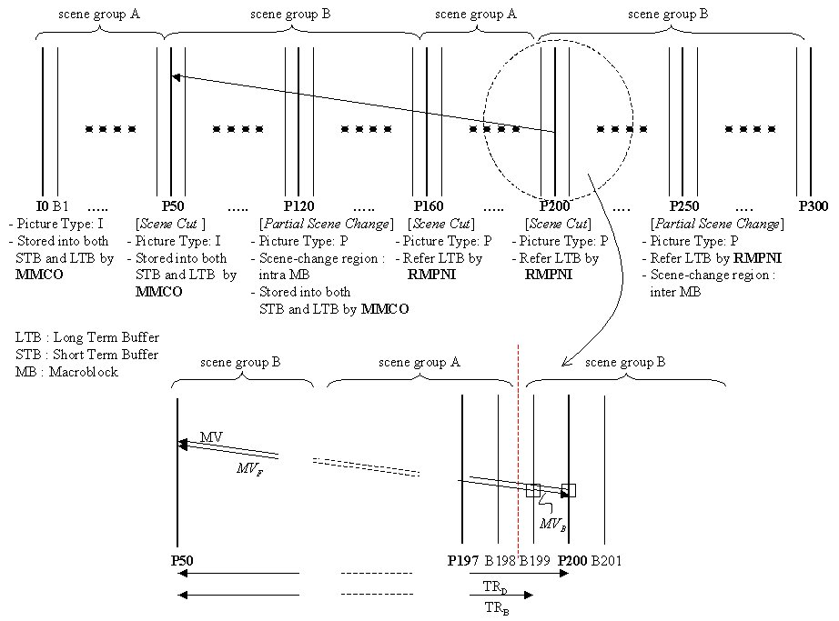
Figure 1. B picture coding for the sequence with repeating scene changes

3. Simulation

Experiments were conducted on a synthetically composed sequence from ‘News’, “Akiyo’, and ‘Foreman’ with QCIF format, in which especially ‘News’ has repeating partial scene changes from two dancers to one dancer at background. And we followed the simulation common conditions of JVT. The followings and Figure 2 show the video clips in the synthesized sequence and the specified pictures in Figure 2 mean scene cut pictures or partial scene-change pictures.
Five 55 pictures : ‘News” with 2 dancers (scene group A)
Five 50 pictures : ‘News’ with 1 dancer (scene group B)
Five 55 pictures : ‘Akiyo’ (scene group C)
Five 50 pictures : ‘Foreman’ (scene group D)

Figure 2. video clips in the synthesized sequence

The current JM2.0 software still includes the bugs regarding RMPNI and MMCO operations in encoder, so we fixed those bugs and tested. For the reference, Figure 3 depicts the number of bits per picture in IPPP pattern with and without the long-term buffer in order to confirm the advantage of the long-term buffer scheme. Figure 3 clearly shows that the scene cut pictures and the partial scene-change pictures are associated with a sudden increase in the number of bits and the use of the long-term picture can significantly reduce the number of bits consumed for a repeating scene change.

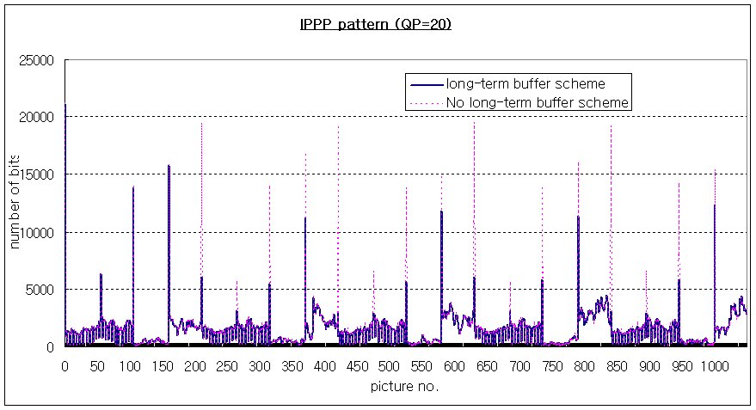
Figure 3. Number of bits per picture for IPPP pattern (QP=20)

In order to prove the benefits of the proposed B picture coding method in practice and also to show the influence of the direct mode using the long-term picture, we inserted 1, 2, and 3 B pictures (i.e., IBPBP, IBBP, IBBP patterns) and compared the R-D performances of only some B pictures by setting the direct mode using the long-term picture ON and OFF, wherein there is an actual scene change in those B pictures and thus they are capable of selecting the direct mode using the long-term picture that the subsequent picture used. The reason to exclude the results of the other I, P, and B pictures except the B pictures with an actual scene change from the comparison is that their results are identical in all two cases. Table 1 gives the objective difference between RD curves using avsnr software and the results show that the B picture coding with direct mode using the long-term picture can improve the coding efficiency significantly when compared with B picture coding without direct mode using long-term picture. This benefit is derived from the fact that the selection of the direct mode using the long-term picture provides significant bit saving at the little cost of quality degradation. From Figure 4, 5, and 6, you can find the gains obtained from the direct mode using long-term picture increase gradually as the bit rate decreases.

 | Bit rate | DPSNR
IBP pattern | -17.26% | 1.645 dB
IBBP pattern | -9.37% | 0.664 dB
IBBBP pattern | -18.23% | 2.169 dB
Table 1. Difference between setting direct mode using long-term picture ON and OFF

Figure 4. IBPBP

Figure 5. IBBP pattern

Figure 6. IBBBP pattern

4. Proposed changes in WD2

11.4.2 Motion vectors in direct mode

(Additional case)

Case 5: The collocated MB has a forward motion vector obtained from a long-term picture

There are multiple repeating scene changes in the sequences such as news, sports broadcasting, a close-up conversation, and multi-point video conferencing and the multiple reference picture prediction employing the long-term buffer scheme provides the improved coding efficiency for those sequences.
When the collocated MB in the temporally subsequent reference picture has a forward motion vector obtained from a long-term picture that belongs to the same scene group, it is impractical to calculate the exact temporal distances TR_{B} and TR_{D} because there are a large number of pictures in the different scene groups between the long-term picture and the subsequent reference picture and particularly TR is a 8-bit number with 256 possible values.
In this case, the long-term picture used for the collocated MB in the subsequent reference picture is used as a forward reference picture for the direct mode and the forward and backward MVs for the direct mode are calculated as the forward MV of the collocated MB and 0 respectively, because there is a strong correlation between B picture and the subsequent reference picture.

MV_{F} = MV
MV_{B} = 0

(Append for Proposal Documents)

JVT Patent Disclosure Form

International Telecommunication Union  Telecommunication Standardization Sector | International Organization for Standardization | International Electrotechnical Commission
 |  | 
Joint Video Coding Experts Group - Patent Disclosure Form
(Typically one per contribution and one per Standard | Recommendation)

Please send to:
JVT Rapporteur Gary Sullivan, Microsoft Corp., One Microsoft Way, Bldg. 9, Redmond WA 98052-6399, USA
Email (preferred): Gary.Sullivan@itu.int Fax: +1 425 706 7329 (+1 425 70MSFAX)

This form provides the ITU-T | ISO/IEC Joint Video Coding Experts Group (JVT) with information about the patent status of techniques used in or proposed for incorporation in a Recommendation | Standard. JVT requires that all technical contributions be accompanied with this form. Anyone with knowledge of any patent affecting the use of JVT work, of their own or of any other entity (“third parties”), is strongly encouraged to submit this form as well.

This information will be maintained in a “living list” by JVT during the progress of their work, on a best effort basis. If a given technical proposal is not incorporated in a Recommendation | Standard, the relevant patent information will be removed from the “living list”. The intent is that the JVT experts should know in advance of any patent issues with particular proposals or techniques, so that these may be addressed well before final approval.

This is not a binding legal document; it is provided to JVT for information only, on a best effort, good faith basis. Please submit corrected or updated forms if your knowledge or situation changes.

This form is not a substitute for the ITU ISO IEC Patent Statement and Licensing Declaration, which should be submitted by Patent Holders to the ITU TSB Director and ISO Secretary General before final approval.

Submitting Organization or Person:
Organization name | LG Electronics Inc.
Mailing address | 16 Woomyeon-Dong, Seocho-Gu,  Seoul 137-724, Korea
Country | Korea
Contact person | Byeong-Moon Jeon
Telephone | 82-2-526-4415
Fax | 82-2-3461-1347
Email | jeonbm@lge.com
Place and date of submission | Seoul, Korea, May 1st 2002
Relevant Recommendation | Standard and, if applicable, Contribution:
Name (ex: “JVT”) |  | JVT
Title |  | B picture coding for sequence with repeating scene changes
Contribution number |  | JVT-C120

(Form continues on next page)

Disclosure information – Submitting Organization/Person (choose one box)
2.0 The submitter is not aware of having any granted, pending, or planned patents associated with the technical content of the Recommendation | Standard or Contribution.

or,
The submitter (Patent Holder) has granted, pending, or planned patents associated with the technical content of the Recommendation | Standard or Contribution. In which case,

2.1 The Patent Holder is prepared to grant – on the basis of reciprocity for the above Recommendation | Standard – a free license to an unrestricted number of applicants on a worldwide, non-discriminatory basis to manufacture, use and/or sell implementations of the above Recommendation | Standard.
2.2 The Patent Holder is prepared to grant – on the basis of reciprocity for the above Recommendation | Standard – a license to an unrestricted number of applicants on a worldwide, non-discriminatory basis and on reasonable terms and conditions to manufacture, use and/ or sell implementations of the above Recommendation | Standard.

Such negotiations are left to the parties concerned and are performed outside the ITU | ISO/IEC.
2.2.1 The same as box 2.2 above, but in addition the Patent Holder is prepared to grant a “royalty-free” license to anyone on condition that all other patent holders do the same.
2.3 The Patent Holder is unwilling to grant licenses according to the provisions of either 2.1, 2.2, or 2.2.1 above. In this case, the following information must be provided as part of this declaration:
- patent registration/application number;
- an indication of which portions of the Recommendation | Standard are affected.
- a description of the patent claims covering the Recommendation | Standard;
In the case of any box other than 2.0 above, please provide the following:
Patent number(s)/status
Inventor(s)/Assignee(s)
Relevance to JVT
Any other remarks:
(please provide attachments if more space is needed)

(form continues on next page)
Third party patent information – fill in based on your best knowledge of relevant patents granted, pending, or planned by other people or by organizations other than your own.

Disclosure information – Third Party Patents (choose one box)
3.1 The submitter is not aware of any granted, pending, or planned patents held by third parties associated with the technical content of the Recommendation | Standard or Contribution.

3.2 The submitter believes third parties may have granted, pending, or planned patents associated with the technical content of the Recommendation | Standard or Contribution.

For box 3.2, please provide as much information as is known (provide attachments if more space needed) - JVT will attempt to contact third parties to obtain more information:

3rd party name(s)
Mailing address
Country
Contact person
Telephone
Fax
Email
Patent number/status
Inventor/Assignee
Relevance to JVT

Any other comments or remarks:

