INTERNATIONAL TELECOMMUNICATION UNION |  | IPTV-GSI
TELECOMMUNICATION  STANDARDIZATION SECTOR  STUDY PERIOD 2009-2012 |  | IPTV-GSI-C-520
English only
Original: English
Question(s): | 13/16 | Pune, 13-17th December, 2010
CONTRIBUTION
Source: | Cisco Systems
Title: | Addition of Appendix VI-4 “AMF Configuration Example” to AM.0
- Abstract
This contribution adds Appendix VI-4 “Configuration Example” to AM.0
- Proposals
- It is proposed to add a service independent configuration example as an appendix; which is aligned with the revised AMF configuration clause 12.1.2. Configuration of audience measurement functions.
Note that this uses only metadata from AM0. Further development of this appendix is needed.
- Add the following reference to the end of clause 12.1.2 to this appendix. “Examples of the following configuration constructs are provided in appendix VI-4.”

VI-4 AMF Configuration Example

Clause 12.1.2. “Configuration of audience measurement functions” details the configuration of AMFs. This appendix includes a configuration example which uses the constructs of clause 12.1.2. It uses metadata names and simplified values rather than actual formatted values to aid understanding.

This configuration example uses five measurement requests, it features:
- Configuration based user permission (per clause 6.5.2.1 ) , which addresses the AMFs within STBs of subscribers who permit measurement with reporting of viewing events and context, identifiable user, with user profile (per Table 2, permission level 5).
- The first measurement request (example1a) features
  - Linear service measurement (* for service specific detailed parameters to be measured see AM1)
  - Metadata to be reported includes
    - Service type ( ** for service specific detailed parameters to be reported see AM1), contentId, contentIdType, sampleTime
    - Events of video resize with parameters
    - User ID with method and confidence parameters, user presence confidence with parameter of user presence method, and current location
  - Event plus time driven sampling every 5 mins between 2pm-11pm,
  - Time driven sampling every 10 mins between 11pm – 2pm
  - AMF reporting upon event or every 10 minutes, with random offset, even if null data reported
  - AMF report retransmitting up to 5 additional times following non-acknowledgement from aggregation functions.
  - Measurements will be stored if the AMF misses the reporting time point in a periodic schedule.
- A second measurement request (example1b) to configure additional reporting of slowly changing data features
  - End user device configuration, IPTV provider (as set by measurement request), and IPTV package subscription (as set by measurement request), biographic (as set by end user) and residential elements (as set by end user)
  - Audience segment identifier (as set by measurement request)
  - AMF reporting every 8 hours, or on-demand, with identical reporting parameters for optional report aggregation with data from other measurement requests by AMF for mission 1.
  - Measurements will be stored if the AMF misses the reporting time point in a periodic schedule
  - Lower priority relative to other measurement requests, which in the case of insufficient storage will lead to data associated with this measurement request being discarded before that of the other measurement requests
  - Empty (null) reports are not sent
- A third and fourth measurement request (example1c and example1d) are similar to example1a but addressed to more targeted audiences which additionally cause the reporting of
  - One of two audience segment identifiers (as set by measurement requests) between 8pm-11pm
- A fifth measurement request (example1e) for measurement of events during user engagement with specific content across multiple services (linear and customer pvr)
- Data reported due to three measurement requests (example1a, and its minor variations of example1c and example1d) are associated with two missions, whereas reports of one measurement request (example1b) is associated with one of those missions.
- Data reported due to one measurement request (example1e) is associated with a separate single mission.
- In this configuration example, the three measurement requests example1a, example1b and example1e could be addressed to all audience segments, whereas example1c would be addressed to one audience segment and example1d would be addressed to the other.

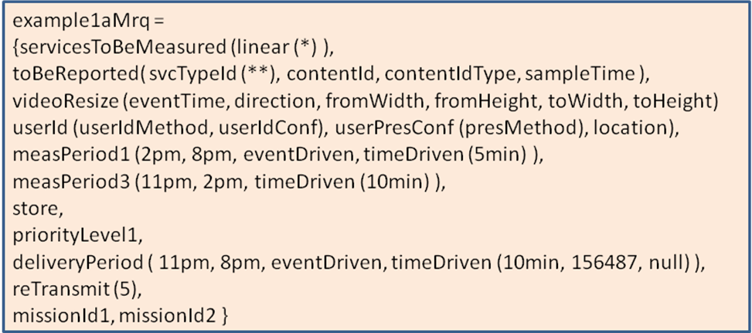
Figure VI-4.1a – Example measurement request 1a

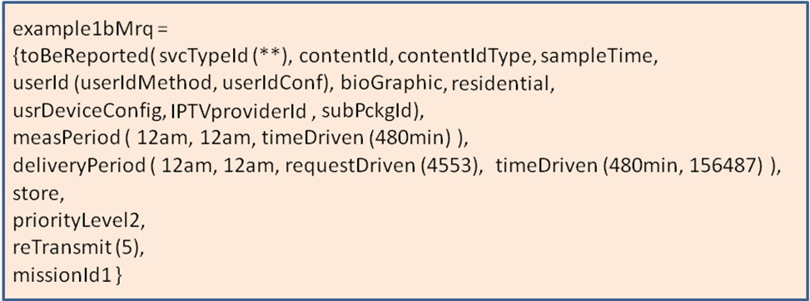
Figure VI-4.1b – Example measurement request 1b, for slowly changing data

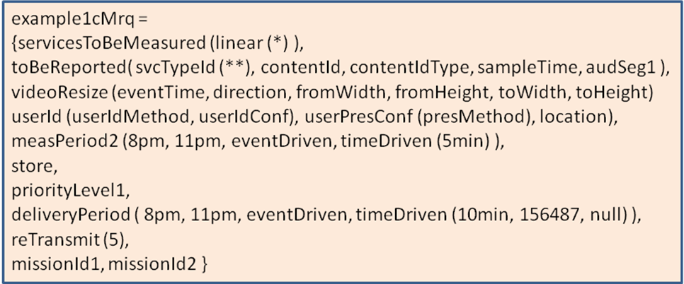
Figure VI-4.1c – Example measurement request 1c, special time period and audience segment 1

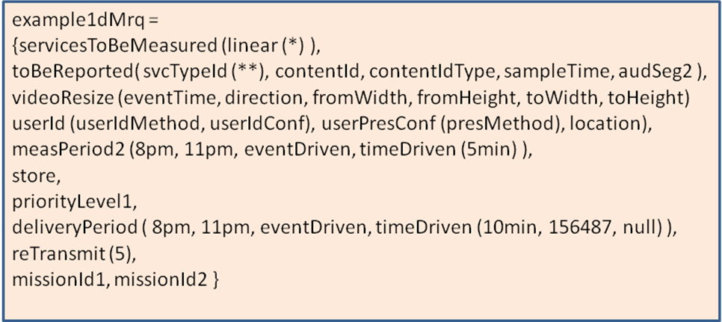
Figure VI-4.1d – Example measurement request 1d, special time period and audience segment 2

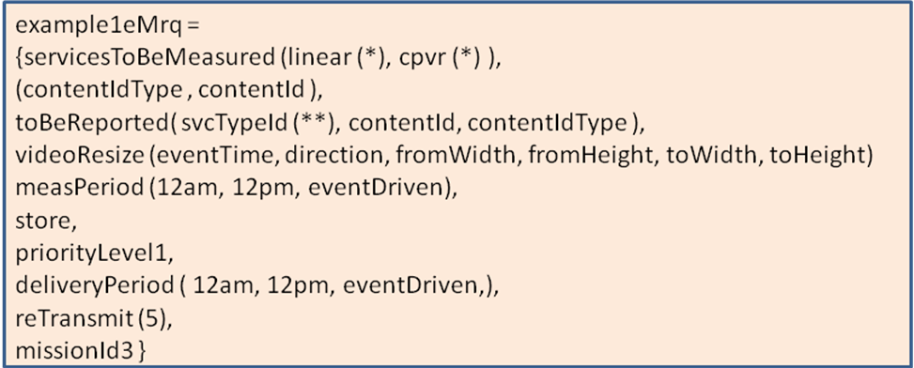
Figure VI-4.1e – Example measurement request 1e, for specific content across services

___________________

