|  |  |  |
| --- | --- | --- |
| INTERNATIONAL TELECOMMUNICATION UNION | | **IPTV-GSI** |
| **TELECOMMUNICATION STANDARDIZATION SECTOR**  STUDY PERIOD 2009-2012 | | **IPTV-GSI-C-517** |
| **English only**  **Original: English** |
| **Question(s):** | 13/16 | Pune, india, 13-17 December 2010 |
| **CONTRIBUTION** | | |
| **Source:** | ETRI | |
| **Title:** | Proposal on modification of procedure for IPTV terminal in HSTP.IPTV-CRTD | |

# Introduction

The draft Recommendation HSTP.IPTV-CRTD “Configuration procedure for retail IPTV terminal devices” describes provisioning procedure of IPTV terminal device for IPTV service.

In HSTP.IPTV-CRTD clause 9 describes procedures for adoption of retail IPTV terminal device. We propose to add more detail text for each procedure and add figures for IPTV procedure steps.

# 2. Proposal

As described in the introduction part, this contribution proposes modification of clause 9 part as follows :

* Add some figures in clause 9
* Add text and figure in clause 9.2
* Add text in clause 9.3

1. Procedures for adoption of retail IPTV Terminal Device

The IPTV TD is recommended to support provisioning when it is attached to an IP network environment. The provisioning is to perform initial IPTV TD configuration and diagnostic tests, and download software via the remote Provisioning Server. Provisioning procedure of IPTV TD is as follows.



Figure1 Proposed Provisioning Procedure of IPTV Terminal Device

* Step 0 is the basic step and pre-configuration. It configures a physical IPTV TD and may perform self-diagnostic tests. In this step, it may be performed manually input by user.
* Step 1 is Network Attachment. In this step, TD gets IP address and attach to the network.
* Step 2 is Service Provider Discovery and Selection. TD gets available IPTV service provider information.
* Step 3 is Service Provider Attachment. TD attaches to and interacts with SP. In this step, it is needed to authorize the client. TD shall get provisioning server information.
* Step 4 is IPTV TD configuration. First TD attached to the provisioning server. TD request configuration information with TD attributes – manufacturer, memory resource, etc. Using configuration information, TD downloads S/W and setup TD.

Service Discovery is the process by which a TD receives the necessary data elements which enable the TD to access the available IPTV Services. That is out of scope of this document. Service discovery is described in H.770.

It is possible that each step has multiple alternatives and the detailed methods will be discussed.

Figure 2 shows example of IPTV terminal provisioning procedure for IPTV services. Figure 3 show more detailed procedure of figure 1.

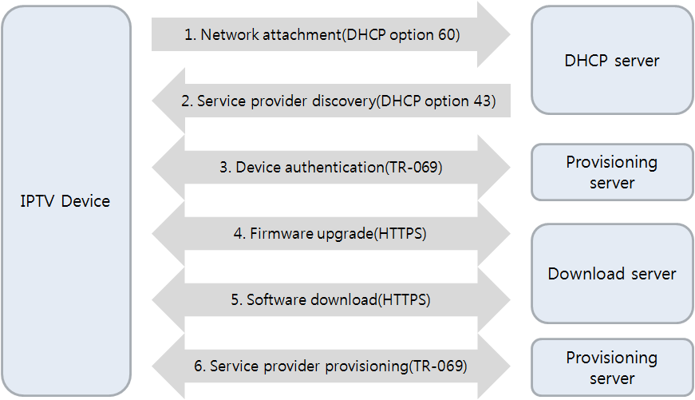

Figure 2. IPTV terminal provisioning procedure

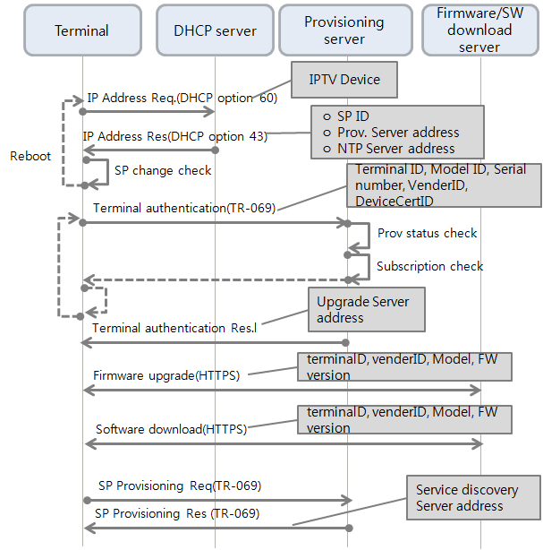

Figure 3. Detailed IPTV terminal provisioning procedure

* 1. Setup and Preconfiguration

This phase is the basic step and pre-configuration. It configures a physical IPTV TD and may perform self-diagnostic tests. In this step, it may be performed manually input by user.

* 1. Network Attachment

This phase is Network Attachment. In this step, TD gets IP address and attach to the network.

IPTV terminal network attachment refer to the activities associated with the IPTV terminal device establishing Layer 3 connectivity to the an IP network and obtaining network configuration data.

Figure 4 shows how to obtaining IP address and network configuration data.



Figure 4. IPTV terminal network attachment

During the network attachment step the following information can be obtained :

1. IPv4 address, network mask, default route.
2. Service Provider provisioning server address.
   1. Service Provider Discovery and Selection

This Phase is Service Provider Discovery and Selection. TD gets available IPTV service provider information.

* + 1. Service Provider Discovery

Using DHCP Container and TR-069 protocol, IPTV terminal device attach service provider information. Service provider information is follows.

* Service Provider Provisioning Service Sever Address (required)
* Service Provider ID (optional)
* Service Provider description(optional)
* NPT Server address (optional)
  + 1. Service Provider Selection
  1. Service Provider Attachement

This phase is Service Provider Attachment. TD attaches to and interacts with SP. In this step, it is needed to authorize the client. TD shall get provisioning server information.

* + 1. Terminal Device Sign-On

Included in the IPTV TD Sign-On is the following set of parameters:

* Terminal Device ID
* Manufacturer ID
* Device Model
* Mac Address

In order for the Service Provider to authorize the TD, the TD must sign on and authenticate with the SP associated initial provisioning information for Service Discovery and IPTV Application servers attachment.

________________