INTERNATIONAL TELECOMMUNICATION UNION |  | IPTV-GSI
TELECOMMUNICATION  STANDARDIZATION SECTOR  STUDY PERIOD 2009-2012 |  | IPTV-GSI-C-507
English only
Original: English
Question(s): | 13/16 | Pune, India, 13-17 December 2010
CONTRIBUTION
Source: | ETRI
Title: | Update of appendix VI for H.IPTV-WBTM, “Web-based Terminal Middleware for IPTV”

Background
From the last meetings, appendix of draft recommendation of H.IPTV-WBTM is described for IDL(Interface Description Language) description of WBTM, and made an additional suggestion for more informative description with an example program of WBTM implementation how WBTM capabilities can be shown in appendix VI.

Now we think that appendix VI is necessary to show an example of WBTM implementation, which gives understanding how WBTM can be running in terminal device as a case.
But, it needs to confine with more simple demonstration example for WBTM working environment, because this is enough informative to show how WBTM is working.

Last meeting comment:
[Editor’s note: This appendix need to modify with simple IDL code and need to remove HTML coding for less confusion. And, it was suggested that the JavaScript code should be modified as in an abstract language.]

Proposal
This contribution is modification of appendix 6 for draft Recommendation H.IPTV-WBTM.

(Proposal)
Appendix VI
An implementation example for WBTM with IDL

This example is an implementation case and shows how WBTM can be working on terminal device.

- Case 1: Interface List of WBTM
This example shows overall function list to support interactive IPTV applications, which are composed of WBTM.

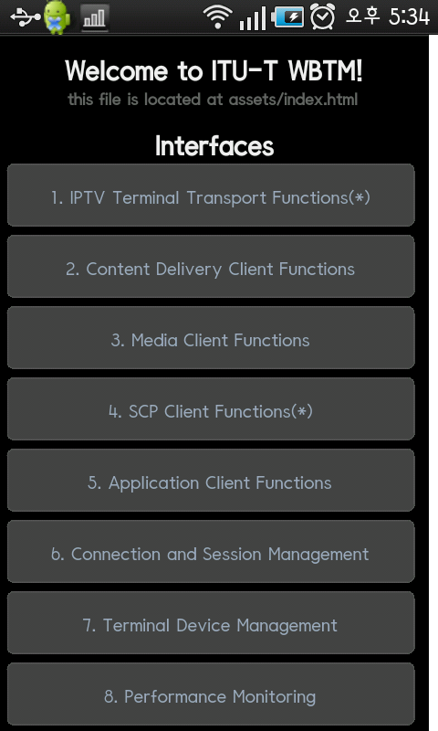

- Case 2: Media Client Functions interfaces for WBTM
This example shows for media client, which supports media related information.
Below is the html code and script for the media client function.
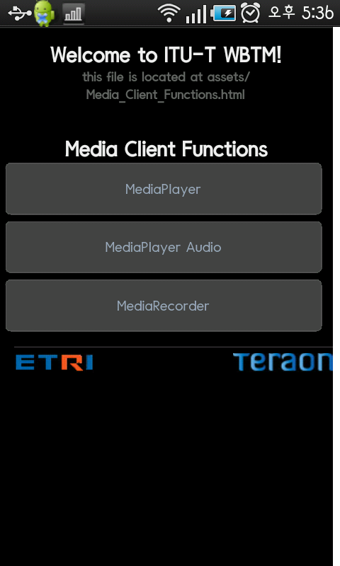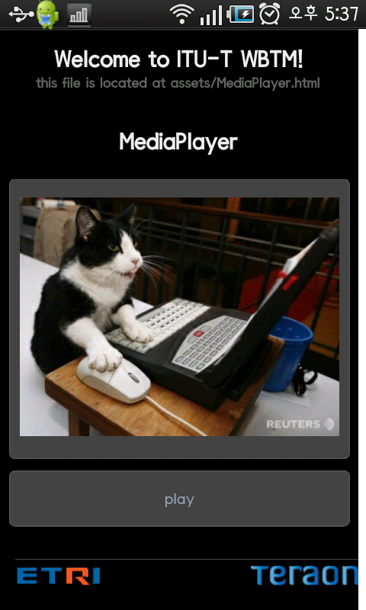

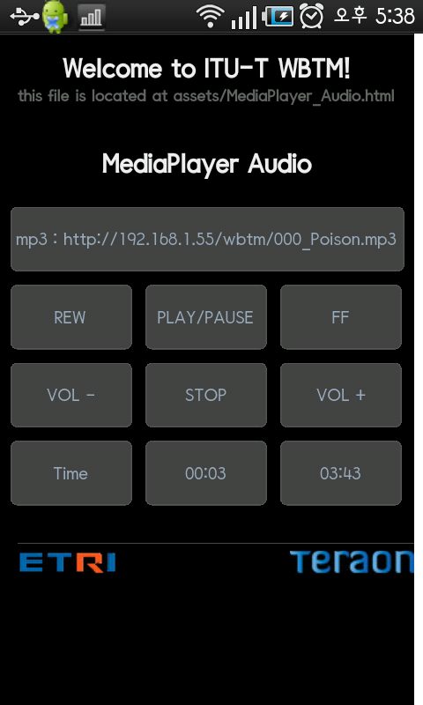

function play() //AudioPlayer play
{
MediaPlayer.play();
}

function pause() //Pauses playback
{
MediaPlayer.pause();
}

function stop() //AudioPlayer stop
{
MediaPlayer.stop();
}

function start() //AudioPlayer stop
{
AudioPlayer.audioPlay();
duration();
}

function stop() //AudioPlayer stop
{
on = 1;
AudioPlayer.audioStop();
}

function FF() //AudioPlayer fast-foward (5 seconds)
{
AudioPlayer.audioFF();
}

function REW() //Audioplayer rewand (5 seconds)
{
AudioPlayer.audioREW();
}

function volumeUp( ) //Sets Audio Volume up

{
AudioPlayer.audioVolumeUp();
}

function volumeDown() //Sets Audio Volume down
{
AudioPlayer.audioVolumeDown();
}

function audioPath(arg) //the audiopath of the file
{
AudioPlayer.audioPath(arg);
}

function gerDuration() //Get the duration of the file
{
time = String(AudioPlayer.audioDuration());
}

function getCurrentPosition() //Get the current playback position
{
time = String(AudioPlayer.audioCurrentPosition());
}

______________

