INTERNATIONAL TELECOMMUNICATION UNION |  | IPTV-GSI
TELECOMMUNICATION  STANDARDIZATION SECTOR  STUDY PERIOD 2009-2012 |  | IPTV-GSI-C-501
English only
Original: English
Question(s): | 13/16 | Pune, 13-17 December 2010
CONTRIBUTION
Source: | Huawei Technologies
Title: | H.IPTV-AM.0: Editorial comments
Background
In the previous meeting, many elements have been added and inconsistencies have been introduced in H.IPTV-AM.0.

Summary
This contribution proposes a number of editorial modifications along the draft text of H.IPTV-AM.0.

Proposal 1
Existing figure in section " 6.1 Audience measurement as an application event handling"
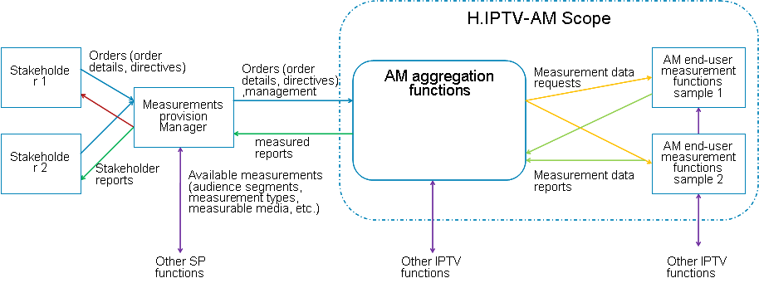
Point 1: Since the beginning of ITU-T IPTV Recommendations, it has been decided to put always end user on left and content provider on right. This figure should be modified to follow the common rule.
Point 2: This figure needs to be aligned with the following figure in section " 16 Reference points in audience measurement" concerning Aggregation function outside interfaces C2 and C3, in particular the interface between "Aggregation function" and "content provider":
Alignement with the following figure in section "17.7 VI-1 Deployment considerations of End-User Measurement Functions and aggregation functions" is also necessary.
Point 3: the purple arrows seem to imply that there is a relation between the two related entities and in fact they indicate that there are similar entities but with no relation. If it is the case they should be removed or a clarification should be added or names of the related entities should be more explicit if there are real relations between these entities. Maybe we should have dotted arrow to link similar entities or blocks. For example for the arrow between "Aggregation function" and "Other IPTV functions" what are these IPTV functions? as we have also "Other IPTV functions" for the next arrow.
Point 4: what means "sample" in "AM measurement function"?
Point 5: Interface between "Aggregation function" and "Content provider" is missing on the figure and should be added. Not all content providers will relate to "Aggregation function" through another entity.
Point 6: it is preferable to have separate recommendations for the outside interface of the aggregation function and the internal interface as we have for the IPTV services themselves with a recommendation for the content provider interface and one for the terminal. So to make this clear it is proposed to reduce the area of the AM scope not to cut the outside interface but to cut the aggregation function as follows:
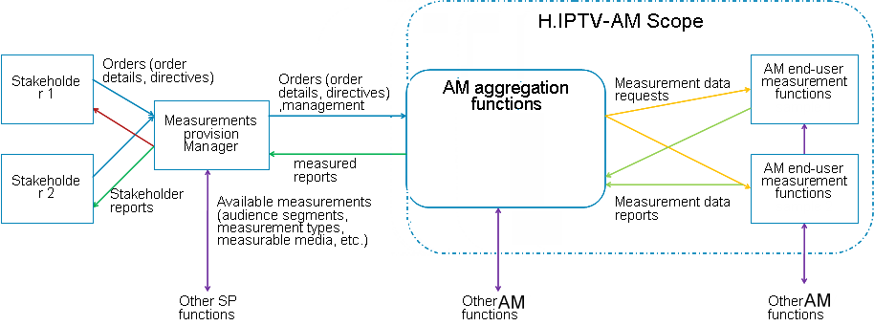

Proposal 2.
Existing text in section "8.3.3 Timing of requests"
- Request by end-user via IPTV services to change permissions
It is proposed to replace this text by:
- Request by end-user via IPTV services to change permissions

Proposal 3.
Existing text in section "8.3.4 Method of requests " requires clarification, in particular green-highlighted part
Requests for user permission are recommended to be asked over an IPTV service. The language and format of the request is recommended to be selected to match the user and device.

Proposal 4.
Figure in section"9 Audience measurement functional architecture" below requires clarification on
- the meaning of dotted lines around some functional blocks.
- definition in the draft Rec. of what is a "Measurement object" is required

Proposal 5.
Existing text in section "10.1 Requirements for audience measurement data requests and configuration packages"
[AMR-01] The audience measurement requests are recommended to identify the IPTV terminal devices which are requested to make audience measurements (e.g. all of them, selected IPTV terminal devices, randomly selected terminal devices, etc.)
It is proposed to replace this text by:
[AMR-01] The audience measurement data requests (if broadcast or multicast to all devices) are recommended to identify the IPTV terminal devices which are requested to make audience measurements (e.g. all of them, selected IPTV terminal devices, randomly selected terminal devices, etc.)

Proposal 6.
Existing text in section "10.1 Requirements for audience measurement data requests and configuration packages"
[AMR-03] The audience measurement requests and configuration packages are recommended to identify the elements to be measured (e.g. channel identifier for linear TV, content identifier for VoD, etc.) and/or a measurement profile with more or less private elements with end-user permission
It is proposed to replace this text by:
[AMR-03] The audience measurement requests and configuration packages are recommended to identify the elements to be measured (e.g. channel identifier for linear TV, content identifier for VoD, etc.) and/or a measurement profile with more or less private elements with end-user permission

Proposal 7.
Existing text in section "10.1 Requirements for audience measurement data requests and configuration packages"
[AMR-06] The traffic generated by the audience measurement requests can optionally not depend on the number of connected audience measurement devices.
It is proposed to replace this text by:
[AMR-06] The traffic generated by the audience measurement requests can optionally not depend on is recommended not to be proportional to the number of connected audience measurement devices.

___________

