INTERNATIONAL TELECOMMUNICATION UNION |  | IPTV-GSI
TELECOMMUNICATION  STANDARDIZATION SECTOR  STUDY PERIOD 2009-2012 |  | IPTV-GSI-C-500
English only
Original: English
Question(s): | 13/16 | Pune, India, 13-17 December 2010
CONTRIBUTION
Source: | Huawei Technologies
Title: | H.IPTV-AM.0: Data structures for AMF configuration
Background
In H.IPTV-AM.0, metadata elements for AMF configuration are being defined but what is missing is a general picture to show their groupings and relations.

Summary
It is proposed to add a picture of the AMF configuration data elements.

Proposal
It is proposed to insert at the beginning of section "10 Measurement data requests and configuration packages for audience measurement configuration"
===== start of text to be inserted =======
The AMF configuration is based on the combination of a set of measurement requests with a set of user permissions providing what is called an effective measurement configuration illustrated by the following figure.
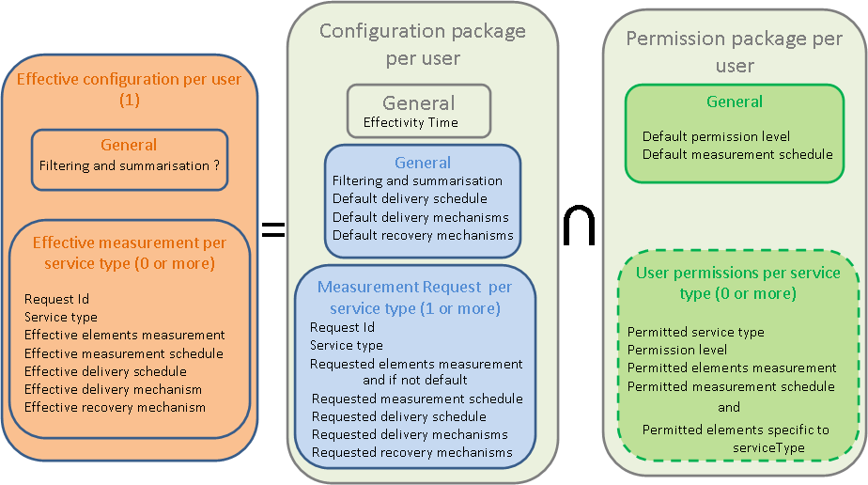
Figure 1-1 - Data structures for AMF configuration

===== end of text to be inserted =======
_____________

