INTERNATIONAL TELECOMMUNICATION UNION |  | IPTV-GSI
TELECOMMUNICATION  STANDARDIZATION SECTOR  STUDY PERIOD 2009-2012 |  | IPTV-GSI-C-493
English only
Original: English
Question(s): | 13/16 | Singapore, 20-27 September 2010
CONTRIBUTION
Source: | Huawei
Title: | Additional text for HSTP.IPTV-AISC, Technical Paper on Access to Internet-Sourced AV Contents
Background
In the previous meeting, a new Technical Paper on "Access to Internet-Sourced AV Contents" was accepted and a first draft was produced.

Summary
This contribution proposes to add a new chapter on the communication modes between IPTV service providers and Internet content providers.

Proposal
It is proposed to insert a new chapter as follows

7. Communication modes between Internet content providers and IPTV service providers
Two communication modes have been identified in the description of the different configurations.
Configurations | Content declaration mode | Content information request mode
Full content integration | A | A
Catalogue integration without content storage | A | A
No Internet content integration at all | NA | A
No integration at all with external browsing | NA | A
Browsing and consumption by two different devices | A | NA
Note: "A" means applicable, "NA" means "Not Applicable".
These two communication modes are described below.

7.1. Content declaration mode
This mode is used by the Internet content provider to declare contents to the IPTV service provider as follows:
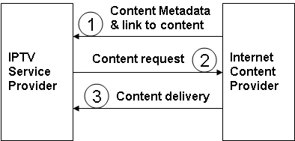
Figure 7.1-1. Exchanges between Internet content provider and IPTV service provider in content declaration mode with integration in the IPTV service provider catalogue

Content metadata may be exhaustive when it is to be used for integration in the content catalogue of the IPTV service provider. It should include content description, content format, etc.
Content metadata may be very limited when Internet content providers just want to inform the IPTV service provider about AV contents which have been selected by end users using another terminal device for consumption by an IPTV terminal device. In this case specific metadata is needed to associate the end user identifier and the selected content and to identify the purpose of the selection (to be viewed, present, recommendation, for information, etc.)
Content metadata may be also very limited when Internet AV contents are not to be integrated in the content catalogue of the IPTV service provider. In this configuration, an additional exchange is necessary to provide a content reference or location to the Internet content provider as illustrated below:
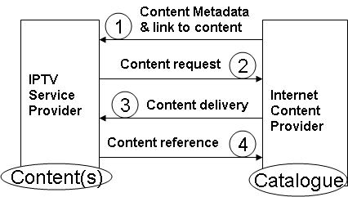
Figure 7.1-2. Exchanges between Internet content provider and IPTV service provider in content declaration mode without integration in the IPTV service provider catalogue

The content request may follow immediately the content declaration from the Internet content provider or be issued later. It may be linked or not to consumer request.
What is to be specified?
- Mechanism for the Internet content provider to send content metadata to the IPTV service provider
- Content metadata for Internet AV content declaration
- Mechanism for the IPTV service provider to acquire the AV content from the Internet content provider
- Mechanism to provide content reference back to the Internet content provider
- Content reference metadata for Internet AV content acquired by the IPTV service platform.

Here are the requirements for these elements.
Requirements for the Mechanism for the Internet content provider to send content metadata to the IPTV service provider
TBD
Requirements for the content metadata for Internet AV content declaration
- content description,
- content format,
- etc.
Requirements for the mechanism for the IPTV service provider to acquire the AV content from the Internet content provider
TBD
Requirements for the mechanism to provide content reference back to the Internet content provider
TBD
Requirements for the content reference metadata for Internet AV content acquired by the IPTV service platform
TBD

7.2. Content information request mode
This mode is used by IPTV service providers wishing to get information from Internet content providers to deliver Internet AV contents with an improved QoS allowed by the IPTV service operation.
In this mode, the IPTV service providers discover Internet AV contents without previous content declaration from the Internet content providers.
Following or anticipating consumer request, the IPTV service provider relates to the Internet content provider to get information about contents for further delivery of these contents to the consumers as appropriate.
To get information about an Internet AV content, the IPTV service provider has to use elements of the URL of the AV content to generate its request to the relevant Internet content provider
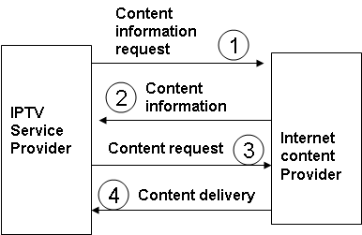
Figure 7.2-1. Exchanges between Internet content provider and IPTV service provider in content information request mode
What is to be specified?
- Mechanism to generate a content information request from the URL of the Internet AV content
- Content information semantics and syntax (should be already specified in the content declaration mode)
- Mechanism for the IPTV service provider to acquire the AV content from the Internet content provider (should be the same as for content declaration mode)

Here are the requirements for these elements.
Requirements for the mechanism to generate a content information request from the URL of the Internet AV content
TBD
Requirements for the content information semantics and syntax
TBD
Requirements for the mechanism for the IPTV service provider to acquire the AV content from the Internet content provider
TBD

_____________

