INTERNATIONAL TELECOMMUNICATION UNION |  | IPTV-GSI
TELECOMMUNICATION  STANDARDIZATION SECTOR  STUDY PERIOD 2009-2012 |  | IPTV-GSI-C-492
English only
Original: English
Question(s): | 13/16 | Singapore, 20-27 September 2010
CONTRIBUTION
Source: | Huawei
Title: | New Scenario for access Internet-sourced contents
Background
In the previous meeting, a new Technical Paper on "Access to Internet-Sourced AV Contents" was accepted and a first draft was produced.

Summary
This contribution proposes to add a new scenario for section 6.5 ( 6.5 Browsing and consumption by two different devices).

Proposal

Browsing and consumption by two different devices
In this configuration, a different device is used to browse the Internet and select an Internet AV content, which will be required later by an IPTV terminal device without having to browse again the Internet.
This is illustrated on the following figure.
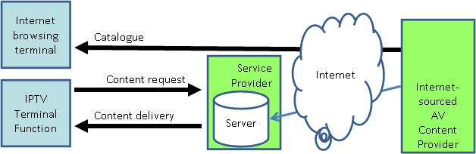
Figure ‎6-1. Architecture for browsing and consumption by two different devices
Scenario 1:
In this configuration, an Internet browsing terminal (e.g. a PC, a mobile phone, etc.) is used to browse the Internet.
Then the end user discovers an AV Content he would like to see on his big home screen using his IPTV terminal device or to send a recommendation to watch to a friend who is also an IPTV customer.
The end user presses a button on the web page from the Internet web site and the web site requests the identification of the IPTV service provider to be used later for content consumption and some additional data (to be defined) to allow simple identification at consuming time.
Later the targeted end user connects its IPTV terminal device and he is immediately informed of an Internet AV content to watch. Some information is available about the content. If he decides to watch it or to record it, he requests this content.
Operation:
In this configuration the content is declared by the Internet AV content provider to the IPTV service provider and the IPTV service provider may decide to get immediately the content (this would allow a better delivery QoS) or to wait for the consumer request for the content.
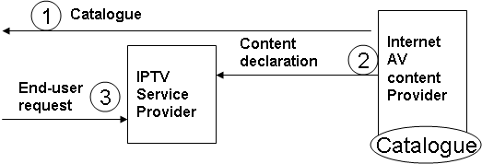
Figure ‎6-2. Exchanges for browsing and consumption by two different devices
Scenario 2:
In this configuration, an Internet browsing terminal (e.g. a PC, a mobile phone, etc.) is used to browse the Internet.
Then the end user discovers an AV Content, and begins to watch it with the Internet browsing terminal (for instance, in the office). After a while, the end user needs to go back home and hopes to continue watching the AV Content (for instance, in home) through IPTV from where he/she stops. The end user pauses the player and presses a button on the web page from the Internet web site and the web site requests the identification of the IPTV service provider to be used later for content consumption. At this time, the web site will generate a record of pause status for the play, which includes at least the AV Content Identifier, the playing time progress; and send the record of pause status to the IPTV SP.
Later the targeted end user connects its IPTV terminal device and he is immediately informed of an Internet AV content to be continued watching. IPTV terminal can renew the play from the time point where the content was paused according to the AV Content Identifier, the playing time progress, etc., in the record of pause status.
.
Operation:
The operation is almost the same as the above Scenario 1, except that the content declaration contains more information, such as the playing time progress.
Editor's note:
It would be of interest to consider also :
- non-free Internet AV Contents in which the IPTV service provider may get delegation from the Internet AV content provider to charge end users for access to their contents.
- advertisement insertion in Internet-sourced AV contents: e.g. Internet content providers are interested in dynamic insertion of commercials in their AV contents at specific locations, depending on user preferences, time of the day, number of plays for an advertisement, etc. This possibility should be kept even if the Internet-sourced AV contents are acquired by the IPTV service providers before any end user request.

___________

