INTERNATIONAL TELECOMMUNICATION UNION |  | IPTV-GSI
TELECOMMUNICATION  STANDARDIZATION SECTOR  STUDY PERIOD 2009-2012 |  | IPTV-GSI-C-477
English only
Original: English
Question(s): | 13/16 | Singapore, 20-27 September 2010
CONTRIBUTION
Source: | ETRI
Title: | Proposal on modification to clause 6.3 and 6.4 of HSTP.IPTV-AISC

1. Introduction
The draft Technical Paper HSTP.IPTV-AISC “Access to Internet-Sourced AV Contents” describes solutions to allow IPTV end-users to access Internet Sourced AV Contents from their IPTV terminal devices. Clause 6.3(No Internet content integration at all) and 6.4(No integration at all with external browsing) in HSTP.IPTV-AISC contains description of operation modes, but it needs to be more described for clearly understanding the difference between clause 6.3 and 6.4. And if quality of service may be impacted by late acquisition of content, such as HD, internet AV contents needs to be delivered to IPTV service provider in advance for service quality. This contribution is based on TD-417, updated draft new Technical Paper HSTP.IPTV-AISC “Access to Internet-Sourced AV Contents”, an output document of July 2010 SG16/Q.13 meeting.

2. Proposal
As described in the introduction part, this contribution proposes modification to clause 6.3 and 6.4 of HSTP.IPTV-AISC as follows:

The proposed text is as follows:

No Internet content integration at all
In this configuration, the IPTV service platform does not integrate the internet-sourced AV content in its catalogue so no exchange of content description metadata is needed.
Content catalogue is managed by the Internet sourced AV content provider and contents remain in the Internet server until end-user request. Catalogue browsing goes through the IPTV service provider to IPTV terminal function.

This is illustrated on the following figure.
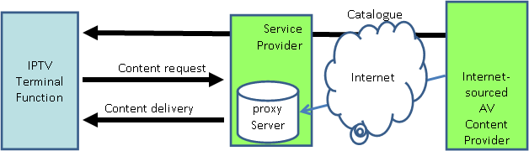
Figure ‎6-1. Architecture for no Internet content integration by service provider
In this operation mode, the service provider platform is used for content delivery over the managed network.
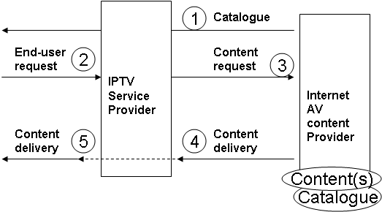
Figure ‎6-2. Exchanges for no Internet content integration at all by the IPTV service provider
In this operation mode, the IPTV service provider intercepts the request for Internet-sourced AV contents, requests the content from the Internet Content provider and delivers it through the managed network.
Two mode of operation are also possible: a pull mode and a push mode.
The description of the pull mode and the push mode is similar to the description to the description made in the previous configuration.
In push mode, authorised Internet AV content providers declare their contents to the ITV service providers and deliver contents.
In case the quality of service of the content delivery is impacted due to the late content acquisition or the content size such as HD contents, authorised Internet AV content providers may deliver these contents to IPTV service providers in advance. This allows the internet AV content provider to make their contents uploaded to IPTV service provider as soon as the contents are available to the IPTV end-users.

No integration at all with external browsing
In this configuration, the IPTV service platform does not integrate the internet-sourced AV content in its catalogue so no exchange of content description metadata is needed.
Content catalogue is managed by the Internet sourced AV content provider and contents remain in the Internet server until end-user request. Catalogue browsing goes outside the IPTV service provider.

This is illustrated on the following figure.
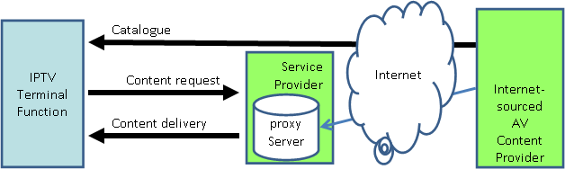
Figure ‎6-3. Architecture for no Internet content integration with external browsing
In this operation mode, the service provider platform is used for content delivery over the managed network.
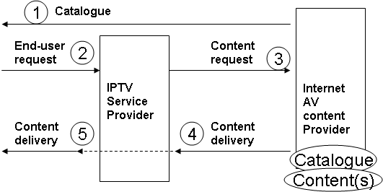
Figure ‎6-4. Exchanges for no Internet content integration at all with external browsing
In this operation mode, the IPTV service provider gets the request for Internet-sourced AV contents, requests the content for the Internet Server and delivers it through the managed network.
Two mode of operation are also possible: a pull mode and a push mode.
The description of the pull mode and the push mode is similar to the description to the description made in the previous configuration.
In push mode, authorised Internet AV content providers declare their contents to the ITV service providers and deliver contents.
In case the quality of service of the content delivery is impacted due to the late content acquisition or the content size such as HD contents, authorised Internet AV content providers may deliver these contents to IPTV service providers in advance. This allows the internet AV content provider to make their contents uploaded to IPTV service provider as soon as the contents are available to the IPTV end-users.
_______________

