|  |  |  |
| --- | --- | --- |
| INTERNATIONAL TELECOMMUNICATION UNION | | **IPTV-GSI** |
| **TELECOMMUNICATION STANDARDIZATION SECTOR**  STUDY PERIOD 2009-2012 | | **IPTV-GSI-C-476** |
| **English only**  **Original: English** |
| **Question(s):** | 13/16 | Singapore, 20-27 September 2010 |
| **CONTRIBUTION** | | |
| **Source:** | Cisco Systems & ZTE | |
| **Title:** | Proposals for revised text of H.IPTV-AM.0 regarding addition of functional blocks to aggregation functions | |

1. **Abstract**

This contribution proposes modified content for H.IPTV-AM.0 “IPTV application event handling: Overall aspects of audience measurement for IPTV services”. It proposes to add functional blocks to the aggregation functions to support handling of orders input from stakeholders, and reports from end user measurement functions. It is proposed that clauses 7, 10, 11 and 15 are to be modified. Two further blocks are proposed to be added to the aggregation functions, also requiring modification of clause 11.

1. **Introduction**

AM0 does not yet include aggregation functions which handle incoming orders from stakeholders, including decomposition, analysis and recomposition into data directives to be dispatched to the correct EUMF sets.

AM0 also does not yet include aggregation functions which handle incoming EUMF reports including decomposition, analysis, and recomposition into reports to be dispatched to the appropriate stakeholders.

Traffic volume control and error control descriptions are included in the body text of AM0, but not yet shown as aggregation functions.

1. **Discussion**

The functions to handle information flow for both directions (incoming and outgoing) are similar. The need for these functions is independent of the choice regarding the detailed structure of orders, data requests, EUMF reports and stakeholder reports. The four blocks to be added are:

1. Directives decomposition functional block
2. Data request composition & dispatcher functional block
3. Report recomposition & dispatcher functional block
4. Report decomposition functional block

Of these, there are two functional block to support the information flow in each direction, with communication between the blocks for each direction.

A focussed view on these new functional blocks and the flow of orders and reports is as follows:

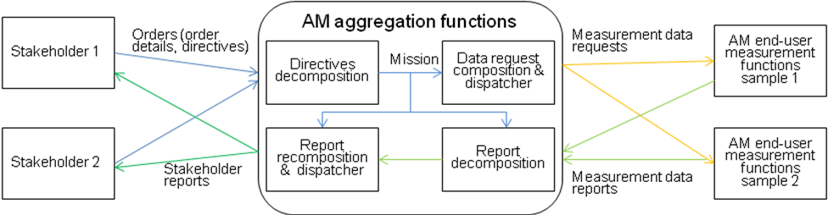

In this view, the Mission describes the current aggregated purpose of AM. It includes which stakeholder has asked for what, what is being asked, and whom it should be asked of. This information is used to compose data requests to be dispatched to particular audience segments, to direct how EUMF reports should be parsed, and how report elements should be recomposed and dispatched to multiple stakeholders.

Additionally, traffic volume control and error control are proposed as new aggregation functions.

1. **Proposals**

### Add content to clause 7, to show the scope of AM relative to Stakeholders and business systems.

### Modify clause 7.4.4, Audience measurement data aggregation and analysis to reflect additional functionality

### Modify clause 7.4.5, Audience measurement result output to reflect additional functionality

### Add text to clause 10.4, Application functional requirements, to add requirements for order processing and report processing

### In clause 11, modify figure 11 to show new function blocks

### Add a clause to 11.2.1, measurement object configuration functions regarding new traffic volume control function block

### Add clauses 11.2.6, 11.2.6.1 and 11.2.6.2 to describe Order Processing Functions

### Add clauses 11.2.7, 11.2.7.1 and 11.2.7.2 to describe Report Processing Functions

### Add clause 11.2.8 regarding new error control function block

### Modify the description of reference points C2 and C3 to reflect the new aggregation functions in clauses 15.7 and 15.8.

**Content for proposal 1 -** add the following to clause 7

The context of audience measurement is shown in figure 1

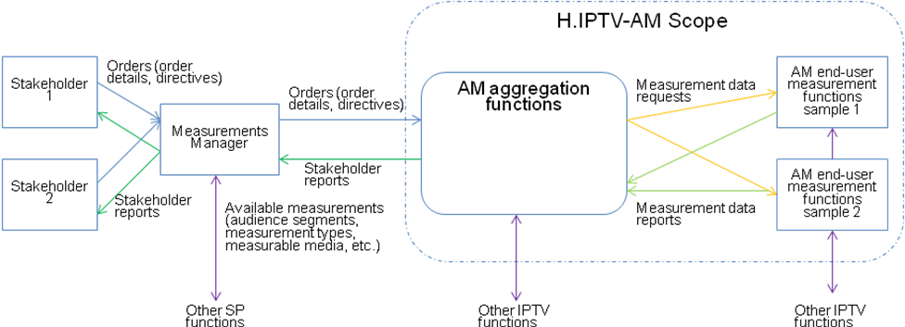

Figure - Context of audience measurement overview

Stakeholders such as content providers, advertisers, and service providers may request orders which may be accepted by the audience measurement service provider. Orders are sent to the audience measurement functions which subsequently fulfil those orders by the return of requested reports to those stakeholders. This recommendation focuses on the audience measurement functions.

### Content for proposal 2 – modify clause 7.4.4

**From:**

### 7.4.4 Audience measurement data aggregation and analysis

Aggregation functions receive audience measurement data from end-user measurement functions through network functions or directly. Following validation of received measurement data, they store, combine, analyse, and then store these measurements in accordance with predefined configuration based on requirements.

*[Editor’s Note] More contributions are needed regarding configuration about aggregation functions. (May, 2010)*

### To:

### 7.4.4 Audience measurement data aggregation and analysis

Aggregation functions receive audience measurement data from end-user measurement functions through network functions or directly. Following validation of received measurement data, they store, combine, analyse, and then store these measurements in accordance with predefined configuration based on the mission.

*[Editor’s Note] More contributions are needed regarding configuration about aggregation functions. (May, 2010)*

### Content for proposal 3 – modify clause 7.4.5

**From:**

### 7.4.5 Audience measurement result output

Report output functions in aggregation functions may read the audience measurement result data from database and prepares it for other applications.

*[Editor’s Note] Database is one option to store the audience measurement data. However in 7.4.5, database seems to be indispensable. More contributions are needed to modify the description about it. (May, 2010)*

**To:**

### 7.4.5 Audience measurement result output

Report output functions in aggregation functions read the audience measurement result data from the database, composes it into reports, and dispatches reports to the appropriate requestor in accordance with the stakeholder’s order.

*[Editor’s Note] Database is one option to store the audience measurement data. However in 7.4.5, database seems to be indispensable. More contributions are needed to modify the description about it. (May, 2010)*

### Content for proposal 4 – add requirements for order processing and report processing to clause 10.4, as follows

c) Order processing requirements

* The IPTV aggregation functions are recommended, to have the ability to deconstruct multiple stakeholders’ orders, aggregate them into measurement data requests, and dispatch those requests to the appropriate sets of end-user measurement functions.

1. Report processing requirements

* The IPTV aggregation functions are recommended, to have the ability to deconstruct multiple end-user measurement functions reports, and aggregate them into stakeholder reports, and dispatch those reports to the appropriate stakeholders.

### Content for proposal 5 - modify figure 11 to replace the aggregation functions as follows



### Content for proposal 6 – Add text to clause 11.2.1

### c) Traffic volume control function block

The traffic volume control function block handles the traffic limit process as the number of audience measurement objects and devices measured are increased. The methods of traffic volume control are configured when audience measurement is initiated and is selected based on the traffic situation.

### Content for proposal 7 – Add clauses 11.2.6, 11.2.6.1 and 11.2.6.2

### 11.2.6 Order Processing Functions

The order processing functions handle incoming orders from stakeholders, including decomposition, analysis and recomposition into data directives to be dispatched to the correct EUMF sets.

### 11.2.6.1 Directives Decomposition Functional Block

This block receives orders from stakeholders. It decomposes orders into directives of multiple defined types such as timing, etc. The aggregate of directives from multiple stakeholders is produced as the current mission.

### 11.2.6.2 Data Request Composition & Dispatcher Functional Block

This block takes the current mission as input, forms measurement data requests, and addresses and dispatches them to appropriate sets of end-user measurement functions.

### Content for proposal 8 – Add clauses 11.2.7, 11.2.7.1 and 11.2.7.2

### 11.2.7 Report Processing Functions

The report processing functions handle incoming EUMF reports including decomposition, analysis, and recomposition into reports to be dispatched to the appropriate stakeholders.

### 11.2.7.1 Report Decomposition Functional Block

This block, under direction of the current mission, decomposes and analyses the incoming end-user measurement reports.

### 11.2.7.2 Report Recomposition & Dispatcher Functional Block

This block, under direction of the current mission, takes the output of the report decomposition functional block and recomposes the information into stakeholder reports with optional assistance of the statistical analysis function. It addresses and dispatches these reports to stakeholders

**Content for proposal 9 –** Add clause 11.2.8

### 11.2.8 Error Control Function Block

This block handles the process while abnormal situation is detected. It is configured when audience measurement is initiated.

**Content for proposal 10 –** modify reference point C2 and C3 descriptions, in clause 15 as follows

**From:**

## 15.7 Reference point C2

The C2 reference point is between the aggregation functions and content provider functions.

This reference point is used to transmit the audience measurement result data to IPTV content provider for making a report, e.g., to draw a visual histogram.

## 15.8 Reference point C3

The C3 reference point is between the aggregation functions and the related functional entities.

**To:**

## 15.7 Reference point C2

The C2 reference point is between the aggregation functions and content provider functions.

This reference point is used to:

* Receive measurement orders from content provider stakeholders
* Transmit the audience measurement result data to IPTV content provider for making a report, e.g., to draw a visual histogram.

## 15.8 Reference point C3

The C3 reference point is between the aggregation functions and the related functional entities.

This reference point is used to:

* Receive measurement orders from advertiser and service provider stakeholders

___________________