 | INTERNATIONAL TELECOMMUNICATION UNION |  |  |  | IPTV-GSI – C 460 – E
 | TELECOMMUNICATION  STANDARDIZATION SECTOR  STUDY PERIOD 2009-2012 |  |  | September 2010
English only
Original: English
Question(s): |  | 13/16
IPTV-GSI – CONTRIBUTION 460
Source: |  | ETRI
Title: |  | Proposal of basic operation for HSTP.IPTV-RIA, “Guideline of Richer Interactive Application for IPTV Services”

Background
For the last meeting, we started the technical paper H.IPTV-RIA, Guideline of Richer Interactive Applications for IPTV Services from the SG16 Rapporteur meeting (Q13) meeting held in Geneva, 26-30 October 2009, TD253.
After the meeting, H.IPTV-RIA document needs further progress. This contribution try to start how to support the interactive IPTV application with WBTM (Web-based terminal middleware), because WBTM can be used for development of the interactive IPTV applications.
And this example will give the understanding basic interactive IPTV operation mechanism, and then can be extended RIA IPTV applications with relevant ITU-T specifications together.

Proposal
This contribution is for the HSTP.IPTV-RIA document and proposal is to put the new section 5 after re-chartering original HSTP.IPTV-RIA.

(Proposal)

To provide interactive IPTV RIA service, WBTM can be used for development of the interactive IPTV applications. This section shows the one example of script codes with WBTM engine for RIA operations. This section is described some parts of example codes necessary for understanding of interactive IPTV applications. And, with this script code and extended codes, interactive services can be developed for IPTV.

- Basic API lists for interactive operation
This example shows overall function list to support interactive IPTV applications, which are composed of WBTM.
Below is the html code for the WBTM functions.

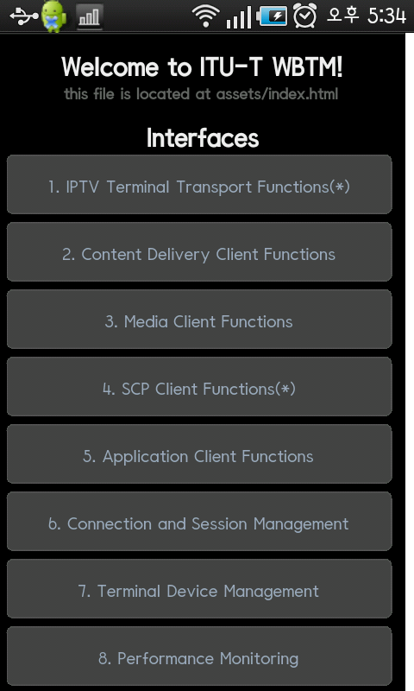

[ HTML : index.html ]
<!DOCTYPE HTML>
<html>
<head>
<meta name="viewport" content="width=320; user-scalable=no" />
<meta http-equiv="Content-type" content="text/html; charset=utf-8">
<title>WBTM</title>
<link rel="stylesheet" href="master.css" type="text/css" media="screen" title="no title" charset="utf-8">
</script>
</head>
<body onload="init();" id="stage" class="theme">
<h1>Welcome to ITU-T WBTM!</h1>
<h2>this file is located at assets/index.html</h2>
<h1>Interfaces</h1>
<a href="IPTV_Terminal_Transport_Functions.html" class="btn menu" onclick="">1. IPTV Terminal Transport Functions(*)</a>
<a href="Content_Delivery_Client_Functions.html" class="btn menu" onclick="">2. Content Delivery Client Functions</a>
<a href="Media_Client_Functions.html" class="btn menu" onclick="">3. Media Client Functions</a>
<a href="SCP_Client_Functions.html" class="btn menu" onclick="">4. SCP Client Functions(*)</a>
<a href="Application_Client_Functions.html" class="btn menu" onclick="">5. Application Client Functions</a>
<a href="Connection_and_Session_Management.html" class="btn menu" onclick="">6. Connection and Session Management</a>
<a href="Terminal_Device_Management.html" class="btn menu" onclick="">7. Terminal Device Management</a>
<a href="Performance_Monitoring.html" class="btn menu" onclick="">8. Performance Monitoring</a>
<p>
<img src= "bottom_line.jpg" width="300"/> <br>
<img src= "etri_logo.jpg" align="left"><img src= "teraon_logo.jpg" align="right"/>
</body>
</html>

  - Content Delivery Client Functions Interface

This example shows for content delivery, which supports broadcast type and channel information.
Below is the html code and script for the content delivery function.

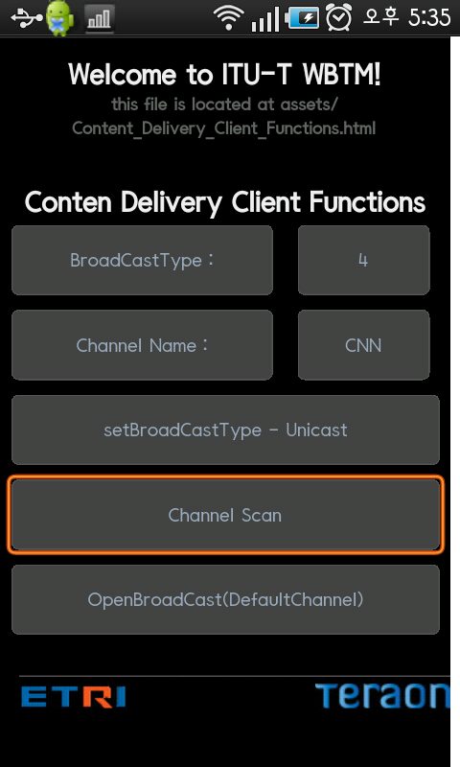

[ HTML : Content_Delivery_Client_Functions.html ]
<!DOCTYPE HTML>
<html>
<head>
<meta name="viewport" content="width=320; user-scalable=no" />
<meta http-equiv="Content-type" content="text/html; charset=utf-8">
<title>WBTM</title>
<link rel="stylesheet" href="master.css" type="text/css" media="screen" title="no title" charset="utf-8">
<script type="text/javascript" charset="utf-8" src="wbtm.js"></script>
</head>
<body onload="UpdateBroadcast()" id="stage" class="theme">
<h1>Welcome to ITU-T WBTM!</h1>
<h2>this file is located at assets/Content_Delivery_Client_Functions.html</h2><br>
<h1>Conten Delivery Client Functions</h1>
<TABLE>
<TR>
<TD> <a class="btn small" >BroadCastType :</a></TD>
<TD> <a class="btn default" id="boardcastType">N/A</a> </TD>
</TR>
<TR>
<TD> <a class="btn small" >Channel Name :</a></TD>
<TD> <a class="btn default" id="boardcastChannel">N/A</a> </TD>
</TR>
<TR>
<TD COLSPAN=3><a class="btn large" onclick="setBroadCastType(4)" value='Change Text'>setBroadCastType - Unicast</a></TD>
</TR>
<TR>
<TD colspan=3><a class="btn large" onclick="ChannelScan()">Channel Scan</a></TD>
</TR>
<TR>
<TD colspan=3><a class="btn large" onclick="OpenBroadCast()">OpenBroadCast(DefaultChannel)</a></TD>
</TR>
</TABLE>
<p>
<img src= "bottom_line.jpg" width="300"/> <br>
<img src= "etri_logo.jpg" align="left"><img src= "teraon_logo.jpg" align="right"/>
</body>
</html>

[Java Script : wbtm.js ]
<! Wbtm.js
var BroadCastType = "";
var ChannelName = "";
function UpdateBroadcast() // Refresh Screen
{
BroadCastType = Broadcast.getBroadCastType();
ChannelName = Broadcast.getCurrentChannelName();
result();
}
function result() // Print Result to Screen
{
document.getElementById("boardcastType").innerHTML = BroadCastType;
document.getElementById("boardcastChannel").innerHTML = ChannelName;
}
function setBroadCastType(nType) // Set Broadcasting Type
{
Broadcast.setBroadCastType(nType);
UpdateBroadcast();
}
function ChannelScan() // Start Channel scan
{
Broadcast.setBroadCastType(4); // Unicast channels
if (Broadcast.StartChannelScan())
{
alert( "Channel Scan Succeeded! : "+ Broadcast.getChannelCount() );
Broadcast.SetDefaultChannel();
UpdateBroadcast();
}
else
alert("Failed to Channel scan");
}
function OpenBroadCast() // Play broadcasting
{
Broadcast.SetDefaultChannel();
UpdateBroadcast();
Broadcast.OpenBroadCast();
}
// -->
</script>

  - Media Client Functions interfaces
This example shows for media client, which supports media related information.
Below is the html code and script for the media client function.
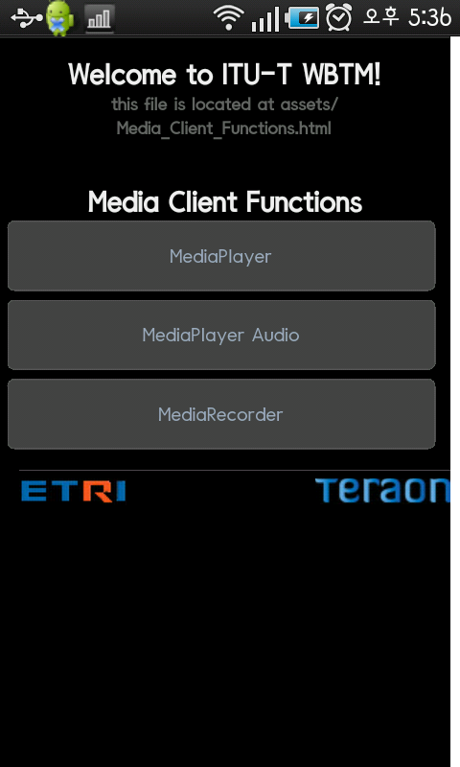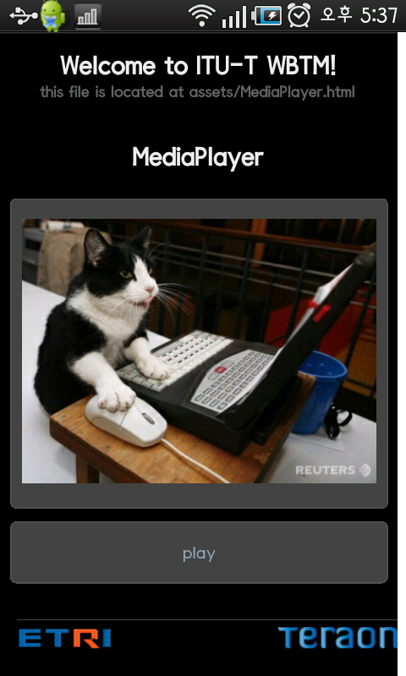
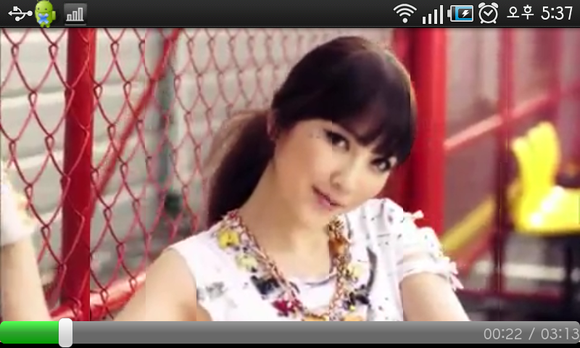

[ HTML : MediaPlayer.html ]
<!DOCTYPE HTML>
<html>
<head>
<meta name="viewport" content="width=320; user-scalable=no" />
<meta http-equiv="Content-type" content="text/html; charset=utf-8">
<title>WBTM</title>
<link rel="stylesheet" href="master.css" type="text/css" media="screen" title="no title" charset="utf-8">
<script type="text/javascript" charset="utf-8" src="wbtm.js"></script>
</head>
<body onload="" id="stage" class="theme">
<h1>Welcome to ITU-T WBTM!</h1>
<h2>this file is located at assets/MediaPlayer.html</h2><br>
<h1>MediaPlayer</h1><br>
<TABLE>
<TR>
<TD><a class="btn large"><img src="test.jpg" width = 280></a></TD>
</TR>
<TR>
<TD><a onclick="MediaPlayer.play('/sdcard/移대씪(KARA) - MISTER MV (Japanese .mp4');" class="btn large">play</a></TD>
</TR>
</TABLE>
<p>
<img src= "bottom_line.jpg" width="300"/> <br>
<img src= "etri_logo.jpg" align="left"><img src= "teraon_logo.jpg" align="right"/>
</body>
</html>

[Java Script : wbtm.js ]
<script type="text/javascript" charset="utf-8">
function play(){
MediaPlayer.play();
}
function pause()
{
MediaPlayer.pause();
}
function stop()
{
MediaPlayer.stop();
}
</script>

Below is the html code and script for the audio player function.
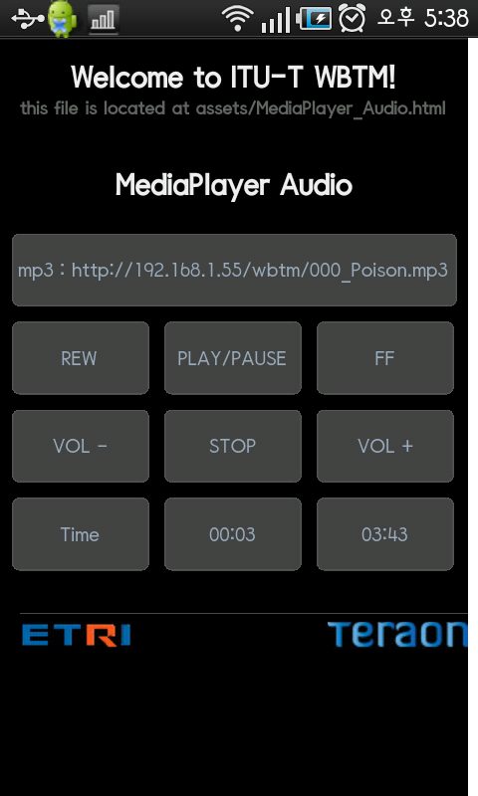

[ HTML : MediaPlayer_Audio.html ]
<!DOCTYPE HTML>
<html>
<head>
<meta name="viewport" content="width=320; user-scalable=no" />
<meta http-equiv="Content-type" content="text/html; charset=utf-8">
<title>WBTM</title>
<link rel="stylesheet" href="master.css" type="text/css" media="screen" title="no title" charset="utf-8">
<script type="text/javascript" charset="utf-8" src="wbtm.js"></script>
</head>
<body onload="audioPath('http://192.168.1.55/wbtm/000_Poison.mp3');" id="stage" onunload="stop();" class="theme">
<h1>Welcome to ITU-T WBTM!</h1>
<h2>this file is located at assets/MediaPlayer_Audio.html</h2><br>
<h1>MediaPlayer Audio</h1><br>
<TABLE>
<TR>
<TD COLSPAN=3><a class="btn large" onclick="">mp3 : http://192.168.1.55/wbtm/000_Poison.mp3</a></TD>
</TR>
<TR>
<TD><a class="btn default" onclick="REW();">REW</a></TD>
<TD><a class="btn default" onclick="buttonChange();" id="pp" >PLAY/PAUSE</a></TD>
<TD><a class="btn default" onclick="FF();">FF</a></TD>
</TR>
<TR>
<TD><a class="btn default" onclick="volumeDown()">VOL -</a></TD>
<TD><a class="btn default" onclick="stop();">STOP</a></TD>
<TD><a class="btn default" onclick="volumeUp()">VOL +</a></TD>
</TR>
<TR>
<TD><a class="btn default">Time</a></TD>
<TD><a class="btn default" id="current">default</a></TD>
<TD><a class="btn default" id="duration">default</a><TD>
</TABLE>
<p>
<img src= "bottom_line.jpg" width="300"/> <br>
<img src= "etri_logo.jpg" align="left"><img src= "teraon_logo.jpg" align="right"/>
</body>
</html>

[Java Script : wbtm.js ]
<script type="text/javascript" charset="utf-8">
var on = 1;
function buttonChange(arg)
{
if(on == 1){
on = 0;
start();
}
else{
on = 1;
pause();
}
}

function start(){
AudioPlayer.audioPlay();
duration();
}

function stop(){
on = 1;
AudioPlayer.audioStop();
}

function pause(){
AudioPlayer.audioPause();
}

function FF(){
AudioPlayer.audioFF();
}

function REW(){
AudioPlayer.audioREW();
}

function volumeUp(){
AudioPlayer.audioVolumeUp();
}

function volumeDown(){
AudioPlayer.audioVolumeDown();
}

function audioPath(arg){
AudioPlayer.audioPath(arg);
}

function duration(){
time = String(AudioPlayer.audioDuration());
document.getElementById("duration").innerHTML = time;
}

function currentPosition(){
if(on == 0){
time = String(AudioPlayer.audioCurrentPosition());
document.getElementById("current").innerHTML = time;
}
}
window.setInterval(currentPosition,500);
</script>

  - SCP Client Functions Interfaces

  - Application Client Functions Interface

This example shows for application client function, which supports browsing and service discovery.
Below is the html code and script for the application client function.

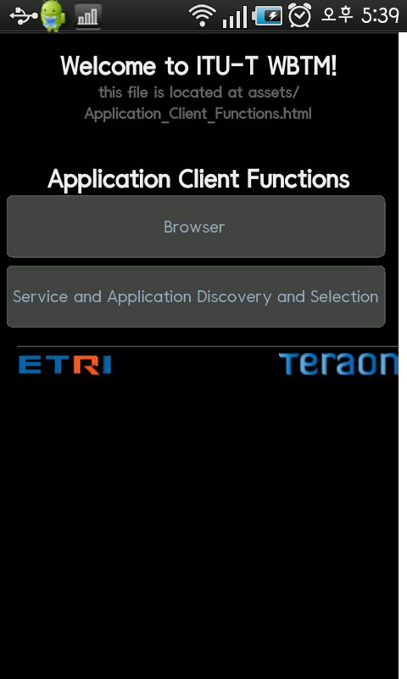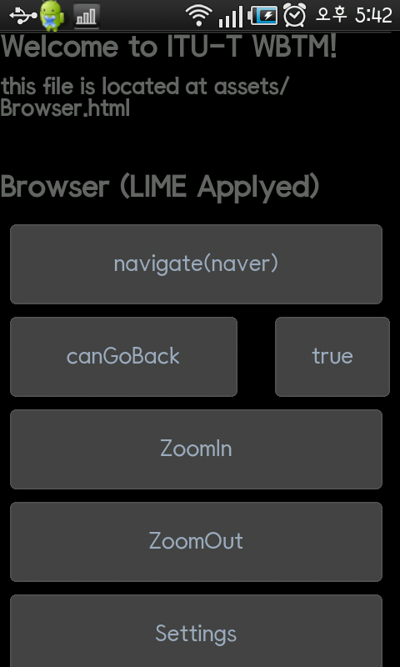
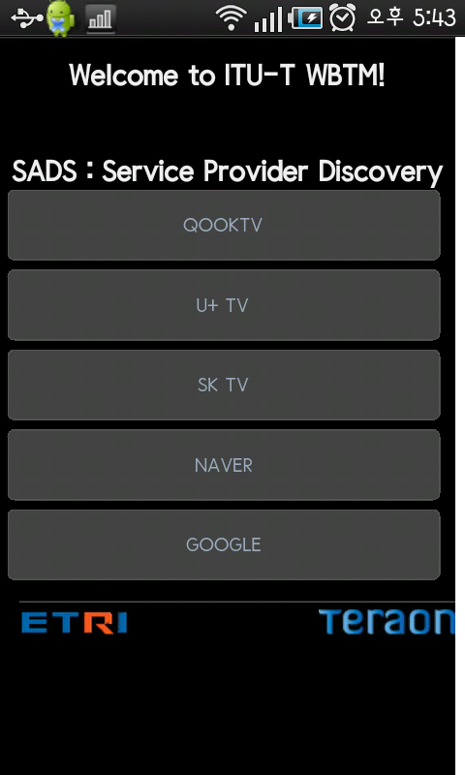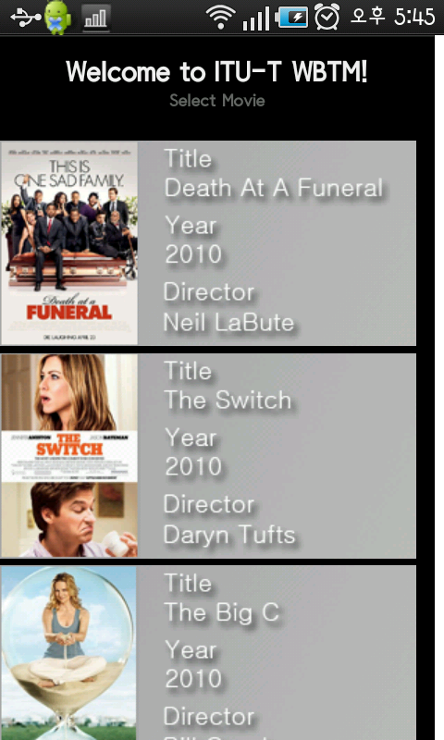

[ HTML : Browser.html ]
<?xml version="1.0" encoding="EUC-JP" ?>
<!DOCTYPE bml PUBLIC
"-//IPTVF CDN:2008//DTD BML Document for IPTV//JA"
"http://www.iptvforum.jp/CDN/DTD/bml_100_0_iptv.dtd">
<?bml bml-version="100.0" ?>
<bml>
<head>
<meta name="viewport" content="width=320; user-scalable=yes" />
<meta http-equiv="Content-type" content="text/html; charset=utf-8">
<title>WBTM</title>
<link rel="stylesheet" href="master.css" type="text/css" media="screen" title="no title" charset="utf-8">
<script type="text/javascript" charset="utf-8" src="wbtm.js"></script>
</head>
<body onload="" id="stage" class="theme">
<h1>Welcome to ITU-T WBTM!</h1>
<h2>this file is located at assets/Browser.html</h2><br>
<h1>Browser (LIME Applyed)</h1>
<table>
<tr>
<td colspan=2><a href="#" class="btn large" onclick="Browser.navigate('http://www.naver.com');">navigate(naver)</a></td>
</tr>
<tr>
<td><a href="#" class="btn small" onclick="canGoBack();">canGoBack</a></td>
<td><a href="#" class="btn default" onclick="" id="back">default</a></td>
</tr>
<tr>
<td colspan=2><a href="#" class="btn large" onclick="WebView.zoomIn();">ZoomIn</a></td>
</tr>
<tr>
<td colspan=2><a href="#" class="btn large" onclick="WebView.zoomOut();">ZoomOut</a></td>
</tr>
<tr>
<td colspan=2><a href="WBTMWebBrowserSettings.html" class="btn large">Settings</a></td>
</tr>
<tr>
<td colspan=2><a href="URLUtil.html" class="btn large">URL Util</a></td>
</tr>
<tr>
<td colspan=2>
<div id="d" style="width:320px;height:480px">
<object id="id_1" type="image/jpeg" data="photo1.jpg" style="width:260px;height:180px;"/>
</div></td></tr>
</table>
<p>
<img src= "bottom_line.jpg" width="300"/> <br>
<img src= "etri_logo.jpg" align="left"><img src= "teraon_logo.jpg" align="right"/>
</body>
</bml>

[Java Script : wbtm.js ]
<script type="text/javascript" charset="utf-8">
function canGoBack(){
document.getElementById("back").innerHTML = Browser.canGoBack();
}
function result() {
document.getElementById("FontSize").innerHTML = WebSettings.getDefaultFontSize();
document.getElementById("JavaScriptEnabled").innerHTML = WebSettings.getJavaScriptEnabled();
document.getElementById("DefaultZoom").innerHTML = WebSettings.getDefaultZoom();
document.getElementById("DefaultTextEncodingName").innerHTML = WebSettings.getDefaultTextEncodingName();
document.getElementById("DatabasePath").innerHTML = WebSettings.getDatabasePath();
document.getElementById("CacheMode").innerHTML = WebSettings.getCacheMode();
}
</script>

  - Connection and Session Management Interface
This example shows for connection and session, which supports cookies manipulation.
Below is the html code and script for the connection and session management function.

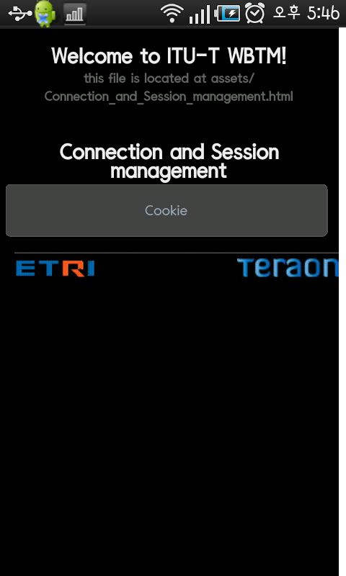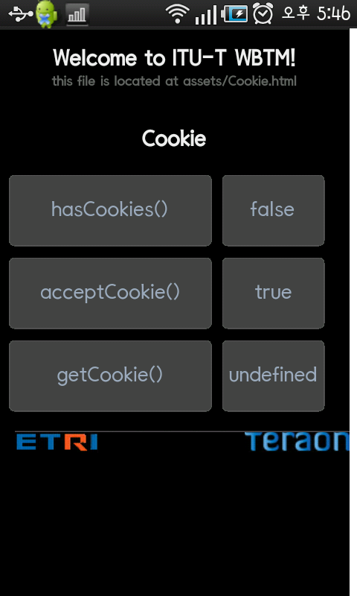

[ HTML : Cookie.html ]
<!DOCTYPE bml PUBLIC "-//IPTVF CDN:2008//DTD BML Document for IPTV//JA" "http://www.iptvforum.jp/CDN/DTD/bml_100_0_iptv.dtd">
<html>
<head>
<meta name="viewport" content="width=320; user-scalable=no" />
<meta http-equiv="Content-type" content="text/html; charset=utf-8">
<title>WBTM</title>
<link rel="stylesheet" href="master.css" type="text/css" media="screen" title="no title" charset="utf-8">
<script type="text/javascript" charset="utf-8" src="wbtm.js"></script>
</head>
<body onload="result()" id="stage" class="theme">
<h1>Welcome to ITU-T WBTM!</h1>
<h2>this file is located at assets/Cookie.html</h2><br>
<h1>Cookie</h1><br>
<TABLE>
<TR>
<TD><a class="btn small">hasCookies()</a> </TD>
<TD><a id="hasCookies" class="btn default">default</a></TD>
</TR>
<TR>
<TD><a class="btn small">acceptCookie()</a> </TD>
<TD><a id="acceptCookie" class="btn default">default</a></TD>
</TR>
<TR>
<TD><a class="btn small">getCookie()</a> </TD>
<TD><a id="getCookie" class="btn default">default</a></TD>
</TR>
</TABLE>
<p>
<img src= "bottom_line.jpg" width="300"/> <br>
<img src= "etri_logo.jpg" align="left"><img src= "teraon_logo.jpg" align="right"/>
</body>
</html>
[Java Script : wbtm.js ]
<script type="text/javascript" charset="utf-8">
function result()
{
document.getElementById("hasCookies").innerHTML = CookieManager.hasCookies();
document.getElementById("acceptCookie").innerHTML = CookieManager.acceptCookie();
document.getElementById("getCookie").innerHTML = CookieManager.getCookie("http://www.google.com");
}
</script>

  - Terminal Device Management Interface
This example shows for terminal device management function, which supports device management.
Below is the html code and script for the terminal device management function.

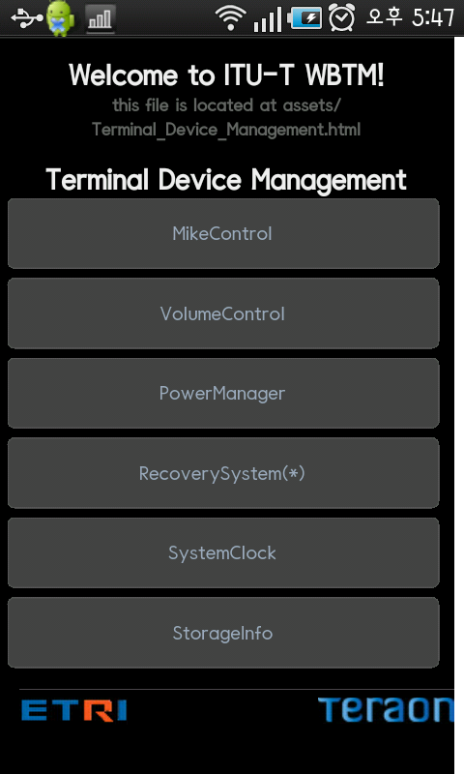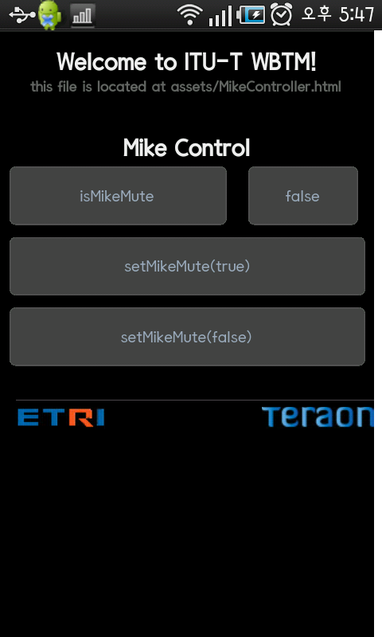
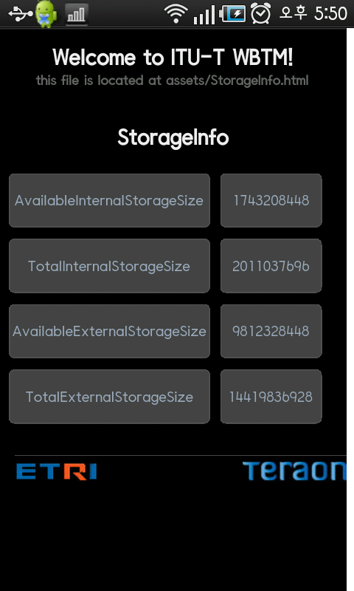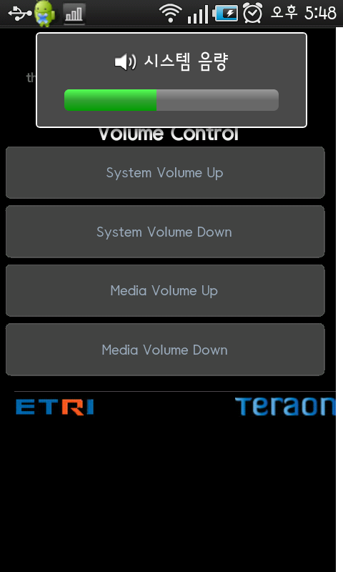

[ HTML : VolumControl.html ]
<!DOCTYPE HTML>
<html>
<head>
<meta name="viewport" content="width=320; user-scalable=no" />
<meta http-equiv="Content-type" content="text/html; charset=utf-8">
<title>WBTM</title>
<link rel="stylesheet" href="master.css" type="text/css" media="screen" title="no title" charset="utf-8">
<script type="text/javascript" charset="utf-8" src="wbtm.js"></script>
<script type="text/javascript" charset="utf-8">
</script>
</head>
<body onload="" id="stage" class="theme">
<h1>Welcome to ITU-T WBTM!</h1>
<h2>this file is located at assets/VolumeControl.html</h2><br>
<h1>Volume Control</h1>
<a href="#" class="btn large" onclick="VolumeController.systemVolumeUp();">System Volume Up</a>
<a href="#" class="btn large" onclick="VolumeController.systemVolumeDown();">System Volume Down</a>
<a href="#" class="btn large" onclick="VolumeController.mediaVolumeUp();">Media Volume Up</a>
<a href="#" class="btn large" onclick="VolumeController.mediaVolumeDown();">Media Volume Down</a>
<p>
<img src= "bottom_line.jpg" width="300"/> <br>
<img src= "etri_logo.jpg" align="left"><img src= "teraon_logo.jpg" align="right"/>
</body>
</html>
[ HTML : MikeControl.html ]
<!DOCTYPE HTML>
<html>
<head>
<meta name="viewport" content="width=320; user-scalable=no" />
<meta http-equiv="Content-type" content="text/html; charset=utf-8">
<title>WBTM</title>
<link rel="stylesheet" href="master.css" type="text/css" media="screen" title="no title" charset="utf-8">
<script type="text/javascript" charset="utf-8" src="wbtm.js"></script>
<script type="text/javascript" charset="utf-8">
function mute(){
document.getElementById("mute").innerHTML = MikeController.isMikeMute();
}
</script>
</head>
<body onload="" id="stage" class="theme">
<h1>Welcome to ITU-T WBTM!</h1>
<h2>this file is located at assets/MikeController.html</h2><br>
<h1>Mike Control</h1>
<table>
<tr>
<td><a href="#" class="btn small" onclick="mute();">isMikeMute</a></td>
<td><a href="#" class="btn default" id="mute">default</a></td>
</tr>
<tr>
<td colspan=2><a href="#" class="btn large" onclick="MikeController.setMikeMute(true);">setMikeMute(true)</a></td>
</tr>
<tr>
<td colspan=2><a href="#" class="btn large" onclick="MikeController.setMikeMute(false);">setMikeMute(false)</a></td>
</tr>
</table>
<p>
<img src= "bottom_line.jpg" width="300"/> <br>
<img src= "etri_logo.jpg" align="left"><img src= "teraon_logo.jpg" align="right"/>
</body>
</html>
[ HTML : Storage.html ]
<!DOCTYPE HTML>
<html>
<head>
<meta name="viewport" content="width=320; user-scalable=no" />
<meta http-equiv="Content-type" content="text/html; charset=utf-8">
<title>WBTM</title>
<link rel="stylesheet" href="master.css" type="text/css" media="screen" title="no title" charset="utf-8">
<script type="text/javascript" charset="utf-8" src="wbtm.js"></script>
</head>
<body onload="result()" id="stage" class="theme">
<h1>Welcome to ITU-T WBTM!</h1>
<h2>this file is located at assets/StorageInfo.html</h2><br>
<h1>StorageInfo</h1><br>
<TABLE>
<TR>
<TD><a class="btn small">AvailableInternalStorageSize</a> </TD>
<TD><a id="AvailableInternal"class="btn default">default<br></a></TD>
</TR>
<TR>
<TD><a class="btn small">TotalInternalStorageSize</a></TD>
<TD><a id="TotalInternal" class="btn default">default<br></a></TD>
</TR>
<TR>
<TD><a class="btn small">AvailableExternalStorageSize</a></TD>
<TD><a id="AvailableExternal" class="btn default">default<br></a></TD>
</TR>
<TR>
<TD><a class="btn small">TotalExternalStorageSize</a></TD>
<TD><a id="TotalExternal" class="btn default">default<br></a></TD>
</TR>
</TABLE>
<p>
<img src= "bottom_line.jpg" width="300"/> <br>
<img src= "etri_logo.jpg" align="left"><img src= "teraon_logo.jpg" align="right"/>
</body>
</html>
[Java Script : wbtm.js ]
<script type="text/javascript" charset="utf-8">
function result(){
document.getElementById("AvailableInternal").innerHTML = availableInternal;
document.getElementById("TotalInternal").innerHTML = totalInternal;
document.getElementById("AvailableExternal").innerHTML = availableExternal;
document.getElementById("TotalExternal").innerHTML = totalExternal;
}
</script>

  - Performance Monitoring Interface
This example shows for performance monitoring, which supports memory usage, etc.
Below is the html code and script for the performance monitoring function.

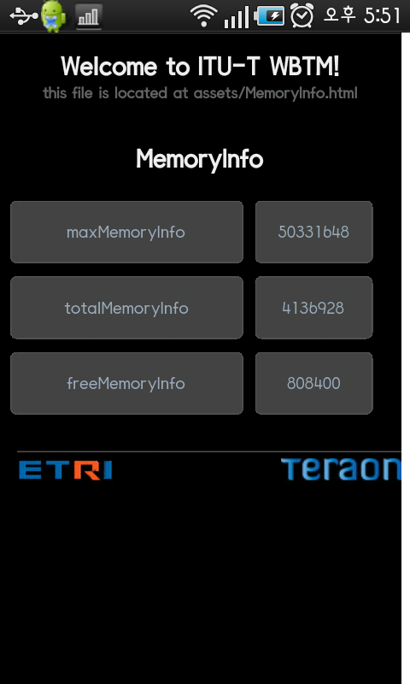
[ HTML : MemoryInfo.html ]
<!DOCTYPE HTML>
<html>
<head>
<meta name="viewport" content="width=320; user-scalable=no" />
<meta http-equiv="Content-type" content="text/html; charset=utf-8">
<title>WBTM</title>
<link rel="stylesheet" href="master.css" type="text/css" media="screen" title="no title" charset="utf-8">
<script type="text/javascript" charset="utf-8" src="wbtm.js"></script>
</head>
<body onload="result()" id="stage" class="theme">
<h1>Welcome to ITU-T WBTM!</h1>
<h2>this file is located at assets/MemoryInfo.html</h2><br>
<h1>MemoryInfo</h1><br>
<TABLE>
<TR>
<TD><a class="btn small">maxMemoryInfo</a> </TD>
<TD><a id="max"class="btn default">default</a></TD>
</TR>
<TR>
<TD><a class="btn small">totalMemoryInfo</a></TD>
<TD><a id="total" class="btn default">default</a></TD>
</TR>
<TR>
<TD><a class="btn small">freeMemoryInfo</a></TD>
<TD><a id="free" class="btn default">default</a></TD>
</TR>
</TABLE>
<p>
<img src= "bottom_line.jpg" width="300"/> <br>
<img src= "etri_logo.jpg" align="left"><img src= "teraon_logo.jpg" align="right"/>
</body>
</html>
[Java Script : wbtm.js ]
<script type="text/javascript" charset="utf-8">
function result(){
document.getElementById("max").innerHTML = maxMemory;
document.getElementById("total").innerHTML = totalMemory;
document.getElementById("free").innerHTML = freeMemory;
}
</script>

______________

