**CHANGZHOU GENERAL INFORMATION**

**Venue Information**

Weijing International Hotel and Creative Industrial Park

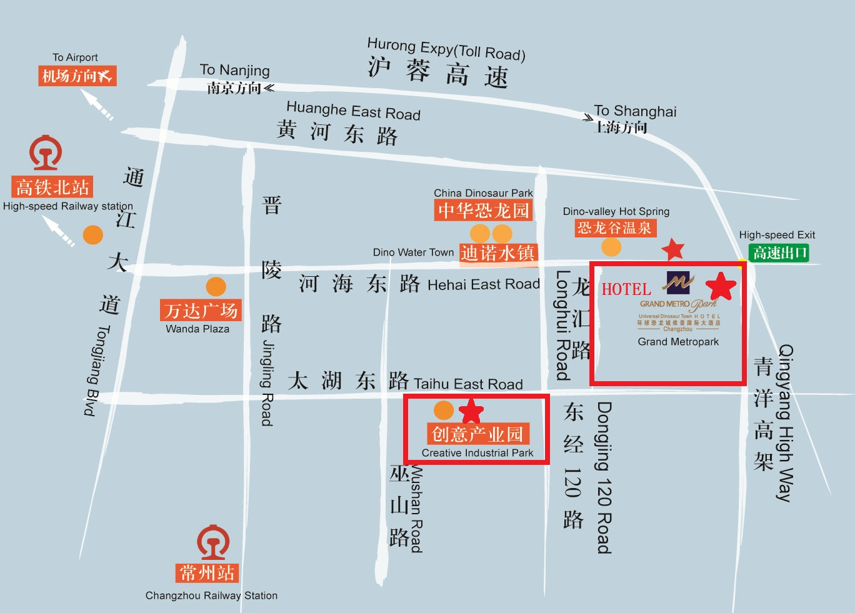

****Venue Information****

Venue: Weijing International Hotel

The 2nd floor tower B

Yi Jing Conference Room

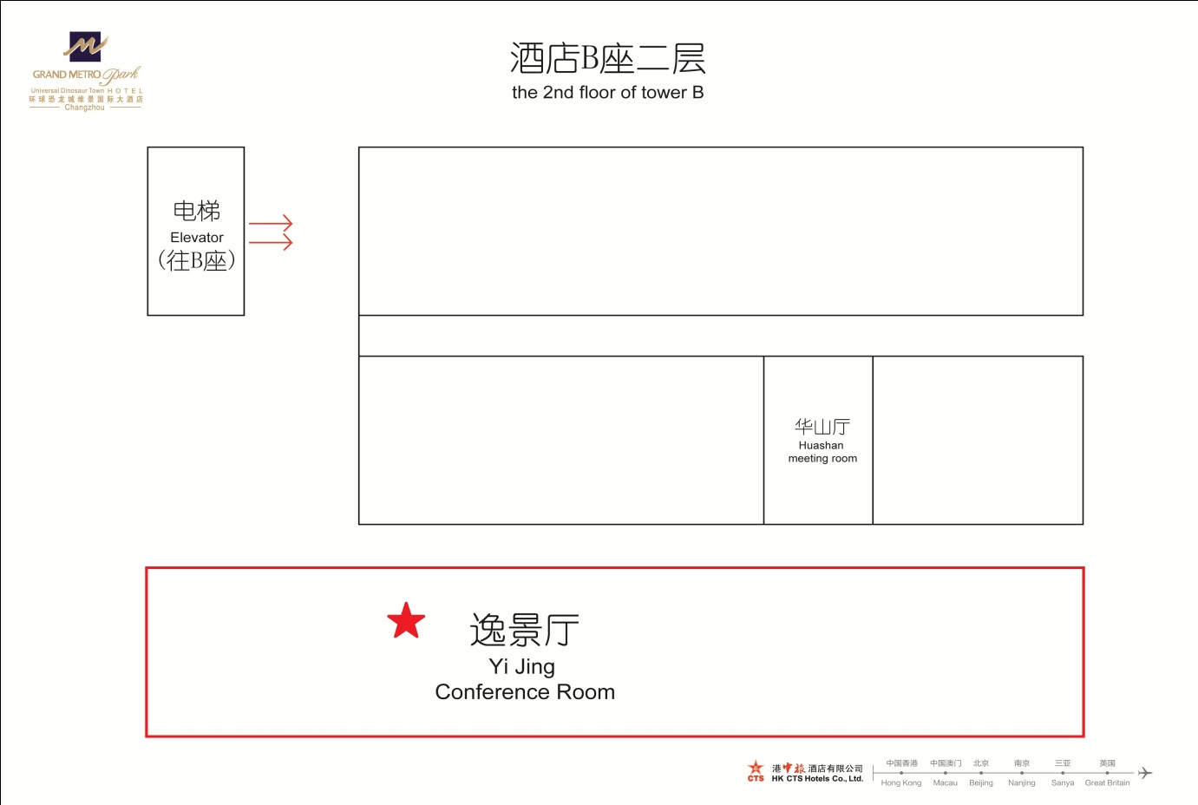

****Hotel Information****

One hotel, **Weijing International Hotel**, is recommended by the host organization.

Tel: +86-0519-82090365

Address: No. 56 Hehai East Road, Xinhei District, Changzhou (beside Dinosaur Valley Hot Spring)

More information can be found in the official site of the hotel.

<http://www.aatox.cn/hliy4xqz/37827/index.html>

Following types of rooms are available at the reduced group rate.

Business Double room: RMB468(About USD80) per night, Breakfast included (for two person)

**We would like to help you to researve the room**.

Please send your researvation information to chen hong (chenhong@ccbupt.cn) as soon as possible. The following information should be included.

1. Title: Mr. Ms. …
2. Full Name (Given name, Family name):
3. Room Type Business Doulbe (RMB 468)
4. Period of Stay Date of Check-In: Date of Check-Out:

You can also find other hotels nearby in booking.com or ctrip.com.

****Travel Information****

From airport to Hotel (Weijing International Hotel)

1.Airplane landing city: Shanghai. You may arrival at Shanghai Hongqiao Airport(SHA) or Shanghai Pudong Airport(PVG). You can find more information about the airport of Shanghai at <http://en.shairport.com>.

2a.From Shanghai Hongqiao Airport(SHA): go to Hongqiao Railway Station by foot or airport subway, then go to Changzhou Station or Changzhou North Station by train (departure every half hour, about 50mins)

2b. From Shanghai Pudong Airport(PVG): go to Shanghai Railway Station or Hongqiao Railway Station by taxi, then go to Changzhou Station or Changzhou North Station by train (departure every half hour, about 1hour)

3.After arriving at Changzhou Railway Station or Changzhou North Station, take a taxi to Weijing International Hotel in Changzhou Universe Dinosaur City (beside Dinosaur Valley Hot Spring) (about 20 minutes). It is strongly recommended to take taxi to the hotel. Changzhou North Station and the hotel is about 10km. Taxi fee is about RMB30-35 at daytime (6:00-23:00) and 30-35 at nighttime (23:00-6:00). (Please note that traffic jam is not taken into consideration which might incur extra fee).

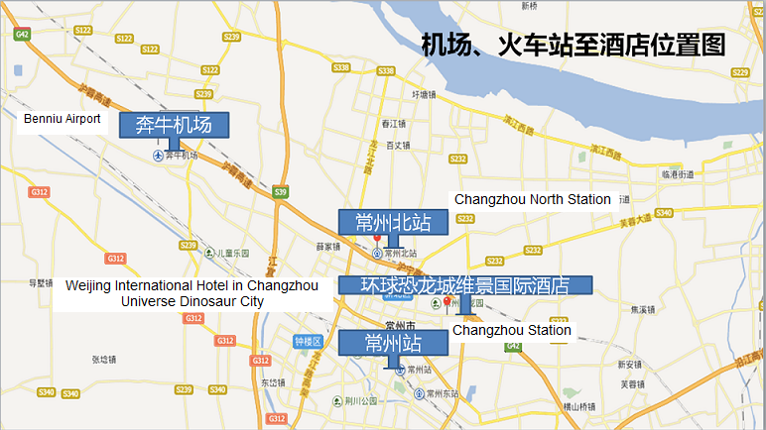

For more information of Changzhou City, please refer to:

<https://www.travelchinaguide.com/cityguides/jiangsu/changzhou/>

Note: people who participate in the meeting held in Changzhou Creative Industry Park are picked up by special cars uniformly arranged by the Committee.

Please show the following card to the taxi driver whenever you want to go to the hotel.

**To Weijing International Hotel in** **Universe Dinosaur City**

**您好，我需要前往常州环球恐龙城维景国际大酒店。**

1. From Hotel to the meeting site (No. 56 Hehai East Road, Xinhei District, Changzhou (beside Dinosaur Valley Hot Spring)).

Taxi is preferred.

Please show the following card to the taxi driver whenever you want to go to No. 56 Hehai East Road, Xinhei District, Changzhou (beside Dinosaur Valley Hot Spring)

**To No. 56 Hehai East Road, Xinhei District, Changzhou (beside Dinosaur Valley Hot Spring)**

**您好，我需要前往常州市新北区河海东路56号(恐龙谷温泉旁)**

Whenever you need help, don’t hesitate to call me at +86-13601172389 or . If your phone cannot work in Changzhou, please show the following card to some guy near you.

**My phone cannot work. Please help me to call ZHOU PING**

**您好，我是到常州创意产业园参加会议的。我的手机没法使用，可不可以借您的电话用一下。麻烦您帮忙打一下北京邮电大学周萍老师的电话 13601172389。谢谢。**

****Visa Application****

The host organization, Beijing University of Post and Telecommuncations(BUPT), would like to send you an invitation letter. If you need one to present to the Chinese Embassy / Consulate in your area in order to obtain your visa. Please send the following information to zhou ping (rebecca0628@qq.com)

1. Title:
2. Full Name:
3. Full name of Company/University/other organization
4. Address
5. Phone No.
6. Email

An invitation letter with the stamp of BUPT will be scanned and sent to you by email. If you need hard copy or any other document to support your visa application, please inform zhouping

****General Information for stay in Changzhou****

# Currency & exchange

The Chinese currency is the RMB(indicated ￥). The exchange rates between RMB and some other currencies are as below:

1 US dollar = 6.68RMB

1 Euro = 7.36 RMB

1 JPY = 0.0629 RMB

1 HKD = 0.86RMB

1 AUD = 5.01 RMB

1 KRW= 0.568RMB

The rates above are collected on July 20, 2016. The up-to-date rates may be a little different.

Below are some pictures of RMB bills.

100.00 RMB 50.00 RMB

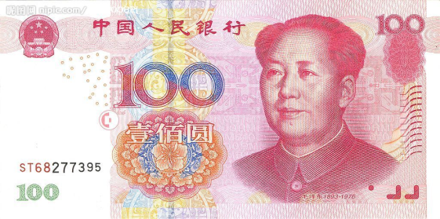 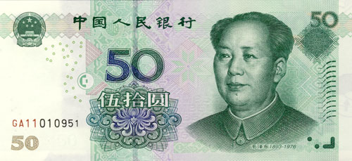

20.00 RMB 10.00RMB

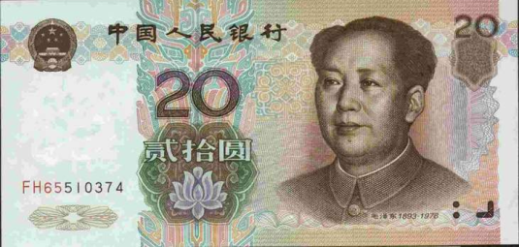 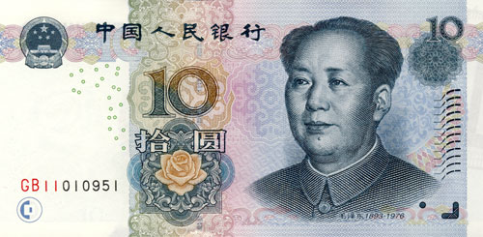

5.00 RMB

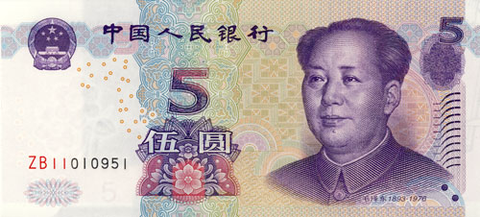

# Taxi

For taxi in Changzhou, the starting price is 10 yuan within 3.3 km, 1.80 yuan per kilometer between 3.3 km and 6 km, and 2.70 yuan per kilometer for more than 6 km. The starting price is 13 yuan between 11 p.m. and 5 a.m., 2.34 yuan per kilometer between 3.3 km -6 km, and 3.24 yuan per kilometer for more than 6 kilometers.

# Tipping

Tipping is not a traditional custom in China.

# Weather

In Changzhou , according to historical experience, the temperature in September is between 19 degrees Celsius and 28 degrees Celsius, it is mainly cloudy, and sometimes accompanied by thunderstorms. For real time weather query, please log on <http://www.weather.com.cn/weather/101191101.shtml>

# Electricity

The standard supply is 220 volts with AC/50 cycles. Electrical outlets for 220 volts are available at the hotels. Here is a picture of two kinds of standard electrical outlets in China.

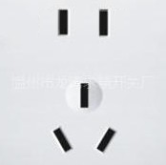

Please be sure you have the correct adapter. Voltage converters will not be provided at the meeting. Serveral adapters will be provided in the meeting room.

# Emergencies

Police: 110  
Fire Department: 119  
Medical Emergencies: 120

# Business Hours

Most government offices are open in 8:30 – 12:00 a.m. and 1:30 – 5:00 p.m. from Monday to Friday. Most stores are usually open from 10:00 to 21:00, including Sundays, but smaller shops tend to be open earlier and close later every day of the week.

# Local time

GMT + 8 hours. (same as Beijing time)

# Automated Teller Machines (ATM) for Foreign Traveller

Traveller who carry internationally recognized credit cards(such as visa and mastercard) can get a cash advance in Shanghai at Automated Teller Machines (ATMs) installed at airports, major hotels, department stores, subway stations and tourist attractions.

# Computer Networking

Free WIFI is available in all the rooms and public area of the hotel (Weijing International Hotel). You can resort to the waiter of the hotel for the account and the password, if necessary.