ITU-T SG16 WP1 Joint Rapporteur Meeting, Chengdu, China
8 – 12th June 2015
CHENGDU GENERAL INFORMATION

Map
Tianfu Sunshine Hotel and Shahe Campus of UESTC (University of Electronic Science and Technology )

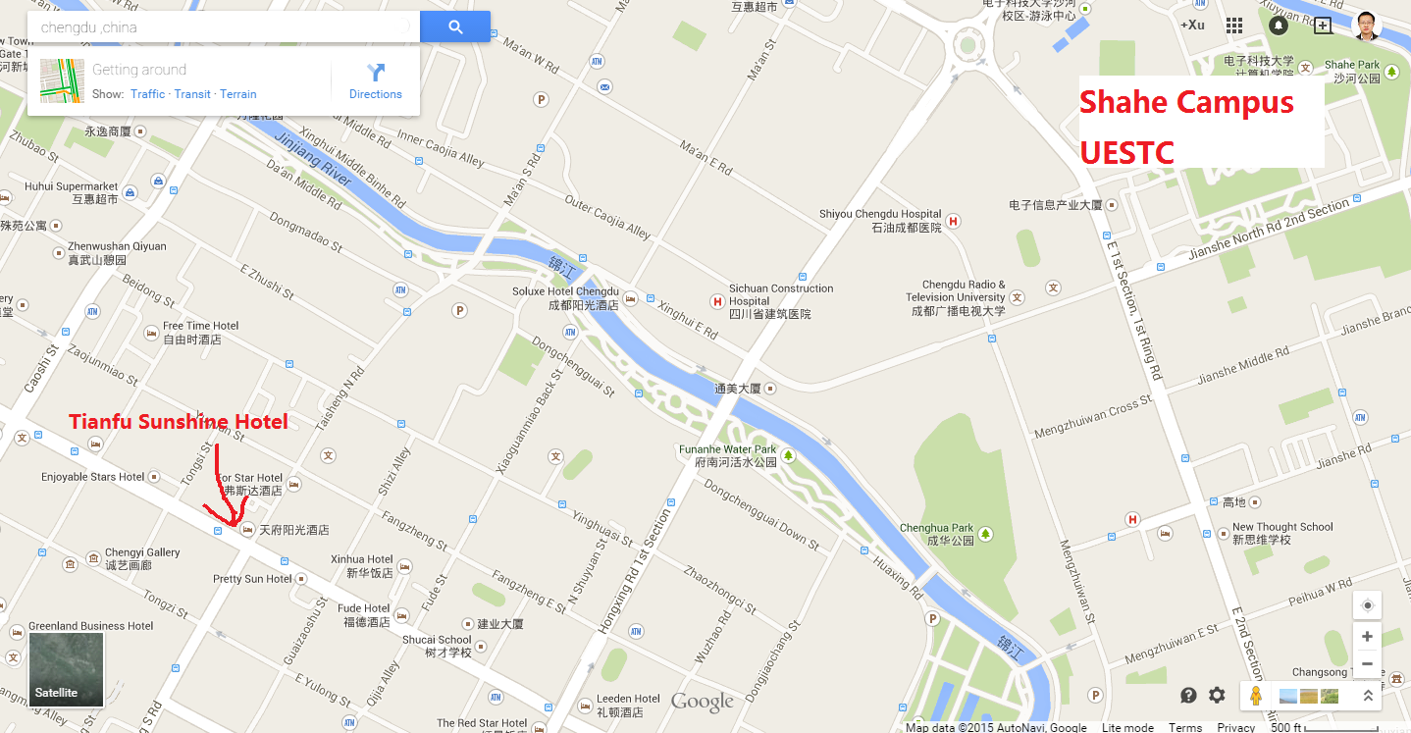

Venue Information
Venue: Shahe Campus of UESTC (University of Electronic Science and Technology )
No.4, Section 2, North Jianshe Road, Chengdu

Meeting Room: To be determined. Meeting room information will be provided closer to the meeting date.
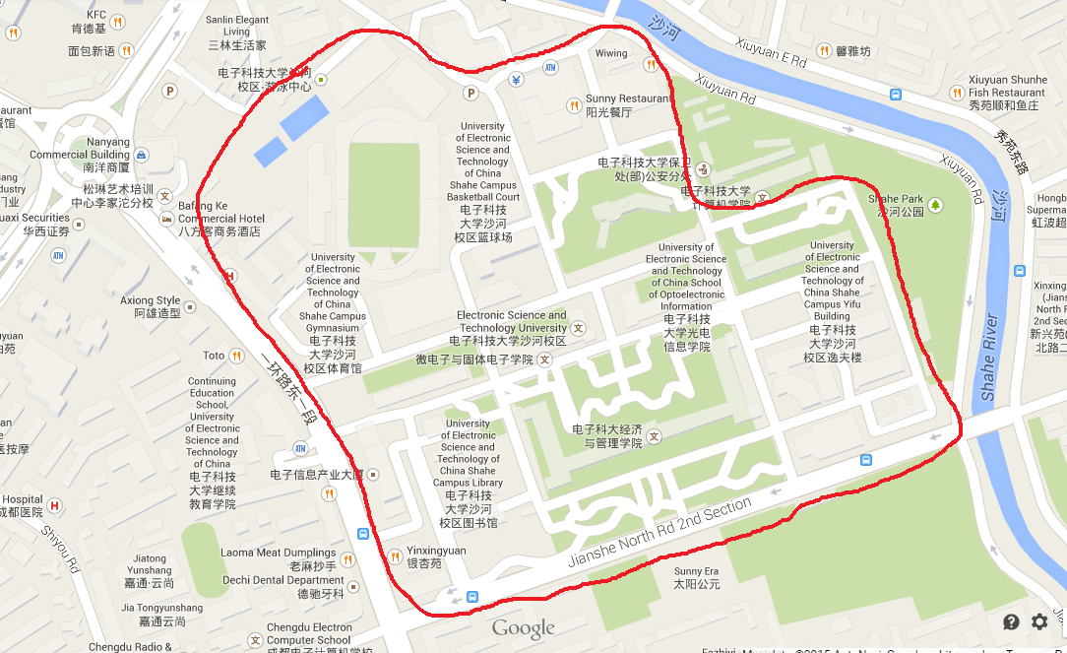

Hotel Information
The Tianfu Sunshine Hotel is recommended by the host organization.
Tianfu Sunshine Hotel
Tel: +86-28-86922233
Address: 2 Taisheng Bei Lu (2 Taisheng North Road), Chengdu
More information can be found in the official site of the hotel.
http://tfsunshinehotel.com/en-us/index.html
Please refer to the hotel introduction document for more information:
http://ftp3.itu.int/av-arch/avc-site/2013-2016/1506_Che/Tianfu Sunshine Hotel.pdf

Two types of rooms are available at the reduced group rate:
Deluxe Double: RMB 430 (about USD70) per night, Breakfast included (for one person)
Business Double: RMB 680 (about USD110) per night, Breakfast included (for two persons)

The meeting host would like to help you to reserve the room.
Please send your reservation information to Dr Shizhong Xu (xsz.uestc@gmail.com) as soon as possible. The following information should be included:
1. Title: Mr. Ms. …
2. Full Name (Given name, Family name):
3. Room Type Deluxe Double (RMB430) Business Double (RMB 680)
4. Period of Stay Check-In: Check-Out:
5. Any special requests such as non-smoking room etc.
You can also find other hotels nearby in booking.com or ctrip.com.

Travel Information

From airport to Hotel (Tianfu Sunshine Hotel)
There are two terminals in Chengdu Shuangliu International Airport (CTU), Terminal 1 for all the international flights and domestic flights of Sichuan Airlines, Terminal 2 for other domestic flights.
More information can be found in the website of the CTU airport.
http://www.cdairport.com/front_en/index.jsp
It is strongly recommended to take a taxi to the hotel. The distance between the airport and the hotel is about 22km. The taxi fee is about RMB 50-55 at daytime (6:00-23:00) and 60-65 at night time (23:00-6:00). (Please note that traffic jams are not taken into consideration which might incur extra fees.)
Taxi pick-up Point for Terminal 1: Outside arrival hall gate 2
Taxi pick-up Point for Terminal 2: Outside arrival hall gates 4 and 5

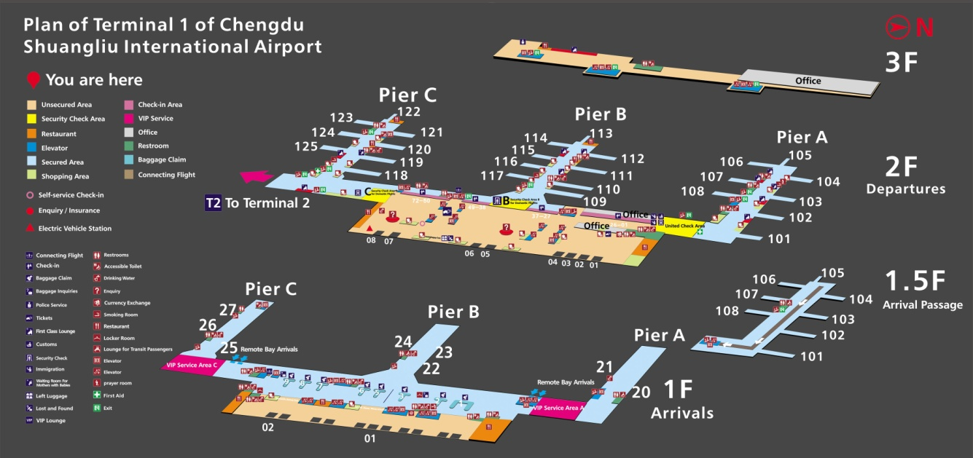

http://www.cdairport.com/front_en/images/terminal1_en.jpg

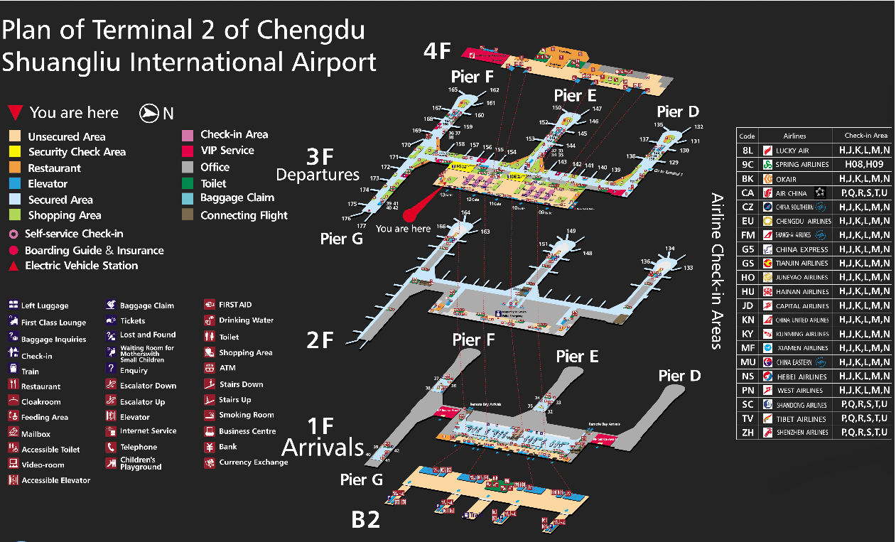
http://www.cdairport.com/front_en/images/terminal2_en.jpg

Please show the following card to the taxi driver whenever you want to go to the hotel.
To Tianfu Sunshine Hotel
您好，我需要前往 太升北路与新华大道交叉路口处的 天府阳光酒店。

From the hotel to the meeting site (Shahe Campus of UESTC).

Taxi
Taxi is the preferred option. Please show the following card to the taxi driver whenever you want to go to Shahe Campus of UESTC.

To Shahe Campus of UESTC
您好，我需要前往 建设北路/厂北路的电子科技大学老校区的南大门。

Walking
The walk between the hotel to the meeting site is ~3km and takes ~35 minutes.

General
Whenever you need help, don’t hesitate to call me at +86-18981791682 or +86-13981814140. If your phone cannot work in Chengdu, please show the following card to some person near you.

My phone cannot work. Please help me to call Dr. Xu of UESTC.
您好，我是到电子科技大学参加会议的。我的手机没法使用，可不可以借您的电话用一下。麻烦您帮忙打一下电子科技大学徐老师的电话 18981791682 或者13981814140。谢谢。

Visa Application
The host organization, UESTC, will provide invitation letters. If you need one to present to the Chinese Embassy / Consulate in your area in order to obtain your visa please send the following information to Dr. Shizhong Xu (xsz.uestc@gmail.com):
Title:
Full Name:
Full name of Company/University/other organization:
Address:
Phone No.:
Email:
An invitation letter with the stamp of UESTC will be scanned and sent to you by email. If you need hard copy or any other document to support your visa application, please inform Dr. Shizhong Xu.

General Information for stay in Chengdu

Currency & exchange
The Chinese currency is the RMB. The exchange rates between RMB and some other currencies are as below:
1 US dollar = 6.14 RMB
1 Euro = 6.66 RMB
1 JPY = 0.0513 RMB
1 HKD = 0.79 RMB
1 AUD = 4.74 RMB
1 KRW= 0.56 RMB
The rates above are collected on March 31, 2015. The up-to-date rates may be a little different.
Below are some pictures of RMB bills.

100.00 RMB 50.00 RMB
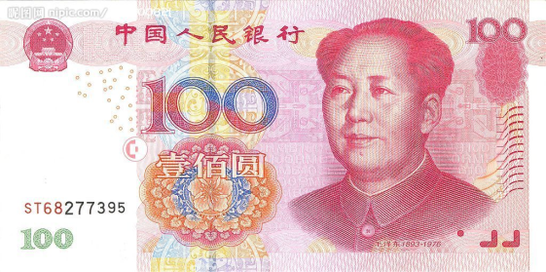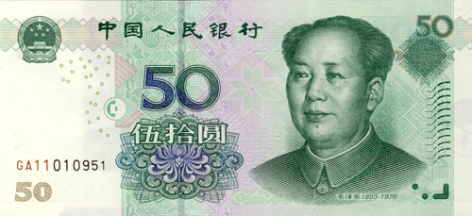

20.00 RMB 10.00RMB
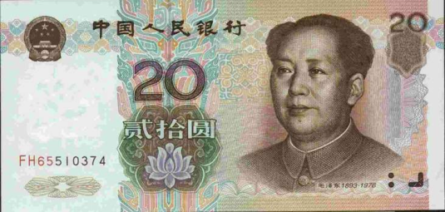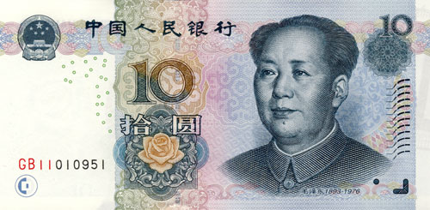
5.00 RMB
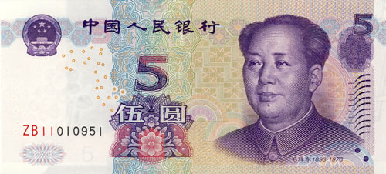

Taxi
The starting fee is 8 RMB for 0~2 km and the fee for per kilometre out of 2km is 1.9 RMB. There would be an extra 50% fee if the distance is more than 10km. And there would be an extra 30% fee during night hours (23:00-6:00).

Tipping
Tipping is not a traditional custom in China.

Weather
The weather may be rather hot in June. The temperature ranges from 25°C to 30°C approximately. The weather will be rainy according to history experience. For up-to-date weather information, please refer to http://en.weather.com.cn/weather/101270101.shtml .

Electricity
The standard supply is 220 volts with AC/50 cycles. Electrical outlets for 220 volts are available at the hotels. Here is a picture of two kinds of standard electrical outlets in China.
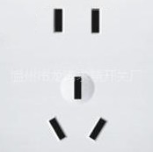

Please be sure you have the correct adapter. Voltage converters will not be provided at the meeting. Several adapters will be provided in the meeting room.

Emergencies
Police: 110
Fire Department: 119
Medical Emergencies: 120

Business Hours
Most government offices are open between 8:30 – 12:00 a.m. and 1:30 – 5:00 p.m. from Monday to Friday. Most stores are usually open from 10:00 to 21:00, including Sundays, but smaller shops tend to be open earlier and close later every day of the week.

Local time
GMT + 8 hours (same as Beijing time).

Automated Teller Machines (ATM) for Foreign Traveller
Traveller who carry internationally recognized credit cards (such as Visa and MasterCard) can get a cash advance in Shanghai at Automated Teller Machines (ATMs) installed at airports, major hotels, department stores, subway stations and tourist attractions.

Computer Networking
Free WIFI is available in all the rooms and public area of the hotel (Tianfu Sunshine Hotel). You can resort to the waiter of the hotel for the account and the password, if necessary.
WIFI access will be provided at the meeting.

_______________

