    Joint Collaborative Team on Video Coding (JCT-VC)  of ITU-T SG16 WP3 and ISO/IEC JTC1/SC29/WG11  3rd Meeting: Guangzhou, CN, 7-15 October, 2010 | Document: JCTVC-C111

Title: | Integration of Plane Mode in Unified Intra Prediction
Status: | Input Document to JCT-VC
Purpose: | Proposal
Author(s) or  Contact(s): | Guichun Li (Santa Clara University),  Lingzhi Liu (Hisilicon Technologies Co. Ltd.) ,  Nam Ling (Santa Clara University),  Jianhua Zheng (Hisilicon Technologies Co. Ltd.),  Philipp Zhang (Hisilicon Technologies Co. Ltd.), | Tel:  Email: | +1-408-554-4794  g1li@scu.edu  lzliu@huawei.com  nling@scu.edu  zhengjianhua@huawei.com  pzhang@huawei.com
Source: | Santa Clara University & Hisilicon Technologies Co. Ltd.
_____________________________

Abstract
The current default intra prediction method in TMuC, Unified Intra Prediction, has up to 33 directional modes and only 1 non-directional mode, which is intra DC mode. Having only 1 non-directional mode may be insufficient for accuracy on prediction units with complex texture. In this contribution, Plane Mode is integrated as an additional non-directional mode; an improved Multiple Predictor Set method is introduced; and a new method of intra mode prediction is used to obtain higher accuracy on intra mode prediction. Experimental results have shown that coding efficiency can be improved with the proposed method.
- Introduction
In video coding systems, intra prediction is used to reduce spatial redundancy between spatially adjacent blocks, in which pixels from the already coded neighboring blocks are used to predict the current block.
For luminance block, H.264 introduces a total of 9 intra prediction modes for 4x4 and 8x8 blocks. The 9 predictors include 8 directional modes and 1 non-directional mode, which is intra DC mode.
Latest video coding technologies use more intra prediction modes to improve prediction accuracy. In the Testing Model under Consideration (TMuC) from JCT-VC, the default intra prediction is Unified Intra Prediction, which has up to 34 modes (33 directional modes and 1 DC mode). This produces higher accuracy of prediction on blocks with complex texture. But using only DC mode for non-directional intra prediction is a weakness, there’s some room for improvement.
Another possible weakness is that to represent larger prediction mode numbers, more bits are required in the bit stream, thus the cost is increased. The proposed method groups the intra prediction modes into subsets (groups), as shown in Figure 1. Besides the intra mode number, each prediction mode can be represented by a group number and an index number in the group. Based on the group number and index number, current PU’s prediction mode can be predicted upon the coded spatially adjacent blocks. This approach can reduce cost for coding the prediction modes.
- Additional Non-Directional Modes in Unified Intra Prediction
The proposed method introduces improved Multiple Predictor Sets. Intra prediction modes are grouped into 4 subsets. Within each subset, there are 9 modes. The basic group, Group 0, has exactly the same predictors as H.264/AVC. All other groups can be obtained by rotating the basic group for a certain angle. To generate the predictors of Unified Intra Prediction, the angle between a pair of neighboring groups is set to π/32, as shown in Figure - 1. The non-directional predictor in Group 2 is Intra-Plane predictor (mode 34).
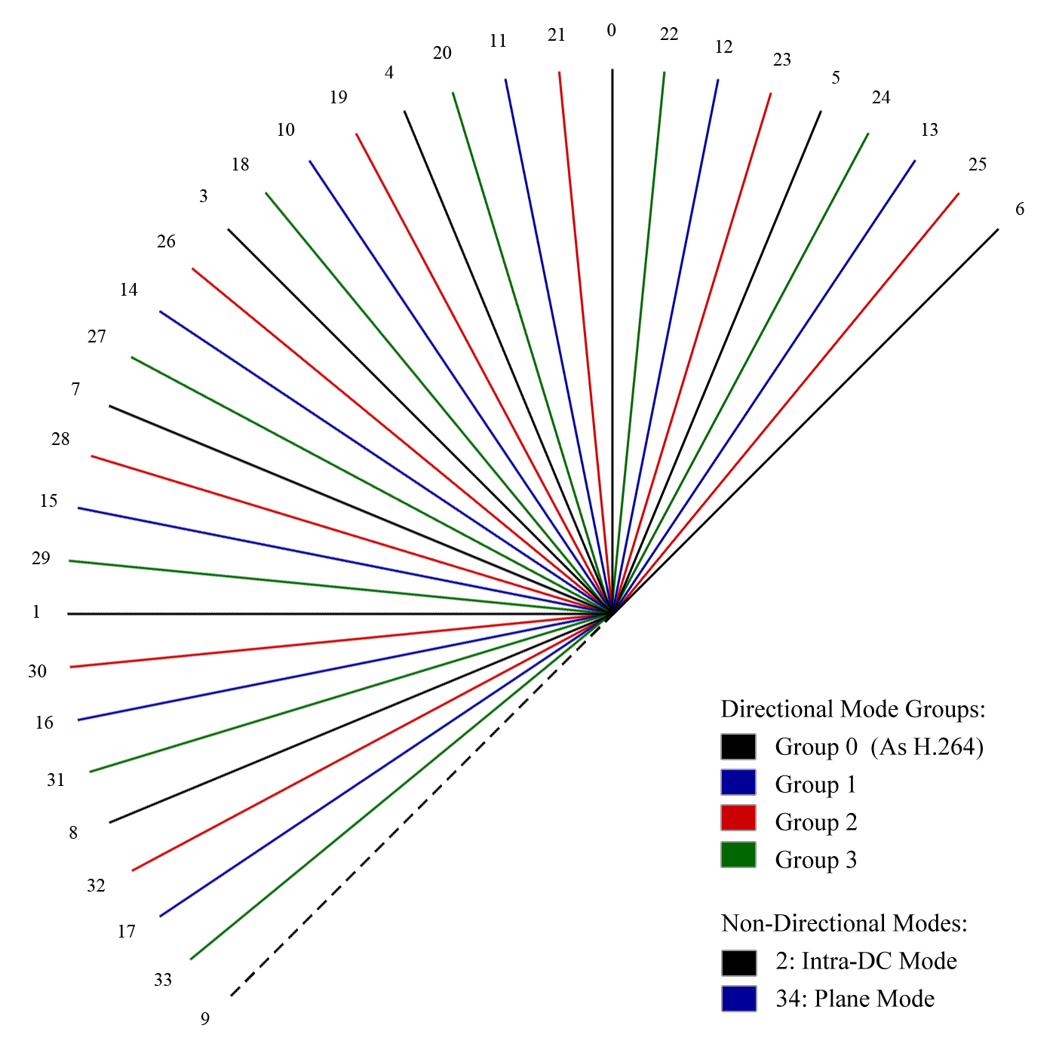
Figure 1 – Unified Intra Prediction Modes Grouped into Multiple Predictor Sets
Each intra prediction mode number can be represented by the combination of a group number and an index number within the group.
Group 0 contains the 9 basic intra modes as in H.264/AVC (8 directional modes and DC mode); the directional modes in Group 1 are obtained by rotating the 8 directional modes in Group 0 by π/16 counterclockwise, the non-directional mode in this group is Plane Mode; respectively, the directional modes of Group 2 and Group 3 are obtained by rotating Group 1’s directional modes by π/32 clockwise and counterclockwise. In order to make it compatible with Unified Intra Prediction and utilize the current tools in TMuC, some predictors are modified in the table. Mode 9 in Unified Intra prediction does not belong to any of the 4 groups, but it is preserved and is put at the original location of 17 (Group 1, Index 8). As a result, Prediction Units with the size of 4x4 pixels, the intra prediction modes are all included in the first 2 groups, and an extra non-directional mode is also available. Thus the modification of other tools is minimized.
- Intra Mode Prediction Method
Since more intra prediction modes are used, it’s necessary to improve the efficiency of the prediction for Intra Modes. The Intra Mode Prediction method currently used in TMuC 0.7 is getting the minimum value of the prediction mode of the above prediction unit and the left prediction unit. If any of above or left block is not available, the predicted current mode will be DC.
PredCurrentMode = Min ( AboveIntraMode, LeftIntraMode );
The weakness of this method is that when the predicted mode is not the actual mode, the whole mode number must be send into the bit stream. When the number of modes is large, it can be a big overhead.

 | AboveIntraMode |  |  | AboveIntraMode  [ AboveGroup, AboveIdx ]
LeftIntraMode | PredCurrentMode =  Min( AboveIntraMode,  LeftIntraMode ) |  | LeftMode  [ LeftGroup, LeftIdx ] | PredCurrentIntraMode= ModeTable  [ Min(LeftGroup,  AboveGroup), Min(LeftIdx,  AboveIdx) ]
Figure 2 -
Left: Current Intra Mode Prediction Method Used in TMuC 0.7
Right: Invented Intra Mode Prediction Method

The proposed intra mode prediction method utilizes the Group Numbers and the Group Indices. The predicted current mode is determined by the minimum Group Number and the minimum Group Index from the above block and the left block. Similarly, if any of above or left block is not available, the predicted current mode will be DC.
PredCurrentMode = ModeTable [ Min ( AboveGroup, LeftGroup ), Min ( AboveIdx, LeftIdx ) ];
If any of the predicted Group Number is not the same as the actual value, bits representing the Group Number will be sent. This reduced the probability of the need of sending all the bits of the prediction mode number. The comparison of the two prediction methods is shown in Figure – 2.

Additional Modes in R-D Search
The TMuC version 0.7 runs two rounds of R-D cost search are performed for each PU. Using Hadamard transform, he first round calculates the SAD between the original block and the predicted block for a set of directional modes. The tested directional mode with lowest SAD value is picked as the estimated best directional intra mode, and is going to be compared with the predictors in a basic prediction mode set(The predictor sets varies according to PU sizes), using real R-D cost calculation.
To make better utilization of the proposed Intra Mode Prediction method, additional modes are calculated in the second round of R-D search. For 4x4 PUs, mode 34 (Plane Mode) is added to the R-D search. For 4x4, 8x8, 16x16, 32x32, along with the estimated best directional mode, the prediction modes within the same index number in Group 0 and Group 1 are calculated as well. This method increases the probability of predicting intra modes for current PU accurately.

Experimental Results
 | BD-rate Y | BD-rate U | BD-rate V
Kimono
ParkScene
Cactus
BasketballDrive
BQTerrace
BasketballDrill
BasketballPass
Figure 3 – Coding Gain of Intra Only Mode

Conclusion
According to the experimental result, using the proposed method, the coding gains on high resolution sequences are prominent. Decoder side computational complexity is not significantly increased. The modification on the TMuC code is minimized. All the original predictors in Unified Intra Prediction are preserved; the ADI plane mode predictor is utilized for the proposed Intra Mode 34; the modification to the entropy encoders/decoders does not require any change on input or output. In conclusion, the proposed method is a potential part of the Intra Prediction Tool for the next generation video coding standard.

References
- Lingzhi Liu, “Multiple Predictor Sets for Intra Coding”, ITU-T SG16 WP3 and ISO/IEC JTC1/SC29/WG11, JCT-VC A022E, April 2010.
- Jung-Hye Min, Sunil Lee, Il-Koo Kim, Woo-Jin Han, Jani Lainema, Kemal Ugur, “Unification of the Directional Intra Prediction Methods in TMuC”, ITU-T SG16 WP3 and ISO/IEC JTC1/SC29/WG11, JCTVC-B100, July 2010.
- B.-D. Choi, J.-H. Kim, and S.-J. Ko, “Adaptive Coefficient Scanning Based on the Intra Prediction Mode,” ETRI Journal, Vol. 29, No. 5, pp.694-696 Oct. 2007.
- JCT-VC , “Test Model under Consideration”, Joint Collaborative Team on Video Coding (JCT-VC), of ITU-T SG16 WP3 and ISO/IEC JTC1/SC29/WG11, 2nd Meeting: Geneva, CH, 21-28 July, 2010
- J. Yang, B. Yin, Y Sun and N. Zhang, “A Block-Matching Based Intra Frame Prediction for H.264/AVC,” IEEE. International Conference on Multimedia and Expo., Jan. 2000

Patent rights declaration(s)
Hisilicon Technologies Co., Ltd. may have IPR relating to the technology described in this contribution and, conditioned on reciprocity, is prepared to grant licenses under reasonable and non-discriminatory terms as necessary for implementation of the resulting ITU-T Recommendation | ISO/IEC International Standard (per box 2 of the ITU-T/ITU-R/ISO/IEC patent statement and licensing declaration form).

